http://www.zdnet.com/article/stacking-up-the-cloud-vendors-aws-vs-microsoft-azure-ibm-google-oracle/ sw

<http://www.zdnet.com/article/stacking-up-the-cloud-vendors-aws-vs-microsoft-azure-ibm-google-oracle/> sw

Stacking up the cloud vendors: AWS vs. Microsoft Azure, IBM, Google, Oracle

# 云供应商大比拼：AWS与微软Azure、IBM、谷歌、甲骨文之间的较量

It's not easy tracking the girth of public cloud providers amid run rates, as-a-service sales projections, and a lack of transparency. Here's how AWS stacks up against Microsoft Azure, IBM, Google, and Oracle.

Na

By Larry Dignan for Between the Lines | February 3, 2017 -- 11:00 GMT (19:00 GMT+08:00) | Topic: Cloud

na

aws-q4-results-2016.png

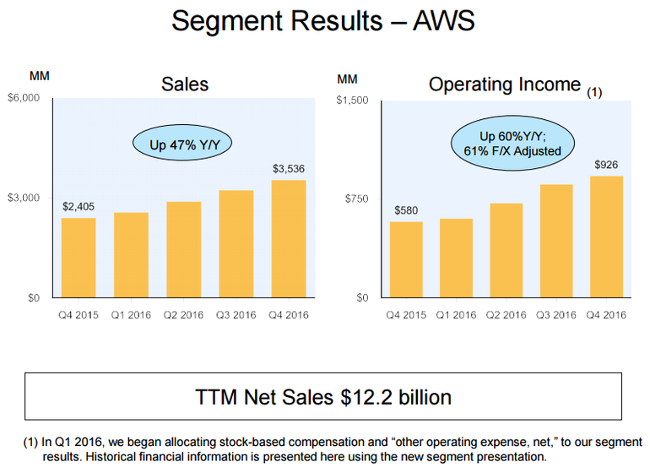

Amazon Web Services continues to lead the cloud pack as it delivered a 2016 operating profit of $3.1 billion on revenue of $12.22 billion, up from $7.88 billion in 2015.

亚马逊网络服务（AWS）日前公布，2016年的营业利润为31亿美元，营收为122.2亿美元，高于2015年的78.8亿美元。AWS仍然是云提供商里的头羊。

While analysts will fret about Amazon's e-commerce business and growth ahead, you need to realize that AWS is the profit engine. To wit:

尽管分析师在此之前曾担心亚马逊的电子商务业务和增长，但要知道AWS可是个利润引擎。其各项表现如下：

AWS' 2016 operating income was $3.11 billion on revenue of $12.22 billion.

AWS 2016年营业收入为31.1亿美元，总收入为122.2亿美元。

AWS' annual operating profit margin was more than 25 percent.

AWS的年度营业利润率超过25%。

Amazon's North American e-commerce operating margin was 2.95 percent.

亚马逊的北美电子商务营业利润率为2.95%。

And it's also worth noting that Amazon discloses actual revenue -- not a run rate. On that score, it's worth a tip of the cap on Amazon transparency when it comes to evaluating your cloud provider. Now that Amazon is out of the way, it's worth noting the big cloud providers and where they stand in the horse race based on earnings reports over the last two weeks.

值得注意的是，亚马逊披露了实际收入，而不是运行率（Run rate）。在这一点上，亚马逊的透明度作为云提供商值得点赞。讲完亚马逊了，来看看各大云提供商，各家在过去两个星期里发布了收益报告。

Naturally, AWS has a run rate too. Amazon CFO Brian Olsavsky said on the company's fourth quarter earnings conference call:

自然，AWS也有自己的运行率。亚马逊首席财务长Brian Olsavsky在第四季度收益电话会议上表示:

We feel we've got a very broad base of customers from startups to small medium businesses to large enterprises to the public sector. We are continuing to see strong growth across all those sectors. The business is now a $14 billion annualized run rate. We have been pretty clear that this business is all about creating new functionality for customers.

*我们觉得我们的客户基础非常广泛，从初创到小中型企业到大型企业到公共部门。我们持续在所有这些领域里录得强劲增长。我们的AWS业务年运行率现在是140亿美元。我们清醒地认识到，AWS业务就是要为客户创造新的功能。*

Here's a look at the standings among cloud giants.

来看一下各云计算巨头的情况。

Microsoft cited a commercial cloud annual run rate topping $14 billion. The catch? It's not easy to figure out what the run rate includes. Officially: Commercial cloud run rate is calculated by taking revenue from the last month of the quarter for Office 365 commercial, Azure, Dynamics 365, and other cloud properties and multiplying it by 12. Got that?

微软曾称商业云的年运行率超过140亿美元。玄机是什么？外人不太容易知道这个运行率涵括了什么。据官方发布的资料，商业云计算运行率的计算方法是用该季度最后一个月Office 365商业版、Azure、Dynamics 365和其他云产品收入乘以12。明白了吗?

Nevertheless, Microsoft has a bunch of cloud assets that are combining to be a formidable unit. Microsoft is a clear rival to Amazon Web Services, but a different animal entirely. Microsoft Azure plugs into hybrid clouds well. It's not a big leap from products like Windows Server to Azure and Active Directory is almost like a cloud gateway drug. CEO Satya Nadella said:

不过，微软一堆的云资产组合在一起构成了一个庞大部门。微软明显是亚马逊AWS的强劲竞争对手，但微软和AWS大不相同。微软Azure与混合云能很好地整合。从Windows服务器等产品到Azure不是太大的一步，Active Directory几乎就像一款云网关灵丹妙药。首席执行官Satya Nadella表示，

Our commercial cloud annualized revenue run rate now exceeds $14 billion, and we are on track to achieve our goal of $20 billion in fiscal year 18.

*我们现在的商业云收入年运行率超过140亿美元，我们正在迈向在2018年财年里实现200亿美元的目标。*

Customers choose the Microsoft Cloud for the following reasons: They want a trusted, global, hyper-scale cloud provider that meets enterprise grade needs. They want hybrid support that is architected into the hyper-scale service as well as the cloud servers. They want higher level services to help build their own digital capability across IoT and Enterprise App development, advanced analytics, and AI capability. Moreover, and most importantly... CIOs, CSOs, BDMs and developers are all seeing the benefits from the operational consistency, productivity and security across their entire digital estate spanning Windows 10 cloud security & management, Office 365, Dynamics 365, Enterprise Mobility and Azure.

客户选择微软云有以下的原因：他们想要一个值得信赖的、全球性的超级规模云提供商，以满足企业品位的需要。他们想要得到混合支持架构，并能够整合到超级规模服务以及云服务器里。他们想要得到更高层次的服务，以帮助自己在在物联网和企业应用开发、先进分析和人工智能功能方面建立起数字功能。此外，最重要的一点是，CIO、CSO、BDM和开发人员都认识到，他们的数字资产分布在Windows 10云安全与管理、Office 365、Dynamics 365，企业移动性和Azure里，因此，选择微软云有操作一致性、效率和安全上的好处。

That take sounds swell, but I'd love to see Azure's actual sales a quarter and fiscal year broken down based on infrastructure-as-a-service. Transparency grade: C. Maybe.

听起来很妙，但笔者希望看到Azure实际销售在该季度和财政年度的基于“基础架构即服务”的详细分类。透明度打分：丙。大概这个样子。

IBM during its fourth quarter cited an as-a-service run rate of $8.6 billion, up 53 percent from a year ago. IBM's as-a-service run rate includes software-, infrastructure- and platform-as-a-service. IBM said its fourth quarter run rate for as-a-service was $1.8 billion for its cognitive solutions unit (Watson), $1.1 billion for its global business services segment; and $5.8 billion for its technology services and cloud platform business. The spin on IBM's cloud transparency is that it is combining cognitive computing and cloud in more engagements.

IBM称第4季度即服务运行率为86亿美元，较上年同期增长53%。IBM的即服务运行率包括软件平台、基础设施平台。IBM表示，第4季度旗下认知解决方案部门(Watson)的即服务运行率为18亿美元，全球业务服务部的运行率为11亿美元；技术服务和云平台业务的运行率为58亿美元。IBM云透明度的玄机在于，IBM将认知计算和云在多个方面合在了一起。

Transparency grade: B. IBM gives you enough to work with to divine its cloud and Watson transition, but you have to follow the bouncing technology and marketing ball through the various divisions.

透明度打分：乙 。 IBM提供了足够的资料让人可以看到旗下云和Watson转型的神奇之处，但要搞明白就必须在各部门的科技和营销的之间迂回。

Google is cited as a cloud contender and key player in the market. And Google's Cloud Platform combined with apps and machine learning is a powerful notion. Yet, Google Cloud is mixed in with the other category when it comes to earnings.

业界人士普遍认为谷歌是云竞争者及市场上的关键玩家。谷歌的云平台将应用和机器学习合在一起，有关的概念十分强大。但谷歌云收益却是混在其他类里。

Other revenue for Google in the fourth quarter was $3.4 billion, up 62 percent from a year ago. Google said it saw strong performance from hardware, Google Play, and Google Cloud.

谷歌第4季度的其他类营收为34亿美元，较上年同期增长了62%。谷歌表示，可以看到硬件、谷歌Play和谷歌云的表现强劲。

Google CEO Sundar Pichai said on the company's earnings conference call:

谷歌首席执行官Sundar Pichai在收益电话会议上表示，

In 2016, we made huge strides building out our product offerings across all areas of Google Cloud Platform or GCP. We routinely hear from customers that we have now moved well beyond table stakes, and we have truly differentiated offerings in four key areas, data analytics and machine learning, security and privacy, tools for application development, and the ability to create connected business platforms leveraging our recent acquisition of Apigee.

*2016年里我们在打造谷歌云平台（GCP）在各领域的产品方面取得了巨大的进步。我们经常听到客户说我们已经远远超出了新手阶段，而且，我们在四个关键领域拥有真正具特色的产品，包括数据分析和机器学习、安全与隐私、应用程序开发工具及利用我们最近收购的Apigee创建连接业务平台的能力。*

For 2016, Google's other category had revenue of $10.07 billion. We don't know what the split is between Play and Cloud and hardware. My guess is that Play accounts for the bulk of sales for now with a heavy dose of Google Apps. Transparency grade: D.

谷歌2016年其他类的收入为100.7亿美元。我们不知道该数字在Play、云和硬件之间的分配。笔者的猜测是，Play现在占销售额的大部分， 而Google Apps有重大贡献。透明度评分：丁。

And the rest of the pack. Oracle for the six months ended November 30, reported total cloud revenue of $2 billion, up 11 percent from a year ago. Oracle breaks out software-, platform- and infrastructure-as a-service. Toss in NetSuite going forward and Oracle will be able to boast run rates along with the big guns. The transparency between the as-a-service flavors is welcome.

剩下的云提供商是甲骨文。甲骨文在截至11月30日为止的六个月里的云总收入为20亿美元，较上年同期增长了11%。甲骨文将软件、平台和基础架构即服务分了类。以后再加上NetSuite，甲骨文的运行率大可与一众大腕平起平坐。但各种即服务产品的透明度有改进的空间。