1 Plant-based meat alternatives and their associated microbial communities

2 Franz-Ferdinand Rocha, Monika Dzieciola, Narciso Martin Quijadaa, Patrick-Julian Mestera, Evelyne

3 Selberherra,∗

*aUnit of Food Microbiology Institute of Food Safety Food Technology and Veterinary Public Health Department for Farm Animals and Veterinary Public Health University of Veterinary Medicine Vienna*

# 4 Abstract

It is still unclear whether vegan meat substitutes are a short-lived trend or have come to stay. However, they are currently a popular way for flexitarians to reduce their meat consumption without having to give up the pleasure of burgers and the like. Over the last few years, the trend of increasing sales and diversifying the product range has continued, but publication activity on these products is currently limited mainly to market research and food technology topics. The paucity of research results on more microbiological levels has prompted us to investigate vegan meat substitutes from Austrian supermarkets using culture-dependent and culture-independent methods (16S rRNA gene amplicon sequencing) to find out whether product- characteristic microbial communities can be identified. The products examined showed a total of three different microbial profiles. The majority of the products were dominated by lactic acid bacteria (either *Leuconostoc* or *Latilactobacillus*), and generally had low alpha diversity. The other part of the products was dominated by *Proteobacteria* based on 16S rRNA gene amplicon sequencing data. The dominance of individual amplicon sequence variants (ASVs) is noticeably weaker and the alpha diversity distinctly higher than in the lactic acid bacteria (LAB) dominated samples. However, the cultivability of the represented genera was lower in these samples, which raises the legitimate question of whether living representatives of these genera are actually found on the final products. In addition to the dominant representatives of the LABs, a high diversity of different *Bacillus*, but also some *Enterobacteriaceae* and potentially pathogenic species were found in the cultivation. We assume that especially the dominance of the heterofermentative LABs has a high relevance for the product stability and quality and that there is potential for an improved shelf life of the products. The *Enterobacteriaceae* and potential pathogens found are relatively low, but they also show that these products are certainly suitable culture media for them. Even though the products examined all had to be heated before consumption, we would like to point out that the lack of consumer experience with this type of product (spoilage detection, preparation, storage and shelf life) is relatively low, which is why we believe that further research into product safety, taking these aspects into account, would

be desirable.

5 *Keywords:* meat analogue, vegan meat, meat substitute, microbial profile, food safety, plant protein

# 6 1. Introduction:

7 For most of the population of the Western world, meat consumption is an integral part of their diet. An

8 average U.S. American consumed 102 kg and a European Union citizen 69 kg of meat in 2020 (European

9 Commission and Directorate-General for Agriculture and Rural Development, 2020; OECD, 2022). The

10 global meat consumption increased from 24 kg per year and capita in 1990 to 34 kg in 2020 (OECD

11 and Food and Agriculture Organization of the United Nations, 2022; OECD, 2022). Although the OECD

12 estimates that consumption will level off at around 35 kg per year and capita by 2030, the total meat

13 consumption will further increase with population growth (OECD and Food and Agriculture Organization

14 of the United Nations, 2022). This globally growing appetite for meat is linked to livestock farming and

15 consequently plays a major role in the ecological issues we are currently facing. Land degradation, climate

16 change, water pollution and biodiversity loss are just some of the notable consequences for the environment

17 (Steinfeld, 2006; Bianchi et al., 2018). Additionally, common industrial animal husbandry influences public

18 health by supporting the spread of antibiotic resistances and vector-borne disease (Economou and Gousia,

19 2015; Bianchi et al., 2018; Watts et al., 2018). Apart from this, high meat consumption, as practiced in the

20 Western world and increasingly in transition countries, contributes significantly to many widespread common

21 diseases, which, in addition to individual illnesses, also burden health care systems (Micha et al., 2010; Chan

22 et al., 2011; Parkin et al., 2011; Feskens et al., 2013). All together (animal welfare, environmental issues

23 and increased health awareness) are main drivers for more and more people in western civilization to change

24 their meat consumption routines (Stoll-Kleemann and Schmidt, 2017; Ploll and Stern, 2020). In a survey,

25 conducted 2021 in ten different European countries, 2% of the participants referred to themselves as vegan,

26 5% as vegetarians, 3% as pescetarians and 30% as flexitarians (European Union’s Horizon 2020 reasearch and

27 innovation programme, b). The last group is characterized, among other things, by the fact that they want

28 to reduce their meat consumption, but do not want to give up the positive experience that comes with it. As

29 main target group, flexitarians account for about 90% of the sales of plant based meat alternatives (Neuhofer

30 and Lusk, 2022). A market research within “The Smart Protein Project” noted a sales value increase of

31 82% for plant-based meat (vegan and vegetarian) within 2018 and 2020 for Austria (European Union’s

∗Corresponding author

*Email address:*[evelyne.selberherr@vetmeduni.ac.at](mailto:evelyne.selberherr@vetmeduni.ac.at) (Evelyne Selberherr)

*Preprint submitted to Food Microbiology December 22, 2022*

32 Horizon 2020 reasearch and innovation programme, a). The sales of this product group and the number of

33 different products have increased strongly over the last few years (Curtain and Grafenauer, 2019; European

34 Union’s Horizon 2020 reasearch and innovation programme, a). Despite the increased consumption of these

35 products, there have been only a few studies on their microbiological properties. However, these would be

36 important for ensuring food safety, characterizing potential hazards, assessing risks, and for sustainability

37 questions. Since two of the UN’s sustainability goals (goal 2 – zero hunger and 12 – responsible consumption

38 and production) affects our eating habits, increased attention should be paid to reducing food waste. As

39 30% of food products in primary processing does not even reach the consumer, mainly because of microbial

40 spoilage or pathogen contamination, it is essential to improve the knowledge of the microbial communities

41 of our food, which could help to increase the shelf life and reduce the contamination with pathogens. Still

42 largely unanswered is the question if and how a high microbial diversity on food (consisting of living and

43 dead microbiota) can have a positive effect on consumer’s health. For example, a high microbial diversity

44 permanently stimulates the innate and adaptive immune system and provides resistance against colonizing

45 pathogens (Crowe et al., 1973; Mackowiak, 1982; Smith et al., 2007). It was also supposed recently, that

46 the loss of microbial diversity including the disappearance of ancestral indigenous microbiota, which is

47 currently happening in western countries, affects human health and contributes to post-modern conditions

48 such as obesity and asthma (Blaser and Falkow, 2009; Vangay et al., 2018). For all these research questions

49 fundamental knowledge on the microbial compositions on food are necessary, but still lacking. Since, little

50 is known on these products, we sampled a selection of plant-based meat alternatives available in Austria’s

51 supermarkets to investigate the general microbial community patterns. Further we described characteristic

52 microbial profiles and compared four groups of the most common product types (pea and soybean based

53 products with either “minced” (minced meat, burgers, etc.) or “fibrous” (meat chunks, Schnitzel, etc.)

54 texture. We hypothesized that products within one group have, based on similar protein processing, more

55 similar communities than between the groups. Since we examined a relatively undescribed product group,

56 we have chosen a combined approach using culture-dependent and culture-independent techniques. This

57 allowed a more complete description of the microbial community than any of the applications could stand

58 on their own, but also raised additional questions and uncertainties that are relevant to future microbial

59 research of (highly processed) foods.

# 60 2. Material and Methods

61 *2.1. Sample acquisition*

62 We purchased 32 different plant-based meat alternative products, between July 12 and July 14, 2021,

63 from four supermarket chains in Vienna, Austria. Pea- and soybean- protein based products with either a

64 minced or a fibrous texture were the most common representatives of this product group at this time point

65 in Austria. Additional criteria for the selection were, that the products where entirely plant-based (vegan)

66 and do not contain fermented products, like tofu. Beside these characteristics, the samples were different

67 in their composition, packing, shelf-life, etc. (Table 1). All samples, including two frozen products, were

68 transported refrigerated and stored at 4°C until processing. Sample processing took place within the shelf

69 life and latest five days after purchase.

70 *2.2. Sample preparation*

71 In total, 10 g of each sample, representing all layers of a product, were placed in sterile Stomacher !!!

72 400 classic strainer bags (Seward Ltd, Worthing, United Kingdom) and diluted with 90 ml sterile phosphate

73 buffered saline (PBS, gibco, Bleiswijk, The Netherlands). A Stomacher . . . was used to mechanically

74 comminute the samples for 120 s. To remove coarse food particles, 45 ml of the homogenate was centrifuged

75 at 300 rcf (relative centrifugal force) for 2 min at room temperature (RT) using an Eppendorf Centrifuge

76 5810R and an A-4-62 rotor. The remaining supernatants were transferred to new tubes and centrifuged at

77 3,000 rcf (30 min at RT). The obtained cell pellets were diluted 1:10 with sterile PBS.

78 *2.3. Bacterial and fungal isolation*

79 We carried out two sets of cultivation experiments. The first set was done with a general selection

80 of media (Columbia agar (BioMérieux, Marcy l’Etoile, France), Violet Red Bile Glucose agar (VRBG,

81 Biokar diagnostics, Allonne, France), brain heart infusion agar (BHI broth (Biokar diagnostics) + 1.5%

82 agar (bacteriological agar type E, Biokar diagnostics)), plate count agar (PCA, Biokar diagnostics), Rose

83 Bengal Chloramphenicol agar (Biokar diagnostics), and Baird Parker agar (GranuCult™, Merck, Darmstadt,

84 Germany)), to get a broad range of the expected microbial community. The plates were inoculated with

85 a 102 dilution and aerobically and semi-anaerobically incubated at 37°C. In order to recover high amounts

86 of different species, the plates were incubated for 16-68 hr, depending on colony size and growth density.

87 Samples with growth densities too high for picking single colonies after 16 hr of incubation were diluted 103

88 or 104 in sterile PBS and plated again. For the second media set we used the information from the 16S rRNA

89 gene amplicon sequencing to select specific media and growth conditions in order to isolate representatives

90 of genera we could not isolate under the first set’s conditions. Depending on the sample specific microbial

91 composition we used Luria Bertani Agar (1% tryptone (Oxoid), 0.5% yeast extract (micro-granulated,

92 Roth, Karlsruhe, Germany), 1% NaCl (Sigma-Aldrich, St. Louis, USA), 2% agar, pH 7.0), nutrient agar

93 (0.5% casein peptone, tryptic digest (Roth), 0.3% beef extract powder (Fluka analytical, Seelze, Germany),

94 1.5% agar, pH 7.0), trypto-casein soy agar (TSA,Biokar diagnostics), marine agar (marine broth (Roth)

95 + 1.5% agar ), corynebacterium agar (1% casein peptone, tryptic digest, 0.5% yeast extract, 0.5% D(+)-

96 glucose (Roth), 0.5% NaCl, 1.5% agar, pH 7.3), De-Man-Rogosa-Sharpe agar (MRS, Oxoid, Basingstoke,

97 Hampshire, UK) and pseudomonas agar F (1% tryptone, 1% casein peptone, 0.15% K2HPO4, 0.15% (Roth),

98 MgSO4 (Merck), 1% glycerol (Roth), 1.5% agar) and cultivated the samples (dilution 102-105) aerobically at

99 25°C for 48 hr. In both sets we selected morphologically unique, single colonies for re-cultivation and Sanger

100 sequencing. DNA was extracted, using a protocol modified after Walsh et al. (Walsh et al., 2013), by lysing

101 pure cultures with 100 *µ*l 0.01 M TRIS/HCl (Trizma®base, Sigma-Aldrich, St. Louis, United States) and

102 400 *µ*l 2.5% Chelex®100 resin solution (BioRad, Hercules, United States) at 95°C for 10 min, followed by

103 centrifugation with 15,000 rcf for 30 s. The supernatants were subsequently used for 16S rRNA gene PCR,

104 using a final concentration of 200 nM of each of the universal primers from LGC Genomics GmbH (Berlin,

105 Germany; 27F – 5’-GAG TTT GAT C**M**T GGC TCA G-3’ and 1492R – 5’-GG**Y** TAC CTT GTT ACG

106 ACT T-3’), 0.025 U/*µ*l Platinum™Taq DNA-Polymerase (Invitrogen™, Vilnius, Lithuania), 1x TaqMan

107 PCR buffer, 2 mM MgCl2, and 250 nM dNTP Mix (Thermo Scientific™, Vilnius, Lithuania). For the

108 reaction a protocol of 95°C for 5 min (Taq activation) followed by 35 cycles of 40 s at 95°C (denaturation)

109 40 s at 52°C (annealing ) and 1 min at 72°C (elongation) was used. For negative control a reaction with

110 ddH20 as well as a reaction the negative extraction control were performed. In-house *Listeria monocytogenes*

111 DNA served as positive control. All PCR products were checked with a QIAxcel DNA High Resolution Kit

112 (Qiagen, Hilden, Germany) in a QIAxcel Advanced system (Qiagen). Negative PCR results were followed

113 by an ITS2 gene PCR (200 nM of each of the primers ITS3 – 5’-GCA TCG ATG AAG AAC GCA GC-3’

114 and ITS4 – 5’-TCC TCC GCT TAT TGA TAT GC-3’ (White et al. 1990), 0.025 U/*µ*l Platinum™Taq

115 DNA-Polymerase (Invitrogen™), 1x TaqMan PCR buffer, 2 mM MgCl2, and 250 nM dNTP Mix (Thermo

116 Scientific™), with a protocol of 95°C for 5 min (Taq activation) followed by 30 cycles of 40 s at 94°C, 40 s

117 at 56°C and 1 min at 72°C). For cultures, negative in 16S rRNA and ITS2 PCR, we repeated the extraction

118 with the NucleoSpin tissue kit (Machery-Nagel, Düren, Germany), using the manual in combination with

119 the recommendations for hard-to-lyse bacteria. LGC Genomics GmbH purified and sequenced the PCR

120 products in one direction (using 27F primer for 16S rRNA and ITS4 for the ITS2 region). Potential

121 pathogens and unclassified *Enterobactericeae* were further whole genome sequenced with FLO-MIN106 flow

122 cells on a MinION Mk1C (Oxford Nanopore Technologies, Oxford, UK). The library preparation for this

123 approach was done according to the protocol of Oxford Nanopore Technologies (“Ligation sequencing gDNA

124 - native barcoding (SQK-LSK109 with EXP-NBD196)”) using the NEBNext® FFPE DNA repair kit (New

125 England BioLabs® Inc., Ipswich, United States) for DNA repair and end-preparation, NEB Blunt/TA Ligase

126 Master Mix (New England BioLabs® Inc.) and Native Barcoding Kit 96 (EXP-NBD196, Oxford Nanopore

127 Technologies), for native barcode ligation, Adapter Mix II (Oxford Nanopore Technologies) and NEBNext®

128 Quick Ligation Module (New England BioLabs® Inc.), for adapter ligation, Agencourt AMPure XP beads

129 (Beckman Coulter™), for clean-up steps and SQK-LSK109 sequencing kit (Oxford Nanopore Technologies).

130 *2.4. Bacterial quantification and composition*

131 For direct DNA extraction the DNeasy PowerFood® kit (Qiagen) was used. That for, the in PBS

132 stored cell pellets (-80°C) were thawed, centrifuged (3,000 g, 30 min) and resuspended in 450 *µ*l MBL buffer.

133 Deviating from the DNeasy PowerFood protocol, the lysis step was proceeded in Lysing Matrix A, 2 ml tubes

134 (MP Biomedicals Germany GmbH, Eschwege, Germany). The further steps were processed according to the

135 protocol. The elution step was done twice with 30 *µ*l ddH2O, respectively. Parallel an extraction of ddH2O

136 was performed as negative extraction control. Sequencing libraries of the 16S rNRA gene (V3/4 region) were

137 prepared based on Illumina 16S Metagenomic Sequencing Library Preparation recommendations. Primers

138 341F (5’-CCT ACG GG**N** GGC **W**GC AG-3’) and 805R (5’-GAC TAC **HV**G GGT ATC TAA TCC-3’)

139 (Klindworth et al. 2013) were used together with Illumina adapter sequences (5’ CGT CGG CAG CGT CAG

140 ATG TGT ATA AGA GAC AG-3’ and 5’ GTC TCG TGG GCT CGG AGA TGT GTA TAA GAG ACA

141 G-3’, respectively) for amplification. Libraries were constructed by ligating sequencing adapters and indices

142 onto purified PCR products using the Nextera XT Sample Preparation Kit (Illumina). Equimolar amounts

143 of each of the purified amplicons were pooled and sequenced on an Illumina MiSeq Sequencer with a 300

144 bp paired-end read protocol. 16S rRNA gene amplicon library generation and sequencing was performed at

145 the Vienna Biocenter Core Facilities NGS Unit (Vienna, Austria, www.vbcf.ac.at).

146 *2.5. Sequence Processing and Statistics*

147 The data obtained from the MiSeq sequencing went through a QIIME 2™v2021.4.0 (Bolyen et al., 2019)

148 workflow including demultiplexing and DADA2 denoising and quality control filtering. The taxonomic

149 classification was done with the Scikit-learn algorithm using a pre-trained full-length-uniform-classifier based

150 on the SILVA 138.1 database (Quast et al., 2013; Bokulich et al., 2018; Kaehler et al., 2019; Robeson et al.,

151 2021; Kaehler). After removal of sequences with mitochondrial or chloroplastic origin, further analyses were

152 performed with R (R Core Team, 2021). To estimate the alpha diversities of the samples Hill-Simpson

153 and Hill-Shannon diversity were calculated using the “iNEXT” package (Hsieh et al., 2022), based on

154 99.5% coverage rarefied samples (Chao and Jost, 2012; Roswell et al., 2021). Group comparisons were done

155 with Kruskal-Wallis tests followed by Bonferroni-alpha-corrected Dunn’s tests for pairwise comparisons.

156 For beta diversity analyses the samples were rarefied with 100 iterations based on a coverage of 99.5%

157 using the package “phyloseq” (McMurdie et al., 2021) and “metagMisc” (Mikryukov, 2022). Based on

158 that we generated distance matrices with Bray-Curtis dissimilarities, Jaccard indices and Jensen-Shannon

159 divergence and use them for graphical (t-distributed stochastic neighbor embedding - tSNE) and statistical

160 (PERMANOVA, LEfse) analysis. For tSNE we used the “Rtsne” package (Krijthe, 2022) with a maximum

161 of 1000 iterations, a perplexity of 5 and two initial dimensions, as recommended by Oskolkov (Oskolkov,

162 2019). The high variability of the products and little knowledge on the underlying production conditions

163 made it impossible to find adequate variables for PERMANOVA, besides the main protein source and the

164 texture. The producing facility as additional variable would be meaningful, but the product assortment

165 is dominated by one company, which made the model design very unbalanced. PERMANOVA was done

166 with the “vegan” package (Oksanen et al., 2022) using “betadisp” to check for homogeneous dispersion

167 and “adonis” functions for PERMANOVA with 999 iterations using main protein source and texture as

168 explanation variables. LEfse was done with the relative abundance data of the coverage rarefied data in

169 combination with “phyloseqCompanion” package (Stagaman, 2022), for data transformation and the LEfse

170 Bioconda tool by Segata et al. (Segata et al., 2011), using the protein source and texture as class, a

171 normalization of 1 million and a log10 LDA score threshold of 4.0. In parallel, a group comparison for the

172 same features, as examined with LEfse, was done with Kruskal-Wallis tests followed by a Benjamin-Hochberg

173 alpha correction. The Sanger sequences from the isolates were trimmed using the “SangerRead” function

174 within the “sangeranalyseR” package (Lanfear and Chao, 2021) with a Phred score mean quality cutoff of

175 40 and a sliding window size of 15 bp. Trimmed sequences, with >100 bp length, were classified with the

176 “assignTaxonomy” function of the “dada2” package in R (with kmer size 8 and 50 bootstrap replicates),

177 based on an RDP Naïve Bayesian Classifier algorithm (Wang et al. 2007). Further, the isolate sequences

178 were assigned to a database generated from the MiSeq data set to connect the culture-based and culture-

179 independent approaches. For figure 1, the isolate sequences of each genus were clustered within each sample,

180 group and producer using the “IdClusters” function from the “DECIPHER” package (Wright, 2021) with a

181 cutoff of 0.06. More clusters within each genus were interpreted as a higher species or strain diversity within

182 each genus. The whole genome data sequenced with the MinION were trimmed and filtered with Filtlong

183 v0.2.1 (Wick, 2021), assembled with Flye v2.9 (Kolmogorov et al., 2019; Lin et al., 2016) followed by several

184 polishing steps (four repetitions of Racon v1.5.0 (Vaser et al., 2017) and a final step with Medaka v1.6.0

185 (Oxford Nanopore Technologies, 2022) ), before they were used in the TORMES v1.3.0 (Quijada et al.,

186 2019) workflow.

187 **3. Results**

188 *3.1. Product descriptions*

189 The four groups did not have the same sizes, since the product portfolio for each group was not large

190 enough. Still, we had an overall of 16 pea-based and 16 soybean-based products (Table 1). Beside the four

191 main properties, the products were quite diverse. Particularly noteworthy is the number of ingredients used

192 per product (4-27, with a total of about 120 different used ingredients within the 32 sampled products) and

193 the large range of shelf life. The products are also different on factors, which might influence the bacterial

194 composition, i.e. pre-heating or freezing steps, as well as packing in modified atmosphere. Most of the

195 products had clear cooking instructions on the labels, including the recommendation for thorough cooking

196 (Table 1). In total, 27 samples were packed in modified atmosphere with unknown composition. Out of 30

197 samples sold refrigerated (the other two frozen) six products were frozen at any point during the retail chain

198 (Table 1).

199 *3.2. Cultivable microbial communities*

200 In total, 465 colonies were picked and selected for 16S rRNA or ITS gene sequencing. Among these,

201 431 could be classified to the genus level, representing 38 genera in four different phyla (Figure 1). The

202 remaining isolates could only be assigned to family level (n=16, all Enterobactericeae), were fungi (n=15;

203 Wickerhamomyces (n=7), Issatchenkia (n=6), Yarrowia (n=1), Dipodascus (n=1)), or stayed unassigned

204 (n=3). We isolated Bacillus from 19, Leuconostoc from 18, Enterococcus from 12, Latilactobacillus from 10

205 samples. Species from the genus *Bacillus*, Leuconostoc and *Latilactobacillus* could be isolated from each of

206 the four sample groups. *Enterobacteriaceae*, which are usually surveyed as an additional hygiene criterion,

207 were only found in the pea protein products of a single manufacturer (Figure 1). A selection of these

208 *Enterobacteriaceae* and isolates classified as potential pathogens (i.e. *Staphylococcus aureus*, *Bacillus cereus*

209 group, *Klebsiella* sp.) were whole genome sequenced with a MinION device. DATA MISSING

210 *3.3. Lactic acid bacteria and gamma-*Proteobacteria *dominate the 16S rRNA amplicon sequences*

211 In total, 28 samples (883,866 sequences; median frequency per sample: 25,627; range: 439-253,681)

212 passed the quality criteria and were processed with QIIME 2. Because we used coverage based rarefaction

213 (with a coverage of 99.5%) and all of the remaining samples meat this coverage, we removed none of them for

214 further analysis. Over all samples, the ASVs were assigned to 25 different Phyla, however, only three Phyla

215 with >3% in at least one of the samples were found (i.e. *Firmicutes* 0.00-0.95%, *Proteobacteria* 0.00-0.31%,

216 *Bacteroidota* 0.00-0.11%). In total, 18 samples were dominated (>50% relative abundance) by *Firmicutes* (10

217 samples with >90%), while in the other 9 samples *Proteobacteria* is the most abundant Phylum. The most

218 common genera were *Leuconostoc* (detected in 25 samples; 0.03-100.00% rel. abundance), *Latilactobacillus*

219 (detected in 21 samples; 0.02-86.38% rel. abundance), *Pseudomonas* (detected in 20 samples; 0.36-35.25%

220 rel. abundance), *Serratia* (detected in 19 samples; 0.03-8.92% rel. abundance), and Acinetobacter (detected

221 in 17 samples; 0.09-15.40% rel. abundance). The genus Leuconostoc was the most abundant in 13 samples,

222 followed by Latilactobacillus (4 products), and Shewanella (4 products) (Figure 2). Some genera were found

223 proportionally high (>10%) in one or more samples, but could not be isolated (i.e. *Shewanella*, *Xanthomonas*,

224 *Photobacterium*, *Myroides*, *Pediococcus*).

225 *3.4. Protein source and texture are not the main driver for the community pattern*

226 The Kruskal-Wallis tests comparing the alpha-diversity indices (i.e. Hill-Shannon index and Hill-Simpson

227 index) between the four groups (based on proteins source and texture) were significant (p.value = 0.020 and

228 0.052), but in post-hoc Dunn’s test with Bonferroni alpha adjustment only the Hill-Shannon index between

229 groups “pea-fibrous” and “pea-minced” differed significantly (p.value= 0.016 - Supplement Figure xy). The

230 group dispersions were homogenous in all examined distance methods (i.e. Bray-Curtis, Jaccard, JSD).

231 The PERMANOVA showed that texture and protein source significantly affects the microbial composition

232 (Supplement Table 2), but explained only between 15.9371178and 23.4413074% of the total variance. The

233 variance explanation by the PERMANOVA would increase, if the manufacturer as variable was added to

234 the model, but since the sampling was very unbalanced on that, we avoided this step.

235 LEFSE FEHLT HIER

236 *3.5. 16S rRNA sequencing revealed three distinct community profiles*

237 In the tSNE plot we see three distinct clusters (Figure 3), which we described, based on the dominating

238 genera as *Leuconostocaceae*-, *Latilactobacillus*- and *Proteobacteria*-profiles. The clustering is traceable, when

239 comparing the similarity of the relative abundance patterns of the samples within each cluster. Although

240 there is some clustering, there is no clear separation based on the examined variables (main protein source,

241 status, manufacturer).

242 ALPHA DIV AND LEFSE FOR PROFILES LEfSe identified 32 discriminative features with an LDA

243 Effect Size >4.0 (Fig 3). This analysis highlighted a predominance of Leuconostocaceae (log LDA 5.48)

244 and its classification levels above in pre-cooked pea products. It identified *Proteobacteria* (log LDA 5.33)

245 as most characteristic for raw pea products, mainly based on the predominance of Pseudomonas (log LDA

246 4.81). Highly discriminant for soy products were some low abundant features. LEfSe calculated and log

247 LDA score of 4.68 for Acetobacter in pre-cooked soy products and of 4.62 for *Flavobacteriaceae* in raw soy

248 products.

249 **4. Discussion**

250 Highly processed food, like the plant-based meat alternatives we examined in this study, brings challenges

251 to microbiologists. The broad range of ingredients (~120 in in the 32 examined products),different processing

252 steps, and a variety of equipment lead to many potential sources for bacterial contamination. The product

253 specific production processes were not available, but up to the present low (LMEC) and high moisture

254 extrusion cooking (HMEC) are the most common commercially used technologies to produce meat textured

255 plant proteins (Dekkers et al., 2018). Both methods are based on an interaction of heat, shear force and

256 pressure, but the conditions for extrusion process depends on the original protein source and the desired

257 final protein structure (Lin et al., 2002; Beniwal et al., 2021; Ferawati et al., 2021) . From the perspective of

258 microbial survival during this process temperature, pressure and time are the most relevant variables. These

259 parameters depend strongly on the process settings and can therefore only serve as a guide. The extruder

260 barrels show temperature gradients with temperatures at 150-170°C in the high-temperature melting zone

261 for HMEC (Schmid et al., 2022), but the extruder die is approximately 15-25°C cooler than that (Lin et al.,

262 2000). The barrel temperature for LMEC is general lower with 120-150°C (Guyony et al., 2022). The

263 pressures in this barrels is between 1-4 MPa in HMEC and up to 13 MPa in LMEC (Kristiawan et al.,

264 2018; Pietsch et al., 2019; Guyony et al., 2022). Yu et al. showed in different LMEC settings fastest particle

265 residence times (first signs of the tracer) from 10-40 s and extrudate collection times (complete tracer

266 passed) from 60 to 120 s, resulting in mean residence times of 35-87 seconds, depending on feed moisture,

267 screw speed and die diameter (Yu et al., 2014). So far it is described, that vegetative forms of bacteria get

268 inactivated effectively by this process and only spores of bacteria like *Bacilli* and *Clostridia* would survive the

269 extrusion process (Mwangi, 2008; Leutgeb, 2017). However, reactivation of spores during further processing

270 is possible (Filho et al., 2005). This could be one explanation why *Bacillus* was isolated from most of the

271 samples (19/32), while the relative abundance of 16S rRNA gene DNA is relatively low, compared to other

272 genera. We assume, due to this initial extrusion procedure, the main protein is not the source for most of

273 the living bacterial cells we have isolated from the products. Highly probable contamination sources are the

274 addition of ingredients, especially spices and herbs (Sagoo et al., 2009), and production environment.

275 Based on the microbial distribution patterns from the MiSeq data, we roughly describe three different

276 community profiles. Two of them were dominated by lactic acid bacteria (14/28 *Leuconostocaceae* dominated

277 samples, 4/28 *Latilactobacillus* dominated samples). The majority of these samples, was dominated by one

278 ASV, which are mostly assignable to an isolate from the same sample, which suggests that these species are

279 actually active in the final product. This is underlined by the high plate counts of these samples. Based on

280 WGS of representative isolates the ASVs and isolates could be classified as *Leuconostoc mesenteroides* and

281 *Latilactobacillus sakei*.

282 !!!nochmal checken, bzw. sequenzieren!!! L. mesenteroides vs. L. citreum UND checken auf Gene zur

283 Bacteriocin produktion!!!

284 *Leuconostoc mesenteroides* subsp. an important fermenter for products like kimchi and sauerkraut (Chun

285 et al., 2017), or soybean paste (Zhang et al., 2019). Other positive features of *L. mesenteroides* are potential

286 probiotic properties of some strains and antimicrobial activities against pathogenic bacteria, like *Salmonella*

287 *typhymurium* and *Listeria monocytogenes* (de Paula et al., 2015; Thangavel and Thiruvengadam, 2019).

288 Nevertheless, *L. mesenteroides* is usually described as common spoiler for meat, meat products and other

289 food, asssociated with off-odeurs, off-flavours, slime and gas production (Björkroth and Holzapfel, 2006,

290 Casaburi et al. (2015); Lianou et al., 2016). Leuconstoc as spoiler is often described in combination modified

291 atmosphere packed products and cold stored products (Hamasaki et al., 2003; Hultman et al., 2015; Pothakos

292 et al., 2014).*Leuconstoc mesenteroides* and the also isolated *Leuconostoc citreum* belong among others to the

293 most isolated lactic acid bacteria from plants and plant-based food (Yu et al., 2020). *Latilactobacillus sakei*

294 subsp. are similarly versatile. They are described as fermenter particularly for sausages (Vinderola et al.,

295 2019), and vegetable products (Jung et al., 2014), as producer of bacteriocines (Castellano et al., 2017), and

296 as probiotics (Park et al., 2008).

297 Geeraerts et al., 2020 examined ready to vegetarian, vegan and insect based meat alternative, including

298 products with fermented ingredients, like fermented sour dough. Based on that, they assumed sour dough as

299 main source for *Latilactobacillus sakei*, which they isolated most (Geeraerts et al., 2020). Different to that

300 study, we excluded products with fermented ingredients, but vinegar. Still we found large amounts of lactic

301 acid bacteria in the examined products. Unlike Geeraerts et al., the majority of the samples in ours study

302 were dominated by *Leuconostoc*, but we could not determine this by product characteristics. For kimchi and

303 other plant products is described, that *Leuconostoc*, *Entercoccus* and *Lactococcus*, as generalists act as initial

304 colonizers, followed later by *Lactobacillus*, *Pediococcus* and *Weissella* (Yu et al., 2020). This can be explained

305 by a better adaptability to environmental conditions (e.g. through a large number of accessory genes), but

306 also by the already high population density on the ingredients, while in later stages decreasing pH values

307 inhibits *Leuconostoc* species sensitive to acids (Yu et al., 2020). However, the examined products were very

308 diverse in their shelf life, so it was impossible to conclude, whether *Latilactobacillus* dominated samples,

309 were in a later stage of shelf life than the *Leuconostoc* dominated samples. In vegan meat alternatives, the

310 drop in pH should not be comparable to kimchi (pH 4.0) (You et al., 2017). It ranks in the range of 5.4-6.6

311 (Geeraerts et al., 2020; Tóth et al., 2021), and thus should not favour *Latilactobacillus sakei*. In general, in

312 both species there are strains that are able to grew at 4°C (Hamasaki et al., 2003; Jung et al., 2014; Zagorec

313 and Champomier-Vergès, 2017), although *Leuconstoc mesenteroides* strains, examined by Comi and Iacumin

314 grew faster at 4°C than *Latilactobacillus sakei* (Comi and Iacumin, 2012). *Leuconostoc* spp., among these

315 *Leuconstoc mesenteroides* and *Leuconstoc citreum* are described to inhibit the growth of *Latilactobacillus*

316 *sakei* strains (Kim, 2013; Lee et al., 2015), but it was also demonstrated, that *Latilactobacillus sakei* is able

317 to inhibit the growth of *Leuconstoc mesenteroides*, when the are inoculated equally to cooked bacon (Comi

318 et al., 2016).

319 Overall, we examined nine samples with high relative abundances of *Proteobacteria*, mainly *Pseudomonas*,

320 *Psychrobacter* and *Shewanella*. These three genera, are common spoilers in meat and fish products, especially

321 in products with slightly higher pH values, like fish, sea food and poultry (Borch et al., 1996, Odeyemi et al.

322 (2018)). Plant-based meat products are usually also slightly higher in pH (Geeraerts et al., 2020, Tóth

323 et al. (2021)). Although the number of ASVs within a these genera is much higher, compared e.g. with

324 *Leuconostoc* from other samples, what we associate with different sources of contamination, there are still

325 single ASVs with relatively high abundances, which indicates either a large entry from one source or an

326 active growth on the product at some time point during the production. The most obvious sources would

327 be the main protein, the used water (via biofilms in water reservoirs or water hoses) or biofilms during the

328 process. From the found genera in the MiSeq data, at least 13 are described as biofilm builders in food

329 processing environments (Wagner et al., 2021), among these *Pseudomonas*, *Psychrobacter* and *Shewanella*.

330 The possibility of biofilm formation on the processing equipment is high, since many of the used machines

331 are hard to clean. However, this is contradicted by the fact that among the nine *Proteobacteria*-dominated

332 samples seven had a very similar pattern, but were from six different producers. There are no available

333 studies on the microbial communities of raw soybean or pea proteins, but 16S rRNA patterns of peas or the

334 phyllosphere of soy do not support the thesis, that this kind of contamination is associated with the main

335 protein source. Only sample B4, which is the only sample, that is dominated by *Alphaproteobacteria*, had

336 high similarities to the microbial community of the soy phyllosphere (Vorholt, 2012). However, some of the

337 producer just have a few products in this food segment, so we would not exclude, that they buy already

338 extruded proteins from a large distributor and use it for their products. Although we assume that most

339 *Proteobacteria* detected here are dead in the final product, the collected microbial communities of these

340 products are not irrelevant. On the one hand, it is possible that bacteria, which are metabolically active

341 at some point during the process, contributes to the development of (off-)odors and (off-)tastes, and on

342 the other hand, it can provide information on whether there are contamination inputs in the ingredients or

343 process areas that could be considered in the HACCP concept in the longer term (e.g. preventing biofilm

344 formations).

345 !!! check Beneficial Microorganisms in food and nutraceuticals chapter Leuconostoc spp. as Starters and

346 Their Beneficial Roles in Fermented Foods!!! . . .

347 !!!HERE BACILLUS!!!

348 Staph aureus

349 Beside the dominating, spoilage associated genera, we also isolated some *Enterobactericeae*, of which

350 selected isolates where whole genome sequenced and taxonomically assigned to *Leclercia*, *Atlantibacter*, *Cit-*

351 *robacter*, *Escherichia* and *Klebsiella*. This confirms the findings of Luchansky et al., who inoculated beef and

352 vegan burgers with Shiga toxin-producing human pathogens (i.e. *Escherichia coli* (STEC), *Salmonella* and

353 *Listeria monocytogenes*) and showed that they could survive and even grow in vegan burgers (Luchansky

354 et al., 2020). Apart from containing pathogenic species, the *Enterobacteriaceae* family serves as a hygiene

355 indicator. In our sample, all isolated *Enterobacteriaceae* came from products of the same manufacturer.

356 However, in MiSeq the relative abundances of *Enterobacteriaceae* were very low in all examined samples.

357 Heating kills effectively *Eterobacteriaceae* in these products (Luchansky et al., 2020). All products were la-

358 belled with cooking instructions, most of them specific with cooking time in minutes, some only with “heat

359 through before consumption”. This final heating step by the consumer is considered the HACCP concept

360 of the manufacturer. While cooking time in minutes is a good guidance for the consumers, “heat through”

361 is in our opinion too imprecise. First there is a lack of experience with these kind of products, second in

362 contrast to animal meat (products) there is no indicator like color change to determine a sufficiently cooked

363 state. However, this lack of experience with these products is not limited to preparation, but also to spoilage

364 detection, handling of the raw product and shelf life or storage before and after preparation. In total, nine

365 out 32 samples had an expiry date, the others a best before date, leaving the final spoilage detection to the

366 consumer. The odor of the products, we tested, were in general not comparable to the corresponding meat

367 product. Although the best-before date on these products is to be welcomed for reasons of sustainability,

368 it is understandable that consumers are more inclined to discard the products once this date has passed,

369 as they do not trust themselves to make an assessment. With regard to the preparation before heating,

370 the products are to be differentiated. Most of them are “ready-to-heat”, so there is no need for handling

371 before the heating step. Additional preparation steps are most likely for vegan mince (mixing and form-

372 ing steps).In this case, the same kind of kitchen hygiene is appropriate as is recommended for raw meat.

373 Toth et al. concluded in their study that dishes with vegan meat substitutes spoiled faster than their meat

374 counterparts when stored after preparation (Tóth et al., 2021). These findings, together with the generally

375 higher refrigerator temperatures than recommended (James et al., 2017), once again shows the importance

376 of increasing consumer awareness of food handling and storage.

377 As already mentioned, the microbiological assessment of highly processed foods is not easy. A solely

378 culture-based focus is not ideal, as only divisible, culturable cells are detected. In this case, for exam-

379 ple, non-culturable species or viable but nonculturable cells completely elude our observation. The latter

380 are particularly relevant for processed foods, as their emergence is often induced by environmental changes

381 (Zhao et al., 2017). This cell state is described for a long list of human pathogens and other bacteria (Li

382 et al., 2014; Dong et al., 2020). A culture-independent approach alone is also inappropriate, as there is

383 also a large amount of dead cells in these products due to the many process steps, which also leads to a

384 misrepresentation of the microbial ecology of these products. A combined approach, as we have used in this

385 study, complicates the interpretation of the data but provides much information on how to improve future

386 analyses. Overall, it is hard to generalize the results of this study, due to the highly diverse attributes of this

387 product category. Th sampling design was based on main protein source and texture, since we thought that

388 the main ingredient, and its processing contributes substantially to the product’s microbial community. Fur-

389 thermore, they were the only objectivisable product characteristics, with enough products represented per

390 group for a balanced study design. And although main protein source and texture were significant variables

391 in the PERMANOVA, they only explained about 18% of the model’s variance. Adding the manufacturer as

392 additional variable to the PERMANOVA increased the explained variance to 53%. However,the two most

393 frequently represented manufacturers contributed 18 (11+7) out of 32 products in this study, while the other

394 seven manufacturers contributed with a maximum of two samples. For this reason, we consider the sample

395 selection to be too unbalanced to be able to make valid statements under consideration of the manufacturer.

396 Nevertheless, we assume that the production plant has a non-negligible effect on the product’s microbial

397 community.

398 . . .

399 **5. Conclusion**

# 400 6. Conflict of Interest

401 The authors confirm that they have no conflicts of interest with respect to the work described in this

402 manuscript.

# 403 7. Acknowledgements

404 We would like to thank Birgit Bromberger and Christoph Eisenreich for their active support in conducting

405 the experiments.

# 406 8. Contributions of Authors

407 FF.R. and E.S. conceived and planned the experiments. FF.R. and M.D. carried out the experiments.

408 FF.R., NM.Q. and E.S. performed the computations. FF.R. wrote the manuscript with input from all

409 authors. All authors provided critical feedback to the research, analysis and manuscript.

410 **9. Tables**

411 Table 1: Showing the labelled attributes of the examined products

Table 1: Showing the labelled attributes of the examined products

protein source1

ID

*Manufacturer 01*

ingredients

texture2 shelf life3 cooking time4 no. of

additional labelling

A1 pea minced 9 d to ed (0 d) 7-8 min 17 consume only thoroughly

heated; MAP

A4 pea minced 2 d to ed (0 d) 5-8 min 18 consume only thoroughly

heated; MAP

*Manufacturer 02*

protein

Table 1: Showing the labelled attributes of the examined products *(continued)*

no. of

|  |  |  |  |  |  |  |
| --- | --- | --- | --- | --- | --- | --- |
| ID | source1 | texture2 | shelf life3 | cooking time4 | ingredients | additional labelling |
| A2 | pea | minced | 6 d to bbd (1 d) | 3-5 min | 14 | raw; consume only |
|  |  |  |  |  |  | thoroughly heated; MAP |
| A3 | pea | minced | 3 d to bbd (0 d) | 4-6 min | 13 | MAP |
| A5 | pea | minced | 14 d to bbd (1 d) | - | 13 | MAP |
| A7 | pea | minced | 13 d to bbd (1 d) | 2 min | 14 | MAP |
| A8 | pea | minced | 6 d to bbd (1 d) | 3-5 min | 15 | consume only thoroughly |
|  |  |  |  |  |  | heated; MAP |
| D2 | pea | fibrous | 7 d to bbd (1 d) | - | 12 | MAP |
| D4 | pea | fibrous | 28 d to bbd (1 d) | 3-5 min | 11 | MAP |
| D5 | pea | minced | 12 d to bbd (1 d) | - | 14 | pre-heated; MAP |
| D6 | pea | fibrous | 14 d to bbd (1 d) | 3-5 min | 13 | MAP |
| D7 | pea | fibrous | 12 d to bbd (1 d) | 3-5 min | 13 | MAP |
| D8 | pea | fibrous | 28 d to bbd (1 d) | 3-5 min | 10 | MAP |
| *Manufacturer 03* | | | | | | |
| A6 | pea | minced | 29 d to bbd (2 d) | 3-5 min | 6 | |
| B8 | soybean | minced | 22 d to bbd (2 d) | 3-5 min | 8 | |
| *Manufacturer 04* | | | | | | |
| B1 soybean | | minced | 52 d to bbd (3 d) | 4-6 min | 10 | MAP |
| B3 soybean | | minced | 10 d to bbd (3 d) | 4-6 min | 20 | MAP |

*Manufacturer 05*

B2 soybean minced 5 d to ed (-) 7 min 15 raw; consume only

thoroughly heated; frozen once; MAP

B6 soybean minced 3 d to ed (-) 8-10 min 12 raw; consume only

thoroughly heated; frozen once; MAP

B7 soybean minced 3 d to ed (-) 12 min 21 raw; consume only

thoroughly heated; frozen once; MAP

C1 soybean fibrous 13 d to ed (-) 5 min 6 pre-heated; frozen once;

MAP

C2 soybean minced 18 d to ed (-) 5-7 min 22 pre-heated; frozen once;

MAP

C3 soybean fibrous 10 d to ed (-) 4-7 min 16 pre-heated; frozen once;

MAP

|  |  |  |  |  |
| --- | --- | --- | --- | --- |
| fibrous | 24 d to ed (-) | 4-7 min | 18 | pre-heated; frozen once; MAP |
| fibrous | 174 d to bbd (2 d) | 6-8 min | 4 | consume only thoroughly |
|  |  |  |  | heated; frozen once; |

C4 soybean

*Manufacturer 06*

B45 soybean

|  |  |  |  |  |  |  |
| --- | --- | --- | --- | --- | --- | --- |
| B55 | soybean | fibrous | 119 d to bbd (2 d) | 6-8 min | 27 | consume only thoroughly |
|  |  |  |  |  |  | heated; frozen once; |

*Manufacturer 07*

C5 soybean fibrous 0 d to bbd (-) 4-5 min 14 pre-heated; consume only

thoroughly heated; MAP

protein

Table 1: Showing the labelled attributes of the examined products *(continued)*

no. of

|  |  |  |  |  |  |  |
| --- | --- | --- | --- | --- | --- | --- |
| ID | source1 | texture2 | shelf life3 | cooking time4 | ingredients | additional labelling |
| C6 | soybean | fibrous | 0 d to bbd (-) | 4-5 min | 19 | pre-heated; consume only |

thoroughly heated; MAP C7 soybean fibrous 0 d to bbd (-) 4-5 min 21 pre-heated; consume only

thoroughly heated; MAP

*Manufacturer 08*

C8 soybean fibrous 8 d to bbd (1 d) 5 min 23 consume only thoroughly

heated; MAP

*Manufacturer 09*

|  |  |  |  |  |  |  |
| --- | --- | --- | --- | --- | --- | --- |
| D1 | pea | minced | 10 d to bbd (1 d) | - | 16 | MAP |
| D3 | pea | fibrous | 7 d to bbd (1 d) | - | 16 | MAP |

1 Protein basis of the examined product. Only pea or soybean protein products were selected for the study.

2 product designation. Products with a minced ’meat’ basis (i.e. minced meat, burger, cevapcici, sausages) were additionally classified as ’minced’, products immitating pieces of meat or a meat structure (i.e. fillets, steaks, chunks, kebab) were classified as ’fibrous’.

3 days to expiration date (ed) or best before date (bbd) at sampling. In brackets: consume within x days after

opening.

4 Recommended cooking time. If label said (e.g.) 2 minutes per side, the recommended cooking time were doubled to 4 minutes for this table.

412 **10. Figures**

413 Figure 1: Present isolates per sample, group or manufacturer are represented by dots. Isolates with a

414 genus were clustered based on their 16S rRNA gene sequences. Different clusters represents different strains

415 or species. The higher the number of clusters within a genus, the larger the plotted dot in the figure. The

416 surrounding area is shaded according to the relative abundances in the amplicon sequencing (for the group

417 and manufacturer summary, the mean relative abundance of each included sample is used).

418 Figure 2: Taxonomy plot based on amplicon sequencing, showing the relative abundances on genus level.

419 The underlying relative frequencies of the ASVs are recognizable as pale yellow lines within a genus. Genera

420 with a maximum value of 3% across all samples were subsumed by color in the next higher taxonomic level.

421 The samples are ordered by main protein source, texture and manufacturer. ASVs with matching isolates

422 (>99% identity), were outlined in red.

423 Figure 3: **A:** tSNE plot clustered samples to different profiles based on Bray-Curtis dissimilarity (Similar

424 clusters were also found with other distance matrices - see Supplements S4). **B:** Hill-Shannon diversity and

425 **C:** Hill-Simpson diversity comparing these profiles.

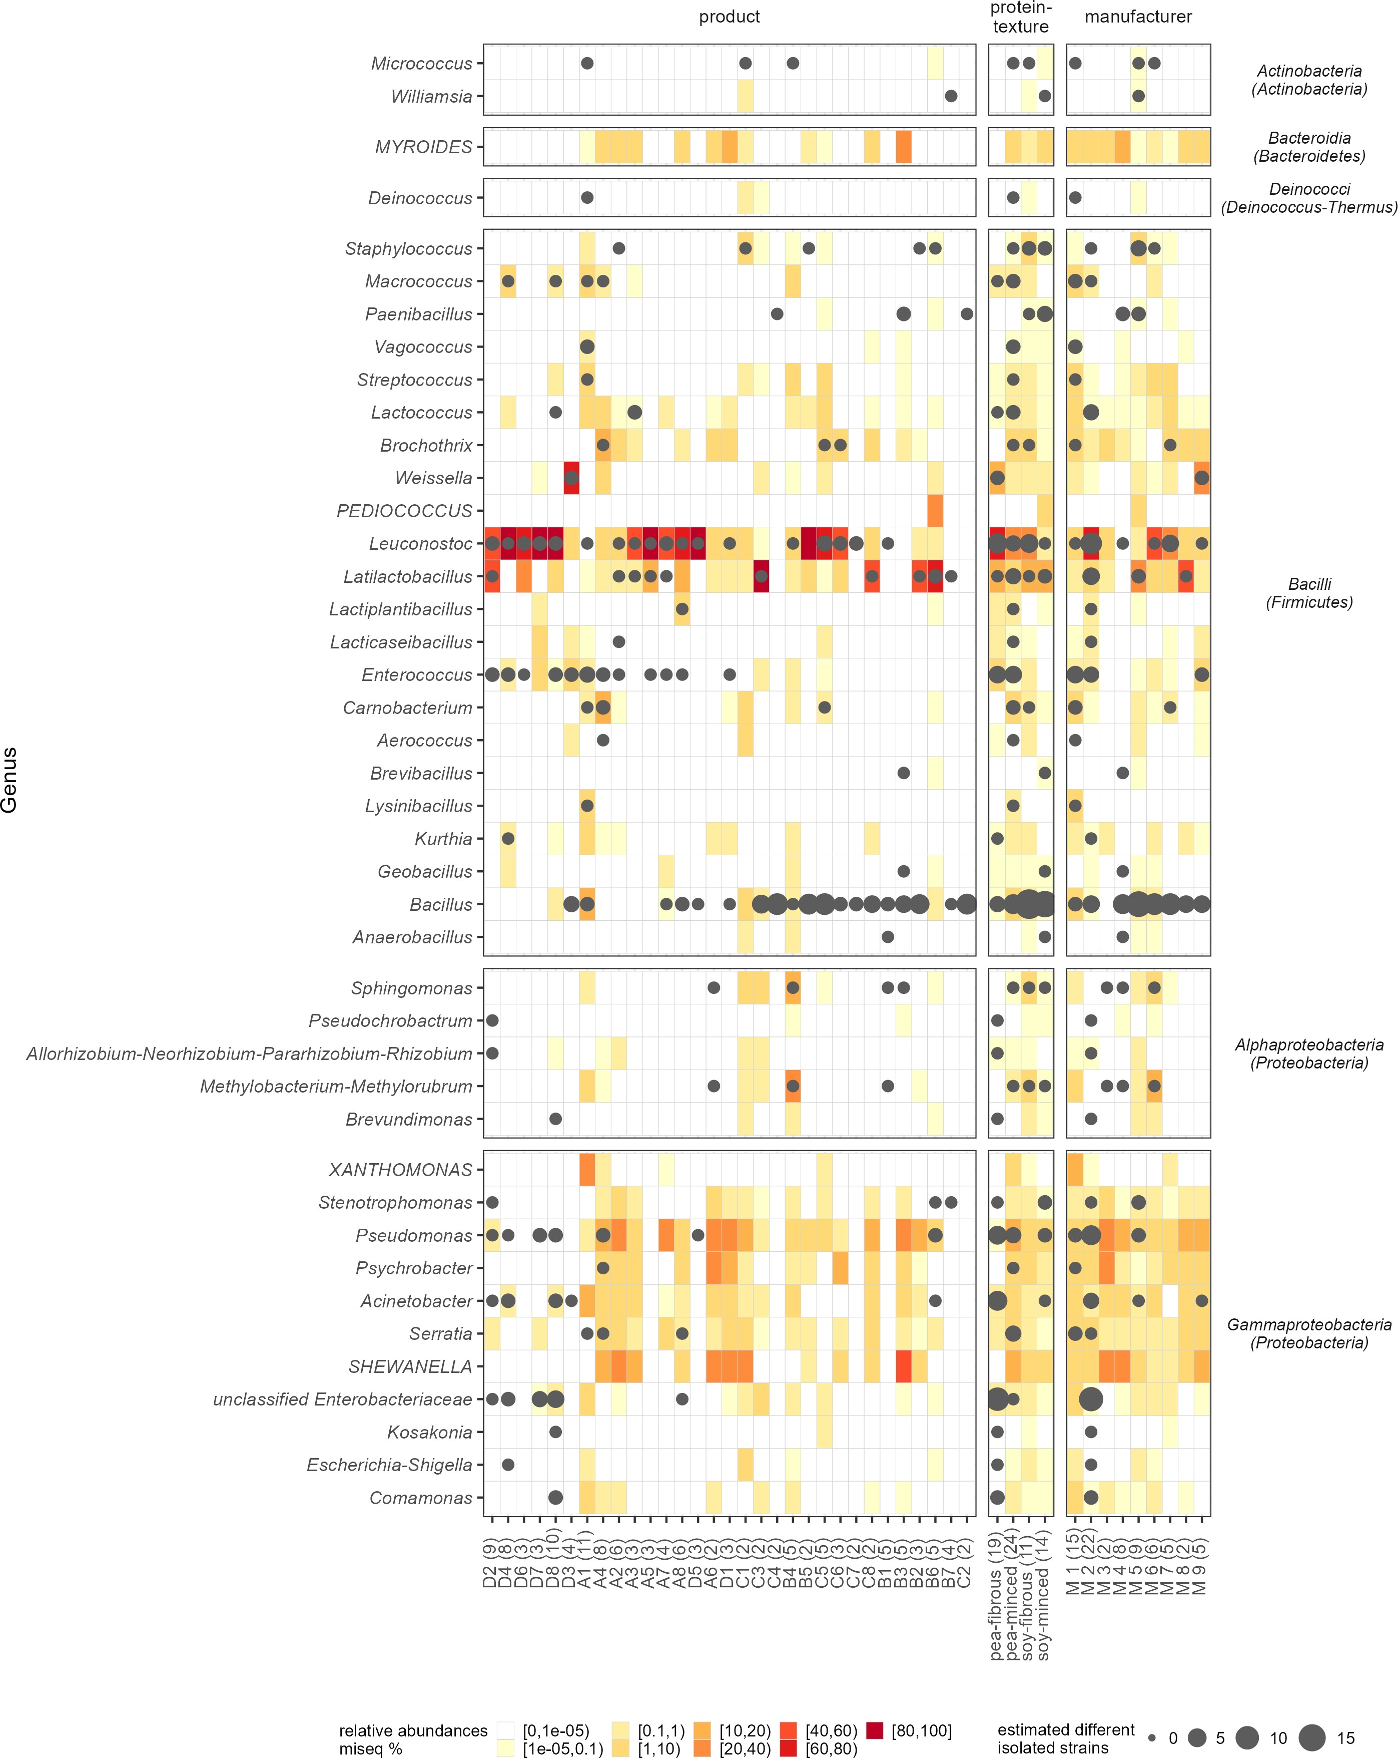

Figure 1: Present isolates per sample, group or manufacturer are represented by dots. Isolates with a genus were clustered based on their 16S rRNA gene sequences. Different clusters represents different strains or species. The higher the number of clusters within a genus, the larger the plotted dot in the figure. The surrounding area is shaded according to the relative abundances in the amplicon sequencing (for the group and manufacturer summary, the mean relative abundance of each included sample is used).

18

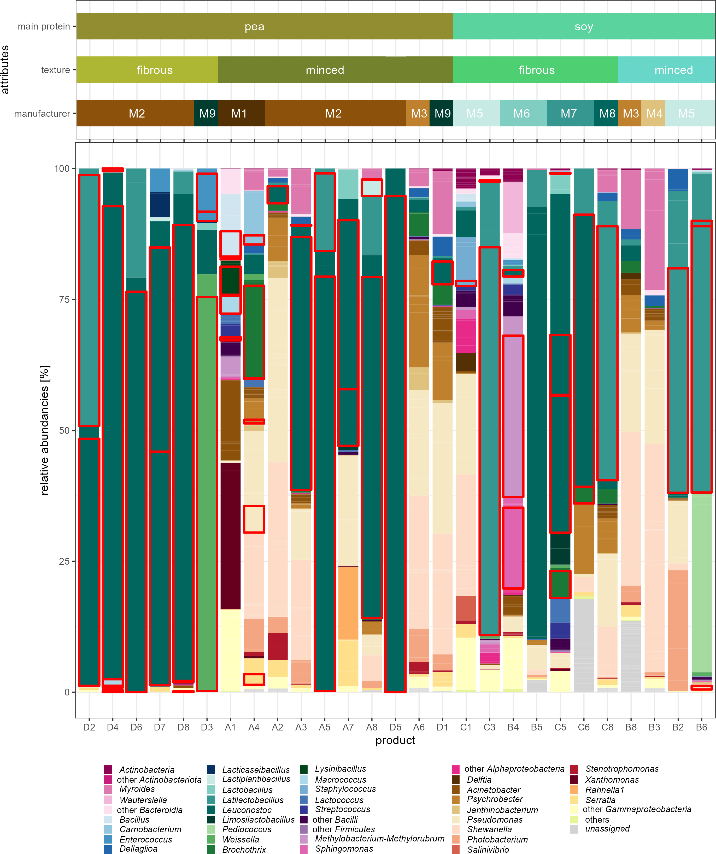

Figure 2: Taxonomy plot based on amplicon sequencing, showing the relative abundances on genus level. The underlying relative frequencies of the ASVs are recognizable as pale yellow lines within a genus. Genera with a maximum value of 3% across all samples were subsumed by color in the next higher taxonomic level. The samples are ordered by main protein source, texture and manufacturer. ASVs with matching isolates (>99% identity), were outlined in red.

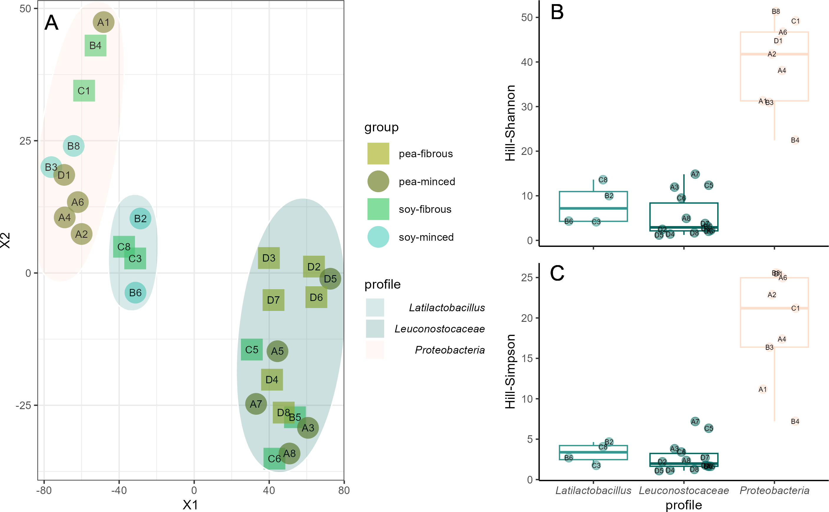

Figure 3: **A:** tSNE plot clustered samples to different profiles based on Bray-Curtis dissimilarity (Similar clusters were also found with other distance matrices - see Supplements S4). **B:** Hill-Shannon diversity and **C:** Hill-Simpson diversity comparing these profiles.

# 426 Supplementary material

427 **11. Supplements**

428 Supplement Table S1:

429 Supplement S1: Groupwise comparison of the alpha-diversity using Hill-Shannon and Hill-Simpson in-

430 dices. Hill-Shannon index differed significantly between fibrous and minced pea products (p-val=0.016).

431 Supplement S2: NMDS plots using different distance methods.

432 Supplement S3: tSNE plots based on Bray-Curtis dissimilarity, Jaccard distance and Jensen-Shannon

433 divergence. In all three methods, the same clusters form.

434 Supplement S4: LEfSe per group

435 Supplement S5: LEfSe per profile.

Table S1: PERMANOVA results based on different distance matrices.

Df Sum of Sqs R2 F Pr. F

# Bray-Curtis

*Permutation test for adonis under reduced model Terms added sequentially (first to last) Permutation: free*

*Number of permutations: 999*

*adonis2(formula = dmlistshort[[i]] ~ protein.source * texture, data = data.frame(sample_data(relab_po)), permutations = 999)*

protein source 1 0.7258 0.0743 2.090 0.030

texture 1 0.8391 0.0859 2.416 0.017

protein source:texture 1 0.2185 0.0224 0.629 0.825

|  |  |  |  |
| --- | --- | --- | --- |
| residual | 23 | 7.9874 | 0.8175 |
| total | 26 | 9.7708 | 1.0000 |

*Permutation test for adonis under reduced model Terms added sequentially (first to last) Permutation: free*

*Number of permutations: 999*

*adonis2(formula = dmlistshort[[i]] ~ texture * protein.source, data = data.frame(sample_data(relab_po)), permutations = 999)*

protein source 1 0.6784 0.0694 1.953 0.041

texture 1 0.8864 0.0907 2.553 0.017

protein source:texture 1 0.2185 0.0224 0.629 0.834

residual 23 7.9874 0.8175

total 26 9.7708 1.0000

# Jaccard

Table S1: PERMANOVA results based on different distance matrices. *(continued)*

Df Sum of Sqs R2 F Pr. F

*Permutation test for adonis under reduced model Terms added sequentially (first to last) Permutation: free*

*Number of permutations: 999*

*adonis2(formula = dmlistshort[[i]] ~ protein.source * texture, data = data.frame(sample_data(relab_po)), permutations = 999)*

protein source 1 0.6774 0.0626 1.712 0.041

texture 1 0.7484 0.0691 1.891 0.022

protein source:texture 1 0.3001 0.0277 0.758 0.789

|  |  |  |  |
| --- | --- | --- | --- |
| residual | 23 | 9.1035 | 0.8406 |
| total | 26 | 10.8295 | 1.0000 |

*Permutation test for adonis under reduced model Terms added sequentially (first to last) Permutation: free*

*Number of permutations: 999*

*adonis2(formula = dmlistshort[[i]] ~ texture * protein.source, data = data.frame(sample_data(relab_po)), permutations = 999)*

protein source 1 0.6367 0.0588 1.609 0.065

texture 1 0.7891 0.0729 1.994 0.014

protein source:texture 1 0.3001 0.0277 0.758 0.770

residual 23 9.1035 0.8406

total 26 10.8295 1.0000

# Jensen-Shannon

*Permutation test for adonis under reduced model Terms added sequentially (first to last) Permutation: free*

*Number of permutations: 999*

*adonis2(formula = dmlistshort[[i]] ~ protein.source * texture, data = data.frame(sample_data(relab_po)), permutations = 999)*

protein source 1 0.3254 0.0874 2.626 0.034

texture 1 0.4556 0.1224 3.676 0.008

protein source:texture 1 0.0918 0.0246 0.740 0.607

|  |  |  |  |
| --- | --- | --- | --- |
| residual | 23 | 2.8504 | 0.7656 |
| total | 26 | 3.7231 | 1.0000 |

*Permutation test for adonis under reduced model Terms added sequentially (first to last) Permutation: free*

*Number of permutations: 999*

*adonis2(formula = dmlistshort[[i]] ~ texture * protein.source, data = data.frame(sample_data(relab_po)), permutations = 999)*

protein source 1 0.3698 0.0993 2.984 0.019

texture 1 0.4111 0.1104 3.318 0.007

protein source:texture 1 0.0918 0.0246 0.740 0.609

residual 23 2.8504 0.7656

total 26 3.7231 1.0000

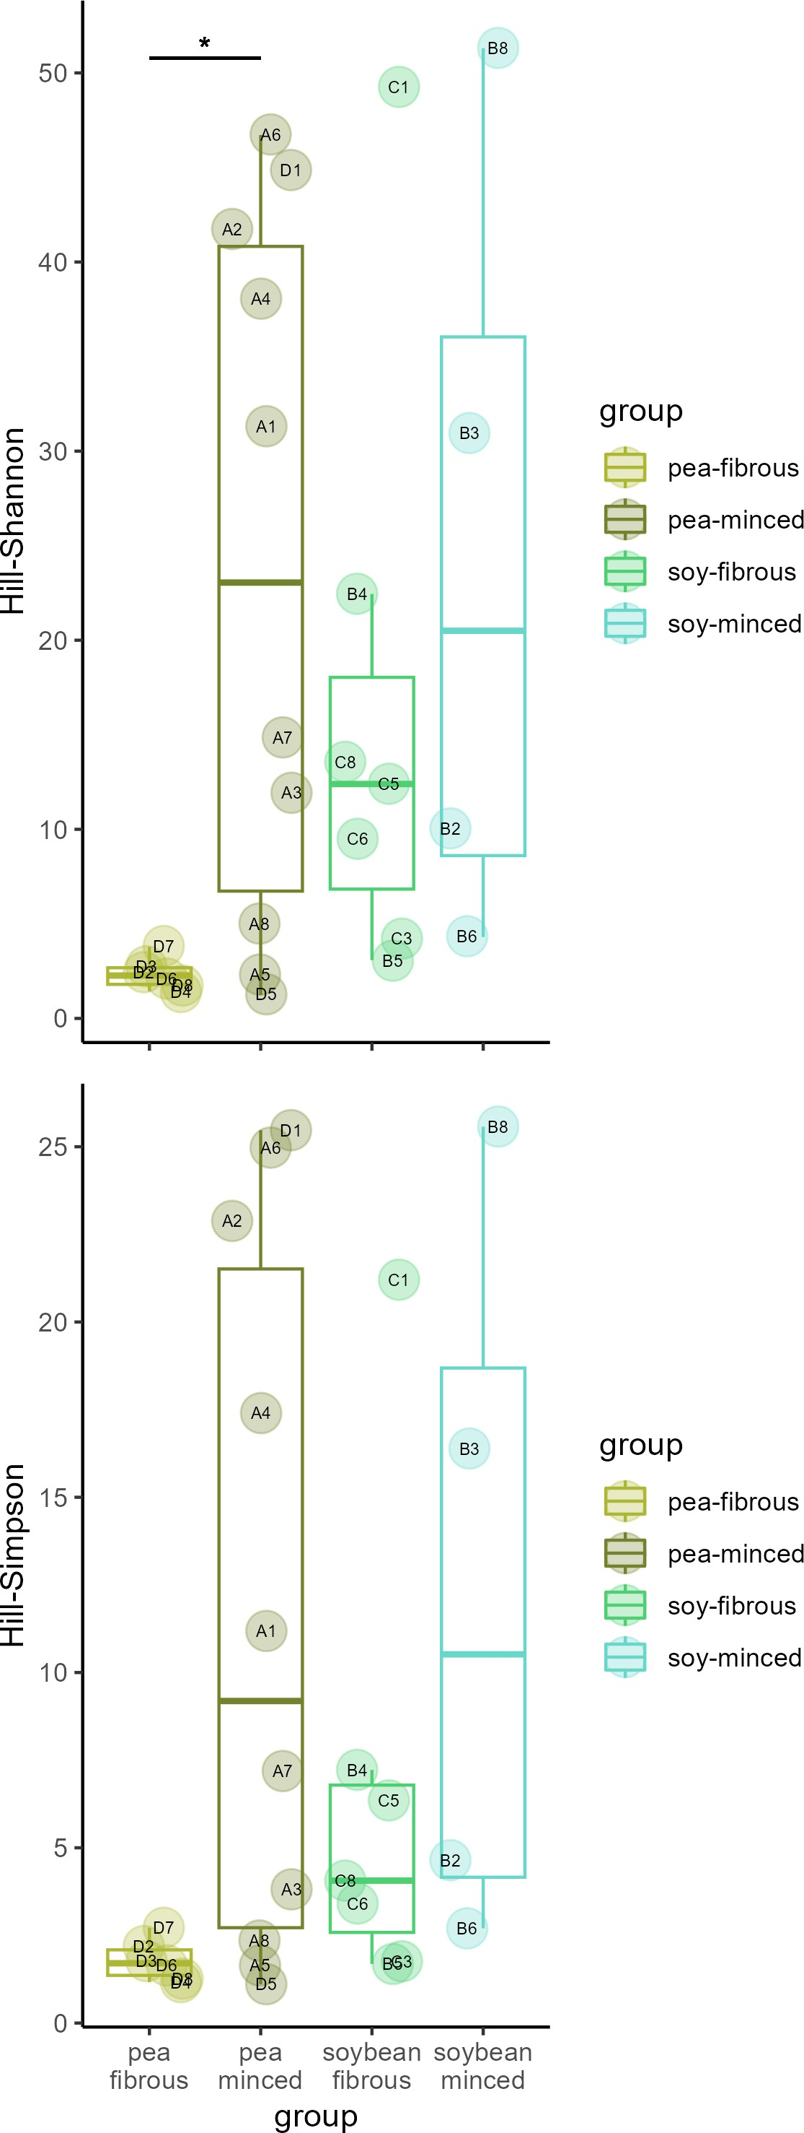

Figure S1: Groupwise comparison of the alpha-diversity using Hill-Shannon and Hill-Simpson indices. Hill-Shannon index differed significantly between fibrous and minced pea products (p-val=0.016).

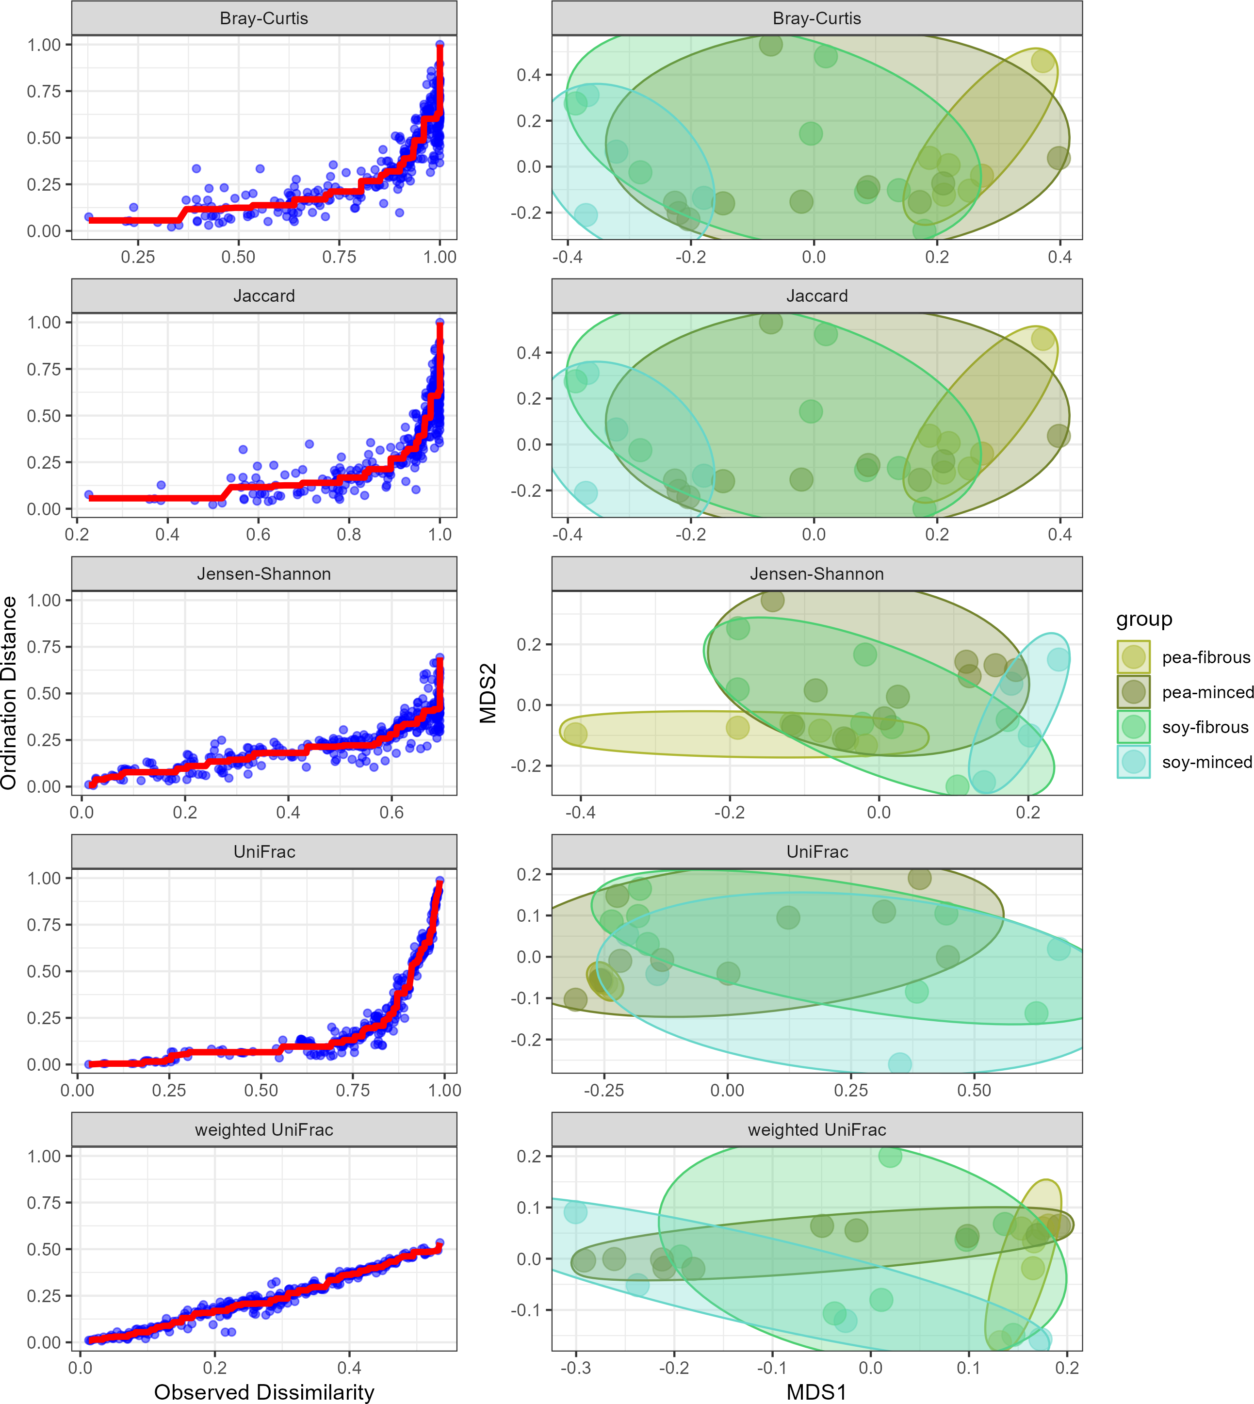

Figure S2: NMDS plots using different distance methods.

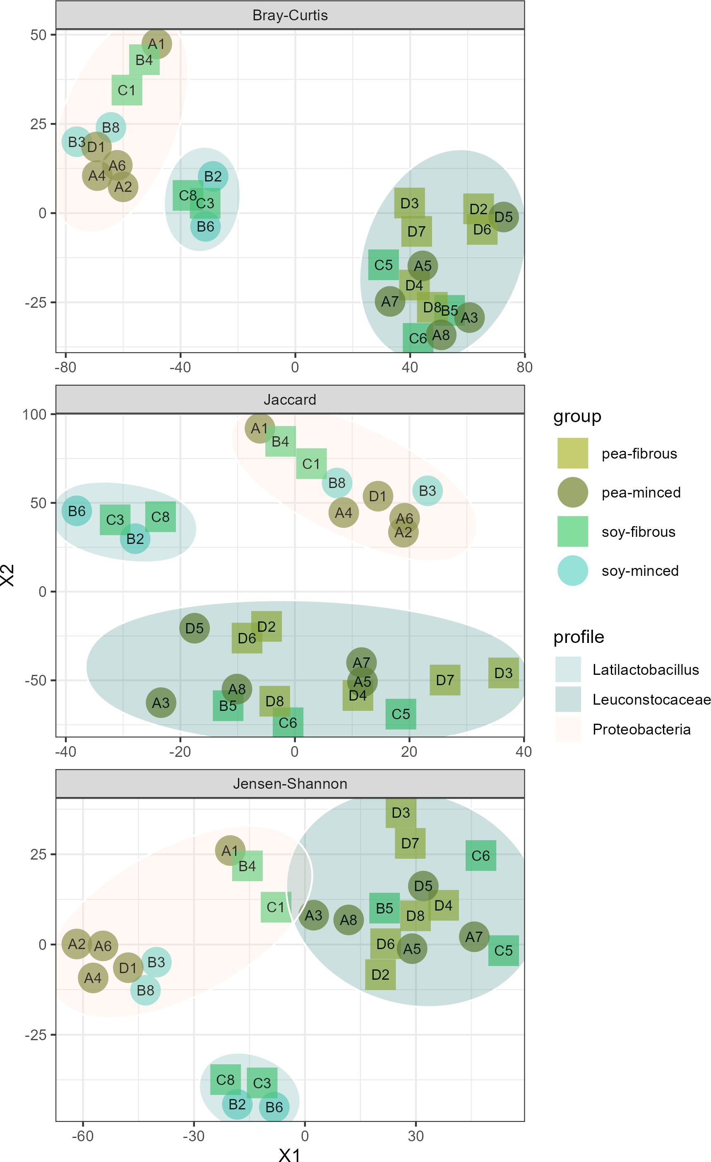

Figure S3: tSNE plots based on Bray-Curtis dissimilarity, Jaccard distance and Jensen-Shannon divergence. In all three methods, the same clusters form.

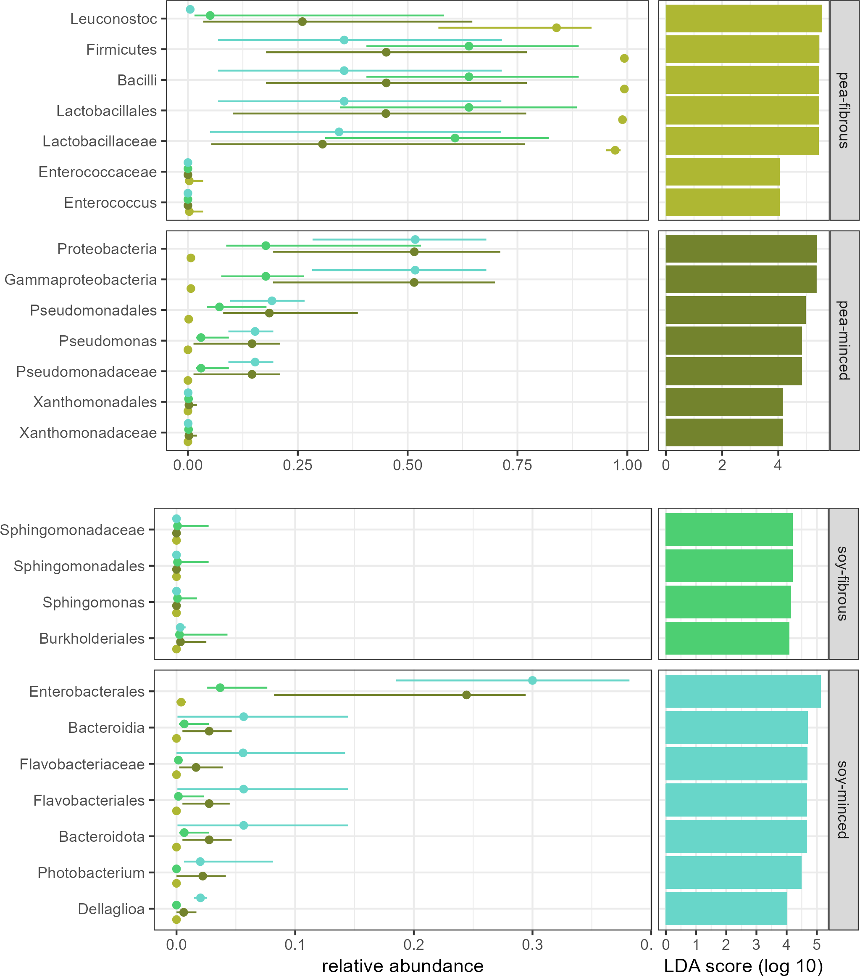

Figure S4: LEfSe per group.

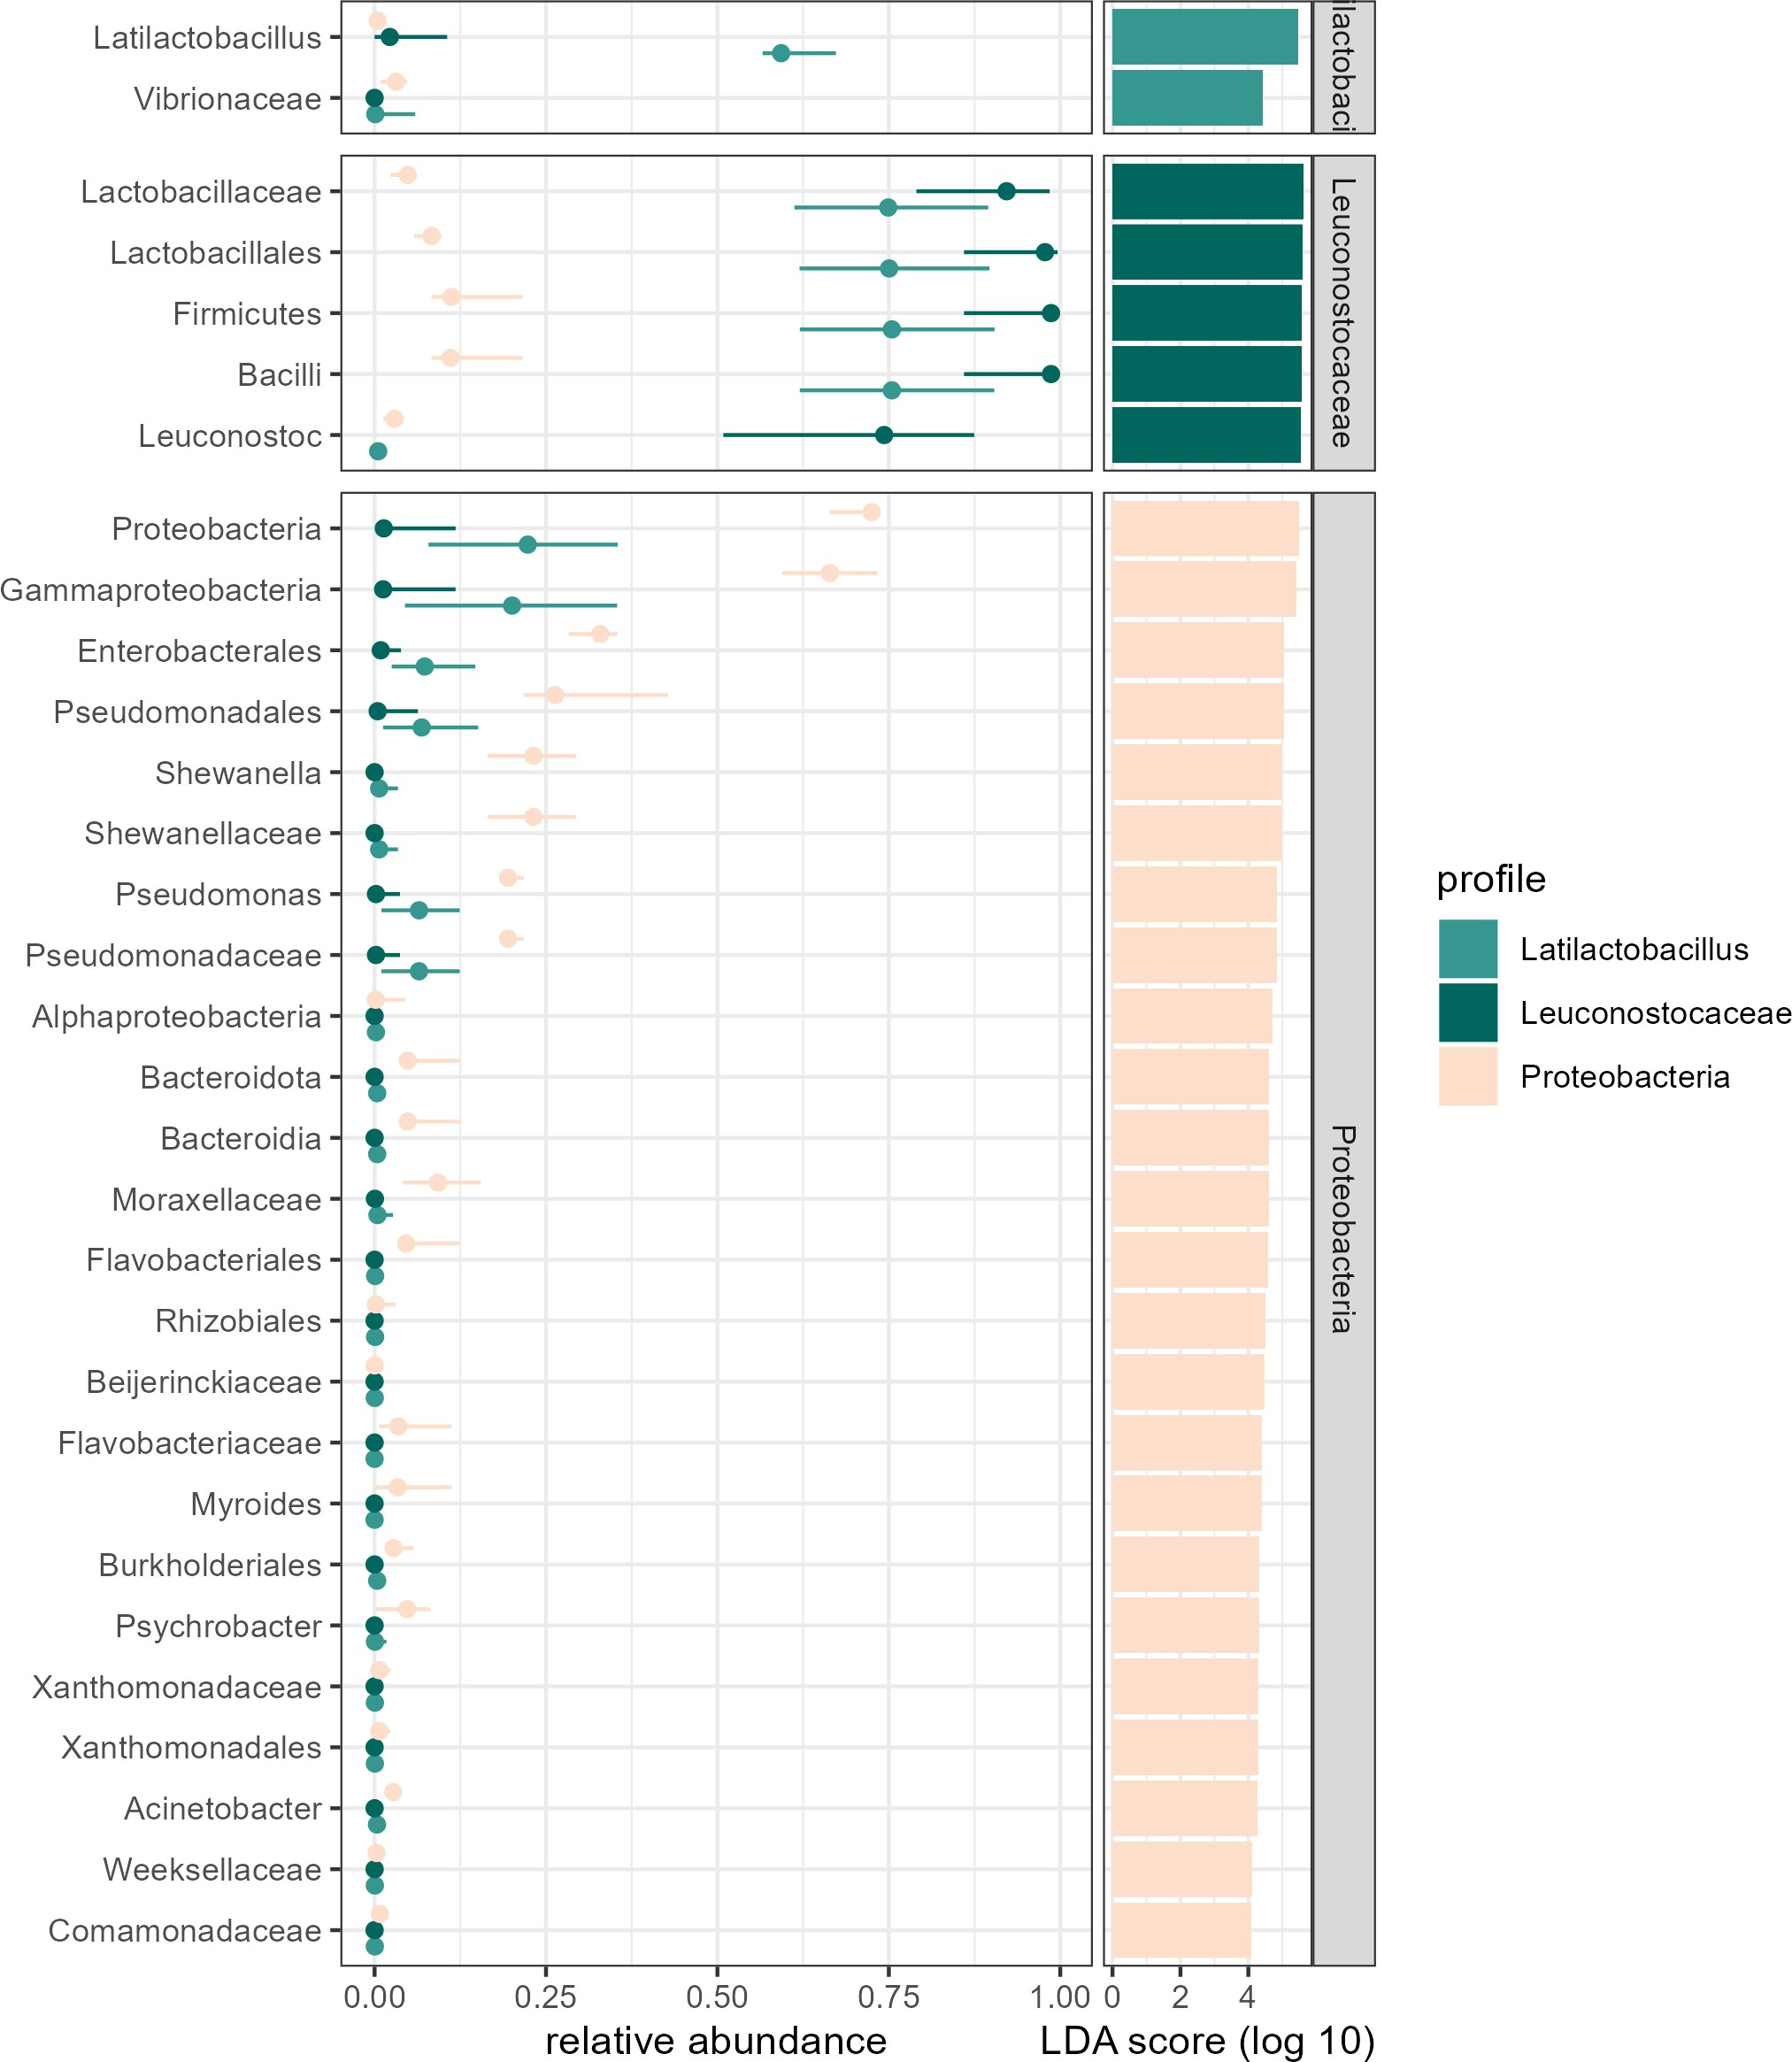

Figure S5: LEfSe per profile.

436 s 1 - alpha div group s 2 - NMDS s 3 - PERMANOVA res s 4 - LEfSE group s 5 - LEfSe profile

437 **References**

438 Akashdeep Singh Beniwal, Jaspreet Singh, Lovedeep Kaur, Allan Hardacre, and Harjinder Singh. Meat analogs: Protein

439 restructuring during thermomechanical processing. *Comprehensive reviews in food science and food safety*, 20(2):1221–1249,

440 2021. doi: 10.1111/1541-4337.12721.

441 Filippo Bianchi, Emma Garnett, Claudia Dorsel, Paul Aveyard, and Susan A. Jebb. Restructuring physical micro-environments

442 to reduce the demand for meat: a systematic review and qualitative comparative analysis. *The Lancet Planetary Health*, 2

443 (9):e384–e397, 2018. ISSN 25425196. doi: 10.1016/S2542-5196(18)30188-8.

444 Johanna Björkroth and Wilhelm Holzapfel. Genera leuconostoc, oenococcus and weissella. In Martin Dworkin, Stanley Falkow,

445 Eugene Rosenberg, Karl-Heinz Schleifer, and Erko Stackebrandt, editors, *The Prokaryotes*, pages 267–319. Springer US,

446 New York, NY, 2006. ISBN 978-0-387-25494-4. doi: 10.1007/0-387-30744-3{\textunderscore}9.

447 Martin J. Blaser and Stanley Falkow. What are the consequences of the disappearing human microbiota? *Nature reviews.*

448 *Microbiology*, 7(12):887–894, 2009. doi: 10.1038/nrmicro2245.

449 Nicholas A. Bokulich, Benjamin D. Kaehler, Jai Ram Rideout, Matthew Dillon, Evan Bolyen, Rob Knight, Gavin A. Huttley,

450 and J. Gregory Caporaso. Optimizing taxonomic classification of marker-gene amplicon sequences with qiime 2’s q2-feature-

451 classifier plugin. *Microbiome*, 6(1):90, 2018. doi: 10.1186/s40168-018-0470-z.

452 Evan Bolyen, Jai Ram Rideout, Matthew R. Dillon, Nicholas A. Bokulich, Christian C. Abnet, Gabriel A. Al-Ghalith, Harriet

453 Alexander, Eric J. Alm, Manimozhiyan Arumugam, Francesco Asnicar, Yang Bai, Jordan E. Bisanz, Kyle Bittinger, Asker

454 Brejnrod, Colin J. Brislawn, C. Titus Brown, Benjamin J. Callahan, Andrés Mauricio Caraballo-Rodríguez, John Chase,

455 Emily K. Cope, Ricardo Da Silva, Christian Diener, Pieter C. Dorrestein, Gavin M. Douglas, Daniel M. Durall, Claire

456 Duvallet, Christian F. Edwardson, Madeleine Ernst, Mehrbod Estaki, Jennifer Fouquier, Julia M. Gauglitz, Sean M. Gibbons,

457 Deanna L. Gibson, Antonio Gonzalez, Kestrel Gorlick, Jiarong Guo, Benjamin Hillmann, Susan Holmes, Hannes Holste,

458 Curtis Huttenhower, Gavin A. Huttley, Stefan Janssen, Alan K. Jarmusch, Lingjing Jiang, Benjamin D. Kaehler, Kyo Bin

459 Kang, Christopher R. Keefe, Paul Keim, Scott T. Kelley, Dan Knights, Irina Koester, Tomasz Kosciolek, Jorden Kreps,

460 Morgan G. I. Langille, Joslynn Lee, Ruth Ley, Yong-Xin Liu, Erikka Loftfield, Catherine Lozupone, Massoud Maher,

461 Clarisse Marotz, Bryan D. Martin, Daniel McDonald, Lauren J. McIver, Alexey V. Melnik, Jessica L. Metcalf, Sydney C.

462 Morgan, Jamie T. Morton, Ahmad Turan Naimey, Jose A. Navas-Molina, Louis Felix Nothias, Stephanie B. Orchanian,

463 Talima Pearson, Samuel L. Peoples, Daniel Petras, Mary Lai Preuss, Elmar Pruesse, Lasse Buur Rasmussen, Adam Rivers,

464 Michael S. Robeson, Patrick Rosenthal, Nicola Segata, Michael Shaffer, Arron Shiffer, Rashmi Sinha, Se Jin Song, John R.

465 Spear, Austin D. Swafford, Luke R. Thompson, Pedro J. Torres, Pauline Trinh, Anupriya Tripathi, Peter J. Turnbaugh,

466 Sabah Ul-Hasan, Justin J. J. van der Hooft, Fernando Vargas, Yoshiki Vázquez-Baeza, Emily Vogtmann, Max von Hippel,

467 William Walters, Yunhu Wan, Mingxun Wang, Jonathan Warren, Kyle C. Weber, Charles H. D. Williamson, Amy D. Willis,

468 Zhenjiang Zech Xu, Jesse R. Zaneveld, Yilong Zhang, Qiyun Zhu, Rob Knight, and J. Gregory Caporaso. Reproducible,

469 interactive, scalable and extensible microbiome data science using qiime 2. *Nature biotechnology*, 37(8):852–857, 2019. doi:

470 10.1038/s41587-019-0209-9.

471 Elisabeth Borch, Marie-Louise Kant-Muermans, and Ylva Blixt. Bacterial spoilage of meat and cured meat products. *Inter-*

472 *national journal of food microbiology*, 33(1):103–120, 1996. doi: 10.1016/0168-1605(96)01135-X.

473 Annalisa Casaburi, Paola Piombino, George-John Nychas, Francesco Villani, and Danilo Ercolini. Bacterial populations and

474 the volatilome associated to meat spoilage. *Food microbiology*, 45(Pt A):83–102, 2015. doi: 10.1016/j.fm.2014.02.002.

475 Patricia Castellano, Mariana Pérez Ibarreche, Mariana Blanco Massani, Cecilia Fontana, and Graciela M. Vignolo. Strategies for

476 pathogen biocontrol using lactic acid bacteria and their metabolites: A focus on meat ecosystems and industrial environments.

477 *Microorganisms*, 5(3), 2017. ISSN 2076-2607. doi: 10.3390/microorganisms5030038.

478 Doris S. M. Chan, Rosa Lau, Dagfinn Aune, Rui Vieira, Darren C. Greenwood, Ellen Kampman, and Teresa Norat. Red and

479 processed meat and colorectal cancer incidence: meta-analysis of prospective studies. *PloS one*, 6(6):e20456, 2011. doi:

480 10.1371/journal.pone.0020456.

481 Anne Chao and Lou Jost. Coverage-based rarefaction and extrapolation: standardizing samples by completeness rather than

482 size. *Ecology*, 93(12):2533–2547, 2012. ISSN 0012-9658. doi: 10.1890/11-1952.1.

483 Byung Hee Chun, Kyung Hyun Kim, Hye Hee Jeon, Se Hee Lee, and Che Ok Jeon. Pan-genomic and transcriptomic analyses

484 of leuconostoc mesenteroides provide insights into its genomic and metabolic features and roles in kimchi fermentation.

485 *Scientific reports*, 7(1):11504, 2017. doi: 10.1038/s41598-017-12016-z.

486 Giuseppe Comi and Lucilla Iacumin. Identification and process origin of bacteria responsible for cavities and volatile off-

487 flavour compounds in artisan cooked ham. *International Journal of Food Science & Technology*, 47(1):114–121, 2012. doi:

488 10.1111/j.1365-2621.2011.02816.x.

489 Giuseppe Comi, Debbie Andyanto, Marisa Manzano, and Lucilla Iacumin. Lactococcus lactis and lactobacillus sakei as bio-

490 protective culture to eliminate leuconostoc mesenteroides spoilage and improve the shelf life and sensorial characteristics of

491 commercial cooked bacon. *Food microbiology*, 58:16–22, 2016. doi: 10.1016/j.fm.2016.03.001.

492 C. C. Crowe, W. E. Sanders, and S. Longley. Bacterial interference. ii. role of the normal throat flora in prevention of

493 colonization by group a streptococcus. *The Journal of infectious diseases*, 128(4):527–532, 1973. ISSN 0022-1899. doi:

494 10.1093/infdis/128.4.527.

495 Felicity Curtain and Sara Grafenauer. Plant-based meat substitutes in the flexitarian age: An audit of products on supermarket

496 shelves. *Nutrients*, 11(11), 2019. ISSN 20726643. doi: 10.3390/nu11112603.

497 Aline T. de Paula, Ana Beatriz Jeronymo-Ceneviva, Svetoslav D. Todorov, and Ana Lúcia B. Penna. The two faces of

498 leuconostoc mesenteroides in food systems. *Food Reviews International*, 31(2):147–171, 2015. ISSN 8755-9129. doi: 10.

499 1080/87559129.2014.981825.

500 Birgit L. Dekkers, Remko M. Boom, and Atze Jan van der Goot. Structuring processes for meat analogues. *Trends in Food*

501 *Science and Technology*, 81:25–36, 2018. ISSN 09242244. doi: 10.1016/j.tifs.2018.08.011.

502 Kai Dong, Hanxu Pan, Dong Yang, Lei Rao, Liang Zhao, Yongtao Wang, and Xiaojun Liao. Induction, detection, formation,

503 and resuscitation of viable but non-culturable state microorganisms. *Comprehensive reviews in food science and food safety*,

504 19(1):149–183, 2020. doi: 10.1111/1541-4337.12513.

505 Vangelis Economou and Panagiota Gousia. Agriculture and food animals as a source of antimicrobial-resistant bacteria.

506 *Infection and drug resistance*, 8:49–61, 2015. ISSN 1178-6973. doi: 10.2147/IDR.S55778.

507 European Commission and Directorate-General for Agriculture and Rural Development. *EU agricultural outlook for markets*

508 *and income 2019-2030*. Publications Office, 2020. doi: 10.2762/904294.

509 European Union’s Horizon 2020 reasearch and innovation programme. Plant-based foods in europe: How big is the market?

510 smart protein plant-based food sector report, a. URL <https://smartproteinproject.eu/plant-based-food-sector-report>.

511 European Union’s Horizon 2020 reasearch and innovation programme. What consumers want: a survey on european consumer

512 attitudes towards plant-based foods, with a focus on flexitarians: European union’s horizon 2020 research and innovation

513 programme (no 862957), b. URL [www.smartproteinproject.eu/consumer-attitudes-plant-based-food-report](http://www.smartproteinproject.eu/consumer-attitudes-plant-based-food-report).

514 Ferawati Ferawati, Izalin Zahari, Malin Barman, Mohammed Hefni, Cecilia Ahlström, Cornelia Witthöft, and Karolina Öst-

515 bring. High-moisture meat analogues produced from yellow pea and faba bean protein isolates/concentrate: Effect of

516 raw material composition and extrusion parameters on texture properties. *Foods*, 10(4), 2021. ISSN 23048158. doi:

517 10.3390/foods10040843.

518 Edith J. M. Feskens, Diewertje Sluik, and Geertruida J. van Woudenbergh. Meat consumption, diabetes, and its complications.

519 *Current diabetes reports*, 13(2):298–306, 2013. doi: 10.1007/s11892-013-0365-0.

520 G.C.S. Filho, R. C. Vessoni Penna, and D. W. Schaffner. Microbiological quality of vegetable proteins during the preparation

521 of a meat analog. *Ital. J. Food Sci.*, 17(3):269–283, 2005.

522 W. Geeraerts, L. de Vuyst, and F. Leroy. Ready-to-eat meat alternatives, a study of their associated bacterial communities. *Food*

523 *Bioscience*, 37, 2020. ISSN 22124292. doi: 10.1016/j.fbio.2020.100681. URL [https://www.scopus.com/inward/record.uri?](https://www.scopus.com/inward/record.uri?eid=2-s2.0-85087740255&doi=10.1016%2fj.fbio.2020.100681&partnerID=40&md5=97cb393ece68ad975b28d430313b6a57)

524 [eid=2-s2.0-85087740255&doi=10.1016%2fj.fbio.2020.100681&partnerID=40&md5=97cb393ece68ad975b28d430313b6a57](https://www.scopus.com/inward/record.uri?eid=2-s2.0-85087740255&doi=10.1016%2fj.fbio.2020.100681&partnerID=40&md5=97cb393ece68ad975b28d430313b6a57).

525 Valérie Guyony, Francine Fayolle, and Vanessa Jury. High moisture extrusion of vegetable proteins for making fibrous meat

526 analogs: A review. *Food Reviews International*, pages 1–26, 2022. ISSN 8755-9129. doi: 10.1080/87559129.2021.2023816.

527 Yoshikatsu Hamasaki, Mitsuko Ayaki, Hidetaka Fuchu, Masaaki Sugiyama, and Hidetoshi Morita. Behavior of psychrotrophic

528 lactic acid bacteria isolated from spoiling cooked meat products. *Applied and environmental microbiology*, 69(6):3668–3671,

529 2003. ISSN 0099-2240. doi: 10.1128/aem.69.6.3668-3671.2003.

530 T. C. Hsieh, K. H. Ma, and Anne Chao. *iNEXT: Interpolation and Extrapolation for Species Diversity*, 2022. URL [http:](http://chao.stat.nthu.edu.tw/wordpress/software_download/)

531 [//chao.stat.nthu.edu.tw/wordpress/software_download/](http://chao.stat.nthu.edu.tw/wordpress/software_download/). R package version 3.0.0.

532 Jenni Hultman, Riitta Rahkila, Javeria Ali, Juho Rousu, and K. Johanna Björkroth. Meat processing plant microbiome

533 and contamination patterns of cold-tolerant bacteria causing food safety and spoilage risks in the manufacture of vacuum-

534 packaged cooked sausages. *Applied and environmental microbiology*, 81(20):7088–7097, 2015. ISSN 0099-2240. doi: 10.1128/

535 aem.02228-15.

536 Christian James, Bukola A. Onarinde, and Stephen J. James. The use and performance of household refrigerators: A review.

537 *Comprehensive reviews in food science and food safety*, 16(1):160–179, 2017. doi: 10.1111/1541-4337.12242.

538 Ji Young Jung, Se Hee Lee, and Che Ok Jeon. Kimchi microflora: history, current status, and perspectives for industrial kimchi

539 production. *Applied microbiology and biotechnology*, 98(6):2385–2393, 2014. doi: 10.1007/s00253-014-5513-1.

540 Benjamin D. Kaehler. Silva 138.1 taxonomy classifiers for use with qiime 2 q2-feature-classifier.

541 Benjamin D. Kaehler, Nicholas A. Bokulich, Daniel McDonald, Rob Knight, J. Gregory Caporaso, and Gavin A. Huttley.

542 Species abundance information improves sequence taxonomy classification accuracy. *Nature communications*, 10(1):4643,

543 2019. doi: 10.1038/s41467-019-12669-6.

544 Hye-Rim Kim. Selection of acid-tolerant and hetero-fermentative lactic acid bacteria producing non-proteinaceous anti-bacterial

545 substances for kimchi fermentation. *Korean Journal of Microbiology and Biotechnology*, 41(1):119–127, 2013. ISSN 1598642X.

546 doi: 10.4014/kjmb.1211.11005.

547 Mikhail Kolmogorov, Jeffrey Yuan, Yu Lin, and Pavel A. Pevzner. Assembly of long, error-prone reads using repeat graphs.

548 *Nature biotechnology*, 37(5):540–546, 2019. doi: 10.1038/s41587-019-0072-8.

549 Jesse Krijthe. *Rtsne: T-Distributed Stochastic Neighbor Embedding using a Barnes-Hut Implementation*, 2022. URL [https:](https://github.com/jkrijthe/Rtsne)

550 [//github.com/jkrijthe/Rtsne](https://github.com/jkrijthe/Rtsne). R package version 0.16.

551 M. Kristiawan, V. Micard, P. Maladira, C. Alchamieh, J-E Maigret, A-L Réguerre, M. A. Emin, and G. Della Valle. Multi-

552 scale structural changes of starch and proteins during pea flour extrusion. *Food research international (Ottawa, Ont.)*, 108:

553 203–215, 2018. doi: 10.1016/j.foodres.2018.03.027.

554 Rob Lanfear and Kuan-Hao Chao. *sangeranalyseR: a suite of functions for the analysis of Sanger sequence data in R*, 2021.

555 R package version 1.2.0.

556 Mo-Eun Lee, Ja-Young Jang, Jong-Hee Lee, Hae-Woong Park, Hak-Jong Choi, and Tae-Woon Kim. Starter cultures for kimchi

557 fermentation. *Journal of microbiology and biotechnology*, 25(5):559–568, 2015. doi: 10.4014/jmb.1501.01019.

558 Katrin Leutgeb. *Microbial examination of raw and extruded products for production of a vegetarian meat analogue*. Masterthe-

559 sis, BOKU-University of natural resources and life sciences, Vienna, Vienna, Austria, 2017. URL [https://forschung.boku.](https://forschung.boku.ac.at/fis/suchen.person_betreuungen?sprache_in=de&menue_id_in=107&id_in=3823)

560 [ac.at/fis/suchen.person_betreuungen?sprache_in=de&menue_id_in=107&id_in=3823](https://forschung.boku.ac.at/fis/suchen.person_betreuungen?sprache_in=de&menue_id_in=107&id_in=3823).

561 Laam Li, Nilmini Mendis, Hana Trigui, James D. Oliver, and Sebastien P. Faucher. The importance of the viable but non-

562 culturable state in human bacterial pathogens. *Frontiers in microbiology*, 5:258, 2014. ISSN 1664-302X. doi: 10.3389/fmicb.

563 2014.00258.

564 A. Lianou, E. Z. Panagou, and G.-J.E. Nychas. Microbiological spoilage of foods and beverages. In *The Stability and Shelf*

565 *Life of Food*, pages 3–42. Elsevier, 2016. ISBN 9780081004357. doi: 10.1016/B978-0-08-100435-7.00001-0.

566 S. Lin, H. E. Huff, and F. Hsieh. Texture and chemical characteristics of soy protein meat analog extruded at high moisture.

567 *Journal of food science*, 65(2):264–269, 2000. ISSN 0022-1147. doi: 10.1111/j.1365-2621.2000.tb15991.x.

568 S. Lin, H. E. Huff, and F. Hsieh. Extrusion process parameters, sensory characteristics, and structural properties of a high

569 moisture soy protein meat analog. *Journal of food science*, 67(3):1066–1072, 2002. ISSN 0022-1147. doi: 10.1111/j.1365-

570 2621.2002.tb09454.x.

571 Yu Lin, Jeffrey Yuan, Mikhail Kolmogorov, Max W. Shen, Mark Chaisson, and Pavel A. Pevzner. Assembly of long error-prone

572 reads using de bruijn graphs. *Proceedings of the National Academy of Sciences of the United States of America*, 113(52):

573 E8396–E8405, 2016. doi: 10.1073/pnas.1604560113.

574 J. B. Luchansky, B. A. Shoyer, Y. Jung, L. E. Shane, M. Osoria, and A.C.S. Porto-Fett. Viability of shiga toxin–producing

575 escherichia coli, salmonella, and listeria monocytogenes within plant versus beef burgers during cold storage and fol-

576 lowing pan frying. *Journal of Food Protection*, 83(3):434–442, 2020. ISSN 0362028X. doi: 10.4315/0362-028X.JFP- 577 19-449. URL [https://www.scopus.com/inward/record.uri?eid=2-s2.0-85079334860&doi=10.4315%2f0362-028X.JFP-19-](https://www.scopus.com/inward/record.uri?eid=2-s2.0-85079334860&doi=10.4315%2f0362-028X.JFP-19-449&partnerID=40&md5=9fc87643ba2315f24bffd40b0efb38a6) 578 [449&partnerID=40&md5=9fc87643ba2315f24bffd40b0efb38a6](https://www.scopus.com/inward/record.uri?eid=2-s2.0-85079334860&doi=10.4315%2f0362-028X.JFP-19-449&partnerID=40&md5=9fc87643ba2315f24bffd40b0efb38a6).

579 P. A. Mackowiak. The normal microbial flora. *The New England journal of medicine*, 307(2):83–93, 1982. ISSN 0028-4793.

580 doi: 10.1056/nejm198207083070203.

581 Paul J. McMurdie, Susan Holmes, with contributions from Gregory Jordan, and Scott Chamberlain. *phyloseq: Handling and*

582 *analysis of high-throughput microbiome census data*, 2021. URL <http://dx.plos.org/10.1371/journal.pone.0061217>. R

583 package version 1.36.0.

584 Renata Micha, Sarah K. Wallace, and Dariush Mozaffarian. Red and processed meat consumption and risk of incident coronary

585 heart disease, stroke, and diabetes mellitus: a systematic review and meta-analysis. *Circulation*, 121(21):2271–2283, 2010.

586 doi: 10.1161/CIRCULATIONAHA.109.924977.

587 Vladimir Mikryukov. *metagMisc: Miscellaneous functions for metagenomic analysis*, 2022. R package version 0.0.4.

588 Rosemary Mwangi. *Inactivation of wild type bacillus spores in a soy meat analog model by extrusion cooking*. 2008. doi:

589 10.32469/10355{\%}2F5763.

590 Zachary T. Neuhofer and Jayson L. Lusk. Most plant-based meat alternative buyers also buy meat: an analysis of household

591 demographics, habit formation, and buying behavior among meat alternative buyers. *Scientific reports*, 12(1):13062, 2022.

592 doi: 10.1038/s41598-022-16996-5.

593 Olumide A. Odeyemi, Christopher M. Burke, Christopher C. J. Bolch, and Roger Stanley. Seafood spoilage microbiota and

594 associated volatile organic compounds at different storage temperatures and packaging conditions. *International journal of*

595 *food microbiology*, 280:87–99, 2018. doi: 10.1016/j.ijfoodmicro.2017.12.029.

596 OECD. *Meat consumption (indicator).* OECD, 2022. doi: 10.1787/fa290fd0-en.

597 OECD and Food and Agriculture Organization of the United Nations. *OECD-FAO Agricultural Outlook 2022-2031*. OECD,

598 2022. ISBN 9789264588707. doi: 10.1787/f1b0b29c-en.

599 Jari Oksanen, Gavin L. Simpson, F. Guillaume Blanchet, Roeland Kindt, Pierre Legendre, Peter R. Minchin, R.B. O’Hara, 600 Peter Solymos, M. Henry H. Stevens, Eduard Szoecs, Helene Wagner, Matt Barbour, Michael Bedward, Ben Bolker, Daniel 601 Borcard, Gustavo Carvalho, Michael Chirico, Miquel De Caceres, Sebastien Durand, Heloisa Beatriz Antoniazi Evangelista, 602 Rich FitzJohn, Michael Friendly, Brendan Furneaux, Geoffrey Hannigan, Mark O. Hill, Leo Lahti, Dan McGlinn, Marie- 603 Helene Ouellette, Eduardo Ribeiro Cunha, Tyler Smith, Adrian Stier, Cajo J.F. Ter Braak, and James Weedon. *vegan:* 604 *Community Ecology Package*, 2022. URL <https://github.com/vegandevs/vegan>. R package version 2.6-4.

605 Nicolay Oskolkov. How to tune hyperparameters of tsne: Three simple rules to make beautiful tsne plots, 2019.

606 URL [https://towardsdatascience.com/how-to-tune-hyperparameters-of-tsne-7c0596a18868#:~:text=The%20optimal%](https://towardsdatascience.com/how-to-tune-hyperparameters-of-tsne-7c0596a18868#%3A~%3Atext%3DThe%20optimal%20perplexity%20can%20be%20calculated%20from%20the%20number%20of%2Cdata%20points%20of%20~100%20units)

607 [20perplexity%20can%20be%20calculated%20from%20the%20number%20of,data%20points%20of%20~100%20units.](https://towardsdatascience.com/how-to-tune-hyperparameters-of-tsne-7c0596a18868#%3A~%3Atext%3DThe%20optimal%20perplexity%20can%20be%20calculated%20from%20the%20number%20of%2Cdata%20points%20of%20~100%20units)

608 Oxford Nanopore Technologies, 2022. URL <https://github.com/nanoporetech/medaka>.

609 Chun Wook Park, Myoungsub Youn, Young-Mi Jung, Hongik Kim, Yoonhwa Jeong, Han-Ki Lee, Hye One Kim, Insun Lee, 610 Soo Won Lee, Kook Hee Kang, and Yong-Ha Park. New functional probiotic lactobacillus sakei probio 65 alleviates atopic 611 symptoms in the mouse. *Journal of medicinal food*, 11(3):405–412, 2008. doi: 10.1089/jmf.2007.0144.

612 D. M. Parkin, L. Boyd, and L. C. Walker. 16. the fraction of cancer attributable to lifestyle and environmental factors in the

613 uk in 2010. *British journal of cancer*, 105 Suppl 2:S77–81, 2011. doi: 10.1038/bjc.2011.489.

614 Valerie L. Pietsch, Jan M. Bühler, Heike P. Karbstein, and M. Azad Emin. High moisture extrusion of soy protein concen- 615 trate: Influence of thermomechanical treatment on protein-protein interactions and rheological properties. *Journal of Food*616 *Engineering*, 251:11–18, 2019. ISSN 02608774. doi: 10.1016/j.jfoodeng.2019.01.001.

617 Ursula Ploll and Tobias Stern. From diet to behaviour: exploring environmental- and animal-conscious behaviour among 618 austrian vegetarians and vegans. *British Food Journal*, 122(11):3249–3265, 2020. ISSN 0007-070X. doi: 10.1108/BFJ-06- 619 2019-0418.

620 Vasileios Pothakos, Cindy Snauwaert, Paul de Vos, Geert Huys, and Frank Devlieghere. Psychrotrophic members of leuconostoc 621 gasicomitatum, leuconostoc gelidum and lactococcus piscium dominate at the end of shelf-life in packaged and chilled-stored 622 food products in belgium. *Food microbiology*, 39:61–67, 2014. doi: 10.1016/j.fm.2013.11.005.

623 Christian Quast, Elmar Pruesse, Pelin Yilmaz, Jan Gerken, Timmy Schweer, Pablo Yarza, Jörg Peplies, and Frank Oliver 624 Glöckner. The silva ribosomal rna gene database project: improved data processing and web-based tools. *Nucleic acids*625 *research*, 41(Database issue):D590–6, 2013. doi: 10.1093/nar/gks1219.

626 Narciso M. Quijada, David Rodríguez-Lázaro, Jose María Eiros, and Marta Hernández. Tormes: an automated pipeline for 627 whole bacterial genome analysis. *Bioinformatics (Oxford, England)*, 35(21):4207–4212, 2019. doi: 10.1093/bioinformatics/ 628 btz220.

629 R Core Team. R: A language and environment for statistical computing, 2021. URL <https://www.R-project.org/>.

630 Michael S. Robeson, Devon R. O’Rourke, Benjamin D. Kaehler, Michal Ziemski, Matthew R. Dillon, Jeffrey T. Foster, and

631 Nicholas A. Bokulich. Rescript: Reproducible sequence taxonomy reference database management. *PLoS computational*

632 *biology*, 17(11):e1009581, 2021. doi: 10.1371/journal.pcbi.1009581.

633 Michael Roswell, Jonathan Dushoff, and Rachael Winfree. A conceptual guide to measuring species diversity. *Oikos*, 130(3):

634 321–338, 2021. ISSN 0030-1299. doi: 10.1111/oik.07202.

635 S. K. Sagoo, C. L. Little, M. Greenwood, V. Mithani, K. A. Grant, J. McLauchlin, E. de Pinna, and E. J. Threlfall. Assessment 636 of the microbiological safety of dried spices and herbs from production and retail premises in the united kingdom. *Food*637 *microbiology*, 26(1):39–43, 2009. doi: 10.1016/j.fm.2008.07.005.

638 Eva-Maria Schmid, Asgar Farahnaky, Benu Adhikari, and Peter J. Torley. High moisture extrusion cooking of meat analogs: 639 A review of mechanisms of protein texturization. *Comprehensive reviews in food science and food safety*, 2022. doi:  640 10.1111/1541-4337.13030.

641 Nicola Segata, Jacques Izard, Levi Waldron, Dirk Gevers, Larisa Miropolsky, Wendy S. Garrett, and Curtis Huttenhower.

642 Metagenomic biomarker discovery and explanation. *Genome biology*, 12(6):R60, 2011. doi: 10.1186/gb-2011-12-6-r60.

643 Karen Smith, Kathy D. McCoy, and Andrew J. Macpherson. Use of axenic animals in studying the adaptation of mammals to 644 their commensal intestinal microbiota. *Seminars in immunology*, 19(2):59–69, 2007. ISSN 1044-5323. doi: 10.1016/j.smim. 645 2006.10.002.

646 Keaton Stagaman. *phyloseqCompanion: Provides additional functions to work with phyloseq objects*, 2022. R package version

647 1.1.

648 Henning Steinfeld. *Livestock’s long shadow: Environmental issues and options*. Food and Agriculture Organization of the

649 United Nations, Rom, 2006. ISBN 978-92-5-105571-7.

650 Susanne Stoll-Kleemann and Uta Johanna Schmidt. Reducing meat consumption in developed and transition countries to 651 counter climate change and biodiversity loss: a review of influence factors. *Regional Environmental Change*, 17(5):1261–  652 1277, 2017. ISSN 1436-3798. doi: 10.1007/s10113-016-1057-5.

653 Gokila Thangavel and Subramaniyan Thiruvengadam. Microorganisms isolated from stored meat in india, with potential 654 antimicrobial activity against food pathogens. *Current pharmaceutical biotechnology*, 20(5):401–409, 2019. doi: 10.2174/ 655 1389201020666190314125534.

656 András J. Tóth, Anna Dunay, Márton Battay, Csaba Bálint Illés, András Bittsánszky, and Miklós Süth. Microbial spoilage of

657 plant-based meat analogues. *Applied Sciences*, 11(18):8309, 2021. doi: 10.3390/app11188309.

658 Pajau Vangay, Abigail J. Johnson, Tonya L. Ward, Gabriel A. Al-Ghalith, Robin R. Shields-Cutler, Benjamin M. Hillmann, 659 Sarah K. Lucas, Lalit K. Beura, Emily A. Thompson, Lisa M. Till, Rodolfo Batres, Bwei Paw, Shannon L. Pergament, Pim- 660 panitta Saenyakul, Mary Xiong, Austin D. Kim, Grant Kim, David Masopust, Eric C. Martens, Chaisiri Angkurawaranon, 661 Rose McGready, Purna C. Kashyap, Kathleen A. Culhane-Pera, and Dan Knights. Us immigration westernizes the human 662 gut microbiome. *Cell*, 175(4):962–972.e10, 2018. doi: 10.1016/j.cell.2018.10.029.

663 Robert Vaser, Ivan Sović, Niranjan Nagarajan, and Mile Šikić. Fast and accurate de novo genome assembly from long uncor-

664 rected reads. *Genome research*, 27(5):737–746, 2017. doi: 10.1101/gr.214270.116.

665 Gabriel Vinderola, Arthur C. Ouwehand, Seppo Salminen, and Atte von Wright, editors. *Lactic acid bacteria: Microbiological*

666 *and functional aspects*. CRC Press, Boca Raton, fifth edition edition, 2019. ISBN 978-0-8153-6648-5.

667 Julia A. Vorholt. Microbial life in the phyllosphere. *Nature reviews. Microbiology*, 10(12):828–840, 2012. doi: 10.1038/

668 nrmicro2910.

669 Eva M. Wagner, Sarah Thalguter, Martin Wagner, and Kathrin Rychli. Presence of microbial contamination and biofilms at a

670 beer can filling production line. *Journal of Food Protection*, 84(5):896–902, 2021. ISSN 0362028X. doi: 10.4315/jfp-20-368.

671 P. Sean Walsh, David A. Metzger, and Russell Higushi. Chelex 100 as a medium for simple extraction of dna for pcr-

672 based typing from forensic material. biotechniques 10(4): 506-13 (april 1991). *BioTechniques*, 54(3):134–139, 2013. doi:

673 10.2144/000114018.

674 Nick Watts, Markus Amann, Sonja Ayeb-Karlsson, Kristine Belesova, Timothy Bouley, Maxwell Boykoff, Peter Byass, Wenjia 675 Cai, Diarmid Campbell-Lendrum, Jonathan Chambers, Peter M. Cox, Meaghan Daly, Niheer Dasandi, Michael Davies, 676 Michael Depledge, Anneliese Depoux, Paula Dominguez-Salas, Paul Drummond, Paul Ekins, Antoine Flahault, Howard 677 Frumkin, Lucien Georgeson, Mostafa Ghanei, Delia Grace, Hilary Graham, Rébecca Grojsman, Andy Haines, Ian Hamilton, 678 Stella Hartinger, Anne Johnson, Ilan Kelman, Gregor Kiesewetter, Dominic Kniveton, Lu Liang, Melissa Lott, Robert 679 Lowe, Georgina Mace, Maquins Odhiambo Sewe, Mark Maslin, Slava Mikhaylov, James Milner, Ali Mohammad Latifi, 680 Maziar Moradi-Lakeh, Karyn Morrissey, Kris Murray, Tara Neville, Maria Nilsson, Tadj Oreszczyn, Fereidoon Owfi, David 681 Pencheon, Steve Pye, Mahnaz Rabbaniha, Elizabeth Robinson, Joacim Rocklöv, Stefanie Schütte, Joy Shumake-Guillemot, 682 Rebecca Steinbach, Meisam Tabatabaei, Nicola Wheeler, Paul Wilkinson, Peng Gong, Hugh Montgomery, and Anthony 683 Costello. The lancet countdown on health and climate change: from 25 years of inaction to a global transformation for  684 public health. *The Lancet*, 391(10120):581–630, 2018. ISSN 01406736. doi: 10.1016/s0140-6736(17)32464-9.

685 Ryan Wick. Filtlong, 2021. URL <https://github.com/rrwick/Filtlong>.

686 Erik Wright. *DECIPHER: Tools for curating, analyzing, and manipulating biological sequences*, 2021. R package version

687 2.20.0.

688 Su-Yeon You, Ji-Su Yang, Sung Hyun Kim, and In Min Hwang. Changes in the physicochemical quality characteristics 689 of cabbage kimchi with respect to storage conditions. *Journal of Food Quality*, 2017:1–7, 2017. ISSN 0146-9428. doi: 690 10.1155/2017/9562981.

691 Annabelle O. Yu, Johan H. J. Leveau, and Maria L. Marco. Abundance, diversity and plant-specific adaptations of plant-

692 associated lactic acid bacteria. *Environmental microbiology reports*, 12(1):16–29, 2020. doi: 10.1111/1758-2229.12794.

693 Liang Yu, Yang Meng, Hosahalli S. Ramaswamy, and Joyce Boye. Residence time distribution of soy protein isolate and corn 694 flour feed mix in a twin-screw extruder. *Journal of Food Processing and Preservation*, 38(1):573–584, 2014. ISSN 01458892. 695 doi: 10.1111/jfpp.12005.

696 Monique Zagorec and Marie-Christine Champomier-Vergès. Lactobacillus sakei: A starter for sausage fermentation, a protective

697 culture for meat products. *Microorganisms*, 5(3), 2017. ISSN 2076-2607. doi: 10.3390/microorganisms5030056.

698 Jinchuang Zhang, Li Liu, Yuanrong Jiang, Shah Faisal, Linlin Wei, Chunjie Cao, Wenhui Yan, and Qiang Wang. Converting 699 peanut protein biomass waste into "double green" meat substitutes using a high-moisture extrusion process: A multiscale 700 method to explore a process for forming a meat-like fibrous structure. *Journal of Agricultural and Food Chemistry*, 67(38): 701 10713–10725, 2019. ISSN 00218561. doi: 10.1021/acs.jafc.9b02711.

702 Xihong Zhao, Junliang Zhong, Caijiao Wei, Chii-Wann Lin, and Tian Ding. Current perspectives on viable but non-culturable

703 state in foodborne pathogens. *Frontiers in microbiology*, 8:580, 2017. ISSN 1664-302X. doi: 10.3389/fmicb.2017.00580.