 

Q1:

Software Requirements Specification

for

<Pet Medical Appointment System> (0.25 point)

Version 1.0 approved

Prepared by

<Tạ Ngọc An QE170035> (0.25 point)

<FPT HCM University> (0.25 point)

<26/03/2024> (0.25 point)

Q2:

<Student must replace this line, answer Q2 by drawing 1 context diagram that reflect this exam paper and copy and then paste the image of that context diagram here

Notes:

1. Draw the correct syntax to describe the context diagram (0.3 point)
2. List the name of >= 4 external entities (0.6 point)
3. Draw the data flows described in this exam paper (1.6 points)

>

Q3:

< Student must replace this line

Notes:

1. Draw the correct syntax to describe the use case diagram (0.4 point)
2. List the name of >= 4 actors and brief descriptions (0.8 point)
3. Draw use cases and brief descriptions (2.8 points)

>

<Student must replace this line, answer Q3 by drawing 1 use case diagram that reflect this exam paper and copy and then paste the image of that use case diagram here>

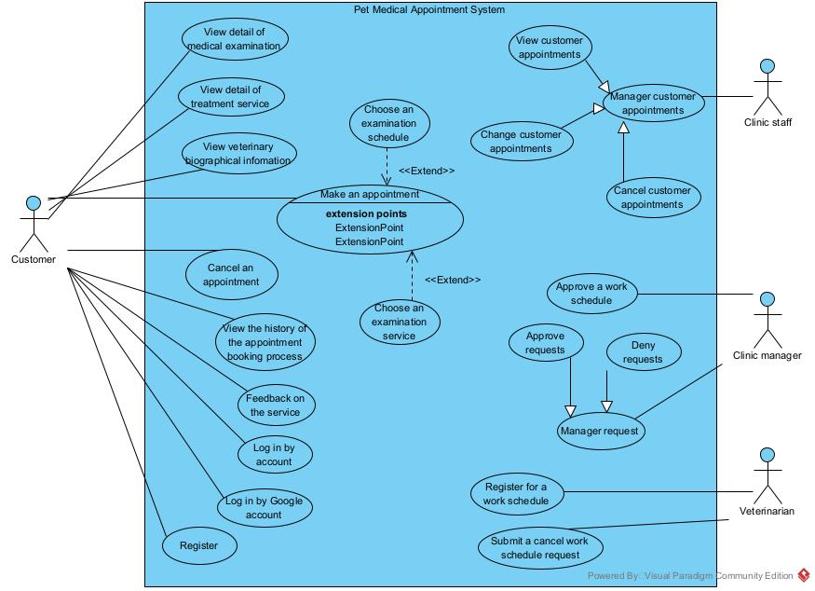

< Student must replace this line, **briefly describe** the actors of the diagram by fill the content to below table>

|  |  |  |
| --- | --- | --- |
| **#** | **Actor** | **Description** |
| 01 | Customer | The customer who need the Veterinarian help to conveniently examine their pet |
| 02 | Veterinarian | The veterinarian is a doctor for pets who registered for a work schedule base on the clinic’s work schedule. |
| 03 | Clinic staff | Clinic staff is a staff of pet medical appointment system |
| 04 | Clinic manager | Clinic manager is a manager of pet medical appointment system who management clinic staff |

< Student must replace this line, **briefly describe** the use cases of the diagram by fill the content to below table>

|  |  |  |  |
| --- | --- | --- | --- |
| **#** | **Use Case** | **Actors** | **Description** |
| UC-01 | Cancel an appointment | Customer | This use case allow customer cancel an appointment. And the system will send an email or text message to the customer to confirm examination appointment. |
| UC-02 | Make an appointment | Customer | This use case allow customer make an appointment. |
| UC-03 | Cancel an appointment | Customer | This use case allow customer cancel an appontment booked. |
| UC-04 | Feedback on the service | Customer | This use case allow customer feedback on the service after use. |

Q4:

< Student must replace this line, answer of Q4 by fill the content to below table that reflect this exam paper

Notes:

1. Describe >= 5 business rules (1.5 point)
2. For each incorrect business rule, 0.3 points will be deducted

>

|  |  |  |  |
| --- | --- | --- | --- |
| ID | Rule Definition | | Use cases |
| BR-01 | In case the customer cancels the appointment 24 hours before the time of examination, the system will transfer the paid money back to the customer. | | UC-01 |
| BR-02 | The customer receives a 15% discount on medical examination service when making appointment for two or more pets. | | UC-02 |
| BR-03 | The system only allows the customer to make appointments 24 hours before the time of examination | | UC-02 |
| BR-04 | The system only allows the customer to feedback ont the service after use. | | UC-04 |
|  | |

**Q5:**

< Student must replace this line, the answer of Q5 must have detail and specific in number of 2 non-functional requirements for the system>

1. All network transaction that involve financial information or personally identifiable information require 256-bit encrytion.
2. The system shell provide a help link from each displayed webpage to explain how to use that page.