 E:\TeachingOldM\Android All\code_examples\androidhtp2_examples\eclipse_projects\FlagQuiz\assets\Asia\Asia-South_Georgia.png L1 FA23

Q1:

Software Requirements Specification

For

FU Project Bank (FUPB)

Version 1.0 approved

Prepared by

Ta Hau Giang SE173685

FPTU - HCM

**14/11/2023**

Q2:

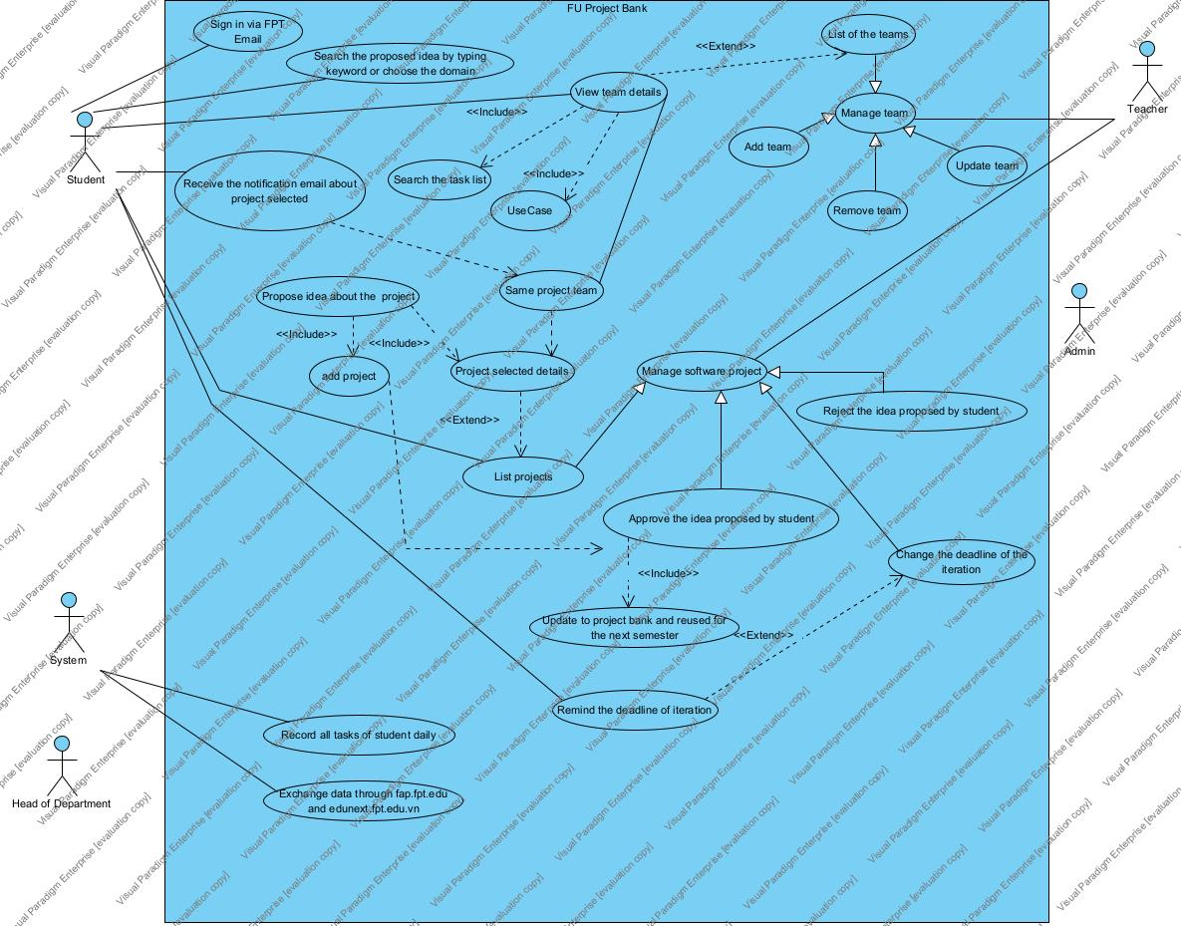

Q3:

< Student must replace this line, answer of Q3 by fill the content to below table that reflect this exam paper>

|  |  |  |  |
| --- | --- | --- | --- |
| UC ID and Name: | UC – Proposed idea about selected project | | |
| Created By: | Giangthse173685 | Date Created: | 14/11/2023. |
| Primary Actor: | Student | Secondary Actors: | Teacher |
| Trigger: | The need to proposed idea about project to the teacher. | | |
| Description: | This use case allows students of the same project team proposed their idea about software project to their teacher. If their idea is approved by teacher , it can be updated to the project bank and reused for the next semester by another class. | | |
| Preconditions: | 1. The student must be authenticated and authorized by FPT email. 2. The student must enrolled to SWP391 course. 3. The student must have team and select project. | | |
| Postconditions: | 1. The new proposed idea about project is added to the project bank. 2. The students is notified of approval form their teacher. | | |
| Normal Flow: | 1. The student login to the FUPB website by FPT email. 2. The student enroll to the SWP391 course in specific semester. 3. The student choose the team member or get random member from teacher. 4. The team member select one project. 5. The team member use “add project” function on the website to propose their own idea about software project for their project team. 6. The teacher approve the idea about software project proposed by student. 7. The idea is updated to the project bank and reused for the next semester. | | |
| Alternative Flows: | 1. The idea is rejected by teacher and not to update to the project bank. | | |
| Exceptions: | 1. The student is not select the project but propose the idea to the teacher. | | |
| Priority: | High | | |
| Frequency of Use: | Daily | | |
| Business Rules: | Idea about project must be update to the project bank. | | |
| Other Information: | (0.1 point) It may be described the quality here for more info. | | |
| Assumptions: | The user has access to a stable internet connection. | | |

**Q4:**

< Student must replace this line, the answer of Q4 must have detail and specific in number of 2 non-functional requirements for FUPB>