Subject: PRF192- PFC
Workshop 04

Objectives:
- Managing data using pointers
- Developing programs using simple menus

Submission:
Please submit your work including a report and source code. All of them should be contained in a directory which is named as Workshop3_yourName_yourStudentID. Then zip this directory and submit.
The report MUST be a pdf file. Name of the file should contain your name and your student ID, such as Workshop3_yourName_yourStudentID.
The report must contain the pictures of all the test cases that you have done to test your programs.

Part 1: Use notebook

Exercise 1 (1 mark) : Explain outputs:

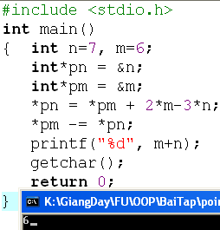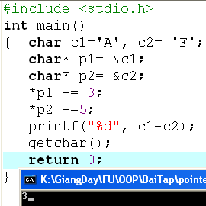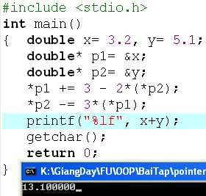

Exercise 2: (1 marks) What are outputs

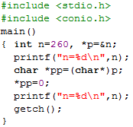

Exercise 3: (2 marks) Walkthroughs

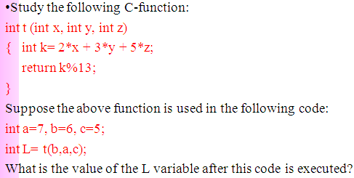

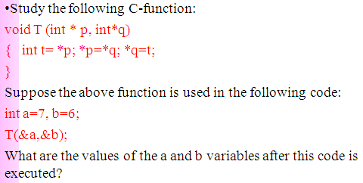

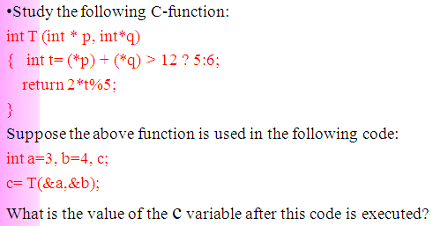

Part 2: Develop a program using simple menu

Program 1(3 marks):

Objectives | Practice implementing a program with simple menu.
Related knowledge | None
Problem | Write a C program that will execute repetitively using a simple menu as following:  - Process primes  - Print min, max digit in an integer;  - Quit  Select an operation:  - When user selects the option 1, the program will accept a positive integral number and print out a message about whether the input number is a prime or not.  - When user selects the option 2, the program will accept a positive integral number and print out the minimum and maximum digit in this number.  - The program will terminate when user selects the option 3.
Analysis | Nouns:  - positive integral number int n  - A number represents a choice of user int choice;  Functions:  int prime( int n) see above  void printMinMaxDigits( int n) see above
Suggested algorithm (logical order of verbs) | Begin  Do /* Print out the menu and get user choice*/  { Print out “1- Process primes\n”;  Print out “2- Print min, max digit in an integer \n”;  Print out “3- Quit\n”;  Print out “Select an operation:”;  switch(choice)  { case 1: do  { Input n;  }  while(n<0);  If ( prime(n)==1) Print “ It is a prime\n”;  Else Print “ It is not a prime\n”;  break;  case 2: do  { Input n;  }  while(n<0);  printMinMaxDigits( int n) ;  break;  }  }  while ( choice >0 & choice<3);  End

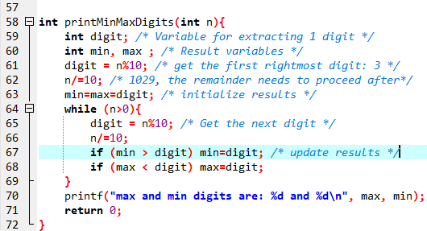

Program 2(3 marks): ( refer to the workshop 2 for algorithms)

Write a C program that will execute repetitively using a simple menu as following:

1-Fibonacci sequence
2-Check a date
3-Quit
Choose an operation:

1- When the option 1 is selected, the program will accept a positive integral number, called as n, then the first n Fibonacci numbers will be printed out
2- When the option 2 is selected, the program will accept a date then the program will tell that whether this data is valid or not.
3- If the option 3 is selected, the program quits

More Programs

You can pick 2 or 3 functions in the workshop 2, associate them to a new program.

