PE_PRN231_SP25_TrialTest
SPRING 2025
Subject: PRN231
Duration: 85 minutes

INSTRUCTIONS
Please read the instructions carefully before doing the questions.
- You are NOT allowed to use any device to share data with others.
- You must use Visual Studio 2019 or above, MSSQL Server 2012 or above for your development tools.
IMPORTANT – before you start doing your solution, MUST do the following steps:
- Create Solutions in Visual Studio named PE_PRN231_SP25_TrialTest_StudentCode_BE for API, and PE_PRN231_SP25_TrialTest_StudentFullname_FE for Client Application. Set the default Client application for your project as Login page.
- To do your program, you must use ASP.NET Core, apply 3-Layer architecture (Presentation Layer, Business Logic Layer, Data Access Layer), there are at least 2 Projects for the BE Solution. The database connection string must get from the appsettings.json file.
In the case your code connects direct to the database from ASP.NET Core Web API or hard coded the connection string, you will get 0 point.
- Create your MS SQL database named Sp25CosmeticsDB by running code in script Sp25CosmeticsDB.sql.
- Please check before you submit your work, no syntax error(s) in the submitted PE. If there are syntax errors or compilation errors in your PE program, you will not pass the PE requirements, the point will be 0.
- Your work will be considered invalid (0 point) if your code inserts stuff that is unrelated to the test.

Implement a part of Cosmetics Store Application. The below Figure is a part of Sp25CosmeticsDB database.
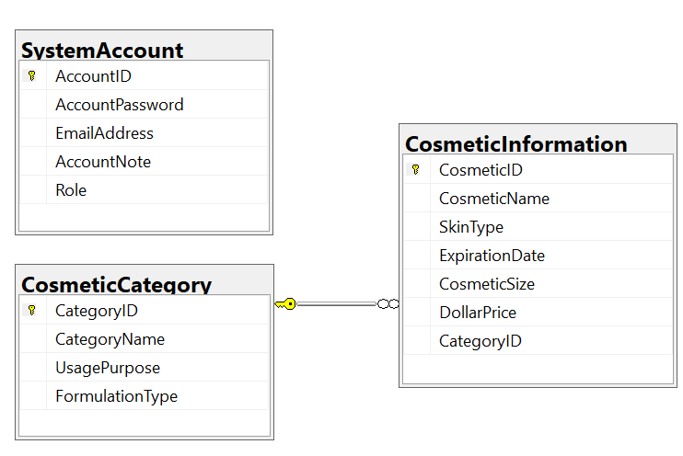
Note that: Role: Administrator=1; Manager = 2; Staff=3; Member= 4.

Part 01 (7.0 points). Create an API using ASP.NET Core Web API with Entity Framework Core. A MS SQL Server database will be created to persist the data and it will be used for reading and managing data.

- Check authentication/authorization with the ASP.NET Core Web API with JSON Web Token (JWT)
- Administrator role will have a permission to all actions (CRUD and search).
- Staff or Member role will have only permission to search information.
- Other roles do not have any permissions.
Note that the permission for Authentication feature is using EmailAddress and AccountPassword.

- Using ASP.NET Core Web API or API.NET Core Web API with OData to implement the functions. CORS is using in this case.
- Implement CRUD actions with CosmeticInformation table. Add new item with the requirements:
  - All fields are required.
  - Value for CosmeticName includes a-z, A-Z, space, @, # and digit 0-9. Each word of the CosmeticName must begin with the capital letter.
  - Value for DollarPrice > 0.
  - The value for CosmeticName and CosmeticSize must be 2 – 80 characters.
- Get all items includes all CosmeticInformation information and CategoryName.
- Search all items in CosmeticInformation table with 3 conditions: CosmeticName, CosmeticSize or SkinType (using relative search). This function must be implemented with OData. Search results need to be grouped by CosmeticName, CosmeticSize and SkinType.

Part 02 (3.0 points).
Student can choose one of these options for client application
- ASP.NET Core Web App with MVC
- ASP.NET Core Razor Pages
- Windows Forms
- Windows Presentation Foundation
- Authentication function
If user with a Administrator role or Staff role logs in successfully, save this information to a temporary parameter.
- Administrator role will have a permission to all actions (CRUD and search).
- Staff or Member role will have only permission to search information.
- Other roles do not have any permissions.
In the case login unsuccessfully, display “You are not allowed to access this function!”

- Check if login successfully, search all items with 3 conditions: CosmeticName, CosmeticSize or SkinType (using relative search). Search results need to be grouped by CosmeticName, CosmeticSize and SkinType.

- Check if login successfully, delete the selected item with the confirmation then update the list of items.

- Check if login successfully, add new item with the requirements:
  - The new item will display at the top of the list.
  - All fields are required.
  - Value for CosmeticName includes a-z, A-Z, space, @, # and digit 0-9. Each word of the CosmeticName must begin with the capital letter.
  - Value for DollarPrice > 0.
  - The value for CosmeticName and CosmeticSize must be 2 – 80 characters.

- Check if login successfully, update existing item with the same requirements with add function.

