Abstract - Nowadays, the business world is continuing to grow every day. Consequently, the number of corporate companies is increasing. All those companies are in a competition in this developing world. One of the most important factors in this competition is the economical state of the company. Success is the most important thing that effects the economical state and the number of qualified members effects the success. Untimely losses of these members effect the companies’ success and economy in a negative way. Also, these losses of members can lead to problematic developments of projects and loss of motivation. Because of these reasons, companies do not want to lose their qualified members. This has become the number one priority of companies. To prevent this, human resource department in a company must work closely with the members and increase their motivation and morale. By doing that, companies can analyse the reasons for untimely losses and find a solution. In this data mining Project, our goal is to make analysis to help companies’ HR departments. We have basically two targets as a result of working in that dataset: First, to understand and analyse why the employees want to leave the company and second, to predict the employees who are likely to leave the company. We want to share our analysis and predictions to the IT department of the company we are working with, thus; necessary work can be done to prevent employees from leaving and companies can prevent themselves from getting negatively affected economically.

I. INTRODUCTION

Databases are increasing and developing every day; as a result of this, the amount of data is increasing. Data’s value is recognised more today. In all of the business sectors, data about that workplace is stored in big databases for an amount of time. After readying the data for analysis, data can be analysed. With the help of those analysis, predictions are made about various areas and under these predictions, amenities are provided to the people.

Even if these developments are not noticed by people, their social media activities, usage of internet and phones are being stored in databases. This data is being analysed and predicted by companies to make human life easier. Today, also companies’ human resource departments store that kind of data. Companies interpret that data to know more about their employees and to improve the company. With the current conditions, these interpretations are crucial.
In today’s developing and changing business life, employees’ loyalty to a company is decreasing. To keep the negative effect of employees leaving the company to the projects in a minimum level, human resource departments are working to predict these kinds of situations in advance. To make those works more efficient, data mining algorithms should be used on the employees’ data. Employers are used to the leaving employees, but the important thing is keeping the qualified members. It is crucial for project managers and directors to predict these kinds of situations before they happen. Solving problems has a great effect on employees; because of that, human resource departments must work hard on that subject.
These kinds of studies are done to find answers to the questions such as: “Why employees quit their job? and “What are the reasons for employees to leave the company?”. Some studies show that employers have a great effect on their employees to solve their problems. Employees’ reasons to quit their current job may be wanting a better career, industrial accidents, lack of projects or so many projects, work hours, not getting a promotion, financial problems [1]. To predict and solve these kind of issues, human resource departments spend long working hours.
Our study’s goal is, by using data obtained by a survey applied on 14999 employees, to find answers to why they left the company and make predictions whether the remaining employees will leave or not and report the reasons to the employers. While making analysis, employees’ salaries, average work times, promotions, number of years worked in the company, number of work accidents they had, departments they work in and their happiness will be considered. Data will be prepared to see if those criteria have any effect on employees leaving company. Different analysis and results were gathered using data from similar subjects.

II. RELATED WORKS

This is an article[2] written about how employees’ job attitudes and decisions about leaving the company effects the company’s performance and endorsement by looking at the data collected from 911 employees. After this research, it is reached that, employees who are less committed to their companies tended to stay %30 versus %9 after the survey for 18 months. This article was published in 1975 by IBM and it is one of the oldest and most important articles about that subject.

In this article[3], studies have been done about predicting the percentage of leaving because of the leaving employees’ negative effects on the company. It is tried to be solved using data mining algorithms. It is aimed that this study’s results will help IT departments to solve the problems. The obtained result is, the most three important factors while determining an employee’s departure are the mean of the number of token in task report, the standard deviation of working hours, and the standard deviation of working hours of project members in the first month.
In this article[4] , which was published in 2014, the reasons of employee departures were focused on and analysed using data mining algorithms. After these analysis, companies were given opportunities to solve departure problems. Finding better jobs, haven’t been able to move forward in their careers and being unhappy with their salaries are some of the most common reasons for employees to leave a company according to the results.

In another published article[5] , data mining algorithms used for predictions for employees leaving work used by human resource departments are focused on. With the help of these articles, human resource departments are told how they can evaluate employees’ futures in the company.

III. METHODS
III.A. DATA SET

Researches done on 14999 employees are included in our dataset. There are 10 attributes about 14999 employees. Leaving work percentages of employees working in a company is %24 and satisfaction level of employees working in a company is 0.61. Attributes of our data types are showed in Table 1.
Table 1 – Attribute types of dataset
satisfaction_level | float64
last_evaluation | float64
number_project | int64
average_montly_hours | int64
time_spend_company | int64
Work_accident | int64
left | int64
promotion_last_5years | int64
sales | object
salary | object

III.B. DATA PREPROCESSING

Before making predictions on the data, we must make analysis. Before making analysis on the data, we must modify the data to make it analyzable. For this, we have checked our data to see if there are any missing values. There were not any missing values after our inspections at Table 2.

Table 2 – Missing values of dataset
satisfaction_level | False
last_evaluation | False
number_project | False
average_montly_hours | False
time_spend_company | False
Work_accident | False
left | False
promotion_last_5years | False
sales | False
salary | False

As the result of our analysis, we have updated the “Left” attribute as the last attribute to provide us convenience. Then, we have found the employees’ leaving work reasons’ percentages. This is done because we are trying to predict their possibility to leave work. As a result, in 14999 employees, 11428 of them remained in the company and 3571 of them left the company. To present it in percentages, the percentage of stayed employees is 0.761917 and the percentage of employees left is 0.238083. By looking at these results, we will try to analyse employees’ reasons to leave work.

III.C. DATA EXPLORATORY ANALYSIS

We have created a correlation matrix to see the power of the relations between the attributes. We have used heatmap structure to visualize correlation matrix (see Figure 1). Expected K-correlation coefficient is between -1 and 1.

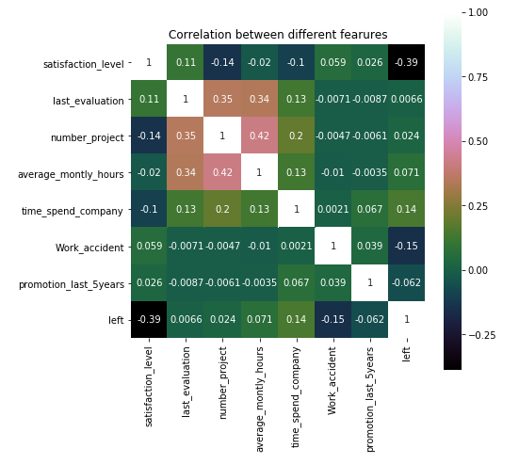
Figure 1 – Heatmap

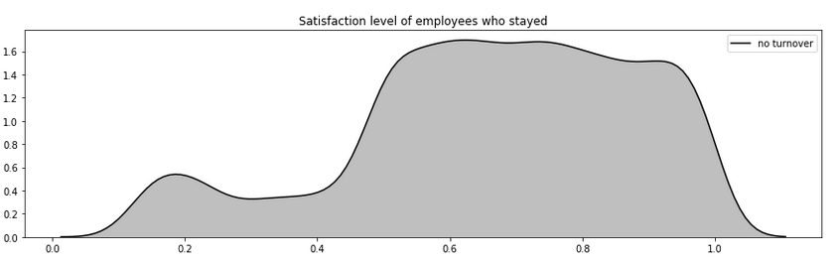
Figure 2 – Satisfaction level of employees who stayed

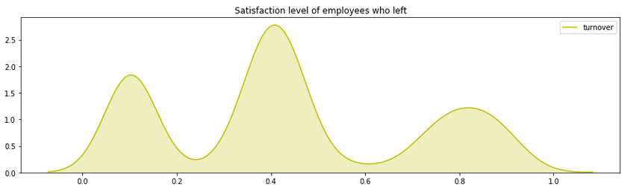
Figure 3 – Satisfaction level of employees who left

When we examine the heatmap, we can see that the leaving work percentage “Left” has the most relationships with the satisfaction of the customers. We have seen the correlation coefficient as -0.39 between those two. This means that the more employees are happy, the less they are likely to leave the company. Even if it is not considered as a strong correlation, the couple which has the most correlation coefficient are satisfaction and left attributes.
When the distribution which includes the relationship between the satisfactory levels and the number of employees in the company is examined (see Figure 2), it is seen that employees’ who are still in the company, has a satisfaction level on and above average. But by looking at that data, we cannot simply say that if an employee’s satisfaction level is high, he/she will not leave the company. When we look at the Figure 3 including left employees and their satisfaction levels, their satisfaction levels are lower and by looking at this result, low satisfaction level employees have a stronger relationship with the employees that have left the company.

While human resource departments are gathering data, they should keep track of how many employees have left work and how many of them are still working in which departments. When we analyse our data, the percentages of employees leaving work are nearly similar between the departments. Sales, Technical and Support departments respectively have the most number of employees. When we analyse these departments, we predict that these departments have the biggest potential for an employee to leave. But, when the ratio of number of employees left and still working to the total number of employees is analyzed, we understand that is not exactly like how we have predicted. For example, it is seen that the number of left employees in human resource departments is more than sales department (see Figure 4). By looking at this, we understand that, number of employees who left the company in a department is not the most important thing; the most important thing is the ratio of employees who left the company to the total number of employees. It is crucial to pay attention to these kinds of analysis while human resource department is making a study to solve problems.

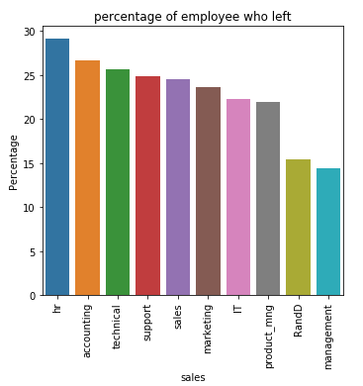
Figure 4 – Percentage of employee who left

For another prediction, we examine the salary-leaving work relationship which is not expected much. It is commonly known that employees with a low salary are more likely to leave work. In our data, salary attribute is grouped as low, medium and high. If we review the salary-leaving work relationship from the table (see Figure 5), we can reach to a result that, employees with a high salary is more likely to stay in the company and employees with a low salary is more likely to leave the company.

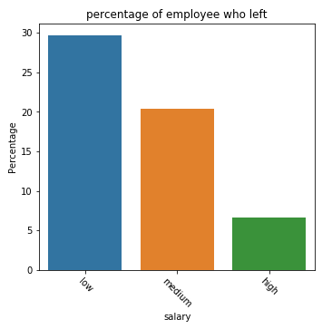
Figure 5 - Salary-Leaving work relationship

The most important reason that we obtained from the correlation matrix is the satisfaction level of an employee is one of the most important factors for the employees who leave work. In the continuation of our work, we wanted to see if the last-evaluation attribute is one of the most important factors. For this, we have sketched a pilot which shows how the satisfaction level and last-evaluation affect the decisions of employees.

When the Figure 6 is examined, it is seen that there are 3 different groups. Firstly, we see a group including employees with satisfaction level between 0.7 and 0.9 and last_evaluation value between 0.8 and 1.0 whom are likely to leave the company. We were not expecting this result, because it can be thought that employees with high satisfaction levels and high last_evaluation values have no problems with the company. But our results show that employees with high satisfaction and last_evaluation go to companies where they can find more opportunities.

In the second group, it is observed that employees with satisfaction level lower than 0.2 and with last_evaluation more than 0.75 are very like to leave the company. By looking at this result, it is important for human resource departments to look into why employees with high last_evalution values have less satisfaction.
The last group on the graphic includes employees with satisfaction levels between 0.35 and 0.45 and last_evaluation values between 0.45 and 0.55. These employees’ percentage of leaving work is very high. It is an expected result that unsuccessful employees have less satisfaction and consequently they want to leave the company.

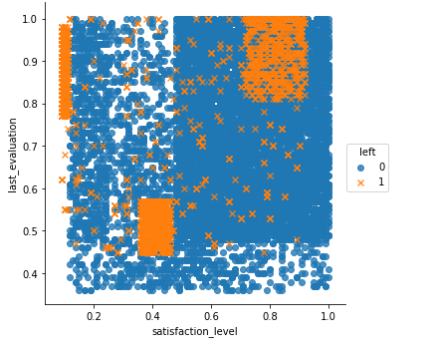
Figure 6 – satisfaction_level-last_evaluation relationship

IV. RESULTS
In the first section, we reported the ways we applied preprocess to our data. Later, to see which values affected the left with target value, we examined the relationship between each attribute and the left. Likewise, we additionally examined the associations of attributes other than the left. We added the program we developed in our project to our interface. Thus, the users could apply the visualizations they wish to the attributes that the data has. In the later sections of our project, we choosed prediction method to form a model for our
data.Before modelling the data, we primarily made feature selection by using feature selection method to decide which attributes we will run on algorithms. For this, we firstly made feature selection with Decision Tree (see Figure 7). As it can be seen in the table, the most important 3 features obtained are ‘satisfaction_level’, ‘time_spend_company’, and ‘last_evaluation’.
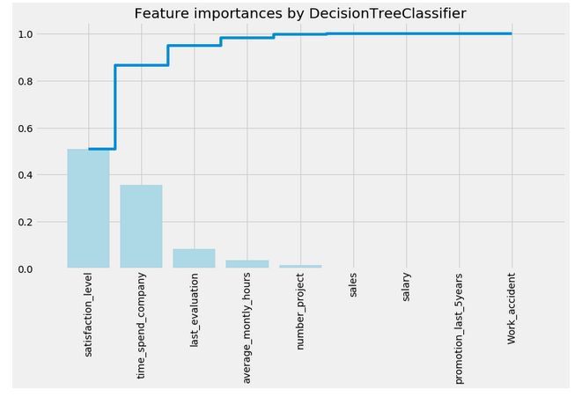
Figure 7 – Feature importance by DecisionTreeClassifier
To form a data model, we applied logistic regression, random forests, and SVM procedures. We segmented our data to 80% as train data, 20% as test data while applying these models. We used the 3 features we found by using decision tree procedure as parameter features. Then we evaluated our success rate in each method we used. We observed that we obtained the highest success rate from using ‘Random Forest’ model.

Logistic Regression
recall_score: 0.267507002801
accuracy_score: 0.764
precision_score: 0.507978723404
roc_auc_score: 0.593289809362

SVM
accuracy_score: 0.913333333333
recall_score: 0.903361344538
precision_score: 0.771531100478
roc_auc_score: 0.909904644272

Random Forest
recall_score: 0.966386554622
accuracy_score: 0.982
precision_score: 0.958333333333
roc_auc_score: 0.976631597521

While considering a better way to predict the results we have, we decided conducting feature selection with another method.
We applied the feature selection process by using the Random Forest algorithm.

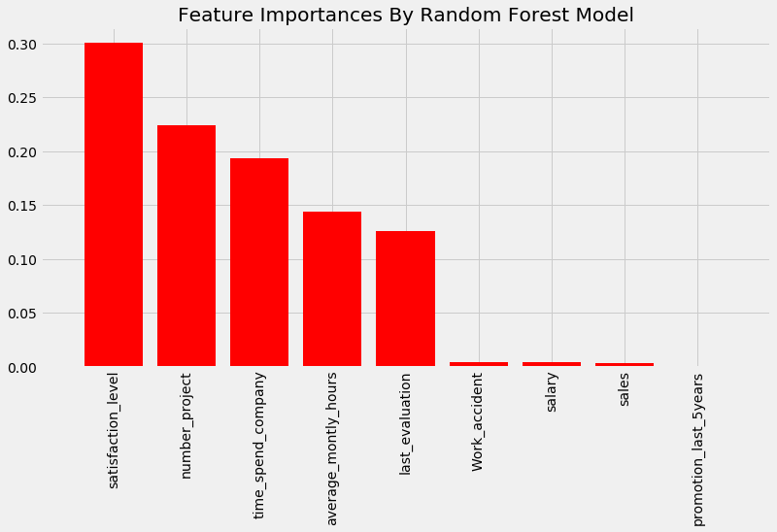
Figure 8 – Feature importance by Random Forest Model

As we can see in the Figure 8 , the most important features are ‘satisfaction_level’, ‘number_projects’, ‘time_spend_company’, ‘average_monthly_hour’, and ‘last_evaluation’. When we compare these results to the results obtained by using Decision Tree, we can see that we have acquired 2 more different features. As a result, we decided to try these 5 features to model our data.
As before, we applied logistic regression, random forests, and SVM procedures on our data. We again segmented our data to 80% as train data, 20% as test data while applying these models. We used the 3 features we found by using decision tree procedure as features in the parameters. Then, we evaluated our success rate in each we method we used. We observed that we obtained the highest success rate from using SVM method.

Logistic Regression
recall_score: 0.261904761905
accuracy_score: 0.765
precision_score: 0.512328767123
roc_auc_score: 0.592019747532

SVM
accuracy_score: 0.954333333333
recall_score: 0.920168067227
precision_score 0.89145183175
roc_auc_score 0.94258622084

Random Forest
recall_score: 0.981792717087
accuracy_score: 0.994
precision_score: 0.992917847025
roc_auc_score: 0.989802745245

Considering these results, we concluded that the random forests method resulted in a better prediction model. We concluded hat our prediction model with 5 features were better when we compare them with the previous prediction results. However, we were aiming for better results in modelling our data in our project. Thus, we normalized our data before applying a model for the data.

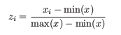

We used principal component analysis(PCA) for dimensionality reduction. In this way,
we reduced the dimensions of our data. As it can be seen in the Figure 9 we observed 90% variance with our first 6 attributes.
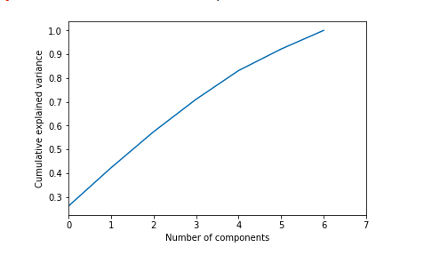
Figure 8
Table 3
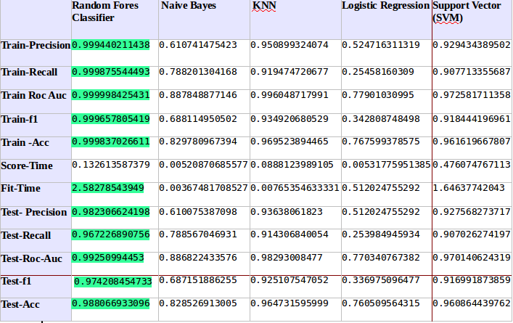

After we carried out the previously mentioned steps, we
decided to apply another analysis on our data. This analysis, we choosed a different path for the modeling process. We used Random Forest Classifier, Guassian Naïve Bayes, KNN, Logistics Regression, and SVM together with cross-validation method on our data. We used cross validation to increase the accuracy rate while modeling our data (for k=10). We took the average of each value resulted from each method. Values are reported in the Table 3. After we examined this table, we identified the Random Forest Classifier method as the best one for our aim.

When the analysis on the test data in the table is examined, we see that we reach the highest values using the Random Forest Classifier algorithm. When look the accuracy value of Random Forest Classifier we see this value as 0.98. The values is higher than recall value of the same algorithm. But this result does not give us exactly the result we want. The most valuable value is test-recall. Because with the recall value, we can understand how many of the employees who have really decided to leave the job are correctly guessing to leave the job by looking at their recall values. We could make the best guess in the Random Forest algorithm with the 0.96 value. In addition, we see that the test-f1 score obtained from the Random Forest Classifier is 0.97, which is higher than the other algorithms.

This is an expected result. Because both the test-precision and the test-recall value are the highest values ​​for the random forest

classifier. The are under the ROC curve is called as Area Under Curve.A large AUC value indicates how good the test is in predicting the correctness of the employee's decision to leave the job. the highest test-roc-auc value was achieved with the Random Forest Classifier algorithm. Which means that the Area Under Curve value is higher in this method.

We used the same algorithms to train the train model to see how overfit and the accuracy of our results, and we showed them on the table.

We prepared an application (Figure 9), which can draw some plots about our data, create a HeatMap, run the kMeans algorithm, run some classification algorithms, filtering. We can inspect all employee who have the features we want in the company. For example, if we want to list employees whose Satisfaction level is above 0.4 and whose last-evaluation values below 0.6 on our dataset, we are also filtering out values that are below the satisfaction level of 0.4 and above the last-evaluation value of 0.6. At the same time, we can apply visualization by analyzing between these two properties.

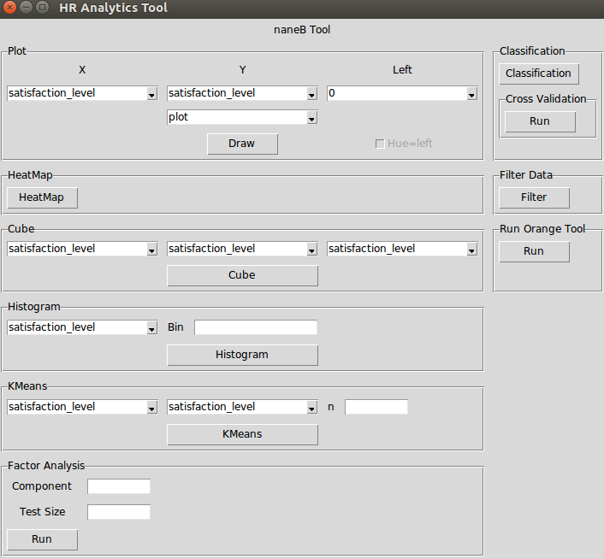
Figure 9

VI. DISCUSSION and CONCLUSION
Since the organization will suffer high costs from a qualified staff’s leave, in time measures taken accordingly by the executives poses a great importance. The ultimate aim of our project was to make an early prediction about employees’ abrupt decisions to leave the firm, and identify the reasons behind these possible decisions. We conducted an exhaustive and rigorous data analysis. The first standing out feature was ‘satisfaction_level’ when we checked the correlation matrix of the features. The analysis results indicated that there was a negative and statistically significant correlation between the satisfaction levels of the employees and their intentions to leave their jobs. Accordingly, when the satisfaction level of the employees increases, their intentions to leave their jobs decrease. We inferred that another alternative factor affecting the intention of leaving the firm was employee’s finding out about opportunities in other companies, even if they were successful and satisfied in their current positions. We forecasted that finding out about other alternative positions in other firms would increase the intentions of quitting their current jobs. On the other hand, while expecting a better prediction factor on the payment levels of the staffs, we found that there was not a significant relationship between this factor and decisions about leaving their current firms. In the related articles, the opposite association was reported about the wages of the employees and their decisions about quitting their jobs. What we understand from our results is that payment level is not itself a sufficient predictor. We concluded that the wage variable loses its explanatory power if the subject’s satisfaction level was kept high with other parameters.

We conducted different analysis on other data set with 10 features in order to find which
features was affecting one another. Hereby the future users of this project can easily make
predictions about the interactions of each employee’s features. The consequences of unexpected leavings of experienced, skilled, and qualified employees would be drastic for the companies. We reason that the human resources should take further measures to increase their employee’s satisfaction to highest possible level with other relevant parameters to keep them. Our most important aim for our project was to make it accurate and eligible enough to help a real firm’s human resources. Our results show us that the data model we propose, with its high success rate in prediction analysis, can be used in a real research project and humans resources departments can come up with adequate solutions for the possibility of a staff’s leaving their current positions in the firm.

References
[1]Carey & Ogden, 2004; Westcott, 2006
[2]Predicting Turnover of Employees from Measured Job Attitudes ,A L L E N I. K R A U T
[3]5-2017 Who Will Leave the Company? A Large-Scale Industry Study of Developer Turnover by Mining Monthly Work Report Lingfeng BAO ,Zhenchang XING ,Xin XIA,David LO Singapore Management University,
[4]Employee Turnover Analysis with Application of Data Mining Methods
URL http://ijcsit.com/docs/Volume%205/vol5issue01/ijcsit20140501119.pdf
[5]A Data Mining Approach to Employee Turnover Prediction URL http://jise.ir/article_10857_380ab2c2c84e1525e1f53647b46d6879.pdf

