Dynamic Model of a Bicycle
from Kinematic and Kinetic Considerations
by Andrew Davol, PhD, P.E. and Frank Owen, PhD, P.E.,
California Polytechnic State University,
San Luis Obispo, California,
adavol@calpoly.edu and fowen@calpoly.edu

This paper analyzes the stability of a bicycle from kinematic and kinetic considerations. It follows the development of this topic as presented by Lowell and McKell in their 1982 paper “The stability of bicycles”.

Bicycle geometry

Figure 1 shows the geometry of the bicycle with important parameters indicated.

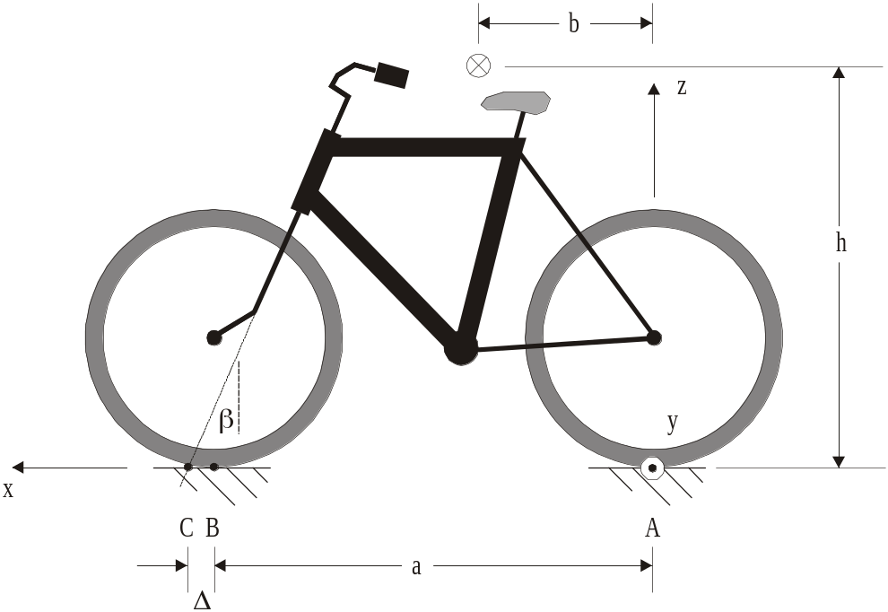

Figure 1 – Bicycle geometry

The bicycle has a coordinate system with its origin at the contact point of the rear wheel (point A). The x axis passes through the contact point of the front wheel. The z axis is vertical, leading up from point A. The y axis leads to the right side of the bicycle.

The main parameters that govern the bike’s dynamics are the wheelbase, a, The height of the center of mass above the ground, h, the distance of the center of mass forward of the origin, b, the head-tube angle, β, and the trail, Δ. Note that B is the contact point of the front wheel on the ground and point C is the point where the steering axis intersects the ground. As we shall see, trail is very important for stability. Point C must be ahead of point B for a stable bicycle, a bicycle that wants to return upright after it has been rolled off the vertical plane.

In Figure 2 the bicycle is shown from above. The bike is proceeding generally to the left with a velocity v. The front fork is deflected through an angle α. In this figure this angle is exaggerated for illustration purposes. If the tires track true, the velocity of the frame is in the x direction and the velocity of the front fork is in direction of the front wheel, so α to the left of the x axis. These two velocity directions fix the location of the instant center, also shown. So at the moment shown the bike rotates around the instant center. This rotation represents a direction change, so it is yaw. The yaw angle is η. So in the position shown, the yaw rate is:  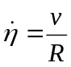  (See Figure 4.)  The geometry of the turn shows that  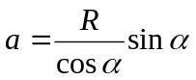  Using small angles so that cos α = 1 and sin α = α,  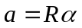 or 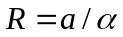 | 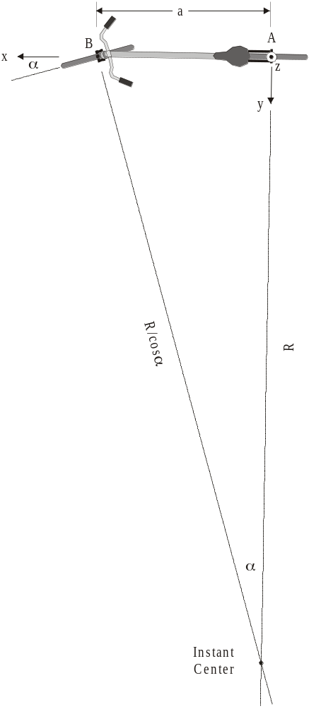  Figure 2 – Turning geometry of bicycle

Figure 3 shows the accelerations acting on the mass center of the bike due to roll acceleration, yaw acceleration, and yaw velocity. These accelerations are all substantially perpendicular to the bicycle frame. They are:  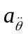 - Roll acceleration. If the angular roll velocity is increasing or decreasing, ≠ 0. The double derivative signifies that this is a tangential acceleration associated with θ.  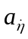 - Normal acceleration toward center of turn. At any instant the bike is yawing about the instant center. Even if the yaw rate, , is constant and the bike is traveling in a circular path, this acceleration will exist. Normal acceleration is always associated with the direction change of the velocity.  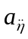 - Yaw acceleration. If the yaw rate, , is not constant, then ≠ 0. This means that the curve followed by the bike is not circular but tightens or loosens. The double derivative signifies that this is a tangential acceleration associated with η.  and are perpendicular to the bike frame, so in the y direction. is directed toward the instant center. But as can be seen in the drawing, it is a good approximation to assume it is also collinear with the other two accelerations. | 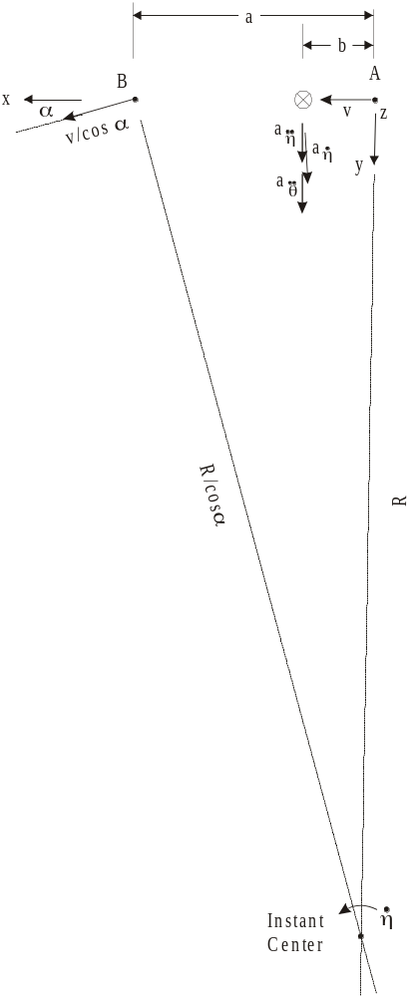  Figure 3 – Yaw motion of bike

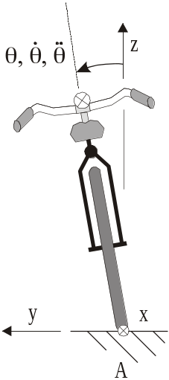  Figure 4 – Rear view of project showing roll angle | Figure 4 shows the bicycle roll angle, velocity, and acceleration. Notice that the roll angle represents a negative rotation about the x axis.

Let’s look at the stability of the bicycle from an upright, straight-ahead path with velocity v. Figure 5 shows the bike from the back with the three previously described accelerations of the mass center.  From a consideration of Figures 3 and 4, it should be clear that the accelerations have the following values:  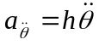  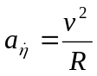  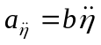 | 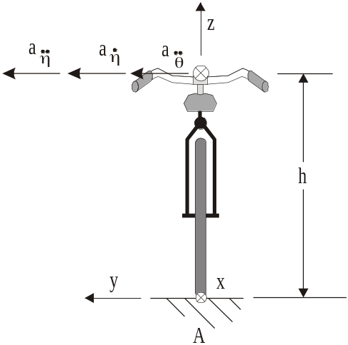  Figure 5 – Rear view of bike showing sideways accelerations

Now give the bike a slight roll angle θ and impose Newton’s Second Law, summing moments about the x axis.

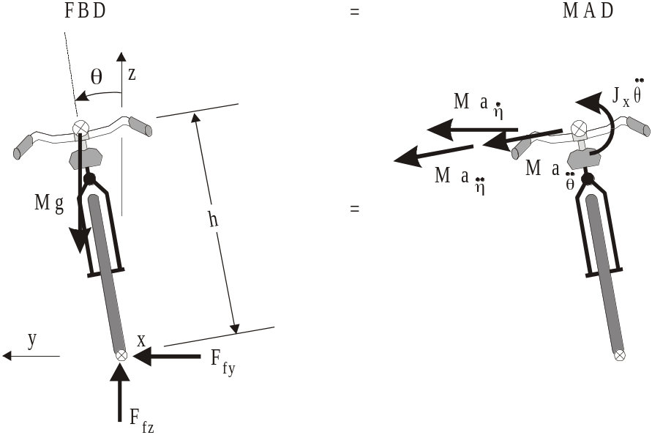

Figure 6 – Free Body Diagram and Mass Acceleration Diagram of rolled bicycle

The moment equation is thus



Applying the small angle approximation for θ, and simplifying the equation,

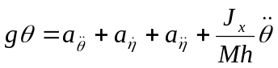

Substituting the values for the accelerations, ignoring the J_{x} term*, and rearranging,

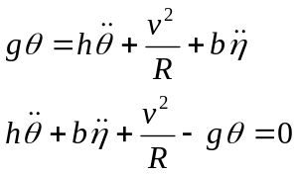

From the yaw relationships ( and ),

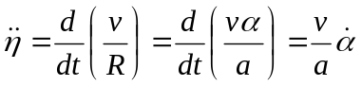

* The authors give no justification for this, so we just accept it for now.
if we consider the case of constant speed (v is constant). Thus

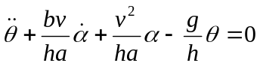 (1)

This is a second order ordinary differential equation in θ, the roll angle. But α, the steering angle, is also in the equation. In fact the equation expresses the fact that the steering angle and the roll angle are coupled. Thus is the bicycle is proceeding straight ahead with no roll angle and a steering angle of 0, the equation states that a sudden steering angle input will induce a roll. Also a sudden roll angle input, for example if the cyclist encounters a sudden sideways puff of wind that causes a roll, will also result in a steering angle deflection. At this point we can start to gauge the stability of the bicycle from this equation.

Imagine the steady state condition where the steering angle is constant (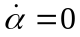) and the roll angle is constant (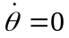 and 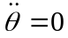). In this case from equation (1) we see that

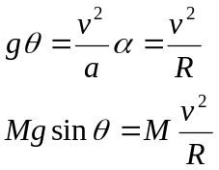
This represents the state where the bicycle is traveling around in a circle (with centripetal acceleration, 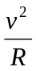, or “centrifugal force”, 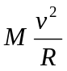) at a constant roll angle. The weight tending to roll the bicycle inward toward the center of the circle is counteracted by the “centrifugal force” tending to make the bike roll over to the outside. That the model correctly represents this known situation gives us some confidence in the model. Also note that the greater the bike velocity, the larger must be the angle of roll. Also the tighter the turn radius, the larger θ must be, again what we would expect.

This represents the state where the bicycle is traveling around in a circle (with centripetal acceleration, , or “centrifugal force”, ) at a constant roll angle (See Figure 7). The weight tending to roll the bicycle inward toward the center of the circle is counteracted by the “centrifugal force” tending to make the bike roll over to the outside. That the model correctly represents this known situation gives us some confidence in the model. Also note that the greater the bike velocity, the larger must be the angle of roll. Also the tighter the turn radius, the larger θ must be, again what we would expect. | 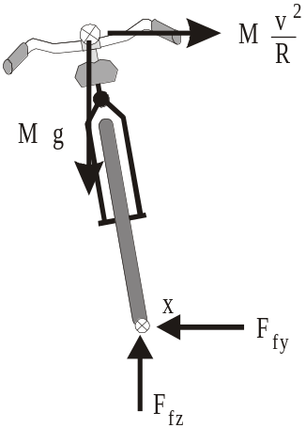  Figure 7 – Bike in a steady circle
Exercise 1: We can look also at the model assuming that α is an input instead of an independent variable. Rewrite equation (1) with α on the right side of the equation (where an input usually goes).

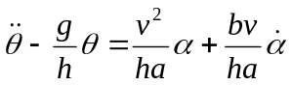

Model this system in Simulink. Use the variables in the paper to represent a real bicycle (See Table 1). Set your model up to accept input in degrees and plot out θ in degrees, in degrees/sec, and in degrees/sec². Assume the bike is going 5 m/sec.

- First try the do-nothing case. Let θ and α be 0 and put in no excitations. What should the bike do?
- Now consider the case of a steady circular path. Pick a particular α, say 3º. Calculate the roll angle that would correspond to this if the bicycle is moving in a steady, circular path. Put this in as an initial θ ₀. Does the bike roll around in a circle at a steady roll angle?
- Now put in a small, sudden deflection of the handlebars, say α ₀ = 1º as a step function. Does the response go to a steady circular path? Interpret the results. If there is an oscillation, what is its frequency?

Table 1 – Bicycle Parameters
a | 1.0 m
b | 0.33 m
h | 1.5 m
M | 80 kg

Another assumption that can be made is that the steering angle is proportional to the roll angle, i.e. 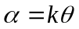. There is no physical reason to assume this, but perhaps this is the way a person rides a bike. As the bike rolls more, the rider compensates by turning the handlebars more to ride the bike up under the direction of fall to stabilize it.

Exercise 2: Make this substitution. This will lead to an ODE in only θ. Interpret the resulting equation. For what values of k will this system be stable, marginally stable, or unstable? Verify your results. Perturb the model by putting in a small, initial θ ₀, say 5º. Try all cases of k that you found above.

Let’s look closer at what happens to the bike if it suddenly rolls from the vertical due to a sudden wind gust. Specifically, let’s look at the gyroscopic effect on the front wheel and how it responds to a sudden change in the axis of rotation. This will be done to assess the bike’s self-stability, i.e. the hands-off stability. This is the ability of the bicycle to right itself without intervention of the rider.

In the Lowell and McKell paper, the bicycle’s steering axis is vertical. The steering axis is out in front of the wheel axle to give positive Δ or trail. Trail is the distance on the ground from the point of intersection of the steering axis (point C) and point B, the contact point of the front wheel (See Figure 1). Usually point C is forward of point B.

The gyroscopic effect is encapsulated in the vector relation from 3-D kinetics

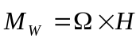

where 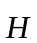 is the angular momentum of the front wheel, 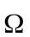 is the rotation through which goes, and 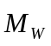 is the corresponding moment. In our analysis, is the angular momentum of the front wheel about its axle, so 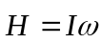, where ω is the rotation rate of the front wheel. If the bicycle is traveling straight ahead, 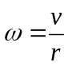, where r is the wheel radius.

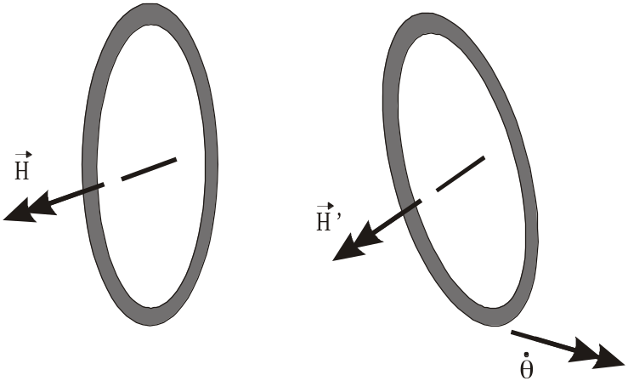  Figure 8 – Change in angular momentum of front wheel with a roll deflection. | Thus  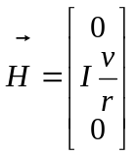  and  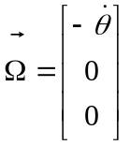

So 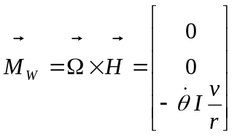

This represents a moment in the negative z direction. If we ignore the rake of the steering axis and take it to be vertical (which it almost is for most bikes), this would represent a clockwise moment about the steering axis, looking from above.

The causality here is a little unclear. Is this moment a cause or an effect? Does the roll induce this moment or is this moment input, a twist about the steering axis, which causes a roll. Specifically it would be a clockwise twist or a turn of the handlebars to the right which would produce a role to the left. Let’s go on with this question of causality unanswered and see if an answer becomes evident with further analysis.

If we consider the moment to be a cause for the change in the angular momentum with the roll, then this moment has been imposed on the wheel to cause the change. The moment was delivered by the fork. The wheel thus delivers an equal and opposite moment to the fork. So the moment on the fork is

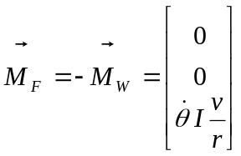

Considering the moment equilibrium of the fork about the steering axis,

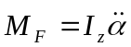

where I_{z} is the mass moment of inertia of the wheel about a diameter. Thus

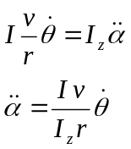

This shows that the gyroscopic effect will accelerate the wheel counterclockwise about the steering axis looking from above. Thus if the roll velocity is positive, that is the rider rotates to the left, the front wheel accelerates to the left, i.e. into the direction of the roll. This steers the bike to the left, thus up under the roll. Therefore it is stabilizing.

As it turns out, this effect is minor (negligible) for most bikes. This is because the mass of the front wheel is small. But for motorcycles, where the wheel mass is higher, this effect is more pronounced.

Notice what happens to the bicycle when the front fork is turned to the left (Figure 9).

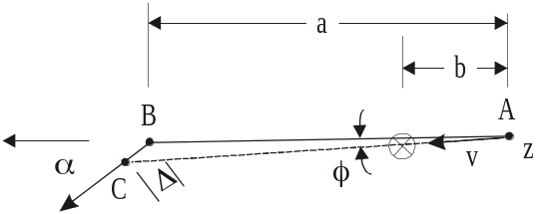

Figure 9 – Effect of trail

This figure shows the steering angle highly exaggerated to show its effect. Recall that point B is the contact point of the front wheel with the ground. C is the intersection of the steering axis with the ground. The x axis is defined by the two contact points. Since the steering axis is bound to the bicycle frame, the bicycle plane is actually along AC, not AB. Thus the center of gravity is shown on this line and the velocity is from A to C. The distance of point B off AC is

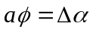

or 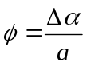

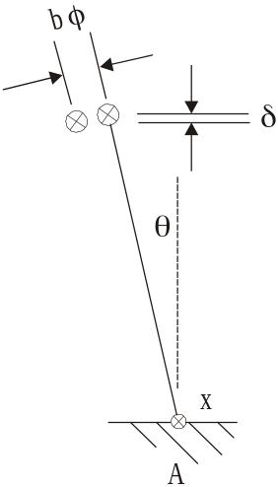  Figure 10 – Drop in CG with steering angle and roll | Also note that the sideways movement of the center of gravity is bφ . If the bicycle is at a certain roll angle, then this sideways movement of the CG involves a lowering of the CG and a loss of potential energy. Figure 10 shows this. Note that this drop, δ, is  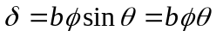  for small roll angles. Thus  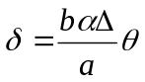  We equate this drop in potential energy with work done about the steering axis.  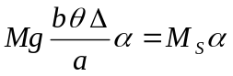

Where M_{S} is the moment about the steering angle as it moves through α. Thus

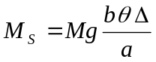

If we sum moments about the steering axis,

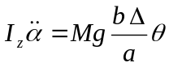

Notice that this represents a coupling between α and θ. A positive roll motion corresponds with a positive acceleration of the steering angle. Thus the bike turns into the roll, which is stabilizing.

Let’s look also at the moment about the steering axis caused by the frictional forces on the tires. These forces are directed toward the center of curvature of the bike path (perpendicular to the tire planes, as shown in Figure 11). If we sum moments around a vertical axis through the center of mass,  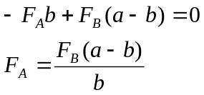 | 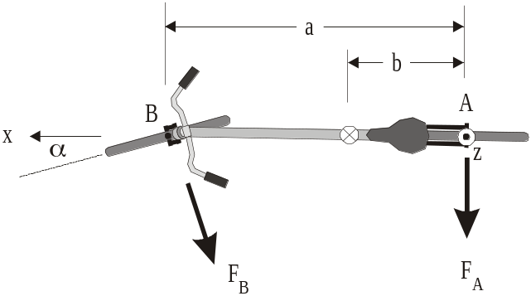  Figure 11 – Frictional forces on tires
Notice that we have used the distance (a-b) for the moment arm of F_{B} , which assumes a small angle for α.

These frictional forces keep the bicycle moving in a curved path. They cause the acceleration of the bicycle toward the instant center. With a small a these forces are roughly parallel. The normal acceleration toward the instant center is

Thus if we apply force equilibrium in a direction perpendicular to the bike frame,

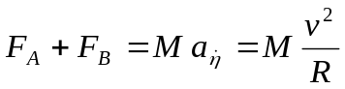

Thus

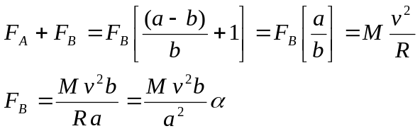

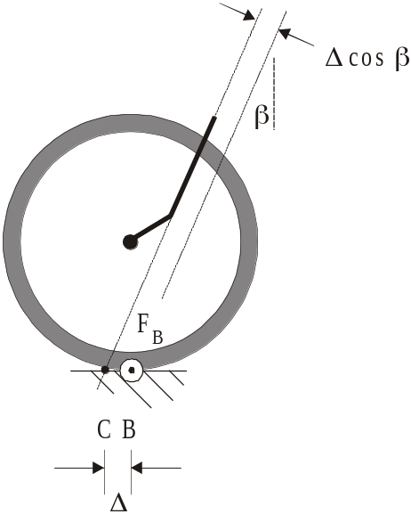  Figure 12 – Moment of F_{B} about steering axis | The moment of this force, the sideways force on the front wheel, shown coming out of the page at B in Figure 12, is  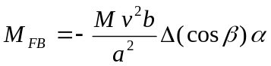  The negative sign here indicates that if α is positive (to the left), this force tends to reduce α.

These three moments about the steering axis are separate, caused by different phenomena: 1) the gyroscopic effect, 2) the reduction in height of the CG, and 3) the sideways friction force of the tire. So the total moment about the steering axis is the sum of all these effects. Thus, applying Newton’s Second Law, the moment about the steering axis is

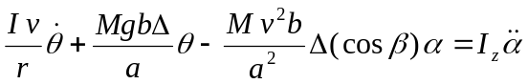

or
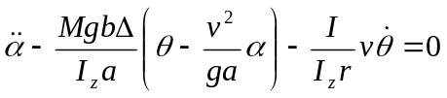 (2)

Thus we have a second, second-order ODE, this one the a equation. This is the matching equation for equation (1), the q equation. Together these two equations model the bicycle, especially the coupling between θ and α.

Summarizing, the dynamic model consists of two second-order coupled equations in θ and α. These equations are those of a free system (only 0s on the right-hand side of these equations). The equations are:

θ equation:

α equation: 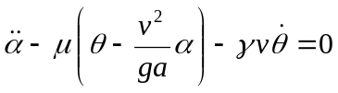
where 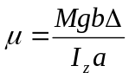 and 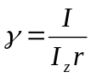. Also in the Lowell paper 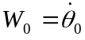 and 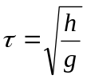.

Exercise 3: Use these equations to model the system in Simulink. Once you have your model, test it

- With the “do nothing” case.
- Input an initial roll angle of 5º. This might be the case you’d experience if you were riding along and got blasted by a sideways gust of wind. Run your model and see what happens. Does the bicycle come back upright? Do we have a way to calculate η? If so, and if the bike does come back upright, is it still headed in the initial direction?
- Get rid of the initial roll angle. Let’s say the bike is going along upright and hits a small obstacle in the road that knocks α over by 3º. What does the bike do? Is it stable or does this cause a crash?
- With your model can you duplicate the curves in Figures 2-5 in the Lowell and McKell paper?

Let’s modify the two equations a bit. They are apparently angular acceleration equations. By Newton’s Second Law, we know that

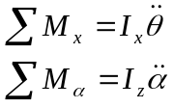

Note that if we multiply the θ equation by I_{x}, the mass moment of inertia about the x axis, we convert the equation into a moment equation. The 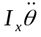 term can be separated from the other three. They form the moment about the x axis from internal effects. If we want to add an externally applied moment, for instance from the wind, we would do this here. So we could modify the equation to read

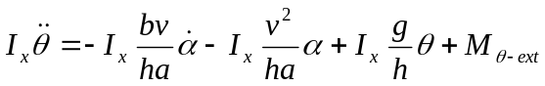

Similarly the α equation can be changed to read

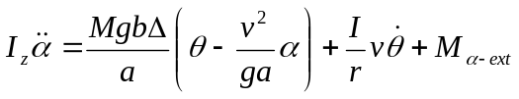

Thus we no longer have free models. There are now terms in each equation that have neither θ or α in them, nor any of their derivatives. These are the external moments, a roll moment and a moment about the steering axis. Thus the model defined by these two equations can have moments as inputs.

Exercise 4: Modify your Simulink model from Exercise 3 to accommodate this change. Check the modified model out. With 0 external moment inputs, does it give the same results as you got in Exercise 3? Prove this to yourself with a few spot checks.

- Now, using step inputs, set up your modified model to accept impulse forces. Let the roll moment be a steady value that lasts for 1 second. This will emulate a blast of wind that results in a steady moment that lasts 1 second. Pick the moment level to cause a maximum deflection of 5º of roll. What happens now? Does the bicycle self-stabilize?
- Do the same with the steering angle moment, except have the moment last only 0.2 seconds (like hitting an obstacle). Set the steady moment level by trial and error, having it cause a maximum α of 3º. Does the bike stabilize itself?
- In both cases above, can you calculate the final η? If so, do so and comment on the direction of the bike after it stabilizes.
- Go back to case 1. Instead of a one-second impulse, put in a step, i.e. a moment that lasts. This would be the equivalent of riding out from behind a barrier and being hit by a sudden, steady sideways wind. Will the bicycle stabilize with a steady side wind? What will be its condition after it stabilizes?

It may be possible with the model from Exercise 4 to consider it the “plant” in a normal control loop. So we may be able to input some kind of controller and make this a self-driven bicycle or a bicycle with the rider as the controller. Nothing to do with this now. But we may come back to it in the future.

