Supplementary Materials

S1. Extended Seed Count Robustness
The primary manuscript reports the frozen 2026-05-21 statistics. To evaluate robustness to larger seed counts, we repeated the online benchmark with 16 seeds per condition. This run pooled thalamus, distributed, and distributed meta-monitor control conditions, so it should be interpreted as a supplementary robustness check rather than as a replacement for the primary validation table.
All five constructs remained above the validation threshold (r >= 0.70), although the pooled estimates were lower than the primary frozen estimates for several constructs.
Construct | Primary frozen r | 16-seed supplementary r | Change
Action agency | 0.874 | 0.727 | -0.147
Boundary self | 0.940 | 0.918 | -0.022
Identity-temporal self | 0.850 | 0.749 | -0.101
Action ownership | 0.996 | 0.987 | -0.009
Distributed body-schema self | 0.924 | 0.902 | -0.022
The largest change was observed for action agency. The 16-seed estimate (r=0.727, 95% CI [0.662, 0.781]) is close to the validation threshold but remains positive, statistically reliable, and above criterion. We interpret this as evidence that the primary 8-seed estimate was somewhat upward-biased, not as evidence against the construct. The action-loop mechanism effect also replicated in the extended run (+0.698, 95% CI [0.695, 0.700]).
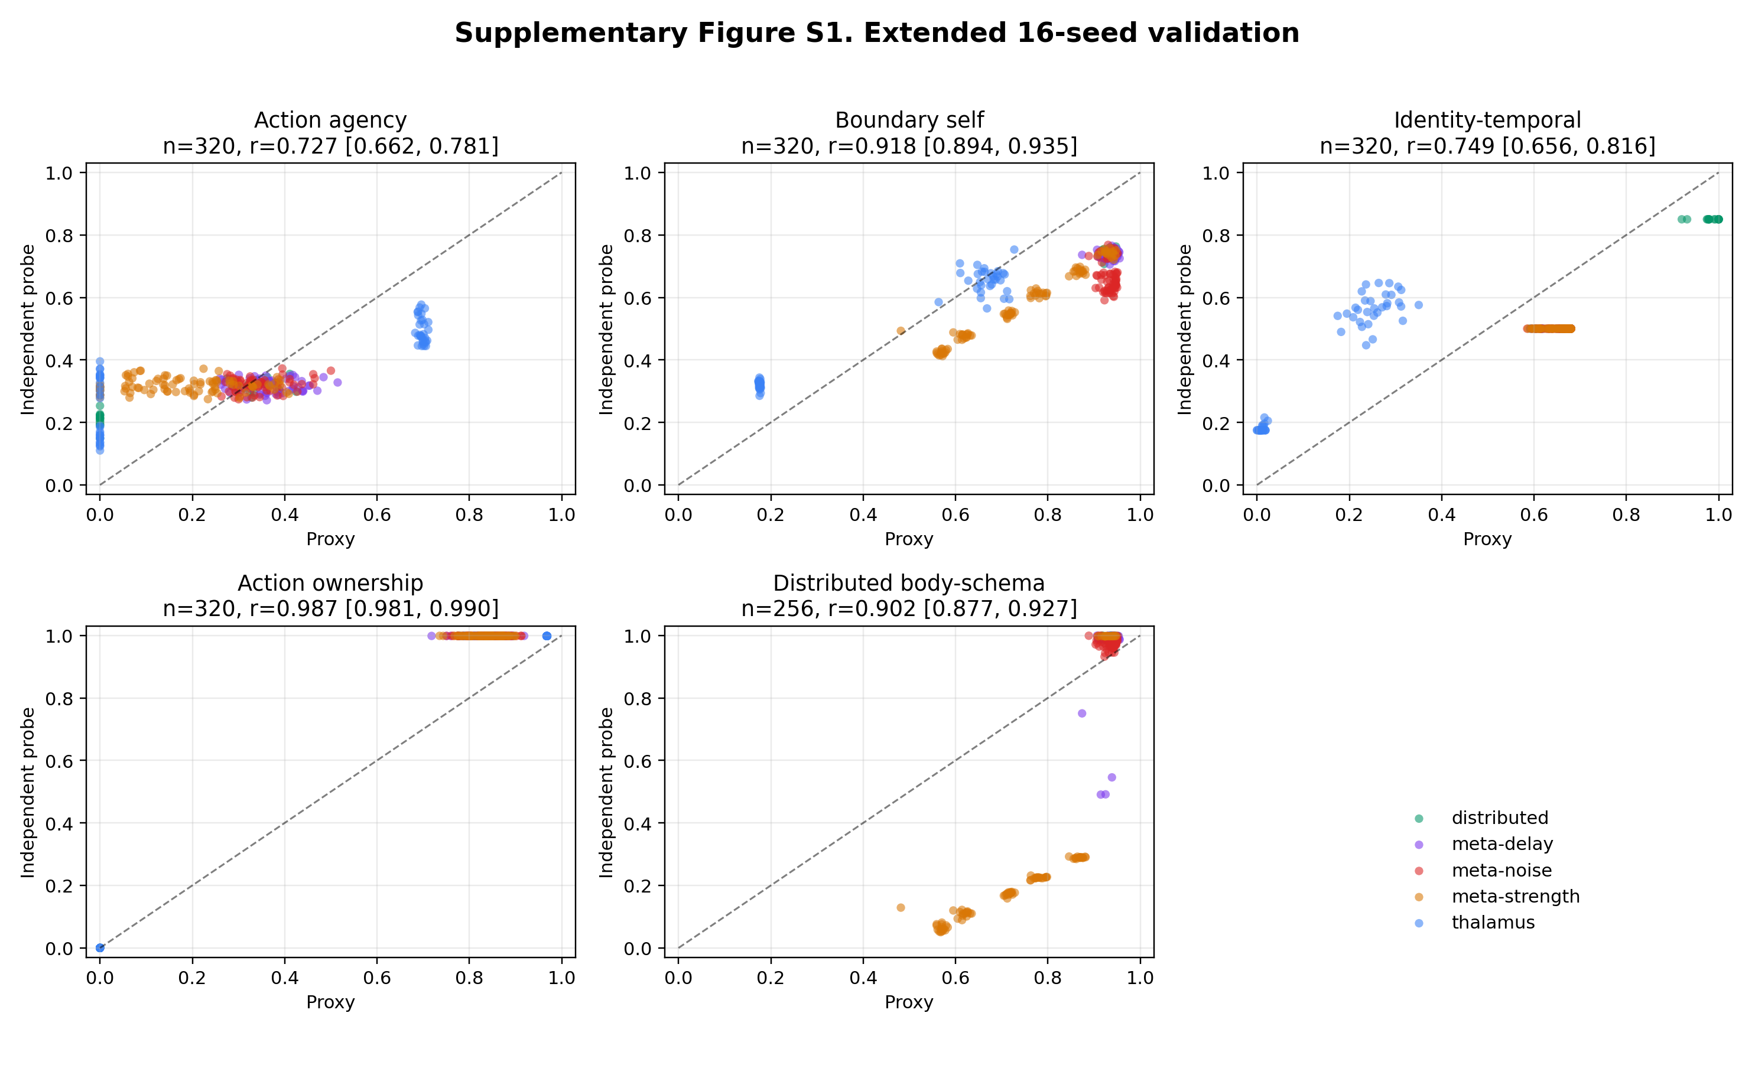
Supplementary Figure S1. Extended 16-seed validation.

S2. Transformer Extended Validation
We also repeated the Transformer-inspired 2x2 follow-up with 16 seeds per condition. The result reinforces the interpretation in the main manuscript: action-loop effects generalize to an attention-based substrate, while self-related validation in the Transformer implementation remains architecture-limited.
Construct | n | r [95% CI] | Interpretation
Action agency | 64 | 0.999826 [0.999734, 0.999907] | near-ceiling convergence
Boundary self | 64 | 0.489 [0.286, 0.674] | not validated
Identity-temporal self | 64 | 0.610 [0.444, 0.747] | exploratory
Action ownership | 64 | 0.999992 [0.999989, 0.999996] | near-ceiling convergence
The mechanism effects remained selective. Action-loop availability increased action agency (+0.8190, 95% CI [0.8182, 0.8198]) and action ownership (+0.8190, 95% CI [0.8182, 0.8197]). Workspace availability strongly increased the internal boundary-self proxy (+0.8357, 95% CI [0.8287, 0.8426]) but did not yield validated boundary-self convergence. Identity-temporal self also dropped into the exploratory range in this extended run. This supports a conservative conclusion: Transformer-like systems reproduce the action-loop mechanism pattern, but current self-related probes do not provide robust construct validation in this substrate.

S3. Workspace Capacity Sweeps
We ran workspace capacity sweeps in the thalamus-inspired and Transformer-inspired architectures. Each sweep tested capacities 0, 1, 2, 4, 8 with 16 seeds per capacity. The contrast between the two architectures clarifies the meaning of the Transformer measurement limitation.

S3.1 Thalamus Architecture
In the thalamus-inspired architecture, workspace capacity produced graded changes in workspace-linked measures. Proxy-independent convergence remained strong for both boundary self and identity-temporal self:
Diagnostic | n | Pearson r [95% CI] | Spearman rho
capacity vs boundary proxy | 80 | 0.668 [0.588, 0.737] | 0.826
capacity vs boundary independent | 80 | 0.391 [0.222, 0.535] | 0.343
capacity vs identity proxy | 80 | 0.417 [0.262, 0.543] | 0.271
capacity vs identity independent | 80 | 0.508 [0.395, 0.608] | 0.442
boundary proxy vs independent | 80 | 0.838 [0.722, 0.910] | 0.325
identity proxy vs independent | 80 | 0.982 [0.965, 0.992] | 0.629

S3.2 Transformer Architecture
In the Transformer-inspired architecture, workspace capacity affected the internal boundary proxy but did not rescue independent boundary validation:
Diagnostic | n | Pearson r [95% CI] | Spearman rho
capacity vs boundary proxy | 80 | 0.494 [0.371, 0.596] | 0.203
capacity vs generic boundary probe | 80 | -0.257 [-0.463, -0.034] | -0.078
capacity vs hard attention boundary | 80 | 0.184 [-0.039, 0.386] | 0.251
proxy vs generic boundary | 80 | 0.404 [0.208, 0.578] | 0.483
proxy vs hard attention boundary | 80 | 0.252 [0.077, 0.435] | 0.360
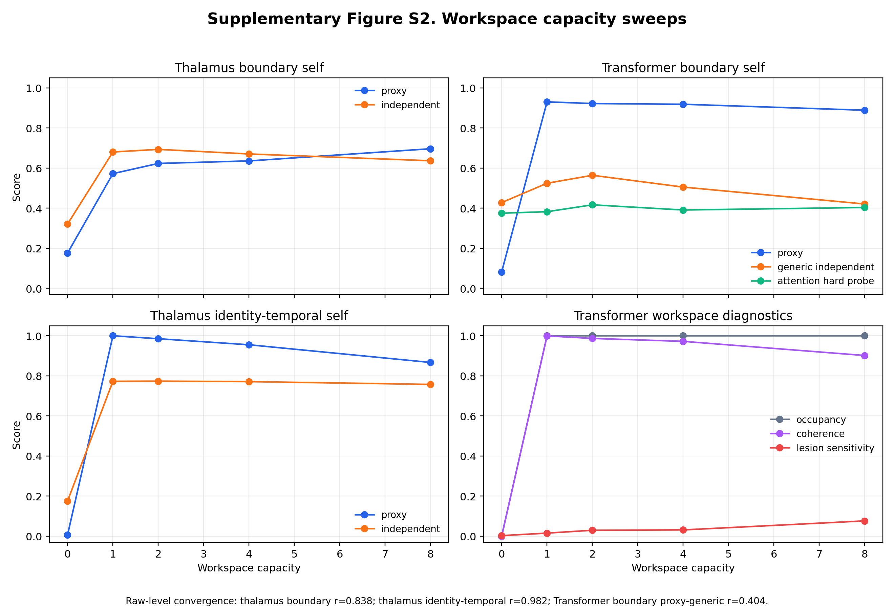
Supplementary Figure S2. Workspace capacity sweeps.

S3.3 Architecture-Conditioned Interpretation
The capacity sweeps show that workspace capacity is not sufficient, by itself, to establish boundary-self validity in every architecture. In the thalamus-inspired architecture, capacity-linked proxy changes corresponded to strong proxy-independent convergence. In the Transformer-inspired architecture, capacity changed internal workspace diagnostics but did not produce validated boundary-maintenance behavior. This pattern supports the main manuscript’s architecture-conditioned interpretation: mechanisms may generalize while construct validity remains architecture dependent.

S4. Data Availability
Supplementary statistics and run metadata are stored in docs/paper/statistics/supplementary_20260522/. Supplementary figures are stored in docs/paper/figures/supplementary_20260522/.
The source run directories are:
- runs/benchmark_online_supplementary/online_20260522_173251/
- runs/supplementary/transformer_validation_20260522_173251/
- runs/supplementary/transformer_workspace_capacity_20260522_173251/
- runs/supplementary/thalamus_workspace_capacity_20260522_173251/
These supplementary runs are not used to overwrite the frozen primary manuscript statistics.

