
UCD School of Electrical and Electronic Engineering
EEEN40280
Digital and Embedded Systems
System on Chip Design Report
Name: Fintan Gilman Student Number: 21468396
Working with: Polo Biju Student Number: 18312753
Working with: Daniel Burov Student Number: 20322326
Date: 03 May 2026 Brightspace Group Number: SoC 10

______________________________________________________________________
By submitting this report through Brightspace, I certify that ALL of the following are true:
- I have read the Student Guide to the UCD Student Plagiarism Policy. (The full policy document is available on Brightspace). I understand the definition of plagiarism and the consequences of plagiarism.
- I recognise that any work that has been plagiarised (in whole or in part) may be subject to penalties, as outlined in the documents above. That includes work that is the result of collaboration, where that is not acknowledged.
- I have not plagiarised any part of this report. The work described was done by the people named above, and this report is all my own original work, except where otherwise acknowledged in the report.
______________________________________________________________________

Introduction
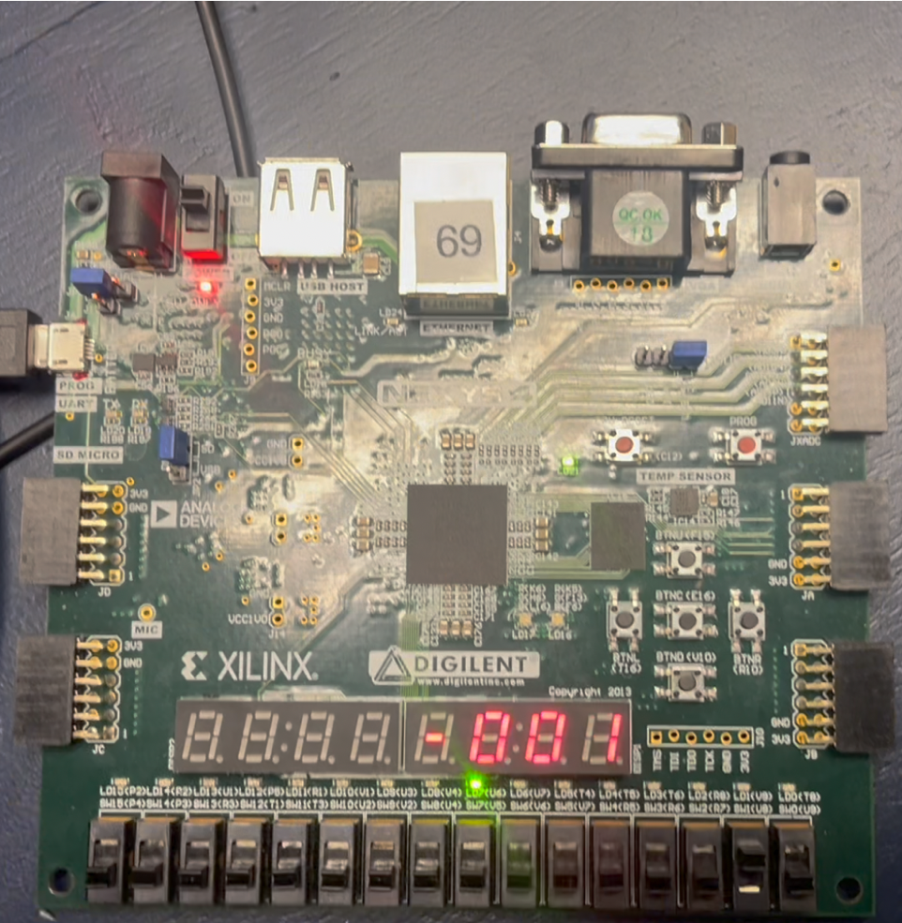
Figure 1: Final Setup of SoC Interacting with Accelerometer in Y mode
In this assignment we were asked to design and implement a system on a chip (SoC) using a Cortex M0 processor provided by ARM. Hardware was first designed with Verilog and then software would then be wrote on top to interact with and display the accelerometer data for the user to read.
The final designed set up can be shown in Fig. 1. Four modes were implemented which could be navigated using the 4 LSB (rightmost) switches in a one hot encoded manner. The four modes implemented were:
- X axis mode: Measure and display acceleration along the X axis of the device.
- Y axis mode: Measure and display acceleration along the Y axis of the device.
- Z axis mode: Measure and display acceleration along the Z axis of the device.
- XY axis mode: Measure and display acceleration along both the X and Y axis. Display X axis on the left four seven-segment units and the Y axis on the right four.
The accelerometer data is displayed in two formats for the user. First on the display numerically for the user to read in units of mg (i.e. g=9.81m/s² denotes the gravitational acceleration on Earth’s surface thus 1mg=0.00981m/s²). The range of the accelerometer display was limited to ±999mg to fit on half the seven-segment display without overflowing.
This range could easily be extended to go up to ±8g if the user wanted more resolution however for us, we adopted ±999mg simply to accommodate the dual XY mode without running out of display digits. It could have been done to allow more resolution for the single axis modes and then go to the 999mg limit for the dual axis mode but for implementation simplicity and homogeny we decided keep them all in this limit.

Furthermore, unless the board is shaken, the g’s experienced should be no more than that caused by the Earths gravitational pull hence 1g which is approximately 999mg which can be used to measure the board tilt. The minus/plus shown on the display indicates the direction of the acceleration experienced in the mode’s direction.

The second method of conveying the information to the user was with the 16 green LED’s shown between the seven-segment display and the switches. In essence this acted as a bubble level commonly seen in construction sites. At any one time only one green LED would be on indicating where in the range the accelerometer is measuring. Hence why we see the middle green LED on in Fig. 1 since the accelerometer is currently reading -001mg which is the middle of the range. If the accelerometer instead read +999mg we would see the left most LED turn on. Likewise, if it instead read -999mg we would see the right most LED turned on etc.
Fintan Gilman did the accelerometer and SPI software. Polo Biju did the display and main loop software work. Daniel Burov did the Verilog SPI for the hardware.

How To Use
- First, you must synthesis, implement and generate the bitstream to the board using Vivado to configure the hardware using DemoSystem.xpr in the ‘Hardware’ folder.
- Next you must build and flash the software using uKeil vision 4 using DES_M0_SoC.uvproj in the ‘Software’ folder.
- Then you must press the reset CPU button and open Realterm to write the ROMcode.txt file to the board.
- Finally with the board set up you use the switches to change modes. You can switch modes using the switches in a one hot encoded manner like:

Switch Positions | Mode
0000 0000 0000 0001 | X Axis Mode
0000 0000 0000 0010 | Y Axis Mode
0000 0000 0000 0100 | Z Axis Mode
0000 0000 0000 1000 | XY Axis Mode
otherwise | X Axis Mode
Table 1: Switch Positions to Enter Each Mode

Design Process
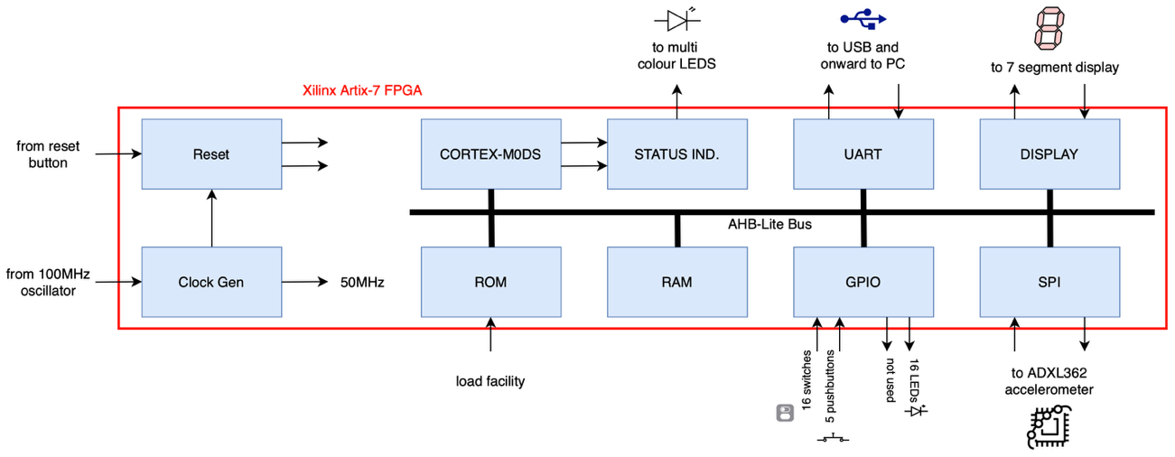
Figure 2: Block Diagram of Hardware
Shown in Fig.2 is a block diagram which is an extension of the one provided in the brief with the addition of the ‘DISPLAY’ and ‘SPI’ blocks. The display block was provided by default in the project however it was not instantiated. Likewise, the UART and GPIO blocks were not provided by default but not instantiated. Therefore, these blocks had to be instantiated and wired up accordingly. To do this the RAM and ROM blocks were viewed and used as inspiration.

Display Hardware Block (AHBdisp.v)
To add the display, block the segments and digit pins in the constraint files had to be uncommented out such that the digit and segment pins can be connected from the AHBliteTop.v module to the AHBdisp.v module. The AHBdisp.v module was then connected similar to how the ROM and RAM were connected.

SPI Hardware Block (AHBspi.v)
The SPI block however had to be implemented from scratch. Upon viewing the datasheet for the ADXL362 accelerometer it was found that the mode 0 SPI was needed where CPOL=0 and CPHA=0. This meant data is sampled on a rising SCK and data is shifted out on a falling SCK.
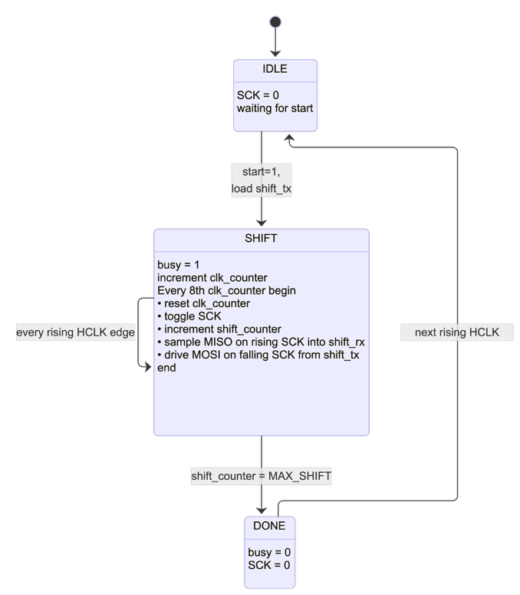
Figure 3: SPI Block State Machine
The SPI block was implemented as a state machine shown like that shown in Fig.3. There are 3 different states that the SPI block can be in:
- IDLE:
  - When the SPI block is idling SCK is kept low.
  - The SPI block will only leave this state when given the start signal.
  - When the start signal is received:
    - shift_tx is then loaded from the HWDATA[7:0] line for data to shift to the ADXL362.
    - Go to SHIFT state.
- SHIFT:
  - After being indicated to start a busy bit flag is then raised.
  - For every rising HCLK a reg named clk_counter is incremented so that we can divide the 50MHz HCLK by 16 to get a 3.125MHz SCK so the accelerometer can work (datasheet says ADXL362 SPI needs to be between 1MHz and 8MHz for).
  - For every 8th HCLK:
    - SCK is then toggled.
    - If SCK is rising, we shift aclMISO into the shift_rx reg to sample the data.
    - If SCK is falling, we shift the shift_tx left by one. aclMOSI wire is set to be equal to the MSB of shift_tx. This way we shift out shift_tx to the ADXL362.
    - All SCK edges are tracked with a shift_counter reg and so shift_counter is incremented.
  - After shift_counter is 16 to indicate 8 rx samples in and 8 tx shift outs (1 byte in and 1 byte out) go to DONE state.
- DONE:
  - Since receival/transmission is done lower busy flag.
  - Put the SCK low to indicate end of transaction.
  - Go to IDLE state.
To indicate to the SPI block which SPI slave we want to interact with we have to set the chip select for the slave low. Since our SPI only interacts with one slave (i.e. the ADXL362) we connect a chip select reg to aclSSn.
To allow the software to be able to interact with the ADXL362 we must set up registers so that we can allow:
- Writing to:
  - Chip select register to select/deselect the ADXL362 slave.
  - Start register to indicate for a transaction to start (to indicate when we want to go from IDLE to SHIFT state).
- Reading from:
  - shift_rx register to see the received transaction from the ADXL362 at the end of a transaction.
  - Chip select register to see if the ADXL362 is selected/deselected.
  - Busy bit flag to see if a transaction is ongoing/ended. To check if we are still in the SHIFT state.

Display Software Block (display.c)
As previously mentioned, there was two methods that we used to convey and display information to the user. Using the numerical display with the DISPLAY block and then with e 16 LEDs using the GPIO block.

The LED display was done using a function called display_accel(int16 y) were y was the value read from the ADXL362. Shown below is this function. The operation of the function is such to map the ±1000mg range to a index between 0 and 15. This index would then be used to shift a one to said index in the GPIO_LED byte to control which LED was to be turned on.

void display_accel(int16 y) {
int pos;
if (y > 1000) y = 1000; // clamp
if (y < -1000) y = -1000;
pos = (y + 1000) * 15 / 2000; // map -1000..+1000 to 0..15
GPIO_LED = (uint16)(1 << pos); // light one LED at that position
}

A second function called display_mg(int16 val, int is_left_value, int dual_mode) was used to write to the seven-segment display. dual_mode decided whether to use all the display or only the right most 4 digits for XY axis mode. val indicated the value returned from the ADXL362 to be written. is_left_value was used to offset the array where the values were being wrote to so that the value would be wrote to array indices that correspond to the left half of the display. DISP_MODE, DISP_ENABLE and DIAP_DIG are the registers used in the DISPLAY block.

void display_mg(int16 val, int is_left_value, int dual_mode) {
uint8 negative;
int offset;
// Set all 8 digits to hex mode, enable only digits 0-3
DISP_MODE = 0xFF; // hex mode on all digits
DISP_ENABLE = dual_mode ? 0xFF : 0x0F; // enable rightmost 8/4 digits led

if (val > 999) val = 999; // Clamp to 999 to prevent display overflowing
if (val < -999) val = -999;

negative = 0;
if (val < 0) {
negative = 1;
val = -val; // work with positive value
}

offset = is_left_value ? 4 : 0; // offset by 4 if writing to left side

// Write digits right to left (digit 0 = rightmost)
DISP_DIG(0+offset) = val % 10; val /= 10;
DISP_DIG(1+offset) = val % 10; val /= 10;
DISP_DIG(2+offset) = val % 10; val /= 10;

// digit 3: minus sign if negative, blank otherwise
DISP_DIG(3+offset) = negative ? 0x11 : 0x1F; // 0x11 = dash, 0x1F = blank
}

SPI Software Block (spi.c)
The SPI software block was relatively simply to implement since we just had to interact with the exposed registers from AHBspi.v. This led to two functions. SPIselect(int select) which was used to control whether the accelerometer chip select was 0 or 1.
SPIbyte(uint8 send) was used to send and receive bytes to and from the ADXL362. A byte would first be sent for the SPI block to transmit. The function would then wait for the busy bit to clear. Any received information would then be returned.
When sending a command to the ADXL362 the returned data would be discarded since it would be useless. Then when receiving a byte from the ADXL362, a null byte would be transmitted uselessly as the send argument, and the received byte would be returned from a previous command sent.
void SPIselect(int select)
{
SPI_CS = select; // select the SPI device
}

uint8 SPIbyte(uint8 send) {
SPI_DATA = send; // writing triggers the transfer
while (SPI_STATUS & 1); // wait until busy bit clears
return SPI_DATA; // return received byte
}

Accelerometer Software Block (accel.c)
The accelerometer software block was made to use the spi.c functions to make predefined sequences of commands to interacting with the accelerometer easier. To understand how to interact with the accelerometer better we can recall the following excerpt from the datasheet to understand how to read/write to the accelerometer:
“The command structure for the read register and write register
commands is as follows (see Figure 36 and Figure 37):
</CS down> <command byte (0x0A or 0x0B)> <address byte>
<data byte> <additional data bytes for multi-byte> …
</CS up>

The read and write register commands support multibyte
(burst) read/write access…”
Where 0x0A is the write command and 0x0B is the read command. Thus, using the spi.c commands four functions were made in accel.c to simplify accelerometer interaction.
uint8 accel_read_reg(uint8 reg_addr);
void accel_write_reg(uint8 reg_addr, uint8 value);
void accel_setup(void);
int16 accel_read(uint8 axis_reg);

accel_read_reg(uint8 reg_addr) was used to read a register value on the ADXL362. Shown below is the function and its implementation. We can observe that the spi.c commands make it incredibly easy to follow the datasheets instructions for interacting with the accelerometer.

uint8 accel_read_reg(uint8 reg_addr)
{
uint8 data;
SPIselect(0); // select the accelerometer
SPIbyte(READ_COMMAND); // send the read command
SPIbyte(reg_addr); // register to read
data = SPIbyte(NULL_BYTE); // send null just to recieve data
SPIselect(1);

return data;
}

Similarly, accel_write_reg() was used to write a given value to a given register on the accelerometer. accel_setup() was used to write the setup instructions to the appropriate setup registers. accel_read() was used to burst read the accelerometer values. Since the function implementations are so similar to the accel_read_reg() function show above these functions exact implementation will be omitted from the report.

Main Software Block (main.c)
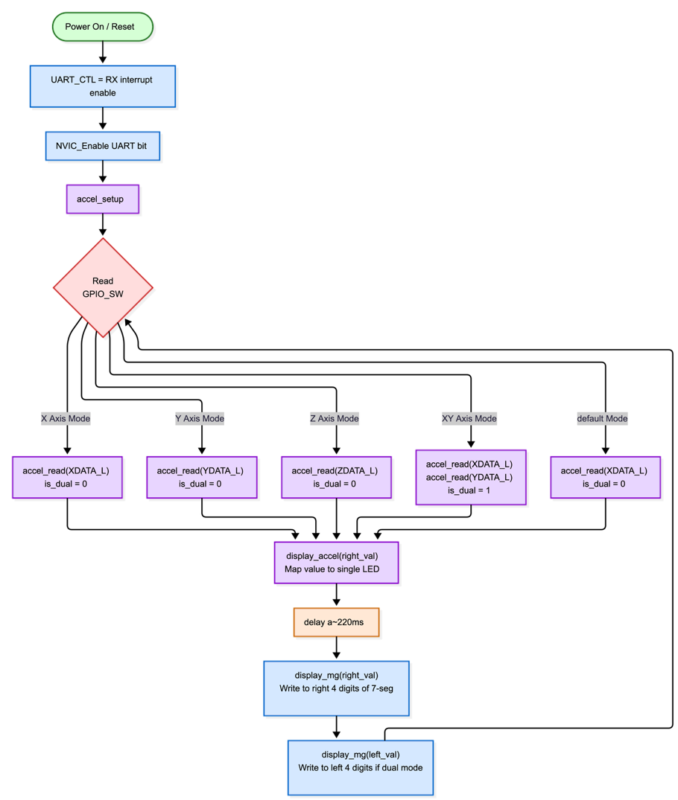
Figure 4: Flow Diagram for main.c
Shown above in figure 4 is a flow diagram showing how main.c works. The program first goes through an initialisation phase whereby all the setup that is needed is first done. Then the program goes into the main program loop.

The main program loop consists of reading the GPIO switches, then determining what mode the switches correspond to. Once we know what mode the user wants, we can burst read the relevant registers. Once we have read the registers, we can then display the values. First the values are mapped to a single LED to get the bubble level working.

Then a 220ms delay is done to prevent the update speed from being too quick for the user. The values read form the registers are then displayed on the left and right sides of the seven-segment display appropriately.

The loop then restarts where we read the switch values again to determine which mode the user has selected again.

Testing
A brief description of the tests you performed, to verify that your system works as intended. One part of that is checking that your SPI master (hardware or software) obeys the rules for SPI and for communicating with the accelerometer. That could be shown using signals captured on an oscilloscope. Another part is checking that the values of acceleration being displayed are correct, at least within the accuracy of the accelerometer.
For hardware blocks that you designed, include example timing diagrams from simulation – maybe one showing some AHB transactions and one at a different scale showing a SPI transaction. You may also include results captured on an oscilloscope.

Conclusion
In conclusion we have implemented a SoC using a ARM Cortex M0 DS processor. Existing GPIO and UART modules which were provided were integrated successfully into the SoC during part 1 of the lab. Additionally, a display module which was also provided was extended onto the SoC to allow the SoC to interact with and display digits onto the integrated seven-segment display on the FPGA unit board.
An SPI module was designed as a state machine with IDLE, SHIFT and DONE state. This SPI module was then implemented in Verilog to enable the SoC to interact with SPI devices. The SPI module was then configured to interact with the ADXL362 accelerometer by setting the chip select low during transactions. Registers were then exposed to allow software interaction with the SPI module.
Software was then written to interact with the SPI module via the exposed registers. These SPI software functions were then adapted into four functions as predefined sequences to further abstract accelerometer software interaction, allowing easier reading and writing to registers on the accelerometer.
Information obtained from the accelerometer was then displayed to the user in two different formats, numerically on the seven-segment display in mg units and then as a bubble level where accelerometer values were mapped to a single LED on an LED strip. Interactions with the DISPLAY and GPIO blocks were then done in software using exposed registers and functions were made to abstract away interactions.
A main loop was then written that allowed the user to switch between four modes. X, Y and Z modes allowed accelerometer data from each respective axis to be displayed if the used wanted to look at different axes. An additional XY mode was implemented that allowed accelerometer data from both the X and Y axes simultaneously.
Modules were thoroughly tested with Verilog testbench simulations. A full integration test on the physical FPGA showed the setup then worked as intended. Video footage was captured cycling into each mode and screenshots were captured from the video before being embedded into this report to demonstrate the success of the full integration.
Overall, a simple SoC has been developed all tasks were successfully accomplished including the additional tasks which were required as a result of being part of a 3 person group.

