Read the text and underline all the examples of the verb to be.
I am a fourteen-year-old girl. I am tall and thin. My hair is brown, and my eyes are green. My family isn't small. There are six people in my family. I have two brothers and one sister. My sister is slim, and her eyes are blue. Her hair isn't blonde. It is dark brown. My younger brother is similar to me. His eyes are green, but his hair is red. He really loves sport. My youngest brother is still a baby. He is only two years old. My parents are tall and slim. My mum's hair is dark brown, and her eyes are blue. My father's hair is red, and his eyes are green. We are a happy family. We aren't lazy. We are active and healthy. I love playing football in my free time and so do my brother and sister. We hope to be football players in the future.

Read the statements about the text. Are they true or false? Write 'true' or 'false' on the lines.
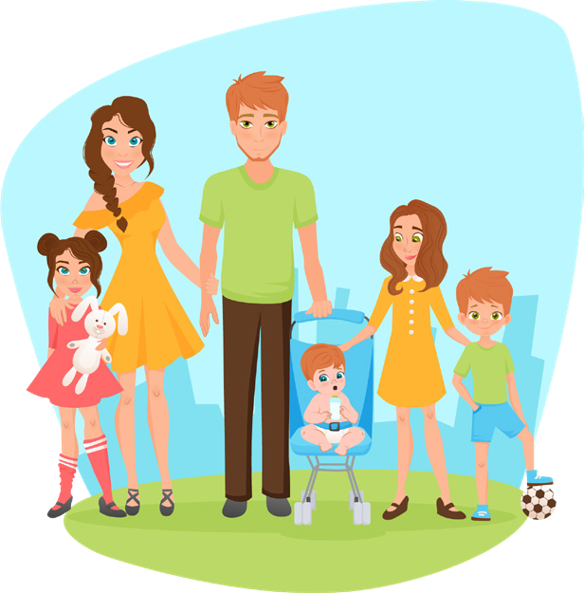
  - She is fifteen years old. ..............
  - There are five people in her family. ..............
  - Her sister is slim. ..............
  - Her brother enjoys sport. ..............
  - Her parents aren't tall. ..............
  - Her mum's hair is dark brown. ..............
  - They are a happy family. ..............
  - Her brother and sister are football players. ..............

Complete the sentences with the correct form of the verb to be.
  - My name ........... Kate. I ........... a student. My friends students too.
  - Max ........... (negative) from here. He from Mexico.
  - My mother's hair ........... long, but my hair short.
  - My father's eyes ........... (negative) blue. They brown.
  - My mum ........... (negative) a doctor. She a nurse.
  - My brother and I ........... in the school band, and we both on the football team.
  - My sister's likes her car because it ........... fast, but I don't like it because it pink.
  - My friends and I ........... (negative) old. We fourteen years old.
  - London ........... a very big city. The people there from all over the world.
  - My father ........... good at making things, but he (negative) good at cooking.

Complete the questions and answers with the correct form of the verb to be.

  - What ........... her name? 6. ........... you OK? No, I ...........
  - Where ........... you from? 7. ........... I right? No, you ...........
  - ........... he your father? Yes, he ........... 8. ........... we there yet? No, we ...........
  - ........... he rich. No, he ........... 9. ........... they students? Yes, they ...........
  - ........... you English? Yes, I ........... 10. ........... she a teacher? Yes, she ...........

Rewrite the sentences, correcting the verb to be errors.

  - We is students. ...................................................................
  - They isn't lazy. They is active. ...................................................................
  - He are smart. ...................................................................
  - We is excited about the holiday. ...................................................................
  - I aren't a doctor. ...................................................................
  - My hair are blonde. ...................................................................
  - This shirt are blue. ...................................................................
  - I aren't tired. ...................................................................
  - You is a dancer. ...................................................................
  - I are 20 years old. ...................................................................

Use the singular and plural forms of the verb to be to make two sentences about each topic.

Example: Your mother
...............M..y...m..o..t.h..e.r...i.s..a...g.o..o..d..c..o.o..k.....H..e.r..c..a..k.e..s..a..r.e...d..e.l.i.c.i.o..u..s...............................................

- Your town or city

..................................................................................................................................

- Your favourite hobby

..................................................................................................................................

- Your friends

..................................................................................................................................

