

**FW upgrade for BLE-IOT-GEVB**

**Manual**

**www.onsemi.com**

This manual provides steps on how to upgrade FW sitting on BLE-IOT-GEVB. New FW binary is fully compatible with IDK software shared at [www.onsemi.com/idk](http://www.onsemi.com/idk) and mobile app ON Semiconductor released.

**Procedure:**

1. Make sure you are using BLE shield with pn# BLE-IOT-GEVB. Remember current jumper configuration on BLE-IOT-GEVB. This should be compatible per picture below.

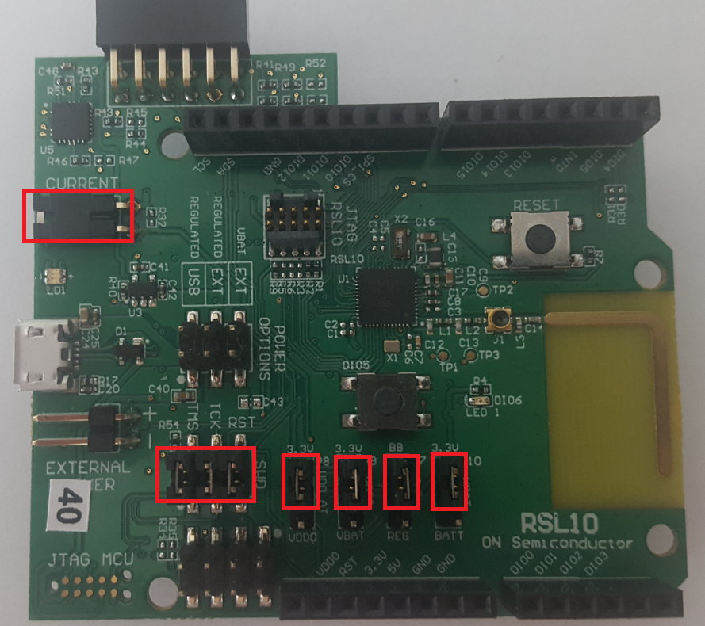

1. Set jumpers as on image below:

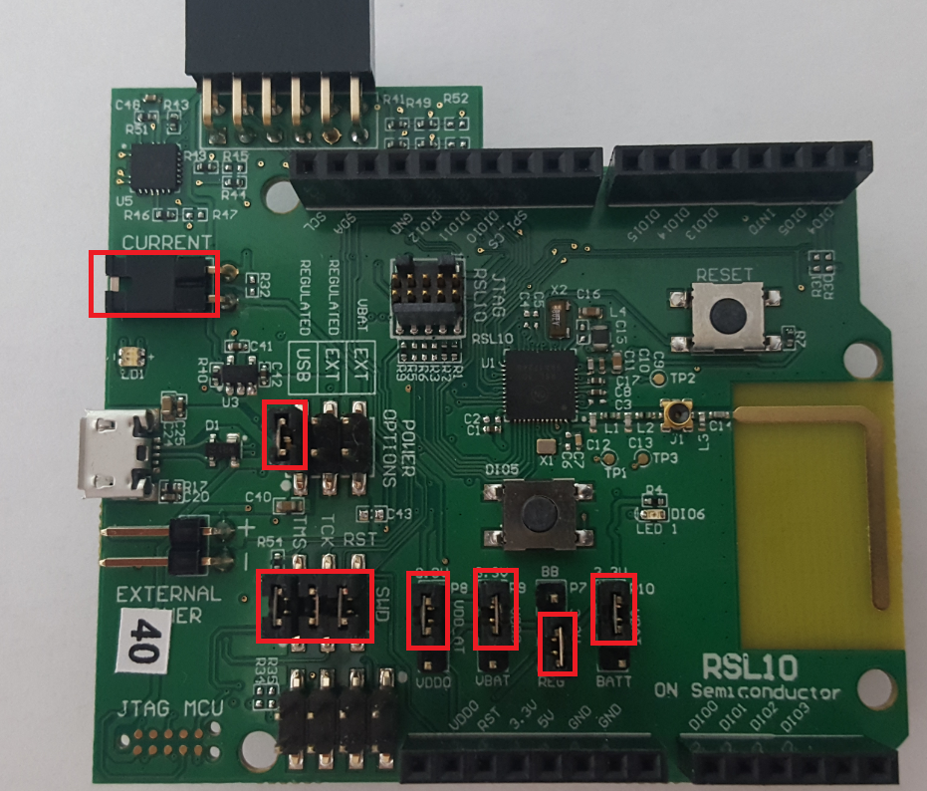

1. Connect board to PC with micro USB cable.
2. Unpack the **RSL10_StandAlone_Flash_Loader.zip** and run **FlashLoader.exe** (This is the same flash loader that can be downloaded within SDK of RSL10 [here](http://www.onsemi.com/PowerSolutions/supportDoc.do?type=software&rpn=RSL10) ).
3. Use Browse button to select the attached **BB_BLE_Terminal.hex** file. Check Erase and Verify and hit Program button. Then done once flashing is finished.

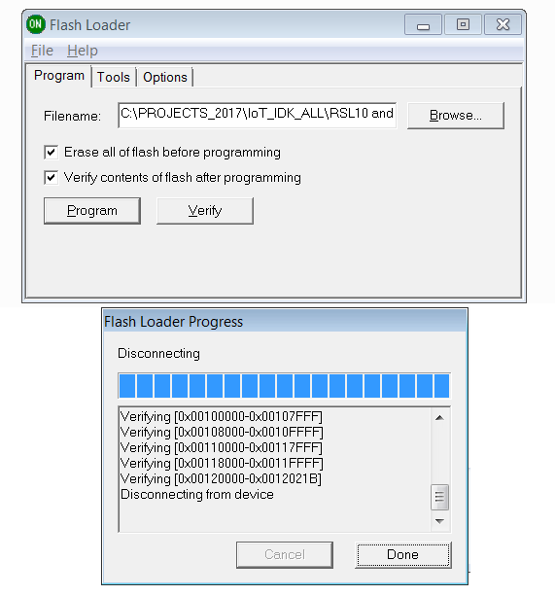

1. Restore jumper configuration from step 1 and use the shield.