Climate change shape the deep-time assembly of biological diversity
2026-10-13
Abstract
Often restricted by the availability of historical data, studies of biodiversity assembly largely focus on contemporary environmental conditions and short-term biodiversity surveys. Newly available paleoclimatic reconstructions combined with georeferenced and dated fossil records offer the opportunity to examine how deep-time climate change has shaped the assembly of regional biodiversity. Here, using spatially explicit paleoclimatic reconstructions and large-mammal fossil records from North America and Europe, we evaluate the relative effects of mean temperature, the rate and direction of climate change, and climatic instability on the replacement of large-mammal taxa through time and across trophic levels. Over approximately 20 million years of the Neogene, turnover between fossil assemblages increased with temporal separation, reaching complete genus-level replacement over temporal distances of approximately 10 Myr. Among climatic predictors, mean temperature showed the strongest and most consistent association with faunal differentiation across continents and trophic groups. Turnover was lowest among fossil assemblages associated with intermediate mean temperatures (8–10°C in North America and 10–14°C in Europe), whereas fossil assemblages associated with warmer or cooler conditions showed greater turnover. For temperature-change rates, turnover was greatest among North American assemblages associated with cooling rates between approximately −1 and 0°C/Myr, whereas European assemblages showed weaker responses to the rate and direction of temperature change. In contrast, climatic instability had comparatively limited effects, with differentiation occurring primarily between stable and unstable climatic conditions rather than increasing progressively with greater instability. Comparable climatic responses in herbivores and carnivores suggest that climate-associated faunal reorganization extends across trophic levels, consistent with climatic effects propagating from changes in vegetation and habitat to prey availability and higher trophic levels. Our results show that multimillion year climate changes across the Neogene contributed to the long-term reorganization of mammalian assemblages against a strong background of gradual temporal faunal replacement. Deep-time records therefore provide an important context for understanding biodiversity reorganization under contemporary climate change.

INTRODUCTION
Present-day biodiversity reflects the cumulative effects of speciation, extinction, dispersal, and ecological turnover acting under changing climatic conditions through geological time. Because contemporary biodiversity patterns emerge from these contingent dynamics, they cannot be fully understood without their underlying historical processes (Fritz et al., 2016a; Jackson & Erwin, 2006; Jackson & Johnson, 2000). The formation of present-day global zoogeographic regions, for example, is often attributed to plate tectonics movement and historical climate, which together structured long-term barriers and opportunities for dispersal (Holt et al., 2013; Mazel et al., 2017). Yet, linking climatic change to the assembly and reorganization of regional biodiversity through time has remained difficult because historical biological and climatic data are sparse and rarely aligned across space and time.
Over deep time, the fossil record provides empirical evidence to reconstruct long-term biodiversity responses to past climatic change (DiMichele et al., 2004; Erwin, 2009). Integrating fossil and paleoclimatic data allows researchers to model statistical associations between climatic change and the long-term reorganization of regional assemblages in pre-anthropogenic ecosystems (Blanco et al., 2021; Jablonski & Shubin, 2015; Mottl et al., 2021). The growing availability of spatially resolved fossil occurrence and paleoclimatic datasets now makes it possible to examine how prehistoric climate change shaped the long-term reorganization of regional fossil assemblage assemblages (Briega-Álvarez et al., 2023; Kocsis et al., 2021). These deep-time relationships provide important historical context for understanding historical processes shaping biodiversity amidst global climate change (Blanco et al., 2021; Jablonski & Shubin, 2015; Mottl et al., 2021).
During the Neogene (23–2 Ma), Earth’s climate shifted from relatively warm toward increasingly cool conditions, culminating in the Northern Hemisphere glaciation around 2–3 Ma (Kennett, 1995). In the northern hemispheres, this global cooling trend over deep time contributed to the expansion of modern temperate biomes (J. C. Zachos et al., 2001; J. C. Zachos et al., 2008). It also coincided with the diversification and geographic expansion of many modern plant and mammal lineages, contributing to the establishment of contemporary terrestrial ecosystems (Ding et al., 2025; Fortelius et al., 2014; Steinthorsdottir, Coxall, Boer, Huber, Barbolini, Bradshaw, Burls, et al., 2021), as well as the extinction of taxa that were previously widespread during the Paleogene (66Ma – 23 Ma) (Costeur et al., 2004). However, within this overall Neogene global cooling trend, some regions experienced warming or stronger cooling than others. Also, climatic conditions did fluctuate through geological periods within the same geographic region. Therefore, deep-time climate change dynamics may be characterized along these multiple aspects (Figure 1): the change direction, indicating whether conditions became warmer or cooler through time; the change rate, describing how rapidly climate changed; and the instability of change, describing how strongly climate patterns fluctuated around the overall deep time trajectory (Blois & Hadly, 2009; Dynesius & Jansson, 2000; Song et al., 2021; J. C. Zachos et al., 2001). However, the relative effects of these dimensions on the long-term turnover of fossil assemblage composition across stratigraphic layers remain poorly understood.
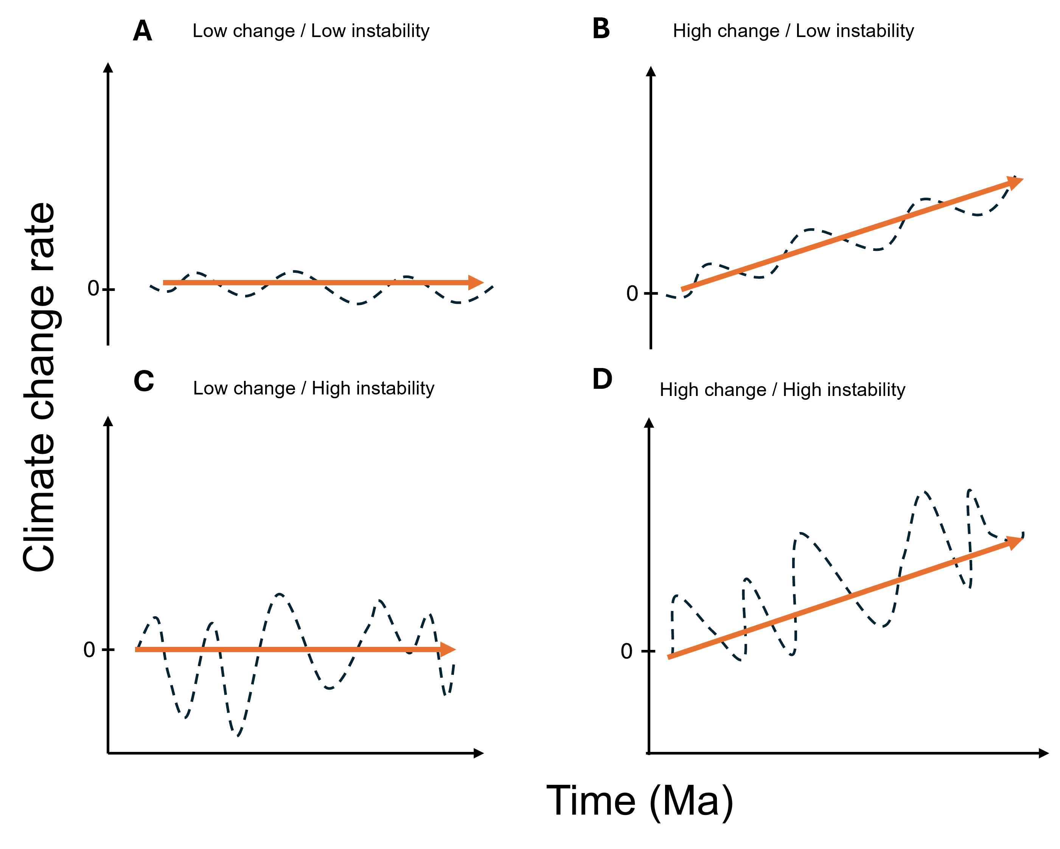
Figure 1: Conceptual representation of the rate and instability of climatic change. Orange arrows represent the direction and magnitude of the long-term temperature-change rate, while dashed lines illustrate variation in temperature through time. Climatic instability represents variation in temperature-change rates through time, quantified as the standard deviation of rates within a moving temporal window. The four panels illustrate combinations of (A) low rate and low instability, (B) high rate and low instability, (C) low rate and high instability, and (D) high rate and high instability. Thus, climatic trajectories with similar long-term rates can differ substantially in instability depending on the variability of temperature-change rates through time.
Here, we link fossil record data for large-mammals in North America and Europe with corresponding paleoclimatic reconstructions to ask how the direction, rate, and instability of climate change are related to the taxonomic turnover of regional fossil assemblages throughout the Neogene (Figure 1). We expect fossil assemblage turnover to increase with greater departures from the past mean temperature states, reflecting long-term climatic filtering of mammalian distributions and habitats (Badgley et al., 2014; Song et al., 2021). We also expect fossil turnover to increase with higher rates of climate change, as rapid climatic shifts may exceed the capacity of species or lineages to track or adapt to changing environmental conditions (Dam et al., 2006; Dynesius & Jansson, 2000; Song et al., 2021). Rapid cooling or aridification, for example, may trigger the decline of forest-associated taxa and the expansion of lineages associated with grasslands and open environments. We also expect greater turnover under increasing climatic instability, as repeated climatic shifts can repeatedly reorganize suitable habitats and mammal distributions, promoting regional fossil replacement (Dam et al., 2006). Beyond climate, we expect a background rate of fossil replacement through time as extinction, origination, dispersal, and other ecological and evolutionary processes continually reshape regional assemblages. Geographic separation should further increase this differentiation as faunas follow increasingly independent biogeographic trajectories. Finally, we test whether these relationships are consistent between Europe and North America and across trophic guilds.

METHODS

Data

Fossil data
We used mammal fossil records extracted from the NOW fossil database (The NOW Community, 2020). Our queried subset of the database contained 18349 species level fossil records spanning six (6) mammal orders: Artiodactyla (40%), Carnivora (26%), Perissodactylia (24%), Primates (1.5%), and Proboscidea (8.6%). We assigned each fossil mammal record to a trophic guild and trophic role based on its taxonomic order. Orders dominated by plant-eating species (Proboscidea, Perissodactyla, and Artiodactyla) were classified as herbivores and primary consumers. Primates were classified as omnivores occupying intermediate trophic roles, and Carnivora were classified as carnivores occupying higher trophic levels. These trophic assignments were added to the fossil dataset by matching each record’s taxonomic order to a reference classification table, while retaining all fossil observations. We excluded records a) georeferenced outside the North America and Europe continents, and b) where the genus and/or family was classified as indeterminate (“indet.”) We ended with a total of 13986 species level fossil records (Table S1).
We aggregated species level fossil records to their genus taxonomic level to reduce biases in sampling completeness across sites (Alba et al., 2001; Fritz et al., 2016a; Madern & Hoek Ostende, 2015). obtaining a total of unique 13013 genus-level fossil space-time observations. We aggregated these genus-level records into fossil assemblages using the paleoverse package in R (Jones et al., 2023). We used a hexagonal equal-area global grid (Uber’s Hexagonal Hierarchical Spatial Index) (Brodsky, 2018) (Figure S1) to create spatial bins defined at H3 resolution, equivalent to ~103.6 km between adjacent cell centroids (Figure S2). Fossils were time-averaged to 1 Myr time bins using the rounded midpoint between their minimum and maximum fossil age estimates (Figure S3). Each fossil assemblage was therefore defined as the list of unique genera occurring within a hexagonal cell and time bin. We excluded fossil assemblages with fewer than three genera. This produced a Neogene fossil assemblage dataset comprised of 456 genera from 1,599 localities in Europe and 312 genera from 509 localities in North America (Figure 3A). Herbivores represented the largest component in both continents, with 279 genera in Europe and 185 in North America, followed by carnivores with 157 and 127 genera, respectively. Omnivores were comparatively rare, with 20 genera recorded in Europe and none in the North American dataset.

Paleo-atmospheric temperature data
We used published reconstructions of near-surface air temperatures for the Cenozoic (60 Ma to present) at 1 Myr temporal resolution (Hagen et al., 2019) to characterize climate change during the Neogene. Hagen’s paleoclimatic reconstructions integrate paleotopographic models from Scotese’s PaleoAtlas (Scotese & Wright, 2018) with lithological and fossil-based climate proxies, including coal, evaporites, bauxites, tillites, and high-latitude occurrences of palms and mangroves (Boucot et al., 2013). Paleoclimatic structure was reconstructed by projecting modern Köppen climatic zones onto paleogeographic maps at 5-Myr intervals and assigning zone-specific mean annual temperatures adjusted to match Cenozoic global temperature trends (Royer et al., 2004). Temperature lapse rates are derived from modern elevation and WorldClim2 data (Fick & Hijmans, 2017) and were applied to paleotopographic reconstructions to generate gridded, topography-corrected temperature surfaces for each Myr time intervals. Full methods to replicate the paleo atmospheric reconstruction are found in (Hagen et al., 2019). From Hagen’s Cenozoic paleoclimatic reconstruction dataset, we extracted the subset corresponding to the temporal span of our fossil data (23–2 Ma) and generated a temperature raster stack for North America and Europe.
Using the paleo-atmospheric temperature raster stack, we modeled each fossil assemblage grid cell’s climate change history with a spline-based smoother (Hastie, 1992; Wood, 2017). The atmospheric temperature stack was converted to a location-by-time matrix in which rows represent the centroid of spatial grid cells and columns represent 1Myr time steps. Then, we built a B-spline basis across the raster layers (time points 23–2 Ma) and fitted it independently per cell, with flexibility set by basis dimension (df = 6) and polynomial degree (degree = 3) (Wood, 2017). Fitted coefficients were estimated via ordinary least-squares for all cells simultaneously. With this procedure, we generated a raster stack with three climatic predictors 1) Mean annual temperature (Ŷ) was the GAM prediction at each cell and time slice. 2) Climate change magnitude (dY) was the first temporal derivative of the smoothed temperature mean (°C Myr⁻¹). 3) Climatic instability was the standard deviation of temperature change rates within a ±3 Ma moving window around each time step.

Statistical analyses

Estimating turnover among fossil assemblages
For each continent, we constructed an incidence matrix representing the presence (1) or absence (0) of a fossil genus in space and time. We quantified compositional turnover between fossil assemblages using Simpson dissimilarity (beta.sim), calculated with the beta.pair() function in the betapart R package (Baselga et al., 2013) (Figure S4). This measure emphasizes genus replacement by separating turnover from compositional differences associated with richness gradients (i.e., nestedness), providing a comparable measure of fossil turnover between Europe and North America despite site-level differences in genus richness. We then used non-metric multidimensional scaling (NMDS) based on the same Simpson dissimilarity matrices to visualize changes in assemblage composition through time and the degree of compositional overlap among Neogene time intervals.

Linking climate change to fossil assemblage turnover
We matched fossil assemblages to their local spatiotemporal climatic conditions (Ŷ, dY, instability) by intersecting their coordinates with 1-Myr-binned midpoint ages. We then modeled compositional fossil assemblage turnover with generalized dissimilarity models (GDMs) (M. Fitzpatrick et al., 2025) on pairwise genus-level dissimilarities between fossil assemblages. Geographic distance (km), temporal separation (Ma), and climatic predictors (Ŷ, dY, instability) were included as nonlinear I-spline gradients in the model (Ferrier & Guisan, 2006; M. C. Fitzpatrick et al., 2021). To control for differences in sampling intensity and richness across fossil assemblages (Figure S2), we used the minimum assemblage richness of fossil assemblage pairs as weights. Models were fitted separately for Europe/North America and all mammals/herbivores/carnivores. We assessed importance of climatic variables on fossil genus turnover using the I-spline heights, with continental/guild differences visually assessed via spline shape and magnitude (Figure S5).

Sensitivity analyses
We conducted sensitivity analyses to test whether inferred relationships between climate dynamics and fossil turnover are robust to assumptions of a) spatial resolution of fossil assemblages, b) climate-smoothing parameters, and c) geographic structuring of the gdm model. For a) spatial sensitivity was evaluated across H3 resolutions (h0–h3), corresponding to average inter-centroid distances of approximately 1,918 km, 725 km, 274 km, and 104 km, respectively (Figure S2). For b), alternative smoothed climate trajectories were reconstructed using alternative B-spline settings (df = 4–8; degree = 2–3). Finally, for c) gdm models were fitted with and without geographic distance between fossil assemblages as covariate.

RESULTS

Atmospheric temperature dynamics across the Neogene
Across the Neogene, mean atmospheric temperatures declined in North America and Europe (Figure 2A,D). North America experienced greater variation in Ŷ, dY and instability. In contrast, Europe experienced relative warmer and more stable atmospheric temperature means across the Neogene. For instance, while mean temperature decreased from ~10.3 °C to ~4.5 °C across all northern latitudes in the 20Ma interval. In North America, temperatures declined from ~9.2 °C to ~2.8 °C, whereas Europe from ~13.3 °C to ~10.6 °C (Figure 2A,D). Similarly, the rate of cooling was consistently stronger in North America than in Europe throughout the Neogene. In North America, mean cooling rates intensified from approximately −0.17 °C Myr⁻¹ at ~22 Ma to a pronounced minimum of about −0.5 °C Myr⁻¹ during the late Miocene (~8–7 Ma), before weakening rapidly toward the late Neogene (2 Ma). (Figure 2B,E). This interval of accelerated cooling coincided with elevated climatic instability, which increased through the middle to late Miocene (~7-2 Ma) (Figure 2C,F). In Europe, there is a steady decrease in the rate of cooling from (-0.3 °C Myr⁻¹ at ~22 Ma to ~0 °C Myr⁻¹ at ~2 Ma (Figure 2B,E). European temperature instability was consistently lower than in North America, reaching a minimum during the middle Miocene (Figure 2C,F).
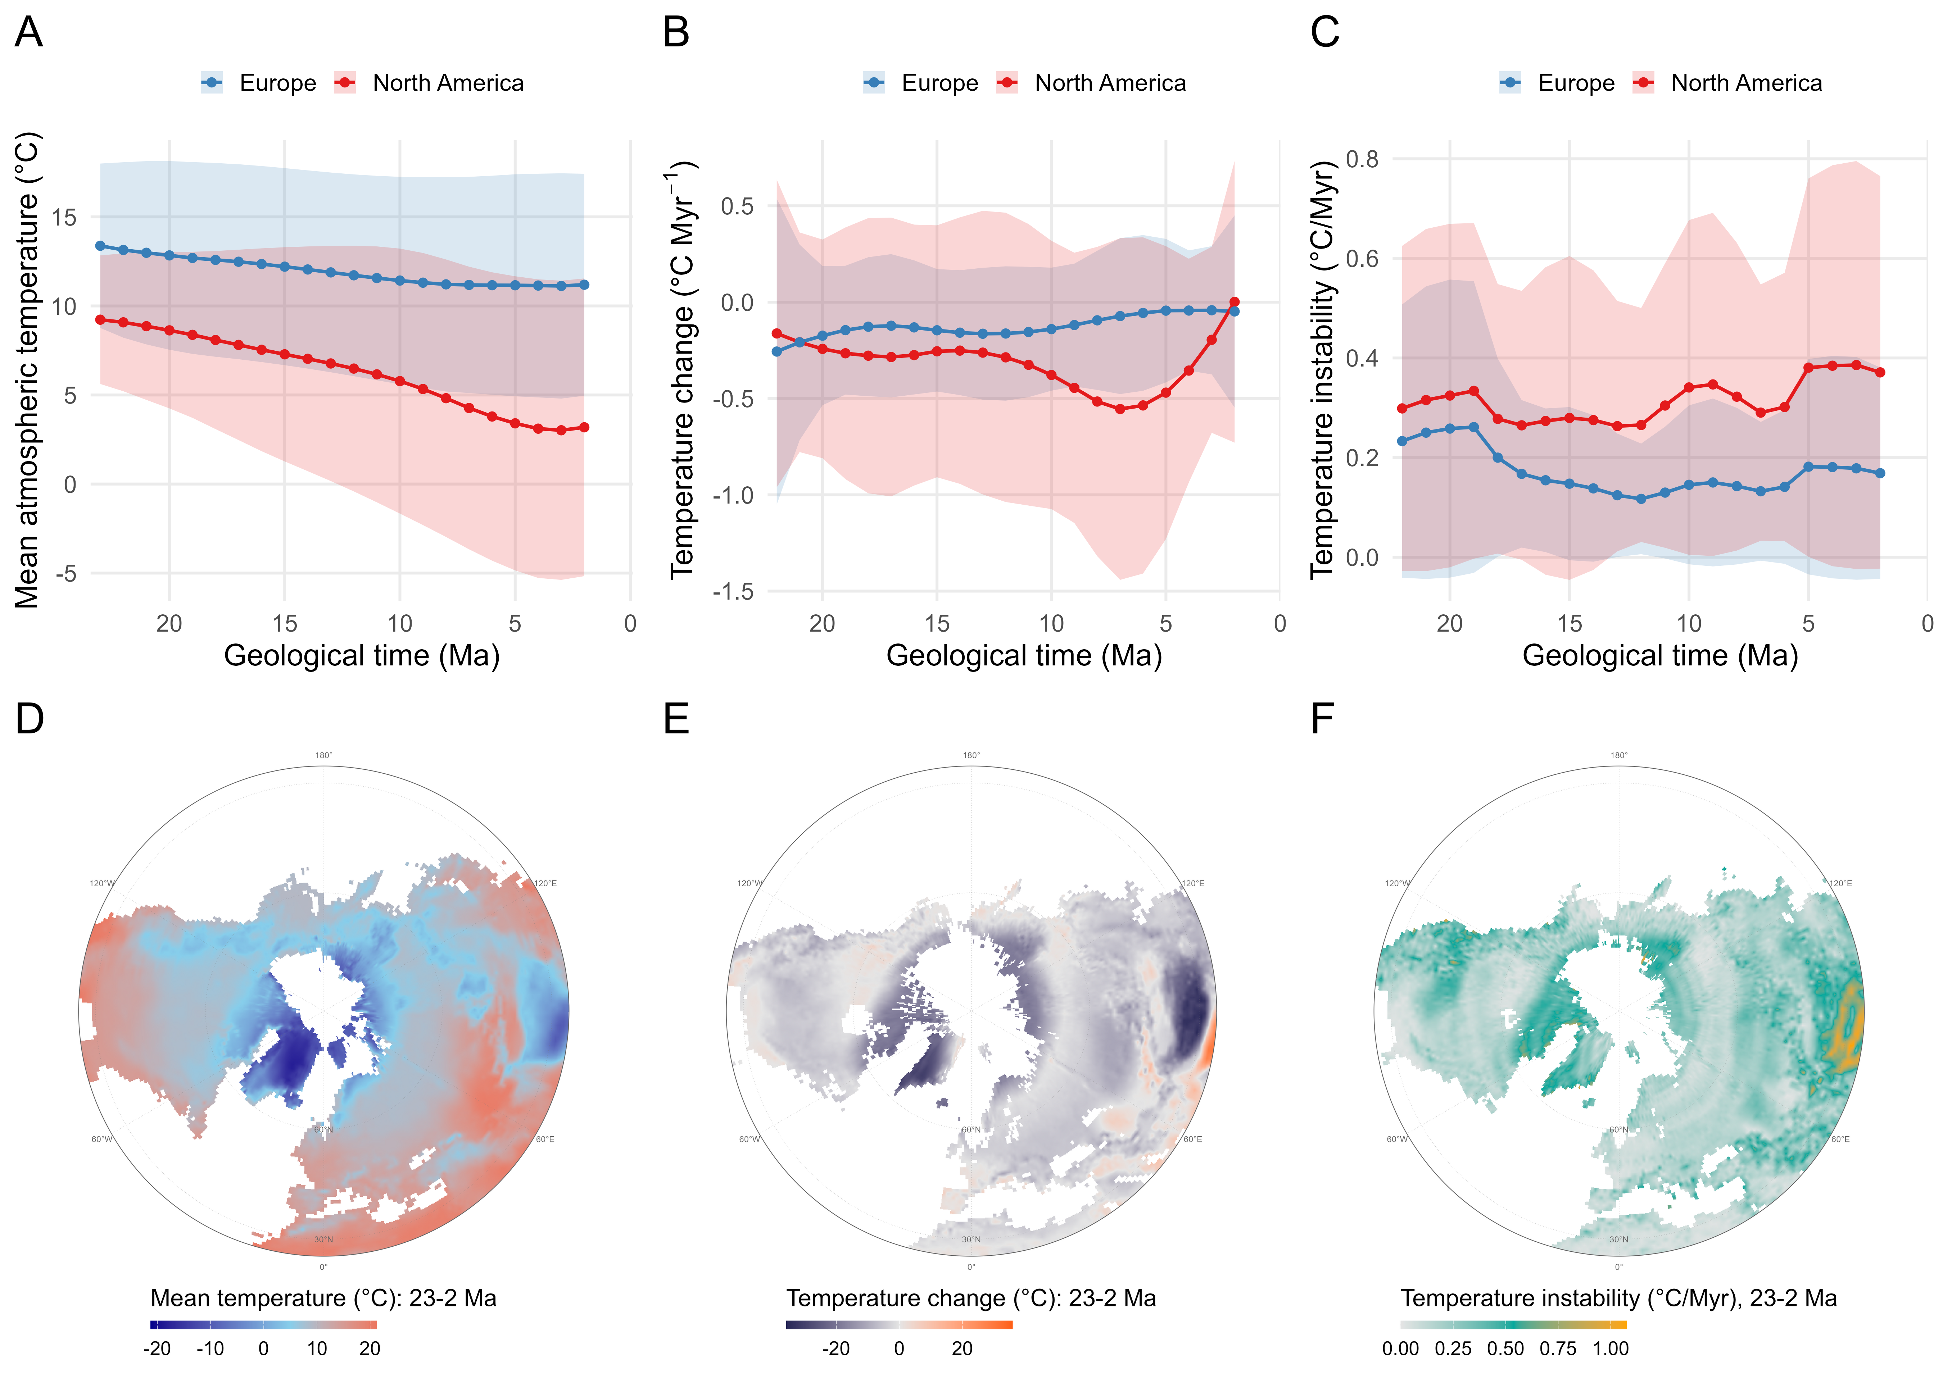
Figure 2: Spatiotemporal patterns of Neogene temperature across Europe and North America. (A–C) Temporal trajectories from 23 to 2 Ma of regional mean atmospheric temperature (A), temperature change (B), and temperature instability (C) for Europe (blue) and North America (red). Points and lines represent regional means, and shaded ribbons indicate variation around these estimates. (D–F) Spatial distribution across the Northern Hemisphere of mean temperature (D), temperature change (E), and temperature instability (F) summarized across the same 23–2 Ma interval. Temperature change is expressed as °C Myr⁻¹ and temperature instability as the magnitude of temporal temperature variation (°C Myr⁻¹).

Taxonomic turnover in fossil assemblages across the Neogene
In both Europe and North America, early-Neogene assemblages (~23–15 Ma) included many families that subsequently declined or disappeared, including amphicyonids and several extinct ungulate groups . late-Neogene (~15-2 Ma), assemblages became increasingly dominated by families characteristic of younger faunas, including Felidae and Canidae among carnivores and Cervidae, Bovidae, Equidae, Camelidae, and Elephantidae/Mammutidae among herbivores (Figure S6). The NMDS (Figure 3 C-D) showed a clear temporal shift in community composition, with older and younger fossil assemblages occupying different parts of the ordination space. Consistent with this pattern, fossil assemblage turnover increased rapidly as assemblages became farther apart in time (Figure 3 E-F). Similar patterns were observed for herbivores and carnivores in both regions (Figure S7).
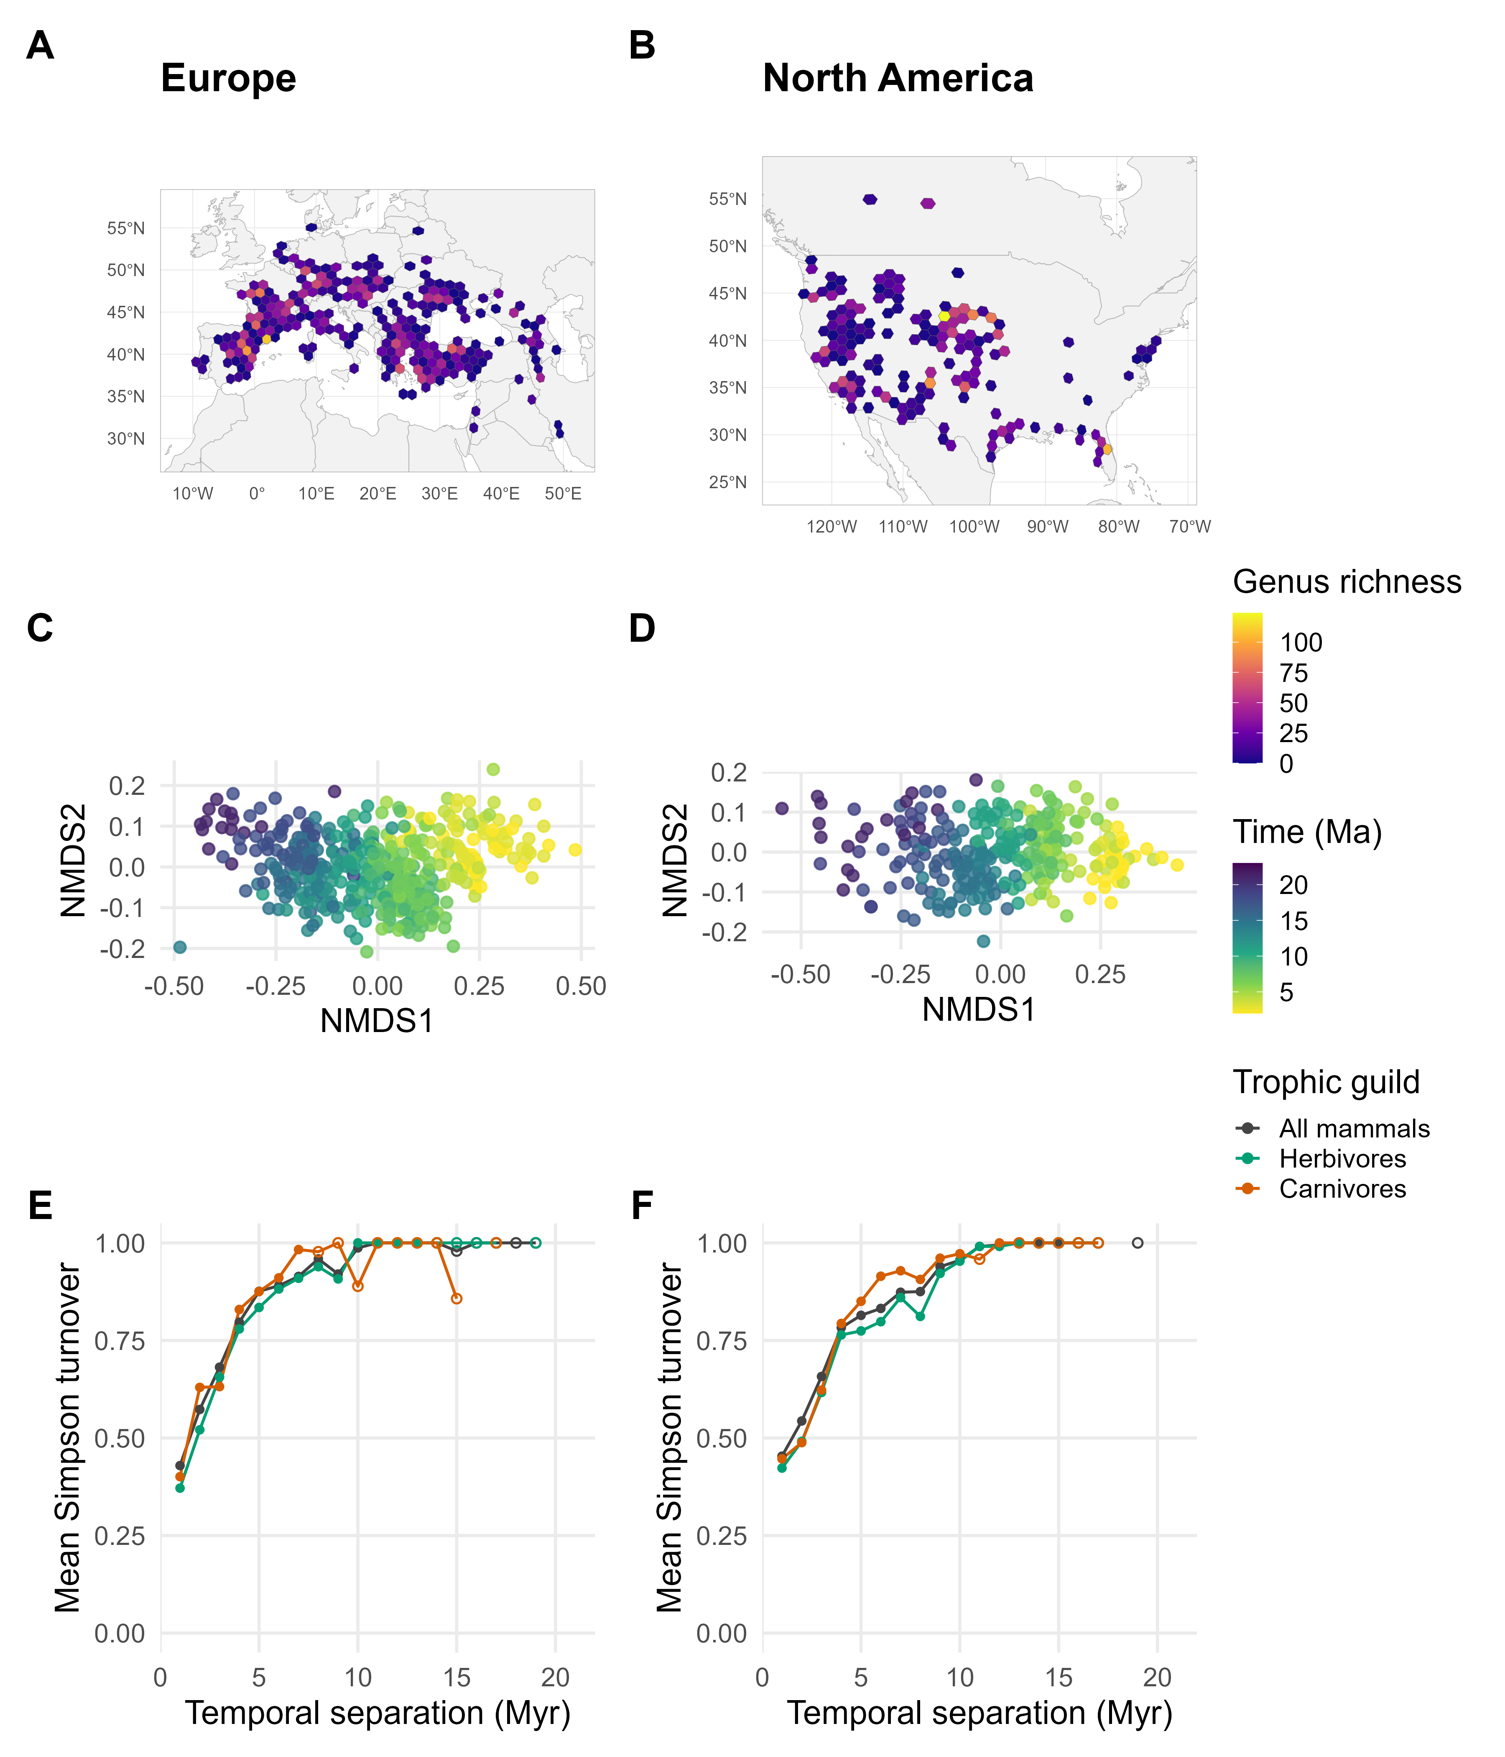
Figure 3: Spatial, compositional, and temporal structure of Neogene mammal assemblages in Europe and North America. (A–B) Geographic distribution of fossil assemblages in Europe (A) and North America (B), with Uber’s h3 hexagons colored by recorded genus richness. (C–D) NMDS ordinations of assemblage composition for Europe (C) and North America (D), with points colored by geological age (Ma), showing progressive temporal shifts in community composition. (E–F) Mean Simpson turnover as a function of temporal separation between assemblages in Europe (E) and North America (F), shown for all mammals, herbivores, and carnivores.

Temperature change drives fossil turnover
GDM splines showed that climatic associations with compositional turnover differed between regions and trophic groups. Along mean temperature, the strongest changes in the fitted response occurred for carnivores in both Europe (Figure 4A) and North America (Figure 4D), whereas herbivore responses were weaker and concentrated toward warmer conditions. For climate-change rate, Europe showed only a weak response, mainly among carnivores (Figure 4B). In North America, the fitted response changed most strongly across negative temperature-change rates, indicating greater compositional differentiation among assemblages experiencing different degrees of cooling, before flattening toward stable and warming conditions (Figure 4E). Climatic instability produced little change in Europe (Figure 4C), whereas in North America most of the fitted response occurred across low levels of instability before rapidly reaching a plateau, again with the strongest response among carnivores (Figure 4F).
Spatial and temporal distance were both associated with mammal turnover, but temporal separation showed a much stronger contribution in both continents (Table S2). In Europe, the fitted spatial response increased gradually with geographic distance for all mammals and herbivores, whereas carnivores showed a weaker response that saturated at greater distances (Figure S8). In North America, geographic distance had a strong nonlinear effect on herbivores and the full assemblage, particularly at larger distances, while the carnivore response remained weak (Figure S8-C). Temporal distance produced the largest fitted contributions in both Europe (Figure S8-B) and North America (Figure S8-D), with turnover increasing continuously across the temporal gradient and broadly similar responses among trophic groups.
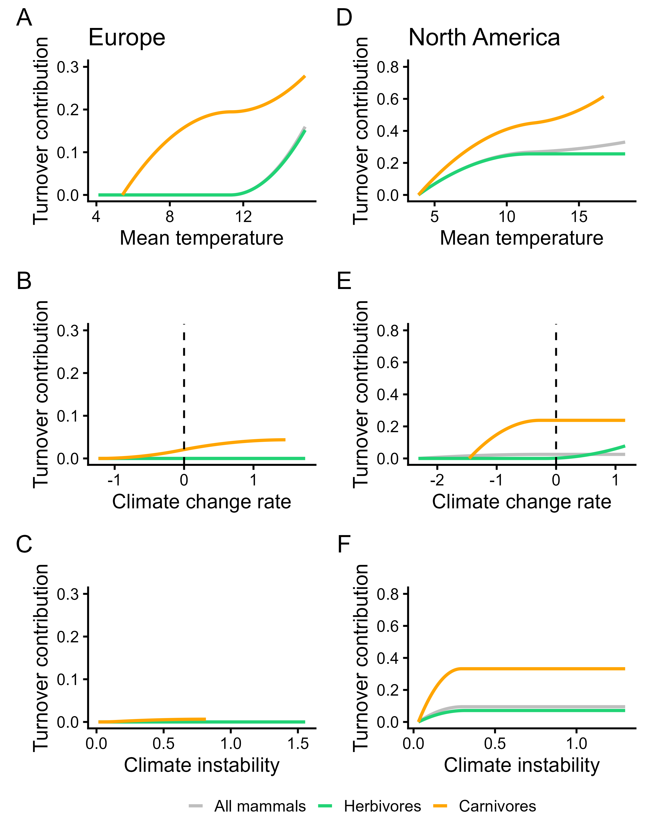
Figure 4: Climatic contributions to mammalian compositional turnover across Europe and North America during the Neogene. Generalized dissimilarity model (GDM) I-splines show the contribution of differences in mean temperature (A, D), climate-change rate (B, E), and climatic instability (C, F) to predicted genus-level compositional turnover in Europe (A–C) and North America (D–F). Curves represent models fitted to all mammals (grey), herbivores (green), and carnivores (orange). Climate-change rate is directional, with negative values indicating cooling and positive values indicating warming; dashed vertical lines denote no directional temperature change. Climatic instability represents variation in temperature-change rates through time, quantified as their standard deviation within a moving temporal window. Increasing I-spline values indicate ranges of each predictor across which differences between assemblages contribute more strongly to predicted compositional differentiation; curve height therefore represents cumulative GDM contribution rather than turnover at a given climatic value. Note that y-axis scales differ between continents.

Sensitivity analyses
Turnover response patterns were broadly robust across spatial resolutions and model configurations, despite variation in the strength of individual GDM splines (Figure 5, Figure S9-S10). Mean temperature produced the most consistent climatic response, particularly in North America, where positive fitted contributions were recovered for all mammals, herbivores, and carnivores across most model settings. Responses to temperature-change rate and climatic instability were less consistent and more sensitive to spatial aggregation. Carnivores generally showed stronger climatic responses than herbivores, especially in North America, with pronounced differentiation across cooling rates and low levels of climatic instability, whereas herbivore responses to these predictors were weaker and more variable (Figure 5). Temporal distance remained a strong predictor across model configurations, while the contribution of geographic distance differed more between continents and trophic groups (Figures S11). Model performance was strongly affected by spatial aggregation, with deviance explained increasing toward coarser spatial resolutions in both Europe and North America and across trophic groups (Figures 5, S12). In contrast, changing climate-spline flexibility had little effect on deviance explained. Including geographic distance produced a small but consistent increase in model performance across spatial resolutions and spline settings. Differences between continents were modest: North American models generally explained slightly more deviance at finer resolutions and across spline settings, whereas performance became similar between continents at coarser spatial resolutions.
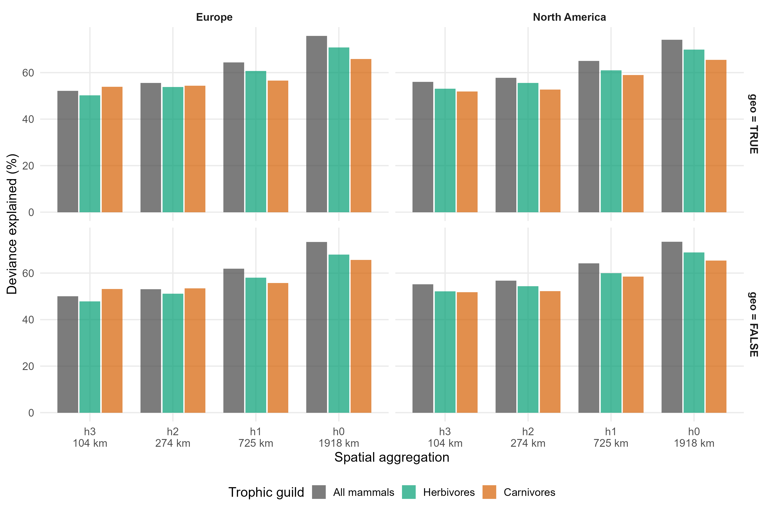
Figure 5: Sensitivity of GDM explanatory power to spatial aggregation. Percentage of deviance explained by generalized dissimilarity models (GDMs). Bars represent the mean deviance explained across all fitted spline configurationsfitted to mammalian fossil assemblage turnover across four H3 spatial resolutions in Europe and North America. Models were fitted separately for all mammals, herbivores, and carnivores, with (top; geo = TRUE) and without (bottom; geo = FALSE) geographic distance between assemblages as a predictor. Spatial aggregation increases from h3 (~104 km) to h0 (~1,918 km). Explained deviance generally increased with spatial aggregation across continents and trophic groups, while inclusion of geographic distance produced comparatively small differences in model fit.

DISCUSSION
Taken together, our results show that Neogene mammal turnover followed a broadly consistent set of temporal and climatic patterns. Temporal separation was the explained the most of compositional change, but mean temperature was the most consistent climatic predictor, particularly during rapid cooling phases. This suggests that climate was a common correlate of long-term mammalian community reassembly across the Neogene, while the climatic conditions associated with the strongest compositional differentiation varied geographically and among trophic groups.
Temporal separation was a consistent predictor of genus-level fossil assemblage turnover in Europe and North America, with compositional differentiation increasing through time and approaching saturation after approximately 10 Myr. This pattern is consistent with the cumulative replacement of genera as extinction, origination, dispersal, and other ecological and evolutionary processes continually reshape regional assemblages. Importantly, the gradual increase in compositional differentiation suggests that large-mammal assemblages undergo substantial reassembly over geological timescales, rather than remaining compositionally stable between major turnover events. This interpretation is consistent with Alroy (1996), who found that North American mammalian extinction rates were compatible with a relatively constant underlying rate, whereas origination occurred in taxonomically asynchronous pulses. Subsequent analyses similarly identified temporal differences among peaks in origination, extinction, and taxonomic change (Alroy, 2000). Comparable long-term faunal replacement has been documented in European Neogene mammals (Costeur et al., 2004; Liow & Finarelli, 2014). Nevertheless, episodic faunal changes documented in individual regions (Domingo et al., 2014), indicate that cumulative turnover at continental scales can coexist with more abrupt regional transitions. The strong temporal component of our GDMs therefore is likely integrating the cumulative effects of extinction, origination, dispersal, and long-term changes shaping continental evolutionary species pools (Mittelbach & Schemske, 2015; Yuan et al., 2026). The recurrence of this pattern across herbivores and carnivores indicates that background turnover rate was a general property of mammalian assemblages rather than a response restricted to particular trophic groups.
Our results also suggest that mean temperature change was a stronger climatic predictor of fossil assemblage differentiation than either the rate or instability of temperature. At the million-year scale represented by our time-averaged fossil assemblages, temperature may structure these faunal turnover processes directly through environmental constraints on mammal distributions and indirectly through associated changes in vegetation, habitat structure, and resource availability (Dam et al., 2006; Eronen et al., 2012). Huang et al. (2022) for example, found that habitat transitions provided an important pathway linking climate to mammalian body-size evolution in Europe and North America. Earlier work, however, has not always detected consistent relationships between mammalian turnover and climate through time (Alroy, 2000). Nonetheless, our spatially explicit results indicate that assemblages occupying regions with different mean temperature states were taxonomically distinct.
Rapid departures from prevailing (warm) climatic conditions were associated with substantial fossil assemblage reorganization. These patterns suggest that the rate of cooling contributed to faunal reorganization beyond differences associated with mean temperature, particularly in North America. Previous studies have linked rapid warming to substantial community turnover during the Pleistocene–Holocene transition (Stivrins et al., 2016), while broader analyses of the fossil record have associated faster temperature changes with higher extinction rates (Song et al., 2021). Our results extend this perspective to Neogene mammals, showing that differences in temperature-change rates were associated with fossil assemblage differentiation across million-year intervals. North American assemblages showed pronounced compositional differentiation across cooling rates, while European assemblages showed weaker differentiation across temperature-change rates. European faunal replacement may have been more strongly influenced by dispersal-mediated changes in regional species pools, potentially weakening the apparent relationship between turnover and directional temperature change (Mazel et al., 2017; Mittelbach & Schemske, 2015) Throughout the Neogene, connections with Asia and intermittent exchanges with Africa allowed new lineages to enter European faunas (Fortelius et al., 2014). Such exchanges could continually reshape regional species pools through immigration, local replacement, and biotic interactions, even where temperature-change rates were relatively stable.
Climatic instability showed weaker and less consistent associations with fossil assemblage differentiation than expected. Where effects occurred, differentiation increased most strongly between relatively stable and unstable climatic conditions, with little additional response at higher levels of instability. This pattern suggests that differences in climatic stability may be more important than the magnitude of instability itself. Repeated changes in warming and cooling rates could promote faunal reorganization through asynchronous range shifts and species replacement, even when mean climatic conditions remain similar (Dam et al., 2006; Dynesius & Jansson, 2000). Such responses may accumulate over geological timescales, although their effects on assemblage composition depend on species-specific responses and opportunities for habitat tracking (Blois & Hadly, 2009; Huang et al., 2022; Roy et al., 1996). Although our temporal resolution cannot resolve climatic fluctuations occurring within individual 1-Myr intervals, the moving-window approach captures variation in climatic trajectories across successive geological intervals, allowing their association with regional fossil assemblage differentiation to be assessed (Roy et al., 1996)
Interestingly, climatic associations were not consistently stronger in herbivores than in carnivores. Although herbivores may respond more directly to climate through changes in vegetation and primary productivity (Fritz et al., 2016b), environmental change can also affect carnivores through shifts in habitat structure, prey communities, and competition (Figueirido et al., 2015; Silvestro et al., 2015). Such processes may generate substantial compositional turnover without corresponding increases in diversity. Although our analysis did not estimate diversification rates separately for trophic groups, the relatively stable number of named species per genus through time (Figure S13) is consistent with changes in regional genus composition rather than increasing species richness within genera. This interpretation agrees with evidence of substantial carnivore taxonomic replacement despite relatively stable ecological guild structure (Morlo et al., 2020) and continuous species turnover accompanied by relatively stable net diversification across the Neogene (Liow & Finarelli, 2014). Climate-associated reorganization of regional carnivore assemblages may therefore occur without corresponding changes in global carnivore diversity.
This multi-million association between long-term climatic cooling and fossil assemblage differentiation provides a deep-time perspective on the ecological consequences of climatic change. Importantly, these consequences may depend not only on the rate and direction of change but also on the climatic conditions from which transitions begin (Williams et al., 2007). Neogene climatic evolution involved a long-term transition from generally warmer toward cooler conditions (Steinthorsdottir, Coxall, Boer, Huber, Barbolini, Bradshaw, & others, 2021; J. Zachos et al., 2001), whereas contemporary climate change involves rapid warming from the comparatively cool climatic conditions of the late Quaternary. Human-induced warming is currently estimated at approximately 0.27°C per decade (Forster et al., 2026), occurring alongside land-use change, habitat fragmentation, and other anthropogenic pressures that further influence biodiversity responses (Keck et al., 2025). Despite substantial differences in temporal resolution and climatic context, fossil evidence demonstrates that climatic transitions have repeatedly reorganized mammalian assemblages across geographic regions and trophic groups, consistent with broader evidence of climate-driven changes in species distributions and ecological interactions (Blois et al., 2013; Pecl et al., 2017).The fossil record therefore provides a valuable long-term context for understanding how sustained climatic change reshapes biodiversity and for evaluating the potential consequences of contemporary global warming.

REFERENCES
Alba, D. M., Agustí, J., & Moyà-Solà, S. (2001). Completeness of the mammalian fossil record in the iberian neogene. Paleobiology, 27(1), 79–83. https://doi.org/10.1666/0094-8373(2001)027<0079:COTMFR>2.0.CO;2
Alroy, J. (1996). Constant extinction, constrained diversification, and uncoordinated stasis in north american mammals. Palaeogeography, Palaeoclimatology, Palaeoecology, 127(1-4), 285–311. https://doi.org/10.1016/S0031-0182(96)00100-9
Alroy, J. (2000). New methods for quantifying macroevolutionary patterns and processes. Paleobiology, 26(4), 707–733. https://doi.org/10.1666/0094-8373(2000)026<0707:NMFQMP>2.0.CO;2
Badgley, C., Smiley, T. M., & Finarelli, J. A. (2014). Great basin mammal diversity in relation to landscape history. Journal of Mammalogy, 95(6), 1090–1106. https://doi.org/10.1644/13-MAMM-S-088
Baselga, A., Orme, C. D. L., Villéger, S., De Bortoli, J., & Leprieur, F. (2013). betapart: Partitioning beta diversity into turnover and nestedness components. https://CRAN.R-project.org/package=betapart
Blanco, F. et al. (2021). Punctuated ecological equilibrium in mammal communities over evolutionary time scales. Science, 372(6539), 300–303. https://doi.org/10.1126/science.abd5110
Blois, J. L., & Hadly, E. A. (2009). Mammalian response to cenozoic climatic change. Annual Review of Earth and Planetary Sciences, 37, 181–208. https://doi.org/10.1146/annurev.earth.031208.100055
Blois, J. L., Zarnetske, P. L., Fitzpatrick, M. C., & Finnegan, S. (2013). Climate change and the past, present, and future of biotic interactions. Science, 341(6145), 499–504. https://doi.org/10.1126/science.1237184
Boucot, A. J., Xu, C., & Scotese, C. R. (2013). Phanerozoic paleoclimate: An atlas of lithologic indicators of climate (Vol. 11). SEPM (Society for Sedimentary Geology).
Briega-Álvarez, A., Siebert, H., Rodrı́guez, M. Á., & Varela, S. (2023). Bioregionalization: From wallace and humboldt to deep-time paleoregion dynamics. bioRxiv, 2023–2003.
Brodsky, I. (2018, June 27). H3: Uber’s hexagonal hierarchical spatial index. Uber Engineering. https://www.uber.com/us/en/blog/h3/
Costeur, L., Legendre, S., & Escarguel, G. (2004). European large mammals palaeobiogeography and biodiversity during the neogene: Palaeogeographic and climatic impacts. Revue de Paléobiologie, Special Volume 9, 99–109.
Dam, J. A. van, Abdul Aziz, H., Álvarez Sierra, M. Á., Hilgen, F. J., van den Hoek Ostende, L. W., Lourens, L. J., Mein, P., van der Meulen, A. J., & Peláez-Campomanes, P. (2006). Long-period astronomical forcing of mammal turnover. Nature, 443, 687–691. https://doi.org/10.1038/nature05163
DiMichele, W. A., Behrensmeyer, A. K., Olszewski, T. D., Labandeira, C. C., Pandolfi, J. M., Wing, S. L., & Bobe, R. (2004). Long-term stasis in ecological assemblages: Evidence from the fossil record. Annual Review of Ecology, Evolution, and Systematics, 35, 285–322. https://doi.org/10.1146/annurev.ecolsys.35.120202.110110
Ding, W., Silvestro, D., Onstein, R. E., Wu, M., Zhou, Z., & Xing, Y. (2025). The stepwise rise of angiosperm-dominated terrestrial ecosystems. Biological Reviews, 100(5), 2131–2149. https://doi.org/10.1111/brv.70039
Domingo, M. S., Badgley, C., Azanza, B., DeMiguel, D., & Alberdi, M. T. (2014). Diversification of mammals from the miocene of spain. Paleobiology, 40(2), 197–221. https://doi.org/10.1666/13043
Dynesius, M., & Jansson, R. (2000). Evolutionary consequences of changes in species’ geographical distributions driven by Milankovitch climate oscillations. Proceedings of the National Academy of Sciences, 97(16), 9115–9120. https://doi.org/10.1073/pnas.97.16.9115
Eronen, J. T. et al. (2012). Neogene aridification of the northern hemisphere. Geology. https://doi.org/10.1130/G33147.1
Erwin, D. H. (2009). Climate as a driver of evolutionary change. Current Biology, 19(14), R575–R583. https://doi.org/10.1016/j.cub.2009.05.047
Ferrier, S., & Guisan, A. (2006). Spatial modelling of biodiversity at the community level. Journal of Applied Ecology, 43(3), 393–404. https://doi.org/10.1111/j.1365-2664.2006.01149.x
Fick, S. E., & Hijmans, R. J. (2017). WorldClim 2: New 1-km spatial resolution climate surfaces for global land areas. International Journal of Climatology.
Figueirido, B., Martín-Serra, A., Tseng, Z. J., & Janis, C. M. (2015). Habitat changes and changing predatory habits in north american fossil canids. Nature Communications, 6, 7976. https://doi.org/10.1038/ncomms8976
Fitzpatrick, M. C., Mokany, K., Manion, G., & Ferrier, S. (2021). Gdm: Generalized dissimilarity modeling. https://CRAN.R-project.org/package=gdm
Fitzpatrick, M., Mokany, K., Manion, G., Nieto-Lugilde, D., & Ferrier, S. (2025). Gdm: Generalized dissimilarity modeling. https://mfitzpatrick.al.umces.edu/gdm/
Forster, P. M., Walsh, T., Smith, C., Lamb, W. F., Lamboll, R., et al. (2026). Indicators of global climate change 2025: Annual update of key indicators of the state of the climate system and human influence. Earth System Science Data, 18, 3889–3933. https://doi.org/10.5194/essd-18-3889-2026
Fortelius, M., Eronen, J. T., Kaya, F., Tang, H., Raia, P., & Puolamäki, K. (2014). Evolution of neogene mammals in eurasia: Environmental forcing and biotic interactions. Annual Review of Earth and Planetary Sciences, 42, 579–604. https://doi.org/10.1146/annurev-earth-050212-124030
Fritz, S. A., Eronen, J. T., Schnitzler, J., Hof, C., Janis, C. M., Mulch, A., Böhning-Gaese, K., & Graham, C. H. (2016a). Twenty-million-year relationship between mammalian diversity and primary productivity. Proceedings of the National Academy of Sciences, 113(39), 10908–10913. https://doi.org/10.1073/pnas.1602145113
Fritz, S. A., Eronen, J. T., Schnitzler, J., Hof, C., Janis, C. M., Mulch, A., Böhning-Gaese, K., & Graham, C. H. (2016b). Twenty-million-year relationship between mammalian diversity and primary productivity. Proceedings of the National Academy of Sciences, 113(39), 10908–10913. https://doi.org/10.1073/pnas.1602145113
Hagen, O., Vaterlaus, L., Albouy, C., Brown, A., Leugger, F., Onstein, R. E., Santana, C. N. de, Scotese, C. R., & Pellissier, L. (2019). Mountain building, climate cooling and the richness of cold-adapted plants in the northern hemisphere. Journal of Biogeography, 46(8), 1792–1807.
Hastie, T. J. (1992). Generalized additive models. In J. M. Chambers & T. J. Hastie (Eds.), Statistical models in s (pp. 249–307). Wadsworth & Brooks/Cole.
Holt, B. G., Lessard, J.-P., Borregaard, M. K., Fritz, S. A., Araújo, M. B., Dimitrov, D., Fabre, P.-H., Graham, C. H., Graves, G. R., Jønsson, K. A., et al. (2013). An update of wallace’s zoogeographic regions of the world. Science, 339(6115), 74–78.
Huang, S., Saarinen, J. J., Eyres, A., Eronen, J. T., & Fritz, S. A. (2022). Mammalian body size evolution was shaped by habitat transitions as an indirect effect of climate change. Global Ecology and Biogeography, 31(12), 2463–2474. https://doi.org/10.1111/geb.13594
Jablonski, D., & Shubin, N. H. (2015). The future of the fossil record: Paleontology in the 21st century. Proceedings of the National Academy of Sciences, 112(16), 4852–4858.
Jackson, J. B., & Erwin, D. H. (2006). What can we learn about ecology and evolution from the fossil record? Trends in Ecology & Evolution, 21(6), 322–328.
Jackson, J. B., & Johnson, K. G. (2000). Life in the last few million years. Paleobiology, 26(S4), 221–235.
Jones, L. A., Gearty, W., Allen, B. J., Eichenseer, K., Dean, C. D., Galván, S., Kouvari, M., Godoy, P. L., Nicholl, C. S., Buffan, L., et al. (2023). Palaeoverse: A community-driven r package to support palaeobiological analysis. Methods in Ecology and Evolution, 14(9), 2205–2215.
Keck, F., Peller, T., Alther, R., Barouillet, C., Blackman, R., et al. (2025). The global human impact on biodiversity. Nature, 641, 395–400. https://doi.org/10.1038/s41586-025-08752-2
Kennett, J. P. (1995). A review of polar climatic evolution during the neogene, based on the marine sediment record. Paleoclimate and Evolution, with Emphasis on Human Origins. Yale University Press, New Haven, 49–64.
Kocsis, Á. T., Reddin, C. J., Scotese, C. R., Valdes, P. J., & Kiessling, W. (2021). Increase in marine provinciality over the last 250 million years governed more by climate change than plate tectonics. Proceedings of the Royal Society B: Biological Sciences, 288(1957), 20211342.
Liow, L. H., & Finarelli, J. A. (2014). A dynamic global equilibrium in carnivoran diversification over 20 million years. Proceedings of the Royal Society B: Biological Sciences, 281(1778), 20132312. https://doi.org/10.1098/rspb.2013.2312
Madern, P. A., & Hoek Ostende, L. W. van den. (2015). Going south: Latitudinal change in mammalian biodiversity in miocene eurasia. Palaeogeography, Palaeoclimatology, Palaeoecology, 424, 123–131. https://doi.org/10.1016/j.palaeo.2015.02.011
Mazel, F., Wüest, R. O., Lessard, J.-P., Renaud, J., Ficetola, G. F., Lavergne, S., & Thuiller, W. (2017). Global patterns of $β$-diversity along the phylogenetic time-scale: The role of climate and plate tectonics. Global Ecology and Biogeography, 26(10), 1211–1221.
Mittelbach, G. G., & Schemske, D. W. (2015). Ecological and evolutionary perspectives on community assembly. Trends in Ecology & Evolution, 30(5), 241–247.
Morlo, M., Nagel, D., & Bastl, K. A. (2020). Evolution of the carnivoran (Carnivora, Mammalia) guild structure across the middle/upper miocene boundary in germany. Palaeogeography, Palaeoclimatology, Palaeoecology, 553, 109801. https://doi.org/10.1016/j.palaeo.2020.109801
Mottl, O., Flantua, S. G., Bhatta, K. P., Felde, V. A., Giesecke, T., Goring, S., Grimm, E. C., Haberle, S., Hooghiemstra, H., Ivory, S., et al. (2021). Global acceleration in rates of vegetation change over the past 18,000 years. Science, 372(6544), 860–864.
Pecl, G. T., Araújo, M. B., Bell, J. D., Blanchard, J., Bonebrake, T. C., et al. (2017). Biodiversity redistribution under climate change: Impacts on ecosystems and human well-being. Science, 355(6332), eaai9214. https://doi.org/10.1126/science.aai9214
Roy, K., Valentine, J. W., Jablonski, D., & Kidwell, S. M. (1996). Scales of climatic variability and time averaging in pleistocene biotas: Implications for ecology and evolution. Trends in Ecology & Evolution, 11(11), 458–463. https://doi.org/10.1016/0169-5347(96)10054-9
Royer, D. L., Berner, R. A., Montañez, I. P., Tabor, N. J., & Beerling, D. J. (2004). CO2 as a primary driver of phanerozoic climate. GSA Today, 14(3), 4–10. https://doi.org/10.1130/1052-5173(2004)014<4:CAAPDO>2.0.CO;2
Scotese, C. R., & Wright, N. M. (2018). PALEOMAP paleodigital elevation models (PaleoDEMs) for the phanerozoic. PALEOMAP Project. https://doi.org/10.5281/zenodo.5460860
Silvestro, D., Antonelli, A., Salamin, N., & Quental, T. B. (2015). The role of clade competition in the diversification of north american canids. Proceedings of the National Academy of Sciences, 112(28), 8684–8689. https://doi.org/10.1073/pnas.1502803112
Song, H., Kemp, D. B., Tian, L., Chu, D., Song, H., & Dai, X. (2021). Thresholds of temperature change for mass extinctions. Nature Communications, 12, 4694. https://doi.org/10.1038/s41467-021-25019-2
Steinthorsdottir, M., Coxall, H. K., Boer, A. M. de, Huber, M., Barbolini, N., Bradshaw, C. D., et al. (2021). The miocene: The future of the past. Paleoceanography and Paleoclimatology, 36, e2020PA004037. https://doi.org/10.1029/2020PA004037
Steinthorsdottir, M., Coxall, H. K., Boer, A. M. de, Huber, M., Barbolini, N., Bradshaw, C. D., Burls, N. J., Feakins, S. J., Gasson, E., Henderiks, J., Holbourn, A. E., Kiel, S., Kohn, M. J., Knorr, G., Kürschner, W. M., Lear, C. H., Liebrand, D., Lunt, D. J., Mörs, T., … Strömberg, C. A. E. (2021). The miocene: The future of the past. Paleoceanography and Paleoclimatology, 36(4), e2020PA004037. https://doi.org/10.1029/2020PA004037
Stivrins, N., Soininen, J., Amon, L., Fontana, S. L., Gryguc, G., Heikkilä, M., Heiri, O., Kisielienė, D., Reitalu, T., Stančikaitė, M., Veski, S., & Seppä, H. (2016). Biotic turnover rates during the pleistocene-holocene transition. Quaternary Science Reviews, 151, 100–110. https://doi.org/10.1016/j.quascirev.2016.09.008
The NOW Community. (2020). NOW — new and old worlds: Database of fossil mammals. Zenodo. https://doi.org/10.5281/zenodo.4268068
Williams, J. W., Jackson, S. T., & Kutzbach, J. E. (2007). Projected distributions of novel and disappearing climates by 2100 AD. Proceedings of the National Academy of Sciences, 104(14), 5738–5742. https://doi.org/10.1073/pnas.0606292104
Wood, S. N. (2017). Generalized additive models: An introduction with r (2nd ed.). Chapman; Hall/CRC. https://doi.org/10.1201/9781315370279
Yuan, S., Zhao, Y., Lessard, J.-P., Martin, T. E., Matthews, T. J., & Si, X. (2026). Rebuilding the species pool within a phylogenetic framework. Trends in Ecology & Evolution.
Zachos, J. C., Dickens, G. R., & Zeebe, R. E. (2008). An early cenozoic perspective on greenhouse warming and carbon-cycle dynamics. Nature, 451(7176), 279–283.
Zachos, J. C., Shackleton, N. J., Revenaugh, J. S., Pälike, H., & Flower, B. P. (2001). Climate response to orbital forcing across the oligocene-miocene boundary. Science, 292(5515), 274–278.
Zachos, J., Pagani, M., Sloan, L., Thomas, E., & Billups, K. (2001). Trends, rhythms, and aberrations in global climate 65 ma to present. Science, 292(5517), 686–693. https://doi.org/10.1126/science.1059412

