Distinct functional responses of producers and consumers to climate generate functional trophic asymmetry
2026-07-18
Abstract
Aim: Trait-based approaches have greatly improved our understanding of community assembly but have largely focused on single trophic levels. Because species interactions emerge through trait matching between consumers and their resources, differential responses of trophic levels to environmental filtering may generate mismatches in functional diversity. We introduce the concept of functional trophic asymmetry (FTA) to quantify these differences and evaluate how climatic gradients shape multitrophic community assembly.
Location: Neotropics.
Time period: Contemporary.
Major taxa studied: Palms and mammalian frugivores.
Methods: We combined species distributions, functional trait data, and pairwise mutualistic interactions to estimate functional trophic asymmetry across the Neotropics. To overcome incomplete interaction data, we trained machine-learning models to downscale a continental interaction metaweb into grid-cell synthetic ecological networks. Functional richness and functional dispersion were quantified independently for palms and mammals, and FTA was estimated as the difference between trophic levels. Generalized additive models were used to relate geographic variation in FTA to major climatic gradients.
Results: Functional trophic asymmetry exhibited pronounced geographic variation across the Neotropics, arising primarily because climatic gradients affected mammalian functional diversity more strongly than palm functional diversity. Climatic effects differed between dimensions of functional diversity: functional richness asymmetry showed little climatic structure, whereas functional dispersion asymmetry varied strongly along a broad climatic gradient from warm, wet, climatically stable environments to colder, drier, and more seasonal regions. These patterns indicate that contemporary climate reorganizes the distribution of consumer functional strategies more readily than the breadth of functional strategies represented across trophic levels.
Main conclusions: Differential climatic filtering across trophic levels generates geographic variation in functional trophic asymmetry, providing a mechanistic link between broad-scale environmental gradients and the functional organization of multitrophic communities. By integrating trait-based ecology across trophic levels, FTA provides a general framework for investigating how environmental change reshapes interaction niches and the functional organization of ecological networks across ecosystems.

INTRODUCTION
Ecologists often examine patterns of functional trait diversity to investigate community assembly processes (Ackerly 2003; Kraft et al. 2015). To date, however, most trait-based approaches have focused on functional trait diversity within a single trophic level, often assuming competition as the dominant species interaction structuring communities (Weiher, Clarke, and Keddy 1998; Tilman 2004). In contrast, research in network ecology has extended trait-based community assembly across trophic levels. For example, studies demonstrated that trait matching across trophic levels plays a key role in the assembly of species interactions (Lavorel 2013) and the emergence of network structure (Allesina, Alonso, and Pascual 2008; Marjakangas et al. 2022; Saravia et al. 2022). However, despite the growing availability of species trait and distribution data across multiple trophic levels (Kissling et al. 2012; Schleuning, García, and Tobias 2023), our understanding of how assembly processes act within and between trophic levels jointly shape multitrophic communities remains limited (Guzman et al. 2019; Marjakangas et al. 2022).
Classical approaches to study community assembly rely on the concept of environmental filtering, where density independent conditions constrain the functional diversity of species assemblages (Laliberté and Legendre 2010; Villéger, Mason, and Mouillot 2008; HilleRisLambers et al. 2012; Kraft et al. 2015). Functional diversity is described through complementary measures such as functional richness (FR) and functional dispersion (FDis) (Mason et al. 2005, 2013). Functional richness is often used to estimate the strength of which environmental filtering constrains the morphological specialization of species assemblages. Functional richness typically measures the total variability of functional traits observed in a community. High functional richness can indicate weak environmental selection whereas low functional richness can indicate strong selection. Functional dispersion is often used to estimate the strength to which species partition the local trait space. Functional dispersion typically measures the degree of species clustering within a community trait space (Mason et al. 2005; Laliberté and Legendre 2010; Kraft and Ackerly 2010). High functional dispersion can indicate the coexistence of functionally distinct species, whereas low functional dispersion can indicate trait convergence (Kraft, Valencia, and Ackerly 2008; Halpern and Floeter 2008; Paine et al. 2011).
In a multitrophic context, where traits mediating species interactions (e.g. plant fruit size - animal body size) across trophic levels can also mediate the responses of species to gradients in their abiotic environment (e.g. water availability – temperature) (McCain and King 2014; Moretti and Legg 2009; Dehling, Barreto, and Graham 2022), the effects of environmental filtering can cascade to other trophic levels such that the environment filters on consumer traits can shape the functional richness or dispersion of their resources (and vice-versa) (Albrecht et al. 2018; Guzman et al. 2019). Moreover, the same environmental gradient could exert ecological pressures of different strength on communities at distinct trophic levels (Marjakangas et al. 2022). These differences may generate asymmetrical patterns of functional richness and dispersion between consumers and resources, modulated by their degree of reciprocal dependency or co-evolution (Medeiros, Garcia, and Guimaraes Jr 2018; Borzone Mas et al. 2026). These asymmetries could potentially shape large scale patterns of interaction assembly and possibly constrain the structure or topologies of trophic networks (Blüthgen, Menzel, and Blüthgen 2006; Schleuning et al. 2012; Saravia et al. 2022; Dehling, Barreto, and Graham 2022).
Here, we introduce the concept of functional trophic asymmetry (FTA), which allows inferring the difference of environmental filtering pressures on the functional diversity of multitrophic assemblages (Figure 1). FTA is the difference of standardized effect sizes (Z-scores) of functional richness and functional dispersion between trophic levels. FTA can occur because traits mediating species interactions (i.e., interaction niches) across trophic levels can also mediate the responses of species to their abiotic environment (i.e., environmental niches) (McCain and King 2014; Moretti and Legg 2009; Dehling et al. 2021). As an example, plant seed size determines the outcome of animal-mediated seed dispersal (Donoso et al. 2017, 2020) as well as physiological limits, such as tolerances of plant seedlings to desiccation (Hoekstra, Golovina, and Buitink 2001). For functional richness, high FTA could indicate differences in the strength of environmental selection over the interaction niches of distinct trophic levels within a multitrophic species assemblage. Alternatively, low FTA could indicate that the strength of the environment selection shaping interaction niches is similar between trophic levels, e.g., equally weak or equally strong (Marjakangas et al. 2022). Low FTA could also emerge under strong trait matching and therefore indicate the influence of trait co-evolution during multitrophic community assembly (Dehling et al. 2021; Albrecht et al. 2018). For functional dispersion, FTA can be an indicator variation in the relative importance between trophic levels of processes promoting trait convergence or divergence, including niche differentiation and dispersal constraints (Fitzgerald et al. 2017; Bauer et al. 2021).
Mutualistic interactions between palms and their mammalian frugivores are important to sustain biodiversity and ecosystem function in tropical ecosystems (Bogoni, Peres, and Ferraz 2020; Marques Dracxler and Kissling 2022). Mammalian frugivores facilitate the dispersal of palm fruits, which helps to prevent local extinctions amid disturbance and to maintain biodiversity in these ecological networks (Acevedo-Quintero, Zamora-Abrego, and García 2020; Messeder et al. 2021; Dehling et al. 2021). To effectively preserve the structure of these interactions, it is crucial to understand how co-occurring palm (producer) and mammalian frugivore (consumer) communities will jointly respond to global climatic change. By examining the co-variation in their functional richness and functional dispersion across broad geographic scales and linking those patterns to spatial and/or temporal variation in climate (Figure 2), we identify the key climatic factors that may influence the assembly of their mutualistic relationships. Here, we ask (1) which climatic variable(s) best explain(s) geographic variation in the functional richness and dispersion of palms and mammalian frugivores, (2) whether differences in these relationships lead to FTA, and (3) which climatic variable best explains geographic variation in FTA across the Neotropics.
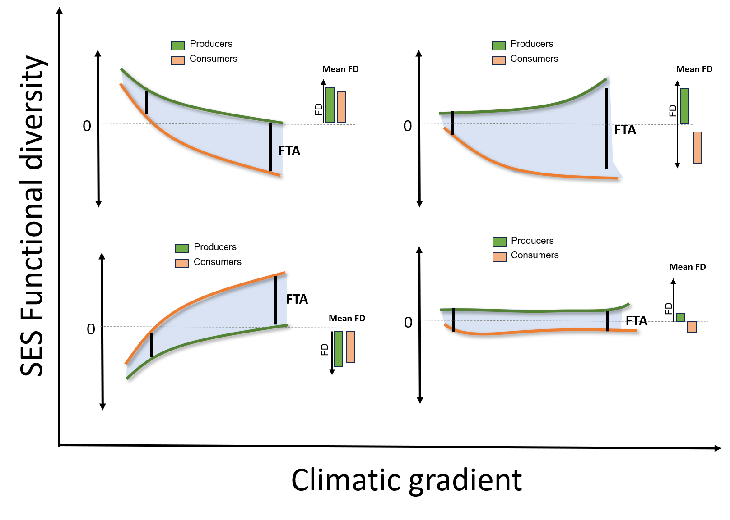
Figure 1: Conceptual illustration of functional trophic asymmetry (FTA) across environmental gradients. Hypothetical responses of producer (green) and consumer (orange) functional diversity to an environmental gradient. The blue shaded area represents functional trophic asymmetry (FTA), quantified as the vertical difference between trophic-level responses under identical environmental conditions. Top panels illustrate scenarios in which asymmetry is greatest at one end of the gradient and decreases toward the other, whereas bottom panels depict scenarios in which asymmetry increases or remains relatively constant across the gradient. Black vertical lines highlight the magnitude of FTA at representative positions along the environmental gradient. Barplots summarize the relative functional diversity of producers and consumers at those positions

METHODS

Study system
We focused on multitrophic assemblages of Neotropical palms and their mutualistic, seed dispersing, mammalian frugivores. Palms (Plantae: Arecaceae) are a keystone plant family from tropical regions that provides fruit resources to a wide variety of vertebrate frugivores, including birds and mammals (Muñoz, Trøjelsgaard, and Kissling 2019; Zona and Henderson 1989). Frugivory-related traits have notably underlain palm diversification and played a key role in the evolution of palm traits (Onstein et al. 2014, 2017). Frugivorous mammals (Animalia: Mammalia) are among the most important palm-seed dispersers, particularly over long distances (Lim et al. 2020). Most frugivorous mammals feeding on palms are seed eaters and pulp eaters, dispersing palm seeds mostly via ectozoochorus dispersal (Messeder et al. 2021; Marques Dracxler and Kissling 2022).

Species occurrence data
We obtained binary species distribution data (presence/absence) of palms from the geographic range maps of (Bjorholm et al. 2005) and on mammals from the IUCN (International Union for the Conservation of Nature) data portal. We defined multitrophic assemblages across the Neotropics, by intersecting species-level range maps with Morrone (2014) delineation of neotropical biogeographic provinces. A species was considered present in a province when at least 5% of its occupied range cells occurred within that province, reducing the influence of marginal overlaps between species ranges and province boundaries. Species represented by fewer than ten occupied raster cells were excluded. This procedure was applied independently to palms and mammals, producing province-level presence–absence matrices for each trophic level.

Species trait data
We collected species-level multitrophic trait data related to the physiological tolerance of palms and frugivorous mammals to the abiotic environment and to their mutualistic interactions. For palms, we extracted data from the PalmTraits 1.0 dataset (Kissling et al. 2019). We collected data on growth form, maximum stem height, and average fruit length. For frugivorous mammals, we obtained trait data from the EltonTraits 1.0 database (Wilman et al. 2014). We selected data on body mass, diet, and daily activities. Diet data from the EltonTraits 1.0 database is coded as percentage use distribution across ten diet categories. We excluded from our analysis species without fruit in their diet. Activity was coded as a dummy variable with three categories (Diurnal, Crepuscular, Nocturnal). Finally, body mass was coded as a numerical variable in kg. We excluded bats from the analysis as almost no Neotropical bat species is feeding on palm fruits (Messeder et al. 2021). In total, we worked with a set of 494 palm species and 488 mammal frugivore species with linked trait and geographic data, which comprised respectively ~61% (Roncal et al. 2013; Balslev et al. 2015) and ~64% (Fuzessy and Pizo 2025)of reported species for the Neotropics.

Climatic data
We used the 19 bioclimatic variables from WorldClim v2.1 (Fick and Hijmans 2017) to characterize large-scale climatic variation across Neotropical biogeographic regions ( Figure 2; Figure S1). For each region, we extracted the mean value of each bioclimatic variable by averaging raster cells contained within regional boundaries. To reduce dimensionality and account for collinearity among climatic predictors, we performed a principal component analysis (PCA) on the standardized bioclimatic variables (Figure S2). The first three principal components captured the dominant gradients of climatic variation across the Neotropics. PCA effectively summarized climatic variation across biogeographic regions into three principal components that together explained 87.9% of the total variance (Figure S3). PC1 (59.7%) described a gradient from warm, wet, and climatically stable environments (negative values) to cooler and more thermally seasonal climates (positive values). PC2 (19.3%) represented variation in dry-season moisture availability, ranging from hot climates with pronounced dry seasons (negative values) to climates with wetter dry periods (positive values). PC3 (8.9%) captured a transition from temperature-driven seasonality (negative values) to precipitation-driven seasonality (positive values) (Figure 2). These linear components were subsequently used as predictors in all analyses of functional diversity and functional trophic asymmetry.
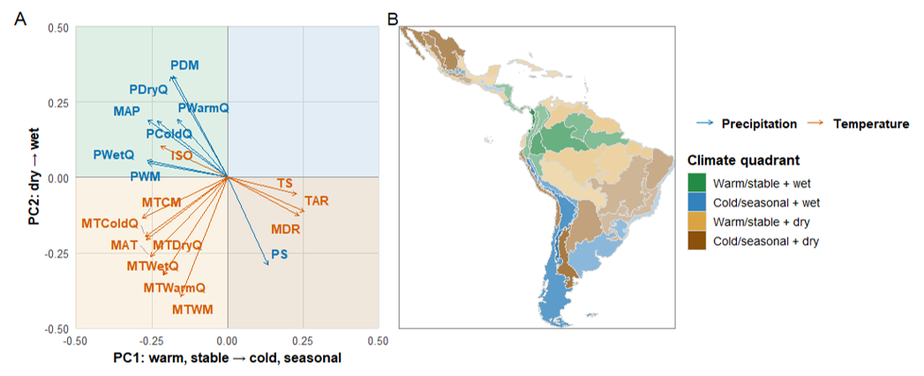
Figure 2: Climatic principal components and their geographic distribution across biogeographic provinces in the Neotropics. (A) PCA loading plot showing the loadings of the 19 WorldClim bioclimatic variables on the first two principal components (PC1 and PC2). Blue arrows represent precipitation variables and orange arrows represent temperature variables. Variable abbreviations are: MAP, mean annual precipitation; PWetQ, precipitation of the wettest quarter; PDryQ, precipitation of the driest quarter; PWarmQ, precipitation of the warmest quarter; PColdQ, precipitation of the coldest quarter; PWM, precipitation of the wettest month; PDM, precipitation of the driest month; PS, precipitation seasonality; MAT, mean annual temperature; MTCM, mean temperature of the coldest month; MTWM, mean temperature of the warmest month; MTColdQ, mean temperature of the coldest quarter; MTWarmQ, mean temperature of the warmest quarter; MTDryQ, mean temperature of the driest quarter; MTWetQ, mean temperature of the wettest quarter; TAR, annual temperature range; MDR, mean diurnal range; TS, temperature seasonality; and ISO, isothermality. The shaded quadrants represent four broad climatic domains defined by the PCA axes: warm/stable + wet, cold/seasonal + wet, warm/stable + dry, and cold/seasonal + dry. Therefore, PC1 represents a gradient from warm, climatically stable environments to colder, more seasonal climates, whereas PC2 represents a gradient from wetter to drier conditions. (B) Geographic distribution of these four climatic domains across biogeographic provinces (Morrone 2014) in the Neotropics

Statistical analysis
Functional diversity (FD) metrics were quantified from multidimensional trait spaces constructed independently for palms and mammals. Species-level functional dissimilarities were calculated using Gower distances to accommodate mixed trait types, and principal coordinates analysis (PCoA) was used to project species into continuous functional trait spaces (Figure S4). For each trophic level, we retained the minimum number of PCoA axes required to explain at least 75% of the total trait variation (Figure S5). In mammals, activity period and body mass were the primary determinants of trait-space structure, while stem height and growth form (erect vs. acaulescent) contributed most strongly to palm trait-space organization (Figure S6).
Local FD metrics were calculated from the subset of species present within a biogeographical province. For each assemblage, we quantified species richness, functional richness (FR) and functional dispersion (FDis). Functional richness (FR) measured the occupied volume of the local assemblage within the larger trait space of the continental pool. Functional dispersion (FDis) measured the clustering of species within trait space relative to the assemblage centroid (Laliberté and Legendre 2010). Metrics were calculated separately for palms and mammals using the FD package in R (Laliberté and Legendre 2010). Biogeographic assemblages containing fewer than three species of palms and mammals respectively were excluded from estimations.
We standardized each observed functional richness and functional dispersion metric against a richness-constrained expected metric values drawn from a distribution of null assemblages. For each palm and mammal assemblage, we generated 999 null assemblages by randomly selecting the same number of observed species from the continental species pool without replacement and recalculating FR and FDis at each permutation (Chase et al. 2011). Standardized effect sizes were calculated as the difference between the observed value and the mean null expectation, divided by the standard deviation of the null distribution. Positive SES values indicate increased trait volumes (FR-SES) or trait over-dispersion (Fdis-SES) ), whereas negative values indicate reduced trait-space volumes (FR-SES) and trait clustering (Fdis-SES).
We quantified functional trophic asymmetry (FTA) as the difference between mammal and palm standardized effect sizes (SES; $FTA=SES_{mammals}-SES_{palms}$). Positive values indicate that mammal assemblages exhibit greater positive departures from null expectations than palm assemblages. For functional richness, this corresponds to mammals occupying a relatively larger volume of functional trait space than expected given species richness. For functional dispersion, positive values indicate that mammal assemblages are relatively more overdispersed (or less functionally clustered) than palm assemblages. Conversely, negative values indicate that palms exhibit greater positive departures from null expectations, reflecting relatively larger functional trait-space volume (FR) or greater functional overdispersion (FDis) than mammals.
To assess climatic influences on functional trophic asymmetry, we fitted separate Generalized Additive Models (GAMs) for FTA-FR and FTA-FDis using the three climatic principal components described above as predictors. GAMs are allowed for non-linear responses through penalized smooth functions (Wood and N 2017), with separate smooths fitted for each climatic predictor. Visual inspection of diagnostic plots indicated that Gaussian model assumptions were adequately met, with no evidence of systematic residual patterns or heteroscedasticity (Figure S7, S8).

RESULTS

Spatial distribution of trophic functional diversity and asymmetry
Functional diversity exhibited marked geographic variation across the Neotropics. Palm functional richness was generally highest in Central America and parts of eastern and southern South America (Figure 3 (A)), whereas mammal functional richness was highest in eastern Brazil but comparatively low across much of Amazonia and western South America (Figure 3 (B)). Consequently, functional trophic asymmetry in richness exhibited a pronounced west–east gradient (Figure 3 (C)), with palm assemblages exceeding mammal assemblages across much of Amazonia and mammal assemblages exhibiting relatively greater functional richness in eastern South America. Patterns of functional dispersion differed from those of richness. Palm functional dispersion peaked in southeastern Brazil (Figure 3 (D)), whereas mammal functional dispersion was elevated throughout much of tropical South America (Figure 3 (E)). Functional trophic asymmetry in dispersion displayed a distinct spatial pattern characterized by broadly positive values across much of the Neotropics but negative values concentrated in southeastern Brazil (Figure 3 (F)).
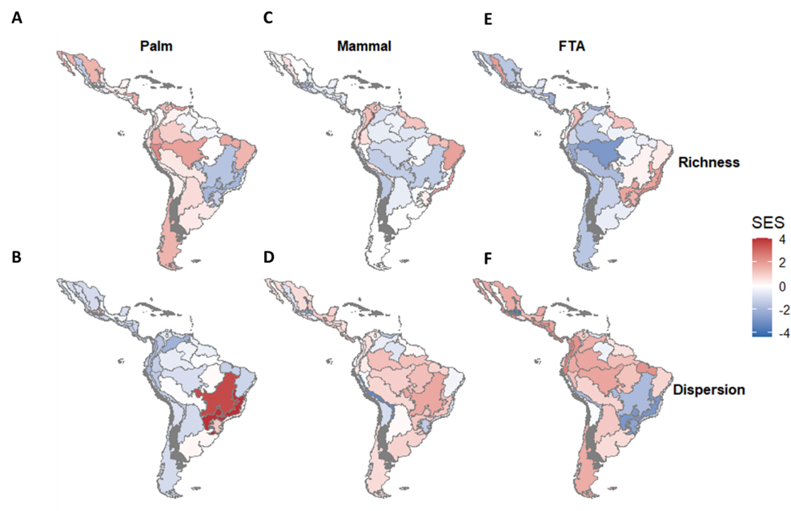
Figure 3: Spatial patterns of functional richness, functional dispersion, and functional trophic asymmetry across Neotropical biogeographic provinces. Maps show standardized effect sizes (SES) of functional richness (top row) and functional dispersion (bottom row) for palm assemblages (left column), mammal assemblages (middle column), and functional trophic asymmetry (FTA; right column). Positive SES values (red) indicate greater functional structure than expected under null model expectations, whereas negative SES values (blue) indicate lower functional structure than expected. FTA represents the difference in SES between producer and consumer assemblages for each biogeographic province. Biogeographic provinces are delineated according to the Neotropical regionalization of Morrone (2014).

The influence of climate on the functional diversity of palms and mammals
Precipitation seasonality and dry-season severity shaped mammal functional richness but had little influence on palm functional richness (Figure 4 (A-B), Table 1). Mammal SES functional richness was significantly associated with PC2, the moisture availability and dry-season intensity gradient (F = 1.23, P = 0.022), while PC1 showed a weak, non-significant trend (P = 0.101) (Table 1). The mammal model explained 19.8% of the deviance (adjusted R² = 0.140) (Table 2). In contrast, Palm SES functional richness showed no significant relationship with any climatic axis, with the model explaining only 4.1% of the deviance (adjusted R² = 0.025) (Tables 1, 2). Temperature seasonality, moisture availability, and climatic stability shaped mammal functional dispersion but had comparatively little influence on palm functional dispersion (Figure 4 (C-D), Table 1). Mammal SES functional dispersion was significantly associated with both PC1, the broad temperature–seasonality gradient (F = 1.99, P = 0.007), while PC2 showed a marginal effect (P = 0.071) (Table 1). The mammal model explained 32.2% of the deviance (adjusted R² = 0.265) (Table 2). In contrast, Palm SES functional dispersion showed only a weak, non-significant association with PC1, the temperature–seasonality gradient (F = 0.72, P = 0.091), while PC2 had no significant effects (Table 1). The palm model explained 14.4% of the deviance (adjusted R² = 0.098) (Table 2). Climatic gradients remained robust predictors of multitrophic functional diversity after controlling for biogeographical spatial structure (Figure S9). Specifically, model support remained virtually unchanged for palm functional richness, mammal functional dispersion (ΔAIC < 1). However, models of palm functional dispersion showed a modest improvement after accounting for space (ΔAIC = 3.85), whereas mammal functional richness exhibited a substantial increase in model support (ΔAIC = 22.6; deviance explained = 70.3%) (Table 2).
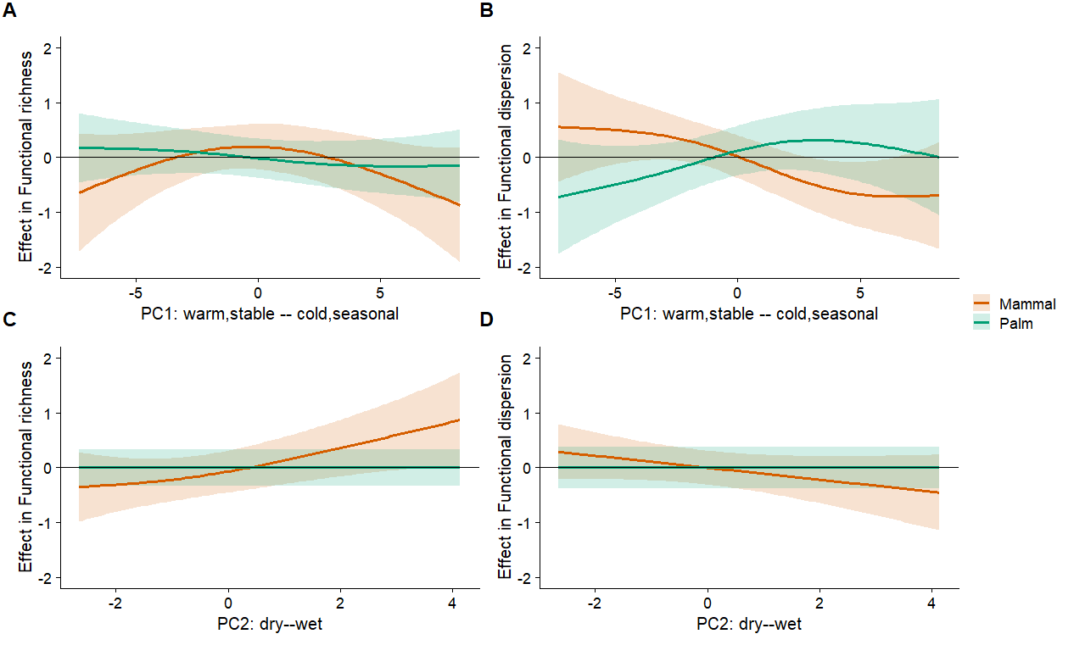
Figure 4: Figure 4. Climatic responses of producer and consumer functional diversity across the two major climatic gradients. Partial effects from generalized additive models relating climatic principal components to functional richness (FR; left column) and functional dispersion (FDis; right column) of palm (green) and mammal (orange) assemblages. (A) FR responses to PC1. (B) FDis responses to PC1. (C) FR responses to PC2. (D) FDis responses to PC2. Solid lines represent fitted smooth functions and shaded ribbons denote ±2 standard errors. Principal components summarize multivariate climatic variation derived from 19 bioclimatic variables (Figure 2). Responses are shown on the scale of the model partial effects, with positive and negative values indicating increases and decreases in functional diversity relative to the model intercept, respectively.

The influence of climate on functional trophic asymmetry
The influence of climate differed markedly between the two dimensions of functional diversity. Functional richness asymmetry exhibited little climatic structure, with no significant relationships along any climatic gradient and climate explaining only 1.4% of the deviance. Consistent with this result, mean standardized effect sizes for palms, mammals, and functional trophic asymmetry varied only modestly among climatic domains, with confidence intervals broadly overlapping zero (Figure 5). In contrast, functional dispersion asymmetry emerged because palms and mammals responded differently to the primary climatic gradient (PC1), which was the only significant predictor of asymmetry (F = 2.86, P = 0.002), explaining 29.4% of the deviance (adjusted R² = 0.243), whereas PC2 had no detectable effect (Figure S10; Table 1). In warm, climatically stable regions, palm assemblages were more functionally clustered than expected from null models (negative SES FDis), whereas mammal assemblages were more functionally overdispersed (positive SES FDis). These contrasting responses generated strong positive functional trophic asymmetry, indicating that consumers occupied a more evenly distributed functional space than producers under the same environmental conditions. By contrast, in colder and more seasonal climates, both trophic levels converged toward null expectations, reducing differences in their functional organization and causing functional trophic asymmetry to approach zero (Figure 5; Figure S11). Accounting for geographic structure had negligible effects on either functional trophic asymmetry metric (ΔAIC < 1; Figure S7).
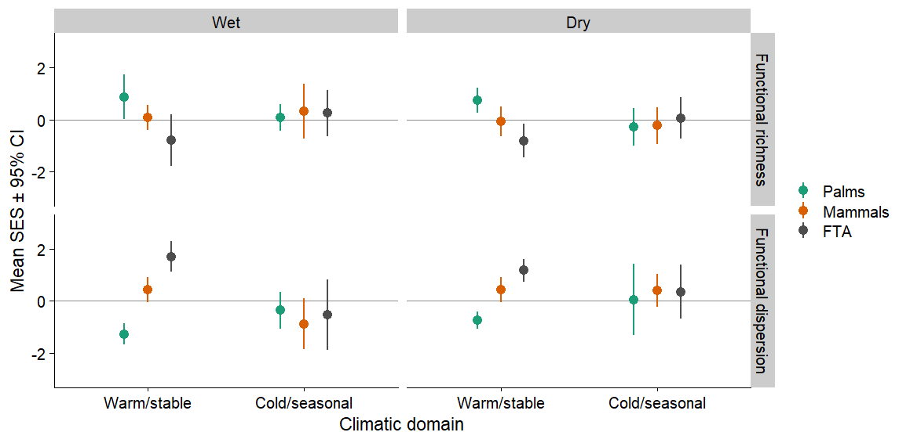
Figure 5: Functional richness, functional dispersion, and functional trophic asymmetry across major climatic domains. Mean standardized effect sizes (SES ± 95% confidence intervals) of palm (green) and mammal (orange) assemblages, together with functional trophic asymmetry (FTA; grey), across climatic domains defined by moisture availability (wet versus dry) and the temperature–seasonality gradient (warm/stable versus cold/seasonal). Upper panels show functional richness (FRic) and lower panels show functional dispersion (FDis). Positive SES values indicate greater functional diversity than expected under richness-constrained null models, whereas negative values indicate lower-than-expected functional diversity. Positive FTA values indicate greater SES in mammal assemblages relative to palm assemblages, whereas negative values indicate greater SES in palm assemblages. Error bars represent 95% confidence intervals.
 Table 1: Significance of climatic gradients in generalized additive models of functional diversity and trophic asymmetry.
Estimated degrees of freedom (EDF), F-statistics, and associated P-values for smooth terms relating the first three climatic principal components (PC1–PC3) to functional richness (FRic), functional dispersion (FDis), and functional trophic asymmetry (FTA). Climatic effects were generally weak for richness-based metrics, with only mammal FRic showing a significant association with PC2. In contrast, dispersion-based metrics exhibited stronger climatic relationships, particularly for mammal FDis, which was significantly associated with PC1 and PC3, and FTA FDis, which showed a significant association with PC1. Estimated degrees of freedom close to zero indicate little support for nonlinear responses along the corresponding climatic gradient.
Response | PC1 |  |  | PC2 |  |  | PC3
 | edf | F | P | edf | F | P | edf | F | P
Palm FRic | 0.60 | 0.25 | 0.201 | 0.00 | 0.00 | 0.441 | 0.00 | 0.00 | 0.623
Palm FDis | 1.19 | 0.72 | 0.091 | 0.00 | 0.00 | 0.363 | 0.73 | 0.34 | 0.159
Mammal FRic | 1.43 | 0.83 | 0.101 | 1.17 | 1.23 | 0.022 | 0.00 | 0.00 | 0.634
Mammal FDis | 1.45 | 1.99 | 0.007 | 0.69 | 0.55 | 0.071 | 0.81 | 1.06 | 0.028
FTA FRic | 0.00 | 0.00 | 0.399 | 0.24 | 0.08 | 0.260 | 0.00 | 0.00 | 0.979
FTA FDis | 1.65 | 2.86 | 0.002 | 0.92 | 0.40 | 0.166 | 0.00 | 0.00 | 0.927

DISCUSSION
Our study reveals that functional traits relevant to the assembly of mutualistic interactions between producers (palms) and their consumers (mammalian frugivores) are differentially filtered by climate across trophic levels and geographic regions of the Neotropics. Climatic gradients exert substantially stronger effects on mammalian than palm functional diversity, with both temperature/seasonality (PC1) and moisture regime (PC2) jointly determining where functional trophic asymmetries emerge. The strongest asymmetries occurred in biogeographic regions with warm, climatically stable environments. However, its direction depended on moisture availability. In warm/stable, dry regions, mammalian assemblages were relatively more functionally dispersed than palm assemblages, whereas in warm/stable, wet regions the opposite pattern emerged, with palms exhibiting greater functional dispersion. By contrast, functional trophic asymmetry was comparatively weak across cold/seasonal climatic domains.

The influence of climate on FTA
Functional trophic asymmetry emerged because climate influenced mammal functional diversity more strongly than palm functional diversity, with stronger effects on functional dispersion than on functional richness. The stronger climatic signal for mammalian functional dispersion is consistent with previous observations of ecological packing in species-rich tropical assemblages, where warm, productive and climatically stable environments promote the coexistence of functionally similar species (Kraft et al. 2015; Safi et al. 2011; González-Maya et al. 2017). Increased packing of consumer functional space is expected to increase overlap in potential interaction niches, allowing multiple mammal species to exploit similar sets of palm resources. Consequently, contemporary climate may reshape the organization of mutualistic interactions primarily by reorganizing consumer functional space rather than by changing the breadth of ecological strategies available for palm seed dispersal. The comparatively weak climatic response of palm functional diversity suggests that producer functional traits are buffered against contemporary climatic filtering. Mammalian functional traits may respond more rapidly to energetic constraints and resource availability (Boratyński 2021; Brandl et al. 2023), whereas palm functional traits are likely constrained by longer generation times and stronger historical legacies. This interpretation is consistent with evidence that present-day palm assemblages retain a strong imprint of past climatic conditions, reducing their sensitivity to contemporary environmental gradients (Kissling et al. 2012; Göldel, Böhning-Gaese, and Schleuning 2015).
 Table 2: Performance of generalized additive models relating climatic gradients to functional diversity and trophic asymmetry across Neotropical biogeographic provinces.
Model performance is summarized by the percentage of deviance explained, adjusted R², Akaike Information Criterion (AIC), and the change in AIC following the inclusion of spatial structure (ΔAIC). Positive ΔAIC values indicate support for including spatial predictors, whereas negative values indicate no improvement over climate-only models.
Response | Deviance explained (%) | Adjusted R² | AIC | ΔAIC
Palm FR | 4.1 | 0.025 | 118.07 | -0.38
Palm FDis | 14.4 | 0.098 | 131.60 | 0.44
Mammal FR | 19.8 | 0.140 | 120.03 | 1.75
Mammal FDis | 32.2 | 0.265 | 115.30 | 7.68
FTA-FR | 1.4 | 0.008 | 136.89 | -0.27
FTA-FDis | 29.4 | 0.243 | 143.56 | 6.69

The potential consequences of FTA for ecological network assembly
Differential climatic responses across trophic levels may have important consequences for the assembly and persistence of ecological interactions. Because mutualistic interactions emerge through trait matching between producers and consumers, the ecological consequences of functional trophic asymmetry are likely to depend on the degree to which interactions are constrained by compatible trait combinations (Dehling et al. 2021; Bartomeus et al. 2016; Albrecht et al. 2018; Armbruster, Pélabon, and Hansen 2014). Consequently, the effects of regional functional trophic asymmetry in the assembly of local networks should depend on the capacity of species in the community to establish novel interactions (Marjakangas et al. 2022). Where interactions are flexible, changes in consumer functional composition may be accommodated through partner switching, allowing networks to reorganize while maintaining overall connectivity (Caradonna, Bain, and Waser 2021). In contrast, where interactions depend on a narrow range of compatible trait combinations, asymmetric changes in producer and consumer functional diversity may reduce the availability of suitable partners, increasing the risk of interaction loss and secondary extinctions (Schleuning et al. 2012; Schleuning, Fründ, and García 2015; Gillespie et al. 2024). Functional trophic asymmetry may therefore help identify regions where climatic change is most likely to reorganize ecological networks (Classen et al. 2020), providing a functional link between environmental filtering, trait matching, and the assembly of multitrophic networks (Marjakangas et al. 2022).
An important next step is to evaluate whether functional trophic asymmetry predicts the organization of empirical ecological networks (Classen et al. 2020; Opedal and Hegland 2020; Yahaya et al. 2024). Although our framework infers potential interaction niches from species traits and distributions, the increasing availability of standardized regional interaction datasets (metawebs) Caron et al. (2022)] provides an opportunity to test whether regions with greater functional trophic asymmetry exhibit predictable differences in network architecture, including specialization, modularity, connectance, and robustness to species loss (Montoya and Raffaelli 2010; Schleuning, Fründ, and García 2015; Schleuning, García, and Tobias 2023) Such tests would determine whether asymmetries in producer and consumer functional diversity translate into realized differences in network structure and ecosystem functioning (Schleuning, Fründ, and García 2016; Strydom et al. 2022). Extending this framework by projecting synthetic interaction networks to local assemblages using species abundances, habitat suitability, dispersal constraints, and local environmental conditions (Banville et al. 2024; Beumer et al. 2025) would allow direct evaluation of how functional trophic asymmetry influences the assembly of ecological networks across spatial scales (Galiana et al. 2018; Ponisio et al. 2019; Thuiller et al. 2024).

Functional trophic asymmetry as a multitrophic indicator of ecological processes and their response to global changes
Our findings suggest that climatic filtering is one mechanism generating functional trophic asymmetry, but climate is unlikely to be the only driver. Habitat loss, defaunation, biological invasions, and other forms of anthropogenic environmental change can independently alter the functional composition of producers or consumers, potentially increasing or reducing asymmetry between trophic levels (Tinoco et al. 2018; Guevara, Torres, and Graham 2023b, 2023a; Bello, Schleuning, and Graham 2023; Guerra et al. 2025). Indeed, a growing body of evidence shows that anthropogenic disturbances often affect trophic levels asymmetrically, with consumer communities, particularly large vertebrates, experiencing greater functional losses than producers (Duffy and E 2003; Hogsden, Xenopoulos, and Rusak 2009; Dirzo et al. 2014). Functional trophic asymmetry provides a framework for quantifying these differential responses and comparing how diverse environmental drivers reshape the relative functional organization of interacting trophic levels. By extending trait-based approaches beyond individual trophic levels, FTA offers a common framework for investigating how environmental change propagates through multitrophic communities and ultimately influences the organization of ecological interactions.
Climate strongly structured functional dispersion asymmetry but had comparatively little influence on functional richness asymmetry. This contrast suggests that the two dimensions of functional trophic asymmetry differ in their sensitivity to contemporary climatic filtering. Because functional trophic asymmetry was evaluated across biogeographic provinces, the comparatively weak climatic signal for functional richness asymmetry indicates that province-specific historical processes may also contribute to regional differences. Biogeographic provinces integrate long-term histories of diversification, extinction, and dispersal that shape the regional pool of functional strategies available to interacting trophic levels. Functional richness asymmetry may therefore be more strongly influenced by these historical legacies, whereas functional dispersion appears more responsive to present-day environmental conditions.
This interpretation is consistent with previous studies showing that historical and contemporary processes often contribute differently to patterns of functional diversity. For example, Quaternary climatic history exerts a strong influence on plant functional diversity (Ordonez and Svenning 2017), whereas contemporary climatic gradients more strongly structure functional diversity in woody plants and mammals (Swenson et al. 2012; Hedberg and Smith 2025). Other systems exhibit the opposite pattern. For instance, global freshwater fish assemblages show stronger historical controls on functional dispersion but stronger contemporary controls on functional richness (Su et al. 2022), illustrating that the balance between historical legacies and contemporary environmental filtering varies among taxa. Functional trophic asymmetry therefore provides a framework for investigating how historical eco-evolutionary processes and contemporary environmental filtering jointly shape the functional organization of interacting trophic levels.

CONCLUSION
As climate change alters precipitation regimes, dry-season intensity, and climatic stability, functional trophic asymmetry is likely to change across Neotropical palm–frugivore assemblages. Because climate and other global change drivers can differentially affect producer and consumer functional diversity, they may reshape potential interaction niches and the functional organization of ecological networks, particularly where opportunities for interaction rewiring are limited (Tylianakis et al. 2008; Caradonna, Bain, and Waser 2021; Cruz, Souza, and Rosumek 2023). Functional trophic asymmetry therefore provides a framework for generating and testing predictions about how differential functional responses across trophic levels influence the reorganization of ecological networks under environmental change. Evaluating these predictions across diverse ecosystems will establish the generality of functional trophic asymmetry as an indicator of multitrophic responses to global change (Acosta-Rojas et al. 2023; Nowak et al. 2022; Landim et al. 2025; Rabeau et al. 2025). By extending trait-based approaches beyond individual trophic levels, FTA is a general multitrophic framework that links broad-scale environmental filtering to the functional organization of ecological networks.

SUPPLEMENTARY MATERIAL

Figure S1. Correlations among WorldClim bioclimatic variables across Neotropical biogeographic provinces
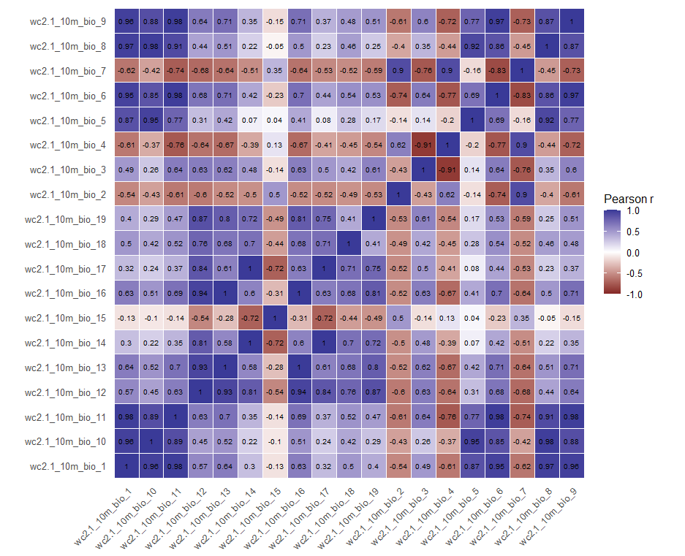
Figure S1. Correlations among WorldClim bioclimatic variables across Neotropical biogeographic provinces. Pearson correlation coefficients were calculated from mean bioclimatic values extracted for each province. Strong correlations among variables justify the use of principal component analysis to summarize climatic variation before modelling functional diversity and functional trophic asymmetry.

Figure S2. Loadings of bioclimatic variables on the first three climatic principal components.
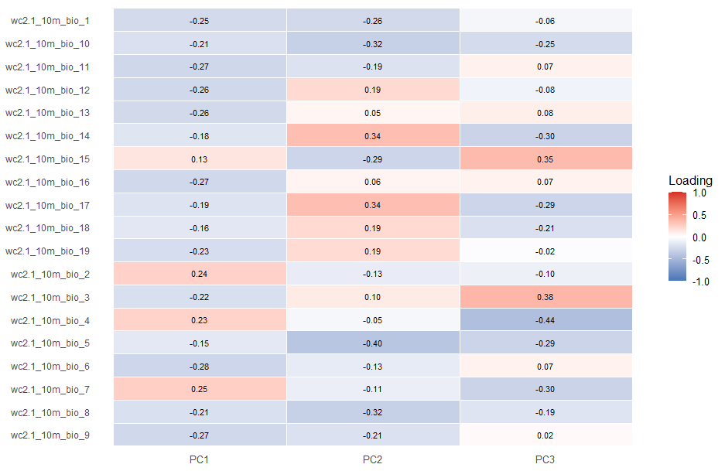
Figure S2. Loadings of bioclimatic variables on the first three climatic principal components. Heatmap showing the loadings of the 19 WorldClim bioclimatic variables (BIO1–BIO19) on the first three principal components (PC1–PC3) derived from principal component analysis (PCA). Cell colours and numerical values indicate the magnitude and direction of each variable’s contribution to each principal component, with red representing positive loadings and blue representing negative loadings. Together, PC1–PC3 explained 87.9% of the total climatic variation across the study region and were subsequently used as predictors of producer, consumer, and functional trophic asymmetry patterns.

Figure S3. Relative contributions of bioclimatic variables to the first three climatic principal components
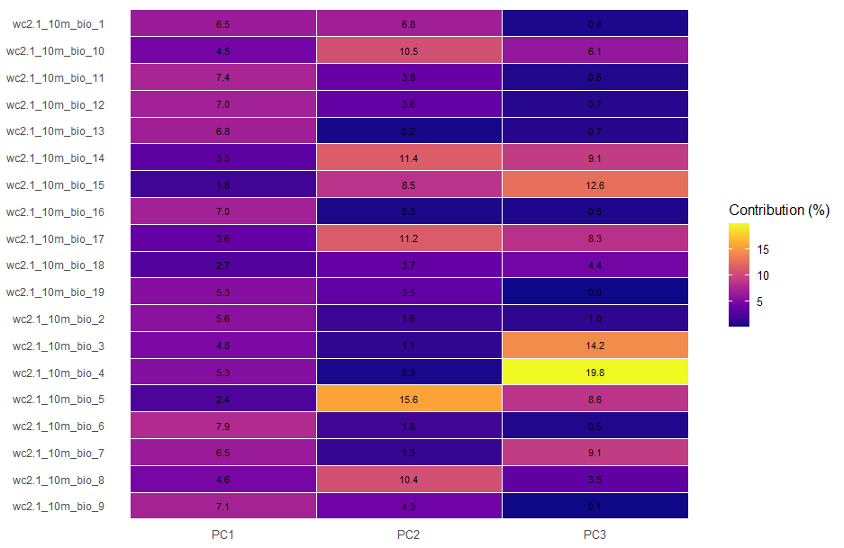
Figure S3. Relative contributions of bioclimatic variables to the first three climatic principal components. Heatmap showing the percentage contribution of the 19 WorldClim bioclimatic variables (BIO1–BIO19) to the first three principal components (PC1–PC3) derived from principal component analysis (PCA). Cell colours and numerical values indicate the relative contribution (%) of each variable to each principal component, with warmer colours representing greater contributions. These contributions were used to aid the ecological interpretation of the climatic gradients represented by PC1–PC3, which together explained 87.9% of the total climatic variation across the study region.

Figure S4: Variance explained by retained functional trait axes.
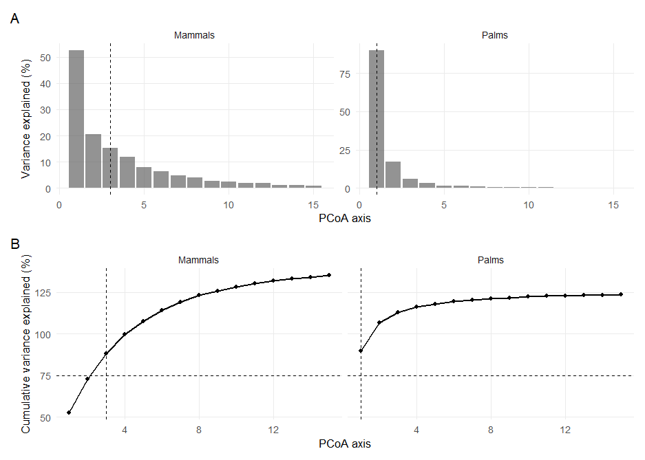
Figure S4: Variance explained by retained functional trait axes. Bars (A) show the percentage of trait variation explained by individual PCoA axes for palms and mammalian frugivores. Lines (B) show cumulative variance explained. Dashed horizontal lines indicate the 75% threshold used to select retained axes, and dashed vertical lines indicate the number of axes retained for each trophic level.

Figure S5. Functional trait spaces of palms and mammals
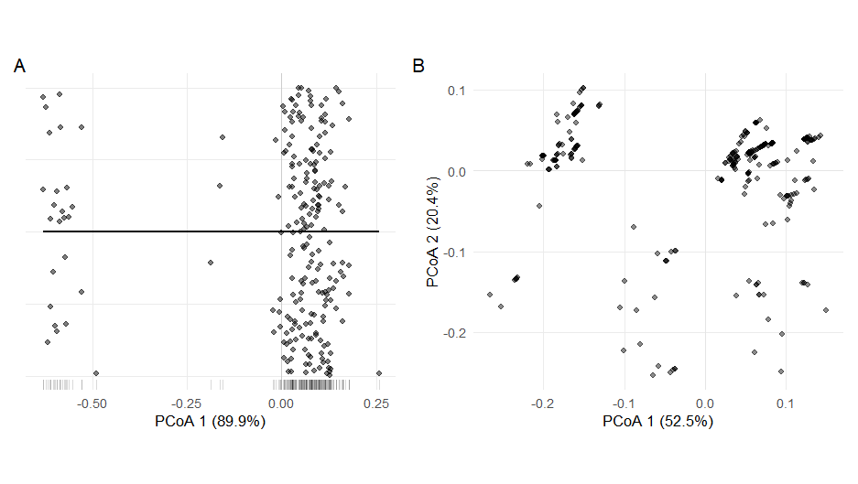
Figure S5. Functional trait spaces of palms and mammals. Principal coordinates analysis (PCoA) of species functional trait spaces for (A) palms and (B) mammalian frugivores. Species are represented as points positioned according to their multivariate trait similarities based on Gower distances. The percentage of total trait variation explained by each axis is shown in parentheses. Panel A displays the first principal coordinate axis for palms, with species distributed along a one-dimensional functional gradient (rug marks indicate species scores on the axis). Panel B shows the first two principal coordinate axes for mammals, illustrating the multidimensional distribution of functional strategies used to estimate functional richness (FRic) and functional dispersion (FDis).

Figure S6. Relative contributions of functional traits to the multidimensional trait spaces of palms and mammals
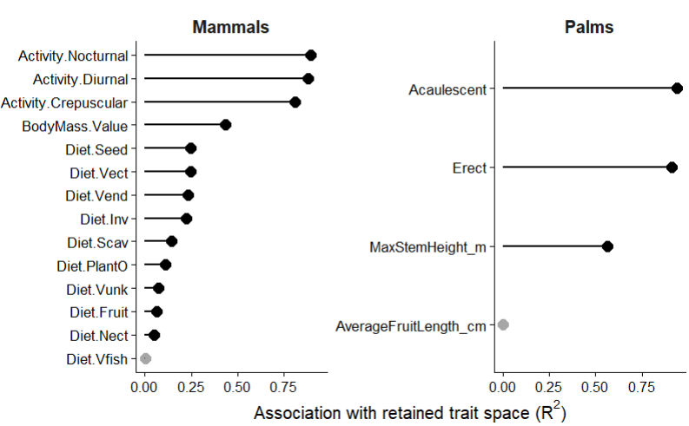
Figure S6. Relative contributions of functional traits to the multidimensional trait spaces of palms and mammals. Trait contributions were quantified by fitting original trait variables onto the retained principal coordinates (PCoA) spaces derived from Gower trait distances using permutation-based environmental fitting (envfit). Points represent the proportion of variation in the retained multidimensional trait space explained by each trait (R²), with horizontal segments extending from zero to the corresponding R² value. Black points indicate statistically significant trait–ordination associations (permutation test, p < 0.05), whereas grey points denote non-significant associations.

Figure S7. Diagnostic plots for the generalized additive model (FR).
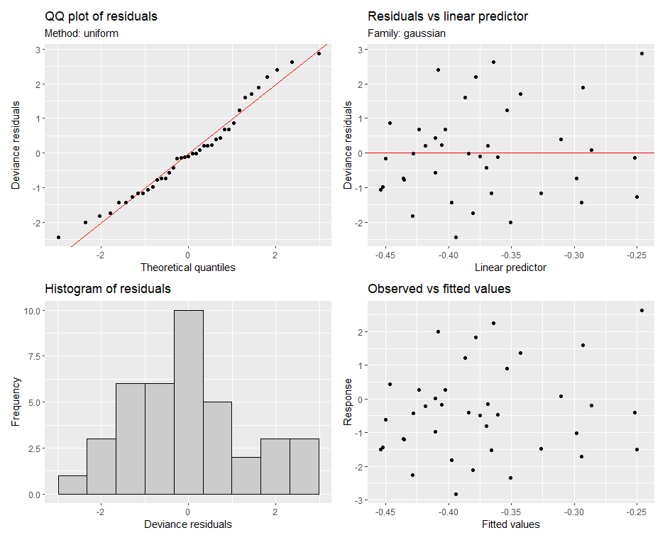

Figure S8. Diagnostic plots for the generalized additive model (FDis).
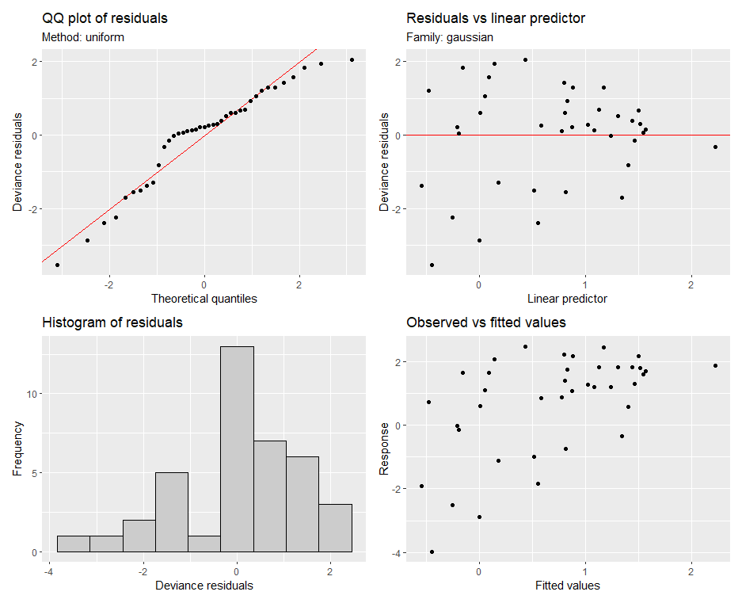
Figure S7. Diagnostic plots for the generalized additive model (FDis). Model diagnostic plots used to evaluate the assumptions of the Gaussian generalized additive model (GAM). Panels show (top left) a quantile–quantile (Q–Q) plot of deviance residuals, (top right) deviance residuals plotted against the linear predictor, (bottom left) the distribution of deviance residuals, and (bottom right) observed versus fitted response values. Together, these diagnostics indicate that model assumptions of residual normality, homoscedasticity, and overall goodness of fit were adequately satisfied.

Figure S9: Improvement in model fit after accounting for spatial structure.
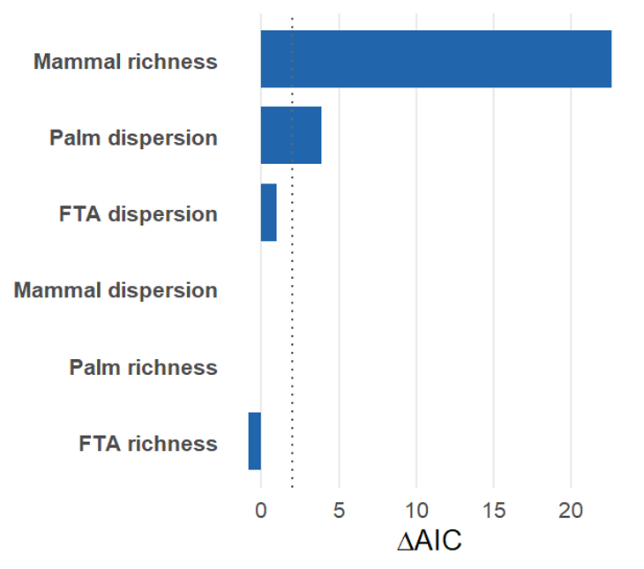
Figure S9: Improvement in model fit after accounting for spatial structure. Bars show the change in Akaike Information Criterion (ΔAIC) between climate-only models and models including both climatic and spatial predictors for functional richness (FRic), functional dispersion (FDis), and functional trophic asymmetry (FTA). Positive values indicate improved model support following the inclusion of spatial structure, whereas negative values indicate no improvement. The vertical dashed line marks ΔAIC = 2, a commonly used threshold for meaningful model improvement.

Figure S10 Climatic distribution of functional trophic asymmetry across the two major climatic gradients
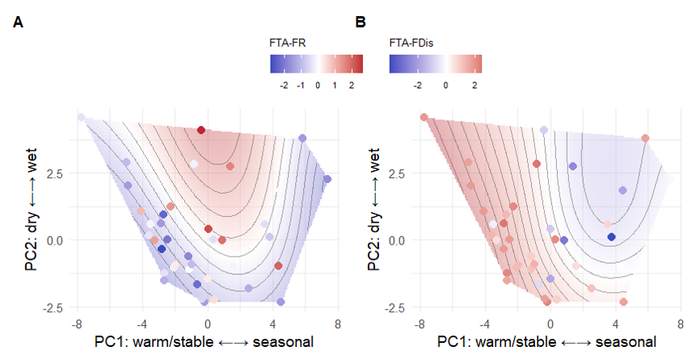
Figure S10. Climatic distribution of functional trophic asymmetry across the two major climatic gradients. Predicted response surfaces from generalized additive models relating climatic principal components PC1 (warm/stable to cold/seasonal) and PC2 (dry to wet) to functional trophic asymmetry in (A) functional richness (FTA-FR) and (B) functional dispersion (FTA-FDis). Colored points represent observed biogeographic provinces, with colors indicating the magnitude and direction of asymmetry (blue = greater palm functional diversity relative to mammals; red = greater mammal functional diversity relative to palms). Contours and shaded surfaces depict model predictions across the climatic space occupied by the Neotropics. Principal components summarize multivariate climatic variation derived from 19 bioclimatic variables (Figure 2).

Figure S11. Relationships between multitrophic functional diversity and functional trophic asymmetry across Neotropical biogeographic provinces.
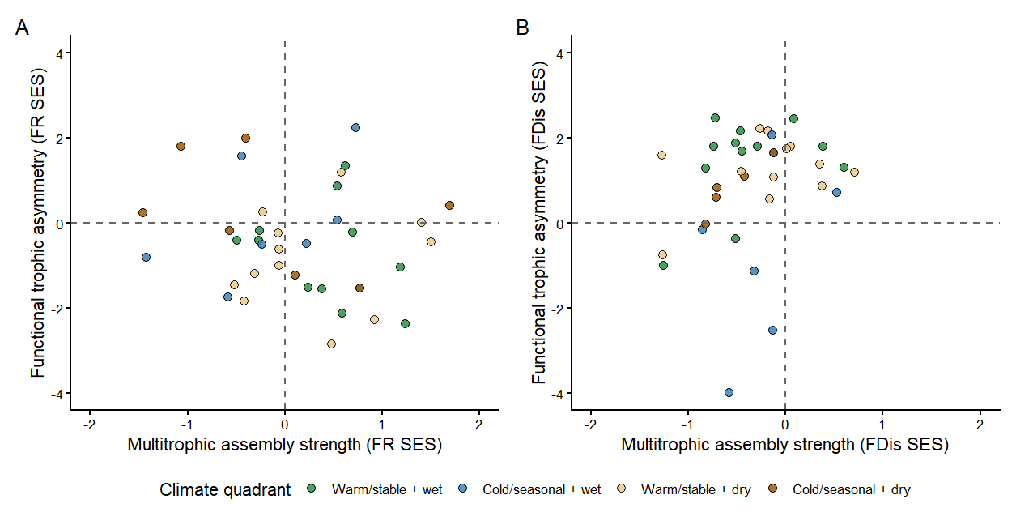
Figure S11. Relationships between multitrophic functional diversity and functional trophic asymmetry across Neotropical biogeographic provinces. Scatterplots showing the association between multitrophic assemblage strength (mean standardized effect size, SES, across palms and mammals) and functional trophic asymmetry (FTA; mammal SES − palm SES) for (A) functional richness (FR) and (B) functional dispersion (FDis). Each point represents a biogeographic province and is coloured according to its climatic domain: warm/stable + wet, cold/seasonal + wet, warm/stable + dry, and cold/seasonal + dry. Dashed horizontal and vertical lines indicate zero values, separating provinces with above- and below-null multitrophic functional diversity and positive or negative functional trophic asymmetry. Positive FTA values indicate greater SES in mammal assemblages relative to palm assemblages, whereas negative values indicate greater SES in palm assemblages.

REFERENCES
Acevedo-Quintero, J. F., J. G. Zamora-Abrego, and D. García. 2020. “From Structure to Function in Mutualistic Interaction Networks: Topologically Important Frugivores Have Greater Potential as Seed Dispersers.” Journal of Animal Ecology 89: 2181–91.
Ackerly, D. D. 2003. “Community Assembly, Niche Conservatism, and Adaptive Evolution in Changing Environments.” International Journal of Plant Sciences 164: S165–84.
Acosta-Rojas, D. C., M. K. Barczyk, C. I. Espinosa, N. Farwig, J. Homeier, Y. Tiede, et al. 2023. “Abiotic Factors Similarly Shape the Distribution of Fruit, Seed and Leaf Traits in Tropical Fleshy-Fruited Tree Communities.” Acta Oecologica 121: 103953.
Albrecht, J., A. Classen, M. G. R. Vollstädt, A. Mayr, N. P. Mollel, D. Schellenberger Costa, et al. 2018. “Plant and Animal Functional Diversity Drive Mutualistic Network Assembly Across an Elevational Gradient.” Nature Communications 9: 3177.
Allesina, S., D. Alonso, and M. Pascual. 2008. “A General Model for Food Web Structure.” Science 320: 658–61.
Armbruster, W. S., Bolstad Pélabon C., and T. F Hansen. 2014. “Integrated Phenotypes: Understanding Trait Covariation in Plants and Animals.” Philosophical Transactions of the Royal Society B: Biological Sciences, 369 (1649): 20130245.
Balslev, H., W. L. Eiserhardt, T. Kristiansen, and F. Borchsenius. 2015. “Palms and Palm Communities in the Seasonally Dry Tropical Forests of the Americas.” Journal of Systematics and Evolution 53: 453–80.
Banville, F., Blyth Strydom T., G., others, and T and Poisot. 2024. “Deciphering Probabilistic Species Interaction Networks.”
Bartomeus, Ignasi, Dominique Gravel, Jason M Tylianakis, Marcelo A Aizen, Ian A Dickie, and Maud Bernard-Verdier. 2016. “A Common Framework for Identifying Linkage Rules Across Different Types of Interactions.” Functional Ecology 30 (12): 1894–1903.
Bauer, Barbara, Michael Kleyer, Dirk C Albach, Bernd Blasius, Ulrich Brose, Thalita Ferreira-Arruda, Ulrike Feudel, et al. 2021. “Functional Trait Dimensions of Trophic Metacommunities.” Ecography 44 (10): 1486–1500.
Bello, C., M. Schleuning, and C. H. Graham. 2023. “Analyzing Trophic Ecosystem Functions with the Interaction Functional Space.” Trends in Ecology & Evolution 38: 424–34.
Beumer, L. T., A. G. Hertel, R. Royaute, M. A. Tucker, J. Albrecht, R. Beltran, et al. 2025. “MoveTraits: A Database for Integrating Animal Behaviour into Trait-Based Ecology.” bioRxiv 2025–2003.
Bjorholm, S., J. -C. Svenning, F. Skov, and H. Balslev. 2005. “Environmental and Spatial Controls of Palm (Arecaceae) Species Richness Across the Americas.” Global Ecology and Biogeography 14: 423–29.
Blüthgen, N., F. Menzel, and N. Blüthgen. 2006. “Measuring Specialization in Species Interaction Networks.” BMC Ecology 6: 1–12.
Bogoni, J. A., C. A. Peres, and K. M. Ferraz. 2020. “Extent, Intensity and Drivers of Mammal Defaunation: A Continental-Scale Analysis Across the Neotropics.” Scientific Reports 10: 14750.
Boratyński, Z. 2021. “Energetic Constraints on Mammalian Distribution Areas.” Journal of Animal Ecology, 90 (8): 1854–63.
Borzone Mas, Dalmiro, Pablo A Scarabotti, Pablo A Vaschetto, Patricio Alvarenga, Martin Vazquez, and Matı́as Arim. 2026. “On Traits Matching and the Modular Organization of Food Web and Occurrence Networks.” Journal of Animal Ecology 95 (5): 837–50.
Brandl, S. J., Lefcheck, J. S., A. E., D. B., and T Norin. 2023. “Can Metabolic Traits Explain Animal Community Assembly and Functioning?” Biological Reviews, 98 (1): 1–18.
Caradonna, P. J., J. M. Bain, and N. M. Waser. 2021. “Anthropogenic Changes in Temperature and Precipitation Alter Floral Traits and Pollinator Visitation.” Ecology Letters 24: 302–13. https://doi.org/10.1111/ele.13640.
Caron, Dominique, Luigi Maiorano, Wilfried Thuiller, and Laura J Pollock. 2022. “Addressing the Eltonian Shortfall with Trait-Based Interaction Models.” Ecology Letters 25 (4): 889–99.
Chase, Jonathan M, Nathan JB Kraft, Kevin G Smith, Mark Vellend, and Brian D Inouye. 2011. “Using Null Models to Disentangle Variation in Community Dissimilarity from Variation in $α$-Diversity.” Ecosphere 2 (2): 1–11.
Classen, Alice, Connal D Eardley, Andreas Hemp, Marcell K Peters, Ralph S Peters, Axel Ssymank, and Ingolf Steffan-Dewenter. 2020. “Specialization of Plant–Pollinator Interactions Increases with Temperature at Mt. Kilimanjaro.” Ecology and Evolution 10 (4): 2182–95.
Cruz, M. M., B. A. Souza, and F. B. Rosumek. 2023. “Climate Change Affects Mutualistic Networks: A Meta-Analysis of Ecological and Evolutionary Responses.” Global Ecology and Biogeography 32: 603–15. https://doi.org/10.1111/geb.13667.
Dehling, D. M., E. Barreto, and C. H. Graham. 2022. “The Contribution of Mutualistic Interactions to Functional and Phylogenetic Diversity.” Trends in Ecology & Evolution 37: 768–76.
Dehling, D. M., I. M. A. Bender, P. G. Blendinger, K. Böhning-Gaese, M. C. Muñoz, E. L. Neuschulz, et al. 2021. “Specialists and Generalists Fulfil Important and Complementary Functional Roles in Ecological Processes.” Functional Ecology 35: 1810–21.
Dirzo, R., Young, M., N. J., and B Collen. 2014. “Defaunation in the Anthropocene.” Science, 345 (6195): 401–6.
Donoso, I., M. Schleuning, D. García, and J. Fründ. 2017. “Defaunation Effects on Plant Recruitment Depend on Size Matching and Size Trade-Offs in Seed-Dispersal Networks.” Proceedings of the Royal Society B 284: 20162664.
Donoso, I., M. C. Sorensen, P. G. Blendinger, W. D. Kissling, E. L. Neuschulz, T. Mueller, and M. Schleuning. 2020. “Downsizing of Animal Communities Triggers Stronger Functional Than Structural Decay in Seed-Dispersal Networks.” Nature Communications 11: 1582.
Duffy, J., and E. 2003. “Biodiversity Loss, Trophic Skew and Ecosystem Functioning.” Ecology Letters, 6 (8): 680–87.
Fick, S. E., and R. J. Hijmans. 2017. “WorldClim 2: New 1-Km Spatial Resolution Climate Surfaces for Global Land Areas.” International Journal of Climatology 37: 4302–15. https://doi.org/10.1002/joc.5086.
Fitzgerald, Daniel B, Kirk O Winemiller, Mark H Sabaj Pérez, and Leandro M Sousa. 2017. “Using Trophic Structure to Reveal Patterns of Trait-Based Community Assembly Across Niche Dimensions.” Functional Ecology 31 (5): 1135–44.
Fuzessy, L. F., and M. A. Pizo. 2025. “Seed Dispersal Networks and the Functional Diversity of Neotropical Mammals.” Ecography.
Galiana, Nuria, Miguel Lurgi, Bernat Claramunt-López, Marie-Josée Fortin, Shawn Leroux, Kevin Cazelles, Dominique Gravel, and José M Montoya. 2018. “The Spatial Scaling of Species Interaction Networks.” Nature Ecology & Evolution 2 (5): 782–90.
Gillespie, Mark AK, Mathilde Baude, Jacobus Biesmeijer, Nigel Boatman, Giles E Budge, Andrew Crowe, Nancy Davies, et al. 2024. “Flowering Plant Communities Mediate the Effects of Habitat Composition and Configuration on Wild Pollinator Communities.” Functional Ecology 38 (12): 2576–94.
Göldel, B., K. Böhning-Gaese, and M. Schleuning. 2015. “Trait-Based Analysis of Bird Community Assembly Along Environmental Gradients in Tropical Mountain Forests.” Journal of Biogeography 42: 2260–71. https://doi.org/10.1111/jbi.12591.
González-Maya, José F, Enrique Martı́nez-Meyer, Rodrigo Medellı́n, and Gerardo Ceballos. 2017. “Distribution of Mammal Functional Diversity in the Neotropical Realm: Influence of Land-Use and Extinction Risk.” PLoS One 12 (4): e0175931.
Guerra, Daniel, Andressa Cabral, Mariana Paetzolt, et al. 2025. “Human-Induced Downsizing of Animal Communities Weakens Trait Matching Between Tropical Plants and Frugivores.” Authorea preprint.
Guevara, J. E., C. A. Torres, and C. H. Graham. 2023a. “Functional Roles of Plants Decline More Rapidly Than Those of Pollinators with Deforestation.” Journal of Applied Ecology 60: 284–94. https://doi.org/10.1111/1365-2664.14309.
———. 2023b. “Habitat Loss Drives Declines in Functional Complementarity in Tropical Pollination Networks.” Ecological Applications 33: e2731. https://doi.org/10.1002/eap.2731.
Guzman, Laura Melissa, Rachel M Germain, Coreen Forbes, Samantha Straus, Mary I O’Connor, Dominique Gravel, Diane S Srivastava, and Patrick L Thompson. 2019. “Towards a Multi-Trophic Extension of Metacommunity Ecology.” Ecology Letters 22 (1): 19–33.
Halpern, B. S., and S. R. Floeter. 2008. “Functional Diversity Responses to Changing Species Richness in Reef Fish Communities.” Marine Ecology Progress Series 364: 147–56.
Hedberg, C. P., and F. A Smith. 2025. “Unraveling the Role of Environmental and Anthropogenic Drivers in Shaping Global Patterns in Mammal Diversity.” Ecography, 2025 (10): e07674.
HilleRisLambers, J., P. B. Adler, W. S. Harpole, J. M. Levine, and M. M. Mayfield. 2012. “Rethinking Community Assembly Through the Lens of Coexistence Theory.” Annual Review of Ecology, Evolution, and Systematics 43: 227–48.
Hoekstra, F. A., E. A. Golovina, and J. Buitink. 2001. “Mechanisms of Plant Desiccation Tolerance.” Trends in Plant Science 6: 431–38.
Hogsden, K. L., M. A. Xenopoulos, and J. A Rusak. 2009. “Asymmetrical Food Web Responses in Trophic-Level Richness, Biomass, and Function Following Lake Acidification.” Aquatic Ecology, 43 (2): 591–606.
Kissling, W. D., H. Balslev, W. J. Baker, J. Dransfield, W. L. Eiserhardt, F. Borchsenius, et al. 2019. “PalmTraits 1.0, a Species-Level Functional Trait Database of Palms Worldwide.” Scientific Data 6: 178. https://doi.org/10.1038/s41597-019-0174-2.
Kissling, W. D., C. F. Dormann, J. Groeneveld, T. Hickler, I. Kühn, G. J. McInerny, et al. 2012. “Towards Novel Approaches to Modelling Biotic Interactions in Multispecies Assemblages at Large Spatial Extents.” Journal of Biogeography 39: 2163–78.
Kraft, N. J. B., and D. D. Ackerly. 2010. “Functional Trait and Phylogenetic Tests of Community Assembly Across Spatial Scales in an Amazonian Forest.” Ecological Monographs 80: 401–22.
Kraft, N. J. B., P. B. Adler, O. Godoy, E. C. James, S. Fuller, and J. M. Levine. 2015. “Community Assembly, Coexistence and the Environmental Filtering Metaphor.” Functional Ecology 29: 592–99.
Kraft, N. J. B., R. Valencia, and D. D. Ackerly. 2008. “Functional Traits and Niche-Based Tree Community Assembly in an Amazonian Forest.” Science 322: 580–82.
Laliberté, E., and P. Legendre. 2010. “A Distance-Based Framework for Measuring Functional Diversity from Multiple Traits.” Ecology 91: 299–305.
Landim, A. R., E. L. Neuschulz, I. Donoso, M. C. Sorensen, T. Mueller, and M. Schleuning. 2025. “Functional Connectivity of Animal-Dispersed Plant Communities Depends on the Interacting Effects of Network Specialization and Resource Diversity.” Proceedings of the Royal Society B 292: 20242995.
Lavorel, S. 2013. “Plant Functional Effects on Ecosystem Services.” Journal of Ecology 101: 4–8.
Lim, Jun Ying, Jens-Christian Svenning, Bastian Göldel, Søren Faurby, and W Daniel Kissling. 2020. “Frugivore-Fruit Size Relationships Between Palms and Mammals Reveal Past and Future Defaunation Impacts.” Nature Communications 11 (1): 4904.
Marjakangas, E.-L., G. Muñoz, S. Turney, J. Albrecht, E. L. Neuschulz, M. Schleuning, and J. -P. Lessard. 2022. “Trait-Based Inference of Ecological Network Assembly: A Conceptual Framework and Methodological Toolbox.” Ecological Monographs 92: e1502.
Marques Dracxler, C., and W. D. Kissling. 2022. “The Mutualism–Antagonism Continuum in Neotropical Palm–Frugivore Interactions: From Interaction Outcomes to Ecosystem Dynamics.” Biological Reviews 97: 527–53.
Mason, Norman WH, Francesco de Bello, David Mouillot, Sandrine Pavoine, and Stéphane Dray. 2013. “A Guide for Using Functional Diversity Indices to Reveal Changes in Assembly Processes Along Ecological Gradients.” Journal of Vegetation Science 24 (5): 794–806.
Mason, Norman WH, David Mouillot, William G Lee, and J Bastow Wilson. 2005. “Functional Richness, Functional Evenness and Functional Divergence: The Primary Components of Functional Diversity.” Oikos 111 (1): 112–18.
McCain, C. M., and S. R. B. King. 2014. “Body Size and Activity Times Mediate Mammalian Responses to Climate Change.” Global Change Biology 20: 1760–69.
Medeiros, L. P., Thompson Garcia G., and P. R Guimaraes Jr. 2018. “The Geographic Mosaic of Coevolution in Mutualistic Networks.” Proceedings of the National Academy of Sciences, 115 (47): 12017–22.
Messeder, J. V. S., F. A. O. Silveira, T. G. Cornelissen, L. F. Fuzessy, and T. J. Guerra. 2021. “Frugivory and Seed Dispersal in a Hyperdiverse Plant Clade and Its Role as a Keystone Resource for the Neotropical Fauna.” Annals of Botany 127: 577–95.
Montoya, J. M., and D. Raffaelli. 2010. “Climate Change, Biotic Interactions and Ecosystem Services.” Philosophical Transactions of the Royal Society B 365: 2013–18.
Moretti, M., and C. Legg. 2009. “Combining Plant and Animal Traits to Assess Community Functional Responses to Disturbance.” Ecography 32: 299–309.
Morrone, Juan J. 2014. “Cladistic Biogeography of the n Eotropical Region: Identifying the Main Events in the Diversification of the Terrestrial Biota.” Cladistics 30 (2): 202–14.
Muñoz, G., K. Trøjelsgaard, and W. D. Kissling. 2019. “A Synthesis of Animal-Mediated Seed Dispersal of Palms Reveals Distinct Biogeographical Differences in Species Interactions.” Journal of Biogeography 46: 466–84.
Nowak, L., E. C. Fricke, A. Traveset, and I. Donoso. 2022. “Climate-Driven Changes in the Trait Diversity of Interacting Avian Frugivores and Fruiting Plants.” Global Change Biology 28: 6561–74. https://doi.org/10.1111/gcb.16334.
Onstein, R. E., W. J. Baker, T. L. P. Couvreur, S. Faurby J.-C. Svenning, and W. D. Kissling. 2017. “Frugivory-Related Traits Promote Speciation of Tropical Palms.” Nature Ecology & Evolution 1: 1903–11.
Onstein, R. E., R. J. Carter, Y. Xing, and H. P. Linder. 2014. “Diversification Rate Shifts in the Cape Floristic Region: The Right Traits in the Right Place at the Right Time.” Perspectives in Plant Ecology, Evolution and Systematics 16: 331–40.
Opedal, Øystein H, and Stein J Hegland. 2020. “Using Hierarchical Joint Models to Study Reproductive Interactions in Plant Communities.” Journal of Ecology 108 (2): 485–95.
Ordonez, A., and J. C Svenning. 2017. “Consistent Role of Quaternary Climate Change in Shaping Current Plant Functional Diversity Patterns Across European Plant Orders.” Scientific Reports, 7 (1): 42988.
Paine, C. E. T., C. Baraloto, J. Chave, and B. Hérault. 2011. “Functional Traits of Individual Trees Reveal Ecological Constraints on Community Assembly in Tropical Rain Forests.” Oikos 120: 720–27.
Ponisio, Lauren C, Fernanda S Valdovinos, Korinna T Allhoff, Marı́lia P Gaiarsa, Allison Barner, Paulo R Guimarães Jr, David H Hembry, Beth Morrison, and Rosemary Gillespie. 2019. “A Network Perspective for Community Assembly.” Frontiers in Ecology and Evolution 7: 103.
Rabeau, A., A. Pigot, J. Tobias, and M. Schleuning. 2025. “Projected Impacts of Climate Change on Plant–Frugivore Interactions Across the Americas.” bioRxiv 2025–2003.
Roncal, J., F. Borchsenius, C. Asmussen-Lange, H. Balslev, and W. J. Baker. 2013. “Dated Molecular Phylogenies of Palms and the Evolution of Growth Forms.” Botanical Journal of the Linnean Society 171: 44–60.
Safi, Kamran, Marcus V Cianciaruso, Rafael D Loyola, Daniel Brito, Katrina Armour-Marshall, and José Alexandre F Diniz-Filho. 2011. “Understanding Global Patterns of Mammalian Functional and Phylogenetic Diversity.” Philosophical Transactions of the Royal Society B: Biological Sciences 366 (1577): 2536.
Saravia, L. A., T. I. Marina, N. P. Kristensen, M. De Troch, and F. R. Momo. 2022. “Ecological Network Assembly: How the Regional Metaweb Influences Local Food Webs.” Journal of Animal Ecology 91: 630–42.
Schleuning, M., J. Fründ A.-M. Klein, S. Abrahamczyk, R. Alarcón, M. Albrecht, et al. 2012. “Specialization of Mutualistic Interaction Networks Decreases Toward Tropical Latitudes.” Current Biology 22: 1925–31.
Schleuning, M., J. Fründ, and D García. 2015. “Predicting Ecosystem Functions from Biodiversity and Mutualistic Networks: An Extension of Trait‐based Concepts to Plant–Animal Interactions.” Ecography, 38 (4): 380–92.
Schleuning, M., J. Fründ, and D. García. 2016. “Predicting Ecosystem Functions from Biodiversity and Mutualistic Networks: An Extension of Trait-Based Concepts to Plant–Animal Interactions.” Ecography 39: 1150–66. https://doi.org/10.1111/ecog.02118.
Schleuning, M., D. García, and J. A. Tobias. 2023. “Animal Functional Traits: Towards a Trait-Based Ecology for Whole Ecosystems.” Functional Ecology 37: 4–12.
Strydom, T., Banville Bouskila S., others, and T and Poisot. 2022. “Food Web Reconstruction Through Phylogenetic Transfer of Low‐rank Network Representation.” Methods in Ecology and Evolution, 13 (12): 2838–49.
Su, G., Tedesco, A., and S Brosse. 2022. “Contemporary Environment and Historical Legacy Explain Functional Diversity of Freshwater Fishes in the World Rivers.” Global Ecology and Biogeography, 31 (4): 700–713.
Swenson, N. G., Enquist, J., B., M. D., others, and K. M and Nolting. 2012. “The Biogeography and Filtering of Woody Plant Functional Diversity in North and South America.” Global Ecology and Biogeography, 21 (8): 798–808.
Thuiller, Wilfried, Irene Calderón-Sanou, Loı̈c Chalmandrier, Pierre Gaüzère, Louise MJ O’Connor, Marc Ohlmann, Giovanni Poggiato, and Tamara Münkemüller. 2024. “Navigating the Integration of Biotic Interactions in Biogeography.” Journal of Biogeography 51 (4): 550–59.
Tilman, D. 2004. “Niche Tradeoffs, Neutrality, and Community Structure: A Stochastic Theory of Resource Competition, Invasion, and Community Assembly.” Proceedings of the National Academy of Sciences, 101 (30): 10854–61.
Tinoco, B. A., C. H. Graham, J. M. Aguilar, and M. Schleuning. 2018. “Effects of Deforestation on Avian Functional Diversity in Tropical Montane Forests.” Biological Conservation 224: 171–79. https://doi.org/10.1016/j.biocon.2018.05.022.
Tylianakis, J. M., R. K. Didham, J. Bascompte, and D. A. Wardle. 2008. “Global Change and Species Interactions in Terrestrial Ecosystems.” Ecology Letters 11: 1351–63.
Villéger, S., N. W. H. Mason, and D. Mouillot. 2008. “New Multidimensional Functional Diversity Indices for a Multifaceted Framework in Functional Ecology.” Ecology 89: 2290–2301.
Weiher, E., G. P. Clarke, and P. A Keddy. 1998. “Community Assembly Rules, Morphological Dispersion, and the Coexistence of Plant Species.”
Wilman, H., J. Belmaker, J. Simpson C. de la Rosa, M. M. Rivadeneira, and W. Jetz. 2014. “EltonTraits 1.0: Species-Level Foraging Attributes of the World’s Birds and Mammals.” Ecology 95: 2027. https://doi.org/10.1890/13-1917.1.
Wood, S., and N. 2017. Generalized Additive Models: An Introduction with r. 2nd ed. Chapman; Hall/CRC. https://doi.org/10.1201/9781315370279.
Yahaya, M. M., Rodger, P., and C Hui. 2024. “Emergence of Structure in Plant–Pollinator Networks: Low Floral Resource Constrains Network Specialisation.” Oikos, 2024 (9): e10533.
Zona, S., and A. Henderson. 1989. “A Review of Animal-Mediated Seed Dispersal of Palms.” Selbyana 11: 6–21.

