Distinct functional diversity responses of producers and consumers to climate generate functional trophic asymmetry
2026-09-02
Abstract
Aim: Trait-based approaches have greatly improved our understanding of community assembly but have largely focused on single trophic levels. Because species interactions emerge through trait matching between consumers and their resources, differential responses of trophic levels to environmental filtering may generate mismatches in functional diversity. We introduce the concept of functional trophic asymmetry (FTA) to quantify these differences and evaluate how climatic gradients shape multitrophic community assembly.
Location: Neotropics.
Time period: Contemporary.
Major taxa studied: Palms and mammalian frugivores.
Methods: We combined species distributions and data on functional traits and pairwise mutualistic interactions to estimate FTA across the Neotropics. Functional richness and functional dispersion were quantified independently for palms and mammals, and FTA was estimated as the difference between trophic levels. Generalized additive models were used to relate geographic variation in FTA to contemporary and past climatic gradients.
Results: FTA exhibited pronounced geographic variation across the Neotropics because climatic gradients affected palm and mammal functional diversity differently. Under current climate, palm functional richness was more strongly related to climate than mammal functional richness, with greater palm trait volume in warmer, less seasonal regions. Conversely, mammal functional dispersion was more strongly related to climate than palm functional dispersion, with greater mammal trait clustering in cooler, wetter and more seasonal regions. Functional richness asymmetry showed little climatic structure, whereas functional dispersion asymmetry varied strongly with climate and was most closely related to late-Holocene conditions. Present-day mammal functional richness and dispersion were most strongly related to Last Glacial Maximum climate.
Main conclusions: Differential climatic filtering across trophic levels generates geographic variation in functional trophic asymmetry, linking broad-scale environmental gradients to the functional organization of multitrophic communities. Present-day palm–frugivore trait structure reflects both current environmental conditions and past climate. By integrating trait-based ecology across trophic levels, FTA provides a general framework for investigating how environmental change reshapes interaction niches and the functional organization of ecological networks.

INTRODUCTION
Ecologists often examine geographical patterns of functional trait diversity to investigate community assembly processes (Ackerly 2003; Kraft et al. 2015). To date, however, most trait-based approaches have focused on functional trait diversity within a single trophic level, often assuming competition as the dominant species interaction structuring communities (Weiher, Clarke, and Keddy 1998; Tilman 2004). In contrast, research in network ecology has extended trait-based community assembly across trophic levels. For example, studies demonstrated that trait matching across trophic levels plays a key role in the assembly of species interactions (Lavorel 2013) and the emergence of network structure (Allesina, Alonso, and Pascual 2008; Marjakangas et al. 2022; Saravia et al. 2022). However, despite the growing availability of species trait and distribution data across multiple trophic levels (Kissling et al. 2012; Schleuning, García, and Tobias 2023), our understanding of how assembly processes act within and between trophic levels to jointly shape multitrophic communities remains limited (Guzman et al. 2019; Marjakangas et al. 2022).
Classical approaches to large-scale community assembly rely on the concept of environmental filtering, where density independent conditions constrain the functional diversity of species assemblages (Laliberté and Legendre 2010; Villéger, Mason, and Mouillot 2008; HilleRisLambers et al. 2012; Kraft et al. 2015). In this context, functional diversity is described through complementary measures such as functional richness (FRic) and functional dispersion (FDis) (Mason et al. 2005, 2013). FRic typically measures the total variability of functional traits observed in a community. (Kraft, Valencia, and Ackerly 2008; Halpern and Floeter 2008; Paine et al. 2011). FDis typically measures the degree of species clustering within a community trait space (Mason et al. 2005; Laliberté and Legendre 2010; Kraft and Ackerly 2010). At local scales, low FRic may indicate that strong environmental selection restricts the range of viable ecological strategies, while low FDis may indicate trait convergence among co-occurring species (Kraft, Valencia, and Ackerly 2008; Halpern and Floeter 2008; Kraft and Ackerly 2010). Conversely, high FR and FDis may suggest weaker filtering and the coexistence of functionally distinct species (Kraft, Valencia, and Ackerly 2008; Kraft and Ackerly 2010; Halpern and Floeter 2008; Paine et al. 2011). At broader spatial scales, however, these patterns may also reflect the historical assembly of regional species pools shaped by past climatic conditions (Kissling et al. 2012; Svenning et al. 2015a). High FRic and FDis may arise through lineage accumulation, diversification, and biotic interchange (Ricklefs 1987; Wiens and Donoghue 2004; Jablonski, Roy, and Valentine 2006), whereas low values may result from limited diversification, selective extinction, dispersal barriers, or phylogenetic conservatism (McCain and King 2014; Moretti and Legg 2009; Kissling et al. 2012)
In multitrophic communities, traits that determine interactions across trophic levels (e.g. plant fruit size - animal body size) also mediate species’ responses to abiotic gradients, including water availability and temperature (Albrecht et al. 2018; Guzman et al. 2019). As an example, plant seed size determines the outcome of animal-mediated seed dispersal (Donoso et al. 2017, 2020) as well as physiological limits, such as tolerances of plant seedlings to desiccation (Hoekstra, Golovina, and Buitink 2001). Consequently, in a consumer-producer context, the effects of environmental filtering can cascade across trophic levels such that the environment filters on consumer traits can shape the functional richness or dispersion of their producers (and vice-versa) (Albrecht et al. 2018; Guzman et al. 2019). Moreover, the same environmental gradient could exert ecological pressures of different strength on communities at distinct trophic levels (Marjakangas et al. 2022). In addition, historical climatic conditions may leave trophic-level-specific legacies in trait distributions, such that contemporary asymmetries reflect both immediate responses to present conditions and lagged responses to past environmental filtering (Kissling et al. 2012). These differences may generate asymmetrical patterns of functional richness and dispersion between consumers and resources, modulated by their degree of reciprocal dependency or co-evolution (Medeiros, Garcia, and Guimaraes Jr 2018; Borzone Mas et al. 2026). These asymmetries could potentially shape large-scale patterns of interaction assembly and possibly constrain the structure or topologies of trophic networks, but quantitative tests are so far limited (Blüthgen, Menzel, and Blüthgen 2006; Schleuning et al. 2012; D. M. Dehling, Barreto, and Graham 2022).
Here, we introduce functional trophic asymmetry (FTA), a quantitative framework to evaluate relative differences in the functional organization of trophic assemblages along environmental gradients. FTA is the difference in either functional richness or functional dispersion between trophic levels, and is expressed in SES units to account for taxonomic richness differences between these levels. FTA can reveal patterns consistent with asymmetries in the strength of environmental filtering among trophic levels (Figure 1). Because species traits jointly mediate trophic interactions (interaction niches) and responses to environmental conditions (environmental niches), FTA reflects asymmetries in the functional organization of trophic assemblages arising from both biotic and abiotic filtering. (McCain and King 2014; Moretti and Legg 2009; D. M. Dehling et al. 2021). For functional richness, high FTA could indicate differences in the strength of environmental filtering of distinct trophic levels within a multitrophic species assemblage. Alternatively, low FTA could indicate that the strength of the environment selection shaping interaction niches is similar between trophic levels, e.g., equally weak or equally strong (Marjakangas et al. 2022). Low FTA could also emerge under strong trait matching and therefore indicate the influence of trait co-evolution during multitrophic community assembly (D. M. Dehling et al. 2021; Albrecht et al. 2018). For functional dispersion, FTA can be an indicator of the relative importance between trophic levels of processes promoting trait convergence or divergence, including niche differentiation and dispersal constraints (Fitzgerald et al. 2017; Bauer et al. 2021).
Mutualistic interactions between palms and mammalian frugivores provide an ideal system for studying spatial patterns of FTA. By dispersing palm seeds, frugivores help prevent local extinctions and maintain ecological networks that support tropical biodiversity and ecosystem functioning (Acevedo-Quintero, Zamora-Abrego, and García 2020; Messeder et al. 2021; D. M. Dehling et al. 2021; Bogoni, Peres, and Ferraz 2020; Marques Dracxler and Kissling 2022). Both groups are well studied, with trait, distribution, and interaction data available across broad geographic scales, allowing their functional diversity to be linked to spatial variation in climate. Here, we ask: (1) which climatic variables best explain geographic variation in the functional richness and dispersion of palms and mammalian frugivores; (2) whether differences between their responses generate FTA; and (3) which climatic variables best explain geographic variation in FTA across the Neotropics. Addressing these questions can clarify how co-occurring palm and frugivore communities may respond asymmetrically to climate change, with potential consequences for their mutualistic interactions.
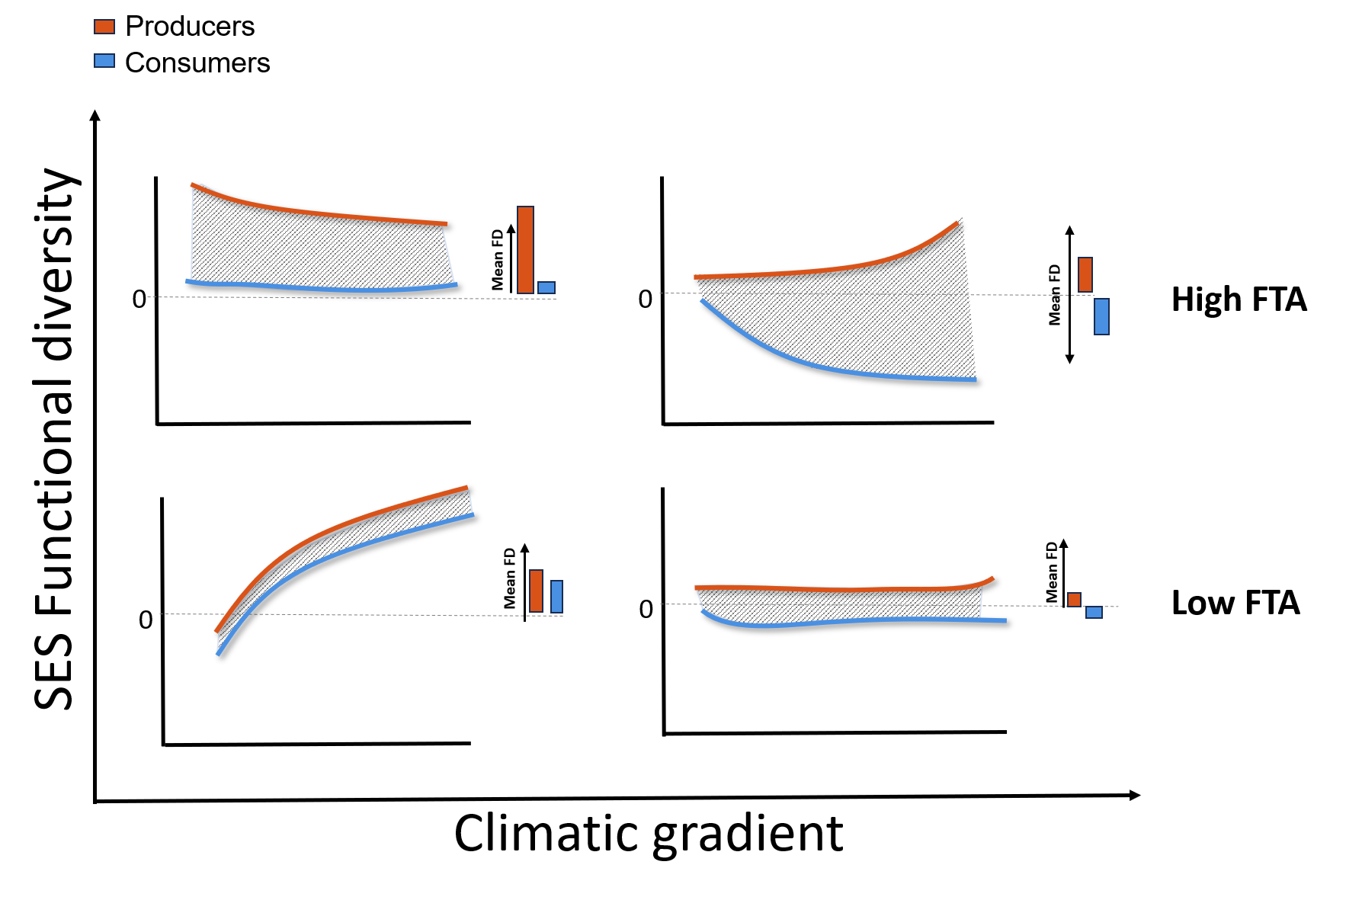
Figure 1: Conceptual illustration of functional trophic asymmetry (FTA) across environmental gradients. Hypothetical responses of producer (blue) and consumer (orange) functional diversity to an environmental gradient. The blue shaded area represents functional trophic asymmetry (FTA), quantified as the vertical difference between trophic-level responses under identical environmental conditions. Top panels illustrate scenarios of high FTA whereas bottom panels depict scenarios of low FTA. Barplots summarize the overall functional diversity of producers and consumers along the climatic gradient

METHODS

Study system
We focused on multitrophic assemblages of Neotropical palms and their mutualistic, seed dispersing, mammalian frugivores. Palms (Plantae: Arecaceae) are a keystone tropical plant family that provides fruit resources to a wide variety of vertebrate frugivores, including birds and mammals (Muñoz, Trøjelsgaard, and Kissling 2019; Zona and Henderson 1989). Frugivory-related traits have notably underlain palm diversification and played a key role in the evolution of palm traits (Onstein et al. 2014, 2017). Frugivorous mammals (Animalia: Mammalia) are among the most important palm-seed dispersers, particularly over long distances (Lim et al. 2020). Most frugivorous mammals feeding on palms are seed eaters and pulp eaters, dispersing palm seeds mostly via ectozoochorus dispersal (Messeder et al. 2021; Marques Dracxler and Kissling 2022).

Species assemblage data
We defined multitrophic assemblages across the Neotropics, by intersecting species-level range maps with Morrone (2014) delineation of Neotropical biogeographic provinces. Species range data of palms come from the geographic range maps of Bjorholm et al. (2005) and species range data for mammals come from the IUCN (International Union for the Conservation of Nature) data portal. For both trophic levels, a species was considered part the species pool of each biogeographic province when at least 5% of its occupied range cells occurred within that province, reducing the influence of marginal overlaps between species ranges and province boundaries. Species represented by fewer than ten occupied raster cells were excluded from the biogeographic assemblage. This procedure was applied independently to palms and mammals.

Species trait data
We collected species-level traits associated with the environmental responses of palms and frugivorous mammals and with their mutualistic interactions. Trait selection was guided by two criteria: ecological relevance to palm–mammal assemblages and sufficient taxonomic coverage for analyses across the Neotropics.
For palms, we extracted growth form, maximum stem height, and average fruit length from the PalmTraits 1.0 dataset (Kissling et al. 2019). Growth form and maximum stem height describe major plant ecological strategies associated with forest structure, light availability, and climatic conditions, while also influencing the vertical accessibility of fruits to mammalian consumers. Fruit length represents a direct interaction trait because it constrains fruit handling and ingestion by mammals and therefore contributes to morphological matching between palms and frugivores.
For frugivorous mammals, we obtained body mass, % diet composition (fruit, nectar, seeds, other plant material, invertebrates, vertebrates, fish, scavenged material, and other/unknown resources), and daily activity data from the EltonTraits 1.0 database (Wilman et al. 2014). Diet was represented by the percentage use of each of the ten dietary categories provided in EltonTraits and was therefore included as a multivariate description of species’ trophic niches. We retained only species with non-zero fruit consumption. Daily activity was represented by the diurnal, crepuscular, and nocturnal activity categories, and body mass was expressed in kilograms. Together, these traits characterize complementary aspects of mammalian functional strategies: diet composition describes trophic specialization and dependence on plant resources, body mass influences metabolic requirements, movement and fruit-handling capacity, and activity period captures temporal differences in resource use and environmental exposure.
In total, our dataset included 494 palm species and 488 mammalian frugivore species with linked trait and geographic data, representing approximately 61% (Roncal et al. 2013; Balslev et al. 2015) and 64% (Fuzessy and Pizo 2025), respectively, of the species reported for the Neotropics. We used complete dietary profiles rather than fruit consumption alone because species with similar levels of frugivory may differ substantially in their use of other resources, reflecting differences in trophic specialization and potential dependence on palm fruits (Wilman et al. 2014).

Climatic data
We used 19 bioclimatic variables obtained from PaleoClim (Brown et al. 2018) to characterize large-scale climatic variation across Neotropical biogeographic provinces under contemporary, mid-Holocene (~6ka), and Last Glacial Maximum (LGM) (~21ka) conditions. The contemporary climatic baseline underlying PaleoClim was derived from the Climatologies at High Resolution for the Earth’s Land Surface Areas (CHELSA) dataset (Karger et al. 2017). For each province and climatic period, we calculated the mean of each bioclimatic variable by averaging the raster cells contained within each biogeographic provinces. To reduce dimensionality while accountting for collinearity among climatic predictors, we performed a principal component analysis (PCA) on the bioclimatic variables for each climatic period (i.e. contemporary, mid-Holocene, LGM conditions ) (Figure 2; Figure S1). Because the signs of PCA axes are arbitrary across time periods, PC1 and PC2 were oriented consistently using temperature seasonality (BIO4) and annual precipitation (BIO12), respectively.
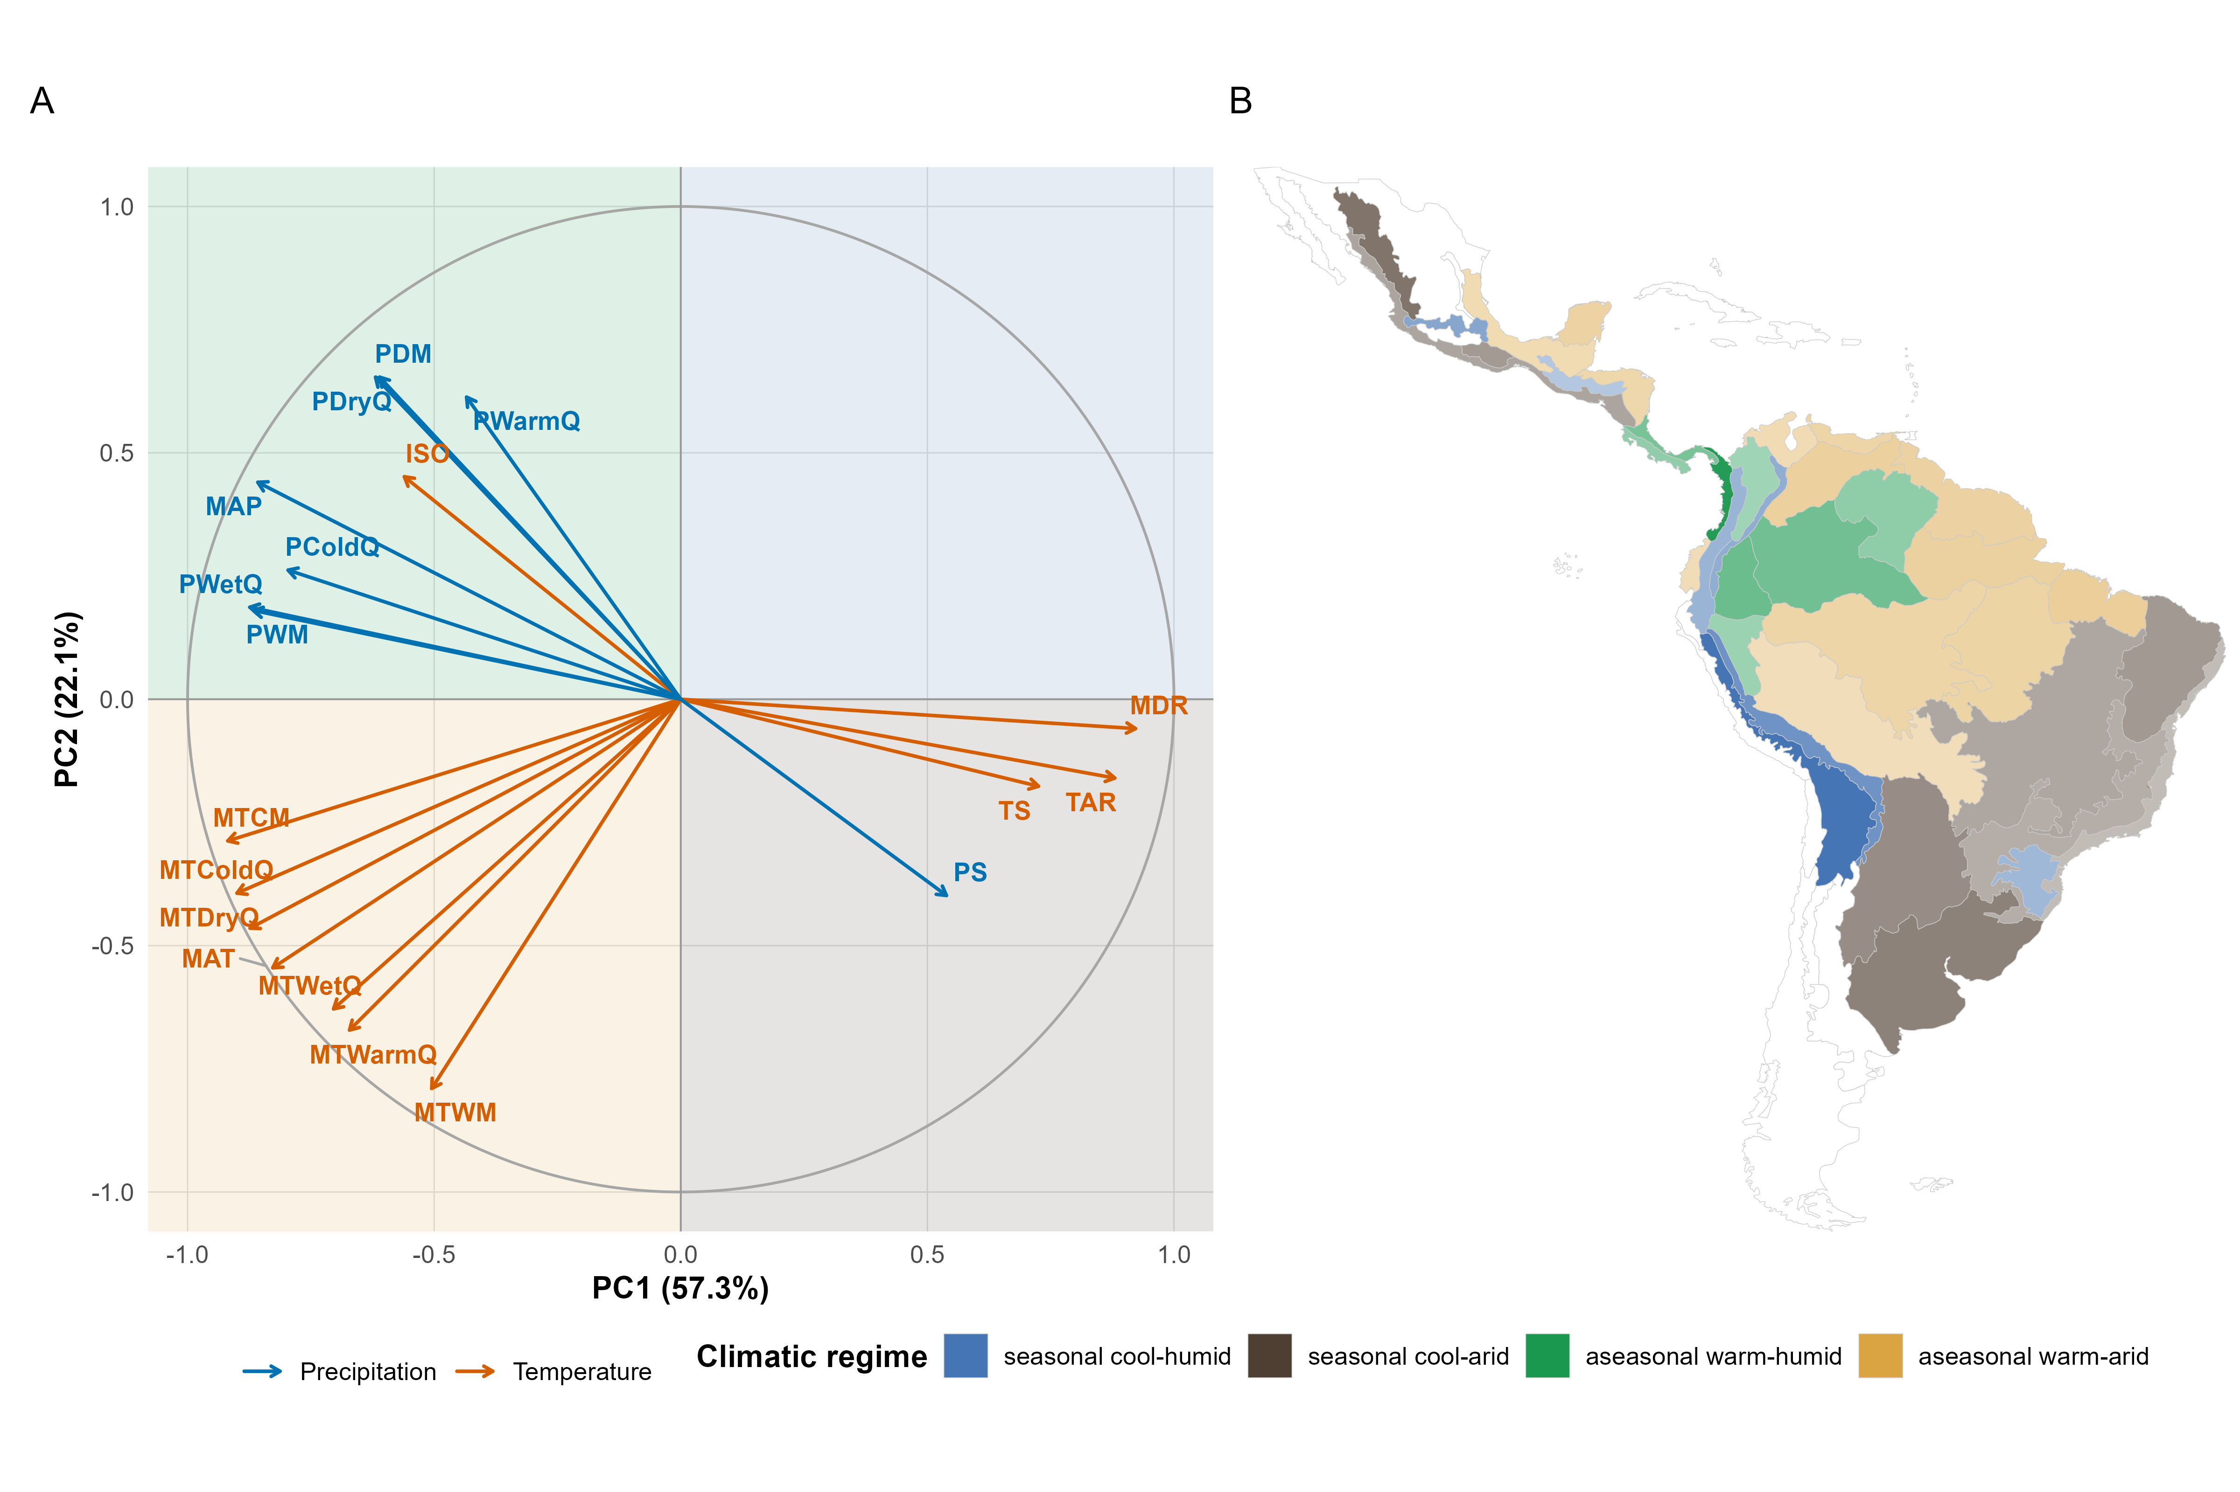
Figure 2: Contemporary climate principal component analysis (PCA) and the geographic distribution of PCA scores across biogeographic provinces in the Neotropics. (A) PCA loading plot showing the loadings of the 19 WorldClim bioclimatic variables on the first two principal components (PC1 and PC2). Blue arrows represent precipitation variables and orange arrows represent temperature variables. Variable abbreviations are: MAP, mean annual precipitation; PWetQ, precipitation of the wettest quarter; PDryQ, precipitation of the driest quarter; PWarmQ, precipitation of the warmest quarter; PColdQ, precipitation of the coldest quarter; PWM, precipitation of the wettest month; PDM, precipitation of the driest month; PS, precipitation seasonality; MAT, mean annual temperature; MTCM, mean temperature of the coldest month; MTWM, mean temperature of the warmest month; MTColdQ, mean temperature of the coldest quarter; MTWarmQ, mean temperature of the warmest quarter; MTDryQ, mean temperature of the driest quarter; MTWetQ, mean temperature of the wettest quarter; TAR, annual temperature range; MDR, mean diurnal range; TS, temperature seasonality; and ISO, isothermality. Therefore, PC1 represents a gradient from warm, climatically stable environments to colder, more seasonal climates, whereas PC2 represents a gradient from wetter to drier conditions. (B) Geographic distribution of these four climatic domains across biogeographic provinces (Morrone 2014) in the Neotropics. The quadrant and province shade colors represent four broad climatic regimes, defined by the direction of PCA axes: (++) seasonal cool–humid; (+-) seasonal cool–arid; (-+) aseasonal warm–humid; and (–) aseasonal warm–arid. The shading darkness repreresents the radial distance $\sqrt{{PC1}^{2}+{PC2}^{2}}$ from the centroid of the two-dimensional PCA space.

Statistical analysis
Functional trait spaces of palms and mammals
We quantified functional diversity (FD) metrics from multidimensional trait spaces constructed separately for palms and mammals. To quantitetivaly describe how species differ across their multiple traits, we calculated differences among species using Gower distances. We then used principal coordinates analysis (PCoA) to embed species within multidimensional continuous trait spaces (Figure S2). For each trophic level, we retained only those axes that comprised at more than 75% of cumulative variance explained (Figure S3). For mammals, we retained two axes, which explained 52.5% and 20.4% of the variation. For palms, we retained one axis, which explained 89.9%. For mammals, the two trait axes captured a trait space with shared variation in both morphology and behavior. For palms, the main axis reflected primarily growth form and maximum stem height, while average fruit length contributed relatively little (Figure S4).
Estimating functional diversity
For each biogeographic assemblage, we quantified functional richness (FRic) and functional dispersion (FDis) on the previously described palm and mammal functional trait spaces (Figure S2). Functional richness (FRic) measured the occupied volume of the local assemblage within the larger trait space of the continental pool. Functional dispersion (FDis) measured the clustering of species within trait space relative to the assemblage centroid (Laliberté and Legendre 2010). We standardized each observed FRic and FDis metric to control for differences in species richness among biogeographic provinces. This resulted in a richness-constrained expected metric value of whether observed FRic and FDis is higher or lower than expected relative to a distribution of FRic and FDis values calculated from null biogeographic assemblages. We generated 999 null biogeographic assemblages by randomly selecting the same number of observed species from the continental species pool without replacement and recalculating FRic and FDis at each permutation (Chase et al. 2011). Standardized effect sizes were calculated as the difference between the observed value and the mean null expectation, divided by the standard deviation of the null distribution. Positive SES values indicate increased trait volumes (FRic-SES) or trait over-dispersion (Fdis-SES), whereas negative values indicate reduced trait-space volumes (FRic-SES) and trait clustering (Fdis-SES). We did this separately for palms and mammals using the FD package in R (Laliberté and Legendre 2010).
Estimating FTA
We quantified functional trophic asymmetry (FTA) from the overall functional trait space that shapes both interaction and environmental niches. Specifically, FTA is measured as the difference between mammal and palm standardized effect sizes (SES; $FTA=SES_{mammals}−SES_{palms}$). Positive values indicate that mammal assemblages exhibit greater positive departures from null expectations than palm assemblages. For functional richness, this corresponds to mammals occupying a relatively larger volume of functional trait space than expected given species richness. For functional dispersion, positive values indicate that mammal assemblages are relatively more overdispersed (or less functionally clustered) than palm assemblages. Conversely, negative values indicate that palms exhibit greater positive departures from null expectations, reflecting relatively larger functional trait-space volume (FRic) or greater functional overdispersion (FDis) than mammals.
Estimating the influence of climate on FD and FTA
For each response variable and climatic period, we fitted separate Generalized Additive Models (GAMs) containing penalized thin-plate regression splines for period-specific climatic PC axes: $FD=s\left(PC1_{t}\right)+s\left(PC2_{t}\right)$ where (t) represents a climatic period. Models were fit using mgcv::gam (Wood and N 2017) with a Gaussian error distribution and identity link. Smooths were fitted using a conservative basis dimension of (k=4), and models were estimated by restricted maximum likelihood with shrinkage selection (Wood and N 2017). Tensor-product interactions were not included. Additionally, to determine whether climatic associations persisted after accounting for broad-scale spatial structure, we fitted spatial sensitivity models that included a two-dimensional smooth of longitude and latitude centroids for each biogeographic province $s\left(longitude,latitude\right)$. Model adequacy was assessed by visual inspection of residual-versus-fitted and normal QQ plots (Figures S7–S8). The explanatory performance of the three temporal models was compared using AIC, adjusted ($R^{2}$), and deviance explained (%).

RESULTS

Geographic distribution of trophic functional diversity and asymmetry
Palm functional richness was highest in Central America and parts of eastern and southern South America (Figure 3, A). Mammal richness peaked in eastern Brazil but was lower across much of Amazonia and western South America (Figure 3 -B). This contrast produced a clear west–east gradient in richness asymmetry. Palm richness was greater across much of Amazonia, while mammal richness was greater in eastern South America (Figure 3, C). Dispersion showed a different pattern. Palm functional dispersion peaked in southeastern Brazil, whereas mammal dispersion was high across much of tropical South America (Figure 3, D–E). Dispersion asymmetry was therefore positive across most of the Neotropics but negative in southeastern Brazil (Figure 3, F).
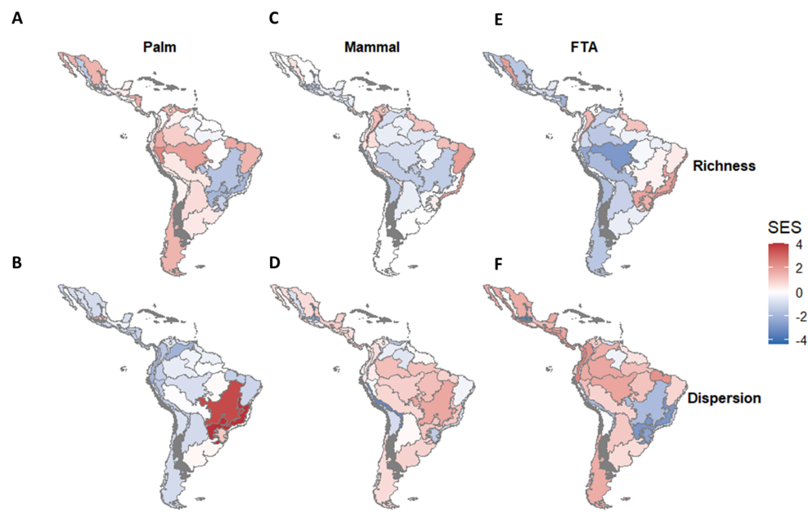
Figure 3: Geographic patterns of functional richness, functional dispersion, and functional trophic asymmetry across Neotropical biogeographic provinces. Maps show standardized effect sizes (SES) of functional richness (top row) and functional dispersion (bottom row) for palm assemblages (left column), mammal assemblages (middle column), and functional trophic asymmetry (FTA; right column). Positive SES values (red) indicate greater functional structure than expected under null model expectations, whereas negative SES values (blue) indicate lower functional structure than expected. FTA represents the difference in SES between producer and consumer assemblages for each biogeographic province. Biogeographic provinces are delineated according to the Neotropical regionalization of Morrone (2014).

Functional diversity responses to climate variation
We found weak relationships between current climate and present-day functional richness. Palm SES-FRic declined non-linearly with PC1 (Figure 4 A) , whereas mammal SES-FRic increased slightly with PC2 (Figure 4 B), although neither relationship was statistically supported (Table 1). Current climate was more strongly associated with present-day functional dispersion: mammal traits became increasingly clustered toward cooler, drier, and more thermally seasonal environments (Figure 4 ; Table 1).
Associations with past climate were broader and reflected potential climatic legacies in present-day assemblages. Present-day mammal assemblages were more functionally clustered in provinces that experienced cooler, drier, and more seasonal conditions during the late Holocene (Figure S5-I ; Table 1). Present-day palm assemblages occupied less trait space in provinces characterized by the coolest, driest, and most thermally seasonal LGM conditions (Figure S5-E ;Table 1). In contrast, present-day mammal assemblages occupied more trait space in provinces that experienced cooler, wetter, and less seasonal LGM conditions (Figure S5-F ; Table 1), with trait dispersion greatest under intermediate LGM climates (Figure S5-L ; Table 1). For functional diversity, model diagnostics showed broadly normal residual distributions, with minor tail departures and some residual curvature in models with low explained deviance (Figures S7;S8). Additionally, accounting for spatial structure improved model fit for palm functional richness (ΔAIC = 5.52), palm functional dispersion (ΔAIC = 17.9), and mammal functional richness (ΔAIC = 15.6). Mammal functional dispersion was unchanged (ΔAIC ≈ 0), indicating little additional contribution from spatial structure (Figure S9).
We found the clearest support for past climatic associations in mammals. LGM models explained 18.9% of mammal SES-FRic and 41.6% of mammal SES-FDis variation, compared with 2.7% and 33.8% for current-climate models (Figure 6 ; Table 2) Past models were also favored for palm functional richness and combined-assemblage functional dispersion. However, current and past climate were often similarly informative (ΔAAIC < 2) (Table 2).
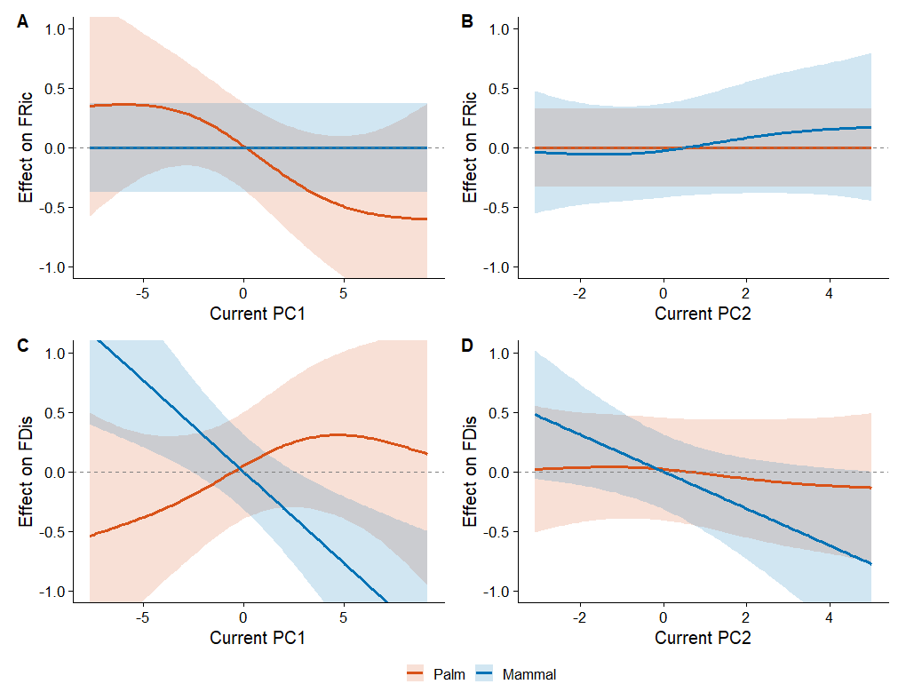
Figure 4: Relationships of present-day functional diversity with current climate. Generalized additive model smooths showing the effects of current climatic PC1 and PC2 on standardized effect sizes of functional richness (FRic; A and B) and functional dispersion (FDis; C and D) for palm and mammal assemblages. Lines show fitted smooths, shaded areas represent 95% confidence intervals, and the horizontal dashed line denotes an effect of zero.

The variation of FTA along climatic gradients
Functional-richness asymmetry changed little under current (Figure 5) and late-Holocene climates ( Figure S6 C–D). It increased weakly along both LGM axes (Figure S6 E-F), but neither effect was significant (Table 1). The LGM model received the most support, although all periods had similar AIC values (Table 2). Climate was more strongly associated with functional-dispersion asymmetry, which declined along PC1 in all periods and along LGM PC2 (Figure 5; Figure S6 A, C, E, F). The late-Holocene PC1 effect was significant $\left(P<0.05\right)$; whereas the current PC1 effect was marginal $\left(P=0.056\right)$; the LGM effects were not significant (Table 1). The late-Holocene model received the most support and explained 31.9% of the deviance ( Table 2). For functional trophic asymmetry, residuals were also approximately normal. The residual-versus-fitted plots showed limited remaining structure, although a few outliers were present, particularly in the LGM models (Figure S7; S8). Adding spatial structure improved both models. The improvement was stronger for richness-based FTA (ΔAIC = 12.9) than for dispersion-based FTA (ΔAIC = 6.66). (Figure S9)
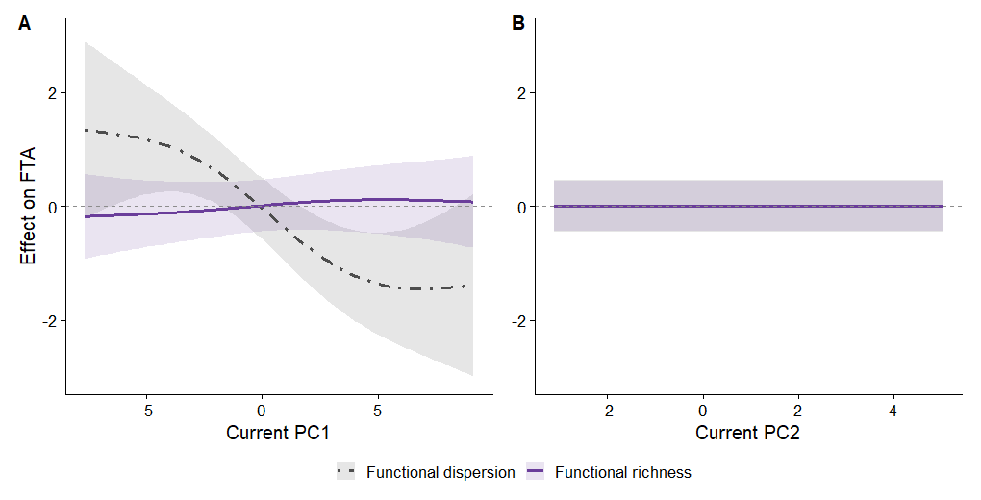
Figure 5: Relationships of functional trait asymmetry with current climatic gradients. Generalized additive model smooths showing the effects of current climatic PC1 (A) and PC2 (B) on functional trait asymmetry (FTA) based on functional richness and functional dispersion. Lines show fitted smooths, shaded areas represent 95% confidence intervals, and the horizontal dashed line denotes an effect of zero.

 Table 1. Climatic associations with functional diversity and functional trait asymmetry.
Generalized additive model results for the effects of the first two climatic principal components (PC1 and PC2) from current, late-Holocene, and Last Glacial Maximum conditions on palm and mammal functional richness (FRic) and functional dispersion (FDis), and on functional trait asymmetry (FTA). Entries report effective degrees of freedom (edf), F statistics, and P values for each smooth term. Significant P values (P<0.05) are highlighted in bold.
Response | Axis | Current |  |  | Late Holocene |  |  | LGM
 |  | edf | F | P | edf | F | P | edf | F | P
Palm FRic | PC1 | <0.001 | <0.001 | 0.155 | <0.001 | <0.001 | 0.299 | 1.239 | 1.468 | 0.040
 | PC2 | <0.001 | <0.001 | 0.462 | <0.001 | <0.001 | 0.658 | <0.001 | <0.001 | 0.395
Palm FDis | PC1 | <0.001 | <0.001 | 0.193 | 0.913 | 0.668 | 0.120 | <0.001 | <0.001 | 0.315
 | PC2 | <0.001 | <0.001 | 0.407 | 0.429 | 0.250 | 0.176 | <0.001 | <0.001 | 0.458
Mammal FRic | PC1 | <0.001 | <0.001 | 0.458 | <0.001 | <0.001 | 0.603 | 1.503 | 1.500 | 0.059
 | PC2 | 0.266 | 0.104 | 0.251 | <0.001 | <0.001 | 0.315 | 0.726 | 0.885 | 0.030
Mammal FDis | PC1 | 0.911 | 3.400 | 0.002 | <0.001 | <0.001 | 0.016 | <0.001 | <0.001 | 0.388
 | PC2 | <0.001 | <0.001 | 0.843 | <0.001 | <0.001 | 0.252 | 1.593 | 3.215 | 0.006
FRic asymmetry | PC1 | <0.001 | <0.001 | 0.225 | 0.608 | 0.304 | 0.221 | <0.001 | <0.001 | 0.256
 | PC2 | <0.001 | <0.001 | 0.859 | <0.001 | <0.001 | 0.918 | 0.500 | 0.333 | 0.155
FDis asymmetry | PC1 | <0.001 | <0.001 | 0.056 | 1.616 | 4.810 | <0.001 | <0.001 | <0.001 | 0.795
 | PC2 | <0.001 | <0.001 | 0.893 | <0.001 | <0.001 | 0.966 | 0.428 | 0.249 | 0.180

DISCUSSION
Our study shows that the functional trait spaces of palms and mammalian frugivores exhibit distinct geographic and climatic patterns across the Neotropics, thus generating FTA. Geographic variation in FTA was driven primarily by differences in palm functional diversity between the Amazon and eastern South America, whereas mammalian functional diversity was more similar across these regions. Under current climate, palm FRic showed a stronger relationship than mammal FRic, with greater palm trait volume in warmer, less seasonal regions. Mammal FDis, however, showed a stronger current-climate relationship than palm FDis, with greater mammal trait clustering in cooler, wetter, and more seasonal regions. When climatic periods were compared, mammal FRic was most strongly related to LGM climate, while mammal FDis was also strongly related to late-Holocene climate. Thus, present-day palm–frugivore trait structure is related to both current climatic conditions and past climate.

The influence of climate on FTA
The different responses of palms and mammals may reflect differences in their sensitivity to climate and their evolutionary histories. Palm FRic was related to current climate, whereas palm FDis varied less, suggesting that climate changes the volume of palm trait space more than the spacing of species within it. However, the strong improvement in the palm FDis model after accounting for spatial structure indicates that broad geographic patterns explain variation not captured by climate alone. This may reflect the persistence of similar ecological strategies despite taxonomic turnover, as reported for Neotropical tree species pools (Pinho et al. 2021), as well as the effects of biogeographic history and dispersal constraints [ Ackerly (2003); Wiens and Donoghue (2004)]. Present-day palm assemblages are shaped by Cenozoic diversification and the long-term persistence of tropical habitats [Kissling et al. (2012)]. Cooling and drying also caused range contractions and regional extinctions, while surviving lineages persisted under different regional conditions (Lim et al. 2022). Together, these processes may have changed palm species composition without producing equally strong changes in trait dispersion.
Mammal FDis responded more strongly to climate than palm FDis and was most strongly related to LGM conditions. Greater mammal trait clustering in cooler and more seasonal regions is consistent with environmental filtering, which may limit the ecological strategies able to persist under demanding conditions. In warmer and more stable regions, greater productivity and resource availability may allow mammals with a wider range of traits to coexist. This interpretation is consistent with evidence that mammal FDis increases with primary productivity (Gorczynski et al. 2021) and that climate shapes mammalian trophic structure (Mendoza and Araújo 2019) through limits related to energy and resource availability (Boratyński 2021; Brandl et al. 2023). The absence of improvement after accounting for spatial structure further indicates that geographic variation in mammal FDis was already well represented by climate. In contrast, the improved spatial model for mammal FRic suggests an additional role for biogeographic history and dispersal constraints (Ackerly 2003; Wiens and Donoghue 2004). For instance, past historical processes, such as the Great American Biotic Interchange and late-Quaternary megafaunal losses, may have further shaped regional mammal trait structure (Rowan et al. 2020; Davies and Buckley 2011; Fergnani and Ruggiero 2015). These historical effects may persist because mammal functional diversity can accumulate more slowly than species richness (Oliveira et al. 2016).
Importantly, responses within each trophic level were not always reflected in FTA. Climate explained little variation in FRic asymmetry, even where palm or mammal FRic responded, possibly because changes in one trophic level were offset by changes in the other. In contrast, climate explained substantial variation in FDis asymmetry, with the strongest relationship under late-Holocene climate, indicating that changes in trait spacing altered the relative trait structure of palms and mammals. However, assemblage-level trait spaces do not directly measure ecological matching because trophic functions depend on the traits of interacting partners and their realized interactions (Bello, Schleuning, and Graham 2023). Plant–frugivore interactions are shaped by correspondence between specific fruit and frugivore traits (D. Matthias Dehling et al. 2016), while climate, species richness, and biogeographic history can affect this matching indirectly (McFadden et al. 2022). Thus, FTA describes the balance between palm and mammal trait spaces, while interaction data are needed to determine whether this balance results from compensation or ecological matching.
 Table 2: Support for current and past climatic models of functional diversity and functional trait asymmetry.
Comparison of models relating palm and mammal functional richness (FRic) and functional dispersion (FDis), and functional trait asymmetry (FTA), to current, late-Holocene, and Last Glacial Maximum climate. Model performance is summarized using the Akaike information criterion (AIC), ΔAIC, percentage of deviance explained, and adjusted R².
Response | Current |  |  |  | Late Holocene |  |  |  | LGM
 | AIC | ΔAIC | Dev. (%) | Adj. R² | AIC | ΔAIC | Dev. (%) | Adj. R² | AIC | ΔAIC | Dev. (%) | Adj. R²
Palm FRic | 109.437 | 0.192 | 13.2 | 0.103 | 109.726 | 0.481 | 12.4 | 0.096 | 109.245 | 0 | 14.0 | 0.109
Palm FDis | 127.367 | 0.508 | 9.3 | 0.062 | 126.858 | 0 | 11.1 | 0.077 | 127.310 | 0.452 | 6.6 | 0.044
Mammal FRic | 118.150 | 2.678 | 2.7 | 0.016 | 117.690 | 2.218 | <0.1 | <0.001 | 115.472 | 0 | 18.9 | 0.134
Mammal FDis | 106.946 | 2.715 | 33.8 | 0.304 | 105.473 | 1.242 | 36.4 | 0.331 | 104.231 | 0 | 41.6 | 0.371
FRic asymmetry | 130.699 | 0.080 | 2.4 | 0.014 | 130.713 | 0.095 | 2.7 | 0.015 | 130.619 | 0 | 8.0 | 0.050
FDis asymmetry | 133.885 | 0.448 | 31.1 | 0.278 | 133.437 | 0 | 31.9 | 0.287 | 134.995 | 1.558 | 28.8 | 0.257
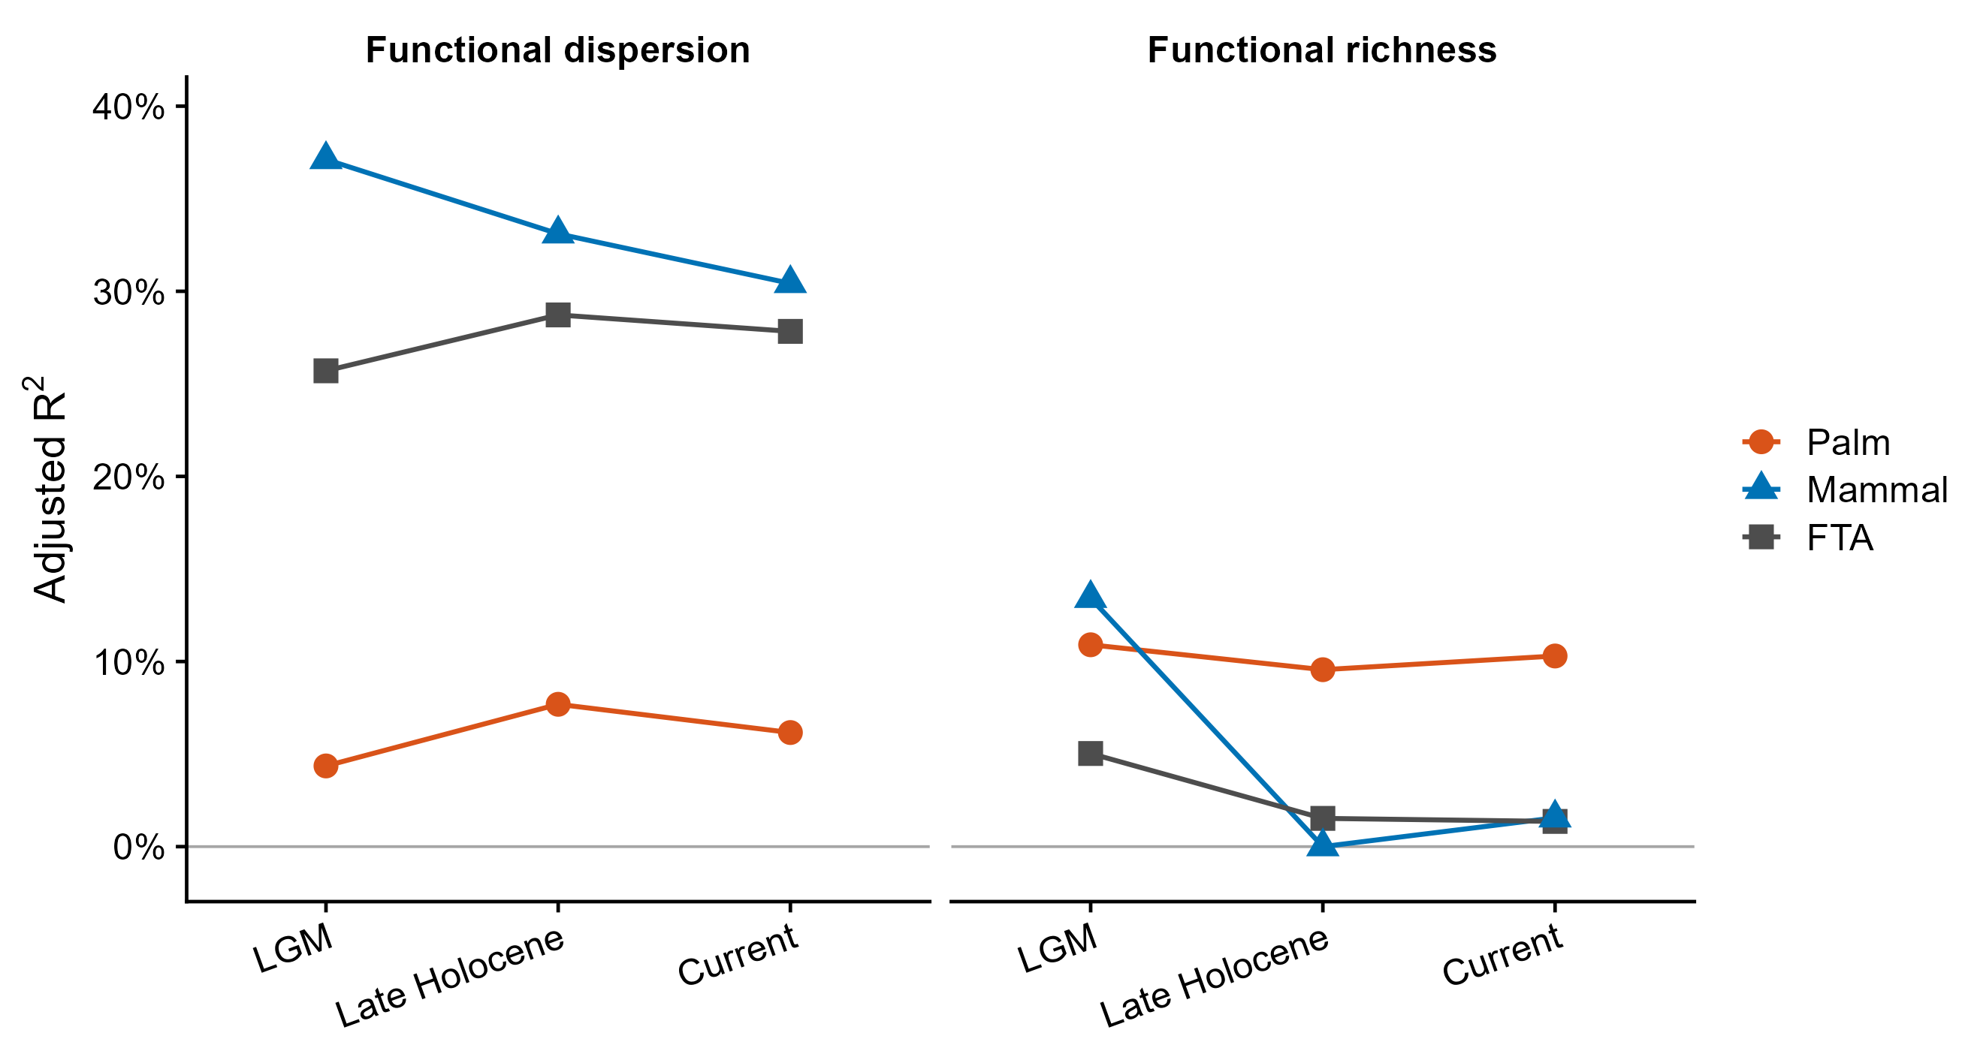
Figure 6: Deviance explained by climatic models of functional diversity and functional trait asymmetry. Percentage of deviance explained by Last Glacial Maximum, late-Holocene, and current-climate models for functional dispersion (A) and functional richness (B). Values are shown for palm assemblages (orange circles), mammal assemblages (blue triangles), and functional trait asymmetry (gray squares); lines connect estimates across periods.

The potential consequences of FTA for ecological network assembly
Differential climatic responses across trophic levels may affect the trait structure from which ecological interactions assemble. Because mutualistic interactions depend partly on producer–consumer trait matching, functional trophic asymmetry describes an imbalance in their available trait spaces (D. M. Dehling et al. 2021; Bartomeus et al. 2016; Albrecht et al. 2018; Armbruster, Pélabon, and Hansen 2014). Historical climate may contribute to this imbalance because present-day assemblages retain climatic legacies through extinction, range shifts, dispersal limitation, and delayed adjustment (Svenning et al. 2015b; Rowan et al. 2020). If producers and consumers responded differently to these processes, their present-day trait spaces may carry distinct historical signals. Whether such asymmetry affects realized interactions will depend on local species composition, trait compatibility, and the capacity to form alternative links. Testing these mechanisms will require digitally available empirical network data (Marjakangas et al. 2022; Caradonna, Bain, and Waser 2021). Importantly, our FTA framework can generate spatial and temporal hypothesis for where current and historical environmental filtering may influence multitrophic network assembly, and thus should not be taken as direct evidence of interaction loss, rewiring, or network instability (Classen et al. 2020).
Therefore, an important next step is to evaluate whether functional trophic asymmetry predicts the organization of empirical ecological networks (Classen et al. 2020; Opedal and Hegland 2020; Yahaya et al. 2024). Although our framework infers potential interaction niches from species traits and distributions, the increasing availability of standardized regional interaction datasets (metawebs) (Caron et al. 2022) provides an opportunity to test whether regions with greater functional trophic asymmetry exhibit predictable differences in network architecture, including specialization, modularity, connectance, and robustness to species loss (Montoya and Raffaelli 2010; Schleuning, Fründ, and García 2015; Schleuning, García, and Tobias 2023) Such tests would determine whether asymmetries in producer and consumer functional diversity translate into realized differences in network structure and ecosystem functioning (Schleuning, Fründ, and García 2016; Strydom et al. 2022). Extending this framework by projecting synthetic interaction networks to local assemblages using species abundances, habitat suitability, dispersal constraints, and local environmental conditions (Banville et al. 2024; Beumer et al. 2025) would allow direct evaluation of how functional trophic asymmetry influences the assembly of ecological networks across spatial scales (Galiana et al. 2018; Ponisio et al. 2019; Thuiller et al. 2024). Similarly, future applications could incorporate ecologically informed null models that preserve additional properties of assemblages (e.g., phylogenetic structure, environmental constraints, dispersal, or interaction rules), allowing FTA to disentangle alternative assembly mechanisms with greater specificity (Marjakangas et al. 2022).

Functional trophic asymmetry as a multitrophic indicator of ecological processes and their response to global changes
Functional richness and dispersion capture different components of assemblage structure and may therefore respond to different processes. Historical conditions can influence dispersion, while contemporary filtering can affect richness, as shown for global freshwater fish assemblages (Su et al. 2022). Climate is therefore one potential source of FTA, but anthropogenic disturbances may also alter producer and consumer trait spaces unequally. In tropical Andean hummingbirds, land-use change reduced functional diversity more strongly than taxonomic diversity by removing species with distinctive combinations of body size, wing shape, and bill morphology (Tinoco et al. 2018). Deforestation can similarly reduce the richness and evenness of fruit traits, altering the diversity and quality of resources available to frugivores (Guevara, Torres, and Graham 2023b, 2023a). Defaunation may act more strongly on the consumer level: frugivore networks can retain much of their structure while losing functional capacity as large-bodied or functionally distinctive dispersers disappear (Bello, Schleuning, and Graham 2023). Biological invasions can further reshuffle trophic structure through competition, predation, and indirect cascades, with outcomes depending on the trophic positions of invaders and resident species (Guerra et al. 2025).
These disturbances could increase or decrease FTA depending on which trophic level and which region of trait space are most affected. Biodiversity loss is often biased toward large consumers and strong animal interactors, whose removal can have effects comparable to much larger losses of plant diversity (Duffy and E 2003). Experimental lake acidification, for example, caused greater richness declines in fish and zooplankton than in phytoplankton and increased variability in upper-trophic-level biomass (Hogsden, Xenopoulos, and Rusak 2009). More broadly, defaunation disproportionately removes medium- and large-bodied vertebrates, with cascading effects on plant recruitment, community composition, and ecosystem functioning (Dirzo et al. 2014). These findings support anthropogenic disturbance as another plausible driver of FTA. Applying the framework in other trophic systems could quantify such unequal responses, provided that distribution, trophic-role, and trait data have comparable coverage and that regional species pools are well defined.

CONCLUSION
At the coarse geographic resolution examined here, FTA likely reflects historical climatic and biogeographic processes as much as contemporary environmental filtering. By contrast, habitat loss, pollution, invasions, and ongoing climate change may alter FTA more rapidly within local communities by affecting producer and consumer functional diversity differently. These changes could reshape interaction niches and network organization, particularly where opportunities for interaction rewiring are limited (Tylianakis et al. 2008; Caradonna, Bain, and Waser 2021; Cruz, Souza, and Rosumek 2023). Applying FTA to finer-resolution and temporal data will therefore be essential for testing how global-change drivers reshuffle multitrophic communities. Comparisons across ecosystems can then establish whether FTA provides a general indicator of multitrophic responses to environmental change (Acosta-Rojas et al. 2023; Nowak et al. 2022; Landim et al. 2025; Rabeau et al. 2025).

SUPPLEMENTARY MATERIAL

Figure S1. Climate principal component analysis (PCA) and the geographic distribution of PCA scores across biogeographic provinces in the Neotropics for contemporary, Late-Holocene, and LGM climatic periods

Figure S1. Principal component analysis (PCA) correlation circles of precipitation (blue) and temperature (orange) variables, with corresponding climatic-regime maps of the Americas, for contemporary (A–B), Late Holocene (C–D), and Last Glacial Maximum (E–F) climates. Percentages on the axes indicate the variance explained by PC1 and PC2. Map colors identify seasonal cool–humid, seasonal cool–arid, aseasonal warm–humid, and aseasonal warm–arid regimes.

Figure S2. Functional trait spaces of palms and mammals
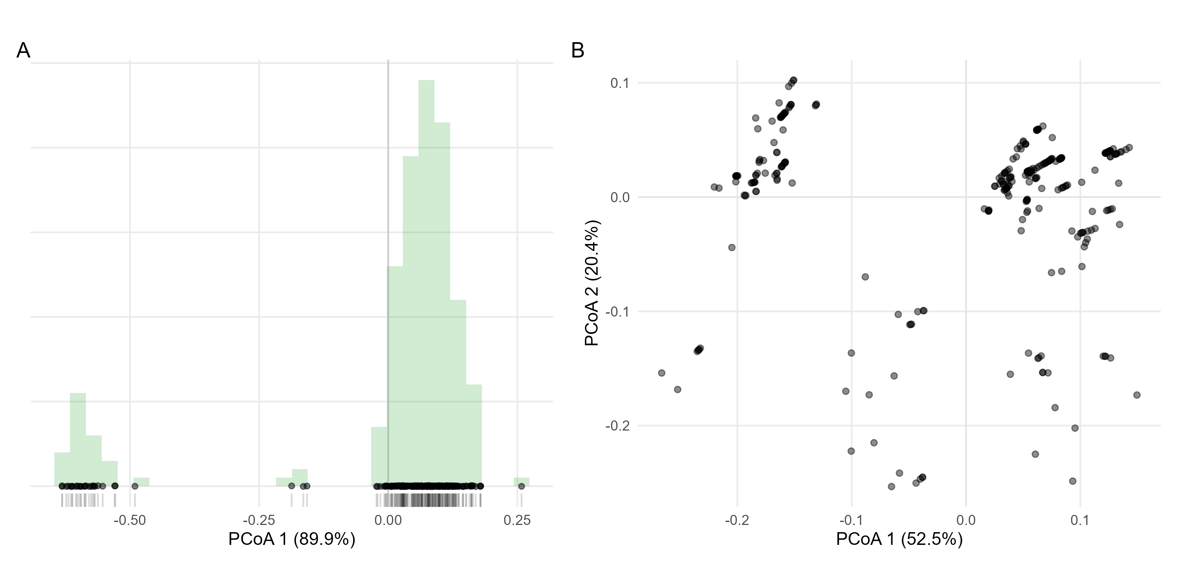
Figure S2. Functional trait spaces of palms and mammals. Principal coordinates analysis (PCoA) of species functional trait spaces for (A) palms and (B) mammalian frugivores. Species are represented as points positioned according to their multivariate trait similarities based on Gower distances. The percentage of total trait variation explained by each axis is shown in parentheses. Panel A displays the first principal coordinate axis for palms, with species distributed along a one-dimensional functional gradient (rug marks indicate species scores on the axis). Panel B shows the first two principal coordinate axes for mammals, illustrating the multidimensional distribution of functional strategies used to estimate functional richness (FRic) and functional dispersion (FDis).

Figure S3: Variance explained by retained functional trait axes.
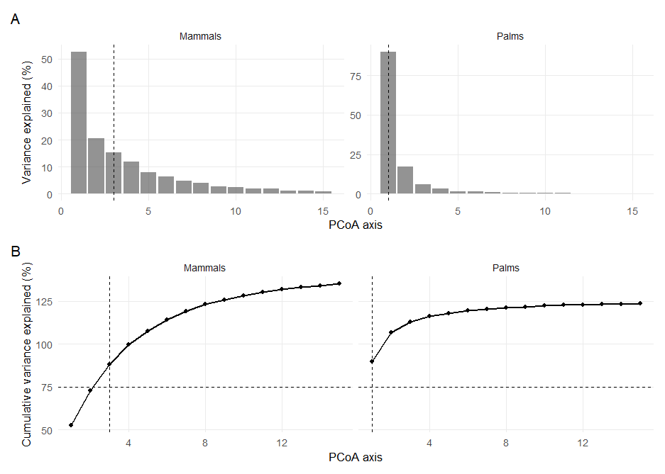
Figure S3: Variance explained by retained functional trait axes. Bars (A) show the percentage of trait variation explained by individual PCoA axes for palms and mammalian frugivores. Lines (B) show cumulative variance explained. Dashed horizontal lines indicate the 75% threshold used to select retained axes, and dashed vertical lines indicate the number of axes retained for each trophic level.

Figure S4. Relative contributions of functional traits to the multidimensional trait spaces of palms and mammals
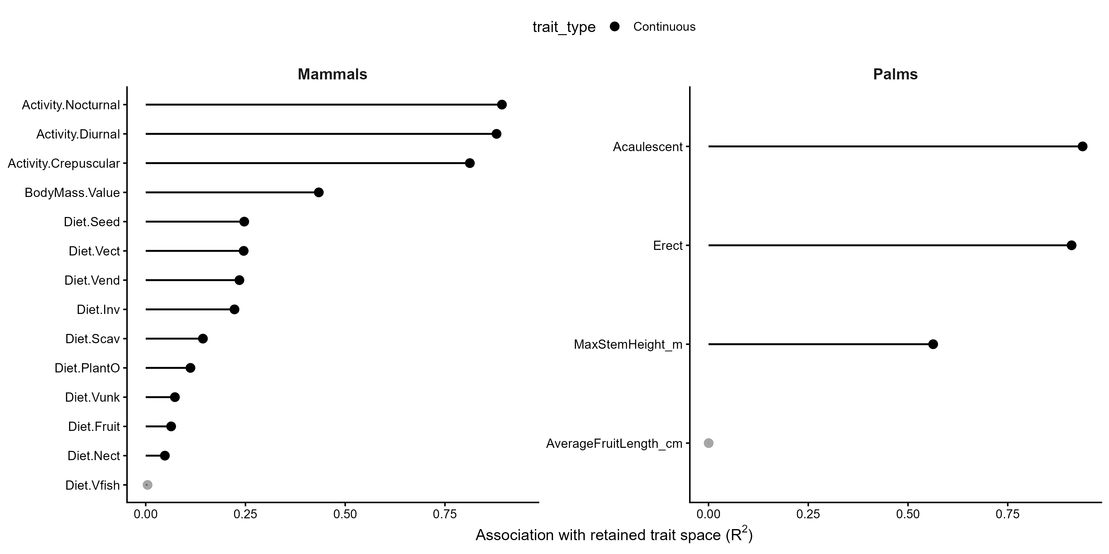
Figure S4. Relative contributions of functional traits to the multidimensional trait spaces of palms and mammals. Trait contributions were quantified by fitting original trait variables onto the retained principal coordinates (PCoA) spaces derived from Gower trait distances using permutation-based environmental fitting (envfit). Points represent the proportion of variation in the retained multidimensional trait space explained by each trait (R²), with horizontal segments extending from zero to the corresponding R² value. Black points indicate statistically significant trait–ordination associations (permutation test, p < 0.05), whereas grey points denote non-significant associations.

Figure S5. Contemporary and past climatic associations with present-day palm and mammal functional diversity
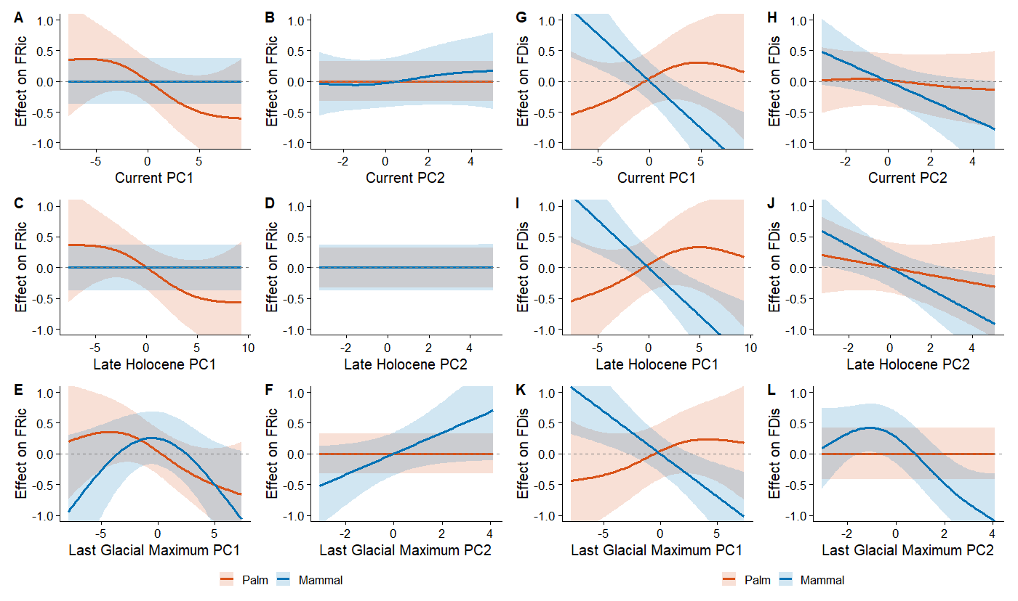
Figure S5. Contemporary and past associations with present-day palm and mammal functional diversity. Generalized additive model smooths showing the effects of climatic PC1 and PC2 under current (A, B, G, and H), late-Holocene (C, D, I, and J), and Last Glacial Maximum conditions (E, F, K, and L) on standardized effect sizes of functional richness (FRic; A–F) and functional dispersion (FDis; G–L). Lines show fitted smooths for palms (orange) and mammals (blue), shaded areas represent 95% confidence intervals, and horizontal dashed lines denote an effect of zero.

Figure S6. Associations of contemporary and past climatic gradients with present-day functional trophic asymmetry.
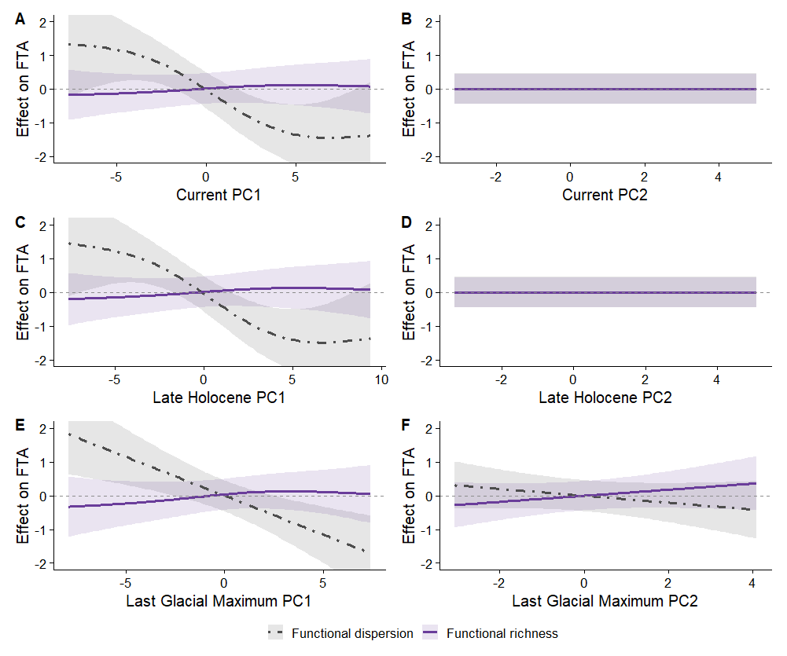
Figure S6. Associations of contemporary and past climatic gradients with present-day functional trophic asymmetry. Generalized additive model smooths showing the effects of climatic PC1 and PC2 under current (A and B), late-Holocene (C and D), and Last Glacial Maximum conditions (E and F) on functional trophic asymmetry (FTA) based on functional richness and functional dispersion. Lines show fitted smooths, shaded areas represent 95% confidence intervals, and horizontal dashed lines denote an effect of zero.

Figure S7. Diagnostic plots for the generalized additive model (FR).
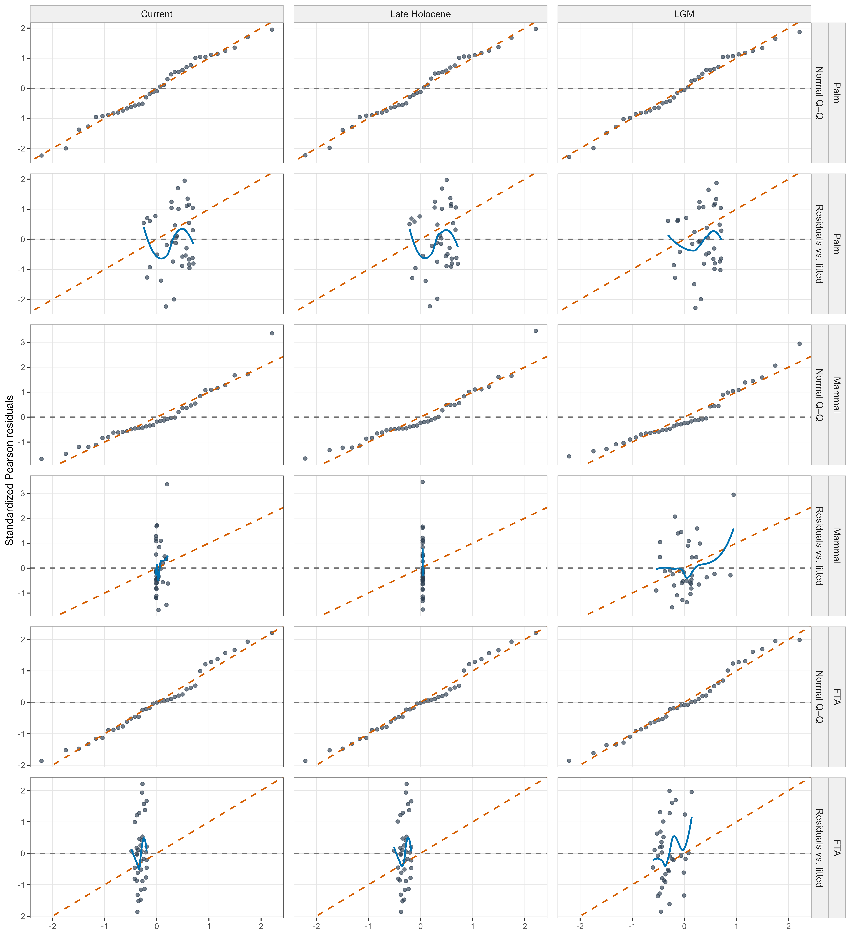
Figure S7. Diagnostic plots for generalized additive models of functional richness. Normal Q–Q plots and standardized Pearson residuals versus fitted values for palm and mammal functional richness and richness-based functional trophic asymmetry (FTA) under current, late-Holocene, and Last Glacial Maximum climate models. Dashed orange lines denote the theoretical normal relationship in Q–Q plots; blue lines show loess trends in residuals.

Figure S8. Diagnostic plots for the generalized additive model (FDis).
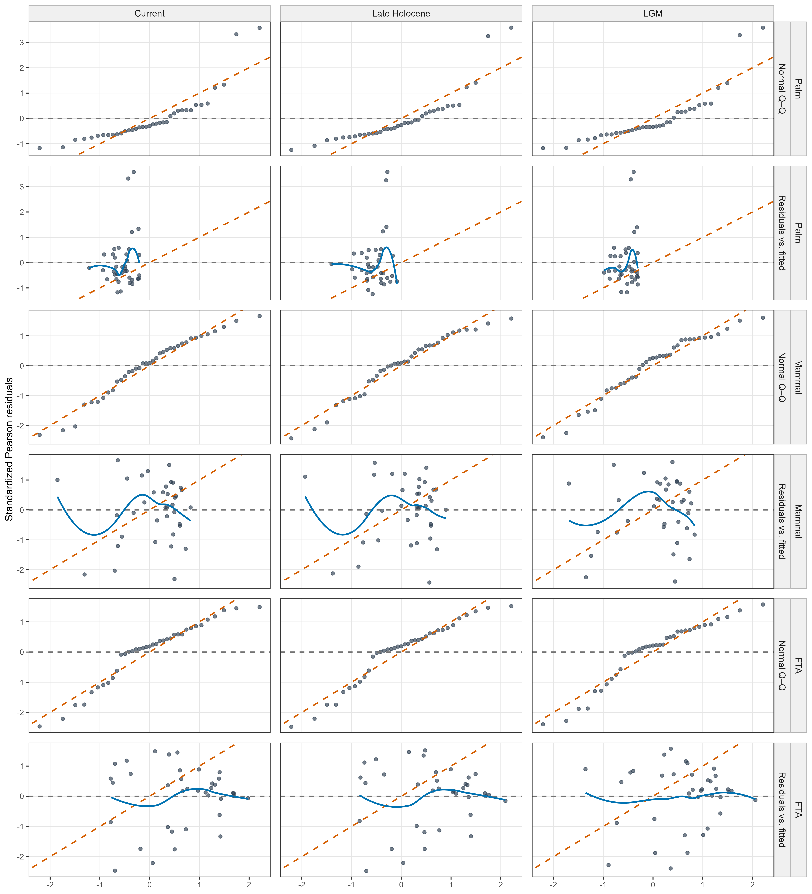
Figure S8. Diagnostic plots for generalized additive models of functional dispersion. Normal Q–Q plots and standardized Pearson residuals versus fitted values for palm and mammal functional dispersion and dispersion-based functional trophic asymmetry (FTA) under current, late-Holocene, and Last Glacial Maximum climate models. Dashed orange lines denote the theoretical normal relationship in Q–Q plots; blue lines show loess trends in residuals.

Figure S9: Improvement in model fit after accounting for spatial structure.
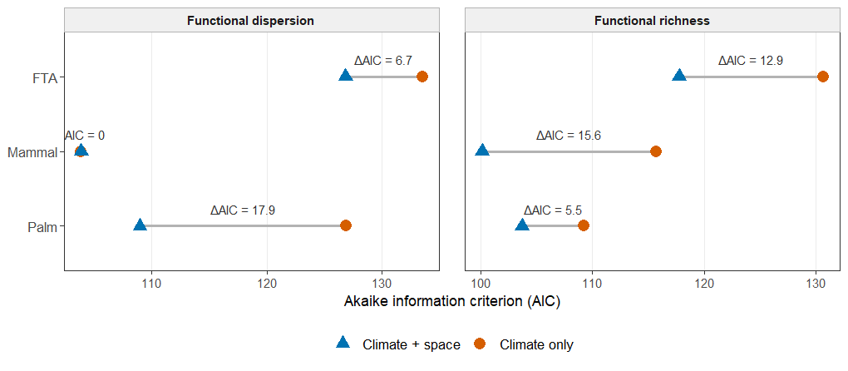
Figure S9. Comparison of climate-only and spatial climatic models. AIC values for models containing climatic predictors only and models additionally containing a spatial smooth for palm and mammal functional richness and dispersion and functional trait asymmetry (FTA). ΔAIC represents the reduction in AIC after spatial structure was included; larger positive values indicate greater support for the climate-plus-space model.

REFERENCES
Acevedo-Quintero, J. F., J. G. Zamora-Abrego, and D. García. 2020. “From Structure to Function in Mutualistic Interaction Networks: Topologically Important Frugivores Have Greater Potential as Seed Dispersers.” Journal of Animal Ecology 89: 2181–91.
Ackerly, D. D. 2003. “Community Assembly, Niche Conservatism, and Adaptive Evolution in Changing Environments.” International Journal of Plant Sciences 164: S165–84.
Acosta-Rojas, D. C., M. K. Barczyk, C. I. Espinosa, N. Farwig, J. Homeier, Y. Tiede, et al. 2023. “Abiotic Factors Similarly Shape the Distribution of Fruit, Seed and Leaf Traits in Tropical Fleshy-Fruited Tree Communities.” Acta Oecologica 121: 103953.
Albrecht, J., A. Classen, M. G. R. Vollstädt, A. Mayr, N. P. Mollel, D. Schellenberger Costa, et al. 2018. “Plant and Animal Functional Diversity Drive Mutualistic Network Assembly Across an Elevational Gradient.” Nature Communications 9: 3177.
Allesina, S., D. Alonso, and M. Pascual. 2008. “A General Model for Food Web Structure.” Science 320: 658–61.
Armbruster, W. S., Bolstad Pélabon C., and T. F Hansen. 2014. “Integrated Phenotypes: Understanding Trait Covariation in Plants and Animals.” Philosophical Transactions of the Royal Society B: Biological Sciences, 369 (1649): 20130245.
Balslev, H., W. L. Eiserhardt, T. Kristiansen, and F. Borchsenius. 2015. “Palms and Palm Communities in the Seasonally Dry Tropical Forests of the Americas.” Journal of Systematics and Evolution 53: 453–80.
Banville, F., Blyth Strydom T., G., others, and T and Poisot. 2024. “Deciphering Probabilistic Species Interaction Networks.”
Bartomeus, Ignasi, Dominique Gravel, Jason M Tylianakis, Marcelo A Aizen, Ian A Dickie, and Maud Bernard-Verdier. 2016. “A Common Framework for Identifying Linkage Rules Across Different Types of Interactions.” Functional Ecology 30 (12): 1894–1903.
Bauer, Barbara, Michael Kleyer, Dirk C Albach, Bernd Blasius, Ulrich Brose, Thalita Ferreira-Arruda, Ulrike Feudel, et al. 2021. “Functional Trait Dimensions of Trophic Metacommunities.” Ecography 44 (10): 1486–1500.
Bello, C., M. Schleuning, and C. H. Graham. 2023. “Analyzing Trophic Ecosystem Functions with the Interaction Functional Space.” Trends in Ecology & Evolution 38: 424–34.
Beumer, L. T., A. G. Hertel, R. Royaute, M. A. Tucker, J. Albrecht, R. Beltran, et al. 2025. “MoveTraits: A Database for Integrating Animal Behaviour into Trait-Based Ecology.” bioRxiv 2025–2003.
Bjorholm, S., J. -C. Svenning, F. Skov, and H. Balslev. 2005. “Environmental and Spatial Controls of Palm (Arecaceae) Species Richness Across the Americas.” Global Ecology and Biogeography 14: 423–29.
Blüthgen, N., F. Menzel, and N. Blüthgen. 2006. “Measuring Specialization in Species Interaction Networks.” BMC Ecology 6: 1–12.
Bogoni, J. A., C. A. Peres, and K. M. Ferraz. 2020. “Extent, Intensity and Drivers of Mammal Defaunation: A Continental-Scale Analysis Across the Neotropics.” Scientific Reports 10: 14750.
Boratyński, Z. 2021. “Energetic Constraints on Mammalian Distribution Areas.” Journal of Animal Ecology, 90 (8): 1854–63.
Borzone Mas, Dalmiro, Pablo A Scarabotti, Pablo A Vaschetto, Patricio Alvarenga, Martin Vazquez, and Matı́as Arim. 2026. “On Traits Matching and the Modular Organization of Food Web and Occurrence Networks.” Journal of Animal Ecology 95 (5): 837–50.
Brandl, S. J., Lefcheck, J. S., A. E., D. B., and T Norin. 2023. “Can Metabolic Traits Explain Animal Community Assembly and Functioning?” Biological Reviews, 98 (1): 1–18.
Brown, Jason L., Daniel J. Hill, Aisling M. Dolan, Ana C. Carnaval, and Alan M. Haywood. 2018. “PaleoClim, High Spatial Resolution Paleoclimate Surfaces for Global Land Areas.” Scientific Data 5: 180254. https://doi.org/10.1038/sdata.2018.254.
Caradonna, P. J., J. M. Bain, and N. M. Waser. 2021. “Anthropogenic Changes in Temperature and Precipitation Alter Floral Traits and Pollinator Visitation.” Ecology Letters 24: 302–13. https://doi.org/10.1111/ele.13640.
Caron, Dominique, Luigi Maiorano, Wilfried Thuiller, and Laura J Pollock. 2022. “Addressing the Eltonian Shortfall with Trait-Based Interaction Models.” Ecology Letters 25 (4): 889–99.
Chase, Jonathan M, Nathan JB Kraft, Kevin G Smith, Mark Vellend, and Brian D Inouye. 2011. “Using Null Models to Disentangle Variation in Community Dissimilarity from Variation in $α$-Diversity.” Ecosphere 2 (2): 1–11.
Classen, Alice, Connal D Eardley, Andreas Hemp, Marcell K Peters, Ralph S Peters, Axel Ssymank, and Ingolf Steffan-Dewenter. 2020. “Specialization of Plant–Pollinator Interactions Increases with Temperature at Mt. Kilimanjaro.” Ecology and Evolution 10 (4): 2182–95.
Cruz, M. M., B. A. Souza, and F. B. Rosumek. 2023. “Climate Change Affects Mutualistic Networks: A Meta-Analysis of Ecological and Evolutionary Responses.” Global Ecology and Biogeography 32: 603–15. https://doi.org/10.1111/geb.13667.
Davies, T. Jonathan, and Lauren B. Buckley. 2011. “Phylogenetic Diversity as a Window into the Evolutionary and Biogeographic Histories of Present-Day Richness Gradients for Mammals.” Philosophical Transactions of the Royal Society B: Biological Sciences 366 (1576): 2414–25. https://doi.org/10.1098/rstb.2011.0058.
Dehling, D. Matthias, Pedro Jordano, H. Martin Schaefer, Katrin Böhning-Gaese, and Matthias Schleuning. 2016. “Morphology Predicts Species’ Functional Roles and Their Degree of Specialization in Plant–Frugivore Interactions.” Proceedings of the Royal Society B: Biological Sciences 283 (1823): 20152444. https://doi.org/10.1098/rspb.2015.2444.
Dehling, D. M., E. Barreto, and C. H. Graham. 2022. “The Contribution of Mutualistic Interactions to Functional and Phylogenetic Diversity.” Trends in Ecology & Evolution 37: 768–76.
Dehling, D. M., I. M. A. Bender, P. G. Blendinger, K. Böhning-Gaese, M. C. Muñoz, E. L. Neuschulz, et al. 2021. “Specialists and Generalists Fulfil Important and Complementary Functional Roles in Ecological Processes.” Functional Ecology 35: 1810–21.
Dirzo, R., Young, M., N. J., and B Collen. 2014. “Defaunation in the Anthropocene.” Science, 345 (6195): 401–6.
Donoso, I., M. Schleuning, D. García, and J. Fründ. 2017. “Defaunation Effects on Plant Recruitment Depend on Size Matching and Size Trade-Offs in Seed-Dispersal Networks.” Proceedings of the Royal Society B 284: 20162664.
Donoso, I., M. C. Sorensen, P. G. Blendinger, W. D. Kissling, E. L. Neuschulz, T. Mueller, and M. Schleuning. 2020. “Downsizing of Animal Communities Triggers Stronger Functional Than Structural Decay in Seed-Dispersal Networks.” Nature Communications 11: 1582.
Duffy, J., and E. 2003. “Biodiversity Loss, Trophic Skew and Ecosystem Functioning.” Ecology Letters, 6 (8): 680–87.
Fergnani, Paula Nilda, and Adriana Ruggiero. 2015. “Ecological Diversity in South American Mammals: Their Geographical Distribution Shows Variable Associations with Phylogenetic Diversity and Does Not Follow the Latitudinal Richness Gradient.” PLOS ONE 10 (6): e0128264. https://doi.org/10.1371/journal.pone.0128264.
Fitzgerald, Daniel B, Kirk O Winemiller, Mark H Sabaj Pérez, and Leandro M Sousa. 2017. “Using Trophic Structure to Reveal Patterns of Trait-Based Community Assembly Across Niche Dimensions.” Functional Ecology 31 (5): 1135–44.
Fuzessy, L. F., and M. A. Pizo. 2025. “Seed Dispersal Networks and the Functional Diversity of Neotropical Mammals.” Ecography.
Galiana, Nuria, Miguel Lurgi, Bernat Claramunt-López, Marie-Josée Fortin, Shawn Leroux, Kevin Cazelles, Dominique Gravel, and José M Montoya. 2018. “The Spatial Scaling of Species Interaction Networks.” Nature Ecology & Evolution 2 (5): 782–90.
Gorczynski, D., C. Hsieh, J. T. Luciano, J. Ahumada, S. Espinosa, S. Johnson, et al. 2021. “Tropical Mammal Functional Diversity Increases with Productivity but Decreases with Anthropogenic Disturbance.” Proceedings of the Royal Society B 288: 20202098.
Guerra, Daniel, Andressa Cabral, Mariana Paetzolt, et al. 2025. “Human-Induced Downsizing of Animal Communities Weakens Trait Matching Between Tropical Plants and Frugivores.” Authorea preprint.
Guevara, J. E., C. A. Torres, and C. H. Graham. 2023a. “Functional Roles of Plants Decline More Rapidly Than Those of Pollinators with Deforestation.” Journal of Applied Ecology 60: 284–94. https://doi.org/10.1111/1365-2664.14309.
———. 2023b. “Habitat Loss Drives Declines in Functional Complementarity in Tropical Pollination Networks.” Ecological Applications 33: e2731. https://doi.org/10.1002/eap.2731.
Guzman, Laura Melissa, Rachel M Germain, Coreen Forbes, Samantha Straus, Mary I O’Connor, Dominique Gravel, Diane S Srivastava, and Patrick L Thompson. 2019. “Towards a Multi-Trophic Extension of Metacommunity Ecology.” Ecology Letters 22 (1): 19–33.
Halpern, B. S., and S. R. Floeter. 2008. “Functional Diversity Responses to Changing Species Richness in Reef Fish Communities.” Marine Ecology Progress Series 364: 147–56.
HilleRisLambers, J., P. B. Adler, W. S. Harpole, J. M. Levine, and M. M. Mayfield. 2012. “Rethinking Community Assembly Through the Lens of Coexistence Theory.” Annual Review of Ecology, Evolution, and Systematics 43: 227–48.
Hoekstra, F. A., E. A. Golovina, and J. Buitink. 2001. “Mechanisms of Plant Desiccation Tolerance.” Trends in Plant Science 6: 431–38.
Hogsden, K. L., M. A. Xenopoulos, and J. A Rusak. 2009. “Asymmetrical Food Web Responses in Trophic-Level Richness, Biomass, and Function Following Lake Acidification.” Aquatic Ecology, 43 (2): 591–606.
Jablonski, David, Kaustuv Roy, and James W. Valentine. 2006. “Out of the Tropics: Evolutionary Dynamics of the Latitudinal Diversity Gradient.” Science 314 (5796): 102–6. https://doi.org/10.1126/science.1130880.
Karger, Dirk Nikolaus, Olaf Conrad, Jürgen Böhner, Tobias Kawohl, Holger Kreft, Rodrigo Wilber Soria-Auza, Niklaus E Zimmermann, H Peter Linder, and Michael Kessler. 2017. “Climatologies at High Resolution for the Earth’s Land Surface Areas.” Scientific Data 4 (1): 170122.
Kissling, W. D., H. Balslev, W. J. Baker, J. Dransfield, W. L. Eiserhardt, F. Borchsenius, et al. 2019. “PalmTraits 1.0, a Species-Level Functional Trait Database of Palms Worldwide.” Scientific Data 6: 178. https://doi.org/10.1038/s41597-019-0174-2.
Kissling, W. D., C. F. Dormann, J. Groeneveld, T. Hickler, I. Kühn, G. J. McInerny, et al. 2012. “Towards Novel Approaches to Modelling Biotic Interactions in Multispecies Assemblages at Large Spatial Extents.” Journal of Biogeography 39: 2163–78.
Kraft, N. J. B., and D. D. Ackerly. 2010. “Functional Trait and Phylogenetic Tests of Community Assembly Across Spatial Scales in an Amazonian Forest.” Ecological Monographs 80: 401–22.
Kraft, N. J. B., P. B. Adler, O. Godoy, E. C. James, S. Fuller, and J. M. Levine. 2015. “Community Assembly, Coexistence and the Environmental Filtering Metaphor.” Functional Ecology 29: 592–99.
Kraft, N. J. B., R. Valencia, and D. D. Ackerly. 2008. “Functional Traits and Niche-Based Tree Community Assembly in an Amazonian Forest.” Science 322: 580–82.
Laliberté, E., and P. Legendre. 2010. “A Distance-Based Framework for Measuring Functional Diversity from Multiple Traits.” Ecology 91: 299–305.
Landim, A. R., E. L. Neuschulz, I. Donoso, M. C. Sorensen, T. Mueller, and M. Schleuning. 2025. “Functional Connectivity of Animal-Dispersed Plant Communities Depends on the Interacting Effects of Network Specialization and Resource Diversity.” Proceedings of the Royal Society B 292: 20242995.
Lavorel, S. 2013. “Plant Functional Effects on Ecosystem Services.” Journal of Ecology 101: 4–8.
Lim, Jun Ying, Huasheng Huang, Alexander Farnsworth, Daniel J. Lunt, William J. Baker, Robert J. Morley, W. Daniel Kissling, and Carina Hoorn. 2022. “The Cenozoic History of Palms: Global Diversification, Biogeography and the Decline of Megathermal Forests.” Global Ecology and Biogeography 31 (3): 425–39. https://doi.org/10.1111/geb.13436.
Lim, Jun Ying, Jens-Christian Svenning, Bastian Göldel, Søren Faurby, and W Daniel Kissling. 2020. “Frugivore-Fruit Size Relationships Between Palms and Mammals Reveal Past and Future Defaunation Impacts.” Nature Communications 11 (1): 4904.
Marjakangas, E.-L., G. Muñoz, S. Turney, J. Albrecht, E. L. Neuschulz, M. Schleuning, and J. -P. Lessard. 2022. “Trait-Based Inference of Ecological Network Assembly: A Conceptual Framework and Methodological Toolbox.” Ecological Monographs 92: e1502.
Marques Dracxler, C., and W. D. Kissling. 2022. “The Mutualism–Antagonism Continuum in Neotropical Palm–Frugivore Interactions: From Interaction Outcomes to Ecosystem Dynamics.” Biological Reviews 97: 527–53.
Mason, Norman WH, Francesco de Bello, David Mouillot, Sandrine Pavoine, and Stéphane Dray. 2013. “A Guide for Using Functional Diversity Indices to Reveal Changes in Assembly Processes Along Ecological Gradients.” Journal of Vegetation Science 24 (5): 794–806.
Mason, Norman WH, David Mouillot, William G Lee, and J Bastow Wilson. 2005. “Functional Richness, Functional Evenness and Functional Divergence: The Primary Components of Functional Diversity.” Oikos 111 (1): 112–18.
McCain, C. M., and S. R. B. King. 2014. “Body Size and Activity Times Mediate Mammalian Responses to Climate Change.” Global Change Biology 20: 1760–69.
McFadden, I. R., S. A. Fritz, N. E. Zimmermann, L. Pellissier, W. D. Kissling, J. A. Tobias, et al. 2022. “Global Plant-Frugivore Trait Matching Is Shaped by Climate and Biogeographic History.” Ecology Letters 25: 686–96.
Medeiros, L. P., Thompson Garcia G., and P. R Guimaraes Jr. 2018. “The Geographic Mosaic of Coevolution in Mutualistic Networks.” Proceedings of the National Academy of Sciences, 115 (47): 12017–22.
Mendoza, Manuel, and Miguel B. Araújo. 2019. “Climate Shapes Mammal Community Trophic Structures and Humans Simplify Them.” Nature Communications 10: 5197. https://doi.org/10.1038/s41467-019-12995-9.
Messeder, J. V. S., F. A. O. Silveira, T. G. Cornelissen, L. F. Fuzessy, and T. J. Guerra. 2021. “Frugivory and Seed Dispersal in a Hyperdiverse Plant Clade and Its Role as a Keystone Resource for the Neotropical Fauna.” Annals of Botany 127: 577–95.
Montoya, J. M., and D. Raffaelli. 2010. “Climate Change, Biotic Interactions and Ecosystem Services.” Philosophical Transactions of the Royal Society B 365: 2013–18.
Moretti, M., and C. Legg. 2009. “Combining Plant and Animal Traits to Assess Community Functional Responses to Disturbance.” Ecography 32: 299–309.
Morrone, Juan J. 2014. “Cladistic Biogeography of the n Eotropical Region: Identifying the Main Events in the Diversification of the Terrestrial Biota.” Cladistics 30 (2): 202–14.
Muñoz, G., K. Trøjelsgaard, and W. D. Kissling. 2019. “A Synthesis of Animal-Mediated Seed Dispersal of Palms Reveals Distinct Biogeographical Differences in Species Interactions.” Journal of Biogeography 46: 466–84.
Nowak, L., E. C. Fricke, A. Traveset, and I. Donoso. 2022. “Climate-Driven Changes in the Trait Diversity of Interacting Avian Frugivores and Fruiting Plants.” Global Change Biology 28: 6561–74. https://doi.org/10.1111/gcb.16334.
Oliveira, Brunno F., Antonin Machac, Gabriel C. Costa, Thomas M. Brooks, Ana D. Davidson, Carlo Rondinini, and Catherine H. Graham. 2016. “Species and Functional Diversity Accumulate Differently in Mammals.” Global Ecology and Biogeography 25 (9): 1119–30. https://doi.org/10.1111/geb.12471.
Onstein, R. E., W. J. Baker, T. L. P. Couvreur, S. Faurby J.-C. Svenning, and W. D. Kissling. 2017. “Frugivory-Related Traits Promote Speciation of Tropical Palms.” Nature Ecology & Evolution 1: 1903–11.
Onstein, R. E., R. J. Carter, Y. Xing, and H. P. Linder. 2014. “Diversification Rate Shifts in the Cape Floristic Region: The Right Traits in the Right Place at the Right Time.” Perspectives in Plant Ecology, Evolution and Systematics 16: 331–40.
Opedal, Øystein H, and Stein J Hegland. 2020. “Using Hierarchical Joint Models to Study Reproductive Interactions in Plant Communities.” Journal of Ecology 108 (2): 485–95.
Paine, C. E. T., C. Baraloto, J. Chave, and B. Hérault. 2011. “Functional Traits of Individual Trees Reveal Ecological Constraints on Community Assembly in Tropical Rain Forests.” Oikos 120: 720–27.
Pinho, Bruno X., Marcelo Tabarelli, Cajo J. F. ter Braak, S. Joseph Wright, Víctor Arroyo-Rodríguez, Maíra Benchimol, Bettina M. J. Engelbrecht, et al. 2021. “Functional Biogeography of Neotropical Moist Forests: Trait–Climate Relationships and Assembly Patterns of Tree Communities.” Global Ecology and Biogeography 30 (7): 1430–46. https://doi.org/10.1111/geb.13309.
Ponisio, Lauren C, Fernanda S Valdovinos, Korinna T Allhoff, Marı́lia P Gaiarsa, Allison Barner, Paulo R Guimarães Jr, David H Hembry, Beth Morrison, and Rosemary Gillespie. 2019. “A Network Perspective for Community Assembly.” Frontiers in Ecology and Evolution 7: 103.
Rabeau, A., A. Pigot, J. Tobias, and M. Schleuning. 2025. “Projected Impacts of Climate Change on Plant–Frugivore Interactions Across the Americas.” bioRxiv 2025–2003.
Ricklefs, Robert E. 1987. “Community Diversity: Relative Roles of Local and Regional Processes.” Science 235 (4785): 167–71. https://doi.org/10.1126/science.235.4785.167.
Roncal, J., F. Borchsenius, C. Asmussen-Lange, H. Balslev, and W. J. Baker. 2013. “Dated Molecular Phylogenies of Palms and the Evolution of Growth Forms.” Botanical Journal of the Linnean Society 171: 44–60.
Rowan, John, Lydia Beaudrot, Janet Franklin, Kaye E. Reed, Irene E. Smail, Andrew Zamora, and Jason M. Kamilar. 2020. “Geographically Divergent Evolutionary and Ecological Legacies Shape Mammal Biodiversity in the Global Tropics and Subtropics.” Proceedings of the National Academy of Sciences 117 (3): 1559–65. https://doi.org/10.1073/pnas.1910489116.
Saravia, L. A., T. I. Marina, N. P. Kristensen, M. De Troch, and F. R. Momo. 2022. “Ecological Network Assembly: How the Regional Metaweb Influences Local Food Webs.” Journal of Animal Ecology 91: 630–42.
Schleuning, M., J. Fründ A.-M. Klein, S. Abrahamczyk, R. Alarcón, M. Albrecht, et al. 2012. “Specialization of Mutualistic Interaction Networks Decreases Toward Tropical Latitudes.” Current Biology 22: 1925–31.
Schleuning, M., J. Fründ, and D García. 2015. “Predicting Ecosystem Functions from Biodiversity and Mutualistic Networks: An Extension of Trait‐based Concepts to Plant–Animal Interactions.” Ecography, 38 (4): 380–92.
Schleuning, M., J. Fründ, and D. García. 2016. “Predicting Ecosystem Functions from Biodiversity and Mutualistic Networks: An Extension of Trait-Based Concepts to Plant–Animal Interactions.” Ecography 39: 1150–66. https://doi.org/10.1111/ecog.02118.
Schleuning, M., D. García, and J. A. Tobias. 2023. “Animal Functional Traits: Towards a Trait-Based Ecology for Whole Ecosystems.” Functional Ecology 37: 4–12.
Strydom, T., Banville Bouskila S., others, and T and Poisot. 2022. “Food Web Reconstruction Through Phylogenetic Transfer of Low‐rank Network Representation.” Methods in Ecology and Evolution, 13 (12): 2838–49.
Su, G., Tedesco, A., and S Brosse. 2022. “Contemporary Environment and Historical Legacy Explain Functional Diversity of Freshwater Fishes in the World Rivers.” Global Ecology and Biogeography, 31 (4): 700–713.
Svenning, Jens-Christian, Wolf L. Eiserhardt, Signe Normand, Alejandro Ordonez, and Brody Sandel. 2015b. “The Influence of Paleoclimate on Present-Day Patterns in Biodiversity and Ecosystems.” Annual Review of Ecology, Evolution, and Systematics 46: 551–72. https://doi.org/10.1146/annurev-ecolsys-112414-054314.
———. 2015a. “The Influence of Paleoclimate on Present-Day Patterns in Biodiversity and Ecosystems.” Annual Review of Ecology, Evolution, and Systematics 46: 551–72. https://doi.org/10.1146/annurev-ecolsys-112414-054314.
Thuiller, Wilfried, Irene Calderón-Sanou, Loı̈c Chalmandrier, Pierre Gaüzère, Louise MJ O’Connor, Marc Ohlmann, Giovanni Poggiato, and Tamara Münkemüller. 2024. “Navigating the Integration of Biotic Interactions in Biogeography.” Journal of Biogeography 51 (4): 550–59.
Tilman, D. 2004. “Niche Tradeoffs, Neutrality, and Community Structure: A Stochastic Theory of Resource Competition, Invasion, and Community Assembly.” Proceedings of the National Academy of Sciences, 101 (30): 10854–61.
Tinoco, B. A., C. H. Graham, J. M. Aguilar, and M. Schleuning. 2018. “Effects of Deforestation on Avian Functional Diversity in Tropical Montane Forests.” Biological Conservation 224: 171–79. https://doi.org/10.1016/j.biocon.2018.05.022.
Tylianakis, J. M., R. K. Didham, J. Bascompte, and D. A. Wardle. 2008. “Global Change and Species Interactions in Terrestrial Ecosystems.” Ecology Letters 11: 1351–63.
Villéger, S., N. W. H. Mason, and D. Mouillot. 2008. “New Multidimensional Functional Diversity Indices for a Multifaceted Framework in Functional Ecology.” Ecology 89: 2290–2301.
Weiher, E., G. P. Clarke, and P. A Keddy. 1998. “Community Assembly Rules, Morphological Dispersion, and the Coexistence of Plant Species.”
Wiens, John J., and Michael J. Donoghue. 2004. “Historical Biogeography, Ecology and Species Richness.” Trends in Ecology & Evolution 19 (12): 639–44. https://doi.org/10.1016/j.tree.2004.09.011.
Wilman, H., J. Belmaker, J. Simpson C. de la Rosa, M. M. Rivadeneira, and W. Jetz. 2014. “EltonTraits 1.0: Species-Level Foraging Attributes of the World’s Birds and Mammals.” Ecology 95: 2027. https://doi.org/10.1890/13-1917.1.
Wood, S., and N. 2017. Generalized Additive Models: An Introduction with r. 2nd ed. Chapman; Hall/CRC. https://doi.org/10.1201/9781315370279.
Yahaya, M. M., Rodger, P., and C Hui. 2024. “Emergence of Structure in Plant–Pollinator Networks: Low Floral Resource Constrains Network Specialisation.” Oikos, 2024 (9): e10533.
Zona, S., and A. Henderson. 1989. “A Review of Animal-Mediated Seed Dispersal of Palms.” Selbyana 11: 6–21.

REVISION HISTORY

Ecological Monographs (25-26) - Editorial Rejection
FTA definition: FTA is central to your article, but there are inconsistencies in how it is defined. At L108–109 you define FTA as the difference in the richness of interaction-relevant traits between trophic levels. However, in the Methods (L189–191) you include both interaction-relevant traits and traits related to physiological tolerance to the abiotic environment. In the Discussion (L481), you again refer only to traits relevant to trophic interactions. This creates confusion. If FTA is meant to be based solely on interaction-relevant traits, then the trait set should be restricted accordingly. If environmental-tolerance traits are intentionally included, the definition of FTA should be revised to reflect this broader scope. In either case, please clarify and justify the trait selection.
We have revised the definition of functional trophic asymmetry throughout the manuscript to clarify that FTA is quantified from the standardized functional diversity of trophic assemblages based on traits that collectively capture both species’ interaction niches and their responses to the abiotic environment. We also added a brief justification of trait selection in the Methods and ensured consistent terminology in the Introduction, Methods, and Discussion.
Briefly describe the dietary categories in brackets for clarity.
Dietary categories are described in brackets
It would be valuable to test the predictions of your downscaling approach by comparing the metaweb-derived networks with some available local networks to evaluate how well the downscaled structure matches empirical data. If validation is not feasible, please acknowledge this limitation in the Discussion—one or two sentences would be sufficient.
The downscaling component because it is being developed as a separate methodological paper dedicated to interaction network downscaling and validation. As a result, this point is no longer directly applicable to the scope of the present study.
“This normalization ensures that our measure reflects trait diversity rather than simply species richness.” I struggle to understand this normalization step. You state that dividing by species richness (i.e., using proportions of species per guild) removes the effect of species richness, but it is unclear how this operation actually isolates functional richness. Could you clarify this?
The downscaling component because it is being developed as a separate methodological paper dedicated to interaction network downscaling and validation. As a result, this point is no longer directly applicable to the scope of the present study.
“We assigned a value of FR = 0 to those guilds with no palm or mammal species present.” What is the purpose of including these zeros?
The interaction-guild framework has been removed from the manuscript. In the revised version, functional richness and functional dispersion are calculated directly from the producer and consumer trait spaces rather than from latent interaction guilds. As a result, this point is no longer directly applicable to the scope of the present study.
FTA is calculated as an absolute difference. Would it make sense to also consider a directional difference? Biologically, having higher functional diversity in consumers than in producers is not equivalent to the opposite case, so the sign may carry meaningful information.
We agree that the direction of the difference carries important biological information. Accordingly, we revised the definition of functional trophic asymmetry (FTA) to use a signed difference rather than an absolute difference, allowing us to distinguish cases where functional diversity is greater in mammal assemblages from those where it is greater in palm assemblages. We updated the definition, equations, conceptual figure, and all corresponding interpretations throughout the manuscript to reflect this change. In addition, we included a complementary analysis in the Supplementary Material (Figure S-11) showing how FTA can be interpreted jointly with the mean standardized effect size across trophic levels, allowing the direction and magnitude of asymmetry to be distinguished from changes in the overall level of functional diversity.
GAM models (L357–361, 371–376): More detail is needed. Which function and package did you use (e.g., mgcv::gam)? Which family and link function? Did you use tensor interactions? Which diagnostic checks did you run (e.g., gam.check, k.check, gratia, residual diagnostics)?
We expanded the Methods to provide additional details on the GAM implementation, including the function and package used (mgcv::gam), the error distribution and link function, the specification of the smooth terms, and the absence of tensor-product interactions. We also clarified the diagnostic procedures used to evaluate model adequacy, including gam.check() and visual inspection of residual diagnostics.
(Table S1): The reported R² values are essentially zero, and some appear negative—please verify this. With such low explanatory power, the interpretability of predictor effects is unclear; significant p-values may simply reflect the large sample size. Also, estimates are reported for abiotic variables but not for guilds—only p-values are shown. Please revise.
Rather than analysing 1° grid cells (as the previous version), all functional diversity metrics are now calculated at the level of biogeographic provinces, which represent the ecological units of inference in this study. This resulted in substantially improved model performance, with higher explained variance and clearer relationships between climatic predictors and functional diversity. Accordingly, the previous concerns regarding near-zero R² values and the interpretation of significant effects due to large sample size are no longer applicable. In addition, the previous interaction-guild framework has been removed from the manuscript, and Tables have been revised to reflect the new analytical approach and model outputs.
Decimals and reporting consistency: Please check for consistency in decimal places throughout the manuscript. It would be better to use a fixed number (e.g., two or three) and report very small p-values as p < 0.001. The manuscript currently mixes formats (e.g., four decimals at L429, three at L422, two at L453). In L460 and L477 you report p > x; please report the actual p-values instead.
We have carefully revised the manuscript to standardize the reporting of numerical values throughout. Decimal places are now reported consistently, very small p-values are presented as p < 0.001, and exact p-values are reported where appropriate instead of expressions such as p > x.
Figures: The figures are informative, but please consider using a colour-blind–safe palette to distinguish producers and consumers. The current colours are difficult to differentiate for colour-blind readers.
Figure 1 (L603–606): I would remove this section. The caption contains more information than necessary, and streamlining would save words without reducing clarity.A similar level of streamlining across all figure captions would benefit the manuscript. I recommend keeping only the minimum information needed to understand each figure and moving the remaining details to the main text.
We have updated the main figures to use a colorblind-friendly blue–orange–gray palette and distinct point shapes for palms, mammals, and FTA
First of all, I disagree with the central premise of the paper, that trait-based approaches considering multiple trophic levels remain rare in the ecological literature. I may be biased, but I believe the research in mutualistic network ecology has been closely associated with the advancements put forward in the past decades in trait-based and functional approaches, particularly those aimed at predicting species interactions from trait linkage rules. Over the past decades, a substantial body of literature has examined how communities of interacting species assemble and disassemble as a function of species traits. This literature appears to be largely undermined here. That said, I do agree that, that “horizontal” diversity studies, are way more common than “multitrophic” diversity. But to say that they are rare, seems to be an exaggeration. And then again, all the work on horizontal functional diversity is, at least implicitly, grounded in the assumption that competition is the structurally dominant ecological interaction underlying community assembly. Moreover, functional symmetry is at least an implicit assumption in many trait-based models, and there has been some recent studies that have explicitly examined asymmetry in how traits and trophic links are organized and function in ecological networks (Zheng, et al. “Asymmetric foraging lowers the trophic level and omnivory in natural food webs.” Journal of Animal Ecology 90.6 (2021): 1444-1454.; Borzone et al. “Symmetries and asymmetries in the topological roles of piscivorous fishes between occurrence networks and food webs.” Journal of Animal Ecology 91.10 2022: 2061-2073; Hidas, A., & Jordán, F. 2025. Causal links indicating ecosystem functioning in food webs. Community Ecology, 26(3), 725-730).
In the revised Introduction, we no longer state that multitrophic trait-based approaches are rare. Instead, we explicitly acknowledge the extensive literature demonstrating how trait matching shapes species interactions and ecological network assembly across trophic levels. We clarify that the current knowledge gap is not the application of traits to multitrophic systems per se, but rather the limited understanding of how community assembly processes jointly shape functional diversity within and between trophic levels across broad spatial scales. We also expanded the Introduction to recognize recent work (including provided references) on asymmetry in ecological networks and better position functional trophic asymmetry within this existing body of research.
The methods proposed by the authors do not appear to make a direct link to actual species traits. Ultimately, the approach seems to detect differences among trophic guilds without explicitly incorporating measured species traits, as the authors show that the stochastic block model better fits the data, in comparison to the trait based models tested by the authors. This contrasts with much of the functional diversity literature cited to justify the work. A stochastic block models are defined purely by structural equivalence, it is not immediately clear whether the inferred groups correspond to distinct combinations of species traits or whether they reflect latent interaction structure unrelated to the measured traits, as the authors explicitly claim and use to infer their functional richness (for instance L 313-318). The authors also claim that their Functional Trophic Asymmetry framework could help to estimate the strength of environmental selection and trait matching. However, the manuscript does not provide evidence demonstrating that the framework can reliably recover these underlying processes. I tend to remain skeptical of new analytical frameworks that are not accompanied by a thorough assessment of their behavior, as I believe ecology currently faces an overabundance of analytical tools that are insufficiently validated.
In the revised manuscript, we substantially revised the analytical framework and removed the stochastic block model and latent interaction-guild approach. Functional richness, functional dispersion, and functional trophic asymmetry are now calculated directly from measured species traits using multidimensional trait spaces for palms and mammals. We also revised the conceptual framing of FTA to clarify that it is a descriptive metric of asymmetries in trophic functional organization rather than a direct estimator of environmental filtering or trait matching. Throughout the manuscript, we now interpret FTA as an indicator of differential responses across trophic levels, while recognizing that the underlying ecological processes require independent testing. Our implementation of FTA relies on a simple richness-constrained null model designed to provide an interpretable baseline for standardized functional diversity.
Finally, the manuscript relies on a large dataset and a complex modeling pipeline to estimate species interactions and Functional Trophic Asymmetry, which seems to be the main point of the manuscript (but see my initial concern). If introducing the FTA is the main goal of the paper, rather than the ecological association between climate and palm-mammal networks in the Neotropics, I think that this level of complexity might be obscuring this main conceptual advance. The authors compiled metawebs and downscale them to local networks using a series of models and analytical steps to detect interactions, but this complex analytical machinery may distract from the core contribution. Thus, as a suggestion, I would say that if the primary goal is to introduce and justify this new conceptual framework (considering my previous ocmments), it might be more effective to introduce it using well-sampled empirical local networks or even a controlled “toy” dataset. Figure 1: In Pij is it suppose to be a Hadamard (element-wise) product, or a standard matrix multiplication? If it is a Hadamard product, the appropriate symbol (⊙) should be used.
In the revised manuscript, we substantially simplified the analytical framework by removing the interaction downscaling component and focusing directly on the development and application of Functional Trophic Asymmetry (FTA) using trait-based functional diversity. Functional richness, functional dispersion, and FTA are now calculated directly from measured species traits rather than inferred interaction networks. This revision considerably reduces the methodological complexity and better aligns the analyses with the primary conceptual contribution of the manuscript

