11111111

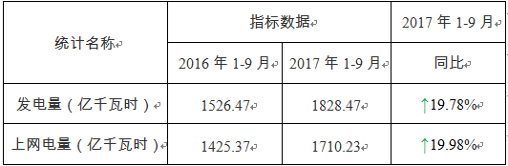

|  |  |  |  |  |  |
| --- | --- | --- | --- | --- | --- |
| 111223 |  |  |  |  |  |
|  |  |  |  |  |  |
|  |  |  |  |  |  |
|  |  |  |  |  |  |
|  |  |  |  | 33332 |  |
|  |  |  |  |  |  |
|  |  |  |  |  |  |