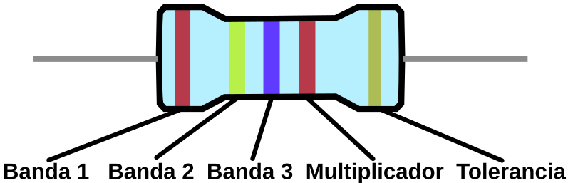
Color | Banda 1 | Banda 2 | Banda 3 | Multiplicador | Tolerancia
Negro | 0 | 0 | 0 | X1⁰, x1R
Marron | 1 | 1 | 1 | X10¹, x10R | ± 1%
Rojo | 2 | 2 | 2 | X10², x100R | ± 2%
Naranja | 3 | 3 | 3 | X10³, x1K
Amarillo | 4 | 4 | 4 | X10⁴, x10K
Verde | 5 | 5 | 5 | x10⁵, x100K | ± 0.5%
Azul | 6 | 6 | 6 | x10⁶, x1M | ± 0.25%
Violeta | 7 | 7 | 7 | x10⁷, x10M | ± 0.1%
Gris | 8 | 8 | 8 | x10⁸, x100M | ± 0.05%
Blanco | 9 | 9 | 9 | x10⁹, x1G
Oro |  |  |  | x10⁻¹, x0,1R | ± 5%
Plata |  |  |  | x10⁻², x0,01R | ± 10%

