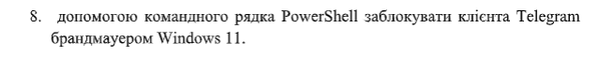
(Get-CimInstance Win32_Process -Filter "Name='Telegram.exe'").ExecutablePath
New-NetFirewallRule -DisplayName "Block Telegram OUT" -Direction Outbound -Program "C:\Users\zohan\AppData\Roaming\Telegram Desktop\Telegram.exe" -Action Block
New-NetFirewallRule -DisplayName "Block Telegram IN" -Direction Inbound -Program "C:\Users\zohan\AppData\Roaming\Telegram Desktop\Telegram.exe" -Action Blockяк зняти блокування
Remove-NetFirewallRule -DisplayName "Block Telegram*"

