# overview

The objective of this project is to create a digital system capable of monitoring the power usage of multiple components involved in the operation of an autonomous unmanned aerial vehicle. The device will measure and record the power draw of each component to allow for accurate modeling of the system’s power consumption. In order to ensure accurate measurements without impeding the aircrafts operation the system should be lightweight and draw minimal power.

# design parameters

* Measure current draw of up to 20A
* High precision and accuracy measurements
* Record current draw of 8 separate devices
* Sample data points regularly at high speed
* Pass measurements to a higher level controller via I­­­2C
* Support 3.3V and 5V logic systems
* Minimal weight/size
* Minimal power consumption

# block diagram

The first key components of the system are a set of eight current sensing devices. These sensors will be placed on the high side of each device to be measured and generate an analog output between ground and the logic voltage proportional to the current draw of the attached load. These analog values will then be sampled by an analog to digital converter (ADC) and the resulting digital values will be transmitted via an I2C serial interface to the high level controller.

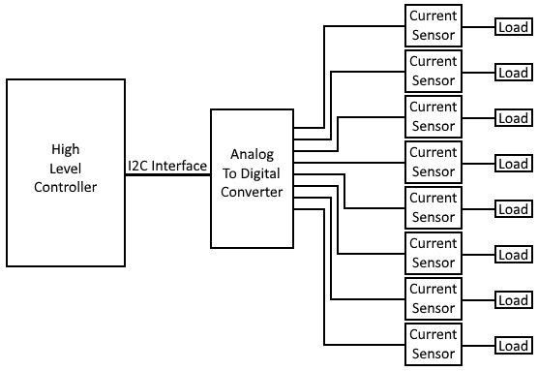

# Component selection

### A Note on Operating Voltage:

While the system as a whole needs to be able to operate on both 3.3V and 5V logic levels, this restriction is not necessarily needed for the operating voltage of all components in the system. As part of the I2C interface the master device pulls the clock and data lines high to its supply voltage. For some systems this is 3.3V while for others it is 5V. Conveniently this means that the logic voltage of the slave devices is not relevant (so long as it can handle the high voltage of the master) as it will only ever be pulling these lines down to ground, not up to its supply voltage. For example the Raspberry Pi is a 3.3V logic system, however this can be connected via I2C to an Arduino device operating with 5V logic. This is possible as logical high from the Raspberry Pi is 3.3V which falls above the 3V cutoff for the Arduino’s logical high.

As the entirety of this system is isolated from the master device by the I2C bus this allows us to choose components that operate on a standard 5V. This higher supply voltage allows the I2C interface to be operated with both 5V and 3.3V masters, provides greater dynamic range when generating analog voltages, and more greatly increases the list of available components to choose from. If 5V is not available in a given implementation an inline buck/boost converter can be added to regulate the supply voltage to 5V. A device like this devices is already integrated into the Raspberry Pi which provides a 5V output.

## Analog to Digital Converter:

The analog to digital converter used in this system will need to be able to receive 8 analog inputs and convert them to high precision digital values. This readings must be refreshed regularly to ensure that measurements reflect the changing current draw of each load. The device must also support an I2C interface to communicate with the high level controller.

### Resolution:

The accuracy of an ADC is largely determined by is resolution, the number of bits used to represent the digital values it generates. A higher resolution is desired as it directly increases a devices ability to sample an analog value accurately. For this implementation a resolution of 12 bits or more is likely desirable, this will guarantee accuracy within ~1.22 mV.

$$accuracy=\frac{vcc}{2^{resolution}}=\frac{5V}{2^{12}}≈0.0012207 V$$

### Sampling Rate:

The sampling rate is the rate at which an ADC can convert analog values to digital ones. While this metric is not highly critical it is a factor to be considered. A higher sampling rate will allow conversion to be completed faster meaning that measurements will more accurately reflect the state of the system and will allow more data points to be collected. These values are measured in samples per second (S/s or sps) and can range from 10 S/s to 200kS/s depending on the device. A minimum of 1kS/s is recommended, for accuracy down to 1ms as loads may change quickly.

### Recommendation:

Based on these criteria I recommend we use the [MAX11614EEE+](https://www.mouser.com/ProductDetail/Maxim-Integrated/MAX11614EEE%2b?qs=sGAEpiMZZMtgJDuTUz7XuzPMBnhTFd6J8AlyGxhho4M%3d) analog to digital converter. It’s capable of reading 8 channels with 12 bit resolution at 94.4ksps and transmitting the results over I2C to a master operating at 3.3V or 5V. It also comes in a 12 channel version which could be implemented in the future if desired with minimal changes to the design.

## Current Sensor

### Functional Principle

The two most popular types of current sensors are Hall Effect current sensors and Current Shunt Monitors. Hall Effect sensors measure the electromagnetic field created by current flowing through a wire and produce an analog output proportional to the field strength. Shunt monitors pass the current over a small resistor and generate an analog output proportional to the voltage drop across the resistor, this allows the current flow to be calculated easily by Ohm’s law. These systems over differing tradeoffs between accuracy

### Accuracy and Range

The current sensors used in this system must be able to accurately measure currents ranging from 0-20A. Currents $≤$ 1A are expected for computational components such as the higher level controller while peak currents of up to 20A may be drawn by the aircrafts motors. Due to this large range it may be difficult to accurately measure low current values.

One possible solution is for the device to have an adjustable gain, this would allow us to adjust the output ratio for each sensor individually and make full use of the sensors output range. For example let us consider a current sensor capable of measuring 0-20A and producing a corresponding output voltage of 0-5V. When connected to a motor drawing the full 20A maximum the sensor would produce an output voltage of 5V. However, when connected to a microcontroller drawing 1A or less the sensor would produce an output of 0.25V. In the second case the sensor is using at most 5% of its output range and in doing so loses accuracy to sample error and voltage fluctuations. Ideally we would adjust the gain of the sensor such that the maximum expected current, in this case 1A, generates the maximum possible output of 5V restoring the devices dynamic range.

While these voltage ranges and adjustable gain are possible with both Hall Effect sensors and shunt monitors, it is far easier to detect a wide range of voltages with a shunt monitor. When using a Hall Effect sensor to accurately measure current flows of <10A it is often necessary to add multi-layer or multi-wind paths as seen in the figure below to concentrate the magnetic field. Without these additions low current readings are likely to be unreliable. Unfortunately these traces are often incapable of handling currents >10A, meaning that we must choose at the time of the board design if a given channel will be able to measure 0A-10A accurately or 10A-20A accurately. This can be problematic if a load varies across these ranges, e.g. if a motor commonly draws 5A-15A.

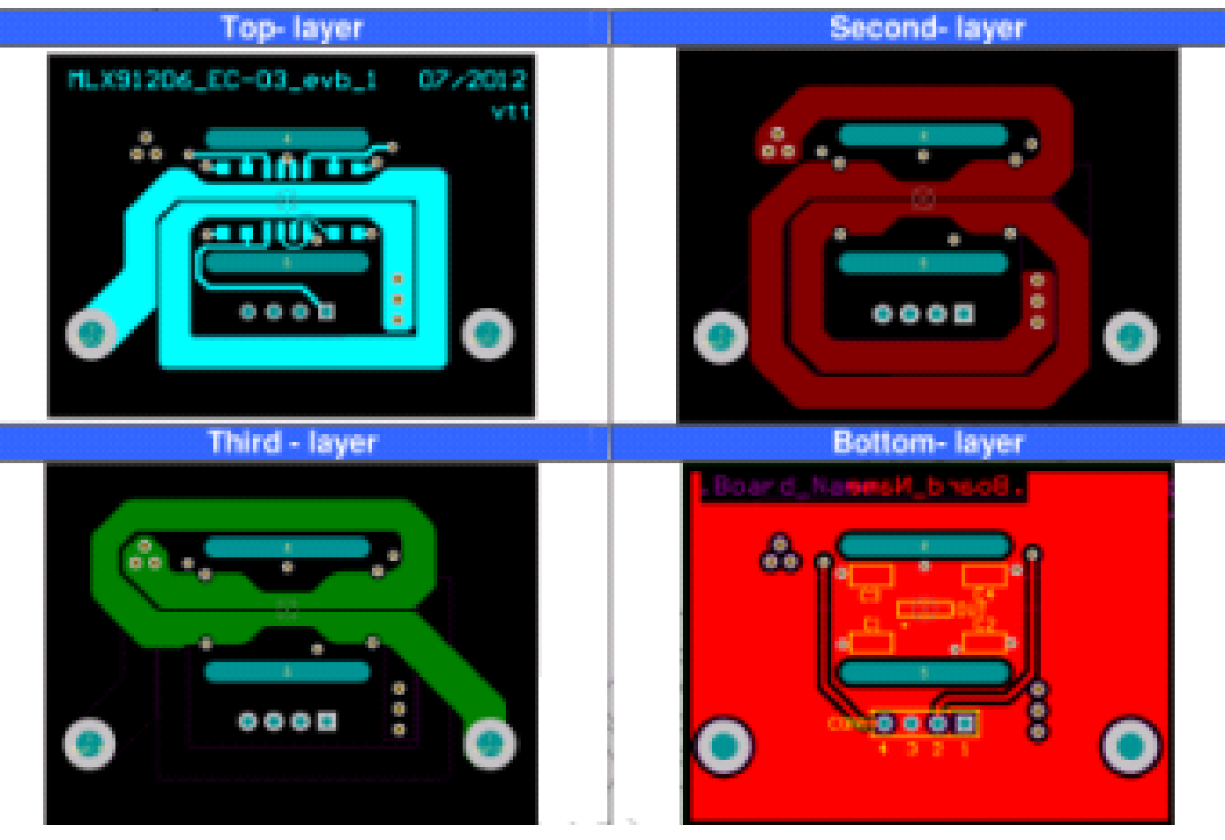

While Hall Effect sensors are moderately more accurate than shunt monitors given these modifications and proper tuning, shunt monitors are desirable for their ability smoothly measure current flow anywhere within the range set by their gain. The gain can be adjusted at any time simply by replacing a resistor on the output line allowing for precise measurements over a flexible range without requiring a redesign of the board itself.

### Isolation

When considering electrical isolation Hall Effect sensors are clearly superior. As Hall Effect sensors measure the magnetic field generate by the current and not the current directly they are non-intrusive and do not need to actually connect to a components power supply. This provides the benefit of an independent load and measurement system, a failure of one is unlikely to cause damage to the other as they are not physically connected. Contrastingly shunt monitors measure the current flow by passing it across a resistors and therefore need to be placed in line between the load and the voltage supply. Accordingly if a shunt resistor fails it may impede the operation of the load it is attached to, and excessively high load currents may damage the sensor itself. Under normal operation this shouldn’t matter but added isolation of a Hall Effect sensor is beneficial for fault protection.

### Complexity

While both Hall Effect Sensors and shunt monitors require passive components for proper operation, shunt monitors are a simpler a more robust option. A shunt monitor can be quickly and easily implemented with only the IC and two resistors. Hall Effect sensors are significantly more complex to setup accurately with recommended implementations using three capacitors, one resistor and a ferromagnetic shield. The shielding requirement is perhaps the most obtrusive, for accurate readings the manufacturer suggests using a U-shaped metal channel to focus the magnetic field from the load line and prevent interference from other electromagnetic sources. Given the application we can expect these sensors to be in close proximity to other components that will generate interference and make this shielding necessary. Lastly once constructed Hall Effect sensors should be tuned to ensure accurate readings. While these steps can ensure that Hall Effect sensors provide very accurate readings, they increase the chance of a manufacturing error or malfunction.

### Power Consumption

To be completed, want to run some calculations through MATLAB

### Recommendation

To be completed, dependent on results of MATLAB simulation