**Project Context**

National Risk Reduction Management Commission (NDRRMC) Monitoring System easily monitor and identify the needs of the area that is going to be affected before a calamity happens. This will allow ease of access to information for NDRRMC and other Government Agencies. The use of NDRRMC Monitoring System it will give awareness and public safety to the community in order to be well prepared in incoming disaster. By using this system, it may reduce the number of families that will be affected.

**Scope and Limitation**

These are the coverage of NDRRMC Monitoring System are:

* NDRRMC Monitoring System Admin can create account for M/CDRRM Admin
* NDRRMC Monitoring System Admin sends predicted disaster details and predicted areas to be affected
* M/CDRRM request needed supplies to Logistic
* NDRMMC Monitoring System provides dashboards

The NDRRMC Monitoring System is limited only to create account for Municipalities/Cities Monitoring System Admin. Also, the disaster details that is being send to M/CDRRM is base from the report of DOST-PAGASA and PHIVOLCS.

**Methodology**

The process starts when NDRRMC Admin sends a predictive disaster details to M/CDRRM monitoring admins for their preparation in the incoming disaster. When M/CDRRM Monitoring admin receives the report from NDRRMC Monitoring, municipality/city monitoring admin sends a request of needed supplies to the logistic, by there the process of logistic, inventory and procurement system will apply.

**ERD**

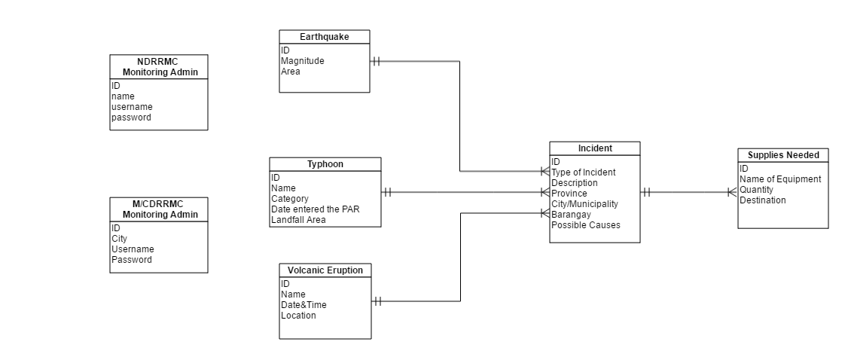

**Data Dictionary**



