

**NDRRMC Monitoring System**

Project Documentation Submitted to the Faculty of School   
of Computing and Information Technology

Asia Pacific College

In Partial Fulfillment of the Requirements  
for the Subject Software Development

By:

Carpio, Aira Joyce A.  
Haboc, Florence Gail G.  
Salazar, Arnold

Professor:   
Mr. Edmundo Casino

April 2017

Contents

Executive Summary 4

Introduction 4

Project Context 4

Purpose and Description 5

Objectives 5

General Objectives 5

Specific Objectives 6

Target Audience 6

Scope and Limitations 7

Definition of Terms 8

Review of Related Literature/System 10

Sahana Eden 10

Pentaho Analysis Tool 10

KSNDMC GIS System 10

Technical Background 11

Relevant Technical Aspects of the Project 11

Methodology, Results and Discussion 11

Requirements Analysis 11

Requirements Documentation 12

Input 12

Output 12

Conceptual Framework 12

Proposed BI Tool 13

About Cloud9 Charts 13

Cloud9 Charts Features 14

Screenshot of Every Module 16

NDRRMC Monitoring System GUI 16

Conclusions and Recommendations 23

Appendices 24

Users Guide 24

System Tables and Diagrams 32

Event Table 32

Context Flow Diagram 32

Data Flow Diagram 33

Use Case Diagram 33

Activity Diagram 34

Data Process 35

BI Tool Plans 36

Curriculum Vitae per team member 37

Bibliography 41

# Executive Summary

NDRRMC Monitoring System is a web-based system that provides data warehouse to connect multi-sourced data from different stand-alone NDRRMC systems (e.g. Logistics, Inventory, Procurement, Law and Order, etc.). The system includes embeddable Business Intelligence(BI) Tool to properly monitor data in real time and for better decision-making.

The system also gives real time reports transmitted from Law and Order System to the respective user(s). With that, the in-charged user(s) registered to Monitoring System will be notified and know what action they should do to respond on the reported area.

# Introduction

## Project Context

The National Disaster Risk Reduction and Management Council is the agency tasked to prepare for, and respond to, natural calamities like typhoons and earthquakes. It also monitors human-induced emergencies, such as armed conflicts and maritime accidents. For better response and preparedness, the team identified the problems of NDRRMC and LGUs when it comes to preparing for a disaster and these are the following:

1. Lack of capacity and technical expertise
2. Lack of public awareness or the threats and impacts of all types of hazards
3. Lack of necessary skills to cope with the impacts of disaster
4. Lack of communication and coordination

The project aims to solve the identified problems by proposing the NDRRMC Monitoring System. With the proposed system, the result must be to strengthen disaster preparedness for effective response at all levels. This will give awareness and public safety to the community to respond to the disaster effectively and be well prepared in incoming disaster. This also allows ease of access of information for NDRRMC and other Government Agencies to easily monitor and identify the needs of the area that was reported. Thus, it will reduce the number of families that might be affected. The coordination and communication will also improve since each of the users will and have an access to the summary reports of different data sources.

## Purpose and Description

The NDRRMC Monitoring System is a system where Local Government Units(LGUs), NDRRMC member agencies, and/or other authorized users can view summary reports of each of the NDRRMC related systems. The summary reports consist of multi-sourced data from different stand-alone NDRRMC systems that are included in system’s data warehouse which has two classifications: The Preparedness Cluster and the Response Cluster. Under the clusters are Inventory System, Procurement System, Logistics System, Food and Non-food System, Dead and Missing System, Camp Management and Coordination System and Law and Order System. Summary reports include data visualization, interactive reporting, dashboards, drill downs and descriptive and predictive analytics for better analyzing and monitoring of the big data and for fast decision-making.

The system also includes transmission of report from Law and Order data to make the information quickly available for better preparedness and respond. The respective user(s) will then receive a notification about the report details. Since the data from different system will be in use and the information of report is already in the system, it will help the NDRRMC and/or the users for recommendation and decision making in analyzing the needs of the affected area. From the collected data and the details of report received, the users can easily evaluate and identify what preparation or response he/she should do. It will also be useful in improving the planning process, correcting problems and obviating similar problems in the future.

## Objectives

### General Objectives

* To increase community disaster awareness and improve disaster preparation coordination

### Specific Objectives

* To enable users to be updated about the reports
* To have the users coordinate with each other
* To help users in decision-making for disaster preparation and respond

## Target Audience

Since the system will be handling all the data from different stand-alone systems of NDRRMC, it is assumed that all system users will already be registered to the Monitoring System by gathering their user details and adding to the registered accounts. They will be the limited users who have the view access to the Monitoring System and can be notified to take action in the report of Law and Order. The diagram below is the Organizational Chart showing the lead agencies and its assigned cluster(s):

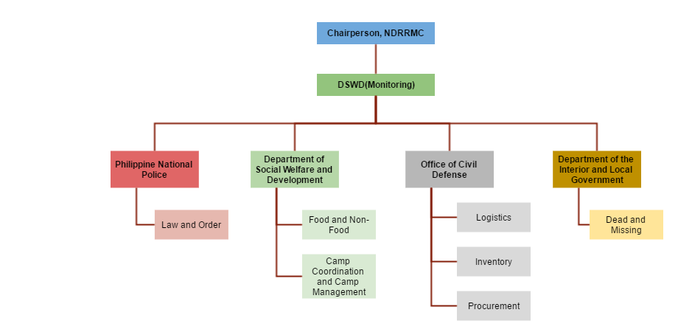  
Figure 1 – Organizational Chart

NDRRMC consists of different agencies with different assigned tasks. NDRRMC chairperson is leading all the clusters. For Monitoring, DSWD is the lead agency and under the Monitoring are different clusters with its lead agencies: PNP is in charge for Law and Order. For DSWD, aside from Monitoring, are Food and Non-Food and Camp and Coordination Management. For OCD, its handled cluster are Logistics, Inventory and Procurement. Lastly, DILG is in charge of the Dead and Missing Cluster.

## Scope and Limitations

At the end of the project, the final output must be a working prototype or proof of concept of the proposed system. The coverage of proposed system is the following:

* NDRRMC Monitoring System providing data warehouse consists of different NDRRMC related systems that are listed below:
  + Inventory
  + Procurement
  + Logistics
  + Law and Order
  + Dead and Missing
  + Food and Non-Food
  + Camp Coordination and Camp Management
* NDRMMC Monitoring System provides summary reports in the form of dashboards using BI tool.
* NDRRMC Monitoring System data transmitted by Law and Order Report will be sent to respective user(s) by notification

The NDRRMC Monitoring System is limited only to register account for LGUs, NDRRMC member agencies, users/admins of different NDRRMC system. Each user will only have view access to the dashboards. The collection of data gathered will not be all visualized since system will only produce summary reports of the data of each of the systems. Due to limited time and cost of the project, each dashboard only consists of descriptive analytics. Also, the report details that is being notified to users heavily depend on Law and Order System inputs such as the reliability and accuracy of the report.

## Definition of Terms

|  |  |
| --- | --- |
| Term | Definition |
| AdminLTE | An admin dashboard and control panel bootstrap template |
| Apache Cassandra | A [free and open-source](https://en.wikipedia.org/wiki/Free_and_open-source_software) [distributed](https://en.wikipedia.org/wiki/Distributed_database) [database](https://en.wikipedia.org/wiki/Database) management system designed to handle large amounts of data across many [commodity servers](https://en.wikipedia.org/wiki/Commodity_computing), providing high availability with no [single point of failure](https://en.wikipedia.org/wiki/Single_point_of_failure). |
| BI Tool | A [free and open-source](https://en.wikipedia.org/wiki/Free_and_open-source_software) [distributed](https://en.wikipedia.org/wiki/Distributed_database) [database](https://en.wikipedia.org/wiki/Database) management system designed to handle large amounts of data across many [commodity servers](https://en.wikipedia.org/wiki/Commodity_computing), providing high availability with no [single point of failure](https://en.wikipedia.org/wiki/Single_point_of_failure). |
| Big data | Extremely large data sets that may be analyzed computationally to reveal patterns, trends, and associations, especially relating to human behavior and interactions. |
| Bootstrap | Bootstrap is the most popular HTML, CSS, and JavaScript framework for developing responsive, mobile-first web sites. |
| Cloud9 Charts | Cloud9 Charts is a next generation analytics platform founded in 2012 that provides analytics from unstructured NoSQL databases, structured databases and files that enable businesses to make data-driven decisions quickly*.* |
| Data warehouse | A large store of data accumulated from a wide range of sources within a company and used to guide management decisions. |
| Descriptive Analytics | Descriptive analysis or statistics does exactly what the name implies they “describe”, or summarize raw data and make it something that is interpretable by humans. |
| DILG | The Department of the Local Interior and Local Government is responsible for promoting peace and order, ensuring public safety and strengthening local government capability aimed towards the effective delivery of basic services to the citizenry |
| Disaster | Natural or man-made emergencies that cannot be handled by affected communities who experience severe danger and incur loss of lives and properties causing disruption in its social structure and prevention of the fulfillment of all or some of the affected community’s essential functions. |
| Drill down | Access data that is in a lower level of a hierarchically structured database. |
| DSWD | Department of Social Welfare and Development is the executive department of the Philippine Government responsible for the protection of the social welfare rights of Filipinos and to promote social development. |
| ETL | (Extract, transform, load) three database functions that are combined into one tool to pull data out of one database and place it into another database. |
| Hazard | Any phenomenon that has the potential to cause disruption or damage to humans and their environment. Or an event or occurrence that has the potential for causing injury to life, property and environment. |
| LGU | The Local Government Unit is a part of the government closest to the people and is in charge of delivering basic services and facilities to its constituents. |
| Linux | Linux is an operating system kernel used by a group of Unix-like operating systems. These are known as Linux operating systems. |
| Machine Learning | Type of artificial intelligence (AI) that provides computers with the ability to learn without being explicitly programmed. |
| MySQL | MySQL is an open source relational database management system (RDBMS) based on Structured Query Language |
| NDRRMC | The National Disaster Risk Reduction and Management Council is the agency tasked to prepare for, and respond to, natural calamities, like typhoons and earthquakes. It also monitors human-induced emergencies, such as armed conflicts and maritime accidents. |
| OCD | Providing leadership in the continuous development of strategic and systematic approaches as well as measures to reduce the vulnerabilities and risks to hazards and manage the consequences of disasters. |
| PHP | PHP (PHP: Hypertext Preprocessor) is a scripting language that helps people make web pages more interactive, by allowing them to do more things. |
| Polyglot Persistence | Using different database technologies to handle unique persistence needs. |
| Predictive Analytics | Predictive analytics has its roots in the ability to “Predict” what might happen. These analytics are about understanding the future. |
| Preparedness | Activities and measures taken in advance to ensure effective response to the impact of hazards, including the issuance of timely and effective early warnings and the temporary evacuation of people and property from threatened locations. |
| PNP | It is administered and controlled by the National Police Commission and is part of the Department of the Interior and Local Government (DILG). Local Police officers are operationally controlled by municipal mayors |
| Response | The act of implementing or translating into actions what are called for by the preparedness plans. Response includes actions taken to save lives and prevent further damage in a disaster or emergency situation. Seeking shelter from strong winds accompanying a typhoon and evacuating to higher grounds due to an impending flood are examples of response. |
| Ubuntu | Ubuntu is a free operating system that uses the Linux kernel. The word "ubuntu" is an old African word meaning "humanity." It is pronounced "oo-boon-too". |
| Yii2 Framework | Yii is a high-performance PHP framework best for developing Web 2.0 applications. |
| Table 1– Definition and Acronyms | |

# Review of Related Literature/System

## Sahana Eden

Sahana Eden (Emergency Development Environment) is a software that provides solution to manage the organizations, people, projects, inventory and assets as well as collecting information through maps. It is designed to help Disaster Management practitioners to better mitigate, prepare for, respond to and recover form disaster more effectively and efficiently. Sahana Eden contains a number of different modules which can be configured to provide a wide range of functionality.  Its main capabilities are organization registry, project tracking, human resources, inventory, assets, assessments, shelter management, scenarios and events, mapping and messaging.

## Pentaho Analysis Tool

Pentaho Business Analytics is an open source visual integration tool with comprehensive data discovery and visualization, interactive reporting, dashboards and predictive analytics. Pentaho is embeddable architecture supports any type or source of data with native support for Hadoop, NoSQL and analytic databases. It also supports and augments “human decision-making” with automated algorithms and machine learning.

## KSNDMC GIS System

KSNDMC (Karnataka State Natural Disaster Monitoring Centre) provides regular weather and natural hazards-related updates to the farming community, agriculture and horticulture sector, fishermen, transport sector, power and electricity sector and state and district level disaster management authorities in Karnataka. The center provides ’Early Warning and Preparedness’ activities related to management of natural hazards in Karnataka. Its objective is to develop a geospatial database for the decision making and management in an event of natural hazards; it envisaged a system to capture the data in a near real-time and automate the generation of reports, alerts and early warnings to government bodies and communities.

# Technical Background

## Relevant Technical Aspects of the Project

To develop the system, the project team propose to use Cloud9 Charts for Data Warehousing and for Data Analytics. Cloud9 charts is embeddable tool that support multiple data resources such as structured and unstructured data which makes it perfectly fit for use in this system. The system uses Yii2 Framework for the interface of the system and AdminLTE, an admin dashboard and control panel bootstrap template to complete the features. For the data storage, the team decided to include one structured data and one unstructured data to test and show the capabilities of the selected BI tool. These are the Cassandra DataStax and MySQL. For the operating system, the team was able to test the BI tool in both Windows10 and Ubuntu operating system.

Since the team can only test the free try out of the said BI tool with 14 days free support, the features that the team accessed were only limited. With that, the embedding of dashboard to the actual system was not implemented. Instead, the team came up with alternative BI tool for data visualization to show the proof of concept of the proposed system which is the Microsoft PowerBI and storage of sample data used is only in Microsoft Excel because it cannot store unstructured data.

# Methodology, Results and Discussion

## Requirements Analysis

After analyzing the problems that the NDRRMC encounter in disaster preparation, the team came up with proposal of possible solutions that the system could provide. Most problems that the NDRRMC encounter are lack of communication and coordination which might lead to absence of public awareness. With the NDRRMC Monitoring System, the problem that the facility encounters will be resolved and minimized.

## Requirements Documentation

### Input

* System admin shall validate the registered users
* Report details transmitted by Law and Order must be notified to users
* System dashboards must be timely updated when there are changes from other systems

### Output

* The Business Intelligence tool shall generate reports
* Users shall only have view access to each of the dashboards
* Only responsible user/s shall receive the notification reported in real time

## Conceptual Framework

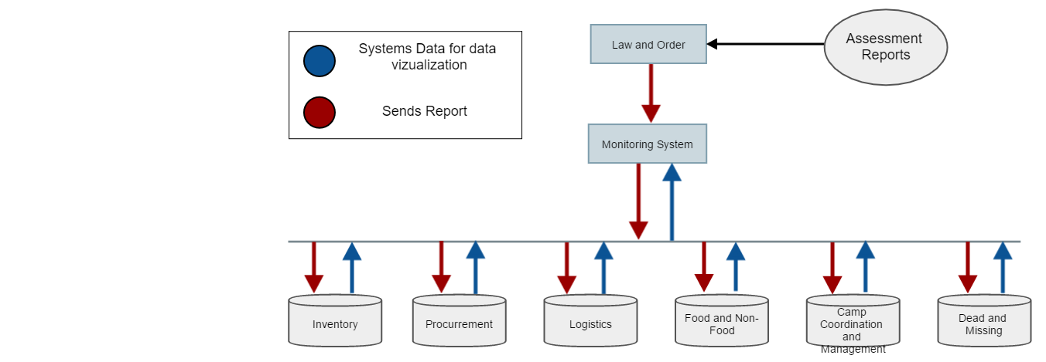  
Figure 2 – Conceptual Framework

The conceptual framework above shows the transmission of different data of systems. The red arrow is the transmission of the Assessment Report of Law and Order to the Monitoring System. Once the system receives the transmitted Assessment Report, the responsible user/s that is specified in the report of Law and Order for taking the action will be notified. On other hand, the blue arrow is for synching of data from stand-alone systems to the Monitoring System for keeping the tracking of data updated.

## Proposed BI Tool

### About Cloud9 Charts

Many enterprises are increasingly adopting “Polyglot Persistence” architecture, a term for using different database technologies to handle unique persistence needs. It means that traditional SQL based relational databases for structured data, in conjunction with newer NoSQL databases and file based sources for unstructured/semi-structured data. This practice is also the same as the proposed system. The challenge is to find a perfect solution to join all the heterogenous data sources as one to develop an effective monitoring system.

Most BI Tool process/approach have 3 stages: first, the Extract, Transform, Load (ETL) which takes a heavy and long process. Second, the data will be stored in one data warehouse. Lastly, once the data is in a structured form in the warehouse, that will be the time where a BI tool comes into play. Each process involves specific tool suites along with specialized engineering and IT resources. For instance, the warehousing layer, typical choices include a custom SQL database or Amazon Redshift, Pentaho/Alteryx for ETL and data processing, Tableau/Qlik for data visualization, etc. But this kind of typical process is far too cumbersome, brittle, expensive and takes a significant amount of time, resources and skills.

Cloud9 Charts takes a different process:

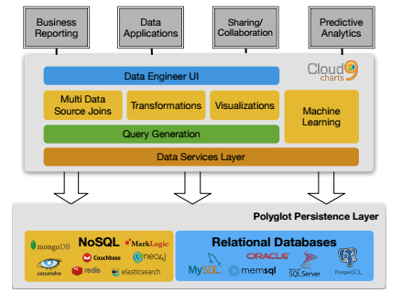Figure 3 – Cloud 9 Charts Process

Cloud9 Charts is a next generation analytics platform that provides analytics from unstructured NoSQL databases, structured databases and files that enable businesses to make data-driven decisions quickly regardless of the volume, velocity and variety of data. It eliminates the need for ETL, ODBC drivers, or data transformation processes that alternate solutions require and dramatically simplify the process to go from raw data to insights seamlessly. It can natively connect, query, store, analyze, visualize and share results from unstructured and structured sources. It provides multiple deployment modes including cloud-hosted, on premise and a hybrid approach. In addition, a flexible, scalable, schema-less data lake is built into Cloud9 Charts that allows warehousing of large amounts of data for reporting data tracking offsetting query loads off raw databases.

### Cloud9 Charts Features

Listed below is the summary of complete features of the BI tool:

* Unlimited Dashboards & Data sources
* Unlimited Cloud9Agent instances
* Connect to any supported data source through UI or using Cloud9Agent
* Fully native integrations into NoSQL Databases, Relational databases, REST API's and files
* Multi-Data source joins
* Scalable, schema-less, flexible Elastic Store (optional)
* Powerful data transformation and cleansing layer using Cloud9QL
* Share dashboards to internal groups or a simple URL
* Works on any device
* 30 visualizations types including Charts, Data Grids, Summary, Geo
* Interactive filters
* Drilldowns
* Drag & Drop Ad hoc Analysis
* Live, auto updating charts/widgets
* Export data to Excel/CSV
* Email Dashboards PDF and CSV data
* Run queries on a schedule
* Plug-in architecture for custom logic & prediction algorithms
* Incremental data pulls and warehouse updates
* Push API to send real-time data
* Data Export API
* Single Sign-On API for embedding inside the portal
* Merge data from various data sources
* Roll ups and aggregations
* On-premise or Cloud or Hybrid deployment modes
* Advanced analytics including prediction modelling, machine learning, cohort analytics etc.

## Screenshot of Every Module

### NDRRMC Monitoring System GUI

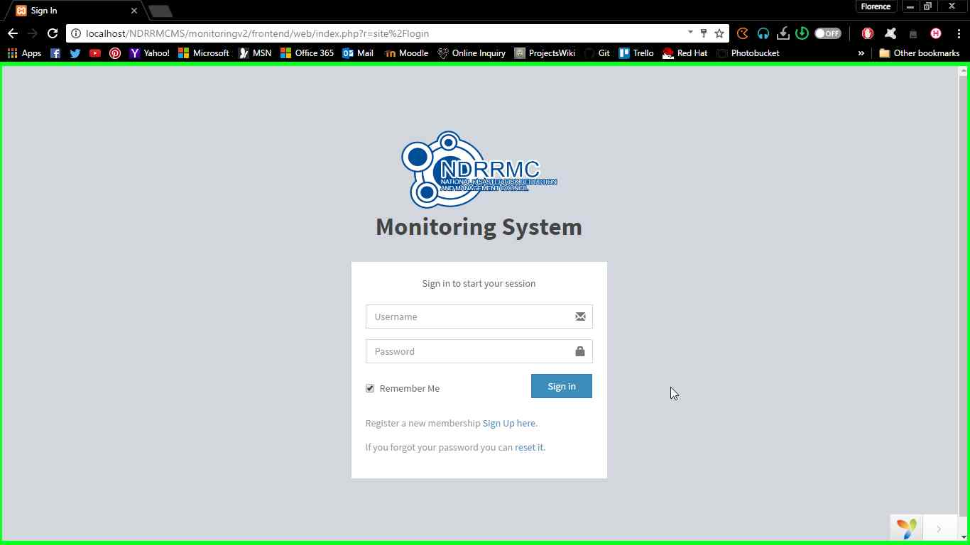  
Figure 4 – Sign In Page

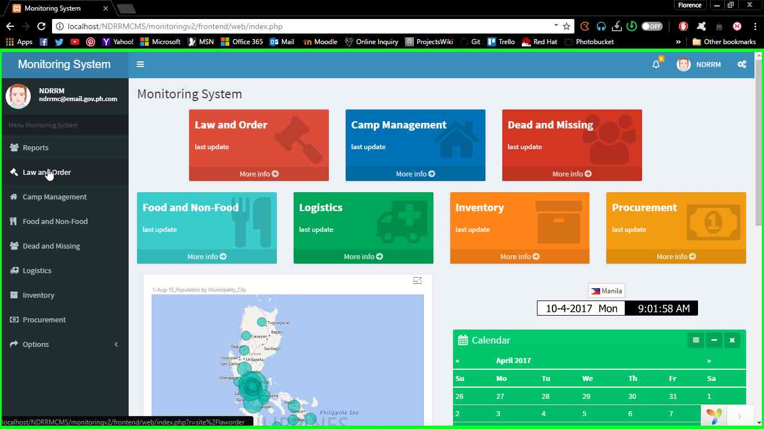  
Figure 5 - Home Page

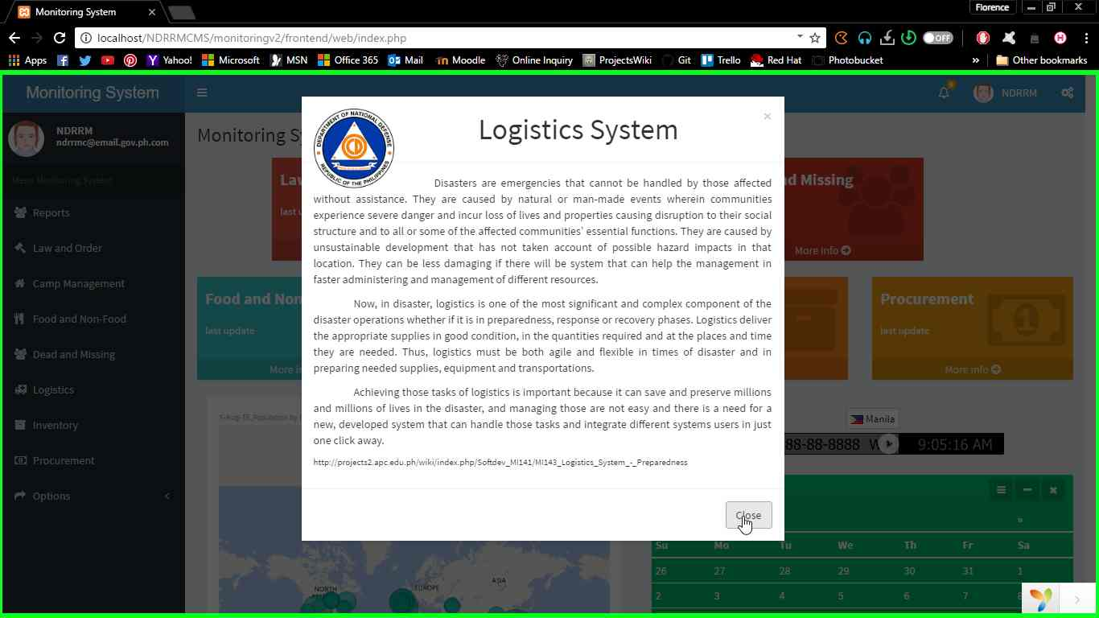  
Figure 6 – Description Pop-up Screen

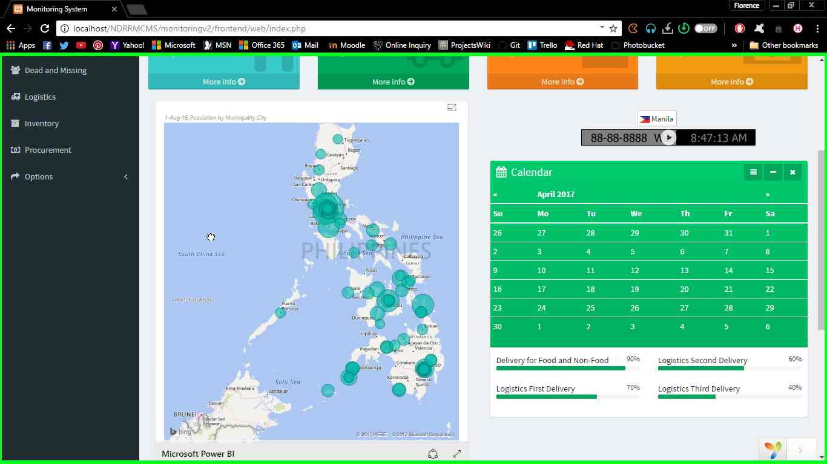  
Figure 7 – Home Page (Cont)

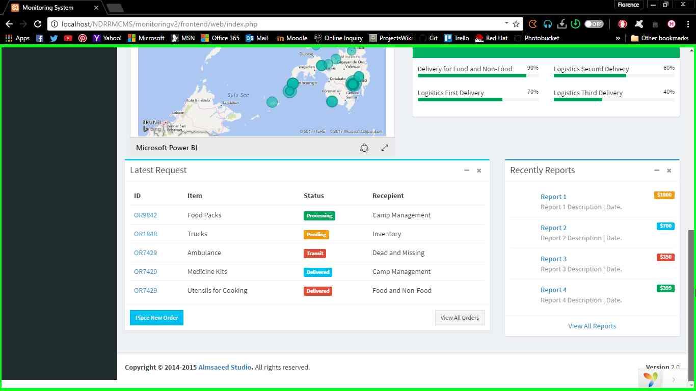  
Figure 8 – Home Page (Cont)

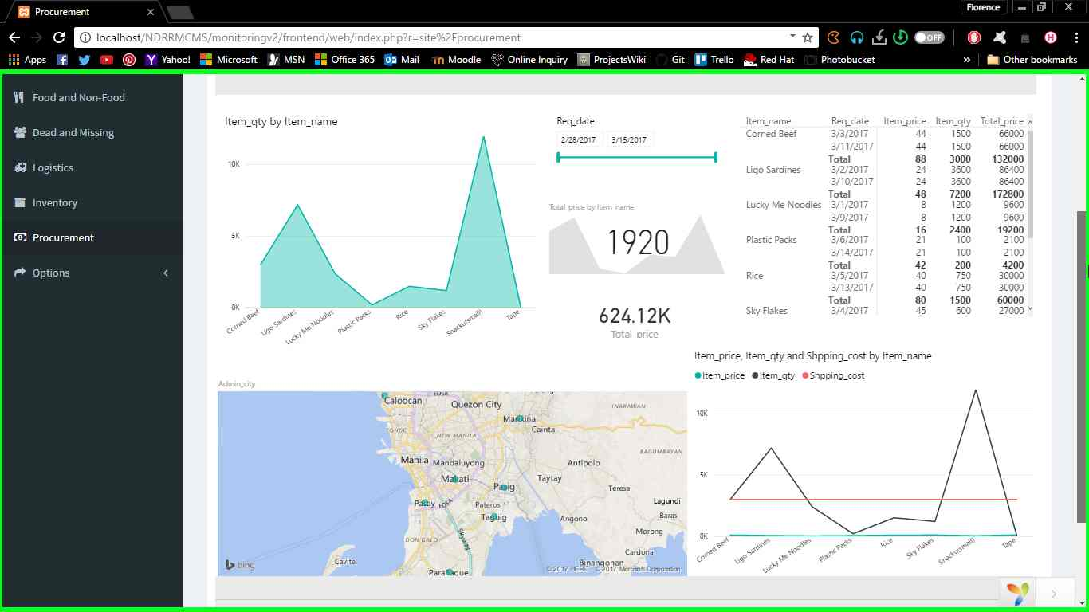  
Figure 9 - Procurement Dashboard

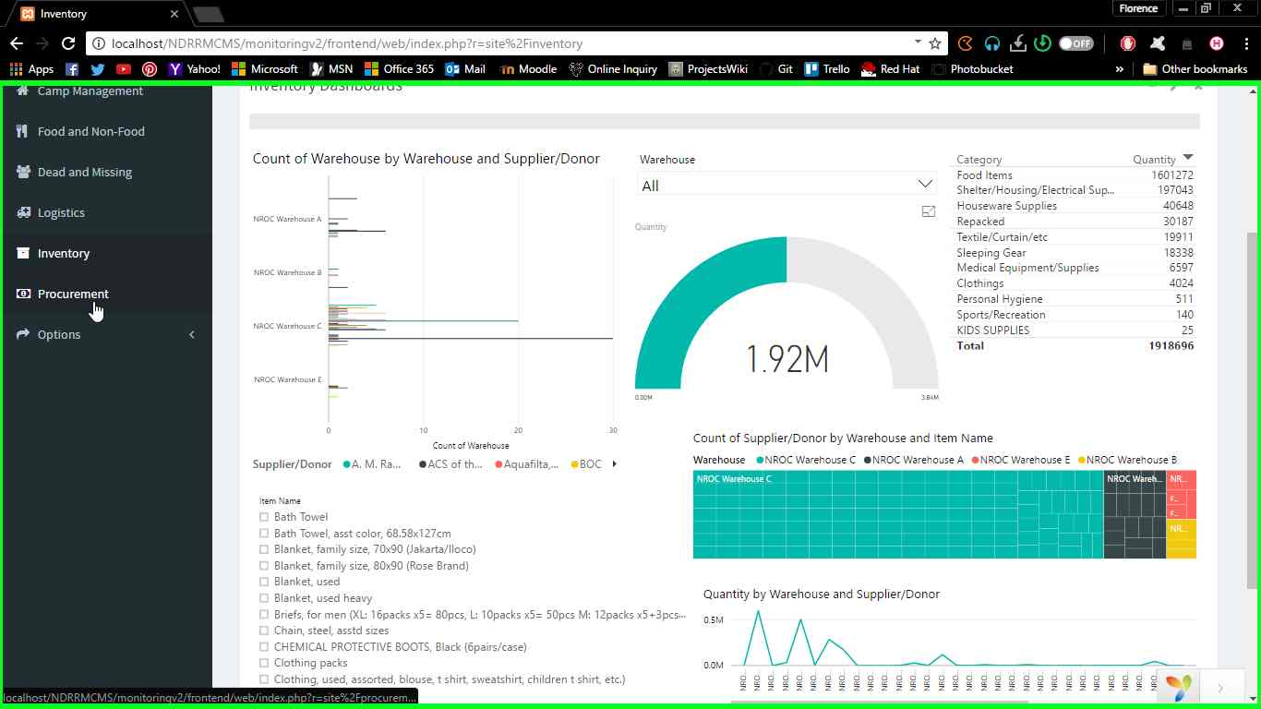  
Figure 10 - Inventory Dashboard

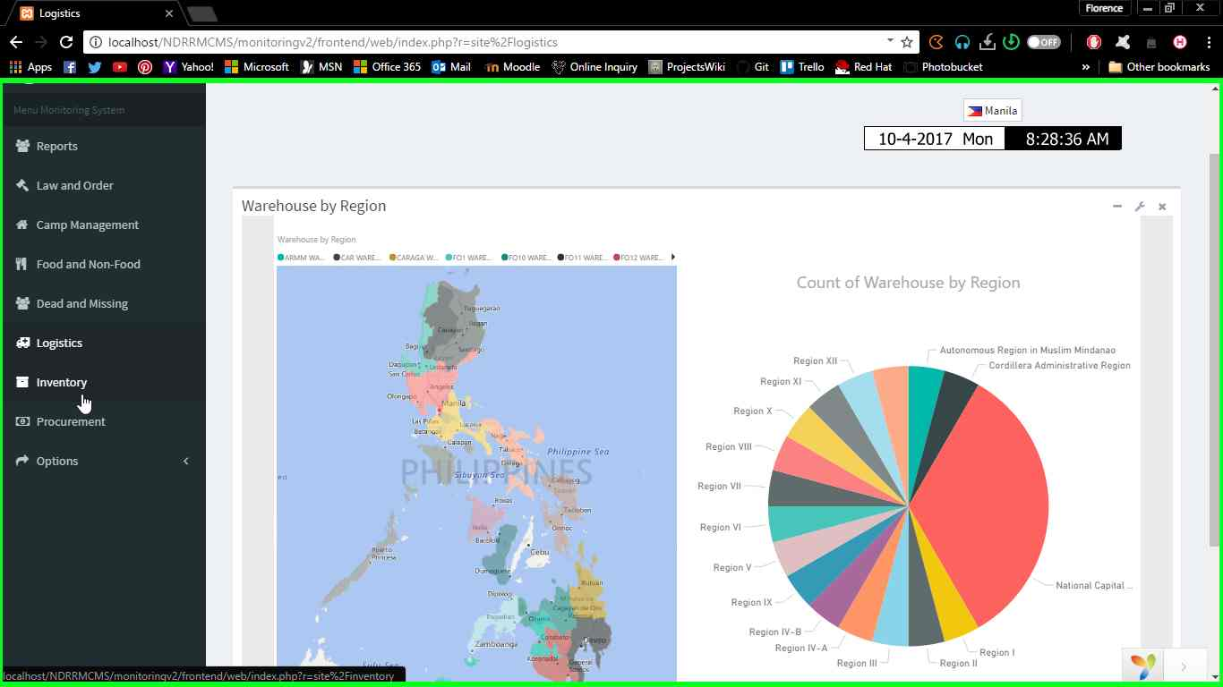  
Figure 11 - Logistics Dashboard

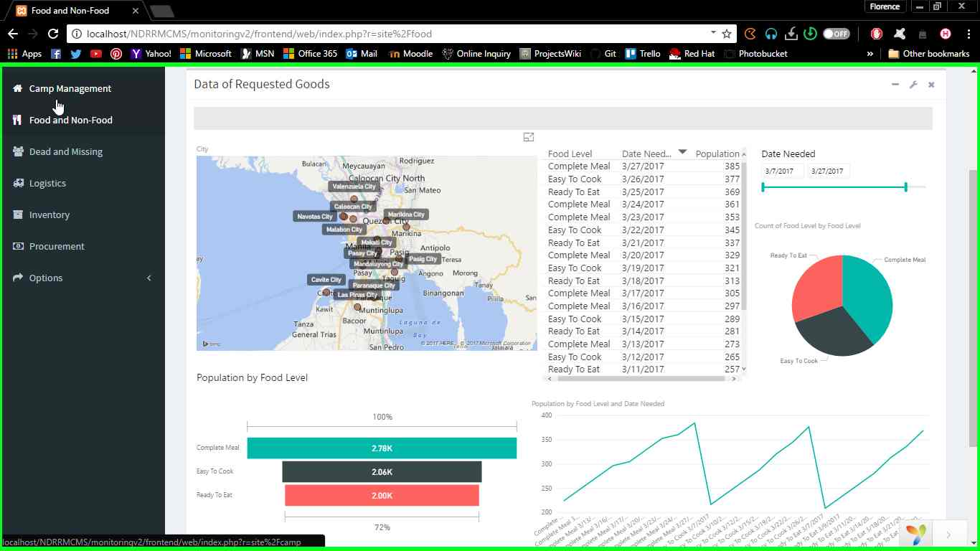  
Figure 12 - Food and Non-Food Dashboard

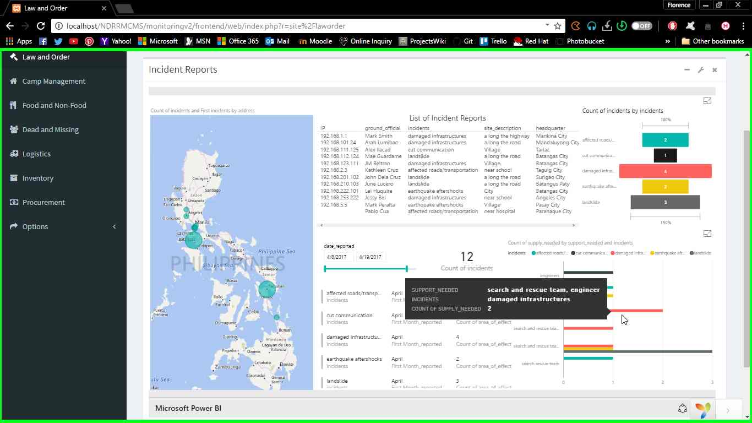Figure 13 - Law and Order Dashboard

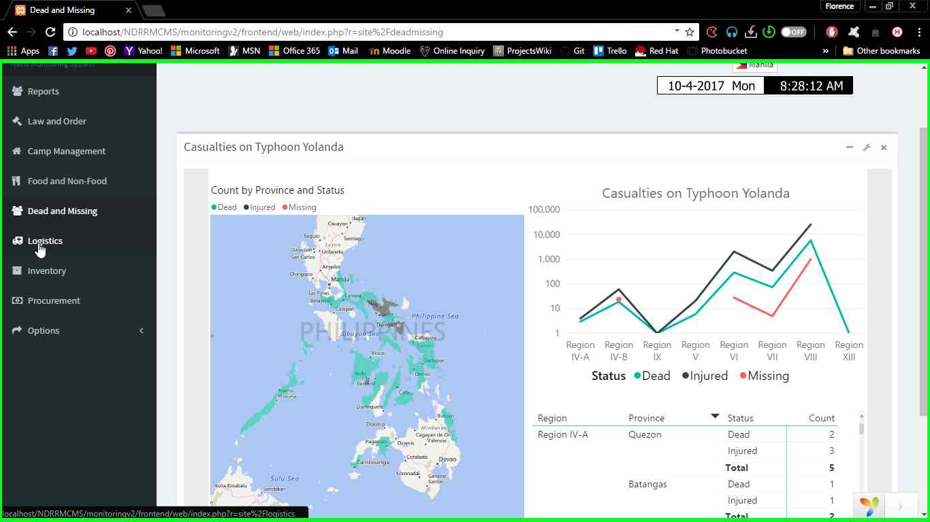Figure 14 - Dead and Missing Dashboard

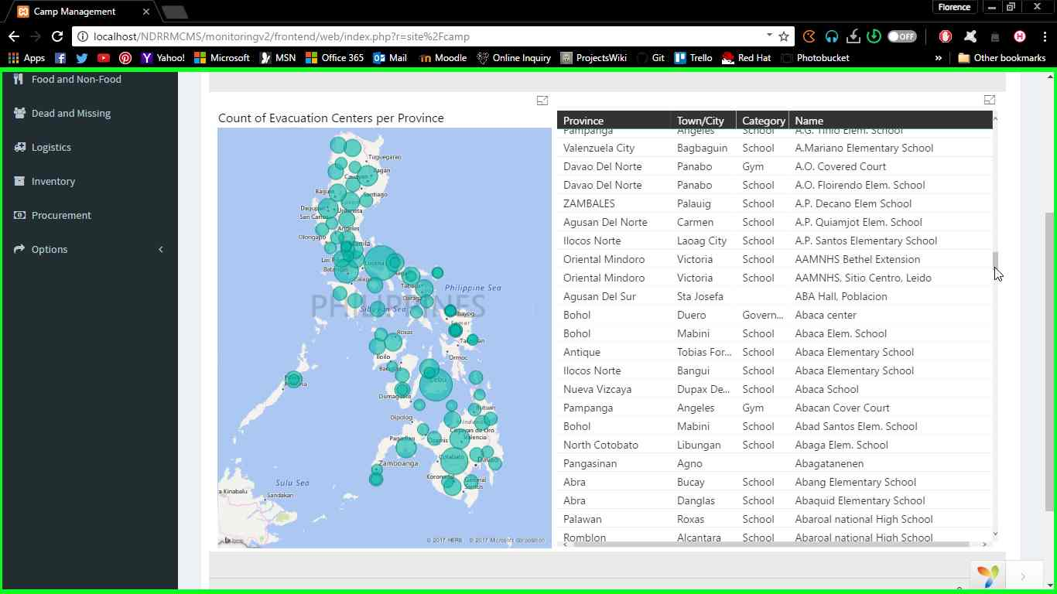  
Figure 15 - Camp Coordination and Camp Management Dashboard

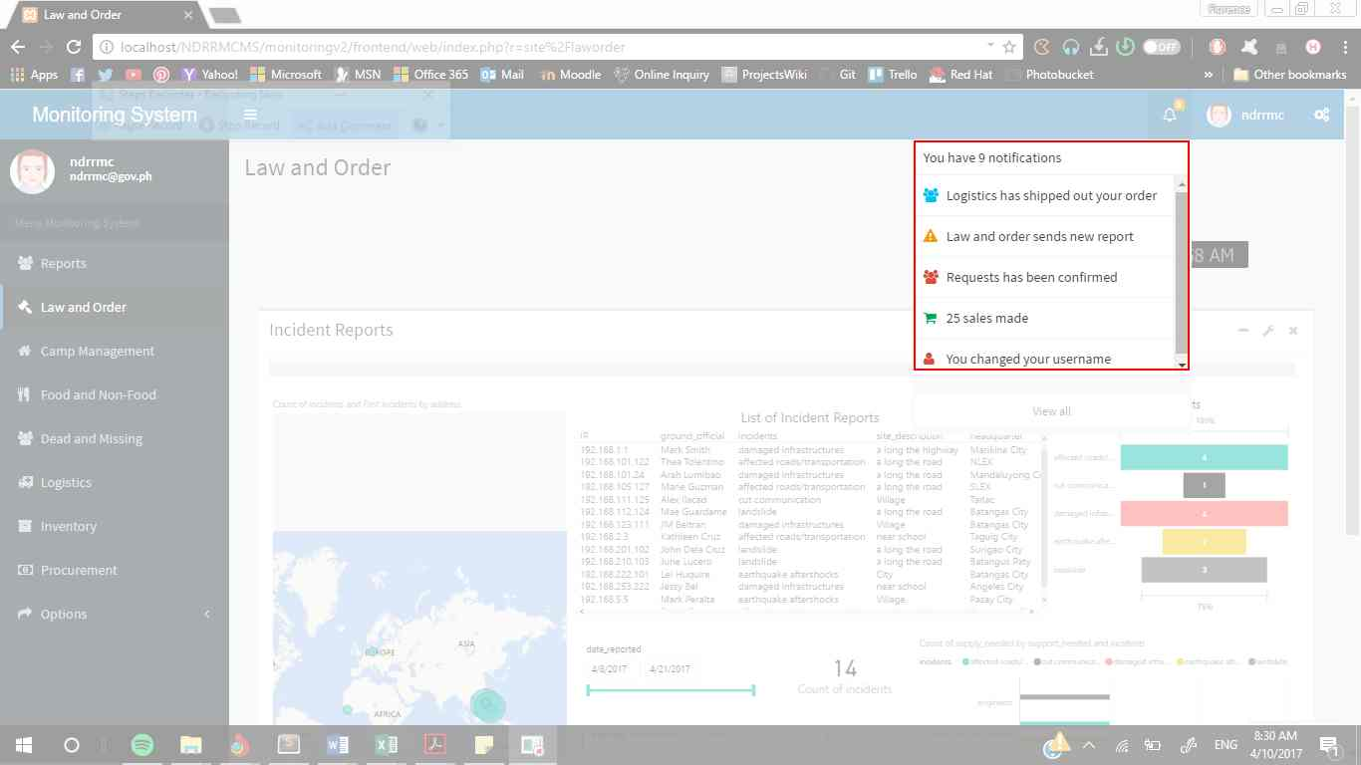

Figure 16 - Notification Menu

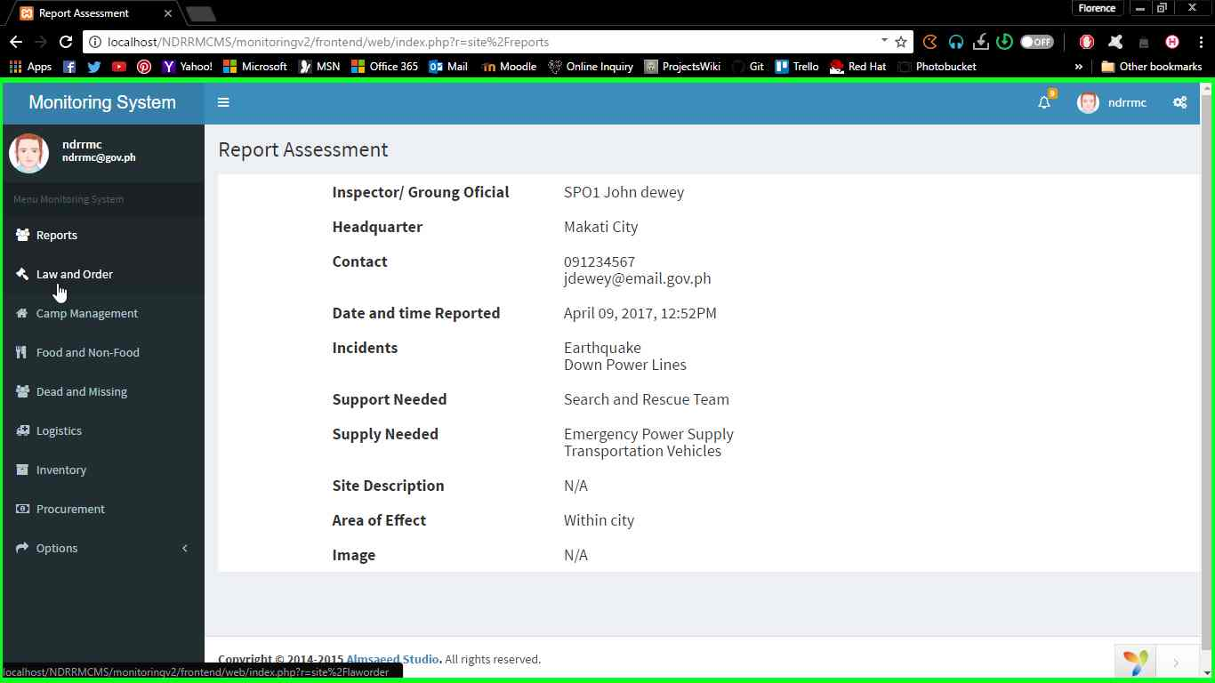  
Figure 17 - Report Assessment Content Page

# Conclusions and Recommendations

In conclusion, the team realized that NDRRMC is playing a huge role when it comes to responding, preparing and mitigating on the hazards that might cause disaster. The proposed system is a lot helpful if it became implemented since technology nowadays is just one click away in solving humanitarian problems specially in big data analytics. But due to limited team members, lack of time and cost in developing the project, the output is only the initial release of proof of concept but the solution is already identified by proposing a BI tool.

If the team were given more time, they can further explore about the BI tool or find another BI tool that is also compatible for the needs of the system. In doing so, the team might find out that there is much better BI tool that can be implemented to the system. The team can further search on the process of the NDRRMC so that the system can include what the NDRRMC requires in developing the system. This will widen the scope of the project and at the same time, make the solution more reliable and effective.

# Appendices

## Users Guide

  
Figure 18 – User Guide Sign In Page

For signing in to the system, user must fill out his/her user credentials in the Username and Password field.

Note: Only registered users gathered from different NDRRMC systems can access the Monitoring System. If the user already has account from different system of NDRRMC (e.g. Law and Order), he/she can automatically access the system else, he/she is not registered in the system.

  
Figure 19 – User Guide Home Page

Once the user signs in, he/she will be redirect to home page. The side navigation consists of widgets of every systems. On the upper widgets, the list of connected systems is identified. User can Click the ‘More Info’ link below each widget to show the descriptions of each.

  
Figure 20 – User Guide Description Pop-up Screen

For instance, in figure 20, once the user clicks the ‘More Info’ on Logistics widgets, a Pop-up screen appears with the description of Logistics Cluster.

  
Figure 21 – User Guide Home Page

Home page consists also of relevant information such as the map of the Philippines showing the total population. On the left side, Logistics calendar is included showing the status of requests of items/goods from different cluster.

  
Figure 22 – User Guide Home Page

Lastly, home page also has most recent status of Logistics delivery process and most recent assessment reports of Law and Order.

  
Figure 23 – User Guide Procurement Dashboard

  
Figure 24 – User Guide Inventory Dashboard

  
Figure 25 – User Guide Logistics Dashboard

  
Figure 26 – User Guide Food and Non-Food Dashboard

  
Figure 27 – User Guide Law and Order Dashboard

  
Figure 28 – User Guide Dead and Missing Dashboard

  
Figure 29 – User Guide Camp Coordination and camp Management Dashboard

Figure 23 – 29 shows the dashboards of every systems connected to the Monitoring System. Each consists of summarized data visualization in descriptive analyzation form and can be interactively sorted once user clicks specific content in widgets.



Figure 30 – User Guide Notification Menu  
The notification menu located at the right side of header navigation is for notifying the user if there is a reported issue that might need to respond or prepared on.

Note: Only the users that Law and Order classified in assessing report will be receiving the transmitted report.

  
Figure 31 – User Guide Report Assessment Content Page

Sample page of Report Assessment once the notification is clicked.

## System Tables and Diagrams

### Event Table

  
Table 2 – Event Table

### Context Flow Diagram

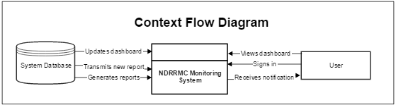  
Figure 32 – Context Flow Diagram

### Data Flow Diagram

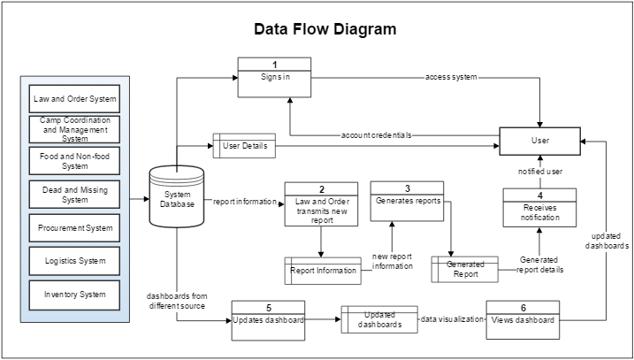  
Figure 33 – Data Flow Diagram

### Use Case Diagram

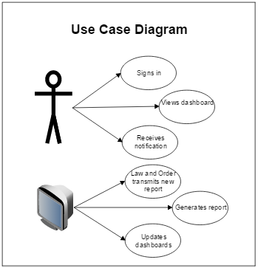  
Figure 34 – Use case Diagram

### Activity Diagram

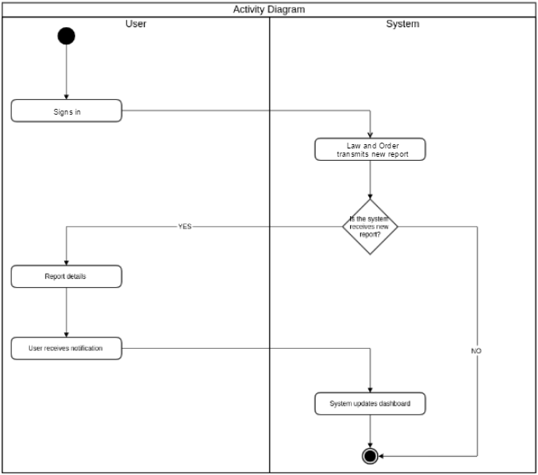  
Figure 35 – Activity Diagram

### Data Process

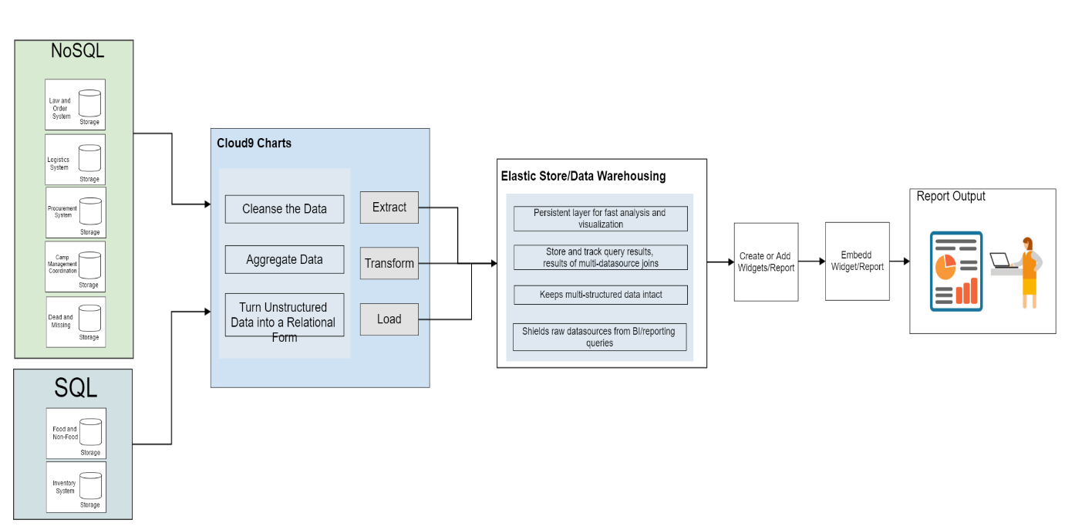  
Figure 36 – System Data Process

## BI Tool Plans

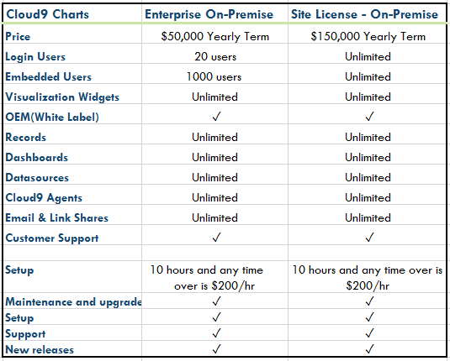  
Table 3 – Cloud9 Charts Plans

## Curriculum Vitae per team member

 **FLORENCE GAIL HABOC**

44-k, 11th Avenue, HHSG, North Signal Village, Taguig City

[fghaboc@gmail.com](mailto:fghaboc@gmail.com)

09179398586

**OBJECTIVE:**

Seeking a challenging career with a progressive organization that provides an opportunity in my skills and abilities.

**EDUCATIONAL BACKGROUND:**

Tertiary

Asia Pacific College

Magallanes, Makati City

Bachelor of Science in Information Technology Major in Mobile and Internet

June, 2014-Present

Secondary

Pres. Diosdado Macapagal High School

North Signal Village, Taguig City

2010 – 2014

**ORGANIZATIONS:**

Junior Philippine Computer Society

Member

Asia Pacific College

Magallanes, Makati City

APC Microsoft Community

Event Team

Asia Pacific College

Magallanes, Makati City

**RELATED SKILLS:**

Research Writing Skills

Technical Skills (MS Word, Excel, PowerPoint, Use of Internet search engines, Email)

Programming Skills (Java, PHP, HTML5, Visual Basic, SQL)

Knowledge on Data Warehousing Concepts

AIRA JOYCE CARPIO

Block 19 Lot 17 Twin Pioneer Street

Don Carlos Village, Pasay City

aacarpio@student.apc.edu.ph

09179471364

**OBJECTIVE:**

To establish myself in a passionate environment where creative and critical skills can be fully utilized.

**EDUCATIONAL BACKGROUND:**

Tertiary

Asia Pacific College

#3 Humabon Place, Magallanes, Makati City

Bachelor of Science in Information Technology

Major in Mobile in Internet Technology

June, 2014-Present

Secondary

Pasay City North High School

Tramo Street, Barangay 57

Pasay City, Metro Manila

2010-2014

**ORGANIZATIONS:**

Teatré Phileo

Finance Director

Asia Pacific College

#3 Humabon Place, Magallanes, Makati City

Junior Philippine Computer Society

Committee of Finance Officer

Asia Pacific College

#3 Humabon Place, Magallanes, Makati City

Junior Information Systems Security Association

Member

Asia Pacific College

#3 Humabon Place, Magallanes, Makati City

Microsoft Community

Member

Asia Pacific College

#3 Humabon Place, Magallanes, Makati City

APC Microsoft Community

Member

Asia Pacific College

#3 Humabon Place, Magallanes, Makati City

Teatro Norte

Fourth Year Representative

Pasay City North High School

Tramo Street, Barangay 57, Pasay City, Metro Manila

**TECHNICAL SKILLS:**

* + Operating Computers
  + Troubleshooting
  + HTML, CSS, XML
  + Java, PHP, SQL
  + R Programming
  + MS Windows / Linux
  + Microsoft Office (Excel, Word, PPT, Publisher)

**OTHER SKILLS:**

* + Research writing
  + Time management skills
  + Organized and detail oriented
  + Ability to work in a team

## Bibliography

Assessment of Disaster Risk Reduction and Management (DRRM) at the Local Level.   
 (n.d.). Retrieved April 8, 2017, from   
 [http://www.coa.gov.ph/phocadownloadpap/userupload/DRRM/Assessment_of_D  
 RRM_at_the_Local_Level.pdf](http://www.coa.gov.ph/phocadownloadpap/userupload/DRRM/Assessment_of_D%09RRM_at_the_Local_Level.pdf)

Cloud9Charts(n.d.). Business Intelligence - NoSQL and SQL Reporting and   
 Visualization. Retrieved April 8, 2017, from <https://www.cloud9charts.com/plans>

Descriptive, Predictive, and Prescriptive Analytics Explained. (2016, August 05).   
 Retrieved April 8, 2017, from [https://halobi.com/2016/07/descriptive-predictive-  
 and-prescriptive-analytics-explained/](https://halobi.com/2016/07/descriptive-predictive-%09and-prescriptive-analytics-explained/)

Disaster Risk Reduction Manual. (2008). Disaster Risk Reduction Manual, 5-9. Retrieved April 8, 2017.

Eden. (2014, January 08). Retrieved April 8, 2017, from   
 https://sahanafoundation.org/products/eden

Gopalakrishnan, J. (2015, August). New BI Paradigm. Retrieved April 8, 2017, from   
 <http://blog.cloud9charts.com/2015/08/new-bi-paradigm_25.html>

Introduction | KSNDMC. (n.d.). Retrieved April 10, 2017, from   
 https://www.ksndmc.org/Introduction.aspx

Loughead, K. (n.d.). 7 Requirements to Deliver Business-Driven Analytics in the Modern   
 Data Age. Retrieved April 10, 2017, from  
 <http://blog.cloud9charts.com/2017/02/modern-analytics-architecture.html>

Solutions: Government. (n.d.). Retrieved April 8, 2017, from   
 <http://www.pentaho.com/solutions/government>