**Executive Summary**

The NDRRMC Monitoring System is a system where Local Government Units(LGUs), NDRRMC member agencies, and other authorized users can view summary reports of each of the NDRRMC related systems. The summary reports consist of multi-sourced data from different stand-alone NDRRMC systems which has two classifications: The Preparedness Team and the Response Team. Under the teams are Inventory System, Procurement System, Logistics System, Food and Non-food System, Dead and Missing System, Camp Management and Coordination System and Law and Order System. Summary reports include data visualization, interactive reporting, dashboards and predictive analytics for better analyzing and monitoring of the big data. This will also help them in fast decision-making.

The system also gives real time reports delivered by the Law and Order System to the system users. With that, the in-charged user of different systems registered to Monitoring System will be notified and know what action they should do to respond on the reported area.

**Project Context**

The team identified the following problems of NDRRMC and LGUs when it comes to preparing for a disaster:

1. Lack of capacity and technical expertise
2. Lack of public awareness or the threats and impacts of all types of hazards
3. Lack of necessary skills to cope with the impacts of disaster
4. Lack of communication and coordination

The NDRRMC Monitoring System will give awareness and public safety to the community to respond to disaster effectively and be well prepared in incoming disaster. It easily monitors and identifies the needs of the area that was reported. This will allow ease of access to information for NDRRMC and other Government Agencies. By using this system, it may reduce the number of families that might be affected. The coordination and communication will also improve since each of the users will and have an access to each summary reports.

**Project Description**

The proposed system has the capability to track relevant data from different NDRRMC independent systems (e.g. Logistics, Inventory, Procurement, etc.) that are connected to Data Warehouse. For the data visualization, the system has embedded Business Intelligence Tool to properly track data in real time. Users must be an authorized LGUs, NDRRMC member agency and/or admin of the related system of NDRRMC.

The system also includes report notification from Law and Order System to make the information rapidly available for better preparedness and action. The responsible users will then receive a notification about the report details. Since the data from different system will be put on use and the information of report is already in the system, it will help the NDRRMC and/or the users for recommendation and decision making in analyzing the needs of the affected area. From the collected data and the details of report received, the users can easily evaluate and identify what preparation he/she should do. It will also be useful in improving the planning process, correcting problems and obviating similar problems in the future.

**Objectives**

*General Objectives*

* The NDRRMC Monitoring System is a system that collects all the data from different related data for data updates

*Specific Objectives*

* To enable Users to be updated about the reports
* To have the users a coordination with each other
* To help Users in decision making for disaster preparation and respond

**Scope and Limitations**

These are the coverage of NDRRMC Monitoring System are:

* NDRRMC Monitoring System collects the data from different resources or system
* NDRRMC Monitoring System data gathered from Law and Order Report will be send to all users as notification
* NDRMMC Monitoring System provides summary reports in form of dashboards using analytic tool

The NDRRMC Monitoring System is limited only to create account for LGUs, NDRRMC related system admin and NDRRMC member agencies. Each user will only have view access to the dashboards. The collection of data gathered will not be all visualized since system will only produce summary of the data of each of the system. Also, the report details that is being send to Users is base from the report of Law and Order.

**Review of Related Literature/System**

Sahana Eden (Emergency Development ENvironment)

This software provides solution to manage the organizations, people, projects, inventory and assets as well as collecting information through maps. This is designed to help Disaster Management practitioners to better mitigate, prepare for, respond to and recover form disaster more effectively and efficiently. Sahana Eden contains a number of different modules which can be configured to provide a wide range of functionality.  Its main capabilities are organization registry, project tracking, human resources, inventory, assets, assessments, shelter management, scenarios and events, mapping and messaging.

(<https://sahanafoundation.org/products/eden> )

Pentaho Analysis Tool

Pentaho Business Analytics is an open source visual integration tool with comprehensive data discovery and visualization, interactive reporting, dashboards and predictive analytics. Pentaho is embeddable architecture supports any type or source of data with native support for Hadoop, NoSQL and analytic databases. It also supports and augments “human decision-making” with automated algorithms and machine learning.

(<http://www.pentaho.com/solutions/government>)

Karnataka State Natural Disaster Monitoring Centre (KSNDMC) GIS System

KSNDMC provides regular weather and natural hazards-related updates to the farming community, agriculture and horticulture sector, fishermen, transport sector, power and electricity sector and state and district level disaster management authorities in Karnataka. The center provides ’Early Warning and Preparedness’ activities related to management of natural hazards in Karnataka. ‘Early Warning and Preparedness’ heavily depends on Department of Science and Technology(S&T) inputs like reliable, accurate real/near real data on the hazard causing parameter, forecasting, data analyses, alert recognition and dissemination of alerts. Its objective is to develop a geospatial database for the decision making and management in an event of natural hazards, envisaged a system to capture the data in a near real-time and automate the generation of reports, alerts and early warnings to government bodies and communities. (<http://www.nasscom.in/sites/default/files/NIIT_Natural%20Disaster%20Monitoring%20Centre.pdf> )

**Technical Background**

To develop the system, the project team propose to use Cloud9 Charts for Data Warehousing and for Data Analytics. Cloud9 charts is embeddable tool that support multiple data resources such as structured and unstructured data which makes it perfectly fit for use in this system. The team will also use Django Framework for the interface of the system and complete the features.

**Methodology**

The process starts when NDRRMC Admin sends advisory to LGUs monitoring admins for their preparation for incoming disaster. When LGUs Monitoring admin receives the report from NDRRMC Monitoring, LGUs monitoring admin sends a request of needed supplies to the logistic, by there the process of logistic, inventory and procurement system will apply.

**Requirements Analysis**

After analyzing the problems that the NDRRMC encounter in disaster preparation, the team came up with proposal of possible solutions that the system could provide. Most problems that the NDRRMC encounter are lack of communication and coordination which might lead to absence of public awareness. With the NDRRMC Monitoring System, the problem that the facility encounters will be resolved and minimized.

**Requirements Documentation**

*Input*

* System admin shall validate the registered users
* Report details from Law and Order must be notified to users
* System dashboards must be timely updated when there is changes from other systems

*Output*

* The Business Intelligence tool shall use data from database used by all other operations
* The Business Intelligence tool shall generate reports
* LGUs shall only view the monitored data visualizations
* Users shall receive the notification reported in real time

**Activity Diagram**

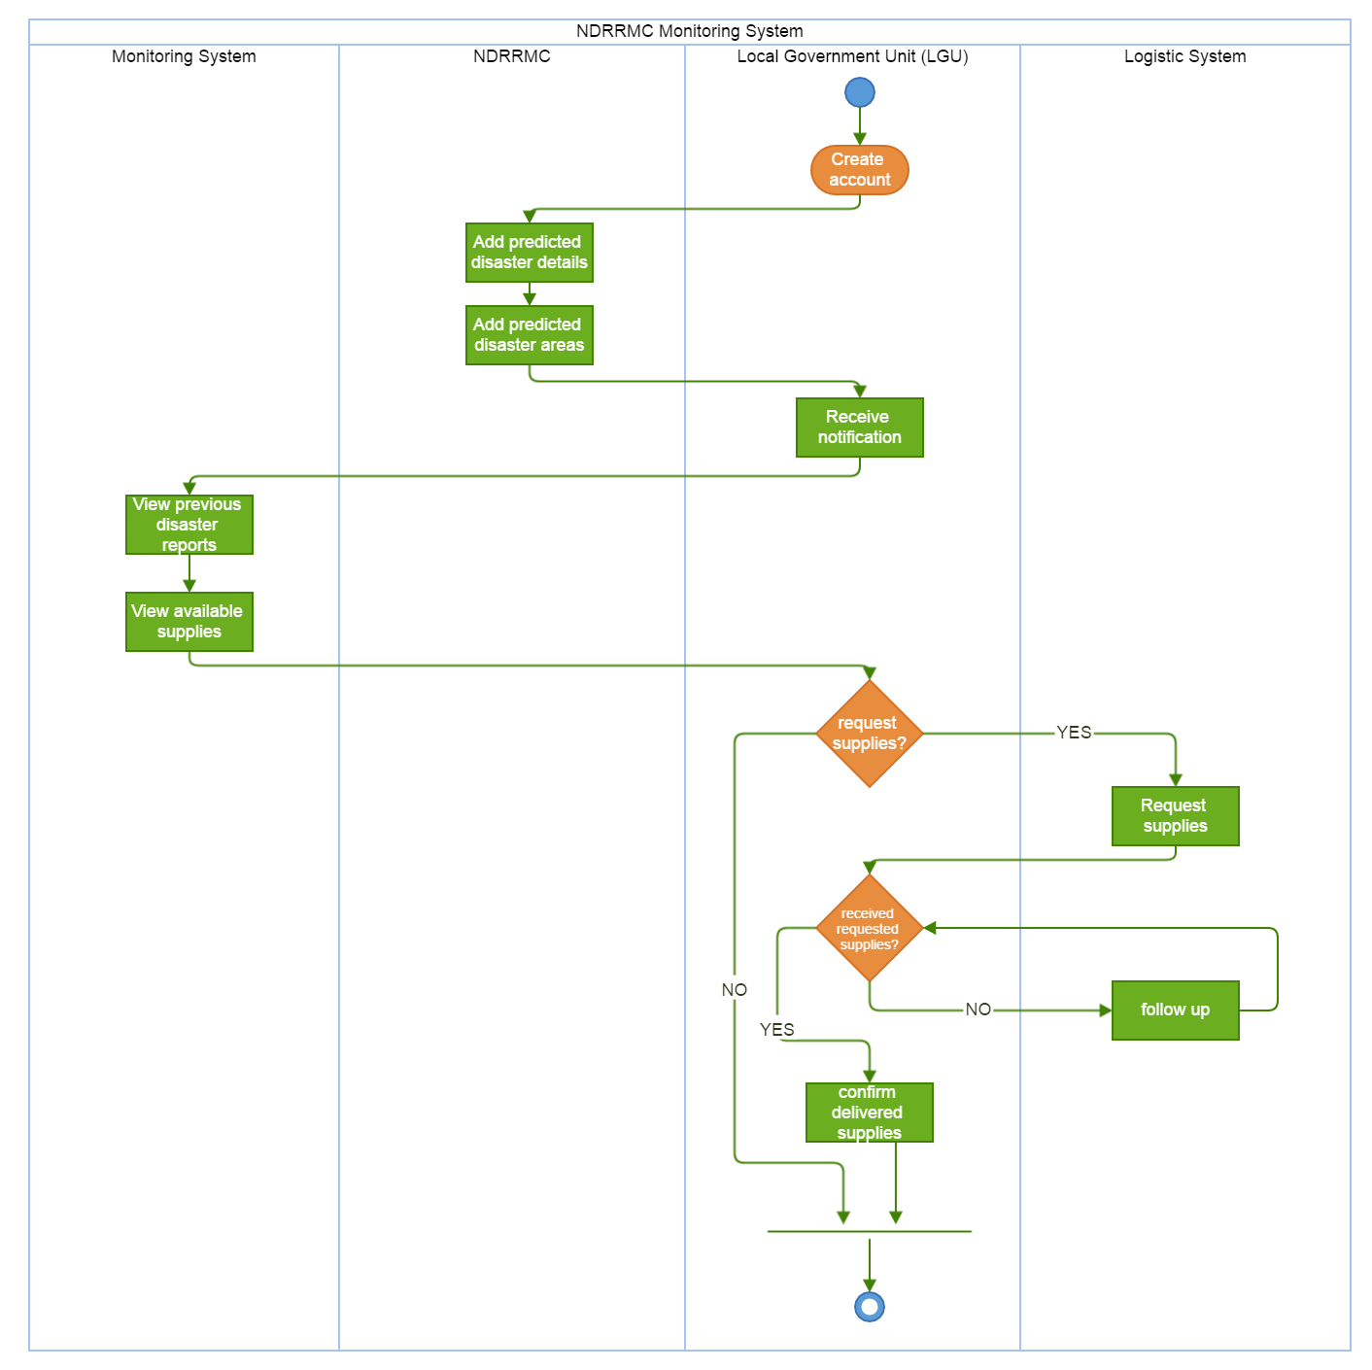

**ERD**

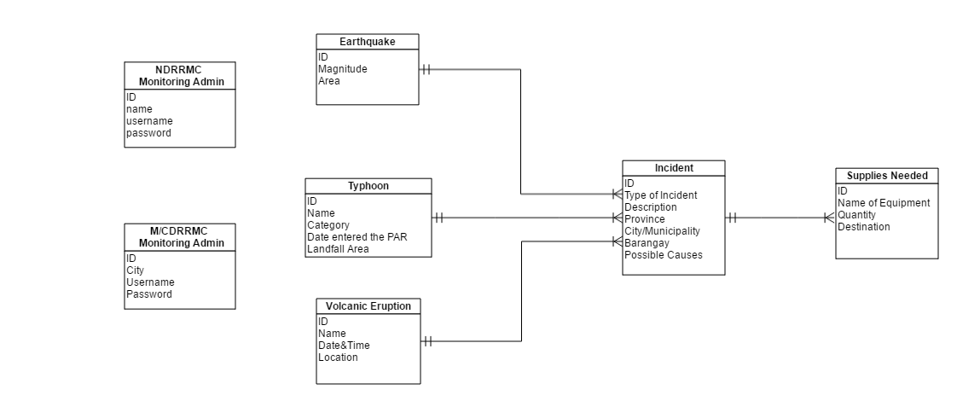

**Data Dictionary**



