- What is GIT fast forward?
If a branch is ahead of the master branch, and the master branch does not have any commits, GIT can merge the branches into a “new” master branch.
- Describe the process of a merge conflict.
A merge conflict occurs when there is difference in local and remote lines of a document. When the local work is pushed it gets rejected by GIT/the repository. To resolve this, you need to pull the conflicted documents to see which line(s) are inflicted, correct them and push when resolved.
Merge conflict error message:
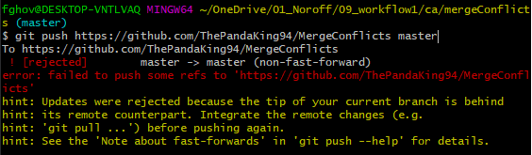
Merged document;
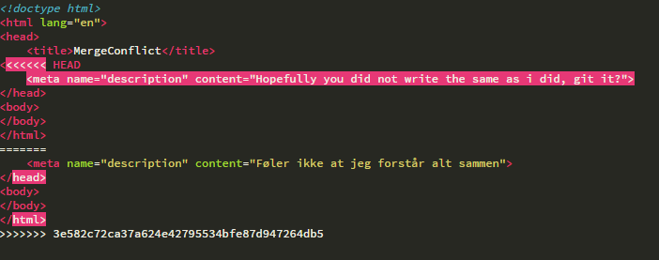
- How do you see which branch you are on?
In Bash you can see the current branch after user details (see example below) and you can also write “git branch“ and get information about the branch you are on:
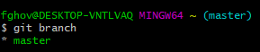
In SourceTree you get visual clues, eg.:
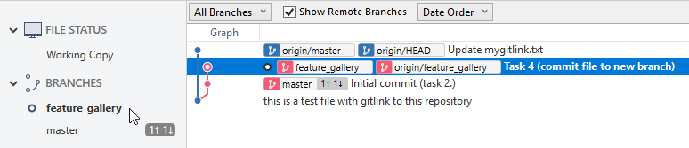
- Briefly describe a pull-request.
A pull-request fetches documents from the repository and merge them with local documents.

