Planetary Civilization Simulator
Game Design & Technical Architecture — GDD / Design Record v0.1

Design synthesis • decisions • rationale • simulation architecture • development roadmap

Version 1.0 — 4 October 2026 · society, public opinion, the player's identity and political credibility (section 38)

1. Purpose of this document
This document consolidates the design discussion into a single reference for the project. It records not only the features proposed, but the reasoning behind the major decisions, the relationships between systems, the intended player experience, the technical architecture, and the staged implementation plan.
The concept began as a climate-change game and evolved into a broader planetary civilization simulator. Climate remains central, but it is treated as a physical consequence of civilization rather than as a score or scripted punishment system.
DECISION Build a planetary civilization simulator in which climate, ecology, resources, technology, economy, population and government interact through causal systems. Climate change is a central consequence and constraint, not the sole objective.

2. Core vision
The player guides a civilization living on a simulated planet. The population wants a better life: food, water, housing, heating, employment, health, transport, energy, education, security and, as prosperity grows, increasingly sophisticated services and environmental quality.
Meeting those demands requires agriculture, extraction, industry, energy, infrastructure and research. These activities alter land use, atmospheric composition, pollution, ecosystems and resource stocks. The planet responds. Those responses feed back into living conditions, the economy, public opinion and politics.
PLANET
↕
Climate / weather / oceans
↕
Ecosystems / resources / hydrology
↕
Agriculture / energy / industry
↕
Economy / infrastructure / logistics
↕
Population / living conditions
↕
Public opinion / government
↕
Research / policy / player decisions
↕
PLANET
The desired experience is not to discover a predefined 'green' solution. It is to understand a complex world, satisfy legitimate human needs, manage short- and long-term trade-offs, and live with the consequences of systems that may persist for generations.

3. Design principles and their logic

3.1 The planet is simulated, not scripted
Where practical, major environmental events should emerge from state and flows rather than calendar-triggered events. A drought should arise from precipitation deficits, heat, soil moisture and circulation; a flood from precipitation, snowmelt, catchment state and river discharge; crop failure from actual growing conditions.
DECISION Prefer emergent physical causality over event scripts. Narrative events may frame situations, but should not replace the underlying simulation.

3.2 Human activity changes physical quantities
A coal plant should not add '+3 climate damage'. It consumes coal, generates electricity, emits CO₂ and pollutants, and produces waste heat. The atmosphere and carbon system then determine the consequences. The same principle applies to forests, agriculture, dams, transport and industry.
This keeps the educational message embedded in the simulation rather than imposed by the interface.

3.3 The player is not omniscient
The simulation contains a true world state, but the normal player interface exposes only what the civilization can observe, estimate and understand. This makes scientific infrastructure and knowledge part of gameplay.
TRUE WORLD STATE
↓ measurement
Sensors / observation network
↓
Measurements + uncertainty
↓
Scientific understanding / models
↓
Observed world / forecasts
↓
PLAYER INTERFACE
DECISION Separate true state from observed state. Better climate monitoring, science and computation progressively improve the player's interface to reality.

3.4 The rendered planet must be readable
Even without instruments, the player should perceive important changes directly: drying vegetation, retreating snow, shrinking rivers, changing sea ice, persistent haze, fires, storm systems and coastal flooding. Numerical overlays explain the planet; they should not be the only way to notice it.
DECISION Treat natural rendering as the first climate interface. A knowledgeable player should be able to infer part of the climate state simply by watching the planet.

3.5 There is no universal correct history
The game should support multiple initial conditions and multiple viable histories. A cold world may initially benefit from warming. A highly industrialized polluted civilization faces transition rather than industrialization. A post-collapse civilization faces reconstruction. The systems should support these situations without changing the core engine.

3.6 Long-lived systems create lock-in
Power plants, cities, mines, railways, dams and industrial regions last for decades. Choices therefore constrain future choices. A technically superior policy may be expensive or politically impossible because earlier infrastructure shaped employment, prices and expectations.

4. Scenarios: the game is larger than 1880
The late nineteenth century remains the preferred first civilization scenario because it provides an intuitive starting point: industrialization is beginning, fossil energy is genuinely attractive, scientific observation is limited, ecosystems are comparatively intact, and many modern systems have not yet been locked in.

4.1 Industrial Dawn
- Approximate technological context: 1880–1900 equivalent.
- Industrialization emerging; coal, rail and steel are powerful development tools.
- Climate knowledge and observation are limited.
- Population demands strongly reward growth, sanitation, heating, food security and mobility.
- The long delay between emissions and consequences creates intergenerational decisions.

4.2 Ice Age
- Large ice sheets, low sea level, limited agricultural area and a cold climate.
- Initial warming may improve habitability and food production.
- Ice-albedo feedback can later accelerate change.
- The scenario demonstrates that 'colder' or 'lower CO₂' is not itself the game's moral objective.

4.3 Polluted Industrial Civilization
- Advanced technology and large industrial capacity, but severe pollution and high greenhouse-gas concentrations.
- The challenge is to transform systems while maintaining electricity, employment, transport, food and social stability.
- Infrastructure lock-in and political acceptance dominate the transition problem.

4.4 Post-collapse and future procedural scenarios
Later scenarios can include post-collapse worlds, dry worlds, water worlds, high-CO₂ greenhouse worlds, or procedurally generated planetary histories. A scenario should initialize planet, climate, biosphere, population, economy, infrastructure, technology, knowledge and government rather than switch to a different game mode.
DECISION Implement scenario loading as a first-class architecture from the beginning. Industrial Dawn is the first major gameplay scenario, not a hard-coded definition of the game.

5. Climate, weather and the physical planet

5.1 Simulation objective
The climate model does not need the complexity of a research-grade general circulation model. It must instead deliver physically plausible causality, stable long-term behavior, recognizable planetary patterns and sufficient local weather variability to drive gameplay.

5.2 Core state
- Surface: elevation, land/ocean mask, albedo, soil moisture, vegetation, snow/ice and biome classification.
- Atmosphere: temperature, pressure, humidity, cloud water, precipitation and wind, ideally over several vertical layers.
- Ocean: surface and deep temperature, currents, salinity or simplified density state, and mixed-layer properties.
- Climate composition: CO₂ initially; later CH₄, aerosols and additional carbon reservoirs.
- Hydrology: evaporation, precipitation, infiltration, runoff, drainage and river discharge.

5.3 Core energy logic
The fundamental thermal balance is conceptually:
C dT/dt = absorbed solar - outgoing infrared + atmospheric exchange + transport + latent heat
Albedo controls reflected solar energy; ocean and land have different thermal inertia; snow and ice feed back through albedo; water phase changes transport latent heat. Greenhouse forcing can initially use a reduced-order formulation such as logarithmic CO₂ radiative forcing.

5.4 Atmospheric circulation
Pressure gradients, Coriolis acceleration and friction should create large-scale circulation. The target is not exact terrestrial weather forecasting, but recognizable trade winds, mid-latitude westerlies, polar circulation and moving weather systems.

5.5 Water cycle and terrain
Evaporation, saturation, condensation, precipitation and latent heat create the hydrological cycle. Terrain forces air upward and should produce orographic precipitation and rain shadows. Surface runoff follows terrain to rivers and oceans.

5.6 Ocean
A first version should use a surface ocean coupled to a deep heat reservoir. Surface currents respond to wind, rotation, coastlines and temperature gradients. The ocean provides large thermal inertia and transports heat, creating delayed climate responses.

5.7 Biosphere
Vegetation initially can be a continuous state driven by temperature, sunlight and soil moisture. Biomes are classifications of resulting conditions rather than manually painted zones. Forests affect carbon, evapotranspiration, soil and albedo as the model develops.

6. Observation, scientific knowledge and uncertainty
This is one of the project's defining mechanics. The simulation knows the complete world state; the civilization does not.

6.1 Observation infrastructure
- Local thermometers and rain gauges.
- Weather stations measuring temperature, pressure, humidity, wind and rainfall.
- Station networks providing spatial coverage.
- Weather balloons providing vertical atmospheric profiles.
- Tide gauges and oceanographic ships.
- Ocean buoys.
- Weather radar.
- Research aircraft.
- Satellites and eventually global Earth-system observation.
Measurements have coverage, sampling frequency, accuracy and uncertainty. Maps shown to the player are reconstructed from observations, not copied from the true simulator state.

6.2 Knowledge is distinct from measurement
Observation → Data → Scientific research → Theory → Models → Forecasts / projections
A civilization can measure warming before it understands the cause. Later, improved physics, computation and observations permit weather prediction and climate projections. Forecast skill itself can therefore evolve.

6.3 Interface progression
In an early scenario, the climate interface may contain sparse local time series with missing years and large uncertainty. A mature civilization may have near-global gridded observations, probabilistic forecasts and ensemble climate projections.
DECISION Scientific progress should literally improve the player's ability to see and predict the simulated world, rather than merely awarding abstract research bonuses.

7. Population and living conditions
The initial design should avoid individual citizen agents. Regional cohorts provide enough heterogeneity for meaningful social and political dynamics while remaining computationally manageable.

7.1 Regional population state
- Population and age structure.
- Employment by sector.
- Education and knowledge access.
- Health and life conditions.
- Wealth or income distribution at a coarse level.
- Food, water, housing and energy security.
- Mobility and access to services.
- Environmental quality and exposure to hazards.

7.2 Evolving needs
Early development emphasizes food, water, shelter, heating, sanitation and employment. Prosperity creates expectations for reliable electricity, transport, consumer goods, education, healthcare, clean air, leisure and environmental quality. Population demand therefore changes the economic problem over time.

7.3 Cities
Cities should emerge from jobs, resources, water, transport and infrastructure rather than being arbitrary decorative placements. A mine can justify a railway; the railway enables a factory; employment attracts migration; migration creates housing and services; a settlement becomes a city.
Version 1.0 expands this section into a full population model: cohorts by region, social group and age band, inequality inside each cohort, demography, urbanization, education, and consumption behaviour that feeds emissions back to the planet. See section 38.

8. Public opinion, government and elections
Politics adds a critical constraint: a technically effective climate policy may fail if its costs are concentrated, poorly timed or perceived as unfair. The player should not receive a direct control for making voters support a desired candidate.

8.1 Population priorities
- Economic security and employment.
- Food and housing.
- Energy prices and reliability.
- Health and public services.
- Tax burden.
- Local environmental quality.
- Climate concern and adaptation.
- Trust in institutions and information.
Priority weights evolve with lived conditions. A recession can elevate employment; repeated floods can elevate adaptation; severe pollution can elevate health and environmental concerns. Information and trust affect how events are interpreted.

8.2 Candidates and government
Candidates or parties have positions across multiple dimensions: economic development, taxation, energy, welfare, infrastructure, environment and climate. Voter choice can be modeled probabilistically from priorities, conditions, trust, information and candidate positions.
P(candidate) = f(issue priorities, economic conditions, policy positions, trust, information, recent experience)

8.3 Player agency
The player influences political feasibility through real conditions: retraining workers before closing mines, building transit before raising fuel costs, insulating homes before energy-price reform, or developing replacement industries before decommissioning legacy infrastructure.
DECISION Model politics as an emergent constraint on policy. Do not model political persuasion as a direct 'move voters toward the climate candidate' mechanic.

8.4 Player identity
The player represents the long-lived civilization, but at any moment acts through its current government. Each government has its own credibility and its own record of promises. When it loses power, the next government starts with fresh credibility, but part of the distrust is carried over by collective memory, so a population that has been lied to becomes cynical about politicians in general.
Losing an election is not the end of the game. The player continues with the new government, which arrives with its own platform: some policies become unavailable, some may be reversed, and new ones open. Elections therefore become dramatic turning points rather than failures. Section 38.8 specifies the mechanism.
DECISION The player is the civilization acting through its current government (hybrid identity). Credibility and promises belong to each administration; distrust partly survives a change of government through collective memory; an election loss continues the game under a new government.

9. Economy, resources, energy and logistics

9.1 Physical flows first
The economy should be detailed enough for physical constraints to matter without becoming a factory-optimization game. Resources move through extraction, transport, production and consumption.
Natural resources → Extraction → Transport → Industry → Products → Population / infrastructure

9.2 Initial commodities
A deliberately small initial set is preferred: coal, oil, iron, wood, water and biomass as raw resources; food, fuel, steel, cement and electricity as processed outputs; labor, capital and knowledge as abstract capacities. Additional resources such as copper, uranium, lithium or fertilizer should be introduced only when they create meaningful choices.

9.3 Energy
Energy deserves its own simulation because it connects resources, infrastructure, climate, industry and living standards. Coal, oil, gas, hydro, nuclear, wind, solar, biomass and storage each have capital cost, operating cost, resource needs, construction time, lifetime, emissions, pollution, reliability and dispatchability.
Renewable generation should use the actual simulated environment: wind turbines consume simulated wind, solar uses sunlight and cloud cover, and hydropower depends on simulated runoff and river flow.

9.4 Transport and infrastructure
Represent logistics as a network of nodes and edges. Nodes include cities, farms, mines, factories, ports and power plants. Edges include roads, railways, shipping lanes, pipelines and power lines, with capacity, cost, travel time, energy consumption and reliability.
Climate impacts then become operational rather than decorative. A flooded bridge can disconnect food supply; drought can reduce hydropower; heat can increase electricity demand.

10. Agriculture, ecosystems and adaptation
Agricultural yield should depend on crop type, temperature, precipitation, soil, irrigation, fertilizer, technology and eventually CO₂ effects. Climate influences food through the same physical variables the player can observe.
Ecosystems should provide functions rather than a generic green score. Forests store carbon, provide timber, regulate water, protect soils, influence evapotranspiration and provide habitat. Wetlands, grasslands and soils can later receive similar functional treatment.
Adaptation and mitigation are separate strategic responses. Flood defenses, irrigation, cooling, crop changes, water storage and relocation may protect people even when emissions remain high; mitigation changes future forcing. The player may need both.

11. Research and technology
Research should unlock capabilities rather than arbitrary percentage bonuses. Thermodynamics can improve engines; electrical science enables grids; chemistry enables fertilizers and industrial processes; electronics enables computing; computing plus atmospheric science enables numerical forecasting and climate modelling.
Research is driven by education, universities, industrial experience, public institutions, economic demand and accumulated knowledge. This allows technology to remain connected to the civilization rather than becoming an isolated tree.

12. Other civilizations
The first playable version does not require fully symmetric AI civilizations, but the long-term design assumes that the player controls only one part of the planet. Other societies develop, extract, trade, emit, adapt and research. Their internal model can be simpler than the player's.
The atmosphere and ocean remain global. This makes climate a shared physical system and creates the eventual need for trade, cooperation and international policy without making diplomacy necessary for the first prototypes.

13. History and counterfactual timelines
The simulator should retain aggregated time series and periodic snapshots of important state: temperature, precipitation, CO₂, population, forests, energy mix, emissions, food, prosperity and other key indicators.
A distinctive future feature is the ability to fork history from a prior snapshot and ask 'what if?'. The player could replay a transition with different energy policy, infrastructure investment or timing and compare resulting worlds.
1880 ───── 1920 ───── 1960 ───── 2000 ───── 2050
│
├──── Alternative history A
│
└──── Alternative history B
DECISION Design save/state history so that counterfactual forks remain technically possible, even if the feature is implemented much later.

14. Technical architecture
The simulation should be a standalone C++20 library/application, independent of the rendering engine. Godot is the preferred first rendering/game engine because it provides a lightweight open workflow, good shader/UI support and C++ integration through GDExtension.
GODOT 4
┌─────────────┼─────────────┐
│ │ │
Renderer UI Gameplay
│ │
└─────────────┬─────────────┘
│
Game API
│
┌──────────────────────────┴──────────────────────────┐
│ PlanetSim C++20 │
│ │
│ Planet / Atmosphere / Ocean / Hydrology │
│ Biosphere / Carbon │
│ Population / Economy / Energy / Infrastructure │
│ Technology / Observation / Government / Scenario │
│ History / Serialization / Scheduler │
└──────────────────────────┬──────────────────────────┘
│
save / replay / fork
DECISION Godot handles presentation and gameplay interaction; PlanetSim owns authoritative simulation state. PlanetSim must run headless without Godot.

14.1 Data layout
An icosphere is the preferred initial global mesh. Geometry and connectivity should be separated from simulation state. Large fields should use structure-of-arrays layouts for cache efficiency and future GPU compatibility.

14.2 Units and determinism
Use SI units internally. A simulation should be deterministic for a given scenario, random seed and code version where practical. This is valuable for debugging, automated experiments, replays and counterfactual histories.

14.3 Multi-rate scheduling
Different systems naturally evolve on different timescales: atmosphere in minutes, weather and hydrology in hours, economy in days, vegetation and population in months, research and politics in years, and deep-ocean processes over months to decades. The scheduler should support subsystem-specific timesteps.

14.4 CPU and GPU
Begin with a clear CPU reference implementation and parallelize across cells/tasks. Add Vulkan compute only after profiling identifies a real bottleneck. Avoid coupling the scientific core to CUDA so the architecture remains portable.

14.5 PC first, Android later
The PC version is the reference game and should not be constrained by mobile hardware. Android is a later derivative that may use lower spatial resolution, fewer layers or reduced-order models validated against the PC simulation while preserving the major causal relationships.
DECISION Do not compromise the PC simulation for Android. Treat mobile as a later reduced derivative of the validated reference model.

15. P0 — Living Planet
The first implementation is intentionally not a civilization game. It is a planetary laboratory whose purpose is to prove that the simulated planet is stable, readable, conservative of energy, water and carbon, and fast enough to be played. Whether the result is compelling cannot be judged without a player acting on it, so that question is tested in parallel on the gameplay prototype (section 31) rather than deferred to P1.

15.1 Initial mesh and state
Resolution is a scenario parameter, not a constant. Development should begin at icosphere subdivision level 5 (approximately 10,240 surface cells) with three atmospheric layers, because solver defects, conservation errors and calibration drift are found several times faster at that size. Level 6 (approximately 81,920 surface cells) and five layers remain the target for the shipped desktop reference, promoted only once the solver is stable and profiling shows the performance budget of section 29 is met.

15.2 Development milestones
Milestone | System | Visible validation
M0 | Icosphere + Godot globe | Stable spherical mesh and camera interaction
M1 | Sun, orbit, rotation, seasons | Day/night, latitude and seasonal illumination
M2 | Terrain + ocean | Procedural continents, elevation and water mask
M3 | Surface energy balance | Warm equator, cold poles, ocean thermal inertia
M4 | Atmosphere + pressure | Stable atmospheric thermal/pressure state
M5 | Wind + Coriolis | Recognizable large-scale circulation
M6 | Humidity + evaporation | Moisture transport from oceans and wet surfaces
M7 | Clouds + precipitation | Moving clouds and rainfall
M8 | Hydrology | Runoff, drainage and dynamic river discharge
M9 | Snow / ice | Seasonal snow and ice-albedo feedback
M10 | Vegetation | Climate-driven green/dry regions
M11 | Ocean heat / currents | Heat redistribution and delayed response
M12 | CO₂ forcing | Controlled greenhouse perturbation
M13 | Climate equilibrium tests | Long-run stability and plausible responses
M14 | Visual polish | Planet understandable without debug overlays

15.3 P0 scientific/debug interface
- Temperature and energy balance.
- Pressure and animated wind.
- Humidity, cloud water and precipitation.
- Soil moisture and runoff.
- Vegetation and biome classification.
- Snow, sea ice and albedo.
- Ocean temperature and currents.
- Atmospheric CO₂ and later carbon reservoirs.

15.4 Conservation diagnostics
Climate simulation bugs can look plausible. Energy, water and later carbon budgets must therefore be explicit diagnostics. Automated tests should report global imbalance and conservation error, not only screenshots.

15.5 Automated experiments
- No-atmosphere planet.
- Zero-rotation or altered-rotation planet.
- High axial tilt.
- Water world and dry world.
- Frozen-world recovery.
- CO₂ doubling experiment.
- Long equilibrium run.

15.6 P0 success criterion
P0 succeeds when a player can look at the natural rendering and recognize equatorial, desert, temperate and polar zones; weather systems; rain shadows; seasonal snow; vegetation patterns; and ocean influence, while scientific overlays quantitatively explain what is visible.
A decisive experiment is to initialize two identical worlds, keep one near a baseline CO₂ concentration, raise the other progressively, run both for decades or centuries, and visually perceive differences in snow, vegetation, hydrology and ocean state before opening graphs.

16. P1 and later gameplay roadmap

P1 — First Civilization
Add population, food, wood, coal, iron, farms, mines, housing, factories, coal power, roads, railways, electricity and a basic economy. The first real gameplay loop is population demand → development → industry/energy → emissions/land use → planetary response → population conditions.
From version 1.0, P1 also carries the foundation of the population model (section 38.14, phases S1 and S2): cohorts, demography, urbanization, education, inequality inside cohorts, needs and consumption behaviour. Consumption is what connects the population to emissions, so it must exist before politics.

P2 — Knowledge
Add weather stations, observation networks, historical records, scientific research, forecasting and climate science. Remove unrestricted true-state overlays from normal gameplay.

P3 — Society
Add opinion dynamics, media and framing, other political actors, the government's credibility and promise record, the implementation gap, elections, protest and legitimacy, migration, bottom-up adaptation and climate perception (section 38.14, phases S3 to S6).

P4+
- Advanced energy and grid systems.
- Richer ecosystems and pollution.
- International trade and other civilizations.
- Other nations as political actors: refugees, trade pressure and climate agreements with free-riders (section 38.14, phase S7).
- Diplomacy and shared climate policy.
- Advanced adaptation.
- Scenario editor and procedural histories.
- Android derivative only after the PC game's essential mechanics are known.

17. Explicit non-goals for early development
- No individual-citizen agent simulation.
- No warfare system in the initial design.
- No full computational-fluid-dynamics atmosphere or research-grade ocean model.
- No detailed financial-market simulation.
- No hundreds of commodities.
- No photorealistic city simulation requirement.
- No multiplayer requirement.
- No historical Earth reproduction requirement.
- No Android constraints on the PC reference model.
These are scope barriers, not permanent prohibitions. Any later feature should justify itself by strengthening the core interaction between civilization and planet.

18. Key decisions register
Decision area | Current direction
Game identity | Planetary civilization simulator; climate is a central physical consequence, not a standalone score.
First scenario | Industrial Dawn (~1880–1900 equivalent), while architecture supports radically different scenarios.
Player objective | Improve and sustain civilization rather than simply minimize emissions.
Climate representation | Reduced-order but causal Earth-system simulation with atmosphere, ocean, hydrology, biosphere and carbon.
Information model | True state is hidden; observations and science determine the player's knowledge and UI.
Politics | Population mood and elections emerge from conditions and priorities; no direct voter-manipulation mechanic.
Player role | Potentially the long-lived civilization rather than a permanent ruler.
Rendering | Natural planet must visually communicate climate and environmental change.
Engine | Godot 4 for presentation; standalone C++20 PlanetSim for authoritative simulation.
Compute | CPU reference first; Vulkan compute later if profiling warrants it.
Platform | Ambitious PC reference first; Android later as a reduced derivative.
Development | P0 Living Planet before population/economy; validate the physical sandbox first.
History | Record state and design serialization so future counterfactual timeline forks are possible.
Feedback timescales | Two coupled physical loops: fast, local and reversible from P1; slow, global and sticky climate. Every major action has a fast-loop consequence (section 36).
Climate knowledge | The climate view is unlocked stage by stage by science; the projection of the committed future is a late unlock computed from the civilization's estimated state (section 37).
Tipping points and adaptation | Tipping points are emergent physical thresholds staged as dramatic events with science-dependent warnings; adaptation is a full strategy with tightening limits (section 37).
Player identity | The civilization acting through its current government; credibility and promises belong to each administration, and an election loss continues the game (sections 8.4 and 38.8).
Population granularity | Cohorts by region, social group and age band, with inequality inside each cohort; representative citizens are presentation only (section 38.2).
Opinion and media | Opinions diffuse through a cohort influence network with anchoring and bounded confidence; media mainly sets the agenda and frames issues; the player is one voice among several actors (sections 38.6 and 38.7).
Words and deeds | Statements create tracked promises; perceived gaps between promises and outcomes erode trust asymmetrically and raise expectations that later turn into anger (section 38.8).

19. Open questions
- How physically sophisticated must atmospheric vertical structure be before gameplay gains stop justifying complexity?
- Answered in version 1.0: the player is the civilization acting through its current government (sections 8.4 and 38.8). Still open: should some scenarios lock the player into one government with an election loss as defeat?
- How much economic price formation is required to create believable trade-offs without overwhelming the climate/civilization loop?
- What is the right spatial resolution for P0 on the target PC, and how aggressively should it change at extreme time acceleration?
- How should clouds be rendered so that they are both beautiful and faithful enough to the simulation to remain informative?
- How should uncertainty be visualized so early scientific interfaces feel incomplete without becoming frustrating?
- How much political heterogeneity is needed before elections feel plausible while remaining understandable?
- What variables must be stored for history forks, and what can be reconstructed from periodic snapshots?
- Which climate-validation benchmarks should define 'plausible enough' for the game?
- How strong should fast-loop penalties be relative to the slow loop, so that local consequences are noticed without turning the game into local housekeeping (section 36)?
- How wide can the first projection cone be before it frustrates rather than informs, and how fast should it narrow (section 37.2)?
- How should scoring and endings value people's living conditions, so that adaptation in a warmer world can still count as success (sections 32 and 37.4)?
- How many social groups and regions are needed before the population feels alive, and at what point does more detail stop being readable (section 38.2)?
- How strong should the trust asymmetry be, so that broken promises matter without making honest but slow policies, such as research, unplayable (section 38.8)?
- Should regime type evolve (democracy, authoritarian rule, revolution) in the first society release, or stay fixed per scenario (section 38.9)?
- How can identity groups and value change be modelled without caricaturing real communities or making one opinion the only rational one (section 38.1)?
Sections 28 to 35 answer, or take a position on, several of these questions: spatial resolution, cloud rendering, what must be stored for history forks, which validation benchmarks define "plausible enough", and the player's role. The rest remain genuinely open.

20. Immediate next step
The next engineering task is the time-acceleration decision record of section 28, because it constrains the scheduler, the field layout and the snapshot API. It should be followed immediately by a P0 technical specification detailed enough to create the repository and first code: icosphere data structures, field containers, timestep scheduler, solar/orbital model, surface energy solver, state snapshot API and Godot GDExtension boundary.
The first visible milestone should be deliberately modest: a rotating procedural spherical planet with continents and oceans, correct solar illumination, seasons and a stable surface energy balance. Each later physical subsystem should be added only after the previous one has measurable tests and a visible validation target.
This preserves the central principle of the project: build one understandable living planet first; then put a civilization on it.

21. Repository and software architecture
The repository structure is part of the architecture rather than a cosmetic organization choice. It should make the separation between authoritative simulation, game presentation, validation, scenarios and tooling obvious to contributors and difficult to accidentally violate.

21.1 Proposed repository tree
planet_game/
├── CMakeLists.txt
├── cmake/
├── docs/
│ ├── design/
│ ├── physics/
│ └── decisions/
│
├── sim/
│ ├── core/
│ │ ├── scheduler/
│ │ ├── fields/
│ │ ├── units/
│ │ ├── math/
│ │ ├── serialization/
│ │ └── diagnostics/
│ ├── planet/
│ │ ├── mesh/
│ │ ├── orbit/
│ │ ├── terrain/
│ │ └── geology/
│ ├── atmosphere/
│ │ ├── radiation/
│ │ ├── thermodynamics/
│ │ ├── circulation/
│ │ ├── moisture/
│ │ └── clouds/
│ ├── ocean/
│ │ ├── surface/
│ │ ├── circulation/
│ │ └── deep_ocean/
│ ├── hydrology/
│ ├── biosphere/
│ ├── carbon/
│ ├── observation/
│ ├── population/ # P1+
│ ├── economy/ # P1+
│ ├── energy/ # P1+
│ ├── infrastructure/ # P1+
│ ├── technology/ # P2+
│ ├── government/ # P3+
│ ├── scenario/
│ └── history/
│
├── apps/
│ ├── planet_cli/
│ ├── climate_lab/
│ └── benchmarks/
│
├── godot/
│ ├── project.godot
│ ├── gdextension/
│ ├── scenes/
│ ├── shaders/
│ ├── materials/
│ ├── ui/
│ └── assets/
│
├── scenarios/
│ ├── validation/
│ ├── industrial_dawn/
│ ├── ice_age/
│ └── polluted_world/
│
├── tests/
│ ├── unit/
│ ├── physics/
│ ├── conservation/
│ ├── regression/
│ └── scenarios/
│
└── tools/
├── planet_generator/
├── climate_analysis/
└── state_inspector/

21.2 Ownership of the main directories
Directory | Owns | Must not own
sim/core | Generic math, fields, scheduling, units, serialization and diagnostics. | Climate rules, Godot types or gameplay policy.
sim/planet | Mesh, coordinates, orbit, terrain and planetary geometry. | Rendering or civilization logic.
sim/atmosphere | Atmospheric physics and state evolution. | Population, buildings or UI decisions.
sim/ocean | Ocean state, exchange and circulation. | Rendering effects or economic rules.
sim/hydrology | Surface water, runoff, drainage and river discharge. | Visual river meshes.
sim/biosphere | Vegetation and ecological state. | Player-facing environmental scores.
sim/observation | Sensors, sampling, uncertainty and reconstruction of observed state. | Authoritative physical truth.
sim/population/economy/... | Human-system state and causal gameplay simulation. | Direct renderer dependencies.
godot | Rendering, scenes, shaders, UI and input. | Authoritative simulation physics.
scenarios | Data defining initial conditions and scenario-specific constraints. | Hard-coded engine behavior.
tests | Validation of units, physics, conservation, regressions and scenarios. | Production gameplay state.
tools | Offline generation, inspection and analysis. | Runtime-only assumptions.

21.3 Dependency rules
Godot / UI / Renderer
↓
Game API
↓
PlanetSim
↓
Domain simulation modules
↓
Core / Math / Fields
Forbidden:
PlanetSim ─X→ Godot
Physics ─X→ UI
Climate ─X→ Population entities
Core ─X→ Domain modules
- Dependencies point inward toward lower-level simulation infrastructure.
- sim/core must remain domain-agnostic.
- Godot may read snapshots and submit player commands, but it does not own authoritative world state.
- Climate and ocean modules operate on physical fields and forcing inputs, not on game entities such as factories or voters.
- Human systems influence physics through explicit interfaces: emissions, land-use changes, water extraction, waste heat, aerosols and similar fluxes.
- Observation reads the true state through sensor models but exposes a separate observed state with uncertainty.
- Scenario files initialize modules through public APIs; they do not bypass invariants by directly mutating arbitrary internal state.
DECISION Enforce one-way dependencies so the physical simulator remains reusable, headless, testable and independent of Godot.

21.4 Authoritative state versus presentation state
AUTHORITATIVE
PlanetSim
│
StateSnapshot
│
▼
Presentation
Godot renderer / UI
│
PlayerCommand
│
▼
PlanetSim
StateSnapshot is a read-oriented representation suitable for rendering and UI. It can be lower-frequency, compressed or transformed relative to internal solver state. PlayerCommand represents requested actions such as construction, policy changes or debug perturbations. Commands are validated and applied by PlanetSim rather than mutating simulation arrays from Godot.

21.5 Physical coupling interface
Subsystems should exchange conserved or interpretable quantities rather than query one another's implementation details. This is particularly important when civilization is introduced.
Civilization
│
├── CO₂ emissions ───────────────► Carbon / atmosphere
├── aerosol emissions ───────────► Atmosphere
├── land-use change ─────────────► Biosphere / surface
├── water withdrawal ────────────► Hydrology
├── reservoir / dam operations ──► Hydrology
└── waste heat ──────────────────► Surface / atmosphere
Planet
│
├── weather ─────────────────────► Agriculture / energy
├── river discharge ─────────────► Hydropower / water supply
├── hazards ─────────────────────► Infrastructure
├── crop conditions ─────────────► Food economy
└── observed climate ────────────► Population / government
This interface-oriented design makes it possible to replace or refine a subsystem without rewriting every consumer.

21.6 Reference physics and accelerated physics
The game requires extreme time acceleration, but the reference physical model should not be distorted merely to make ×10,000 simulation convenient. Maintain a validated reference path and introduce accelerated approximations explicitly.
Reference physics
├── conservative
├── deterministic
├── smaller stable timesteps
└── validation baseline
│
▼
Accelerated modes
├── reduced update frequency
├── larger / adaptive timesteps
├── weather-detail reduction
└── preserved climate budgets
DECISION Treat high-speed simulation as an approximation layer validated against reference physics, rather than designing the reference solver around maximum game speed.

21.7 Applications
- planet_cli: headless scenario runner for long simulations, CI and batch experiments.
- climate_lab: developer-facing interactive laboratory exposing true state and perturbation controls.
- benchmarks: reproducible performance tests for individual solvers and full scenarios.
- Godot game: player-facing application consuming the same PlanetSim API.

21.8 Documentation as architecture
The docs/decisions directory should contain short Architecture Decision Records (ADRs). Important choices such as icosphere topology, atmosphere layering, advection scheme, Godot integration, serialization format and GPU acceleration should record the decision, alternatives considered, rationale and consequences.
This prevents the project from gradually accumulating unexplained technical choices and allows later revisions to distinguish deliberate architecture from historical accident.

22. P0 software boundaries

22.1 Minimum core types
PlanetMesh
geometry + adjacency + cell areas
Field<T>
dense values indexed by CellId / LayerId
SimulationClock
physical simulation time
Scheduler
subsystem update cadence
PlanetState
authoritative collection of physical state
Forcing
solar / greenhouse / scenario perturbations
Diagnostics
energy / water / conservation budgets
StateSnapshot
read-only presentation/export state

22.2 First subsystem interface direction
IPlanetProcess
initialize(context)
stable_timestep(state)
step(state, dt, context)
diagnostics(state)
Initial implementations:
SolarForcing
SurfaceEnergy
AtmosphereThermodynamics
AtmosphericTransport
MoistureCycle
Hydrology
SnowIce
Vegetation
OceanSurface
CarbonCycle
The exact C++ interface should remain lightweight. The important design requirement is explicit ownership of state and update order, not inheritance for its own sake. Composition and plain data-oriented functions may ultimately be preferable to a deep class hierarchy.

22.3 Snapshot cadence
The solver may execute many physical timesteps between visual updates. Godot should receive snapshots at a presentation cadence and interpolate visually. This decouples simulation stability from frame rate and allows headless execution without rendering overhead.

23. Next implementation specification
The next technical document should now define P0-M0 and P0-M1 in code-level detail: icosphere generation and indexing, tangent-space vector representation, Field<T> layout, mesh-neighbor operators, simulation clock, orbital coordinates, solar incidence, surface heat capacity and energy integration.
That specification should also define the first validation tests before implementation begins. The first objective is not yet weather; it is a numerically stable rotating planet whose illumination, seasons and thermal response can be quantitatively checked.

24. Planetary feedback and coupling model
The planet is treated as a coupled dynamical system. Atmosphere, ocean, hydrology, cryosphere, land surface, biosphere and carbon cycle exchange physical quantities continuously. Climate behavior should emerge from these couplings rather than from scripted climate modifiers.

24.1 New and modified features in this revision
Feature / modification | Design consequence
Ocean-to-land climate coupling | Ocean currents transport heat; sea-surface temperature modifies air-sea heat and moisture fluxes; atmospheric transport then changes coastal and inland temperature and precipitation.
Two-way atmosphere-ocean coupling | Atmospheric winds drive ocean surface circulation, while ocean temperature and currents feed heat and moisture back into the atmosphere.
Temperature-salinity ocean dynamics | Long-term ocean architecture must support density changes driven by temperature and salinity so freshwater input and warming can alter large-scale circulation.
Ocean circulation transitions | Circulation weakening or reorganization should emerge from physical state rather than a scripted collapse event.
Planetary engineering | Advanced civilizations may alter physical inputs such as carbon, radiation, freshwater or water transport; the simulator determines the resulting climate response.
Evaporation-cloud-precipitation cycle | Evaporation adds atmospheric water vapor; cooling and ascent produce condensation/cloud water; precipitation returns water to surface reservoirs.
Latent-heat coupling | Evaporation removes energy from the surface and condensation releases latent heat into the atmosphere, coupling the water and energy cycles.
Physical clouds | Clouds are simulated state affecting precipitation and radiation; Godot visualizes the simulated cloud field rather than generating independent cosmetic weather.
Emergent tropical cyclones | Warm ocean, moisture, convection, rotation, atmospheric disturbance and suitable vertical wind shear can organize rotating storms without scripted SpawnHurricane events.
Cyclone-ocean feedback | Storm winds mix the upper ocean and can cool the sea surface, reducing the energy available to the storm and leaving a cold wake.
Storm impacts | Wind, rainfall, river flooding and later storm surge can affect vegetation, infrastructure, agriculture and settlements.
Ice-albedo feedback | Snow/ice loss exposes darker surfaces, increasing absorbed solar energy and reinforcing warming.
Water-vapor feedback | Warming increases evaporation and atmospheric moisture, which affects greenhouse trapping and the hydrological cycle.
Vegetation-rainfall feedback | Vegetation changes evapotranspiration, humidity, clouds, precipitation and soil moisture, potentially creating regional ecological feedbacks.
Forest-carbon-fire feedback | Heat/drought can increase vegetation stress and wildfire; fire releases carbon and reduces future carbon uptake.
Soil-hydrology feedback | Vegetation and soil condition modify infiltration, runoff, erosion, river peaks and flood risk.
Snow-river-water feedback | Changing snow accumulation and melt timing changes seasonal river discharge, irrigation water and hydropower availability.
Cloud-radiation feedback | Clouds can both reflect incoming shortwave radiation and trap outgoing longwave radiation; the simplified model must preserve both effects.
Land surface feedbacks | Vegetation, snow, desertification and urbanization alter albedo, roughness, evapotranspiration and surface heat balance.
Aerosol-climate interaction | Industrial aerosols affect radiation/clouds while greenhouse gases warm the climate; air-quality improvements may remove part of aerosol masking.
Physical coupling registry | Each major field should document its producers, consumers and feedback paths to prevent missing or duplicated couplings.

24.2 Core planetary coupling graph
ICE / SNOW
↕
ALBEDO
↕
SUN → RADIATION ↔ LAND SURFACE ↔ ATMOSPHERE ↔ CLOUDS
↕ ↕ ↕
SOIL ←────── WATER CYCLE ───┘
↕ ↕
VEGETATION OCEAN
↕ ↕ ↕
CARBON SST/HEAT CIRCULATION
↕ ↕ ↕
ATMOSPHERE ←──────────┘
DECISION Climate modules must be designed as a coupled system. No subsystem may replace a physical exchange with an arbitrary gameplay climate modifier when an interpretable flux or state variable can be used.

24.3 Ocean currents and land climate
Ocean current
↓
ocean heat transport
↓
sea-surface temperature (SST)
↓
sensible + latent + radiative air-sea exchange
↓
atmospheric temperature / humidity / pressure
↓
wind and moisture transport
↓
land temperature + precipitation
The land-temperature effect of an ocean current is therefore indirect but physical. It is mediated by SST and the atmosphere, with coastline geometry, prevailing winds and terrain controlling how far the maritime influence penetrates inland.

24.4 Long-term ocean circulation
Ocean V0 may remain a reduced surface-current plus deep-heat-reservoir model for early P0. The architecture must nevertheless permit later replacement by a temperature-salinity-sensitive model. Density should ultimately depend on temperature, salinity and pressure, allowing freshwater input, sea-ice processes and warming to modify vertical mixing and large-scale circulation.
temperature + salinity
↓
density
↓
sinking / mixing / stratification
↓
large-scale circulation
↓
ocean heat transport
↓
regional climate

24.5 Water cycle, clouds and latent heat
ocean / lakes / soil / vegetation
↓ evaporation
atmospheric water vapor
↓ transport + ascent + cooling
condensation
↓
cloud water / ice
↙ ↓ ↘
radiation latent heat precipitation
↓
soil / rivers / ocean
Evaporation and condensation are simultaneously water and energy exchanges. Surface evaporation produces latent cooling; condensation releases latent heat into the atmosphere. This coupling is required for convincing convection, clouds, precipitation and storms.

24.6 Tropical cyclone emergence
Tropical cyclones should be an emergent atmospheric-ocean phenomenon rather than a random disaster object. The reduced model does not need operational hurricane-forecast fidelity, but it should contain the physical ingredients required for organized rotating moist convection.
warm ocean + sufficient upper-ocean heat
+
humid lower atmosphere
+
atmospheric disturbance
+
convective instability
+
sufficiently low shear
+
sufficient planetary rotation
↓
organized convection
↓
condensation / latent heat
↓
pressure decreases
↓
stronger convergent surface wind
↓
evaporation increases
↺
The model should not assume that warm water automatically creates a cyclone. Formation and intensification depend on the atmospheric state and vertical structure as well as ocean conditions. Genuine emergence of organized rotating convection is the most demanding requirement in this document; section 34 therefore stages it, so that the gameplay-relevant behaviour is available long before the atmospheric solver can resolve it.

Cyclone self-limitation and ocean feedback
cyclone winds
↓
upper-ocean mixing / upwelling
↓
cooler SST / cold wake
↓
surface enthalpy supply decreases
↓
storm intensification is limited
This coupling strengthens the requirement for at least a surface mixed layer and a deeper ocean thermal reservoir. Later ocean refinement can improve the representation of mixed-layer depth and subsurface heat content.

Cyclone consequences
CYCLONE
├─ wind ─────────────► infrastructure / vegetation damage
├─ rainfall ─────────► soil moisture / rivers / floods
├─ pressure + wind ──► storm surge (later)
├─ cloud ────────────► radiation
├─ mixing ───────────► ocean temperature
└─ disruption ───────► energy / logistics / economy (P1+)

24.7 Additional climate feedback loops
Feedback | Causal chain | Character
Ice-albedo | warming → snow/ice loss → albedo decreases → absorbed solar energy increases → warming | Amplifying
Water vapor | warming → evaporation increases → atmospheric water vapor increases → radiative forcing changes | Usually amplifying
Cloud-radiation | climate → cloud amount/type → shortwave reflection + longwave trapping → climate | Mixed
Ocean heat inertia | warming → ocean heat uptake → delayed atmospheric response → later redistribution/release | Buffering/delaying
Ocean circulation | warming/freshwater/wind → circulation changes → regional heat transport changes → climate | Mixed
Vegetation-water | vegetation → evapotranspiration → humidity/cloud/rain → soil moisture → vegetation | Mixed/self-reinforcing
Forest-carbon-fire | heat/drought → stress/fire → carbon release + uptake loss → greenhouse forcing | Amplifying
Soil-runoff | vegetation/soil degradation → infiltration decreases → runoff/flood/erosion increases → soil degradation | Amplifying locally
Snow-hydrology | warming → snow storage/timing changes → river seasonality changes → ecosystems/water availability | Mixed
Ocean-carbon | atmospheric CO2 ↔ ocean uptake; warming/stratification modify uptake | Buffering but climate-dependent
Aerosols | combustion aerosols → radiation/cloud effects; pollution controls alter aerosol forcing | Mixed
Urban heat | urban surface + reduced ET + waste heat → local warming → cooling demand | Amplifying with fossil grids

24.8 Civilization interaction with the coupled planet
CIVILIZATION
┌────────┬────────┬────────┬─────────┐
↓ ↓ ↓ ↓ ↓
CO2 aerosols land use water waste heat
↓ ↓ ↓ ↓ ↓
┌──────────────── PLANET ────────────────┐
│ atmosphere-ocean-land-biosphere system│
└──────────────────┬─────────────────────┘
↓
weather / climate / water / resources
↓
CIVILIZATION
Advanced planetary engineering follows the same rule. The player may alter a physical input or flux, but never request a desired climate result directly. Intervention outcomes are generated by PlanetSim and may differ from the civilization's forecast because its knowledge and models are imperfect.

24.9 Coupling registry
Every major state variable should have documented producers, consumers and conservation implications. This becomes an implementation checklist and a debugging aid.
Field | Typical producers | Typical consumers | Budget
Atmospheric water vapor | evaporation, evapotranspiration | condensation, precipitation, transport | Water
Cloud water/ice | condensation | precipitation, evaporation/sublimation | Water
Soil moisture | rain, snowmelt, irrigation | ET, runoff, vegetation | Water
Ocean heat | solar/air-sea flux, currents | air-sea flux, currents, mixing | Energy
Snow/ice | snowfall/freezing | melt/sublimation | Water + energy
Atmospheric CO2 | combustion, fire, soil/ocean flux | vegetation, ocean, capture | Carbon
Vegetation carbon | growth | respiration, fire, harvest | Carbon
Surface temperature | radiation, turbulent/latent fluxes, conduction | same coupled exchanges | Energy

24.10 Illustrated feedback map
The figures below show every feedback the simulation is required to reproduce. They are drawn from the validated prototype, so each arrow corresponds to a coupling that has been measured against the acceptance targets of section 30, not to an intention. Figures 1 to 5 show the cycles as they happen on the planet; figures 6 to 11 give the same couplings as loop diagrams, with amplifying loops marked ⊕ and damping ones ⊖.
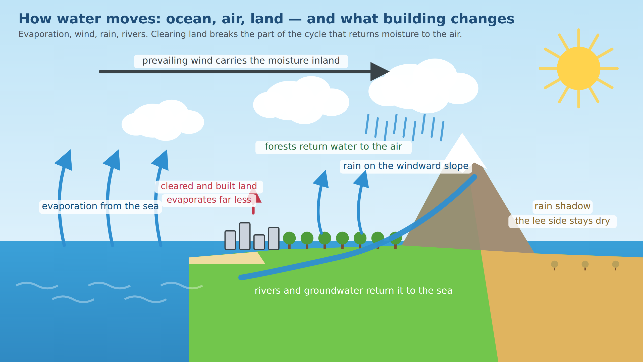
Figure 1 — The water cycle over sea and land
Water evaporates from the sea, the wind carries it inland, mountains wring it out, rivers return it. Forests keep the cycle turning; cleared and built land does not, so the rain downwind weakens.

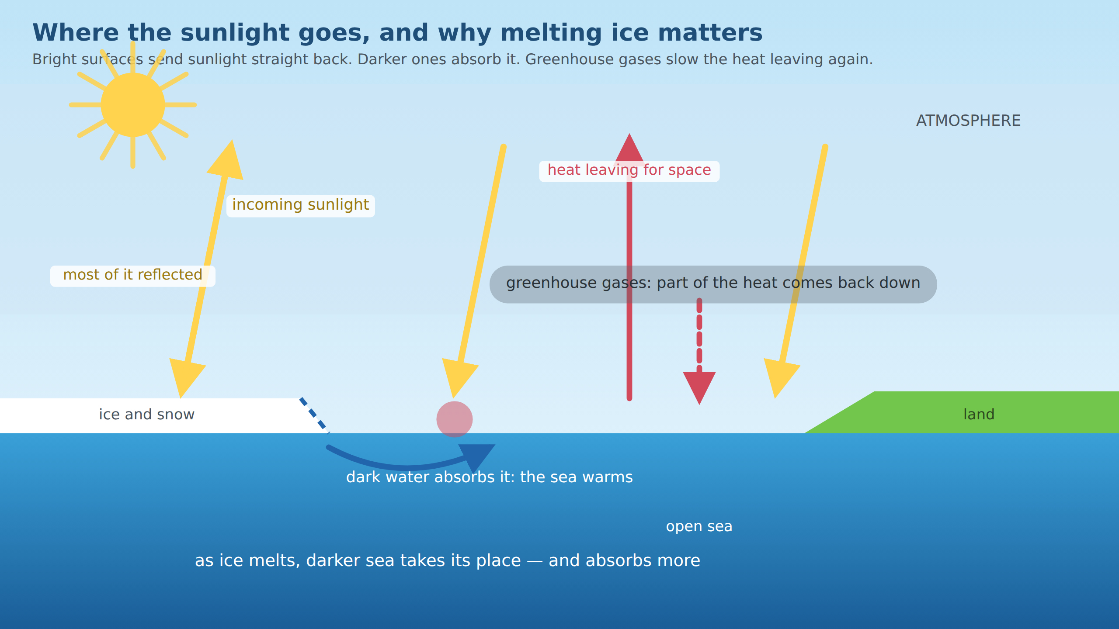
Figure 2 — Where the sunlight goes
Bright ice reflects sunlight straight back; dark water absorbs it. Greenhouse gases slow the heat on its way out. As ice retreats, darker sea takes its place and absorbs still more — the feedback that makes the poles warm fastest.

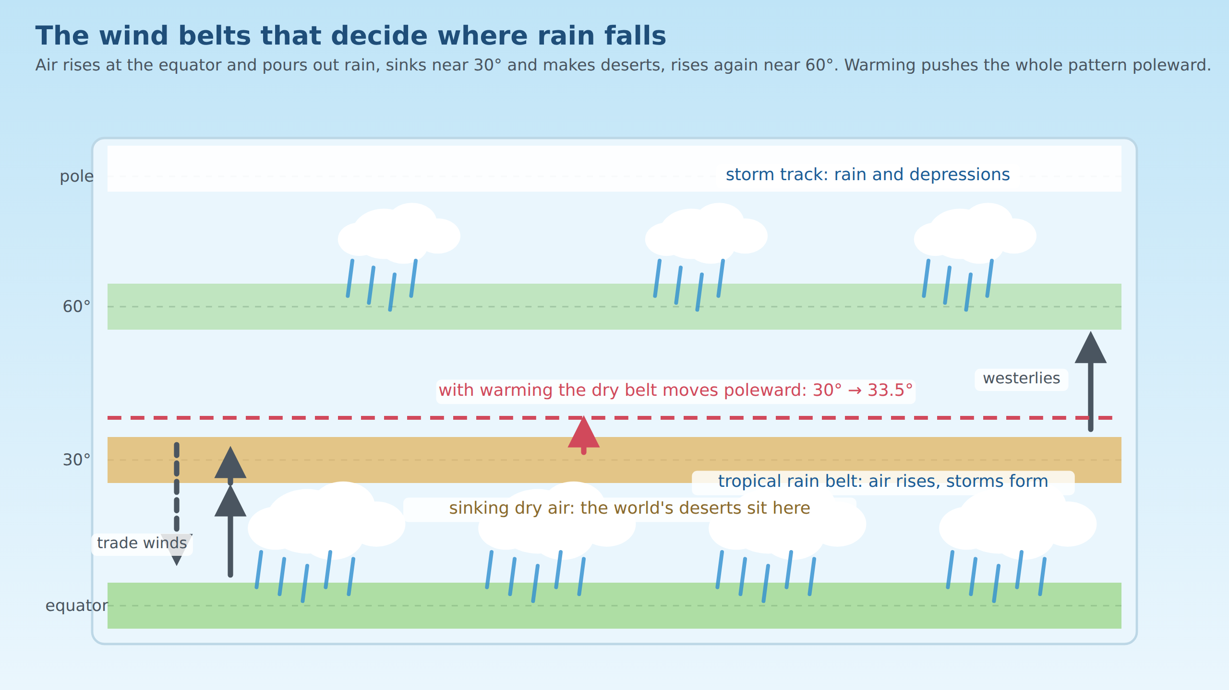
Figure 3 — The wind belts that decide where rain falls
Rising air at the equator makes the tropical rain belt, sinking air near 30° makes the deserts, rising air near 60° makes the storm tracks. Warming pushes the whole pattern poleward, and the deserts travel with it.

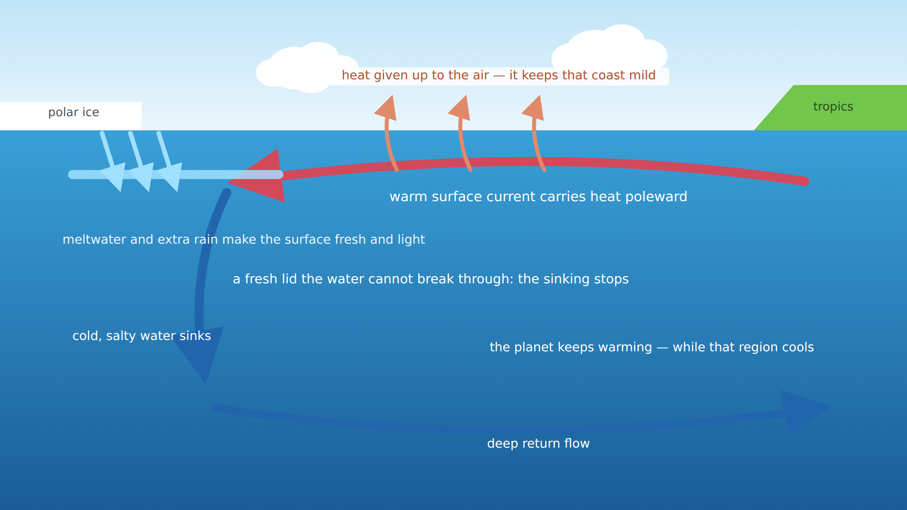
Figure 4 — The ocean's conveyor, and how it can stop
Warm water flows poleward, gives up its heat to the air and sinks. Meltwater and extra rain can leave a fresh, light lid on the surface that the water cannot sink through — and the conveyor stalls.

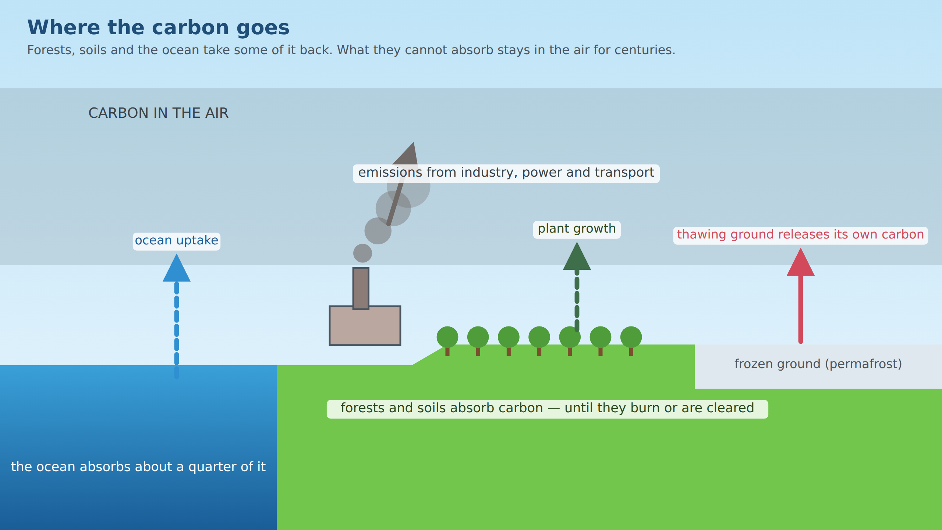
Figure 5 — Where the carbon goes
Forests, soils and the ocean take back part of what is emitted. What they cannot absorb stays in the air for centuries, and thawing ground adds carbon of its own.

The same couplings, as loop diagrams

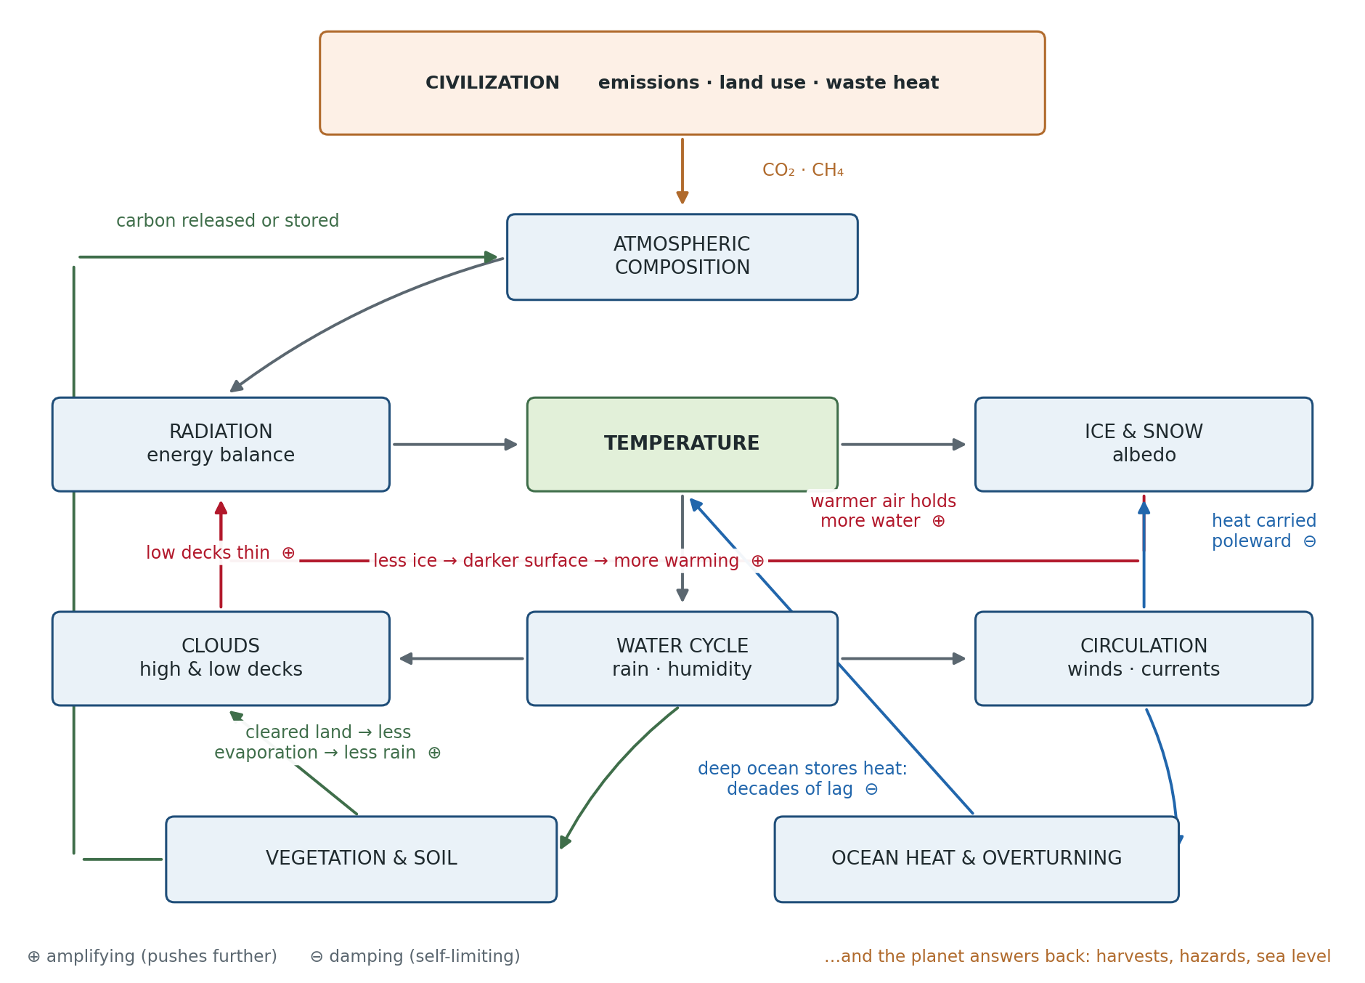
Figure 6 — The coupled system and its feedback loops
Every arrow is a coupling the simulation computes. Red loops amplify a change, blue ones damp it. The civilization enters at the top and receives the consequences at the bottom.

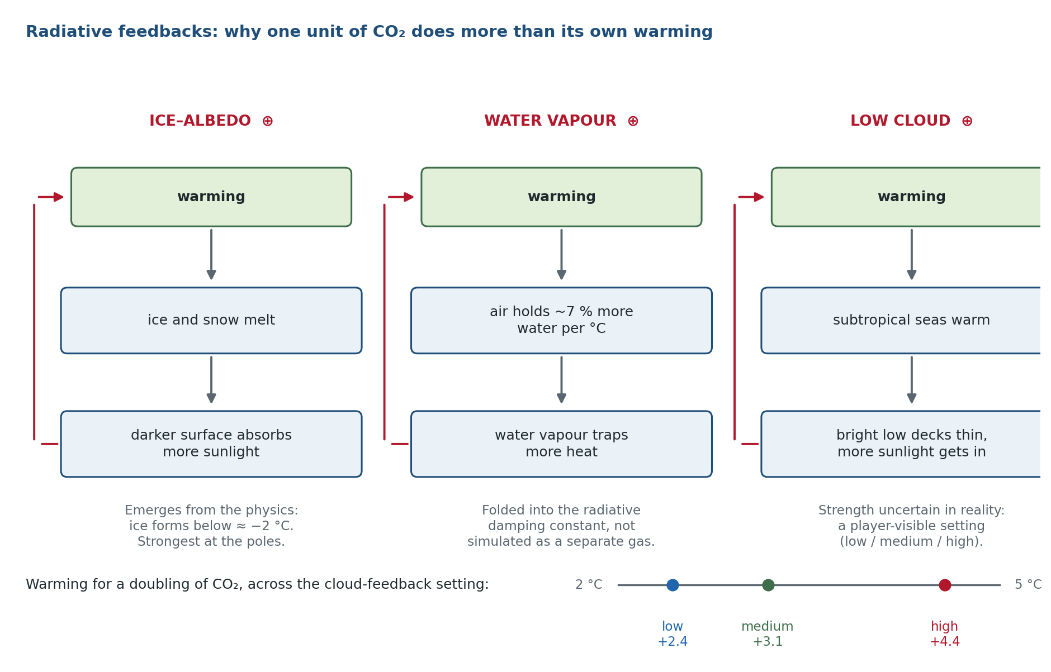
Figure 7 — Radiative feedbacks
Three amplifying loops decide how much warming a given amount of CO₂ produces. The first emerges from the ice physics, the second is folded into the radiative damping constant, and the third is left deliberately uncertain and exposed as a setting.

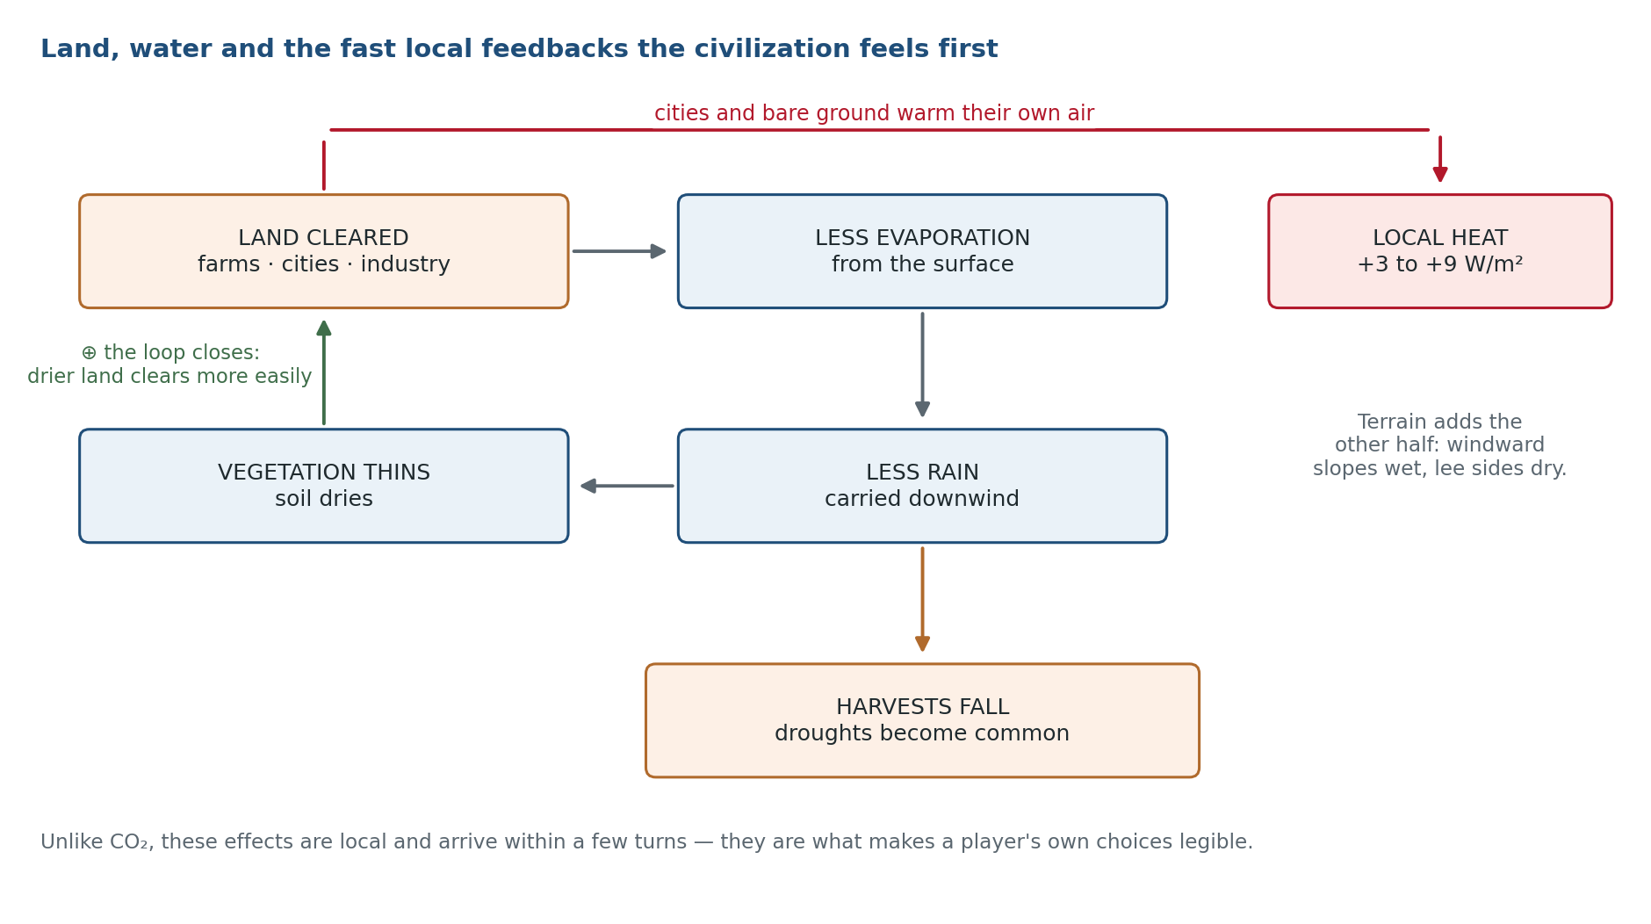
Figure 8 — Land use, the water cycle and the fast local feedbacks
These couplings act within a few years and inside the player's own territory, which is what makes a civilization's choices legible long before CO₂ is.

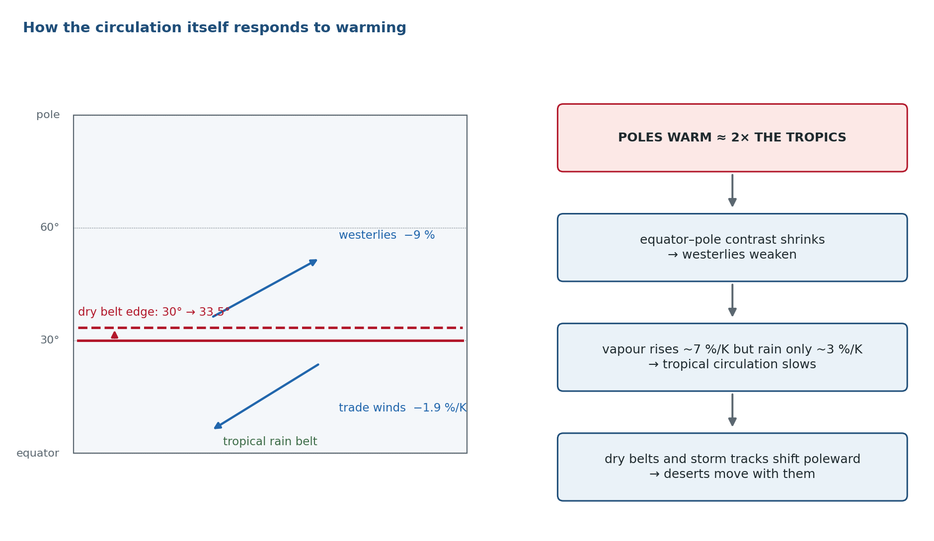
Figure 9 — How the circulation responds
The wind belts do not merely shift position: their strength follows the temperature contrast and the water cycle, and the dry belts travel with them.

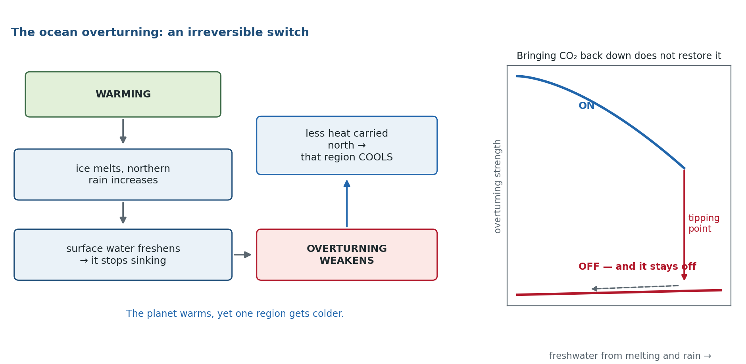
Figure 10 — The overturning circulation as an irreversible switch
Freshwater weakens the sinking that drives the circulation. Past a threshold it collapses, one region cools while the planet warms, and returning CO₂ to its old level does not restore it.

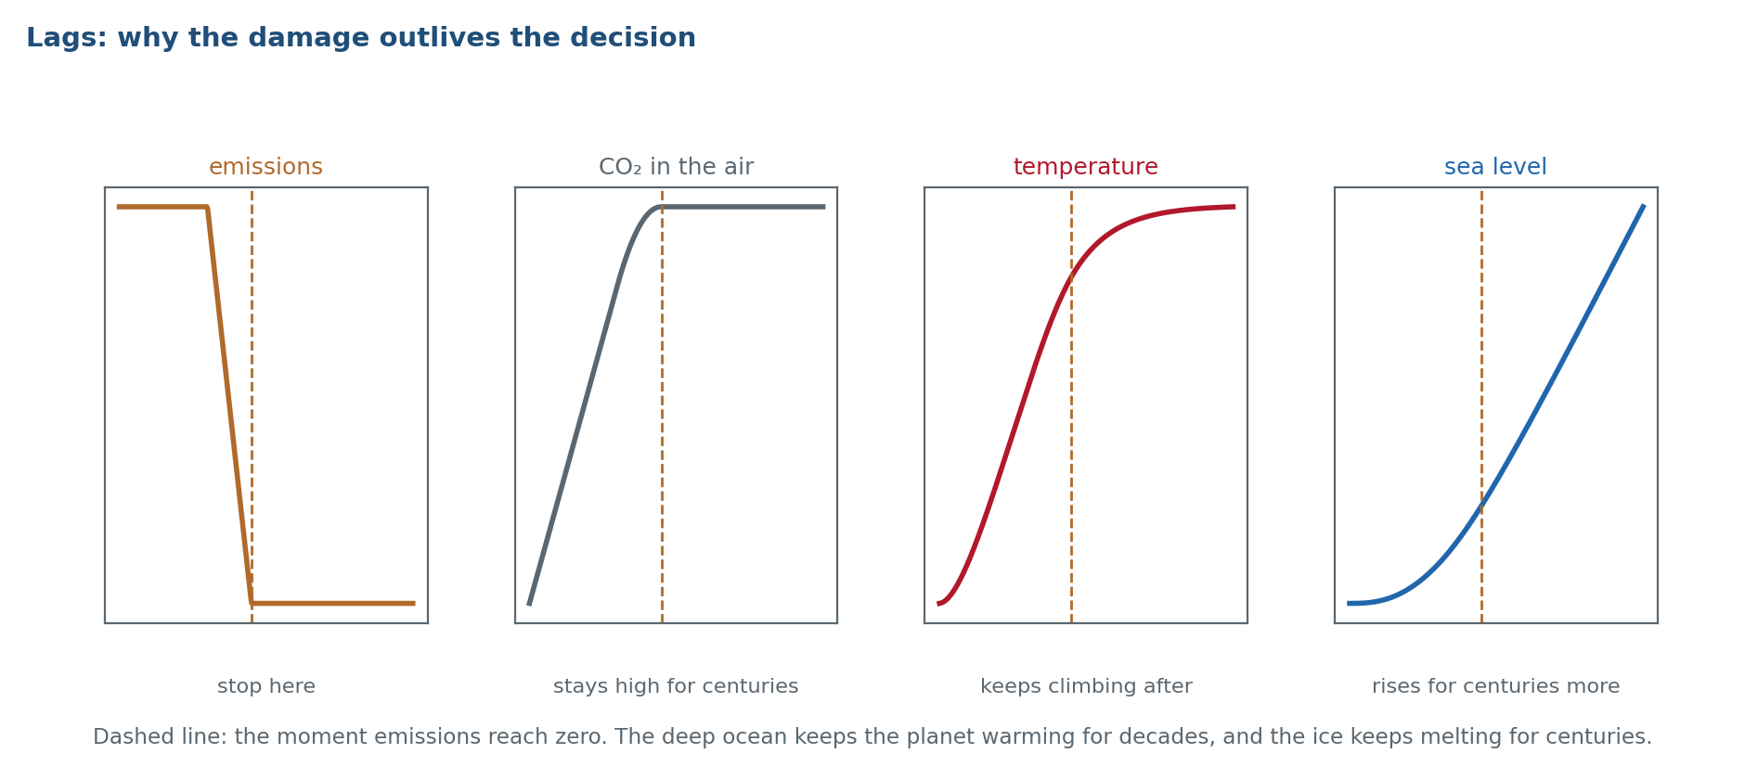
Figure 11 — Lags
Stopping emissions does not stop the consequences. The deep ocean keeps the surface warming for decades, and ice keeps melting for centuries.

24.11 Couplings between people and weather that are not yet in the design
Reviewing the prototype against this document showed that the civilization→planet direction is thinner than the planet→civilization one, and that several of the couplings a player would expect are missing entirely. They are listed here with the reason each one earns its place, so that the P1 civilization work has a checklist rather than an intuition.

People acting on the atmosphere
Coupling | Mechanism | Why it belongs in this game | Stage
Irrigation and water withdrawal | Irrigated land evaporates more: locally cooler and moister, sometimes by more than a degree. Rivers, reservoirs and groundwater are drawn down. | The natural counterweight to clearing, and the way a civilization exhausts its own water without any change in rainfall. | P1
Aerosols and haze | Combustion particles reflect sunlight, dim solar output and weaken monsoons; they wash out within weeks. | Inverts the usual intuition: cleaning the air improves health and solar yield and makes warming faster. One of the strongest dilemmas available. | P1
Surface brightness (albedo) of land use | Crops, bare soil and cities are usually brighter than forest; snow-covered cleared land is much brighter. | Clearing currently only dries the land. In high latitudes clearing can cool a region while still releasing carbon — the kind of genuine trade-off the design asks for. | P1
Methane and other short-lived gases | Livestock, rice, landfill, leaking gas; potent but short-lived. | Behaves differently from CO₂ on the game’s timescale: cuts show results within a player’s term of office. | P1
Dust and soot | Degraded land raises dust that dims the sun; soot darkens snow and speeds melting. | Links land degradation back to the radiative balance and to the ice feedback. | P2
Reservoirs and dams | Evaporation loss, local humidity, methane from flooded vegetation, altered river flow downstream. | Makes water infrastructure a real decision with costs, not a free fix. | P2

Weather acting on people
Coupling | Mechanism | Why it belongs in this game | Stage
Seasons | An annual cycle of insolation: growing seasons, monsoons, winter demand, seasonal ice. | The largest single gap. Without seasons there is no harvest window to miss and no monsoon to fail; weather stays an annual mean instead of an event. | P0/P1
Temperature-driven energy demand | Heating demand falls with warming, cooling demand rises; cooling is electricity. | A closed feedback the player can watch: hotter → more cooling → more emissions → hotter. | P1
Water as a stock | Rivers, reservoirs, groundwater and snowpack, not just rainfall. Snow melting earlier shifts supply out of the dry season. | Hydropower fails in droughts and thermal plants lose output when cooling water is scarce or hot — energy and water become one problem. | P1
Labour and health | Outdoor work slows in extreme heat; disease ranges follow temperature and moisture. | Connects climate to the economy through people rather than through crops alone. | P2
Migration | People leave regions that can no longer feed or cool them. | Replaces “the population fell by N” with movement, and is the natural bridge to the multi-region design. | P2
Adaptation measures | Dikes, irrigation, crop switching, early warning, cooling, building standards. | Without them the player can only mitigate. The real dilemma is mitigate versus adapt, under a budget. | P1
Stores and trade | Granaries and imports turn one bad year into a manageable event. | Prevents a single drought from reading as instant famine, and makes resilience a strategy. | P1
Winners as well as losers | High latitudes gain growing season; some regions get wetter. | A model with only downside reads as propaganda. The unevenness is the honest and interesting part. | P1

24.12 The living biosphere
The design treats vegetation as a single number that follows rainfall and alters evaporation. That is enough for the water cycle, but it omits the carbon that living things hold, the speed at which they can lose it, and the animals on which agriculture depends. Several of the strongest real feedbacks run through the biosphere, and it is also the only part of the system that rewards protection rather than merely limiting damage.

Plants, soil and fire
Process | Mechanism | Behaviour it creates | Stage
Forest as a carbon stock | Decades to accumulate, one season to release. | Clearing becomes a genuinely asymmetric, near-irreversible decision rather than a reversible land-use choice. | P1
Fire regime | Longer, drier fire seasons release stored carbon and clear land without anyone deciding to. | A recurring hazard whose frequency the player changes indirectly, through warming and land management. | P1
Forest dieback | A rainforest recycles much of its own rainfall; past a threshold of clearing, heat and drought it dries itself into savanna. | A tipping point the player can trigger inside their own territory within a handful of turns — the most legible tipping point in the whole model. | P1
CO₂ fertilisation | Plants grow somewhat faster in richer air, limited by nutrients and heat. | A damping feedback, and an honest complication: not every consequence of CO₂ is negative. | P2
Soil carbon | A stock larger than the atmosphere’s, respiring faster when warm, depleted by tillage and rebuilt by cover and rotation. | Ties farming practice directly to the carbon cycle and gives agroecology a measurable payoff. | P1
Peat and permafrost carbon | Biological carbon preserved by cold or water; drainage or thaw releases it irreversibly. | Already a planned tipping point; modelling it as a biological stock makes its irreversibility explicit. | P2

Animals, pollinators and the sea
Process | Mechanism | Behaviour it creates | Stage
Pollinators | Roughly a third of crop production depends on them; they decline with habitat loss, monoculture and chemicals. | A yield multiplier the player controls through habitat, not through machinery. Makes reserves and mixed farming pay. | P1
Pests and crop disease | Warming extends ranges and allows more generations per year. | A warming cost that arrives through biology rather than heat stress, and one that adaptation can answer. | P1
Forest insect outbreaks | Milder winters let bark beetles and similar pests kill forests at scale. | Couples warming to the carbon stock without fire, and surprises players who protected a forest from logging. | P2
Plankton and the biological pump | Ocean life moves carbon to depth; warming, stratification and acidification weaken it. | Explains why the ocean’s carbon uptake is not a fixed fraction. | P2
Fisheries | Stocks shift poleward and collapse under warming, acidification and overfishing. | A food source independent of rainfall, with its own tipping behaviour. | P2
Coral and coastal habitat | Bleaching removes fisheries and the reefs that protect coasts from storms. | Links biodiversity loss to physical exposure: fewer reefs mean worse storm damage. | P2
Grazing pressure | Herds convert grassland to dust, changing surface brightness and raising dust loads. | A land-use lever distinct from cropping, and a route into desertification. | P2

24.13 What to build first
The list above is deliberately longer than P1 can absorb. Ordered by how much each one changes what a player understands per unit of implementation effort:
- 1. Seasons. Everything else in this section depends on them, and they turn weather from an annual mean into an event: a growing season to miss, a monsoon to fail, ice that comes and goes.
- 2. Forest as a carbon stock with fire and dieback. Closes the carbon loop, and gives the player a tipping point inside their own borders.
- 3. Pollinators and pests as a yield multiplier. Cheap, immediately legible, and the first mechanic that rewards protecting something.
- 4. Temperature-driven energy demand. A short, visible feedback loop: hotter, more cooling, more emissions.
- 5. Adaptation measures and stores, so the player faces mitigate-versus-adapt rather than a single track.
- 6. Aerosols, for the dilemma they create: cleaner air, faster warming.
Everything marked P2 in the tables above is deferred deliberately, not forgotten. Each should enter only when a player-visible decision depends on it, and each must arrive with the conservation diagnostics and acceptance targets that section 30 requires.
DECISION Extend the coupling registry (section 24.9) to cover the couplings listed in 24.11 and 24.12, each with producer, consumer, units and conservation implication, before P1 civilization systems are implemented. Build them in the order of 24.13; treat seasons as a P0 completion item, since the whole biosphere depends on them.

25. P0 roadmap modifications
The new coupling requirements modify the P0 milestone interpretation. Individual milestones remain useful for implementation, but the water, cloud, ocean and atmospheric systems must converge into continuous coupled loops rather than remain independent features.
Milestone | Modification | Validation target
M5 Wind + Coriolis | Preserve vertical structure sufficient to later estimate wind shear and organized rotation. | Planetary circulation direction and latitude dependence.
M6 Humidity + evaporation | Couple water transfer to latent-energy flux. | Closed water budget; evaporation cools source surface.
M7 Clouds + precipitation | Cloud water becomes physical state; condensation releases latent heat; clouds affect radiation. | Cloud/rain patterns respond to humidity, ascent and temperature.
M8 Hydrology | Connect precipitation, snowmelt, infiltration, runoff and river discharge. | Water conservation and sensible catchment response.
M9 Snow/ice | Add albedo feedback and freshwater/energy exchanges. | Seasonal snow/ice and energy response.
M10 Vegetation | Add evapotranspiration, albedo and soil-water coupling. | Vegetation changes local water/energy balance.
M11 Ocean heat/current | Promote to core climate coupling: SST, air-sea fluxes, heat transport, mixed/deep layers. | Maritime vs continental climates; current-driven SST patterns.
M12 CO2 forcing | Retain physical forcing; prepare carbon reservoirs and aerosol forcing separately. | Known-sign forcing and energy-budget response.
M13 Climate experiments | Add current perturbation, deforestation, ice-albedo, aerosol and water-cycle experiments. | Feedback signs and conservation remain correct.
M14 Visual polish | Render physical cloud/rain/storm/current fields; no disconnected cosmetic weather. | Visible state agrees with authoritative fields.
M15 Coupled-storm experiment (new) | Test whether the model can generate and sustain organized tropical rotating storms under favorable conditions and suppress them under unfavorable conditions. | Storm formation is condition-dependent; storm modifies ocean and hydrology.
DECISION Ocean heat transport, evaporation-cloud-latent-heat coupling and physical cloud state are now core P0 requirements. Full thermohaline circulation and high-fidelity tropical-cyclone physics remain later refinements, but P0 architecture must support them.

26. New validation experiments
Experiment | Purpose
Ocean-current climate test | Run identical worlds with altered current heat transport; verify SST and downstream coastal climate respond through atmosphere rather than direct land-temperature modifiers.
Evaporation energy test | Increase evaporation and verify surface latent cooling plus conserved water transfer to atmosphere.
Condensation energy test | Condense a known water mass and verify latent heating and water conservation.
Ice-albedo test | Perturb snow/ice cover and verify expected sign of absorbed shortwave response.
Deforestation coupling test | Reduce vegetation and observe changes in ET, soil moisture, runoff and local atmospheric humidity.
Storm environment A/B test | Same warm ocean with low vs high vertical shear; organized rotation should be favored only in the suitable environment.
Cyclone cold-wake test | A strong storm should mix the upper ocean and reduce SST along its track when the ocean vertical structure permits it.
Freshwater circulation test (future ocean model) | Add high-latitude freshwater and verify density/circulation responds without scripted thresholds.
Aerosol masking test (future) | Reduce aerosol forcing at fixed greenhouse concentration and verify the radiative response has the correct sign.

27. Revision note — what changed in v0.4 and why
Version 0.3 was reviewed against a working prototype: a reduced but complete planetary climate model (energy balance, three-cell circulation, moisture and rain, clouds, ice, wind-driven ocean gyres and an overturning circulation) coupled to a small civilization game, implemented in Godot and validated against standard climate benchmarks. That prototype confirmed most of the design and exposed four problems that v0.3 did not address.
Finding from the prototype | Change in v0.4
Extreme time acceleration is the central technical constraint, not an optimisation: minute-scale atmospheric physics cannot be integrated across centuries. | New section 28 defines simulation modes, the reference/accelerated split and a performance budget. Promoted to the first decision record.
Calibration is strongly cross-coupled: adding ocean heat transport invalidated an atmosphere that had been calibrated to carry all transport, and one parameter went unphysical at the poles without any test catching it. | New section 30 (validation acceptance targets) and an explicit requirement for a calibration harness with recorded targets.
Players do not perceive the link between their actions and the climate, even when the physics is correct and visible. | New section 29: the counterfactual planet becomes a first-class player-facing mechanic, not only a history-fork feature.
"Compelling" cannot be validated by a physics milestone. | Section 15 amended; new section 31 defines a parallel gameplay track on the existing prototype.
Several practical questions were unspecified: time control, session shape, save migration, the exact meaning of determinism. | New sections 32 and 33.

28. Time acceleration, simulation modes and the performance budget
The document requires weather that evolves in minutes to hours and histories that span one to three centuries. These are irreconcilable by scheduling alone. A century at a ten-minute atmospheric timestep is roughly five million steps; at level 6 with five layers that is of the order of 10^12 cell-updates per simulated century. No desktop machine will do that at playable speed, so the accelerated path is the normal mode of play and the explicit-weather path is the exception.
REFERENCE MODE explicit weather, small timesteps, full conservation
used for validation, CI and calibration
│
│ climate-mode statistics are fitted to it
▼
CLIMATE MODE long implicit steps, statistical weather,
conserved energy / water / carbon budgets
→ the normal mode of play
│
│ seeds a bounded window on demand
▼
WEATHER WINDOW explicit solver, days to seasons, limited region
→ zoom-in, hazards, in-game forecasts
Climate mode advances the slow state (surface and ocean temperature, soil moisture, vegetation, ice, carbon) with long implicit steps, while weather appears as statistics — frequency and intensity distributions of rainfall, heat, wind and storms — derived from the resolved state. A weather window runs the explicit solver over a limited period or region when the player zooms in, a hazard is unfolding, or a forecast is being produced in-game. The two paths must be reconciled by construction: the climate-mode statistics are fitted to reference-mode runs, and the same conservation diagnostics apply to both.
The performance budget is a requirement, not an aspiration, and should be measured from milestone M3 onward on the target desktop machine:
- Climate mode: at least 20 simulated years per minute of wall-clock time at development resolution, and at least 5 at shipped resolution.
- Weather window: real-time or better for a season over a regional subset.
- Snapshot cadence for presentation: independent of solver cadence, interpolated by Godot.
- A scenario of 250 simulated years must complete in continuous integration in under ten minutes headless.
DECISION Treat accelerated climate mode as the primary simulation path and explicit weather as a bounded window seeded from it. Define both, and their consistency tests, in the first architecture decision record, before the repository is created.

29. The counterfactual planet as a player-facing mechanic
The prototype demonstrated a failure mode that no amount of physical accuracy repairs on its own: with a correct, visibly changing climate, a player still reported no felt connection between their decisions and the planet. The reason is structural. The player sees the world that exists, never the world that would have existed, and global emissions act slowly and everywhere, so nothing in the visible record is attributable.
The fix is to run a second instance of PlanetSim — the shadow planet — initialised identically but never receiving this civilization's fluxes, while the rest of the world behaves as an average one. The difference between the two is the civilization's fingerprint, and it can be stated plainly and honestly:
PlanetSim (real) PlanetSim (shadow: no civilization fluxes)
│ │
└──────────── difference ─────────┘
│
"your region is +0.45 °C and 17 mm/yr drier than it
would have been; the world is +0.52 °C because of you"
The mechanic costs roughly double the simulation time and no new architecture, since the fluxes from civilization to planet are already an explicit interface (section 21.5). It also gives attribution language to the observation layer: a drought can be reported with the share of the rainfall deficit attributable to the civilization, once its science is good enough to estimate it. Because the shadow planet is exactly a history fork with one input zeroed, it shares the serialization work already required by section 13.
Complementing it, the prototype showed that fast, local effects are what make the connection legible: cleared ground returns less moisture to the air and reduces rainfall downwind within a few years, while cities, industry and bare fields warm their own ground. These are physically real, immediate and local, unlike CO₂, and should be present from the first civilization milestone.
DECISION Run a shadow planet without the civilization and expose the difference as the civilization's fingerprint. Prioritise fast local couplings (land use to evapotranspiration to local rainfall, waste heat and albedo to local temperature) as the first civilization-to-planet fluxes implemented.

30. Validation acceptance targets
Section 15.4 requires conservation diagnostics; they are necessary but not sufficient, because a model can conserve energy perfectly and still behave nothing like a planet. The prototype produced a set of quantitative targets that a reduced-order model can be expected to meet, and each of these caught at least one real defect during its calibration. They are proposed as the acceptance criteria for "plausible enough".
Property | Acceptance range | Prototype value
Preindustrial global mean surface temperature | 13–15 °C | 14.0 °C
Equilibrium warming for doubled CO₂ | 2.5–4 °C (IPCC likely range) | +3.1 °C
Same, across the cloud-feedback uncertainty | spans roughly 2–5 °C | +2.4 / +3.1 / +4.4 °C
Transient warming at doubling / equilibrium warming | 0.5–0.75 | 0.63
Polar amplification (poles vs tropics) | ×2–4 | ×1.6 (below target; see note)
Global precipitation response | +2 to +3 %/K | +3.4 %/K
Tropical circulation response | slows, −1 to −2 %/K | −1.9 %/K
Subtropical dry belts | move poleward with warming | 30° → 33.5° at doubling
Tropical rain belt vs subtropics | wet vs dry by a factor of several | 2,300 vs 270 mm/yr
Rain shadows behind terrain | windward clearly wetter | yes
Western boundary currents | poleward and fast on western basin edges | +0.35 m/s west, −0.30 m/s east
Sea surface temperature, western vs eastern basin edge | western warmer at the same latitude | +2.3 °C
Overturning circulation under doubled CO₂ | weakens 15–40 %, no collapse | −29 % after 400 years
Overturning under quadrupled CO₂ | collapse possible | collapses; northern seas end colder than preindustrial
Collapse then CO₂ returned to preindustrial | does not recover (hysteresis) | stays collapsed
Brief overshoot of the threshold, quickly reversed | may recover | recovers
Historical forcing 1850 → 2025 | ≈ +1.2 °C observed | +1.24 °C, not tuned for

Two lessons from producing that table belong in the architecture. First, calibration is cross-coupled: adding explicit ocean heat transport to an atmosphere whose diffusion had been tuned to carry all poleward transport double-counted the transport, warmed the planet by 3 °C and destroyed polar amplification. Any new transport process must be accompanied by recalibration of the ones it partially replaces. Second, a plausible-looking calibration can rest on an unphysical parameter — in the prototype, radiative damping went slightly negative at the poles, which no visual check would ever reveal. Physical parameters need invariant assertions of their own, not only budget checks.
DECISION Maintain a calibration harness and a recorded table of acceptance targets in tests/physics. Any change to a transport or feedback process re-runs it, and calibration constants are versioned with the values they were fitted against.

31. Parallel gameplay validation track
P0 as specified is a long programme, and none of it answers whether the game is worth playing. The existing Godot/GDScript prototype already implements a reduced version of milestones M3 to M12 plus a civilization loop, runs at roughly a second per simulated decade, and can be modified in minutes rather than days. It should be kept alive deliberately, as the fast lane.
Track | Purpose | Language / cadence
PlanetSim P0 (reference) | Physical correctness, conservation, performance, long-term architecture. | C++20, milestone-driven
Gameplay prototype (fast lane) | Does the loop hold attention? Do players perceive causality? What information do they need, and when? Turn length, pacing, onboarding. | GDScript, days

The prototype also serves as a behavioural oracle: the C++ core can be run against the same scenarios and compared with the recorded prototype results before its own calibration is trusted. When the C++ core reaches parity, the prototype is retired rather than merged.
DECISION Run a gameplay prototype track in parallel with P0, use it to answer experience questions and as a behavioural oracle for the C++ core, and retire it only at parity.

32. Time control, session structure and onboarding
The document does not state whether the game is paused-and-stepped, turn-based or continuously running with speed controls. This choice propagates into the scheduler, the snapshot cadence, the UI and the feel of the game, and should be settled before the P0 interface is designed. The recommendation, informed by the prototype, is continuous simulation with speed controls and an explicit decision rhythm: the civilization acts at any time, but the consequences of a period are summarised at fixed intervals (a decade in early scenarios, a year in later ones), because players need a moment where the world reports back. In the prototype that role was played by a newspaper front page, which proved to be the most effective single piece of interface.
- Define the session shape: what a first two-hour session contains, and what ends a game (a date, a collapse, a self-set goal, or nothing).
- Define onboarding for the hidden-state mechanic. Sparse, uncertain data is a strong idea that reads as a broken interface to a new player unless the game explains that the gaps are the point.
- Plan the accessibility of overlays from the start: colour-blind-safe ramps, and a textual reading of every map.

33. Determinism, saves and migration
Determinism as stated in section 14.2 is stronger than it needs to be and harder than it sounds. Bit-exact reproducibility across compilers, platforms and optimisation levels requires strict floating-point control or fixed-point arithmetic, and is easily broken by a library update. The practical scope is: deterministic for a given build, platform and seed; reproducible across builds through recorded inputs rather than recorded arithmetic.
- Store scenario, seed, code version and the ordered list of player commands. A game is then replayable, and a divergence is a bug report.
- Snapshots carry a schema version; a migration path is required from the first release of the save format, because a multi-year project will change state layout many times and history forks make old saves valuable.
- Record which fields are authoritative and which are derived, so snapshots stay small and forks reconstruct the rest.
DECISION Scope determinism to a given build, platform and seed. Guarantee replay through recorded scenario, seed and command history, and version every snapshot schema with an explicit migration path.

34. Tropical cyclones: staged implementation
Emergent cyclogenesis requires vertical structure, shear, moist convection and a resolution at which a rotating storm is representable at all. At level 6 a cell is roughly 90 km across, which is marginal. Rather than gate the feature on a solver capable of resolving it, stage it so that the gameplay-relevant behaviour arrives early and the physics can be upgraded later without changing the consumers.
Stage | Mechanism | What is real
S1 (first) | Genesis probability from resolved conditions (upper-ocean heat, humidity, rotation, shear proxy); storms are tracked objects steered by the resolved winds. | Where and when storms form, where they travel, landfall, rainfall, cold wake, damage.
S2 | As S1, plus two-way coupling: storms mix the upper ocean, extract heat, and modify local humidity and rainfall fields. | Self-limitation and track-dependent ocean cooling.
S3 (research) | Organized convection emerges from the atmospheric solver. | Formation itself.

DECISION Implement cyclones as condition-driven tracked objects with genuine two-way coupling first. Treat emergent cyclogenesis as a research milestone that must not block P0 or P1.

35. Revised immediate next steps
- ADR-0001: time acceleration, simulation modes and the performance budget (section 28).
- ADR-0002: mesh topology, resolution policy and field layout (section 29 of v0.3, amended in section 15.1).
- ADR-0003: determinism scope, snapshot schema and migration (section 33).
- P0-M0/M1 technical specification, including the first validation tests, written before implementation.
- Repository skeleton with continuous integration running conservation diagnostics and the acceptance targets of section 30 from the first commit.
- In parallel, continue the gameplay prototype and run the first external playtests, focusing on perceived causality and session pacing.
- Implement the fast local loops of section 36 in the gameplay prototype and include perceived local causality in the first playtests.
- Specify the knowledge stages of section 37.1 and the projection ensemble of section 37.2 for P2, and add forest dieback as the first staged tipping event in the gameplay prototype.

36. Two-speed feedback: fast local loops and the slow global loop
The civilization's influence on the planet runs on two very different clocks. Global climate — greenhouse gases, ocean heat, ice and sea level — responds over decades to centuries and is hard to reverse. That delay is physically correct and is the heart of the subject, but on its own it makes the early game feel free of consequences and the late game feel unfair: decisions taken in 1900 arrive in 1990, and nothing in the player's experience links the two (section 29). The design therefore treats the planet's response as two loops that run at the same time.

36.1 The fast loop: local, visible, recoverable
Every major civilization action must have at least one consequence that is local (in or near the region that caused it), visible on the rendered planet within one or two report intervals (section 32), and largely recoverable if the cause stops. The fast loop teaches the core rule of the game early and cheaply: what you do here changes the land here.
Local loop | Player action | Physical mechanism | Felt within | Recovery
Haze and air quality | Coal and wood burning, early industry | Aerosols dim sunlight and harm health; rain washes them out. | Weeks to a season | Fast once emissions stop
Downwind drying | Forest clearing | Less evapotranspiration and recycled rainfall downwind; more runoff, erosion and flood peaks. | A few years | Decades of regrowth; past a threshold, dieback (24.12)
Soil exhaustion | Intensive tillage, monoculture | Soil carbon and nutrients fall, yields decline, erosion rises. | 5–20 years | Years to decades with rotation, cover and fallow
Water drawdown | Irrigation, withdrawal, dams | Rivers, lakes and groundwater fall; irrigated land is locally cooler and moister. | Seasons to years | Rivers fast; groundwater slow
Urban heat | City growth, waste heat | Sealed surfaces, less evaporation and waste heat warm the city. | At once | Persists with the city; eased by green space and water
Habitat and yield | Clearing, monoculture, chemicals, overfishing | Pollinators and fish stocks decline; pests spread. | Years | Years, if habitat and stocks are allowed to return

36.2 The slow loop: global, delayed, sticky
Greenhouse gases accumulate; the ocean absorbs heat and delays the atmospheric response; ice sheets and sea level follow over centuries; tipping elements (overturning circulation, permafrost, forest dieback) move toward their thresholds. The slow loop is global, lags the actions that drive it by decades, and does not reverse when emissions stop: CO₂ persists for centuries and committed warming continues after the cause is removed. This asymmetry — fast loops recover, the slow loop does not — is itself something the player should learn by playing.

36.3 Bridges between the loops
The two loops are not separate systems. They are the same physical fluxes seen at two scales, and most of the design value is in the links between them:
Action | Fast, local effect | Slow, global contribution
Burning coal | Haze, ill health, a dimmer sun | CO₂ accumulates; aerosols mask part of the warming, so cleaning the air unmasks it (24.11)
Clearing forest | Downwind drying, erosion, floods | Carbon stock released and sink lost; brighter land can locally cool high latitudes
Intensive farming | High yields, then exhausted soil | Soil carbon released; methane from livestock and rice
Growing cities | Urban heat | Cooling demand → electricity → emissions (24.11)
Irrigation | Local cooling and moisture | Can hide regional warming until the water runs out
The slow loop then returns to the local scale as regional hazards — drought, heatwaves, floods, storms, shifting seasons — often in regions that did not cause them, and with some winners as well as losers (24.11). The player meets the pattern first where they live, then discovers through science (section 6) and the counterfactual planet (section 29) that the same pattern is happening to the whole planet, only slower and much harder to undo.

36.4 Design rules
- No scripted modifiers. Both loops are physical state and fluxes in PlanetSim (sections 3.1 and 3.2), and the fast loop mostly uses couplings already listed in 24.9, 24.11 and 24.12. Its speed comes from short physical residence times (aerosols, soil water, rivers), not from a gameplay multiplier.
- Visible first, measured later. Fast-loop effects must be readable on the rendered planet without instruments (section 3.4): haze, bare and eroded land, shrinking rivers, browning fields. The slow loop becomes legible mainly through observation and science.
- Fast loops warn; they do not decide. Local penalties must be strong enough to be noticed but not so strong that they dominate strategy, or the game turns into local housekeeping and the global story disappears.
- Near-term payoffs for good choices. Cleaner energy, soil care and forest protection should pay back within the fast loop (health, yields, water), so that mitigation is not experienced as pure sacrifice.
- Recovery is part of play. Because fast damage is largely reversible, the player can experiment and repair; the contrast with the irreversible slow loop is the lesson.

36.5 Pacing consequences
The two loops give a game a natural three-act shape. Growth: development is rewarding and the fast loop shows the first local costs. Warning: the slow loop's signals appear in observations and the first regional hazards arrive. Crisis or transition: tipping elements approach and the player chooses between mitigation, adaptation or both. This fits the continuous simulation with a decision rhythm recommended in section 32. The report interval should shorten as the slow loop becomes active — about a decade early in a scenario, a year near a threshold or during a crisis — and the simulation should slow automatically on major events. The physics timestep is unaffected (section 28): pacing is a choice of presentation and decision rhythm, not of simulation.
DECISION Model the civilization–planet response as two coupled physical loops: a fast, local, visible and largely reversible loop present from P1, and a slow, global, delayed and sticky climate loop. Every major civilization action must have at least one fast-loop consequence.

36.6 Validation
- Prototype first (section 31): implement the fast loops in the GDScript prototype and playtest whether players can name the cause of a local change within two report intervals, without help.
- Headless experiments per loop: stop coal burning and verify that haze clears within a season while CO₂ remains; clear and regrow a forest and verify that downwind rainfall falls and recovers with the expected lag.
- A per-region consequence ledger (fast-loop changes and their attributed causes) feeds the newspaper report of section 32 and the attribution of section 29.

37. Knowing, foreseeing and responding: science, the committed future, tipping points and adaptation
Section 36 makes the planet's response felt. This section decides how the player comes to understand it and what they can do about it. Four mechanics are adopted together because each one depends on the next: science reveals the climate; mature science projects its future; the projection shows tipping points coming; and the player answers with mitigation, adaptation or both. Taken alone, a projection would spoil the discovery that section 3.3 protects, tipping points would feel like arbitrary disasters, and adaptation would have nothing to aim at.
Science → climate knowledge → projection of the committed future → warning of tipping points → choice of mitigation, adaptation or both.

37.1 Science as an unlock of the climate view
The player does not begin with a climate interface. At the start of Industrial Dawn they see only the rendered planet (section 3.4), the fast local effects of section 36 and the sparse records of their own region. Each stage of scientific knowledge adds a piece of the climate view. The stages extend the observation chain of section 6: an instrument produces data, but the view unlocks only when the matching knowledge exists.
Knowledge stage | Requires | What the player gains | Historical anchor
Local records | Thermometers, rain gauges, archives | Own-region weather history with gaps; nothing global | Start of Industrial Dawn
Climatology | Station networks, balloons, statistics | Regional norms and anomalies; a first, very uncertain global temperature estimate | c. 1900–1930
Greenhouse physics | Chemistry, precision instruments, a continuous CO₂ record | CO₂ gauge; reports can link emissions to warming | c. 1938–1960
Numerical models | Electronics, computing, atmospheric science | Weather forecasts; the first projection, as a wide cone (37.2) | c. 1950–1975
Satellites and ocean observation | Space programme, buoys, ocean ships | Ice, sea level and ocean heat; narrower projection; early warnings of tipping points (37.3) | c. 1975–2000
Earth-system models | Supercomputing, attribution science | Ensemble projections, attribution of events (section 29), a map of tipping zones | c. 2000 onwards
- Science reveals; it never changes the physics. The planet warms at the same rate whether or not the player can see it.
- Knowledge can lag measurement (section 6.2). A civilization can record warming for decades before its science can explain the cause.
- Science competes for resources with growth, so choosing to understand the climate is a real decision, and one the game rewards later.
- The historical anchors pace Industrial Dawn only. Other scenarios (section 4) may start at any stage, including after a loss of knowledge.
- Onboarding must present the missing climate view as the intended starting point, not a broken interface (section 32).

37.2 The committed future as a late science unlock
Once the civilization has numerical models, it can project the future. The projection is not given to the player; it is computed by the civilization's own science and is only as good as that science. This is what makes it compatible with section 37.1: in the early game there is no projection at all, the first one is crude and wide, and it sharpens only as observation and modelling improve.
- How it is computed: PlanetSim runs forward in climate mode (section 28, ADR-0001) from the civilization's estimated state, not the true state, under the assumption that current policies continue. Its error comes from two honest sources: gaps in observation and the maturity of the models. Several runs with perturbed estimates form an ensemble, and the spread of the ensemble is the cone the player sees.
- What it shows: a ghost coastline and a faint future ice edge on the planet, and a temperature band that extends beyond the current year. Committed warming — what would still arrive if emissions stopped now — is shown separately, so the player learns that part of the future is already locked in (section 36.2).
- Relation to the shadow planet (section 29): the shadow planet shows the past without this civilization; the projection shows the future if it continues. Together they give the player both halves of cause and consequence.
- Honesty: the projection can be wrong, but only because of the civilization's real limits. It is never biased by a script. Better science narrows the cone and moves its centre toward the truth.
- Cost: a coarse ensemble run once per report interval, off the main thread. It shares the history-fork machinery of sections 13 and 29.
DECISION The projection of the committed future is a science unlock (numerical models stage), computed by PlanetSim from the civilization's estimated state as an ensemble whose spread narrows with observation and model maturity. It is never available at the start of Industrial Dawn.

37.3 Tipping points as dramatic events
Tipping elements are already in the physical design: the overturning circulation with hysteresis (24.4 and Figure 10 in 24.10), forest dieback and peat and permafrost carbon (24.12). This section makes them the big moments of the game. A tipping point has three phases, each shown differently: a warning phase that science can detect, a crossing that is shown as an event, and an aftermath that cannot be undone on a gameplay timescale.
Element | Driven by | Early warning | Event on the planet | Reversibility
Forest dieback | Clearing, heat, drought | Less recycled rain, more fires; visible locally | Forest browns to savanna; fire seasons | Not within a game
Permafrost and peat | High-latitude warming, drainage | Warming ground, rising methane (CO₂ record, satellites) | Thaw lakes; a methane pulse that speeds warming | Not within a game
Overturning circulation | Freshwater, warming | Slowing flow and less northward heat (ocean observation) | One region cools while the planet warms; storm tracks and sea level shift | Hysteresis: does not recover when CO₂ falls
Ice sheet loss | Sustained warming | Accelerating mass loss (satellites) | Ice shelves break up; sea level rises for centuries | Millennia
Reef and fishery collapse | Ocean heat, acidity, overfishing | Bleaching, falling catches | Coastal food source fails | Decades at best
- Thresholds emerge from the physics; they are not scripted. The gameplay layer only detects that a threshold has been crossed and stages the event: the simulation slows or pauses (section 32), the camera turns to the place, and the newspaper reports it.
- Early warnings come from real signals. Near a threshold a system recovers more slowly from disturbances and fluctuates more, so the warning appears only when the civilization observes that system well enough (37.1). Without science, the first sign is the event itself.
- The exact thresholds vary between games within their physical range, so the player cannot memorize them and must rely on their science.
- A brief overshoot quickly reversed can still recover, as in the acceptance targets of section 30. This rewards fast reaction to a warning.
- Forest dieback is the first tipping point most players meet: it happens inside their own territory, within a few report intervals, and teaches the pattern before the global elements approach.

37.4 Adaptation as a real path
Section 10 already separates adaptation from mitigation. This section makes adaptation a full strategy, so that a bad start, or a world warmed by other civilizations, becomes a comeback story rather than a slow, certain loss. Adaptation protects people and places; it does not change the planet's forcing.
Measure | Protects against | Cost and lock-in | Limit
Sea walls and dikes | Sea-level rise, storm surge | Construction and permanent upkeep; development gathers behind them | Overtopped beyond their design height, with catastrophic failure
Managed retreat | Coastal loss, drought, heat | Abandoned infrastructure; public resistance (section 8) | Slow; limited by where people can go
New crops and seeds | Heat, drought, shifted seasons | Research and transition years | Heat beyond any crop's tolerance
Irrigation and water storage | Drought, floods | Land, water, downstream effects (36.1) | Multi-year drought; depleted groundwater
Heat-resilient cities | Heatwaves | Energy for cooling, which feeds emissions (36.3) | Humid heat beyond human tolerance
Forecasts and early warning | Storms, floods, heatwaves | Requires the numerical models stage (37.1) | Saves lives, not property
Ecosystem restoration | Surge, floods, drought | Land and time to mature | Slow; but it also stores carbon, so it mitigates too
- Adaptation works and is rewarding. Its benefits are local and fairly quick, like the fast loop of section 36.
- Adaptation has limits that tighten as the planet warms. Without mitigation it becomes a losing race; with mitigation it buys the time mitigation needs. The player learns that the answer is usually both.
- Maladaptation is possible and physical: sea walls attract building into danger, and irrigation can hide regional warming until the water runs out (36.3).
- Adaptation needs knowledge. Knowing where to build a wall or which crop to plant depends on observations and, later, on the projection (37.2).
- No dead end. Success is measured by the living conditions of the population (section 18, player objective), not by the temperature alone, so a well-adapted civilization in a warmer world can still succeed. Section 32 should define scoring and endings so that this holds.
- Phasing: simple measures (irrigation, water storage, crop choice) belong in P1; sea walls, retreat and forecasts arrive with P2 and P3; advanced adaptation remains in P4+ (section 16).

37.5 How the four fit the pacing
The mechanics fall onto the three acts of section 36.5. Growth: there is no climate view, only the fast loop and local records; investing in science is a bet on the future. Warning: climatology and greenhouse physics reveal the trend, the first projection appears as a wide cone, and early warnings start to flag tipping zones. Crisis or transition: the cone is narrow, tipping events arrive as dramatic moments, and the player combines mitigation and adaptation to protect their people. A player who neglected science reaches the crisis with less warning and fewer options, which is the lesson the game is built to teach.
DECISION Adopt four linked mechanics: climate knowledge is unlocked by science (37.1); the projection of the committed future is a late science unlock (37.2); tipping points are emergent physical thresholds staged as dramatic events with science-dependent early warnings (37.3); and adaptation is a full strategy with real benefits and tightening limits (37.4).

37.6 Validation
- Playtests (section 31): do players read the projection cone as uncertainty rather than as an error? Do players who invest in science act earlier and fare better? Can players name the cause of a tipping event without help?
- Headless experiment: projection skill against the true future improves with each knowledge stage, and the ensemble spread contains the true outcome at the stated rate.
- Headless experiment: an adaptation-only strategy outlasts a do-nothing strategy but fails at high warming; adaptation combined with mitigation outlasts both.
- Headless experiment: the same threshold crossed briefly and then reversed recovers, while a sustained crossing does not.

38. Society, public opinion and political credibility
This section turns the population and politics of sections 7 and 8 into a simulation grounded in established sociology, political science and climate psychology. Its central idea is the gap between what a government says and what it does: the player can speak through the media, build, legislate and direct research, and the population compares the promises with what it actually experiences.
The population model is the third, fastest loop of the game. It sits on top of the fast local loop and the slow global loop of section 36, and it feels the slow loop only through what people actually live through.

38.1 Principles
- Cohorts, not individuals. A cohort is a region, a social group and an age band. Heterogeneity comes from the number of cohorts and from inequality inside each one, not from millions of agents.
- Values move slowly, opinions move fast. Values change mostly through generational replacement; opinions react within months.
- Behaviour emerges from established models. Every mechanism below is taken from a published model and validated against stylised facts (section 38.15), not tuned to a scripted outcome.
- Every cohort has legitimate priorities. A miner defending a job is not wrong. Climate concern must never be the only rational opinion, or the game becomes a sermon and players disengage.
- Identity groups stay fictional and abstract. Regional, linguistic or religious cleavages are modelled as invented identities with their own values, never as caricatures of real communities.
- The population reads the planet; the planet never reads the population. Cohorts receive exposure fields (crop yield, flood, heat, sea level) through the coupling interface. The forbidden dependency Climate → Population entities stays intact.
- Determinism. Every stochastic draw uses the seeded streams of section 33.

38.2 Cohort structure
In the Industrial Dawn scenario, a region contains six to eight social groups and three age bands (young, working age, old). New groups appear when the economy creates them.
Social group (1880) | Typical livelihood | Emerges later as
Peasants and rural workers | Farming, forestry, seasonal labour | Shrinks with mechanization and urbanization
Industrial workers | Mines, factories, railways | Splits into industrial and service workers
Artisans and merchants | Workshops, trade, small shops | Small business owners
Bourgeoisie and professionals | Administration, law, medicine, engineering | Educated middle class
Landed and industrial elites | Land, capital, ownership | Corporate and financial elites
Clergy and intellectuals | Churches, schools, press | Teachers, scientists, journalists
(none) | (none) | Students; later digital-native cohorts

With 30 to 50 regions this gives roughly a thousand cohorts, cheap enough for the C++ core at monthly cadence. Inside each cohort, income and wealth are stored as a coarse distribution (for example five quantile bands), so that a carbon tax or a food-price shock can hurt the poorest fifth of a group while the average looks fine.
Representative citizens are drawn from cohorts for presentation only: a named textile worker in a flooded delta, angry at the government. They carry no state of their own and are regenerated from the cohort, so they never break determinism.

38.3 Cohort state
Layer | Contents | Speed | Grounding
Demography | Size, fertility, mortality, age structure, migration flows | Years | Demographic transition
Material conditions | Income distribution, employment, food, energy, housing, health, services | Months to years | Section 7.1
Education | Literacy, schooling, access to information | Decades | Gates media reach and science acceptance
Expectations | Expected level of each need, raised by prosperity and by promises | Years | Relative deprivation (Gurr), J-curve (Davies)
Values | Security–autonomy, tradition–change, material–post-material | Generations | Schwartz; Inglehart
Identity | Membership of fictional regional, linguistic or religious groups | Generations | Social identity theory
Opinions | Position and salience on each issue of section 8.1 | Months | Opinion dynamics (38.6)
Political support | Specific support for the government, diffuse support for the system | Months / decades | Easton
Collective memory | Remembered betrayals, disasters and successes, decaying slowly | Decades | Halbwachs; generational memory
Mobilisation | Grievance, organisation, protest-threshold distribution | Months | Gurr, Tilly, Granovetter
Climate perception | Experienced extremes, perceived risk, personal climate baseline | Years | Section 38.10
Consumption | Energy, transport, goods and food demand; technology adopted | Years | Section 38.5

38.4 Demography, urbanization and education
- Fertility and mortality follow the demographic transition: mortality falls with food security, sanitation and health care; fertility falls later with education, urbanization and prosperity.
- Urbanization is migration from rural to urban cohorts, driven by jobs and wages and limited by housing. Urban cohorts have different needs, denser social networks, better media access and a much higher capacity to protest.
- Education spreads slowly through schools and literacy. It widens media reach, reduces susceptibility to crude framing, and speeds the acceptance of science once section 37.1 unlocks it.
- Health links to the planet: heat waves, polluted air and water, and climate-sensitive disease raise mortality and lower satisfaction, especially in dense cities and among the old.

38.5 Needs, expectations and consumption behaviour
Needs are ordered by priority, as in section 7.2: survival needs dominate until they are met, then comfort, security, services and environmental quality grow. Satisfaction is measured against expectations, not against an absolute level. Prosperity raises expectations, and so do the government's promises (section 38.8).
The population does not only hold opinions; it also consumes. Each cohort has demand for heating, lighting, transport, goods and food, which the economy of section 9 must meet. This consumption is the main channel from society to emissions and land use, so it is built before politics.
- Technology adoption follows a diffusion curve (Rogers; Bass): innovators, early adopters, majority and laggards, with adoption speed set by price, income, education and what neighbours already use.
- Rebound effects are real: a more efficient stove or car lowers the cost of use and some of the saving is spent on more use (Jevons paradox at the scale of the economy).
- Habit and lock-in: once a city is built around coal heating or cars, demand stays even when attitudes change, in the spirit of section 3.6.

38.6 Opinion dynamics
Cohorts influence each other through a weighted network: same region, same social group, economic ties, shared identity, and overlapping media audiences. Three classic models give the useful behaviour.
Model | Mechanism | Behaviour it creates
Friedkin–Johnsen | Each cohort mixes its neighbours' opinions with its own anchored prior, weighted by stubbornness | Stable disagreement; elites and the old move slowly
Bounded confidence (Deffuant; Hegselmann–Krause) | Cohorts only listen to opinions close enough to their own | Polarisation and echo chambers, stronger when media fragments
Two-step flow (Lazarsfeld and Katz) | Media persuades opinion leaders, who then persuade their networks | Clergy, union leaders and notables become pivotal cohorts

- Misinformation and rumour spread through the same network, but their spread depends on fit with existing beliefs and on emotional salience, not on truth. Education and trusted media slow them.
- Collective memory stores events that shaped a cohort: a famine, a lethal flood, a broken promise. It decays slowly, is partly inherited by the next generation, and biases how new events are interpreted.
- Identity amplifies everything: once an issue is tied to a group's identity, evidence stops moving that group (section 38.10).

38.7 Political actors
The player's government is not the only voice. Several actors have their own agenda, resources and media access, and run their own campaigns. Without them the population would only react to the player, which would feel hollow.
Actor | Agenda | Main levers
Opposition parties | Win power; positions on the axes of section 8.2 | Speeches, press, exposing broken promises
Unions | Jobs, wages, working conditions | Strikes, endorsements, mobilisation of workers
Industrial and landed interests | Profit, protection of existing assets | Lobbying, owned newspapers, investment threats
Churches and moral authorities | Values, social order, charity | Opinion leaders, community networks
Scientists | Knowledge, funding, warning of risks | Publications once section 37.1 unlocks them; credibility
Civil society and environmental groups | Local environment, later the climate | Petitions, protests, media campaigns
Independent press | Audience and, depending on freedom, scrutiny | Agenda-setting, investigation of the promise record

Actors are simple rule-based agents with an agenda and a budget of influence, not full AIs. Their messages enter the same media system as the government's and compete for the same cohort attention.

38.8 The player, the government and credibility
Following section 8.4, the player is the civilization acting through its current government. The player has two kinds of levers: words, spoken through the media, and deeds, which are construction, laws, budget, research direction and diplomacy.
Words. Statements go out through the channels of the era: press and posters, then radio, television and digital media. Each channel has a reach per cohort that depends on literacy, urbanization and technology.
Statement type | Effect | Risk
Promise | A concrete commitment with a deadline, recorded in the promise ledger | Raises expectations; a broken promise costs trust
Framing | Changes how an issue is interpreted (a flood as an act of nature or a consequence of deforestation) | Can tie an issue to identity and freeze opinions
Agenda-setting | Changes which issues people care about, not what they think (McCombs and Shaw) | Neglected issues return through lived experience
Blame and credit | Attaches outcomes to actors, including previous governments | Exposed when the press disagrees

The effect of every statement is scaled by the government's credibility, a stock that belongs to the current administration and differs by cohort.
Deeds. Each action has a visibility profile: who notices it, and when.
Deed | Visibility | Consequence for credibility
Factory, dam, railway | Immediate and local | Easy to claim credit, easy to see if it is missing
Tax or price change | Felt widely within a year | Quickly confirms or contradicts promises
Research direction | Invisible until it pays off, often decades | An honest long-term investment can look like a broken promise
Regulation | Visible to the regulated, slowly to others | Concentrated costs create organised opposition

The implementation gap. Between a decision and its effect sit budget, bureaucracy, corruption and local resistance. A government can sincerely promise a railway and still fail to deliver it on time. Implementation capacity is a property of the state that grows with administration, education and stability, and it can be improved as a policy goal in itself.
The promise ledger. Every promise is recorded with its content, audience and deadline. The simulation regularly compares promised outcomes with perceived outcomes, as each cohort sees them through its own experience and through the media it trusts. A gap is only noticed if experience or media reveals it.
Two empirical findings set the shape of the trust response:
- Trust asymmetry (Slovic): trust is lost fast and rebuilt slowly. One exposed lie costs more than several kept promises gain.
- Rising expectations and the J-curve (Gurr; Davies): unrest comes from the gap between expectations and reality rather than from hardship alone. Promises raise expectations, so overpromising directly feeds future anger.
Press freedom is a real choice. Censorship hides gaps for a while, but it erodes diffuse legitimacy, slows the spread of science and ideas, and makes the eventual exposure explode harder. A free press keeps every gap visible and keeps the government honest.
Change of government. When an administration loses power, its credibility stock disappears with it. The new government starts with credibility derived from its own platform and from the general trust in politicians, which collective memory has lowered by every past betrayal. The promise ledger of the old government closes; its unfulfilled promises remain in memory as evidence that politicians lie.
DECISION Implement words and deeds as separate levers linked by a promise ledger. Credibility belongs to each administration and differs by cohort; gap detection depends on experience and media; trust loss is asymmetric; promises raise expectations; implementation capacity sits between decision and effect.

38.9 Population responses
Dissatisfied cohorts respond in three ways (Hirschman, Exit, Voice and Loyalty):
- Loyalty: accepting the situation, buffered by diffuse support, identity and memory of past successes.
- Voice: petitions, strikes, protests and votes. Participation follows a threshold model (Granovetter): each cohort holds a distribution of participation thresholds, so a small trigger can cascade into a mass movement or fizzle out. Organisation, from unions and churches, lowers thresholds.
- Exit: emigration and climate migration, modelled as a gravity flow weighted by distance, wealth gap, climate stress, shared identity and existing diasporas.
Political support has two stocks per cohort (Easton). Specific support is approval of current performance and moves quickly. Diffuse support is the legitimacy of the system itself and moves slowly; it buffers bad years. When diffuse support collapses, the result is a crisis of the regime, not just a lost election.
Elections turn these stocks into consequences, using the probabilistic vote of section 8.2. Regime type is fixed per scenario in the first society release; emergent transitions (democracy, authoritarian rule, revolution) are an open question (section 19).
Bottom-up adaptation: cohorts adapt without the government when they can afford it, by changing crops, raising houses, moving away from floodplains or migrating. This makes adaptation in section 37.4 a social process as well as a policy.

38.10 Climate perception
This is where the population serves the game's purpose directly. Climate psychology explains why societies respond late, and each mechanism is simulated rather than narrated.
Mechanism | Simulation | Behaviour it creates
Experience over statistics | Perceived risk updates from locally experienced extremes, not from global averages | Concern rises after a disaster and fades in quiet years
Shifting baseline (Pauly) | Each cohort's idea of normal climate is set during its youth | Gradual change is invisible across generations
Finite pool of worry (E. Weber) | Salience of issues competes; economic stress crowds out climate | A recession can erase climate concern
Psychological distance | Distant and future harm is discounted | Low concern in regions not yet affected
Identity-protective cognition (Kahan) | Once climate is tied to identity, evidence stops moving that group | Framing mistakes by the player freeze opinions

The knowledge stages of section 37.1 feed this layer: research results enter the media system as new information, which cohorts process with all these biases. Science changes what can be known, not automatically what people believe.

38.11 Other nations
Other civilizations (section 12) appear in the population model as sources and destinations of migrants, refugees and trade shocks, and later as parties to climate agreements. Agreements face the free-rider problem: every nation gains from others' cuts while avoiding its own costs. This layer belongs to P4.

38.12 Coupling and cadence
PLANET (climate, extremes, sea level)
↓ exposure fields per region: yield, flood, drought, heat, health
ECONOMY (jobs, prices, energy, services)
↓
NEEDS AND EXPECTATIONS
↓
PERCEPTION ← experience + media + promise ledger + memory
↓
OPINIONS, TRUST, GRIEVANCE ↔ influence network, political actors
↓
RESPONSES: vote, protest, migrate, adapt, consume, have children
↓
POLITICAL FEASIBILITY for the player + demand, emissions, land use → PLANET
Process | Cadence
Media, opinion diffusion, protest thresholds | Monthly
Needs, consumption, prices, promise checks | Quarterly to yearly
Demography, migration, technology adoption | Yearly
Values, identity, collective memory | By cohort ageing (generational)

All cadences are explicit in the scheduler of section 14.3, and the population state is part of the snapshots of section 33.

38.13 Legibility, calibration and balancing
- Legibility: depth is worthless if the player cannot see it. The interface needs a cohort map by mood and priority, voices of representative citizens, a promise tracker showing kept, pending and broken promises as each group sees them, and newspapers in which other actors speak.
- Calibration: 1880 baselines for population, age structure, literacy, urbanization and class structure, from historical demography, plus the stylised facts of section 38.15.
- Balancing hooks: model parameters (stubbornness, confidence bounds, trust asymmetry, threshold distributions) are exposed as data, so fun can be tuned separately from realism and every tuning is recorded.

38.14 Staged implementation
Phase | Content | Gameplay stage
S1 Foundation | Cohorts, demography, urbanization, education, inequality inside cohorts | P1
S2 Economy and behaviour | Needs and expectations, consumption, technology adoption, rebound effects | P1
S3 Opinion | Influence network, identity, misinformation, collective memory | P3
S4 Politics | Media and statements, political actors, promise ledger, implementation gap, credibility | P3
S5 Responses | Protest thresholds, elections, legitimacy, migration, bottom-up adaptation | P3
S6 Climate perception | Experience-based risk, shifting baselines, worry budget, health impacts | P3, after P2 knowledge
S7 International | Other nations, refugees, trade, climate agreements | P4

Calibration, legibility and balancing hooks run alongside every phase. Phase S2 comes before any politics on purpose: once the population consumes and emits, the planet receives real feedback from society before opinion exists.
DECISION Build the population model in seven phases, S1 to S7. Foundation and consumption belong to P1; opinion, politics, responses and climate perception to P3; the international layer to P4. Each phase must be playable and validated before the next.

38.15 Validation
Validation uses stylised facts rather than precise numbers. Each is a headless experiment with fixed seeds.
- Fertility falls as education, urbanization and income rise, after mortality has fallen.
- Trust falls faster after a broken promise than it rises after a kept one.
- Unrest peaks when improving conditions stall, not at the lowest point of hardship.
- A population with fragmented media and strong identities polarises; one with shared media converges.
- Climate concern rises after local disasters, decays in quiet years and drops during recessions.
- A government that promises little and delivers steadily outlasts one that promises much and delivers the same.
- Censorship delays the fall of support but deepens it when exposure comes.
- Identical worlds with different seeds produce different histories that remain plausible.

39. Revision note — what changed in v1.0 and why
Change | Reason
Player identity settled as a hybrid (8.4) | Keeps the personal cost of broken promises while covering a timeline of centuries
New section 38 on society, opinion and credibility | Sections 7 and 8 listed the state but not the dynamics; the player's media and the gap between words and deeds needed a mechanism
Population foundation and consumption moved into P1 (16) | Consumption is the link from society to emissions and must exist before politics
Political actors, implementation gap and promise ledger added | Without other voices and a delivery gap, the population only reacts to the player
Climate perception made explicit (38.10) | The awareness goal of the game depends on why real societies respond late
Four new open questions (19) | Granularity, trust asymmetry strength, regime change and fair treatment of identities

