1. Start application

Run LMK_gettingStarted.m inside MATLAB

or LMK_gettingStarted.exe outside MATLAB.

Figure LMK_initFig opens:

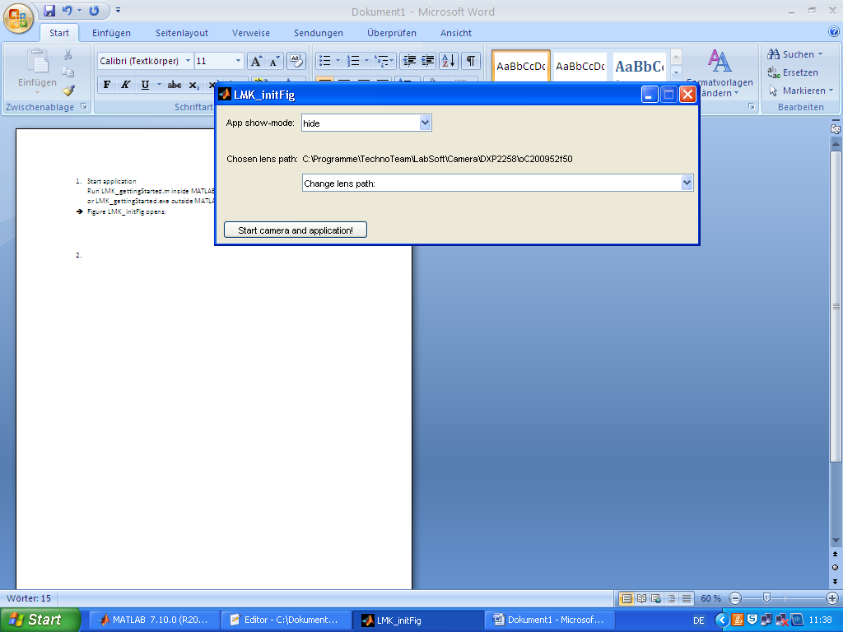

1. Chose lens path

Check path to lens of the camera via Figure, than push Button „Start camera and application!“

Figure LMK_menue opens:

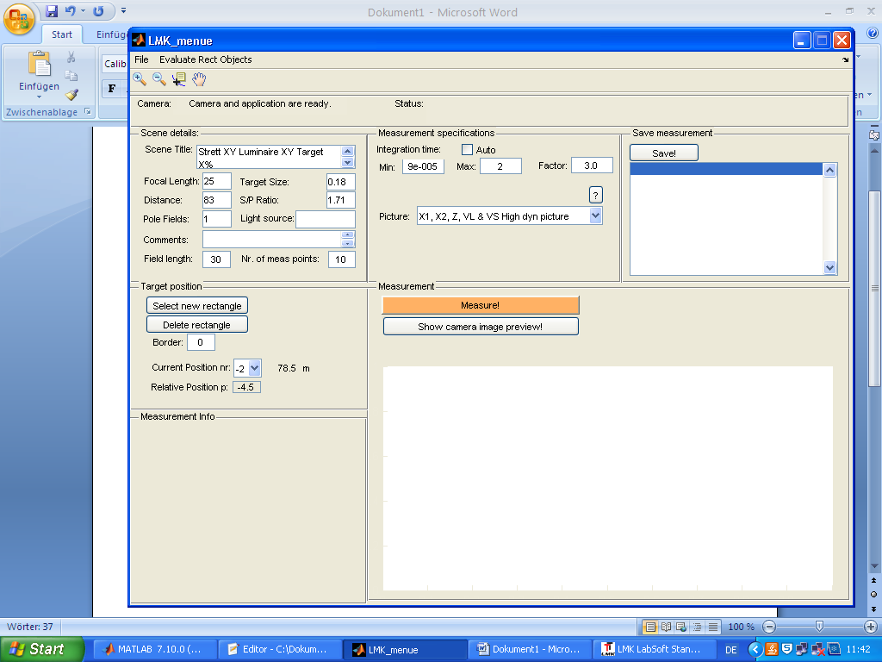

1. Type in scene details

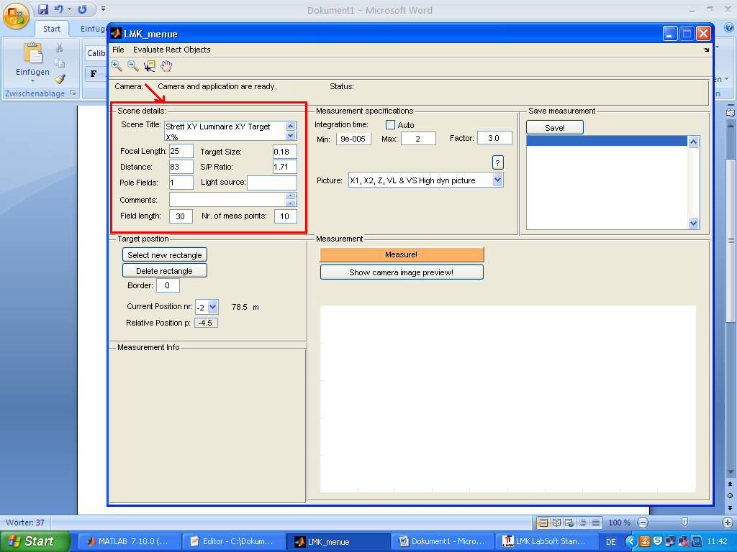

Scene Title: e.g. name of the street

Focal Length: focal length of the camera’s lens in mm

Target Size: lenght of one side of the target in m

Distance: distance of camera to the measurement field in m

S/P Ratio: scotopic to photopic luminance ratio

Pole Fields: number of pole fields in measurement field

Light source: lamp type, e.g. NAV, HQL

Comments: additional details

Field length: length of the measurement field in m

Nr. of meas points: number of measurement points (usually 10 inside, 2 before, 2 after field)

1. Type in measurement specifications

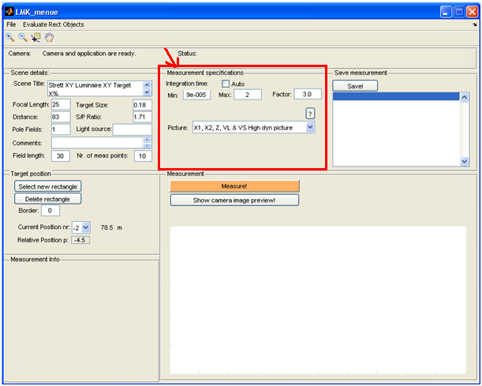

Integration time: set Auto or

Min: smallest integration time (proposal 0.0)

Max: largest integration time

Factor: factor between two times (proposal 3.0)

Picture: chose filter wheels, only high dyn capture algorithm available

VL high dyn picture: capturing with V(λ) filter wheel

(photopic luminance picture will be available after measurement)

VL & VS high dyn picture: capturing with V(λ) & V‘(λ) filter wheel

(photopic & scotopic luminance pictures will be available after measurement)

X1, X2, Z, VL % VS high dyn picture:

(all features will be availalbe after measurement)

1. Do measurement

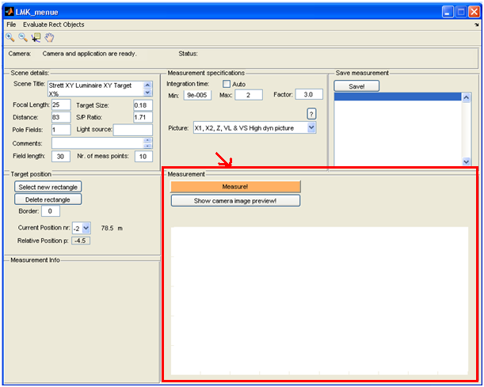

Push „Measure!“ button.

Wait… (The status of the software is shown in „Status“ above.)

A camera picture will be shown shortly.

After measurement the photopic luminance picture will be shown.

You can see – depending on capture algorigthm – different luminance levels with the popupmenu:

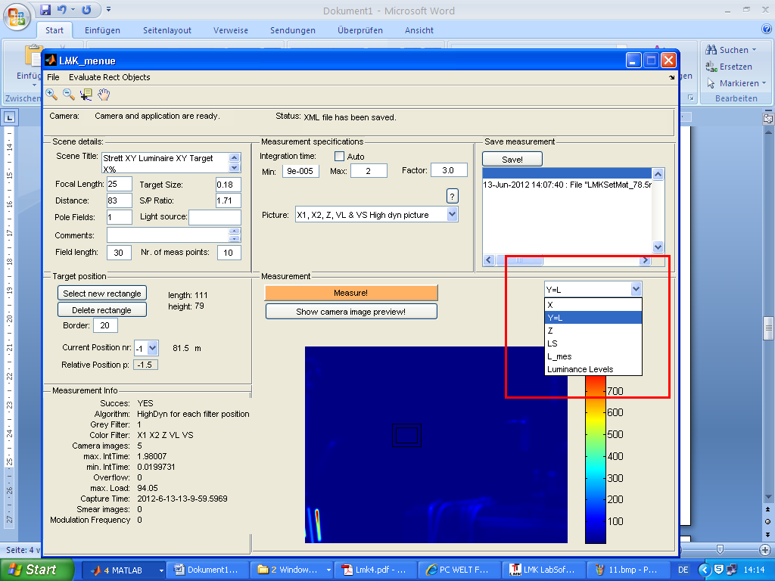

1. Select target position

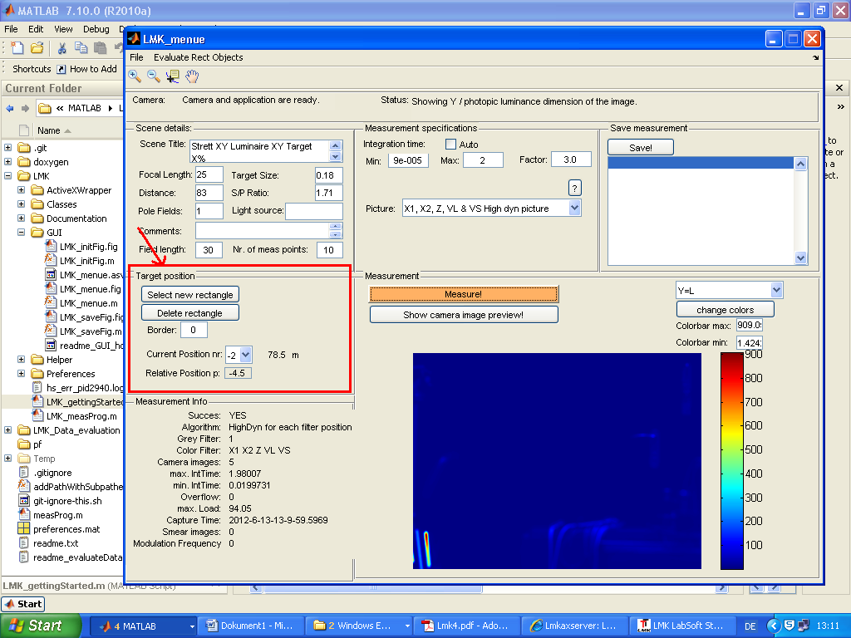

Push button „Select new rectangle“.

Drag and drop with the cursor:

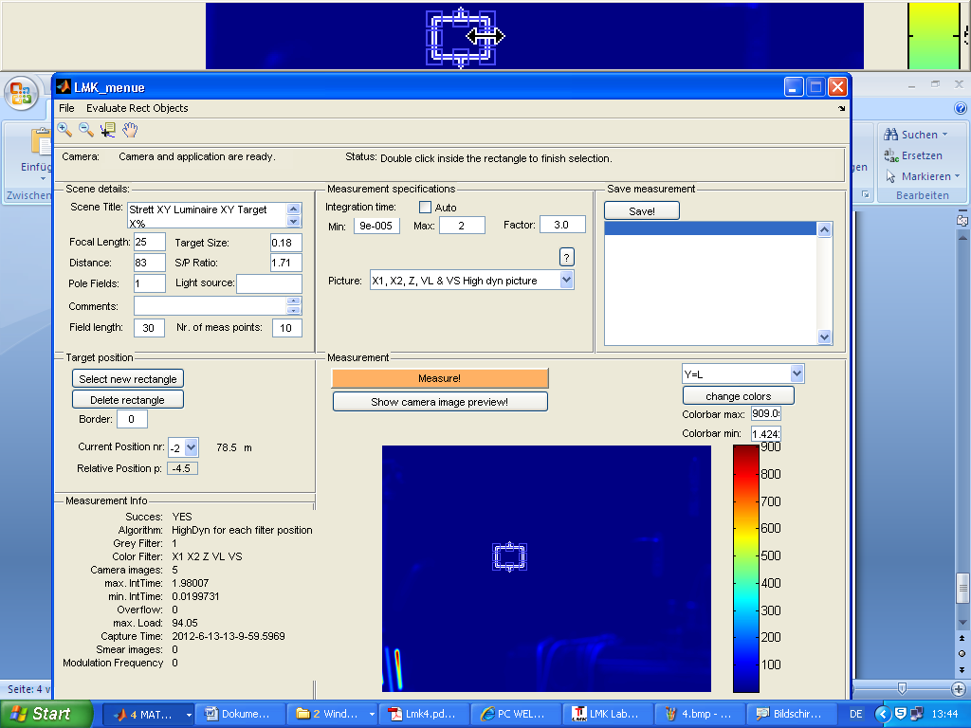

Help yourself with the toolbar, e.g. to zoom and unzoom:

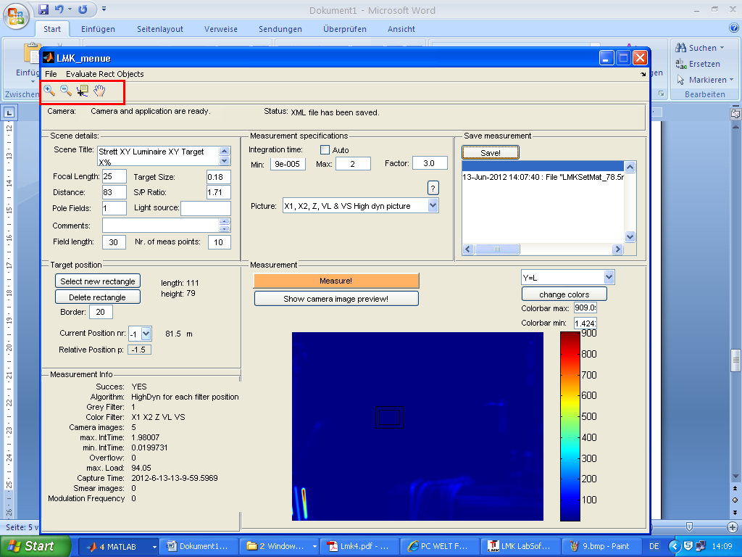

To change the colors or change the colorbar press “change colors” button or edit colorbar maximum / minimum (press enter after editing):

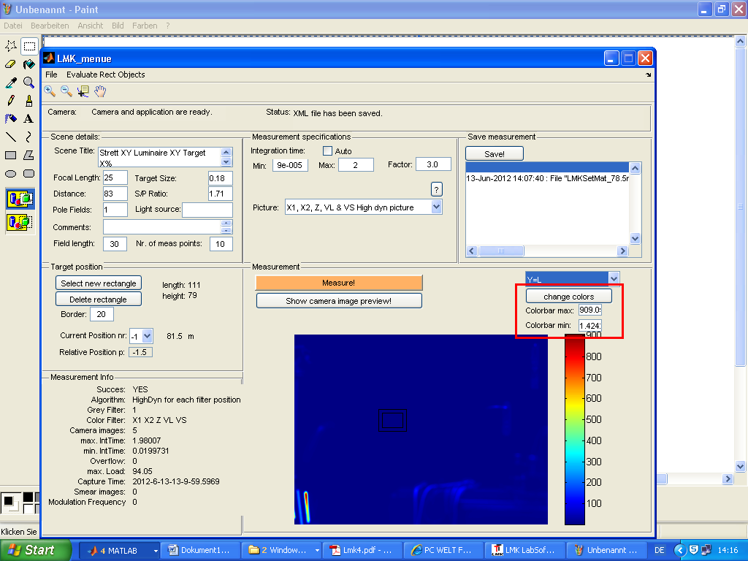

Double click inside the rectangle to fix it. Length & height of the rectangle are shown in the GUI:

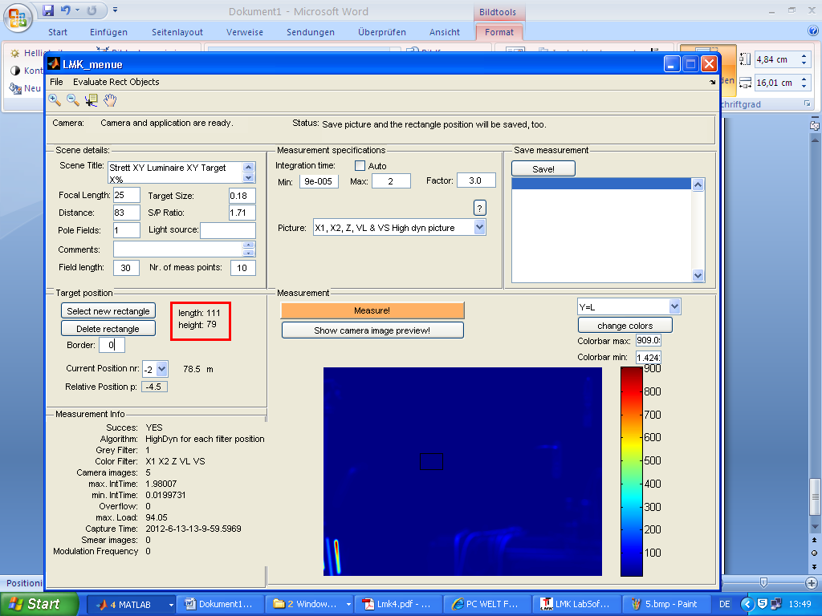

Type in a pixel border if necessary and press enter:

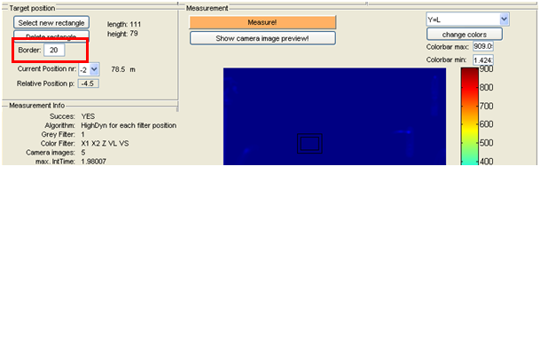

Choose if necessary the current position of the target. The distance to the viewer position is shown:

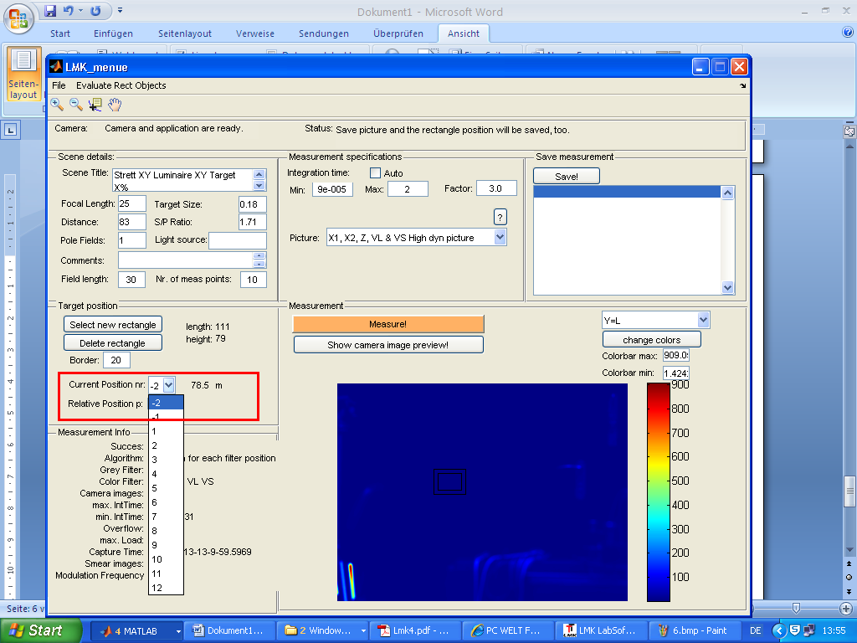

Additionally the relative position of the target (= distance to beginning of measurement field) is shown and can be edited in special cases (press enter after editing):

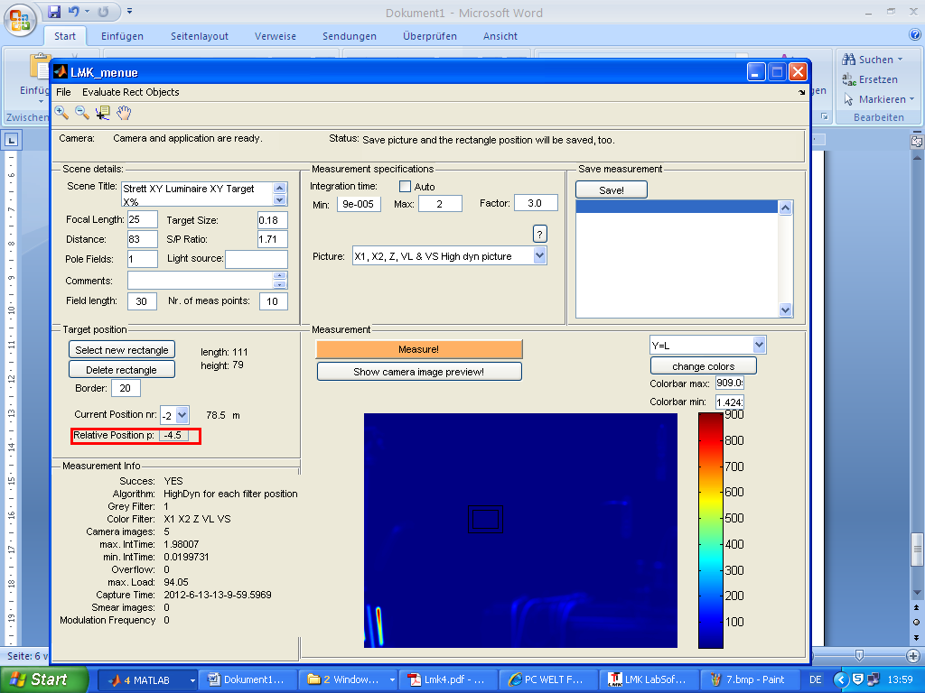

1. Save measurement

If measurement is done and rectangle is chosen, press “Save!” button.

Figure LMK_saveFig opens:

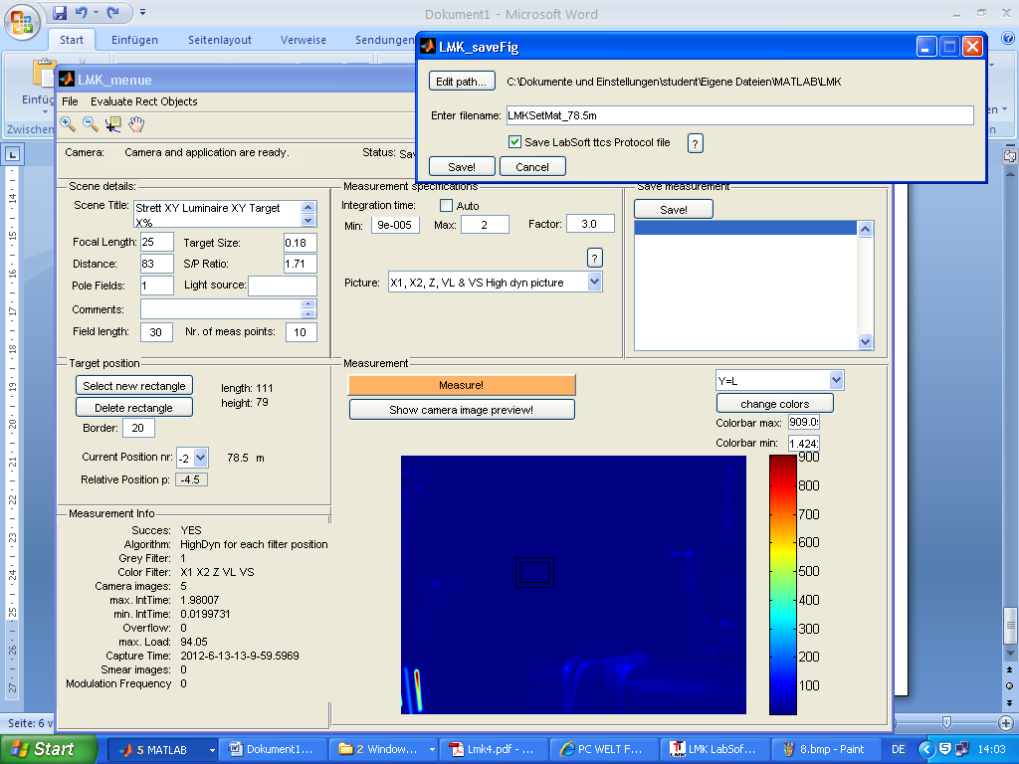

If necessary change edit path and filename and choose whether to save the LabSoft .ttcs protocol.

Press “Save!” button.

All relevant data are saved (.mat, .ttcs., .xml, .dtd) for evaluation.

The current position popup menu steps to the next position number & the text field informs you what was saved:

