Evaluate dataset(s):

1. Prepare data:

Data needed for evaluation:

* LMKSetMat.dtd (copy from “examples” directory)
* LMKSetMat.xml (see example in “examples” directory)
* 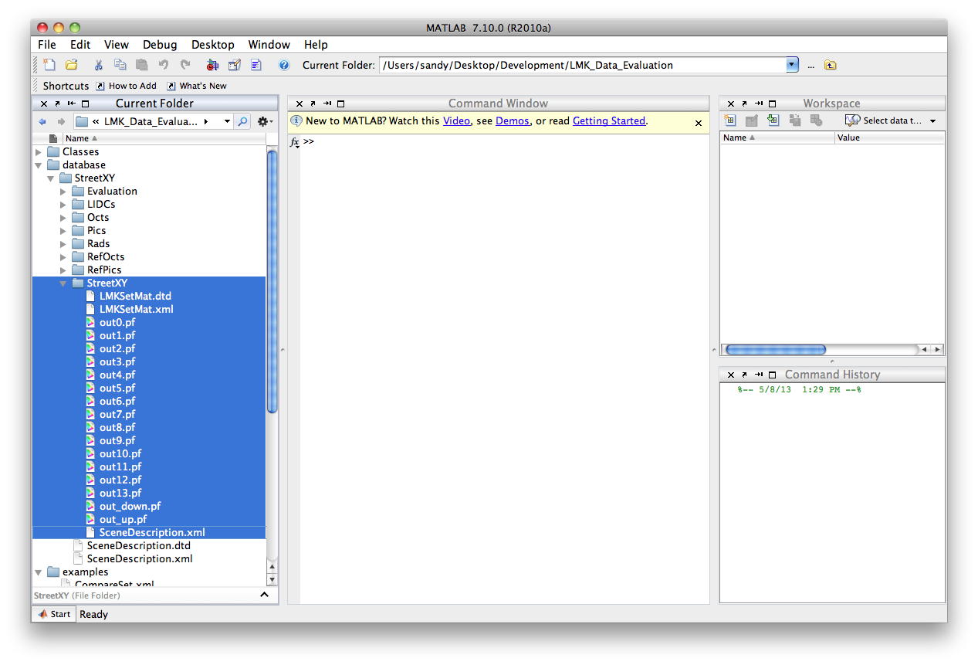14 luminance pictures of the scene with different target positions in .pf format (taken with LMK camera or simulated with radiance framework)
* SceneDescription.xml (see example in “examples” directory)

1. 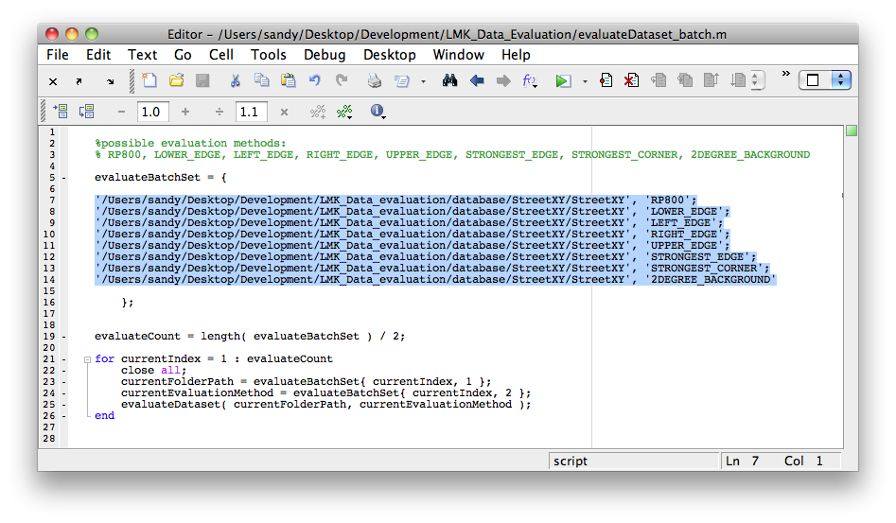Prepare batch file:

Give pathes to your batch set and evaluation methods in evaluateDataset_batch.m

1. Start evaluation:

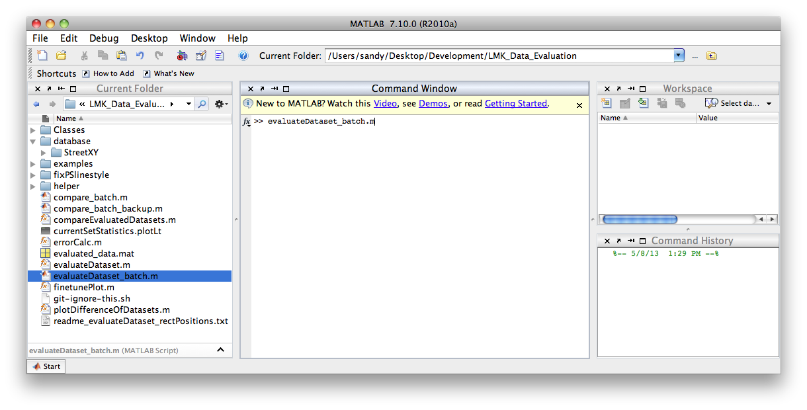Run evaluateDataset_batch.m

1. Check data after evaluation:

* folder „plots“: several plots with contrasts and visibility levels of the target in .fig and .pdf format

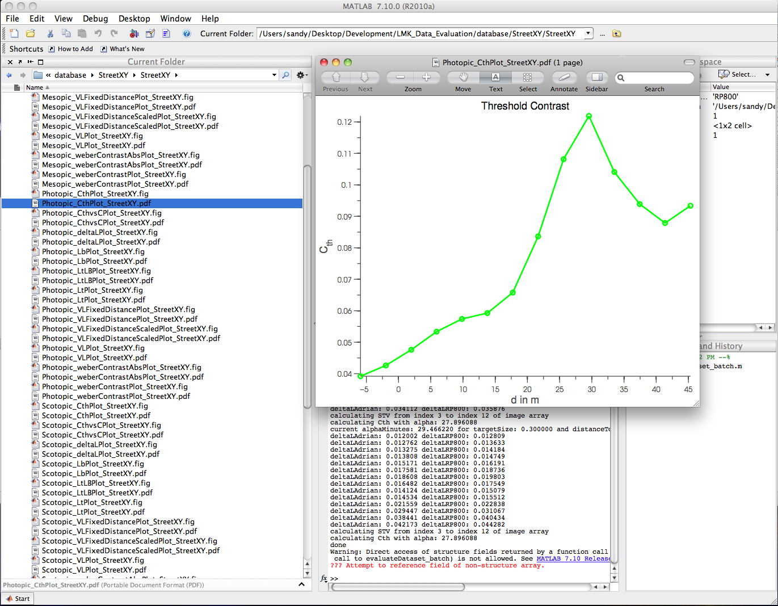

* folder „visImages“: several visualization images with measurement regions in .png format

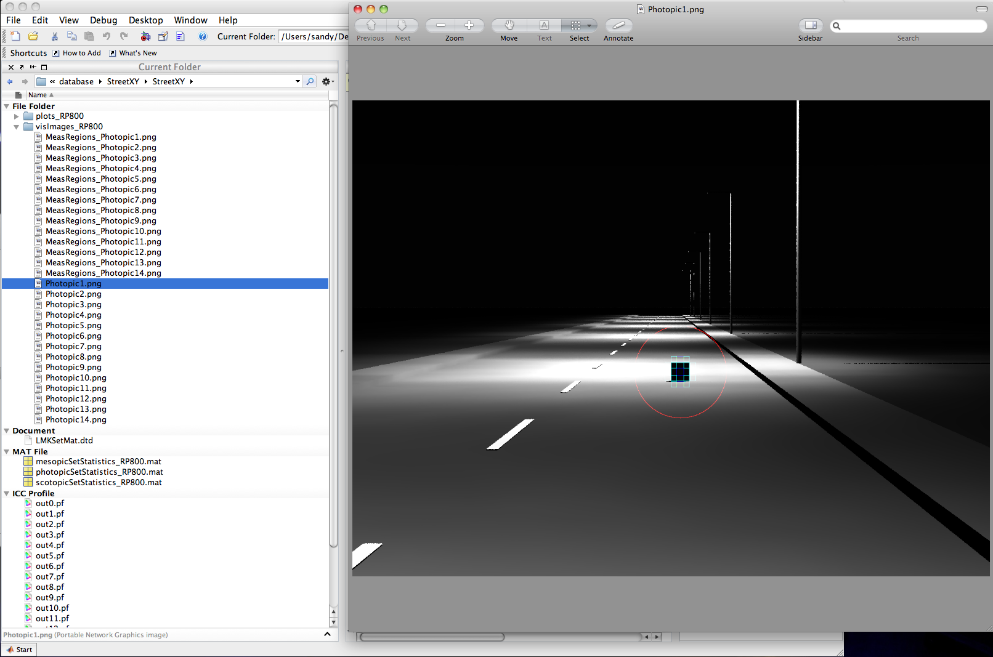

* 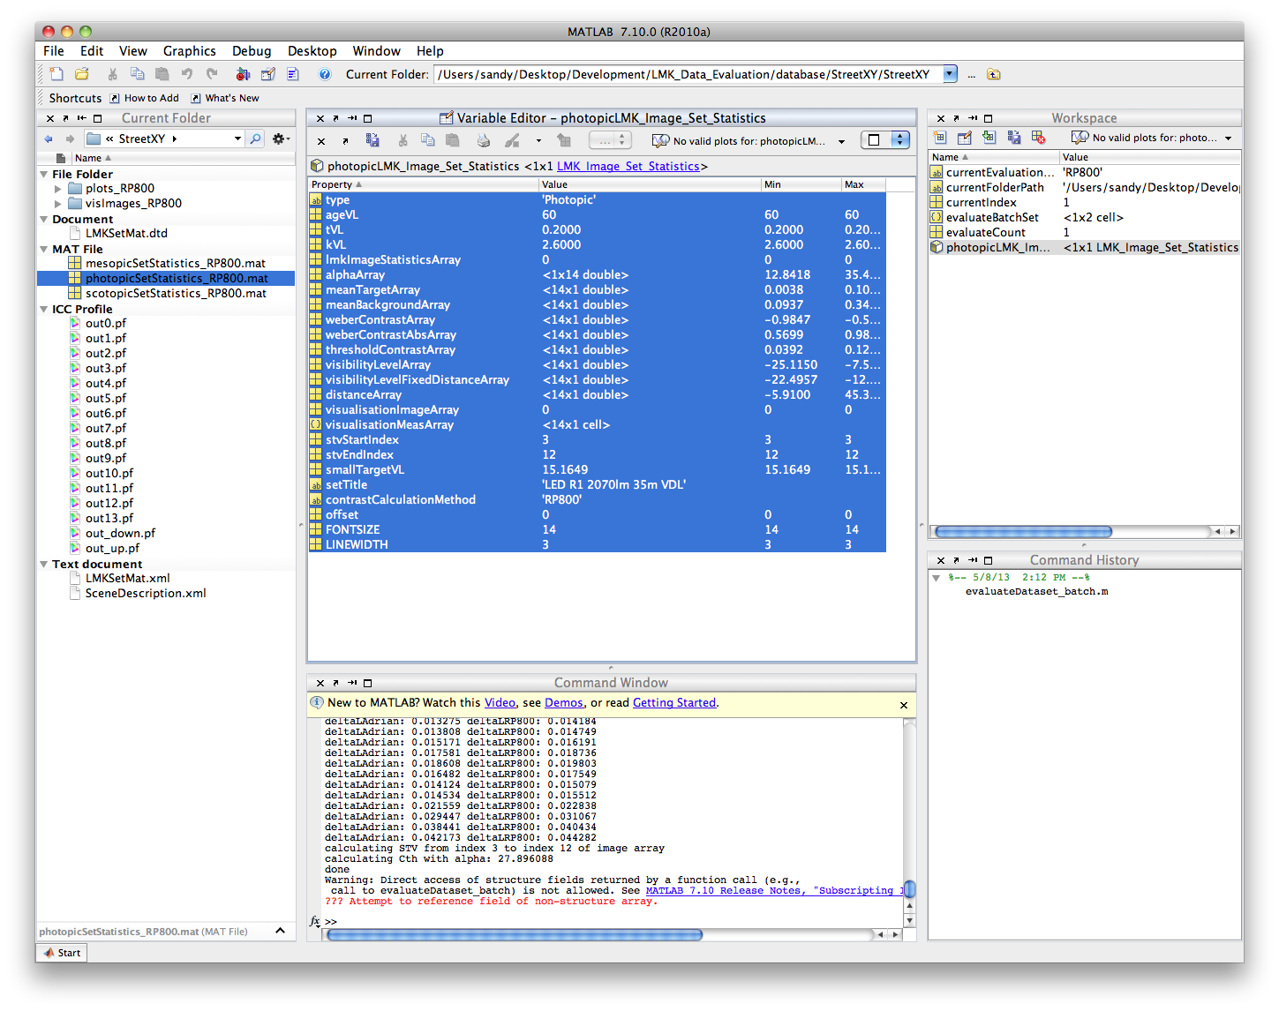.mat files: statistic arrays for individual evaluation

Compare datasets:

1. Prepare data:

Data needed for evaluation:

* min. 2 datasets which have been evaluated

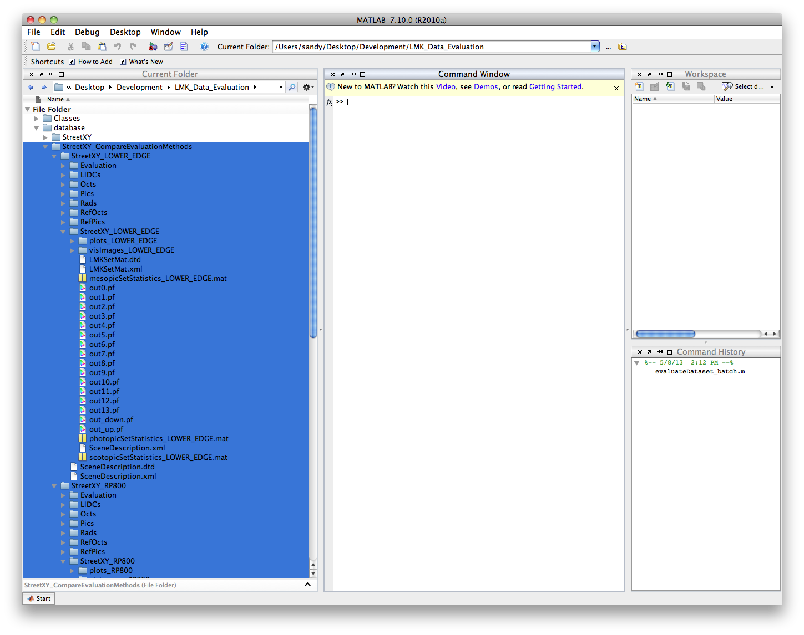

* 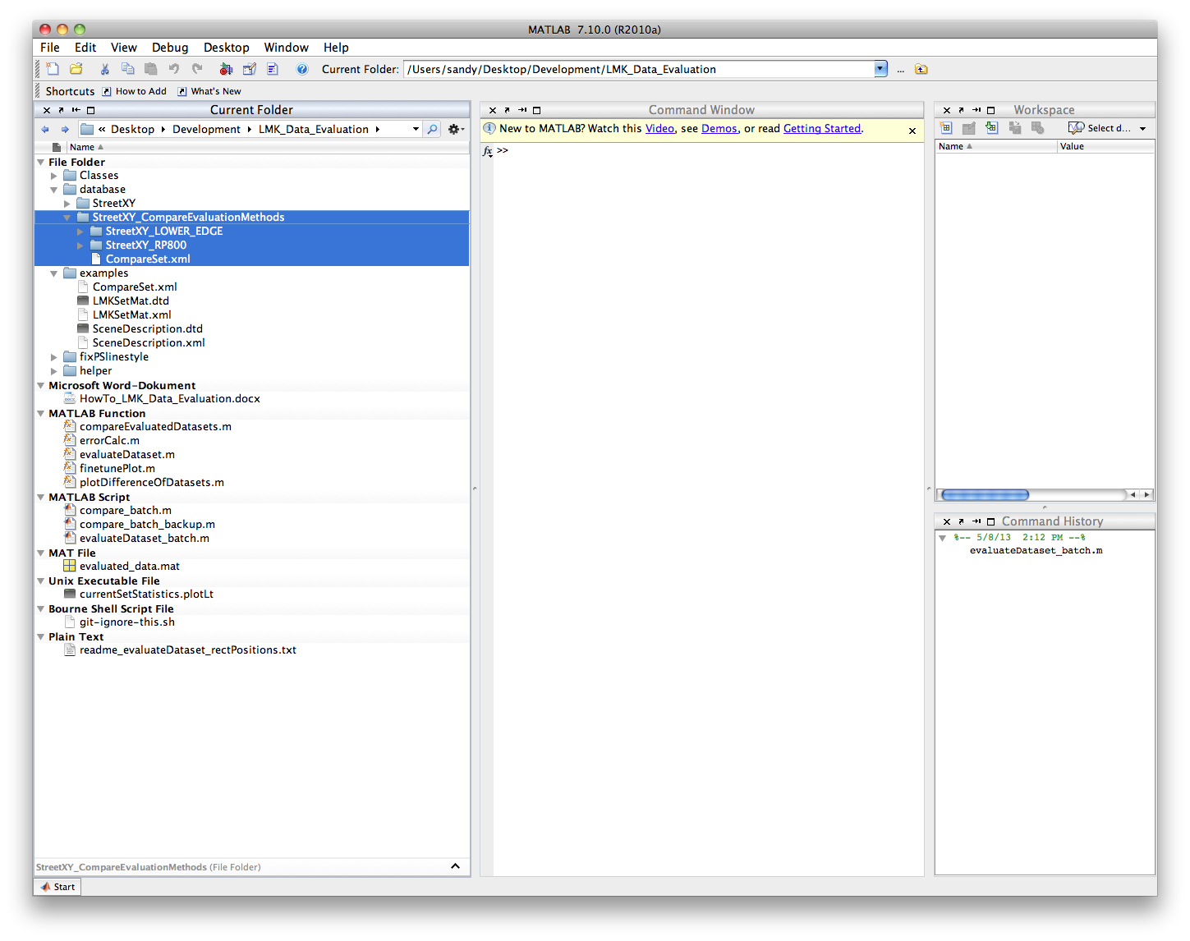compareSet.xml (see example in “examples” directory) where your define legend titles and pathes to the datasets

1. Prepare batch file:

Give pathes to your comparison set and evaluation methods in compare_batch.m

