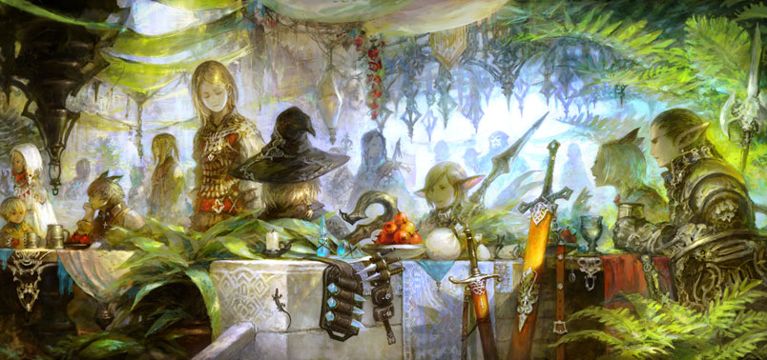

Heroes-of-Pymoli Trend Summary

Key insights:

|  | **Total Count** | **Percentage of Players** |
| --- | --- | --- |
| **Gender** |  |  |
| **Female** | 81 | $14.06 |
| **Male** | 484 | $84.03 |
| **Other / Non-Disclosed** | 11 | $1.91 |

* There were total of 576 gamers
* More males than females that played this game

|  | **Total Count** | **Percentage of Players** |
| --- | --- | --- |
| **Age Group** |  |  |
| **<10** | 17 | $2.95 |
| **10-14** | 22 | $3.82 |
| **15-19** | 107 | $18.58 |
| **20-24** | 258 | $44.79 |
| **25-29** | 77 | $13.37 |
| **30-34** | 52 | $9.03 |
| **35-39** | 31 | $5.38 |
| **40+** | 12 | $2.08 |

* The age group that were engaged was between the ages of 15 – 24.