7.1
The E-R diagram is shown in Figure 7.1. Payments are modeled as weak entities since they are related to a specific policy. Note that the participation of accident in the relationship participated is not total, since it is possible that there is an accident report where the participating car is unknown.
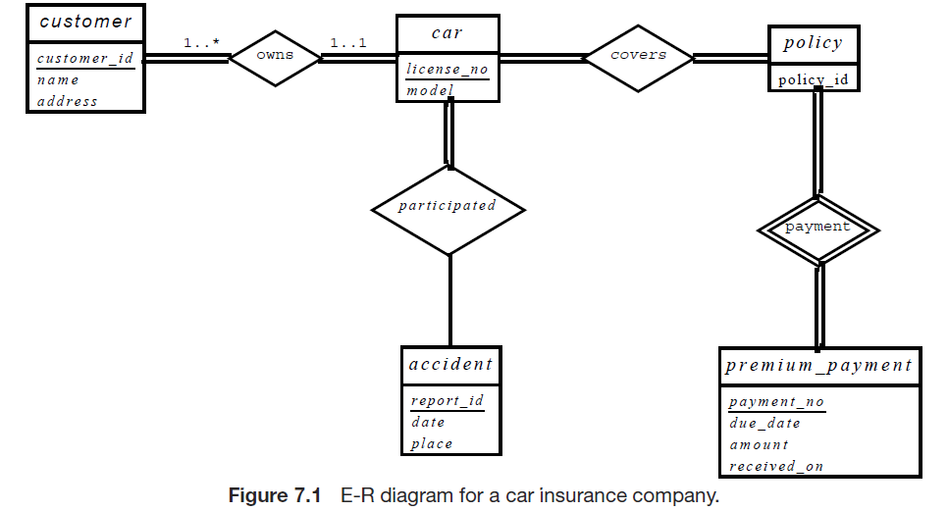

7.2
a. The E-R diagram is shown in Figure 7.2. Note that an alternative is to
model examinations as weak entities related to a section, rather than as a strong entity. The marks relationship would then be a binary relationship between student and exam, without directly involving section.
b. The E-R diagram is shown in Figure 7.3. Note that here we have not modeled the name, place and time of the exam as part of the relationship attributes. Doing so would result in duplication of the information, once per student, and we would not be able to record this information without an associated student. If we wish to represent this information, we would need to retain a separate entity corresponding to each exam.
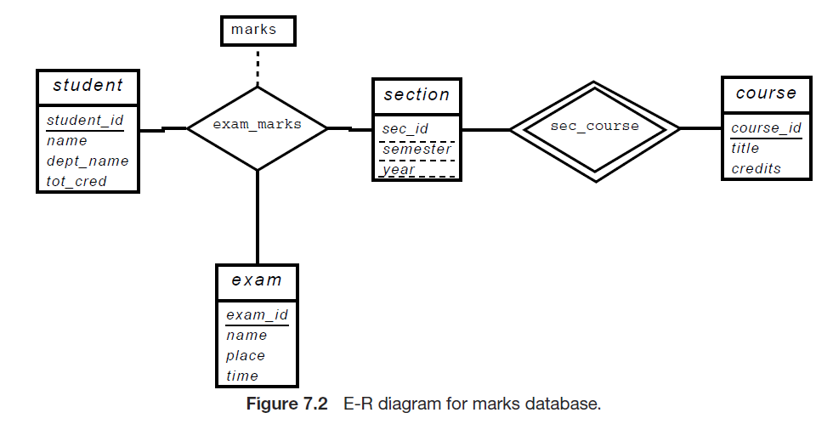

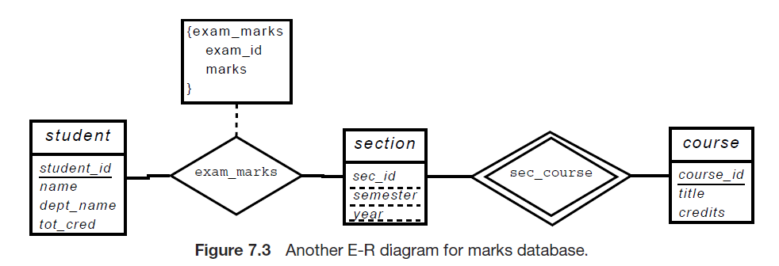

7.3

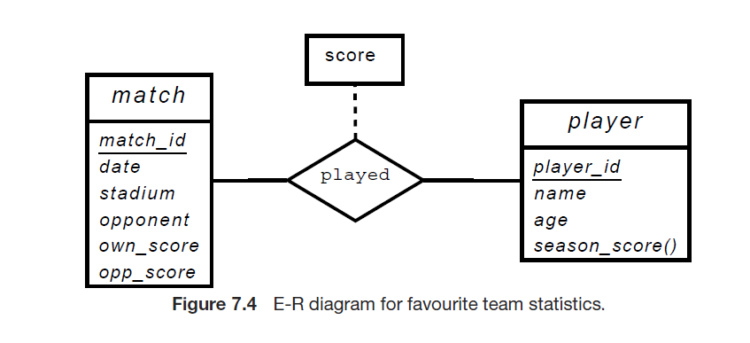

7.21

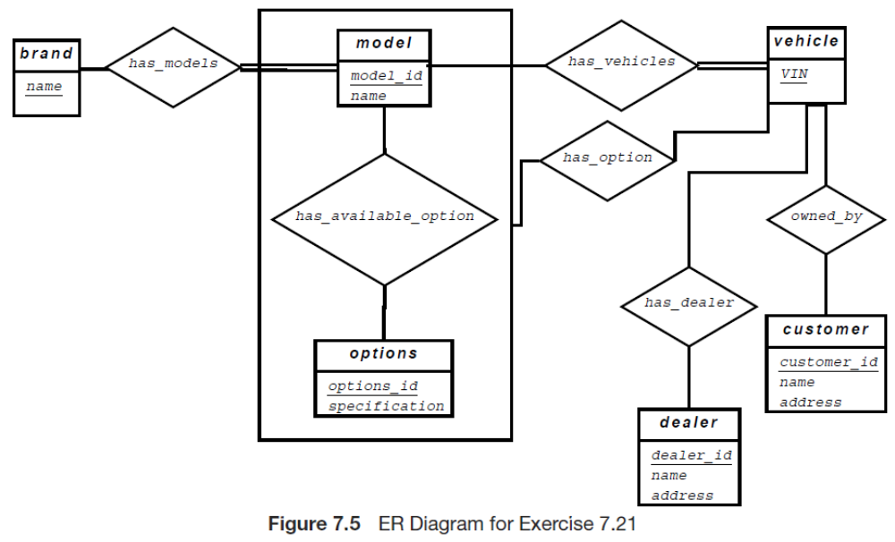
The E-R diagram is shown in Figure 7.5. Note that the has_option relationship links a vehicle to an aggregation on the relationship has_available_option, instead of directly to the entity set options, to ensure that a particular vehicle instance cannot get an option that does not correspond to its model. The alternative of directly linking to options is acceptable if ensuring the above integrity constraint is not critical.
The relational schema, along with primary-key and foreign-key constraints is shown below.

brand(name)
model(model_id,name)
vehicle(VIN)
option(option_id,specification)
customer(customer_id,name,address)
dealer(dealer_id,name,address)
has models(name,model_id ,
foreign key name references brand ,
foreign key model_id references model
)
has vehicles(model_id,VIN,
foreign key VIN references vehicle,
foreign key model_id references model
)
available_options(model_ id,option_ id,
foreign key option_ id references option,
foreign key model_ id references model
)
has_ options(VIN,model_id,option_id,
foreign key VIN references vehicle,
foreign key (model_id, option_id) references available_options
)
has_ dealer(VIN,dealer_ id ,
foreign key dealer_ id references dealer,
foreign key VIN references vehicle
)
owned_by(VIN,customer_ id,
foreign key customer_id references customer,
foreign key VIN references vehicle
)

7.22

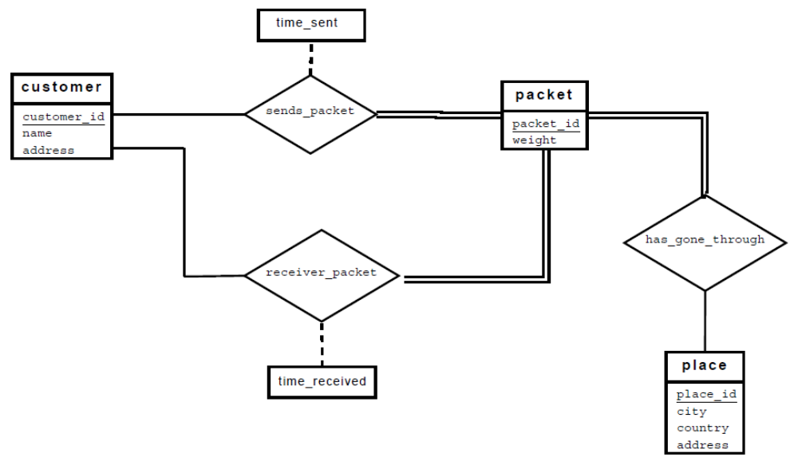
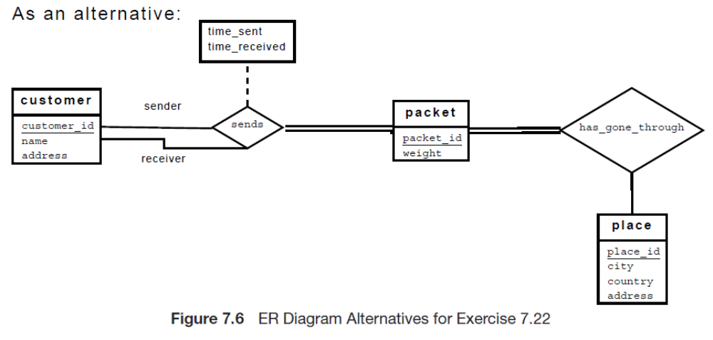
Two alternative E-R diagrams are shown in Figure 7.6.
The relational schema, including primary-key and foreign-key constraints, corresponding to the second alternative is shown below.
customer(customer_ id,name,address)
packet(packet_ id,weight)
place(place_ id,city,country,address)
sends(sender_ id,receiver_ id,packet_ id,time_ received,time_sent,
foreign key sender_ id references customer,
foreign key receiver_id references customer,
foreign key packet_ id references packet
)
has_ gone_ through(packet_ id,place_ id,
foreign key packet_ id references packet,
foreign key place_ id references place
)

7.23

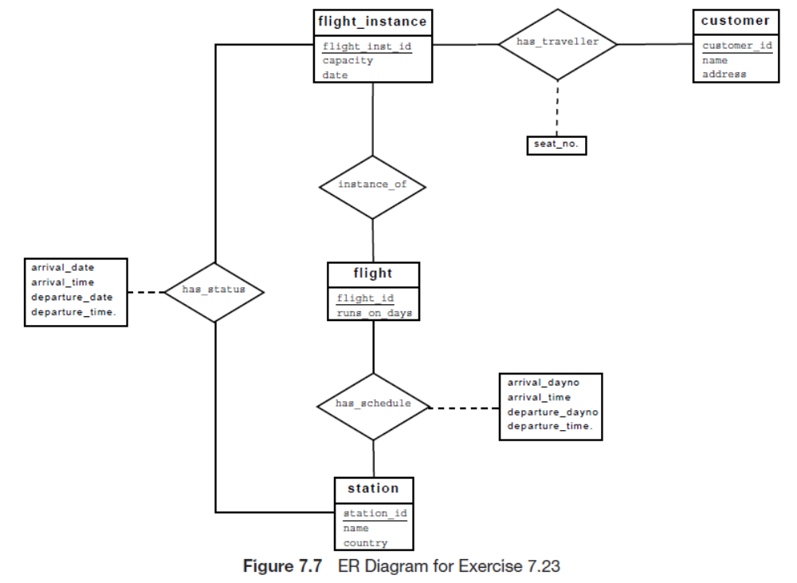
The E-R diagram is shown in Figure 7.7. We assume that the schedule of a flight is fixed across time, although we allow specification of on which days a flight is scheduled. For a particular instance of a flight however we record actual times of departure and arrival. In reality, schedules change with time, so the schedule and routing should be for a particular flight for specified dates, or for a specified range of dates; we ignore this complexity.
flight_ instance(flight_ inst_ id, capacity, date)
customer(customer_ id, name, address)
flight(flight_ id, runs_ on_ days)
station(station_ id, name, country)
has_ traveller(flight_ inst_ id,customer_ id,seat_ number,
foreign key flight_ inst_ id references flight_ instance,
foreign key customer_ id references customer
)
instance_ of(flight_ inst_ id,flight_ id,
foreign key flight_ inst_ id references flight_ instance,
foreign key flight_ id references flight
)
has_ schedule(flight_ id,station_ id,order,arrival_ dayno, arrival_time,departure_ dayno,departure_ time,
foreign key flight_ id references flight,
foreign key station_ id references station
)
has_ status(flight_ inst_ id,station_ id,arrival_ date, arrival_ time, departure_ date, departure_ time,
foreign key flight_ inst_ id references flight_ instance,
foreign key station_ id references station
)

