8.1 证明：(A, B, C) ∩ (A, D, E) = A
A → BC 得 A → ABC
所以是无损分解。

扩充：如何证明R1 ∩R2 → R1 是无损连接分解的充分条件？

8.3
Let Pk(r ) denote the primary key attribute of relation r .
• The functional dependencies Pk(student)→ Pk (instructor) and Pk(instructor)→ Pk(student) indicate a one-to-one relationship because any two tuples with the same value for student must have the same value for instructor, and any two tuples agreeing on instructor must have the same value for student.
• The functional dependency Pk(student)→ Pk(instructor) indicates a many-to-one relationship since any student value which is repeated will have the same instructor value, but many student values may have the same instructor value.

8.6 解：
Starting with A → BC, we can conclude: A → B and A → C.
Since A → B and B → D, A → D (decomposition, transitive)
Since A → CD and CD → E, A → E (union, decomposition, transitive)
Since A → A, we have (reflexive)
A → ABCDE from the above steps (union)
Since E → A, E → ABCDE (transitive)
Since CD → E, CD → ABCDE (transitive)
Since B → D and BC → CD, BC → ABCDE (augmentative, transitive).
Therefore, any functional dependency with A, E, BC, or CD on the left hand
side of the arrow is in F+, no matter which other attributes appear in the FD.
Allow * to represent any set of attributes in R, then F+ is BD → B, BD → D,
C → C, D → D, BD → BD, B → D, B → B, B → BD, and all FDs of
the form A∗ → α, BC∗ → α, CD∗ → α, E∗ → α where α is any subset of
{A, B, C, D, E}. The candidate keys are A, BC, CD, and E.

8.7
F_{C}= F

8.8
本题是选做题，不作为必修要求。
The algorithm is correct because:
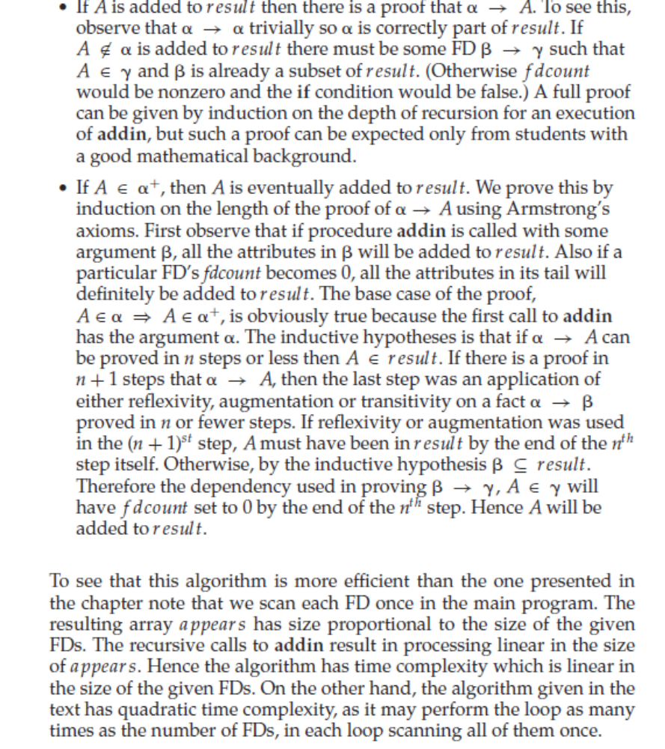

8.16
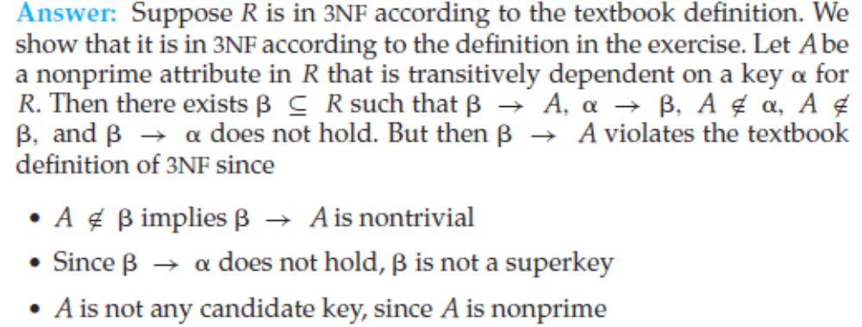
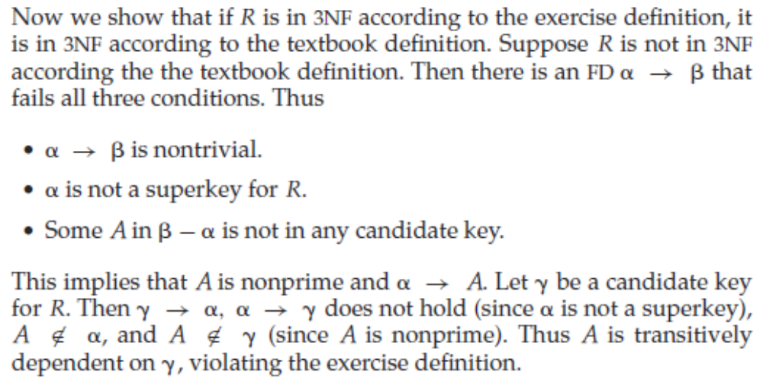
8.17
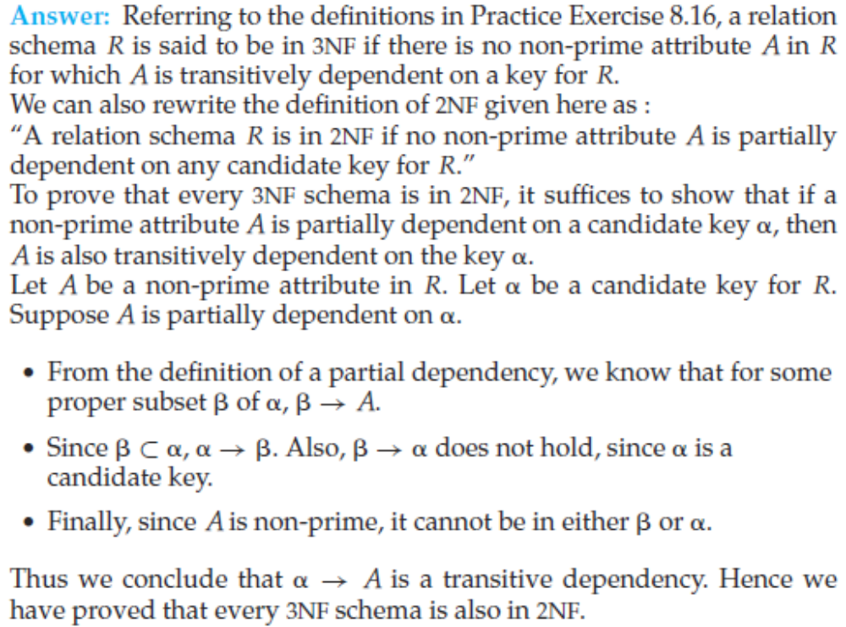
8.19 解：(B, D) (A, B, C, E)
求解思路：
对R = (A, B, C, D, E) 逐个检查F中的依赖，发现非平凡的B → D B不是超码，分解得 (B, D) (A,B, C, E)
(B, D)是BCNF。
对(A,B, C, E)逐个检查F在(A,B, C, E)上的限定，没有发现违背BCNF的非平凡依赖，(A,B, C, E)是BCNF。
（难点：确定F在…上的限定；判断α是否超码。）

8.20 解：(A, B, C) (C, D, E) (B, D) (A, E)
求解思路：
先求Fc，得Fc = F
依据Fc进行构造，得：
(A, B, C) (C, D, E) (B, D) (A, E)

8.24
略。应熟练掌握依据函数依赖的定义证明公理的正确性。

8.25
r:
a1 b1 c1
a1 b1 c2

8.29
- {BDACE}
c. {A→BC, B→DE, D→A}
d. (A,B,C) (B, D, E) ( A, D) (A, F)
e. (A, B, C, D) (A, E, F)
(A, B, C, D)(A, E) (A, F)
f. NO (maybe YES for other relation schema)

