11.1
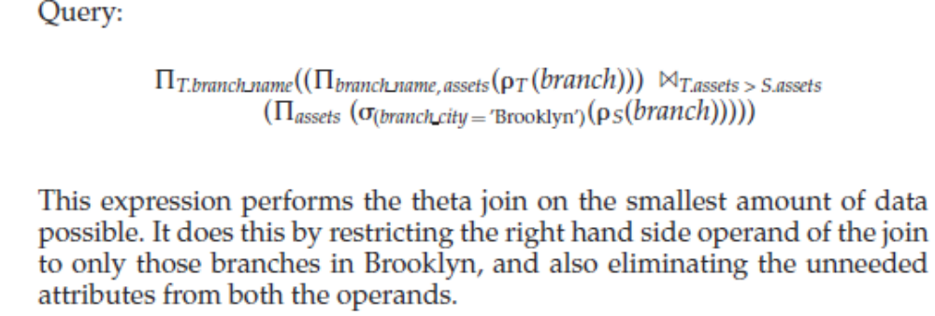
11.2
关于b、c、d的计算，不作为必修要求。
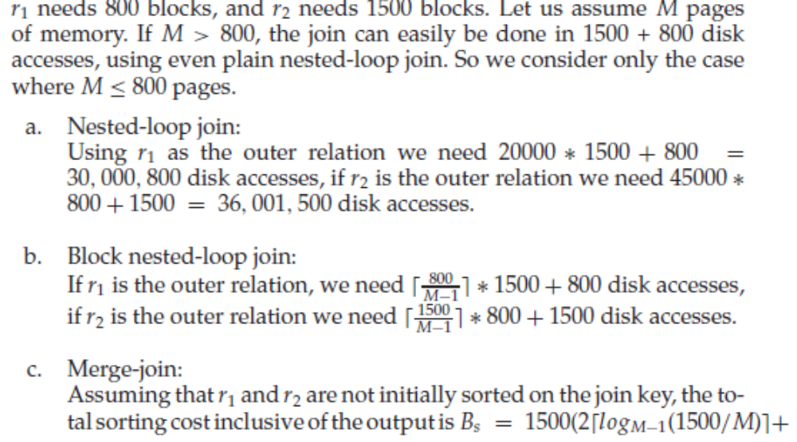

11.3
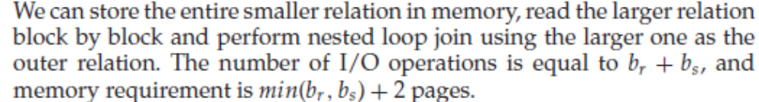
11.4
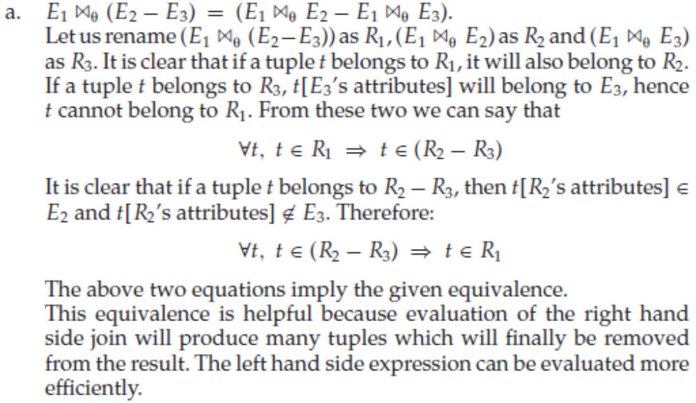
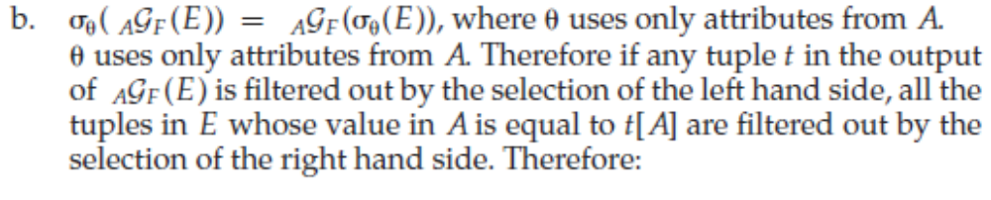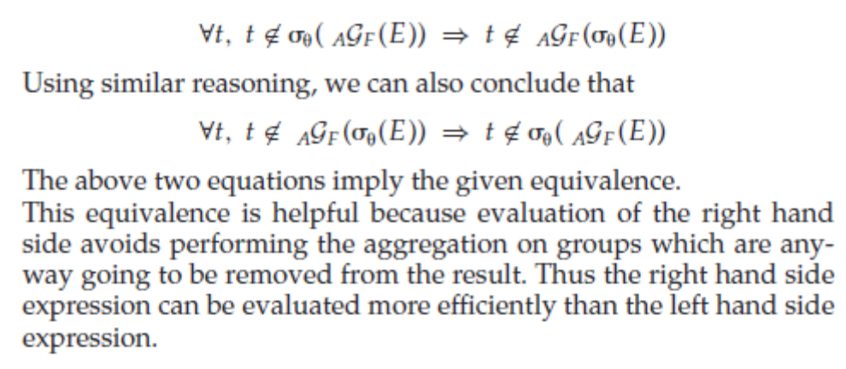
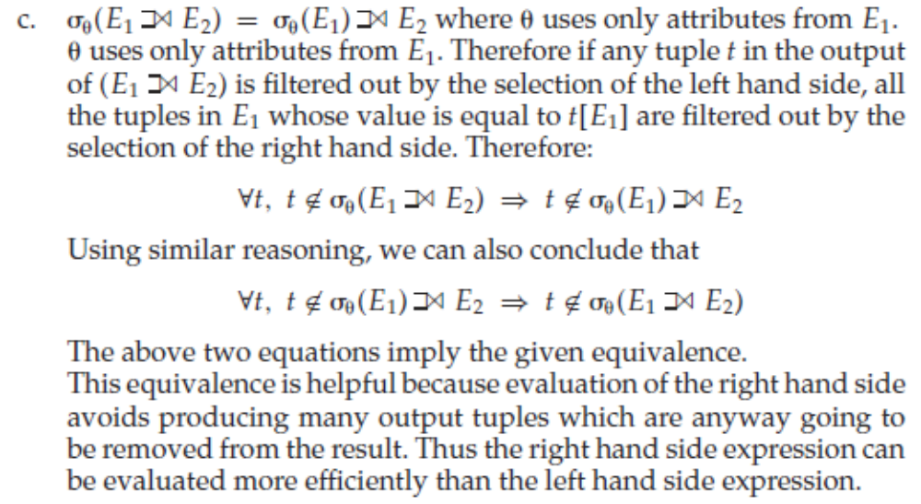
11.6
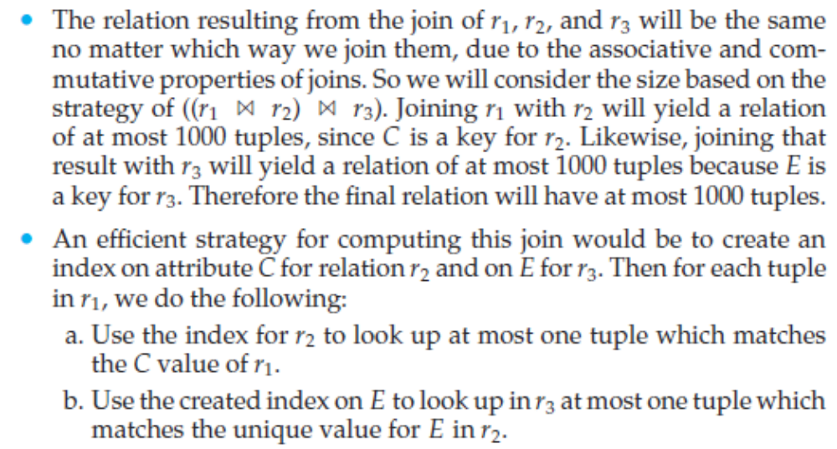
11.7
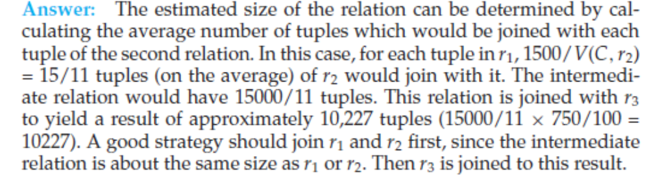
11.8
In general it is not desirable to force users to choose a query processing strategy because naïve users might select an inefficient strategy. The reason users would make poor choices about processing queries is that they would not know how a relation is stored, nor about its indices. It is unreasonable to force users to be aware of these details since ease of user is a major object of database query languages. If users are aware of the costs of different strategies they could write queries efficiently, thus helping performance. This could happen if experts were using the system.

