Females

# 1. Distributions of Motivational Risk Variables

Show violin plots of all distributions and quantiles.

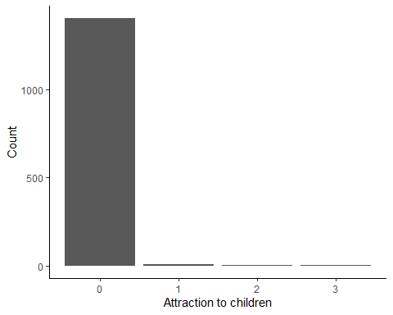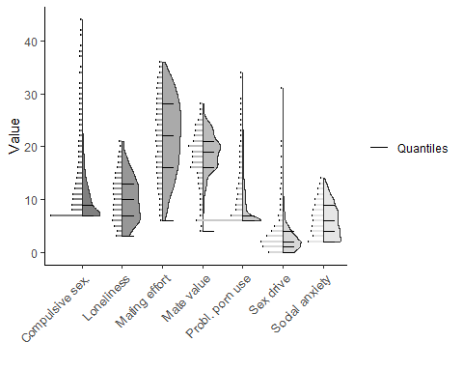

Show new descriptives after categorising the variables according to the quantiles.

| Scale | *N* | Categories | Mode | Modal value | *v* |
| --- | --- | --- | --- | --- | --- |
| Attraction to children | 1,420 | 4 | 489 | [0,1] | 0.73 |
| Compulsive sex. | 1,420 | 4 | 396 | (22,28] | 0.75 |
| Loneliness | 1,420 | 4 | 511 | [2,4] | 0.73 |
| Mating effort | 1,420 | 4 | 445 | [3,7] | 0.74 |
| Mate value | 1,420 | 4 | 386 | (16,19] | 0.75 |
| Probl. porn use | 1,420 | 2 | 1,404 | no attraction | 0.02 |
| Sex drive | 1,420 | 2 | 717 | [7,9] | 0.50 |
| Social anxiety | 1,420 | 2 | 862 | [6,7] | 0.48 |

# 

# 2. Latent Class Analysis

We redo the LCA with the subset of female participants. The cutoff values for fit indices obviously stay the same. It should be noted that two more variables needed to be dichotomised in the female sample, because they were also to skewed to form quantiles. Those were PPCS and CSBD.

## Class Enumeration

Show the BIC values for the different numbers of classes. It is best for three classes.

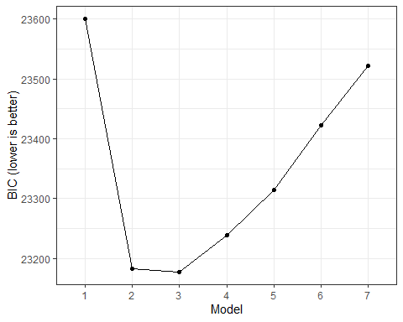

The following table shows how many participants are in which class.

| Class | *N* assigned | Proportion assigned |
| --- | --- | --- |
| 1 | 381 | 30.2% |
| 2 | 314 | 24.8% |
| 3 | 568 | 45.0% |

## Model Evaluation

Show the different fit indices for the different numbers of classes.

| Number of classes | LogLikelihood | *N* | Parameters | BIC | Entropy | Min prob | Min *n* | NP ratio | Local NP |
| --- | --- | --- | --- | --- | --- | --- | --- | --- | --- |
| 1 | -11,735.05 | 1,420 | 18 | 23,600.76 | 1.00 | 1.00 | 1.00 | 78.89 | 78.89 |
| 2 | -11,457.01 | 1,420 | 37 | 23,182.58 | 0.63 | 0.88 | 0.46 | 38.38 | 36.22 |
| 3 | -11,385.34 | 1,420 | 56 | 23,177.16 | 0.62 | 0.69 | 0.20 | 25.36 | 15.50 |
| 4 | -11,347.35 | 1,420 | 75 | 23,239.08 | 0.62 | 0.61 | 0.10 | 18.93 | 8.17 |
| 5 | -11,316.24 | 1,420 | 94 | 23,314.76 | 0.63 | 0.64 | 0.11 | 15.11 | 8.39 |
| 6 | -11,301.20 | 1,420 | 113 | 23,422.59 | 0.62 | 0.67 | 0.05 | 12.57 | 3.72 |
| 7 | -11,282.23 | 1,420 | 132 | 23,522.56 | 0.67 | 0.60 | 0.05 | 10.76 | 3.72 |

## 

## Model Interpretation

The table and plot show the conditional item probabilities for the three-class model.

| Variable | Category | Class 1 | Class 2 | Class 3 |
| --- | --- | --- | --- | --- |
| Sex drive | 1 | 0.16 | 0.32 | 0.49 |
| Sex drive | 2 | 0.16 | 0.28 | 0.18 |
| Sex drive | 3 | 0.37 | 0.24 | 0.23 |
| Sex drive | 4 | 0.31 | 0.16 | 0.11 |
| Mating effort | 1 | 0.03 | 0.26 | 0.37 |
| Mating effort | 2 | 0.17 | 0.24 | 0.35 |
| Mating effort | 3 | 0.35 | 0.30 | 0.20 |
| Mating effort | 4 | 0.44 | 0.20 | 0.07 |
| Social anxiety | 1 | 0.40 | 0.63 | 0.00 |
| Social anxiety | 2 | 0.18 | 0.17 | 0.20 |
| Social anxiety | 3 | 0.28 | 0.17 | 0.39 |
| Social anxiety | 4 | 0.14 | 0.03 | 0.41 |
| Loneliness | 1 | 0.29 | 0.54 | 0.05 |
| Loneliness | 2 | 0.27 | 0.28 | 0.14 |
| Loneliness | 3 | 0.26 | 0.14 | 0.33 |
| Loneliness | 4 | 0.19 | 0.04 | 0.49 |
| Mate value | 1 | 0.16 | 0.15 | 0.47 |
| Mate value | 2 | 0.25 | 0.28 | 0.27 |
| Mate value | 3 | 0.23 | 0.25 | 0.16 |
| Mate value | 4 | 0.36 | 0.32 | 0.09 |
| Attraction to children | 1 | 0.96 | 1.00 | 0.99 |
| Attraction to children | 2 | 0.04 | 0.00 | 0.01 |
| Compulsive sex. | 1 | 0.08 | 0.69 | 0.52 |
| Compulsive sex. | 2 | 0.92 | 0.31 | 0.48 |
| Probl. porn use | 1 | 0.30 | 0.75 | 0.61 |
| Probl. porn use | 2 | 0.70 | 0.25 | 0.39 |

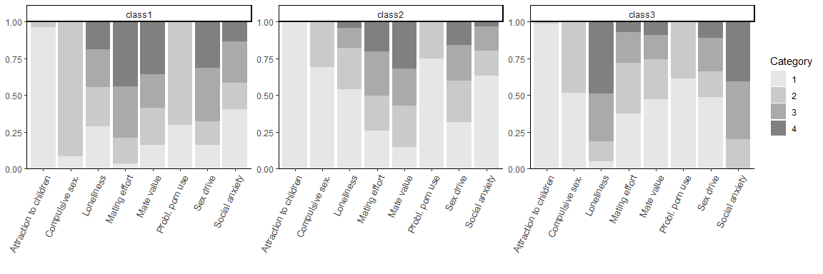

The classes look very similar to those for the male participants. Class 1 is similar to the “high risk” class, class 2 is similar to the “high mate value” class, and class 3 is similar to the “social incompetence” class.

# 3. Distal Outcomes Analyses

Predicted class 1 was chosen as the reference class because it can be interpreted as the “high risk” class. The table and figures show odds and odds ratios (ORs) for all proclivity items per class.

|  | Global LRT | (Intercept) | | Class 2 | | Class 3 | |
| --- | --- | --- | --- | --- | --- | --- | --- |
| Proclivity | *p* | Odds | *p* | OR | *p* | OR | *p* |
| Engaging in sexual activity with a prostitute | < .001 | 0.42 | < .001 | 0.31 | < .001 | 0.66 | .004 |
| Watching porn in public spaces such as a bus or library | < .001 | 0.45 | < .001 | 0.27 | < .001 | 0.43 | < .001 |
| Engaging in sexual activity with an adult who does not agree or is not able to agree, for example, due to intoxication | .006 | 0.04 | < .001 | 0.30 | .002 | 0.68 | .243 |
| Engaging in sexual activity with an animal | .006 | 0.02 | < .001 | 0.17 | .004 | 0.21 | .011 |
| Watching porn depicting a child | .001 | 0.02 | < .001 | 0.09 | < .001 | 0.40 | .062 |
| Watching porn depicting a child on the Darknet | .012 | 0.02 | < .001 | 0.12 | .003 | 0.35 | .076 |
| Flirting or having sexual conversations via chat or webcam with a child | .383 | 0.01 | < .001 | 0.46 | .247 | 0.40 | .204 |
| Paying or giving gifts to a child for online sexual material (for example, videos, images, or online streaming) | .294 | 0.00 | < .001 | 0.14 | .157 | 0.18 | .211 |
| Having offline sex or sexual contact with a child | .056 | 0.01 | < .001 | 0.08 | .034 | 0.10 | .055 |
| Watching porn depicting a young person | < .001 | 0.10 | < .001 | 0.28 | < .001 | 0.68 | .106 |
| Flirting or having sexual conversations via chat or webcam with a young person | < .001 | 0.11 | < .001 | 0.34 | < .001 | 0.67 | .080 |
| Paying or giving gifts to a young person for online sexual material (for example, videos, images, or online streaming | .159 | 0.01 | < .001 | 0.33 | .122 | 0.24 | .078 |
| Having offline sex or sexual contact with a young person | .004 | 0.13 | < .001 | 0.50 | .001 | 0.77 | .205 |
| Driving faster than the posted speed limit | .598 | 18.64 | < .001 | 0.86 | .557 | 0.76 | .311 |
| Driving under the influence of drugs/alcohol | < .001 | 1.30 | .007 | 0.47 | < .001 | 0.52 | < .001 |
| Robbing a bank | < .001 | 2.20 | < .001 | 0.51 | < .001 | 0.63 | < .001 |
| Killing someone | < .001 | 0.36 | < .001 | 0.35 | < .001 | 0.90 | .443 |

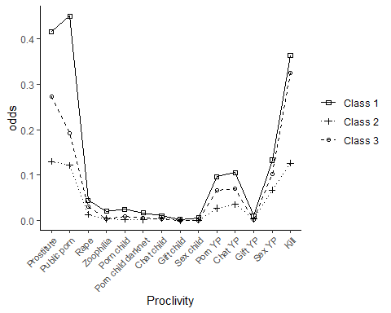

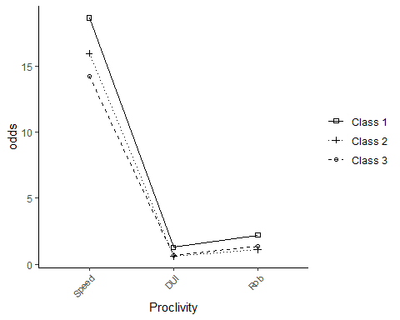

*Note.* Prostitute = “Engaging in sexual activity with a prostitute”; Public porn = “Watching porn in public spaces such as a bus or library”, Rape = “Engaging in sexual activity with an adult who does not agree or is not able to agree, for example, due to intoxication”, Zoophilia = “Engaging in sexual activity with an animal”, Porn child = “Watching porn depicting a child”, Porn child darknet = “Watching porn depicting a child on the Darknet”, Chat child = “Flirting or having sexual conversations via chat or webcam with a child”, Gift child = “Paying or giving gifts to a child for online sexual material (for example, videos, images, or online streaming)”, Sex child = “Having offline sex or sexual contact with a child”, Porn YP = “Watching porn depicting a young person”, Chat YP = “Flirting or having sexual conversations via chat or webcam with a young person”, Gift YP = “Paying or giving gifts to a young person for online sexual material (for example, videos, images, or online streaming”, Sex YP = “Having offline sex or sexual contact with a young person”, Kill = “Killing someone”, Speed = “Driving faster than the posted speed limit”, DUI = “Driving under the influence of drugs/alcohol”, Rob = “Robbing a bank”