LCA & BCH

# **Latent Class Analysis**

After the initial approach (i.e. investigating both genders at once with an LPA and OPTICS) did not result in any interpretable solutions, only participants who identified as male were analysed from here on (for the analyses with the female participants, see the supplemental material). Because of the highly skewed distributions of some of the variables, we decided to split the scales into quantiles (see Figure A), and, when sufficient data to split the data into quantiles was not available, to dichotomise them. This was the case for sexual interest in children, where 97% of the participants completely denied sexual interest in children (i.e., selected 0 on all three items). The descriptives for the newly categorised scales are shown in Table A.

**Table A**

*Descriptives for the Newly Categorised Scales*

| Scale | N | Categories | Mode | Modal value | v |
| --- | --- | --- | --- | --- | --- |
| Attraction to children | 1,263 | 4 | 496 | [0,4] | 0.72 |
| Compulsive sex. | 1,263 | 4 | 359 | [7,8] | 0.75 |
| Loneliness | 1,263 | 4 | 368 | [6,10] | 0.75 |
| Mating effort | 1,263 | 4 | 344 | [6,15] | 0.75 |
| Mate value | 1,263 | 4 | 335 | (7,10] | 0.75 |
| Probl. porn use | 1,263 | 4 | 333 | [3,7] | 0.75 |
| Sex drive | 1,263 | 4 | 374 | [4,15] | 0.74 |
| Social anxiety | 1,263 | 2 | 1,211 | no attraction | 0.08 |

*Note.* Mode refers to how many participants share this modal value. v is a measure of variability for categorical variables and refers to the probability that two randomly drawn participants belong to different categories. Round parentheses are exclusive boundaries, square brackets are inclusive boundaries.

Models with one to seven classes were estimated. For class enumeration, the Bayesian information criterion (BIC) is, according to simulation studies, the most reliable measure (Van Lissa, Garnier-Villarreal, and Anadria 2023; Masyn 2013). It reached a minimum at three classes (see Figure B). Following Van Lissa et al. (2023), a likelihood ratio test (LRT) was not calculated to avoid biased results due to unmet conditions (see also Jeffries (2003)). Instead, fit indices were inspected to assess how well the different models performed.

**Figure B**

*BIC Values for Different Numbers of Classes*

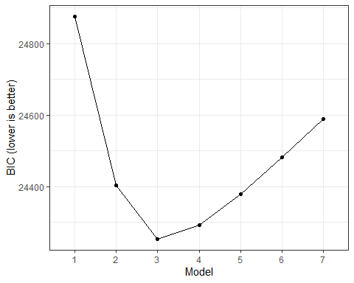

Different fit indices for model evaluation are displayed in Table B. Inverse entropy as a measure of class separability was below the often used target minimum value of .80 for all models (e.g., Nylund-Gibson and Choi (2018); Weller et al., 2020). These results are associated with a misclassification rate of around 20% for the assignment to the correct class (Wang et al., 2017) and might relate to differences between how well the different scales can distinguish between the classes in the sample. Of all models with more than one class, the three-class solution scored the highest value (see Table B).

**Table B**

*Fit Indices for Different Numbers of Classes*

| Number of classes | LogLikelihood | N | Parameters | BIC | Entropy | Min prob | Max prob | Min n | NP ratio | Local NP |
| --- | --- | --- | --- | --- | --- | --- | --- | --- | --- | --- |
| 1 | -12,359.15 | 1,263 | 22 | 24,875.41 | 1.00 | 1.00 | 1.00 | 1.00 | 57.41 | 57.41 |
| 2 | -12,041.49 | 1,263 | 45 | 24,404.34 | 0.64 | 0.88 | 0.90 | 0.49 | 28.07 | 28.41 |
| 3 | -11,884.10 | 1,263 | 68 | 24,253.80 | 0.69 | 0.83 | 0.88 | 0.29 | 18.57 | 16.45 |
| 4 | -11,821.83 | 1,263 | 91 | 24,293.52 | 0.63 | 0.73 | 0.84 | 0.19 | 13.88 | 11.05 |
| 5 | -11,782.13 | 1,263 | 114 | 24,378.35 | 0.65 | 0.72 | 0.84 | 0.13 | 11.08 | 7.55 |
| 6 | -11,751.61 | 1,263 | 137 | 24,481.58 | 0.66 | 0.72 | 0.79 | 0.09 | 9.22 | 4.95 |
| 7 | -11,723.04 | 1,263 | 160 | 24,588.67 | 0.66 | 0.70 | 0.78 | 0.06 | 7.89 | 3.45 |

*Note.* Min prob and Min max are the minimum and maximum values (respectively) on the diagonal of the table of average posterior probabilities by most likely class membership. The higher these values, the better the model fit (recommended cut-off = .7; Masyn (2013); Nylund-Gibson and Choi (2018)). Min n is the proportion of participants that are assigned to the smallest class. NP ratio shows how many observations are accessible for each parameter estimation on average Van Lissa, Garnier-Villarreal, and Anadria (2023). Local NP refers to the number of cases per parameter in the smallest class and indicates how much data there are for each parameter.

According to the BIC values, the model with three classes showed the best fit, while the fit indices for model evaluation confirmed that the fit was mostly acceptable, so that it was chosen for interpretation.

The largest class is class 1 with 43.4% of all male participants (*n* = 548), followed by class 3 with 28.6% (*n* = 361), and class 2 with 28.0% (*n* = 354).

Table C displays conditional item probabilities for the three-class model, which are a measure for class homogeneity, with probabilities > .7 and < .3 showing homogeneity within the classes. This can help identify which items are useful for the separation of the classes.

**Table C**

*Conditional Item Probabilities for the Three-Class Model*

| Variable | Category | Class 1 | Class 2 | Class 3 |
| --- | --- | --- | --- | --- |
| Sex drive | 1 | 0.47 | 0.46 | 0.20 |
| Sex drive | 2 | 0.15 | 0.14 | 0.13 |
| Sex drive | 3 | 0.20 | 0.25 | 0.28 |
| Sex drive | 4 | 0.17 | 0.15 | 0.39 |
| Compulsive sex. | 1 | 0.31 | 0.48 | 0.04 |
| Compulsive sex. | 2 | 0.26 | 0.31 | 0.12 |
| Compulsive sex. | 3 | 0.27 | 0.15 | 0.25 |
| Compulsive sex. | 4 | 0.15 | 0.06 | 0.58 |
| Probl. porn use | 1 | 0.41 | 0.38 | 0.03 |
| Probl. porn use | 2 | 0.29 | 0.32 | 0.09 |
| Probl. porn use | 3 | 0.23 | 0.24 | 0.29 |
| Probl. porn use | 4 | 0.07 | 0.06 | 0.60 |
| Mating effort | 1 | 0.16 | 0.51 | 0.21 |
| Mating effort | 2 | 0.17 | 0.26 | 0.28 |
| Mating effort | 3 | 0.24 | 0.22 | 0.30 |
| Mating effort | 4 | 0.42 | 0.01 | 0.20 |
| Social anxiety | 1 | 0.53 | 0.00 | 0.09 |
| Social anxiety | 2 | 0.29 | 0.23 | 0.20 |
| Social anxiety | 3 | 0.16 | 0.35 | 0.35 |
| Social anxiety | 4 | 0.02 | 0.42 | 0.35 |
| Loneliness | 1 | 0.47 | 0.18 | 0.03 |
| Loneliness | 2 | 0.30 | 0.23 | 0.20 |
| Loneliness | 3 | 0.19 | 0.23 | 0.33 |
| Loneliness | 4 | 0.04 | 0.36 | 0.43 |
| Mate value | 1 | 0.09 | 0.55 | 0.36 |
| Mate value | 2 | 0.27 | 0.28 | 0.26 |
| Mate value | 3 | 0.25 | 0.11 | 0.17 |
| Mate value | 4 | 0.39 | 0.05 | 0.21 |
| Attraction to children | 1 | 0.98 | 0.97 | 0.91 |
| Attraction to children | 2 | 0.02 | 0.03 | 0.09 |

Figure C shows the conditional item probabilities in a more accessible way.

**Figure C**

*Conditional Item Probabilities per Class*

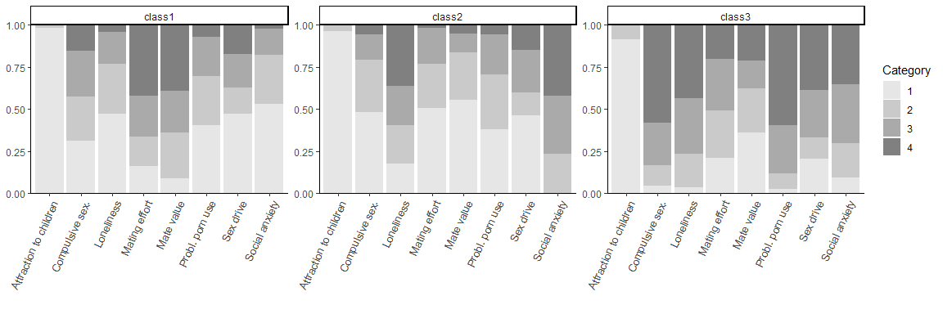

# **Distal Outcomes Analyses**

To test whether class membership is related to the proclivity for sexually deviant behaviours, distal outcomes analyses were performed with all single proclivity items.

Since class membership is measured imperfectly by a LCA, the assignment of participants to a class is associated with a certain amount of error. If this error is left unaccounted for and predicted class membership from a LCA is used as a predictor in subsequent analyses, bias is introduced. Multiple approaches have been proposed, by which the error associated with class assignment is taken into account. The so-called three-step approach will first fit an independent measurement model (here, the LCA without any covariates or outcomes), assign participants to latent classes, and then use the predicted classes as estimates for the latent classes (Bakk & Kuha, 2021). The important difference between naive and recommended three-step approaches is the employment of countermeasures at the second or third step to avoid the bias resulting from imperfect class assignments.

The approach chosen here is known as modified Bolck-Croon-Hagenaars (BCH) approach and was developed by Bakk et al. (2013), building on and generalising the work of Vermunt et al. (2012). In this approach, complex sample weights are obtained for the participants and used in the estimation of the target model in ensuing analyses. However, the weighing resulted in negative weights, which is not uncommon when using the modified BCH approach (e.g. Vermunt, 2010), but can cause problems in the presence of low class separability, as found in the present analysis.

Firth’s logistic regression with intercept correction (FLIC) was chosen as a method of analysis for the dichotomised proclivity items, as the base rate for many of these items was extremely low and standard logistic regression is known to either underestimate the base rate of a rare outcome or to produce impossible regression weights (XXX). According to simulation studies, FLIC out performs other methods to correct logistic results (XXX).

Even though FLIC allows for sample weights, the negative weights led to convergence problems. Therefore, we fixed all negative weights to a value close to zero (here, .01), which is also close to their original values. Thus, the weights for participants where they were assigned to any other class than their modal class assignment would still enter the analysis, but would not influence the estimation much. This will have introduced some bias in the regression weights and standard errors; however, it remains uncertain to which degree our inference statistics are affected by this.

Significance of regression weights was tested using a penalised LRT, as implemented by the R package logistf (Heinze et al., 2023), which was also used to estimate the FLIC models. To make the estimation for the model with the proclivity to have sex with a prostitute item possible, the iteratively weighted least squares method instead of the standard Newton-Raphson approach had to be used for optimisation.

The predicted class 3 was chosen as the reference class because it contained the participants with the highest probabilities of being in high quantiles of the motivator scales. It can therefore be considered a “high risk”-class. Table D shows the odds and odds ratios (ORs) of the different models and classes. The odds indicate how much more likely it is for a member of the high- risk class to choose any answer other than zero on the respective proclivity items (e.g. participants in the-high risk class are 0.08 times more likely to show some proclivity to chat with a child). ORs indicate the change in odds for the respective class 1 or 2 compared to the high-risk class to choose any answer other than zero on the respective proclivity items (e.g. participants in class 1 have 0.20 times the odds of showing some proclivity to chat with a child compared to the high-risk group). Since CIs were obtained through a different method (Wald’s test statistic as is the default in the logistf package) than the p values (which were obtained via penalised LRTs), significance decisions between the two methods can differ. For the present analysis, the LRTs should be relied on because they are based on fewer assumptions than the Wald’s test statistic. The CIs should therefore interpreted with caution, as is indicated by our distal outcomes method.

|  | Global LRT | (Intercept) | | Class 1 | | Class 2 | |
| --- | --- | --- | --- | --- | --- | --- | --- |
| Proclivity | p | Odds | p | OR | p | OR | p |
| Engaging in sexual activity with a prostitute | .000 | 3.01 | .000 | 0.51 | .000 | 0.47 | .000 |
| Watching porn in public spaces such as a bus or library | .000 | 0.99 | .893 | 0.55 | .000 | 0.50 | .000 |
| Engaging in sexual activity with an adult who does not agree or is not able to agree, for example, due to intoxication | .000 | 0.41 | .000 | 0.41 | .000 | 0.40 | .000 |
| Engaging in sexual activity with an animal | .000 | 0.06 | .000 | 0.21 | .000 | 0.40 | .012 |
| Watching porn depicting a child | .000 | 0.09 | .000 | 0.17 | .000 | 0.22 | .000 |
| Watching porn depicting a child on the Darknet | .000 | 0.08 | .000 | 0.17 | .000 | 0.18 | .000 |
| Flirting or having sexual conversations via chat or webcam with a child | .000 | 0.08 | .000 | 0.20 | .000 | 0.30 | .000 |
| Paying or giving gifts to a child for online sexual material (for example, videos, images, or online streaming) | .000 | 0.05 | .000 | 0.09 | .000 | 0.03 | .000 |
| Having offline sex or sexual contact with a child | .000 | 0.06 | .000 | 0.15 | .000 | 0.12 | .000 |
| Watching porn depicting a young person | .000 | 0.44 | .000 | 0.44 | .000 | 0.55 | .000 |
| Flirting or having sexual conversations via chat or webcam with a young person | .000 | 0.38 | .000 | 0.46 | .000 | 0.61 | .002 |
| Paying or giving gifts to a young person for online sexual material (for example, videos, images, or online streaming | .000 | 0.14 | .000 | 0.38 | .000 | 0.43 | .001 |
| Having offline sex or sexual contact with a young person | .000 | 0.54 | .000 | 0.51 | .000 | 0.60 | .001 |
| Driving faster than the posted speed limit | .053 | 20.09 | .000 | 1.11 | .735 | 0.61 | .072 |
| Driving under the influence of drugs/alcohol | .000 | 0.92 | .381 | 0.90 | .415 | 0.55 | .000 |
| Robbing a bank | .000 | 2.27 | .000 | 0.80 | .099 | 0.55 | .000 |
| Killing someone | .000 | 0.58 | .000 | 0.49 | .000 | 0.48 | .000 |

*Note.* Global LRT shows the *p* value of a test of the full against an intercept-only model. Penalised LRTs were used to obtain p values. Confidence intervals are not included because they would have been less reliable than *p* values (see above).

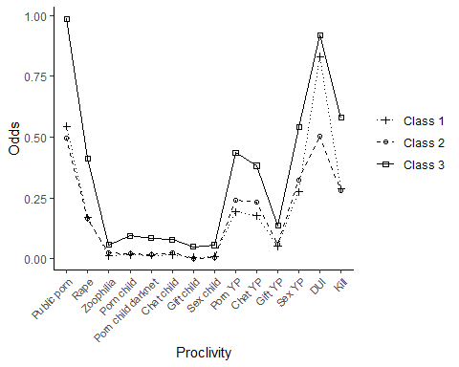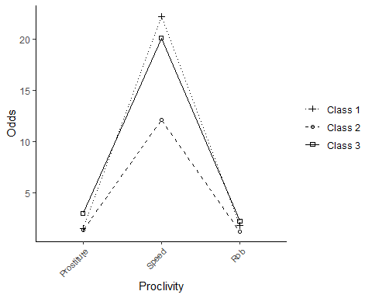

*Note.* Public porn = “Watching porn in public spaces such as a bus or library”, Rape = “Engaging in sexual activity with an adult who does not agree or is not able to agree, for example, due to intoxication”, Zoophilia = “Engaging in sexual activity with an animal”, Porn child = “Watching porn depicting a child”, Porn child darknet = “Watching porn depicting a child on the Darknet”, Chat child = “Flirting or having sexual conversations via chat or webcam with a child”, Gift child = “Paying or giving gifts to a child for online sexual material (for example, videos, images, or online streaming)”, Sex child = “Having offline sex or sexual contact with a child”, Porn YP = “Watching porn depicting a young person”, Chat YP = “Flirting or having sexual conversations via chat or webcam with a young person”, Gift YP = “Paying or giving gifts to a young person for online sexual material (for example, videos, images, or online streaming”, Sex YP = “Having offline sex or sexual contact with a young person”, DUI = “Driving under the influence of drugs/alcohol”, Kill = “Killing someone”, Prostitute = “Engaging in sexual activity with a prostitute”, Speed = “Driving faster than the posted speed limit”, Rob = “Robbing a bank”

# **References**

Jeffries, Neal O. 2003. “A Note on ‘Testing the Number of Components in a Normal Mixture’.” *Biometrika* 90 (4): 991–94. <https://doi.org/10.1093/biomet/90.4.991>.

Masyn, Katherine E. 2013. *Latent Class Analysis and Finite Mixture Modeling*. Oxford University Press. <https://doi.org/10.1093/oxfordhb/9780199934898.013.0025>.

Nylund-Gibson, Karen, and Andrew Young Choi. 2018. “Ten Frequently Asked Questions about Latent Class Analysis.” *Translational Issues in Psychological Science* 4 (4): 440–61. <https://doi.org/10.1037/tps0000176>.

Van Lissa, C. J., M. Garnier-Villarreal, and D. Anadria. 2023. “Recommended Practices in Latent Class Analysis Using the Open-Source R-Package tidySEM.” *Structural Equation Modeling: A Multidisciplinary Journal*, October, 1–9. <https://doi.org/10.1080/10705511.2023.2250920>.