PROJECT DOSSIER
InfoSec Assurance Agent Platform
Migration of the Claude AI GRC/TPRM toolset to Azure AI Foundry
Information Security Assurance — TPRM · ISMS · GRC · ICT GRC
Version 1.0 · 11 September 2026 · Classification: Internal

Document Control
Item | Detail
Title | Project Dossier — InfoSec Assurance Agent Platform on Azure AI Foundry
Version / Status | 1.0 — Draft for review
Date | 11 September 2026
Owner | InfoSec Assurance & Third-Party Risk (F. Gomes)
Repository | github.com/fgomes77/infosec-assurance-azure-foundry
Classification | Internal — contains internal system names; no credentials or personal data
Related artefacts | convertion/README.md · ARCHITECTURE.md · MAPPING.md · governance/HUMAN_APPROVAL.md

Table of Contents

1. Executive Summary
The InfoSec Assurance team operates a mature toolset of 35 AI skills on claude.ai covering third-party risk management (TPRM), the information security management system (ISMS), and GRC / ICT GRC advisory: OSINT supplier assessments (DeepSearch), OneTrust-driven DPIA and CISO reporting, Form B questionnaire support, and regulatory advisors for DORA, NIS2, the EU AI Act, ISO/IEC 27001 and ISO/IEC 42001. This project replicates that capability, with equal or better assurance, on Microsoft Azure AI Foundry — the platform aligned with the wider Euronext technology estate (Entra ID, Microsoft Graph, Defender, SharePoint, Jira, OneTrust).
The delivered solution converts every skill into a Foundry agent with its knowledge, templates and scripts intact (byte-verified against the claude.ai source), adds a reasoning orchestrator and a memory-backed assurance advisor, wires the surrounding toolchain through least-privilege integrations, and enforces a three-layer human-approval control so no agent submits anything of record without a person's explicit sign-off. A one-command, verification-gated pipeline deploys and re-synchronises the whole environment.

2. Background and Context
The current capability lives in the claude.ai account as skills — packaged instructions, reference knowledge (control catalogues, framework mappings, methodologies) and generation scripts. A complete export of that account is preserved in this repository under claude-account-export/ and forms the single source of truth for the conversion. The business drivers for an Azure deployment are: platform alignment with the corporate Microsoft estate and its identity model; direct, governed integration with the systems of record (Jira, OneTrust, IAF, Defender, SharePoint); enterprise observability and audit; and organisational requirements on data residency and access control.
The conversion is faithful by construction: the pipeline reads the export directly and a verification step proves, file by file, that what runs on Azure is what was authored on claude.ai.

3. Objectives
- O1 — Functional parity: Every claude.ai skill is available as an Azure AI Foundry agent producing the same deliverables from the same inputs (reports, dashboards, slides, questionnaire responses, advisory answers).
- O2 — Fidelity: Agent knowledge, templates, rules and requirements are byte-identical to the claude.ai export, provably and repeatably (automated verification, not assertion).
- O3 — Integration: Agents work inside the Euronext toolchain — Jira Cloud, Jira Assets CMDB, OneTrust, SecurityScorecard, Microsoft Defender, SharePoint, the internal IAF API and ENX gateway — with web search and Microsoft 365 Copilot access for team members.
- O4 — Human control: No agent submits anything of record without explicit human review and approval, enforced technically, behaviourally and procedurally.
- O5 — Assurance quality: High-stakes outputs pass reflexive self-checks and an independent rules-based verifier before a human ever sees the release decision.
- O6 — Operability: One-command gated deployment; re-synchronisation from a fresh claude.ai export is the same command; full observability of runs, cost and approvals.

4. Scope

4.1 In scope
- Conversion of the 22 assurance-relevant skills (18 custom GRC/TPRM + 4 document skills); the 13 Anthropic example skills convert on demand via a flag.
- Orchestration layer (orchestrator, advisor with durable memory, output verifier), integrations, workflows, MCP access, Copilot surfacing, infrastructure as code, and the governance controls.

4.2 Out of scope
- Claude model hosting on Azure (not offered in the Azure catalogue — see §11.4); local-hardware transcription (replaced by AI Foundry Speech); the skill excluded from the export for data-protection reasons.

5. Requirements

5.1 Functional requirements
ID | Requirement | Where satisfied
FR-01 | Convert each exported skill into an agent: SKILL.md → instructions; references → RAG vector store; scripts/assets → code interpreter | convertion/scripts/convert_skills.py
FR-02 | Single entry point that routes or decomposes any assurance request across specialists | infosec-assurance-orchestrator (connected agents)
FR-03 | Reasoning generalist covering all persona domains, grounded in the combined knowledge base, with durable team memory | infosec-assurance-advisor + vs-assurance-memory
FR-04 | Integrations: Jira Cloud, Jira Assets CMDB, OneTrust, SecurityScorecard, Defender (Graph), SharePoint (Graph), IAF API, ENX gateway MCP, Bing web search | integrations/ registry + attach_integrations.py
FR-05 | Scheduled/event workflows replacing claude.ai Routines (OneTrust intake, Defender briefs, weekly DeepSearch, Jira–IAF sync) | workflows/ (Logic Apps definitions)
FR-06 | MCP access for team members and internal tooling (ask, route, memory) | mcp-server/ (FastMCP)
FR-07 | Microsoft 365 Copilot surfacing for Q&A agents | integrations/copilot/README.md

5.2 Non-functional requirements
ID | Requirement | Where satisfied
NFR-01 | Deployment is idempotent, gated on verification, and completes as one command | deploy.sh (six gated steps)
NFR-02 | Resilience: retries with backoff, parallel uploads, per-agent failure isolation, upload de-duplication | scripts/_azure_helpers.py
NFR-03 | Cost efficiency: reasoning model (o3-mini) only for analytic agents; gpt-4o for deterministic pipelines; content-hash cache avoids duplicate uploads | registry model tiers + upload cache
NFR-04 | Observability: traces, token/latency metrics, approval audit trail, 90-day ISMS-aligned log retention | App Insights + Log Analytics (Bicep)
NFR-05 | Re-sync from a fresh claude.ai export is the standard pipeline run, with drift detection | verify_conversion.py

5.3 Security and compliance requirements
ID | Requirement | Where satisfied
SEC-01 | No credentials in the repository; secrets in Key Vault-backed Foundry connections; Entra-only auth (local auth disabled) | Bicep + integrations/README.md
SEC-02 | Agents technically cannot write to external systems: non-GET operations stripped from every OpenAPI tool; write grants default to zero | attach_integrations.py (Layer 1)
SEC-03 | Every agent carries an injection-resistant draft-then-approve instruction gate | APPROVAL GATE block (Layer 2)
SEC-04 | Workflows suspend on human-approval webhooks (3-day expiry) before every submission of record | Logic Apps gates (Layer 3)
SEC-05 | Independent output verification (PASS/FAIL against deterministic rules) before human approval | output-verifier agent
SEC-06 | Data minimisation in durable memory; notes timestamped, listable, individually deletable | memory_store.py
SEC-07 | EU AI Act Art. 14 human oversight and ISO/IEC 42001 Annex A control mapping documented with audit evidence pointers | governance/HUMAN_APPROVAL.md

6. Goals and Success Metrics
Goal | Metric | Target
Fidelity | verify_conversion.py result on every deployment | Verified, zero discrepancies (currently: 22 agents, 252 files hash-matched)
Parity | UAT: deliverables vs claude.ai baselines for the same inputs | No material deviation accepted by the team
Human control | Write grants in registry; submissions without an approval callback | 0 and 0
Quality | Verifier first-pass PASS rate on report agents | ≥ 90% steady-state; investigate on decline
Adoption | Assurance team members active via MCP/Copilot per month | Full team within one quarter
Efficiency | Token cost per deliverable; deployment wall-clock | Baseline in hypercare; downward trend

7. Solution Structure
The platform is a five-layer architecture. Team members reach it through three access paths (MCP clients such as Claude Desktop, Microsoft 365 Copilot, and the scheduled Logic Apps workflows); all paths converge on the orchestrator, which routes to the advisor or the specialist agents; agents draw on RAG vector stores, code-interpreter scripts and read-only integration tools; everything runs on the Azure foundation provisioned by the Bicep template.
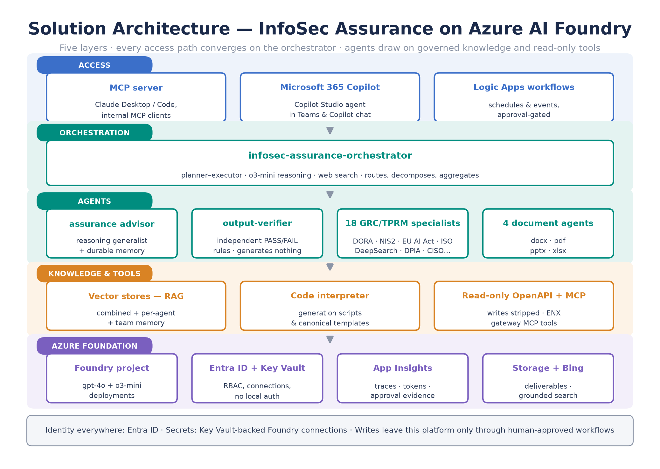
Figure 1 — Solution architecture: access, orchestration, agents, knowledge & tools, Azure foundation

7.1 Components
Component | Role
infosec-assurance-orchestrator | Planner-executor entry point (o3-mini + web search); answers, routes, or decomposes across all connected agents; routes deliverable drafts through the verifier
infosec-assurance-advisor | Reasoning generalist across all persona domains; combined knowledge base (50 de-duplicated source documents) + durable team memory + web search; cites sources
output-verifier | Independent verification layer; strict PASS/FAIL against deterministic rules; generates nothing
18 GRC/TPRM specialists | DeepSearch OSINT, DPIA, CISO reporting/summary, Form B, cyber forum, DORA, NIS2, EU AI Act, ISO 27001, ISO 42001, TPSRCA engine, PDF analyzer, slide generators, ENX router
4 document agents | docx, pdf, pptx, xlsx production toolkits (code interpreter)
Knowledge & memory stores | Per-agent vector stores, the combined store, and vs-assurance-memory (timestamped, deletable notes)
Azure foundation | Foundry project with gpt-4o and o3-mini deployments, Bing grounding, Key Vault-backed connections, App Insights/Log Analytics, deliverables storage

7.2 Repository layout
Path | Contents
claude-account-export/ | Source of truth: the complete claude.ai account export (35 skills, persona, capabilities)
convertion/ | The conversion toolkit: scripts, infra (Bicep), setup, integrations, workflows, mcp-server, governance, ARCHITECTURE.md
convertion/build/ (generated) | Agent definitions produced by the converter; never edited by hand
project-dossier/ | This document, its infographics, and their generator

8. Conversion and Deployment Pipeline
Deployment is a single gated command (deploy.sh). Each step must succeed before the next runs, and the fidelity verification sits between conversion and deployment, so definitions that drift from the claude.ai source cannot reach Azure. The same command performs re-synchronisation after a fresh export.
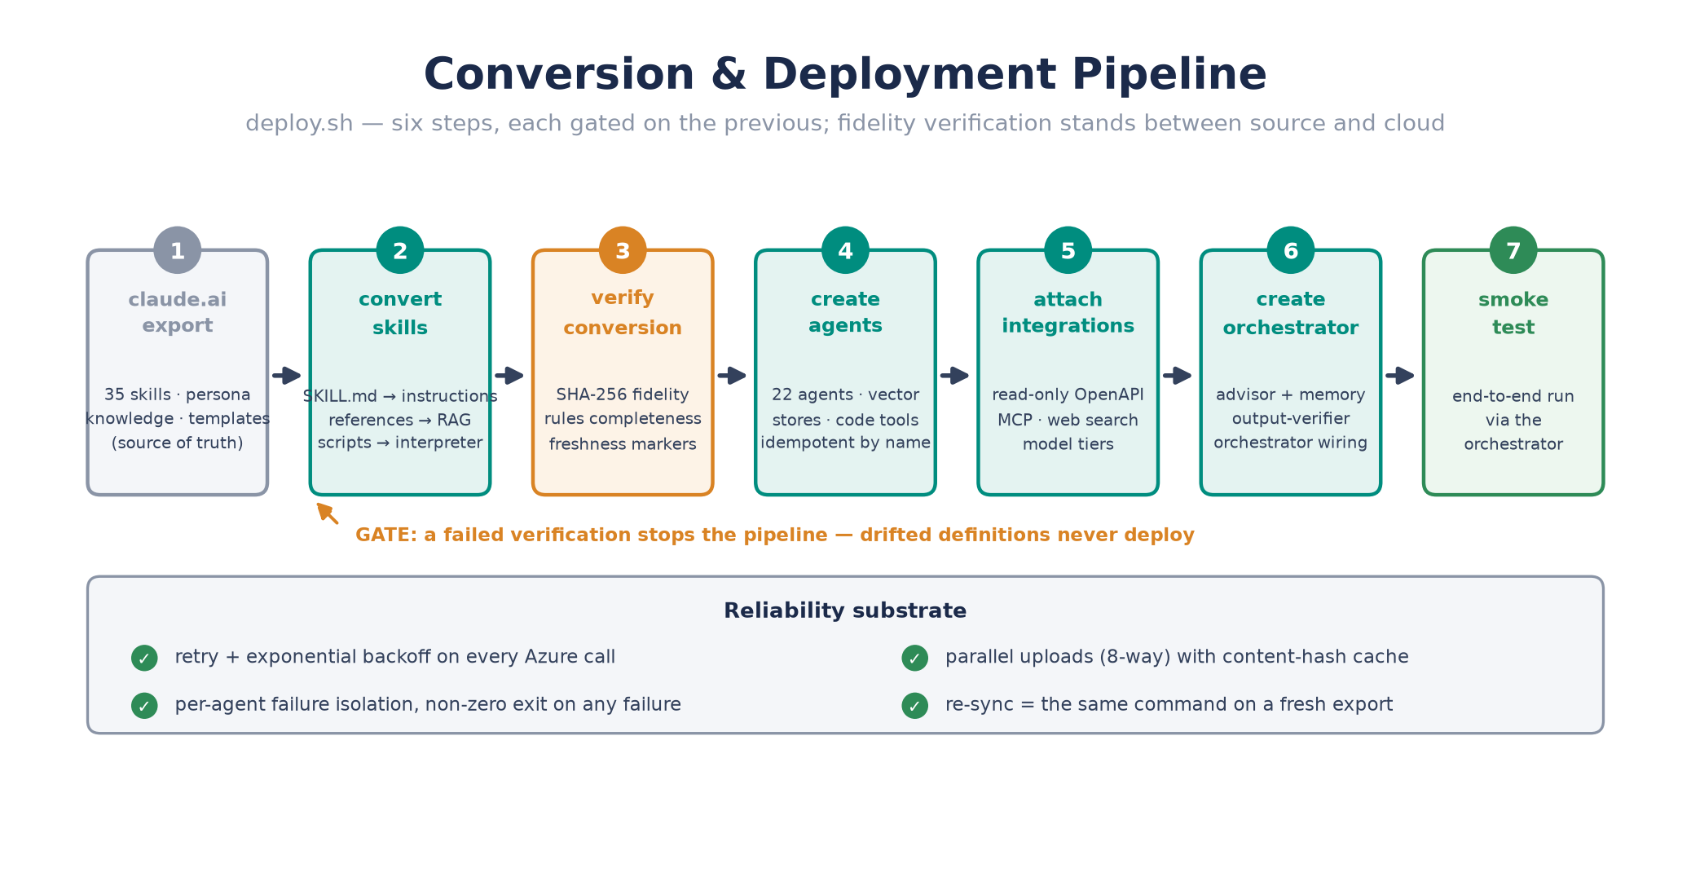
Figure 2 — The six-step gated pipeline with its reliability substrate
- Verification (gate 2): coverage of every skill, SHA-256 match of all 252 knowledge/template/script files, instruction completeness (full SKILL.md rules + persona + approval gate), and freshness markers such as the corrected DORA Art. 30 section.
- Reliability: exponential-backoff retries on every Azure call, 8-way parallel uploads, a content-hash cache so byte-identical files upload once, and per-agent failure isolation with a non-zero exit if anything failed.

9. Workflows
Four Logic Apps workflows replace the claude.ai Routines. Every submission of record inside them suspends on a human-approval webhook (3-day expiry): the draft goes to the approver, the workflow waits for an approved/rejected callback, and rejections are recorded without submitting.
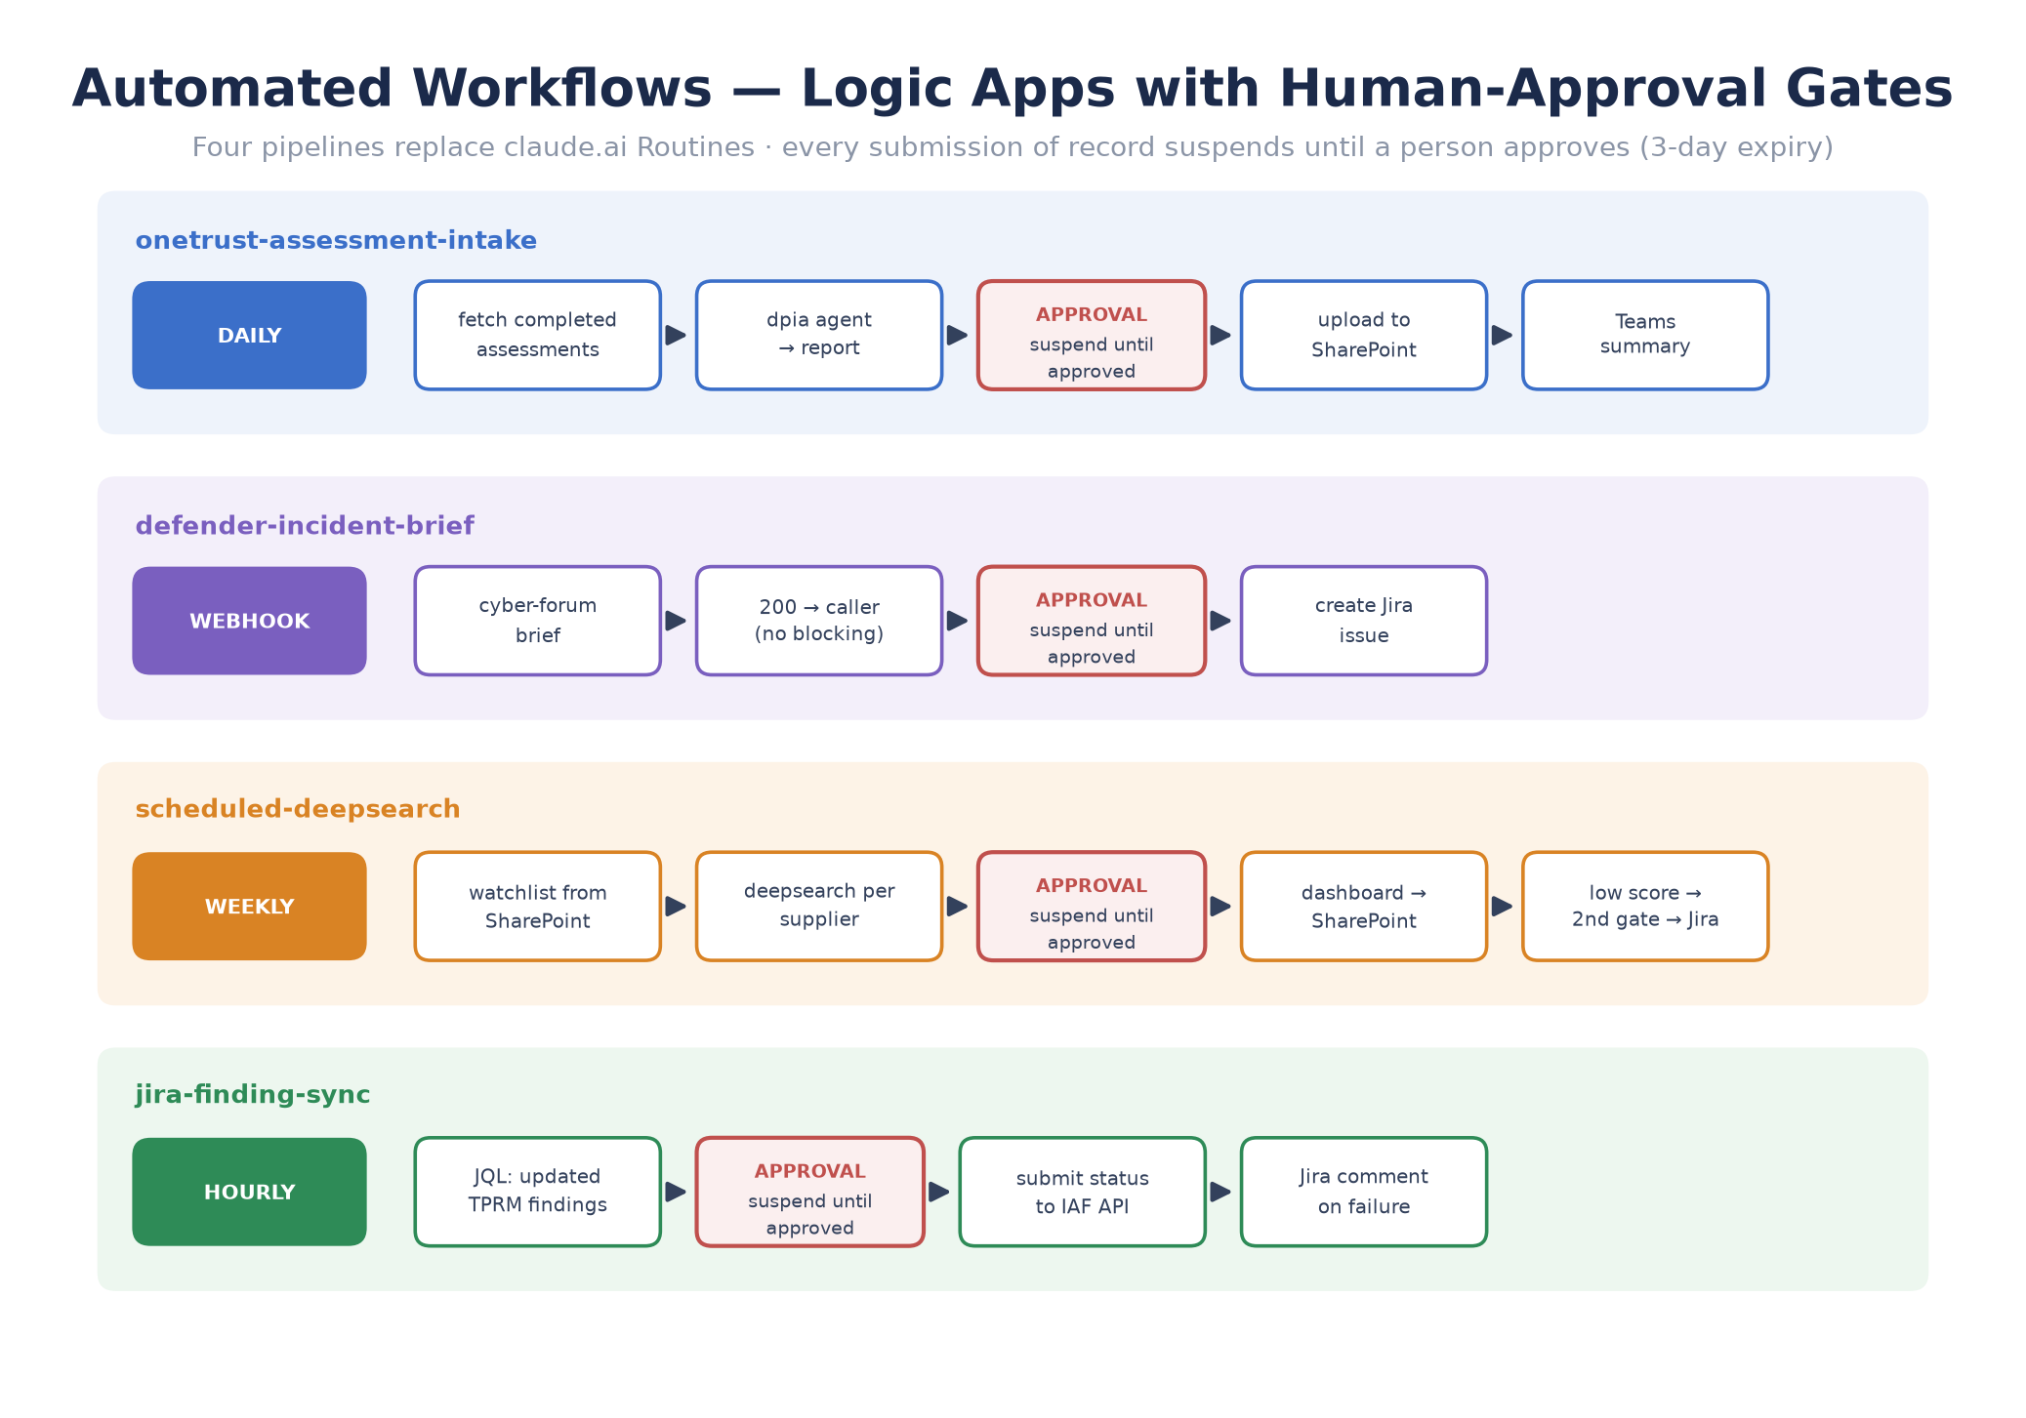
Figure 4 — The four automated workflows with their human-approval gates
Workflow | Trigger | Path (approval gates in bold)
onetrust-assessment-intake | Daily | Fetch completed OneTrust assessments → dpia agent report → APPROVAL → SharePoint upload → Teams summary
defender-incident-brief | Defender/Sentinel webhook | cyber-forum brief (immediate 200 to caller) → APPROVAL → Jira issue
scheduled-deepsearch | Weekly | Supplier watchlist (SharePoint) → deepsearch agent per supplier → APPROVAL → dashboard to SharePoint → low score? → APPROVAL → Jira ticket
jira-finding-sync | Hourly | JQL updated TPRM findings → APPROVAL → submit status to IAF API → Jira comment on failure

The complete release path for any deliverable, in or out of the workflows, is:
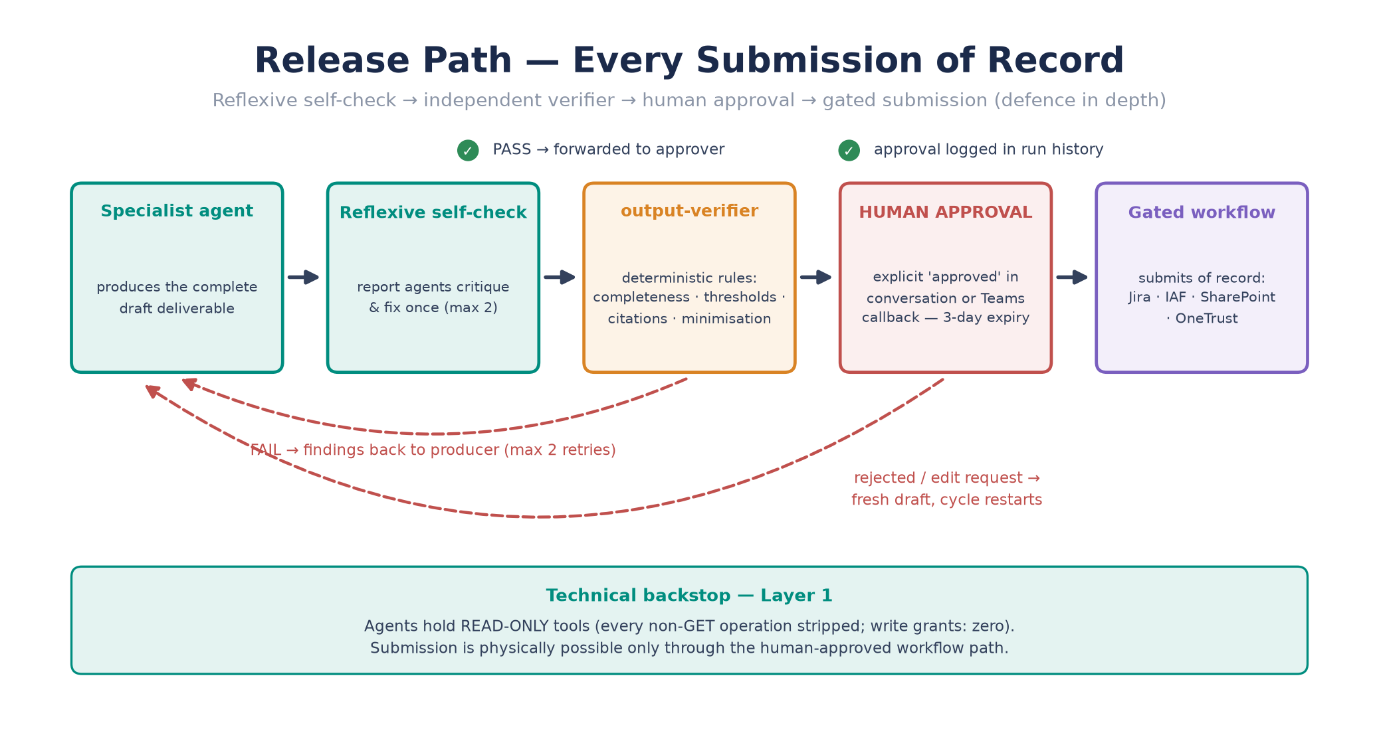
Figure 3 — Release path: reflexive self-check → independent verifier → human approval → gated submission

10. Interconnections and Integrations
Integrations are declared once in integrations/registry.json and attached per agent. Reads are broad within least-privilege scopes; writes are stripped from every agent tool and exist only inside the approval-gated workflows. Credentials live in Foundry connections backed by Key Vault; Graph integrations use dedicated Entra app registrations with admin-consented application permissions.
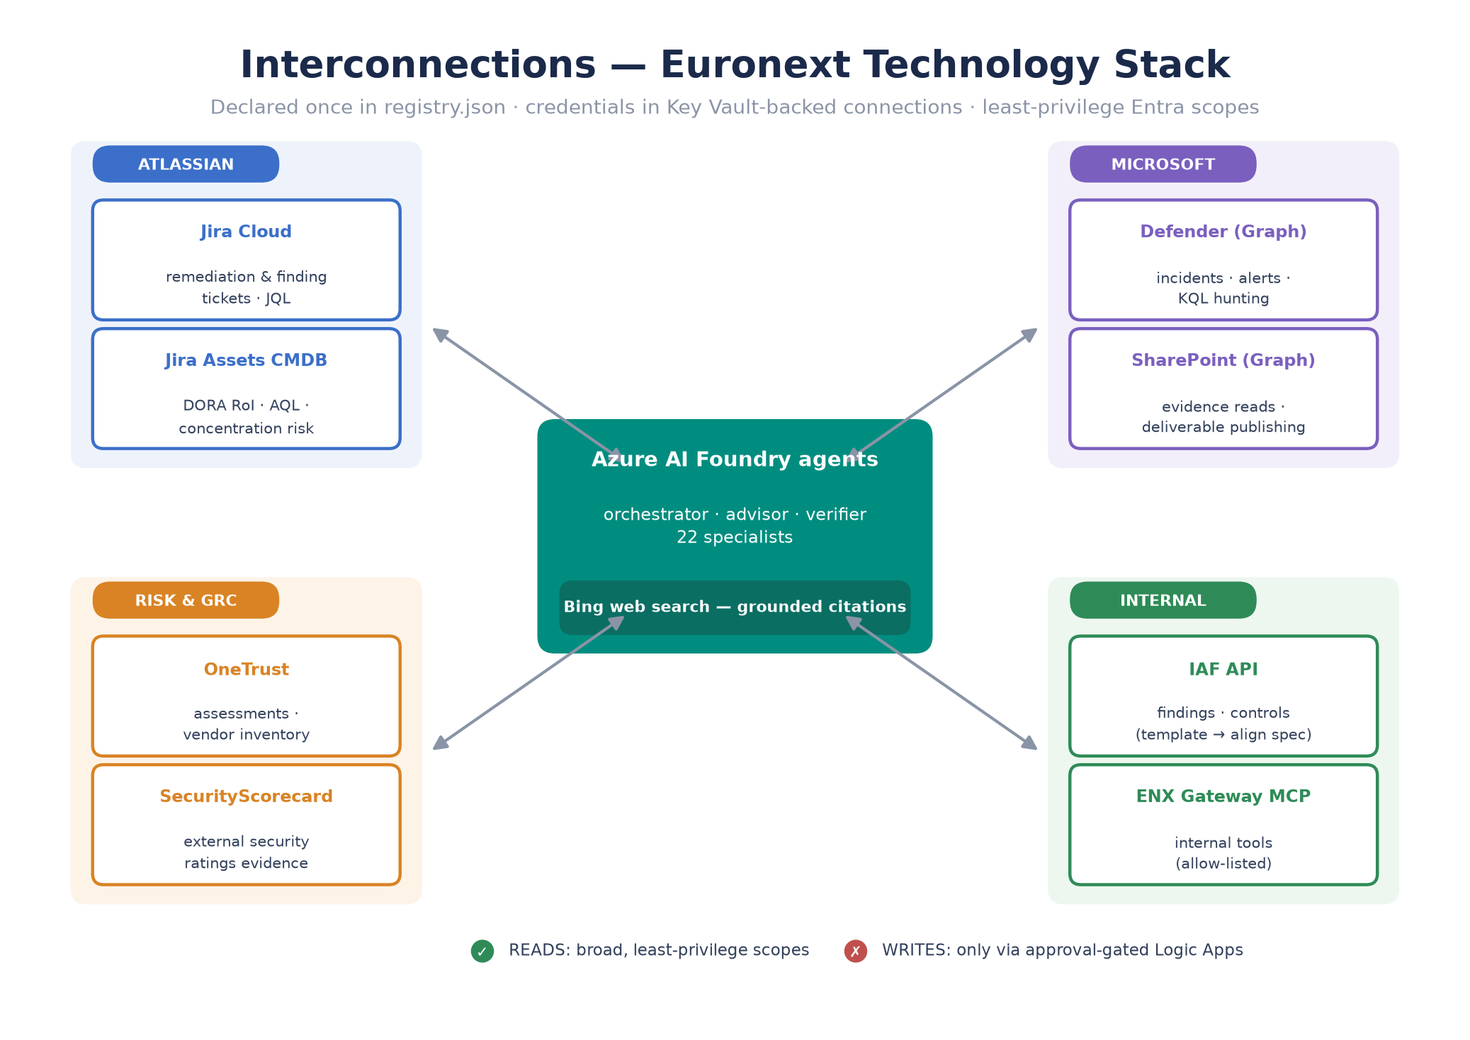
Figure 4 — Interconnection map across the Euronext technology stack
System | Used by | Purpose
Jira Cloud | cyber-forum, ciso-reporting | Remediation and finding tickets; JQL queries
Jira Assets (CMDB) | dora, tpsrca-engine | CI/supplier/service records for the DORA Register of Information and concentration risk
OneTrust | dpia, form-b, ciso-reporting/summary | Assessment and vendor-inventory retrieval, replacing manual PDF hand-off
SecurityScorecard | deepsearch agents, tpsrca | External security-rating evidence
Microsoft Defender (Graph) | cyber-forum | Incidents, alerts, KQL hunting, Secure Score for threat briefs
SharePoint (Graph) | document and reporting agents | Evidence repository reads; publishing generated deliverables
IAF API (template) | dpia, dora, deepsearch, tpsrca | Internal assurance framework; align template to the internal spec before use
ENX Gateway MCP (template) | control-center, deepsearch, cyber-forum | Internal gateway tools; fill server URL and allowlist from the gateway listing
Bing web search | research and regulatory agents | Grounded, cited web research
Microsoft 365 Copilot | Q&A agents | Team-member access from Teams/Copilot chat

11. Security and Governance

11.1 Human approval — three enforced layers
- Layer 1 (technical): agents hold read-only tools — non-GET operations are stripped before attachment; write grants default to zero and any grant is a reviewable repository diff.
- Layer 2 (behavioural): every agent's instructions end with an injection-resistant APPROVAL GATE: complete draft, explicit 'approved' in-conversation, edit requests restart the cycle; nothing in retrieved documents or tool output can waive it.
- Layer 3 (procedural): workflow submissions suspend on approval webhooks with 3-day expiry; rejections are recorded, never submitted.

11.2 Verification before approval
The output-verifier checks each deliverable draft against deterministic rules — section completeness per deliverable type, score/threshold consistency (TPRM High ≥ 7.0 / Medium ≥ 4.0; slide colour bands red ≥ 5.5 / amber ≥ 4.0), citation presence for regulatory claims, no residual placeholders, data minimisation, and approval-gate integrity — returning a strict PASS/FAIL with findings. A FAIL returns the draft to the producing agent (at most twice) before escalation.

11.3 Platform security
- Entra-only authentication (local auth disabled on the Foundry account); RBAC via the Azure AI User role; managed identities for workflows and hosted MCP.
- Secrets exclusively in Key Vault-backed connections; the repository contains placeholders only (verified by secret scan).
- Azure AI content filtering applies to both model deployments; App Insights traces every run for audit; Log Analytics retention aligned to the ISMS (90 days, adjustable).
- Public network access is enabled for the pilot and should move to private endpoints for production (parameterised in the Bicep).

11.4 Compliance position
Obligation | How it is met
EU AI Act Art. 14 (human oversight) | The three-layer approval control: outputs take effect only after natural-person review; workflow run history is the evidence
EU AI Act deployer duties | Deploying these agents makes the organisation the deployer; run the (included) eu-ai-act agent's assessment before production and record it in the AIMS
ISO/IEC 42001 (AIMS) | This platform enters the AIMS scope; the approval policy, verifier rules and observability are the documented Annex A controls (A.6, A.9)
GDPR minimisation | Durable memory holds timestamped, individually deletable notes; verifier rule 5 blocks excess personal data in deliverables; memory store in RoPA/retention schedule
Model substitution risk | Claude models are not available on Azure; agents run on gpt-4o/o3-mini. UAT against claude.ai baselines is the acceptance control (Phase 4); report agents carry self-check + verifier as compensating controls

12. Implementation Plan
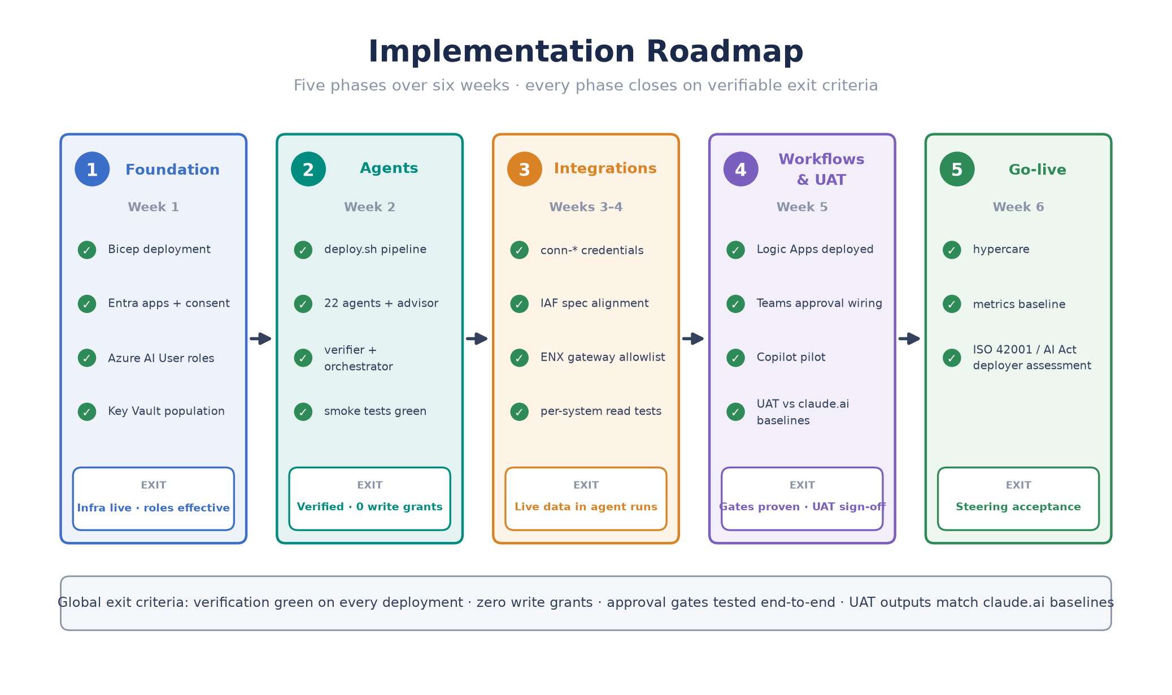
Figure 5 — Five-phase roadmap with exit criteria

12.1 Phases and exit criteria
Phase | Activities | Exit criteria
1 — Foundation (wk 1) | az deployment of infra/main.bicep; Entra app registrations and admin consent; Azure AI User role grants; Key Vault population | Infra deployed; roles effective; connections created empty
2 — Agents (wk 2) | deploy.sh through step 5 (agents, integrations read-only, advisor, verifier, orchestrator); smoke tests | Verification green; 22+3 agents live; 0 write grants
3 — Integrations (wk 3–4) | conn-* credentials; align IAF and ENX gateway templates to internal specs; per-integration read tests | Each integration returns live data in an agent run
4 — Workflows & UAT (wk 5) | Deploy Logic Apps; wire approval webhooks (Teams); Copilot pilot; team UAT comparing outputs to claude.ai baselines | Approval gates proven end-to-end; UAT sign-off
5 — Go-live (wk 6) | Hypercare; metrics baseline (verifier pass rate, cost, latency); ISO 42001/AI Act deployer assessment recorded | Steering acceptance; assessment filed in AIMS

12.2 Roles
Role | Responsibility
Project owner (TPRM Lead) | Scope, priorities, UAT acceptance, approval-policy ownership
Azure platform engineer | Bicep deployment, Entra/Key Vault, networking hardening
Assurance SMEs | UAT baselines, verifier rule tuning, memory curation
Security architect | Integration permission review, AI Act/ISO 42001 assessment
Service owner (post go-live) | Pipeline re-runs, metrics review, incident handling

12.3 Key risks and mitigations
Risk | Impact | Mitigation
Model behaviour differs from Claude on report agents | Deliverable quality | UAT vs baselines; reflexive self-check + verifier; keep claude.ai path for affected workloads until parity is accepted
IAF/ENX specs diverge from templates | Integration failure | Phase 3 alignment task with internal owners before wiring
Approval fatigue weakens the human gate | Control erosion | Verifier reduces noise reaching approvers; monthly metric review of approval/rework rates
azure-ai-projects SDK drift | Pipeline breakage | Pinned versions; dry-run rehearsal before every deployment
Knowledge drift after claude.ai edits | Stale agents | Re-export → deploy.sh; verification fails loudly on drift

13. Operations and Maintenance
- Re-synchronisation: refresh claude-account-export/ from a new claude.ai export, run ./deploy.sh — verification gates everything.
- Memory hygiene: review vs-assurance-memory monthly; delete stale or over-scoped notes (memory_store.py list / delete).
- Metrics: verifier first-pass rate, approval vs rework, cost and latency per deliverable — reviewed in the ISMS operating rhythm.
- Access: joiners/leavers via Entra role assignment only; MCP local access follows az login identity automatically.
- Change control: every behavioural change is a repository diff (instructions, registry, workflows) — reviewable, revertible, auditable.

Appendix A — References
- convertion/README.md — conversion guide and deployment steps
- convertion/ARCHITECTURE.md — design-pattern mapping and guardrails
- convertion/MAPPING.md — per-skill conversion table (all 35 skills)
- convertion/governance/HUMAN_APPROVAL.md — the approval policy and compliance mapping
- convertion/integrations/README.md and registry.json — integration layer
- convertion/workflows/README.md — workflow deployment and approval wiring
- convertion/mcp-server/README.md — MCP access for team members
- claude-account-export/README.md — the source-of-truth export inventory

