Screenshot 1: Project initialization with npm
The project was initialized with npm init -y, which created the package.json file.
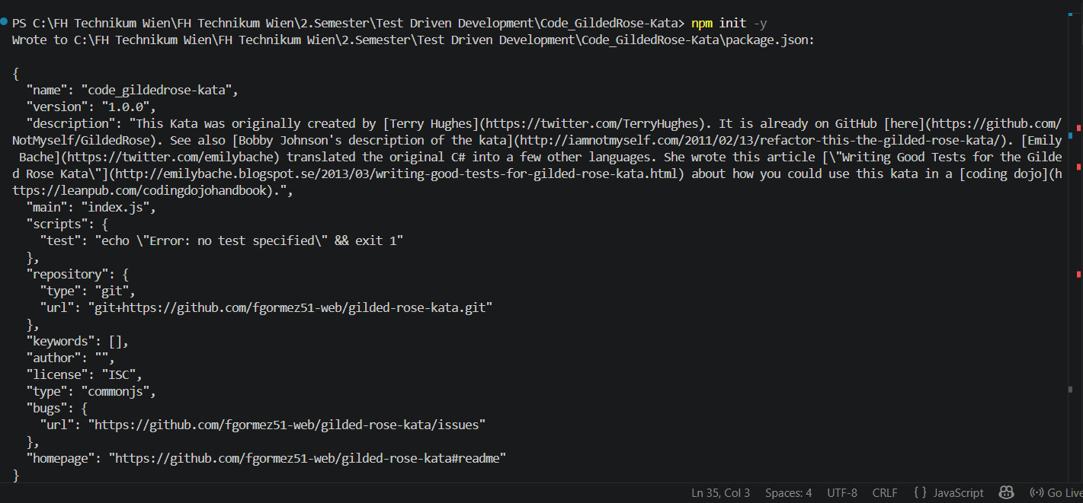

Screenshot 2: ESLint installation
ESLint and @eslint/js were installed as development dependencies for static code analysis.
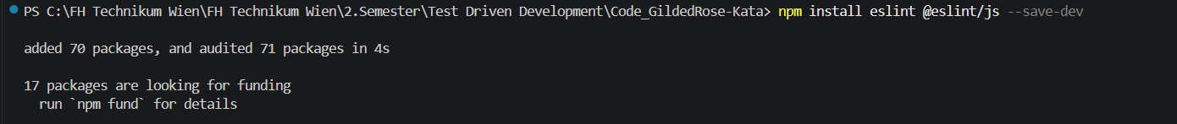

Screenshot 3: Initial ESLint analysis
The first static code analysis run found several issues in the source code, including var usage and non-strict equality comparisons.
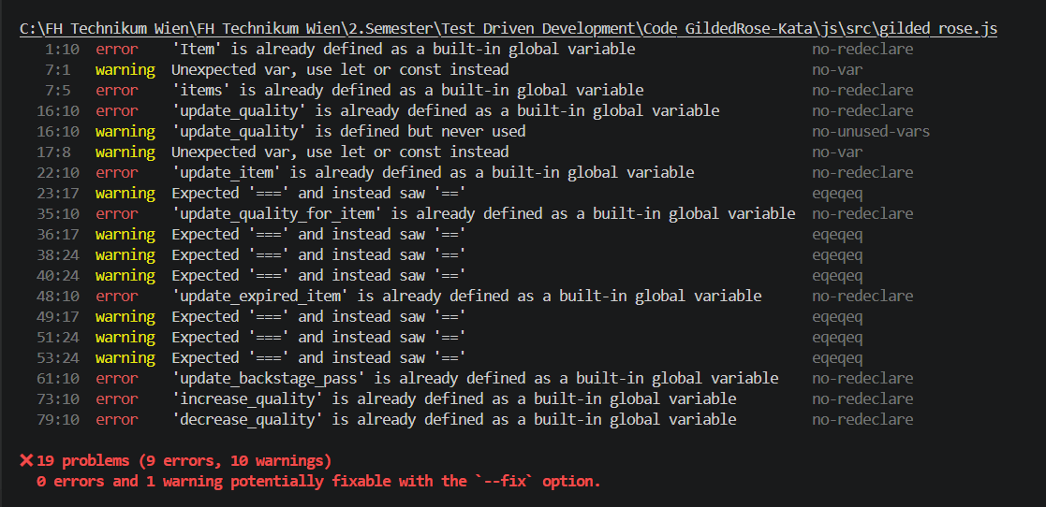

Screenshot 4: Clean ESLint findings before fixing
After adjusting the ESLint configuration, the analysis showed 10 relevant warnings in the source code.
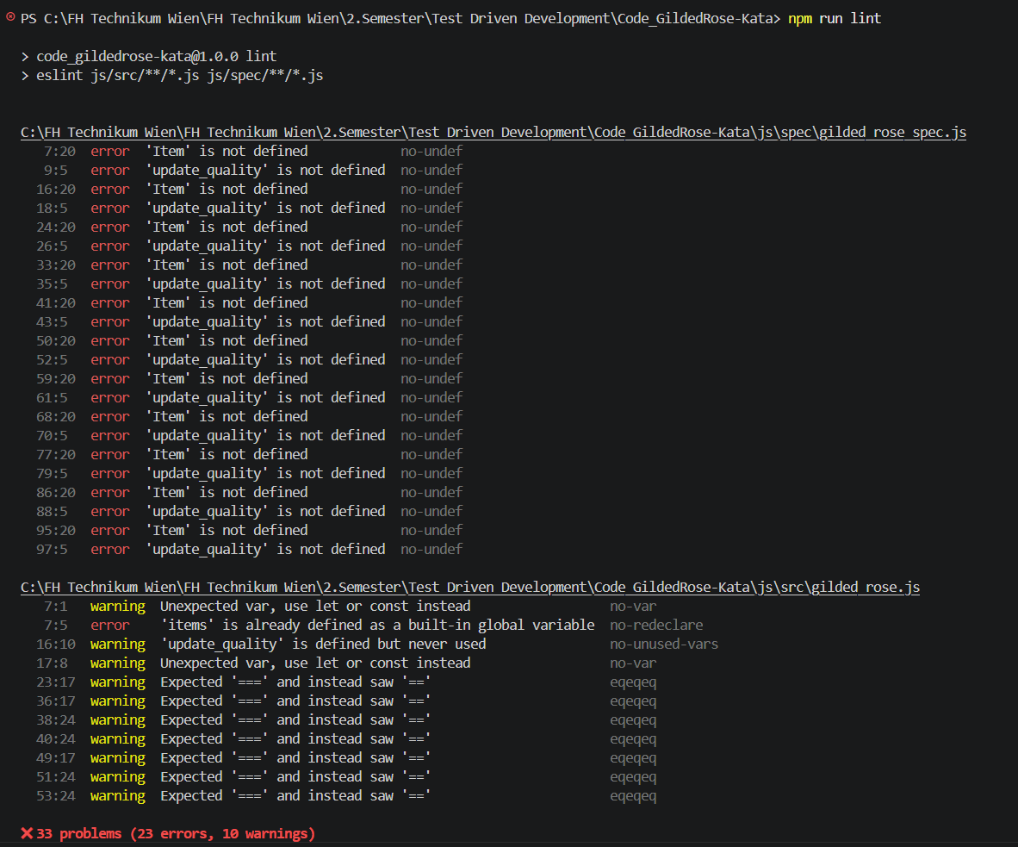

Screenshot 5: Code improvement – strict equality
The code was improved by replacing == with === to avoid type conversion issues.
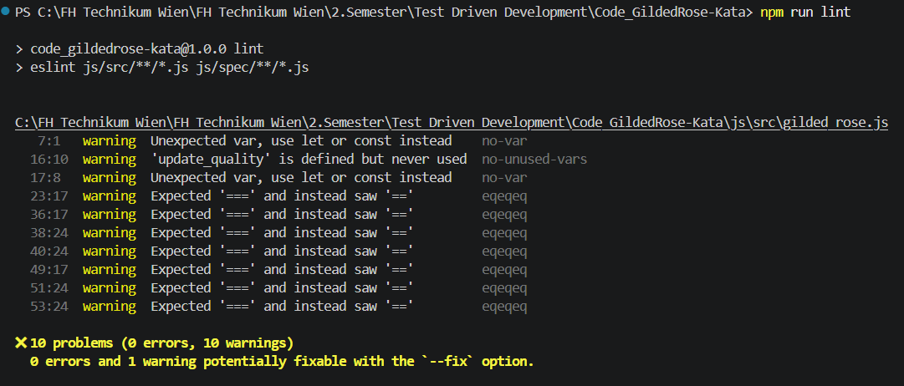

Screenshot 6: Remaining ESLint warnings
ESLint reports two remaining warnings. The warning about items was not changed to const because the Jasmine tests reset the items array in beforeEach. Changing it to const would break the tests. Therefore, this warning was kept intentionally.
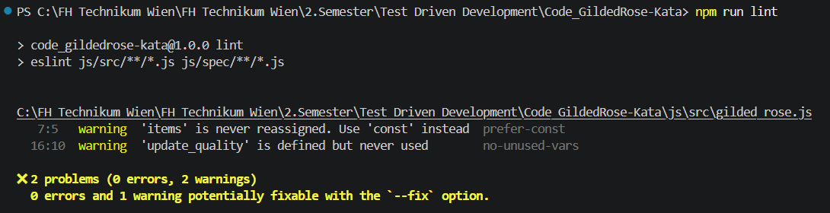

Screenshot 7: Jasmine tests after code fixes
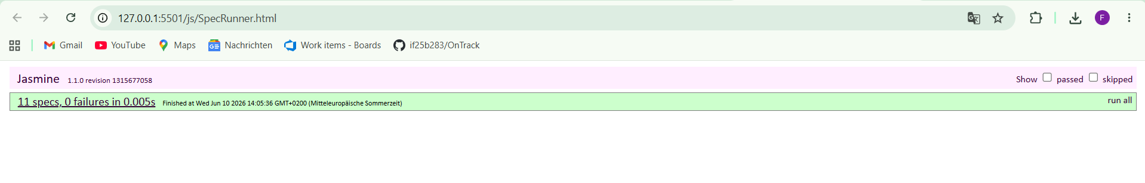
After the code improvements, all Jasmine tests were executed again. The result shows 11 specs and 0 failures, so the existing behavior of the application was not broken.

Screenshot 8: GitHub repository with committed changes
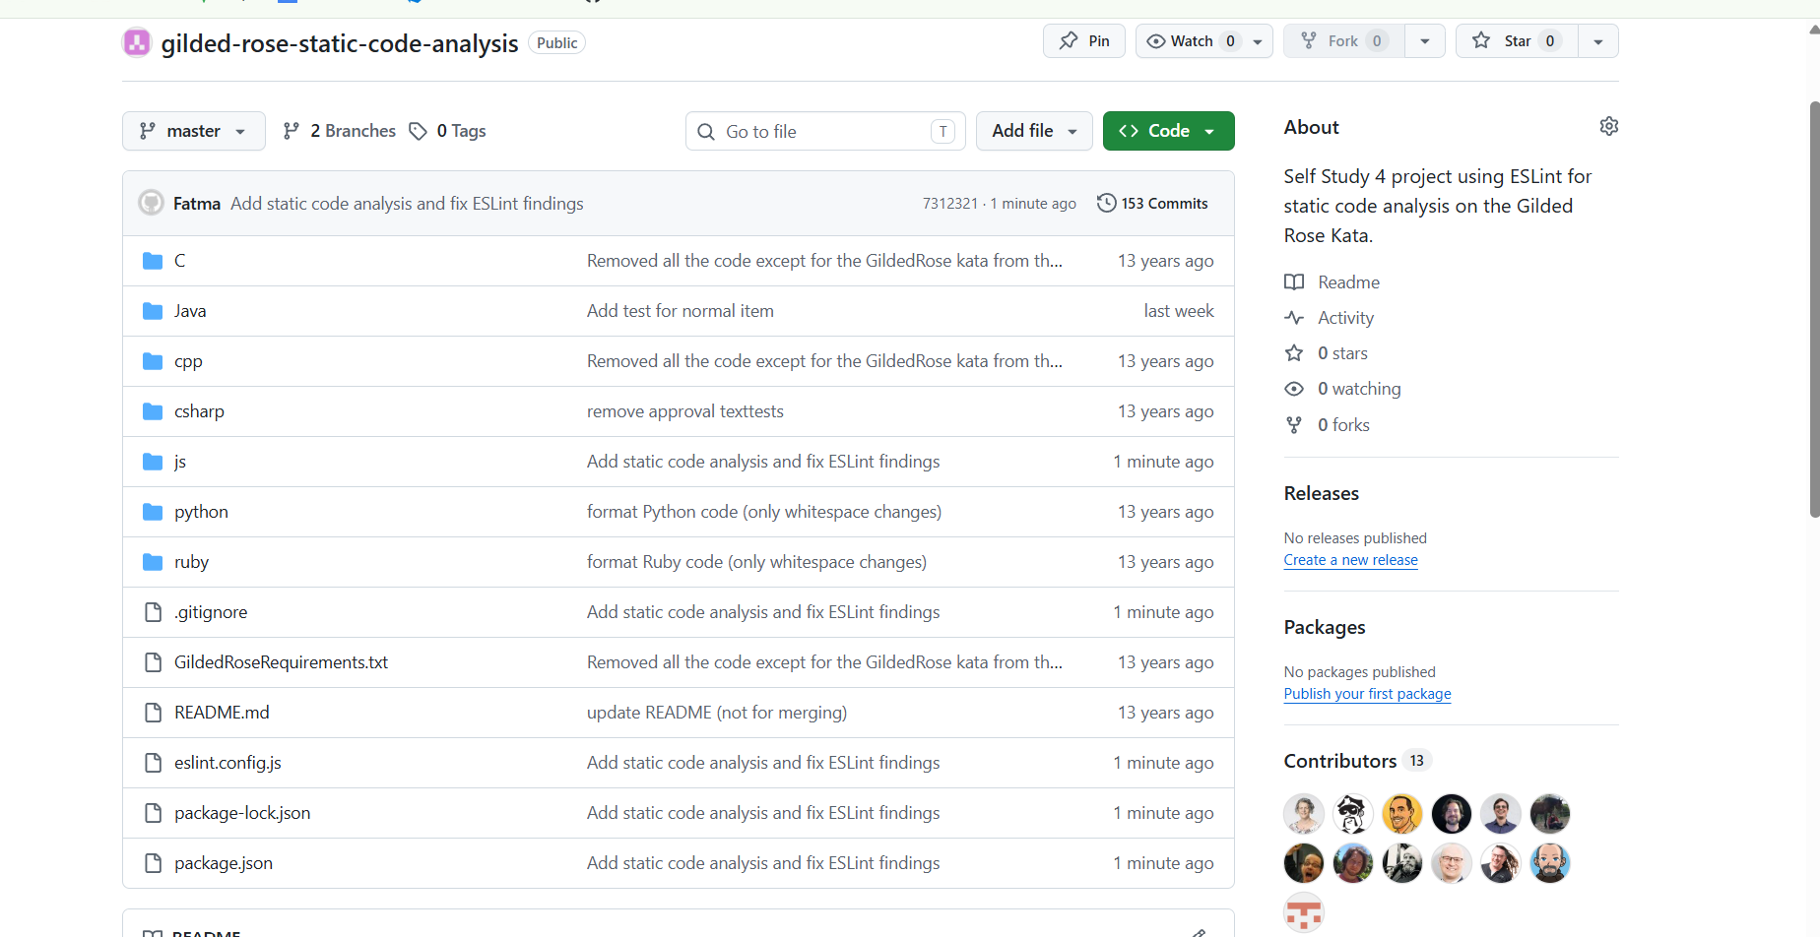
The corrected project was committed and pushed to the GitHub repository. The repository contains the source code, ESLint configuration, package files and the changes made after the static code analysis.

Conclusion
For this self study, Static Code Analysis was performed with ESLint on the Gilded Rose Kata project. The tool found several code quality issues, mainly var usage and non-strict equality comparisons. The most important findings were corrected in the source code. After the fixes, the Jasmine tests still passed with 11 specs and 0 failures, so the existing behavior was not broken.

