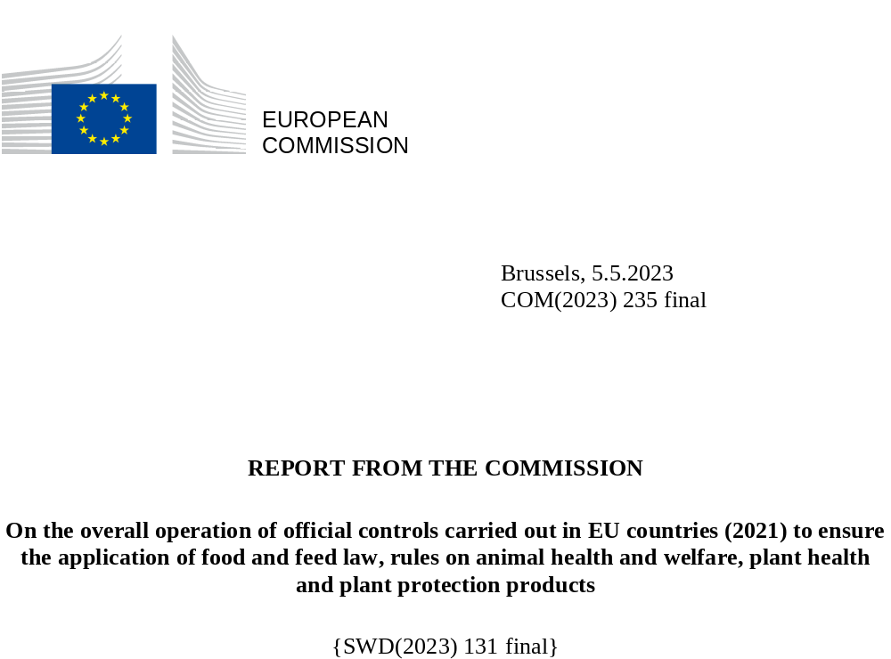

Contents
Executive summary 4
Introduction 6
Part 1
Official controls carried out by EU countries in 2021 8
1.1
General overview 9
1.2
EU countries’ annual reports 13
1.3
Organisation and performance of official control systems 14
1.4
Measures taken to ensure the effective operation of the MANCP 16
1.4.1
Actions taken to ensure business compliance 17
1.4.2
Enforcement by national authorities 18
1.4.3
Actions taken to ensure the effective operation of official controls systems 20
Part 2
Commission control activities in EU countries in 2021 22
2.1
Audits and controls 23
2.2
Recommendations 25
2.3
Highlights from Commission controls carried out in 2021 26
2.4
Systematic follow-up of audit recommendations 29
2. 4.1
General follow-up audits 30
2.4.2
Enforcement 31
Conclusions 32

Disclaimer
The European Commission is presenting this report in accordance with Article 114 of Regulation (EU) 2017/625 ⁽⁾. This report aims to improve the public availability of information on official controls carried out by EU countries – and the Commission controls on them – in the areas of food and feed safety, animal and plant health, animal welfare, organic farming and quality schemes for agricultural products and foodstuffs.
Only the Court of Justice of the European Union is competent to interpret EU law.
Our goal is to keep this information up to date and accurate. If errors are brought to our attention, we will try to correct them.
The material used for this report:
- is information of a general nature and is not intended to address the specific circumstances of any particular individual or entity;
- is not necessarily comprehensive, complete, accurate or up to date; and
- is partly provided by national authorities in the EU countries, over which the Commission has no control and for which the Commission can take no responsibility.
Some data or information in this report may have been created or structured in files or formats that are not error-free.

Executive summary

This report covers the overall operation of EU countries’ official controls and the Commission’s control activities in 2021. These controls aim to ensure a high level of health protection and trust in the food chain, from farm to fork. They are an important way to verify that businesses are complying with their legal requirements so that EU consumers can be confident that the food they eat is safe. They are also key to enabling the smooth operation of safe trade in food, animals and plants, both within the EU and with non-EU countries.
National authorities are responsible for carrying out official controls. If businesses along the food chain do not comply with the relevant legislation, the national authorities are required to enforce the requirements, ensuring that businesses meet their obligations.
In 2021, there were 16.9 million entities within the scope of official controls and national authorities carried out nearly 5 million official controls on them. Based on these controls, around 1 million non-compliance issues were identified, leading to the application of nearly 500 000 administrative sanctions and almost 8 000 judicial actions.
The Commission verifies the EU countries’ implementation of official controls and enforcement activities. The reports from these Commission controls, which are published on the Commission's website, provide a clear picture of national authorities’ performance and are a significant part of the review process that ensures that EU legislation is fit for purpose.
The Commission’s controls show that, overall, national authorities have the necessary systems in place to monitor and ensure that businesses are implementing EU requirements and to act where there are non-compliance issues. In some EU countries, these controls identified shortcomings in official control systems, indicating that there was room for improvement. In these cases, the Commission addresses recommendations to the national authorities.
The Commission systematically follows up on its recommendations and, where necessary, makes use of other enforcement tools. In addition, it supports EU countries by providing technical assistance and training through the Better Training for Safer Food initiative and technical meetings of expert networks.
Since 2020, the national authorities have been required to report the results of their controls in a harmonised electronic format. However, not all EU countries have yet been able to submit all their data in the format required. The Commission will continue to work with national authorities to improve the completeness of data for future annual reports.
During 2021, the COVID-19 pandemic continued to affect the ability of the national authorities and the Commission to carry out their controls and audits as planned.

Introduction

The EU aims to ensure a high level of health protection and trust in the areas of food and feed safety; animal and plant health; animal welfare; organic farming; and geographical origin schemes (protected designation of origin (PDO), protected geographical indication (PGI) and traditional specialties guaranteed (TSG)). The people living in the EU rightly expect high standards in all these areas.
The EU has a comprehensive legal framework to ensure consistent controls throughout the food and feed chain, from farm to fork, and appropriate monitoring, while also ensuring an effective single market and trade with non-EU countries. For the purposes of this report, references to EU countries and the statistical data include the United Kingdom in respect of Northern Ireland ⁽⁾.
One of the pillars of the EU’s integrated food safety policy from farm to fork is that each EU country must have an effective official control system, based on the Official Controls Regulation ⁽⁾, to verify and, where necessary, enforce businesses’ compliance with EU standards throughout the food and feed chain. EU countries have to draw up multiannual national control plans (MANCPs) that cover all areas governed by EU agri-food legislation.
The Commission plays an important role in the overall control framework at EU level ⁽⁾ and carries out controls, including audits, in the EU countries, to verify that the national authorities are meeting their control obligations.
EU countries must submit an annual report to the Commission ⁽⁾ on the implementation of their official controls in line with their MANCP.
The Commission produces a report ⁽⁾ on the operation of official controls in EU countries, taking account of:
- the annual reports submitted by the national authorities on their control activities; and
- the outcome of Commission controls carried out in EU countries.
This report covers the year 2021. It consists of a review of:
- EU countries’ annual reports covering 2021;
- Commission control activities in EU countries in 2021; and
- Commission follow-up and enforcement actions and support provided to national authorities.
It includes a compilation of the data provided by the national authorities for the year 2021. These data will over time make it possible to identify trends in controls and non-compliance issues.
The graphics relating to national official controls are based on the 2021 aggregated data from EU countries.
As the reporting requirements changed since 2020, not all EU countries were able to provide all their data for 2021 in the detail required. This limits the extent to which the graphics can be compared because some EU countries may have provided combined data that has not been analysed into the required sub-categories.
This report is accompanied by a staff working document ⁽⁾ which provides:
- more background information on the legal framework; and
- more detail on the controls and audits carried out by the national authorities and by the Commission in the areas of the food chain that fall under the Official Controls Regulation.
Part 1

Official controls carried out by EU countries in 2021
1.1

General overview

The production and distribution of food from farm to fork takes place in various chains across a broad range of areas and activities ().
Table 1 provides an overview of the total number of entities in the food chain; official controls that were carried out; non-compliance issues that were identified; and administrative sanctions and judicial actions that were taken throughout the food chain at the EU level in 2021.
Table 1: Official controls in 2021 – general figures
Total entities in the food chain | Official controls carried out | Non-compliance issues identified | Administrative sanctions applied | Judicial actions taken
16 961 311 | 4 820 161 | 1 112 663 | 499 365 | 7 903
Figure 1 provides an overview of the official controls carried out by EU countries in 2021 from farm to fork ⁽⁾. It shows the number of operators, official controls carried out, non-compliance issues identified and administrative sanctions applied – analysed by the different activities in the food chain ⁽⁾.
Table 2 shows the top five sectors of the food chain with absolute figures for the number of entities, official controls carried out, non-compliance issues identified, and administrative sanctions applied. The staff working document accompanying this report provides a further breakdown of these figures across the different areas of the food chain.
Figure 1: Official controls carried out by EU countries in 2021
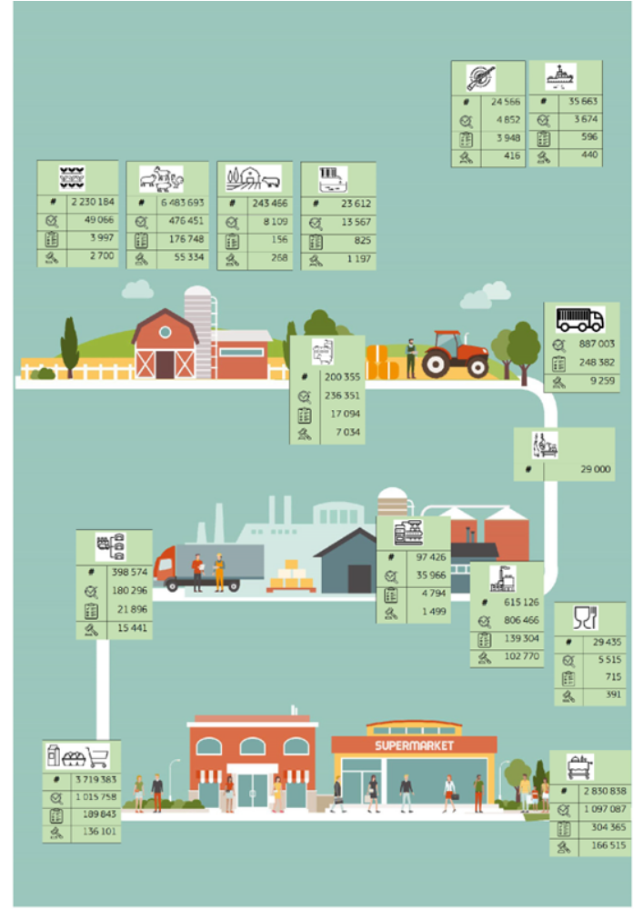

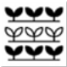 | Farming – plants | # | Number of operators
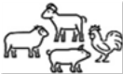 | Farming – animals |  | Number of official controls
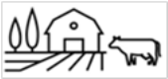 | Farming – mixed |  | Number of non-compliance issues
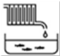 | Aquaculture |  | Number of administrative sanctions
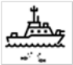 | Fishing
 | Hunting
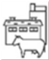 | Animal feed
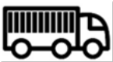 | Transport of animals
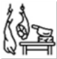 | Slaughterhouses and game handling
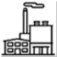 | Food production
 | Animal by-products processing
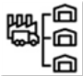 | Food distribution
 | Wholesale and retail
 | Food service
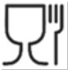 | Food contact materials producers

Table 2: Official controls in 2021 – top five sectors

Entities | 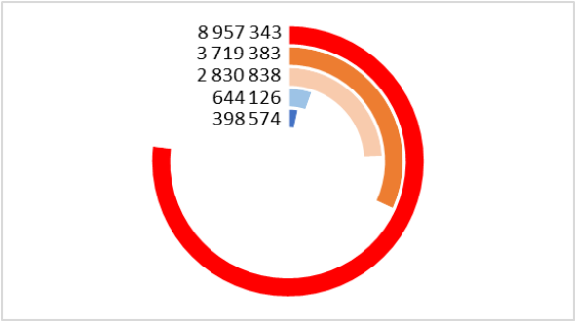
  Farming | 8 957 343
  Food wholesale | 3 719 383
  Food service | 2 830 838
  Food production | 644 126
  Food distribution | 398 574
Official controls | 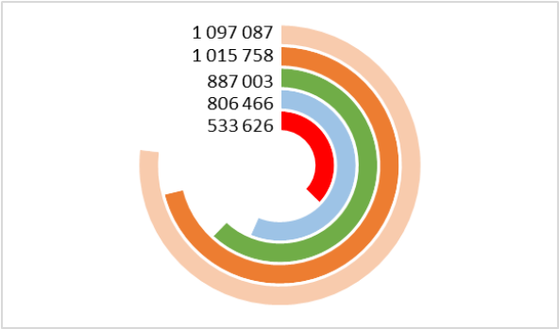
  Food service | 1 097 087
  Food wholesale | 1 015 758
  Animal transport | 887 003
  Food production | 806 466
  Farming | 533 626
Non-compliance issues | 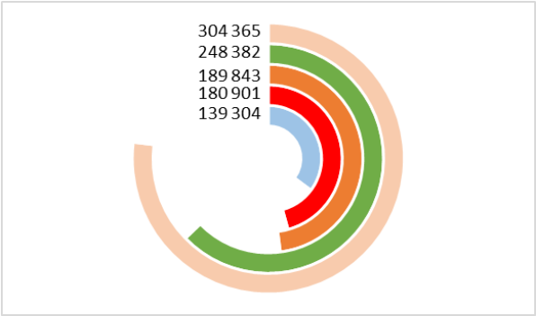
  Food service | 304 365
  Animal transport | 248 382
  Food wholesale | 189 843
  Farming | 180 901
  Food production | 139 304
Administrative sanctions | 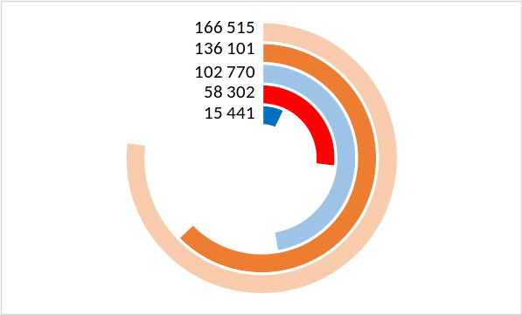
  Food service | 166 515
  Food wholesale | 136 101
  Food production | 102 770
  Farming | 58 302
  Food distribution | 15 441

1.2

EU countries’ annual reports

The deadline for submitting the 2021 annual reports was 31 August 2022. 9 EU countries submitted their report on time, 15 missed the deadline by up to 2 weeks and the last four reports were submitted 29, 42, 42 and 92 days late.
The national authorities were using the new reporting format only for the second time. Some of them were therefore still having problems in compiling the data in the format required. This means that comparisons between the data submitted for 2020 and 2021 may not be reliable. The change to the new format also makes it difficult to compare pre-2020 data with post-2020 data. It is therefore still too early to start comparing the data at EU level year on year.
In their reports, EU countries may present their progress towards achieving their strategic objectives and the challenges they face when implementing their MANCP. They may also include a statement on the overall level of compliance and an overall self-assessment of the suitability and effectiveness of their official controls. The report format contains blank text boxes where they can present this information. However, the national authorities provided less information for 2021 than had been envisaged in the guidance document ⁽⁾.
As regards animal welfare on farms and during transport, the Official Controls Regulation states that the annual reports shall include an analysis of the most serious incidents of non-compliance. This analysis should be the basis for a national action plan to prevent or decrease their occurrence in the coming years ⁽⁾. In general, and as was also the case for 2020, the national authorities did not provide either this analysis or these action plans. This makes it impossible for the Commission to provide the required summary on this point.
The national authorities also provided only very limited information on controls targeting fraudulent and deceptive practices.

1.3

Organisation and performance of official control systems

The EU countries have set up official control systems to verify the application of the legal framework by all businesses along the food chain.
The national authorities’ MANCPs describe the set-up of their control systems and set out their strategic objectives.
The Commission’s guidance for completing the annual reports invites the national authorities to:
- describe any update to the organisation of the official control systems;
- include a table with the results of performance indicators used to measure the strategic objectives; and
- include a statement on the general level of compliance and the effectiveness of the official control systems, based on the analysis and synthesis of the results of the control systems, their objectives and their performance indicators.
Some EU countries describe their control systems in the annual report (as well as in their MANCP). However, not all reports contain an overview of indicators and results, and most do not contain statements on the general level of compliance and the effectiveness of the official control system.
11 EU countries included information on their strategic objectives and 9 of these did so in the form of an overview of the results of their indicators. These indicators are sometimes limited to the number of official controls carried out and samples taken. Some EU countries’ reports do not contain information from all the authorities involved in the official controls along the food chain.
Some good practices to note are as follows:
- the Belgian Agency for the Safety of the Food Chain uses barometers for food safety, animal health and plant health based on indicators; and the results of these barometers allow a year-on-year comparison; and
- the Netherlands defines two information indicators and one performance indicator:
  - the enforcement indicator on enforcement measures taken;
  - the control intensity indicator on the number of businesses controlled in a given area (businesses or products); and
  - the compliance indicator on the level of compliance.
All EU countries still faced problems in implementing their full inspection programmes due to the restrictions put in place to contain the COVID-19 pandemic.
Other factors with a negative impact on the inspection programmes reported by the national authorities included insufficient resources (staff, financial and equipment), the ongoing animal (African swine fever and avian influenza) and plant health issues, and Brexit. Denmark stated that it needed to divert significant human resources to the culling of all minks on farms in order to prevent the spread of COVID-19 to humans.
Because all sectors show a growing trend in distance selling, Finland allocated more resources to controls in this area.
1.4

Measures taken to ensure the effective operation of the MANCP

The objective of MANCPs is to ensure that official controls are carried out in a manner that is risk-based and efficient across the entire agri-food chain, and in compliance with the Official Controls Regulation.
When official controls identify a case of non-compliance, national authorities are required to take action to ensure that the non-compliant business rectifies the issue to prevent any further occurrence ⁽⁾.
National authorities are also required to verify the effective operation of the official control system and to take the actions needed to rectify any shortcomings identified in their control systems ⁽⁾.

1.4.1

Actions taken to ensure business compliance

EU countries run public information campaigns and provide guidance and training to businesses to help them comply with food safety rules.
Nine EU countries provided examples of actions by national authorities to help businesses comply with the applicable rules.
- The Danish Veterinary and Food Administration is working on a number of measures to make it easier to understand minimum food safety requirements when starting a business.
- In Lithuania, the State Plant Service Agency’s activities give priority to advising businesses, providing methodological support and implementing other measures to prevent infringements of legislation – rather than seeking to achieve compliance only by means of sanctions or penalties.
- In Belgium, businesses certified under the national validated self-checking guides benefit from lower fees and a lower frequency of official controls. Tools are also available for sectors for which such a validated self-checking guide is not available. The control checklists are publicly available and contain guidance. Free training courses and material are also available.
1.4.2

Enforcement by national authorities

National authorities apply a range of enforcement actions, from verbal and written warnings through to the seizure and destruction of goods and the (temporary) removal or restriction of approvals of businesses. Administrative fines are used as a deterrent. Formal legal proceedings remain as a last resort.
National authorities must have effective, proportionate and dissuasive sanctions/penalties in place ⁽⁾.
Table 3 shows the number of administrative sanctions applied across the different parts of the food chain. Table 4 shows these sanctions across the different areas and Table 5 shows the number of judicial actions taken across the different areas.
Table 3: Administrative sanctions in 2021 by activity
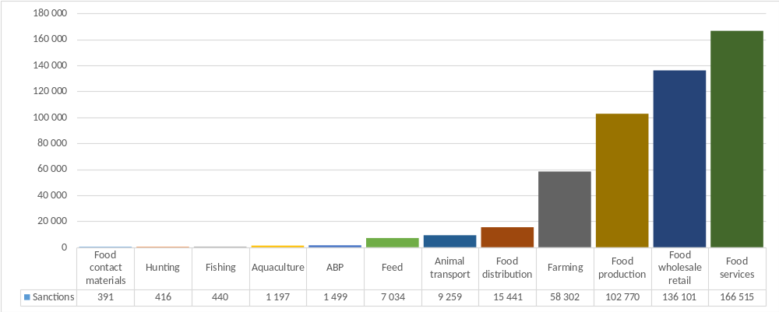
Table 4: Administrative sanctions in 2021 by area
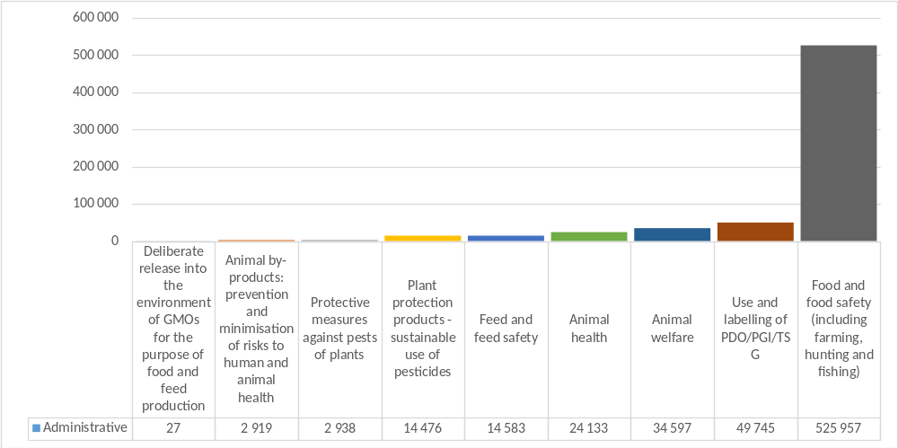
Table 5: Judicial actions taken in 2021
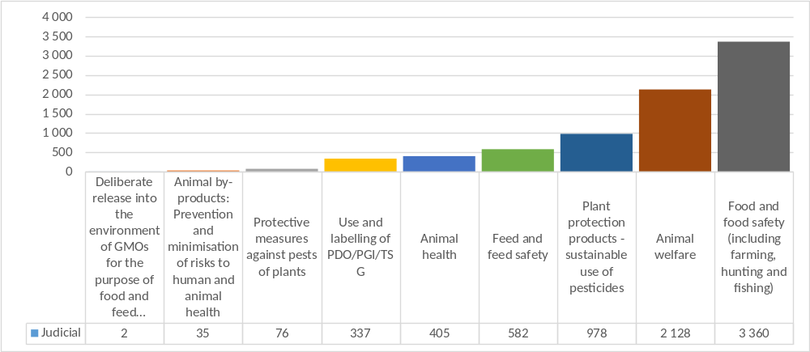
1.4.3

Actions taken to ensure the effective operation of official controls systems

National authorities must have procedures and/or arrangements in place to ensure the effectiveness and appropriateness of official controls. To achieve this they must have or have access to:
- a sufficient number of suitably qualified and experienced staff;
- appropriate and properly maintained facilities and equipment; and
- an adequate laboratory capacity for analysis, testing and diagnosis.
National authorities must carry out audits on their own control systems (or have audits carried out on themselves) and must have control verification procedures ⁽⁾ in place to ensure compliance and that the control systems are effective. This includes audits on any entity or person to whom the national authority might have delegated tasks.
23 annual reports included information on one or more of these aspects. 14 included information on training courses provided to or followed by staff.
The annual reports contain limited information on these audits and other verification activities assessing the effectiveness of the official control systems. The annual reports of Lithuania, Austria and Sweden refer to the audits carried out by the Commission.
On resources:
- Bulgaria reported trends that may impair the operation of official control systems:
  - a decrease in the number of staff involved in official controls;
  - an increased work burden for staff, including the need to work overtime;
  - an increase in the number of sites/businesses subject to official controls; and
  - outdated technical equipment for official controls.
- The Netherlands stated that the sectors subject to control are growing faster than the national authority’s human resources/control capacity, but that extra resources had been allocated by its government.
- The Netherlands will assess whether techniques introduced to enable controls during the COVID-19 pandemic, such as the use of cameras in slaughterhouses, can be kept and further improved; and
- Hungary stated that it is improving its IT systems.
17 EU countries reported changes to their current MANCP. Reasons given for these changes were:
- changes in legislation (5 EU countries);
- significant changes to the structure, management or operation of the national authorities (5);
- the outcome of the official controls carried out (4);
- the outcome of the internal audit system (1);
- the outcome of Commission controls (1); and
- other reasons, such as updated format; new analysis matrices and parameters; a new period of validity; including all the authorities involved; and the effects of the COVID-19 pandemic.

Part 2

Commission control activities in EU countries in 2021

2.1

Audits and controls

 The 2021 audit and analysis programme ⁽⁾ was the first under the 2021-2025 multiannual plan and focused on:
- food and feed safety;
- animal diseases and plant pests; and
- the sustainability of the agri-food chain, with particular regard to
- the sustainable use of pesticides; and
- animal welfare, where a project on the controls on the welfare of laying hens started.
We carried out 98 audits and similar checks on the official control systems of the EU countries in 2021. Chart 1 shows the geographical spread of these controls. Chart 2 shows the number of audits per control area.
Chart 1: Commission controls in 2021
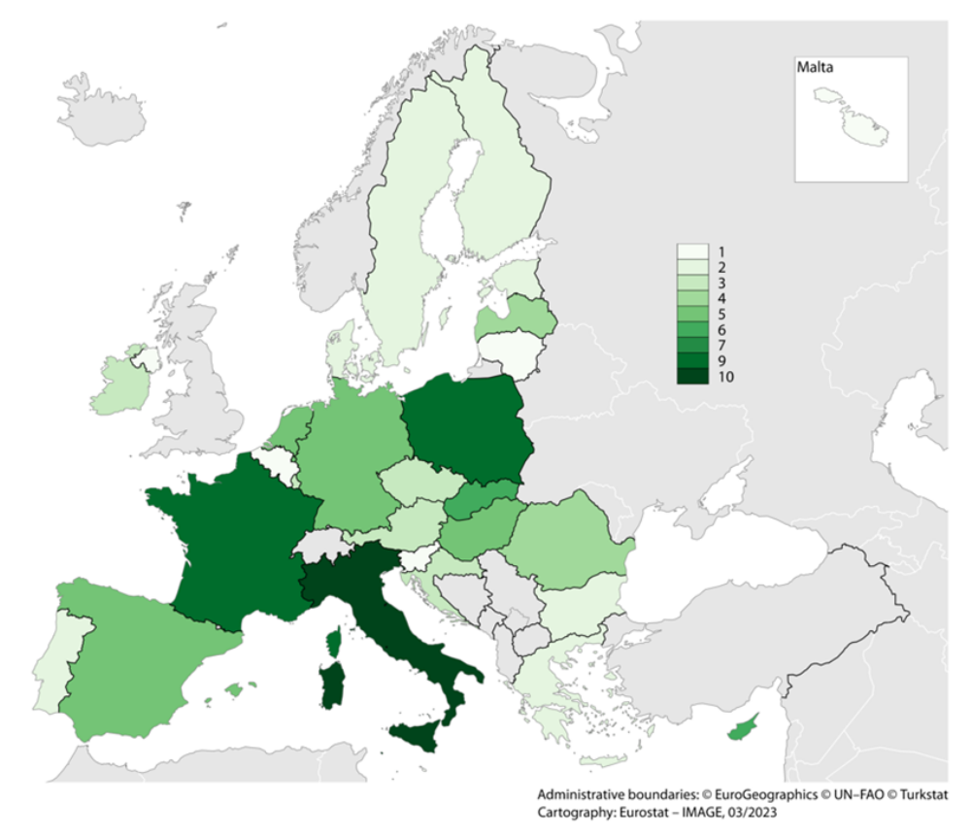

Chart 2: Audits carried out per control area – 2021
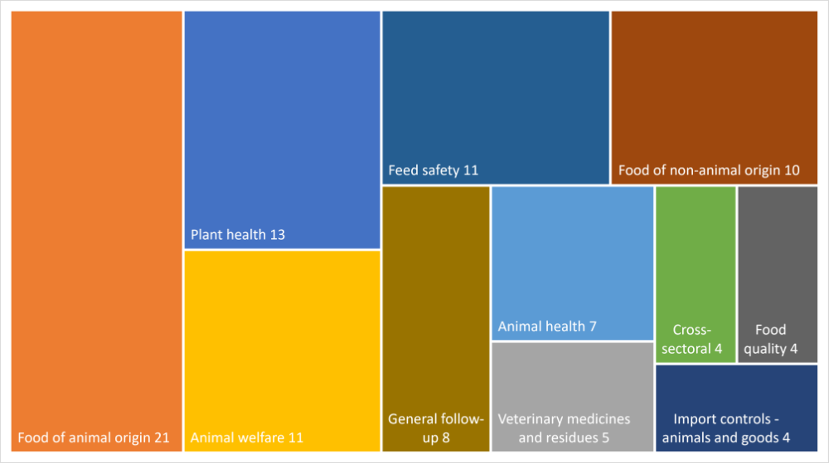

The restrictions put in place to contain the COVID-19 pandemic meant that 83 of the audits and similar controls were carried out entirely remotely, including via videoconferencing. Remote visits to the facilities of businesses to ascertain the implementation of official controls were not possible. 8 were performed partially remotely, with a limited on-site element. 7 were performed fully on the spot.
2.2

Recommendations

The controls carried out in 2021 resulted in a total of 407 recommendations to EU countries. Chart 3 provides an overview of these by sector. The accompanying staff working document provides a further breakdown of the figures by the different areas audited.
Chart 3: Recommendations made in 2021 by sector
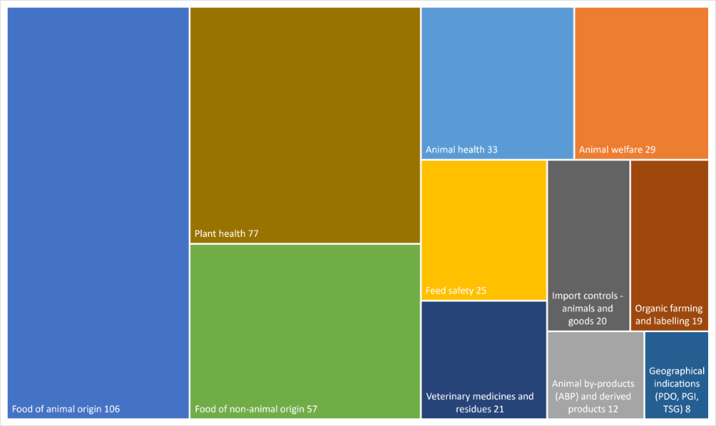
2.3

Highlights from Commission controls carried out in 2021

Food
The audits in the fisheries sector identified weaknesses in the registration and control of small fishing vessels and a lack of controls over landing sites and related operations. The audits on ready-to-eat fishery products confirmed an earlier finding on the requirement to demonstrate that products meet the relevant food safety criteria throughout their shelf-life. A finding we also previously found in the general ready-to-eat products audit series.
Our audits in the meat sector looked further into allegations that cows unfit for slaughter are being slaughtered and assessed new legal requirements introduced for ante- and post-mortem inspections in poultry slaughterhouses. These audits identified gaps in the official control systems as regards training, ante-mortem inspections and emergency slaughtering at the farm. A specific audit assessed the progress made by Poland in addressing the recommendations on these topics that resulted from audits performed in 2019.
In the dairy sector, we identified weaknesses in the quality control systems for non-bovine milk; training; oversight of controls performed; and the rating and enforcement of incidents of non-compliance.
On food of non-animal origin, the audits on the microbiological risks in primary production continued. Improvements were observed by comparison with the previous audit series, but it was found that seeds for sprouting are still not adequately controlled and that the registration of primary producers needs to improve so that they can all be risk-assessed and included in the control system at an appropriate frequency.
Feed
Audits in the feed sector identified problems with the assessment of operators’ hazard analysis and critical control points (HACCP) systems; the implementation of sampling protocols; and the official controls on labelling of feed.
Animal health
The audits focused on African swine fever. The audit results were also used to assess and further improve the Commission’s support to EU countries.
Animal by-products
Based on experience from previous audits, we focused on the official controls at critical points in the animal by-products chain. The audits also assessed the impact of the COVID-19 pandemic on the organisation of official controls. The findings of these audits resulted in the refinement of the scope for further audits in this area until 2024.
Animal welfare
Further to the successful ‘end the cage age’ citizens’ initiative ⁽⁾, the audit assessed the official control systems for the welfare of laying hens. Overstocking of animals is the main area of weakness. The lack of legal welfare requirements specific to breeding flocks and young hens means that there is no consistency in the way official controls are performed.
To help improve animal welfare during sea transport, we continued to work with the European Maritime Safety Agency to improve the system of official controls on livestock vessels.
Plant health
Our audit and analysis activities assisted in the further improvement of the timely reporting of new outbreaks and updates on existing ones of plant pests and the assessment of information to allow rapid decision making. An audit series on import controls supported the national authorities to improve their control systems.
Plant protection products
The preparation for the update of the EU’s legislation on the sustainable use of pesticides continued. We published the updated harmonised indicators ⁽⁾ for 2011-2019. The indicators show the continuing progress made. Our audits and training series focused on the sustainable use of pesticides and integrated pest management.
Organic production and labelling of organic products
In most EU countries, private control bodies certify organic production and the use and labelling of these products. The supervision of these control bodies by the competent authorities needs further improvement.
Protected designation of origin, protected geographical indications and traditional specialities guaranteed
Overall, the organisation and implementation of official controls are effective. Their effectiveness is higher at the production and processing stages than in the downstream sector (wholesalers and retailers).
However, official controls do not always verify whether these products comply with all the rules in the product specifications.
In addition, market controls carried out for the use of registered names of these products are not systematic and risk-based. They are mainly based on complaints or external information.
Fraudulent and deceptive practices
Based on the results of fact-finding studies and meetings with national authorities, the Commission is preparing a guidance document to assist national authorities with their official controls to identify fraudulent and deceptive practices in the agri-food chain.
The coordinated programmes targeting counterfeit and sub-standard foodstuffs, as well as food fraud and adulteration, remain in place.
Entry of animals and goods into the EU
The results of the audits show that, with one exception, EU countries have continued to improve their systems and implementation of controls.
Residues of veterinary medicinal products and environmental contaminants in animals and products of animal origin
The results of the assessment of the residue-monitoring plans and of the five audits that were carried out indicate that the EU countries are compliant.
2.4

Systematic follow-up of audit recommendations

2. 4.1

General follow-up audits

Based on our 3-year cycle, we carried out eight general follow-up audits in 2021.
Table 6: General follow-up audits in 2021
General follow-up audits: | 

The systematic review of actions taken by Member States to address audit recommendations continued to be effective in dealing with most of the identified issues. The results of the general follow-up audits have been published in the relevant country profiles.
At the end of December 2021, national authorities had taken corrective action or provided satisfactory commitments to address most of the identified shortcomings within acceptable timelines. Based on a three-year rolling indicator, commitments to corrective actions had been made for 90% of the recommendations resulting from audits carried out in the three-year period 2017-2019. All open recommendations continue to be monitored through general follow-up audits.
2.4.2

Enforcement

In 2021, the Commission sent an additional reasoned opinion to Czechia on its obligation to systematically report the arrival of certain foodstuffs coming from another EU country when those foodstuffs enter Czechia for the first time ⁽⁾.

In 2021, the Commission did not refer any cases to the Court of Justice of the EU in the areas subject to official controls covered by this report.

Conclusions

The EU countries’ annual reports on official controls demonstrate that national authorities continued in 2021 to fulfil their role of monitoring and verifying that businesses along the food chain comply with relevant EU requirements and took enforcement measures when this was not the case.
National authorities still need to complete the adaptation of their internal data systems to allow for the submission of complete and consistent data in the required format. Following the Commission’s guidance on completing the annual report should further improve the comparability of the information provided for 2022 and subsequent years.
The annual reports could also be improved when national authorities have sufficient data to include statements on the overall level of compliance; the overall effectiveness of the official control systems; and their suitability for achieving the objectives of the Official Controls Regulation ⁽⁾.
Regarding the official controls on animal welfare, future annual reports must provide a better analysis of the main incidents of non-compliance and the national action plans to prevent any recurrence of such incidents of non-compliance.
The results of the official controls carried out by EU countries and of the controls carried out by the Commission on the national authorities show that the necessary control systems are in place and that, overall, they provide levels of compliance that are compatible with food and feed safety requirements and a healthy internal EU market. Commission controls nevertheless identified weaknesses in some control systems and highlighted further room for improvement.
The Commission’s systematic follow-up of audit recommendations shows that national authorities are generally taking appropriate corrective measures to address identified shortcomings.
Working in partnership with the national authorities, the Commission continues to support them in continuously improving their official control systems through the networks of national experts and the Better Training for Safer Food initiative.
During 2021, the restrictions imposed due to the COVID-19 pandemic continued to make it difficult for national authorities and the Commission to carry out their control plans. Staffing levels and resource constraints were also cited as reasons why national authorities had not completely implemented their planned programmes.

⁽⁾Regulation (EU) 2017/625 of the European Parliament and of the Council of 15 March 2017 on official control and other official activities performed to ensure the application of food and feed law, rules on animal health and welfare, plant health and plant protection products
⁽⁾ In accordance with the Agreement on the withdrawal of the United Kingdom of Great Britain and Northern Ireland from the European Union and the European Atomic Energy Community, and in particular Article 5(4) of the Protocol on Ireland/Northern Ireland in conjunction with Annex 2 to that Protocol.
⁽⁾ Regulation (EU) 2017/625 of the European Parliament and of the Council of 15 March 2017 on official control and other official activities performed to ensure the application of food and feed law, rules on animal health and welfare, plant health and plant protection products.
⁽⁾ Article 116 of Regulation (EU) 2017/625.
⁽⁾ Article 113(1) of Regulation (EU) 2017/625.
⁽⁾ Article 114 of Regulation (EU) 2017/625.
⁽⁾ Commission staff working document (SWD(2023) 131 final) accompanying the report from the Commission on the overall operation of official controls carried out in EU countries (2021) to ensure the application of food and feed law, rules on animal health and welfare, plant health and plant protection products.
⁽⁾ See Eurostat – key figures of the European food chain – 2021 for a selection of data for the EU’s agriculture and fisheries sectors, and for the wider farm to fork chain.
⁽⁾ This figure does not include controls related to plant health (i.e. issuing plant passports and applying the ISPM15 mark to wood packaging to show that it has been treated to prevent the spread of insects, seeds and fungi), the marketing of plant protection products and the sustainable use of pesticides outside agriculture.
⁽⁾ National authorities do not have to report the number of entities active in animal transport. The data requested for official controls and non-compliance issues for slaughterhouses and game-handling establishments can be given as the number of carcasses or the weight, therefore a total cannot be used.
⁽⁾Commission Notice on a guidance document on how to fill in the standard model form
⁽⁾ Articles 151, 152, 154, 156, 157 and 158 of Regulation (EU) 2017/625.
⁽⁾ Article 138 of Regulation (EU) 2017/625.
⁽⁾ Article 12(2) and (3) of Regulation (EU) 2017/625.
⁽⁾ Articles 137, 138 and 139 of Regulation (EU) 2017/625.
⁽⁾ Articles 6 and 12 of Regulation (EU) 2017/625.
⁽⁾ The work programmes are published on the Commission website.
⁽⁾ The European Citizens' Initiative is a unique way to help shape the EU. Once an initiative has reached 1 million signatures, the Commission will decide on what action to take. More information on the and the cage age citizens’ initiative.
⁽⁾ Harmonised risk indicators are used to estimate trends in risks related to pesticide use.
⁽⁾ A letter of formal notice was sent in January 2019 and a reasoned opinion in July 2019. Given that Regulation (EU) 2017/625 repealed and replaced the previously applicable legislation on official controls and in order to ensure legal certainty regarding the provisions that the Commission considered Czechia to have infringed, an additional letter of formal notice was sent in July 2020 and an additional reasoned opinion in September 2021.
⁽⁾Regulation (EU) 2017/625.

