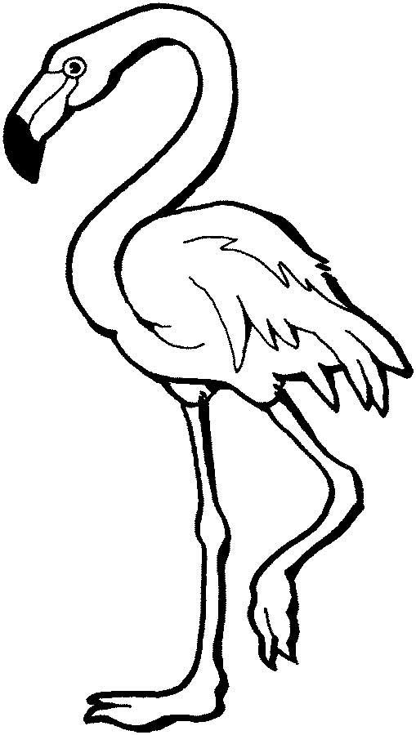

**Flamingo**

**Ff**

|  |  |  |  |
| --- | --- | --- | --- |
| **F** | **F** | **F** | **F** |
| **F** | **F** | **F** | **F** |
| **F** | **F** | **F** | **F** |
| **F** | **F** | **F** | **F** |
| **F** | **F** | **F** | **F** |
| **F** | **F** | **F** | **F** |
| **F** | **F** | **F** | **F** |
| **F** | **F** | **F** | **F** |

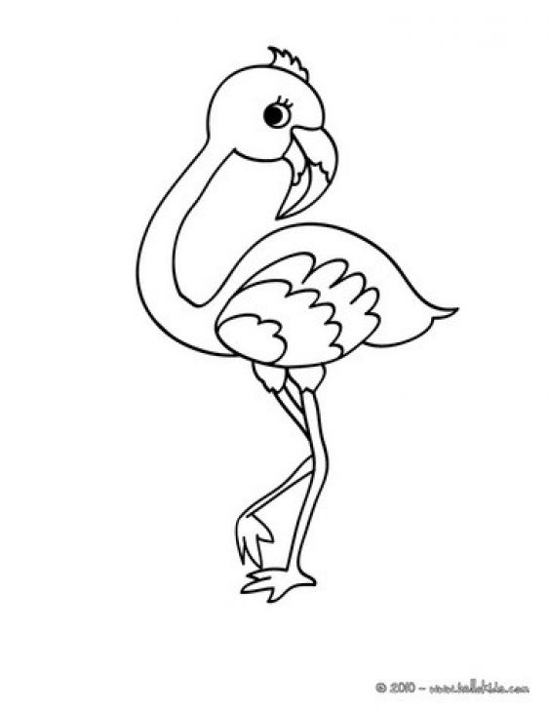

**Flamingo**

**Ff**

|  |  |  |  |
| --- | --- | --- | --- |
| **f** | **f** | **f** | **f** |
| f | f | f | f |
| f | f | f | f |
| f | f | f | f |
| f | f | f | f |
| f | f | f | f |
| f | f | f | f |
| f | f | f | f |