**Hiu**

**Hh**

|  |  |  |  |
| --- | --- | --- | --- |
| **H** | **H** | **H** | **H** |
| **H** | **H** | **H** | **H** |
| **H** | **H** | **H** | **H** |
| **H** | **H** | **H** | **H** |
| **H** | **H** | **H** | **H** |
| **H** | **H** | **H** | **H** |
| **H** | **H** | **H** | **H** |
| **H** | **H** | **H** | **H** |

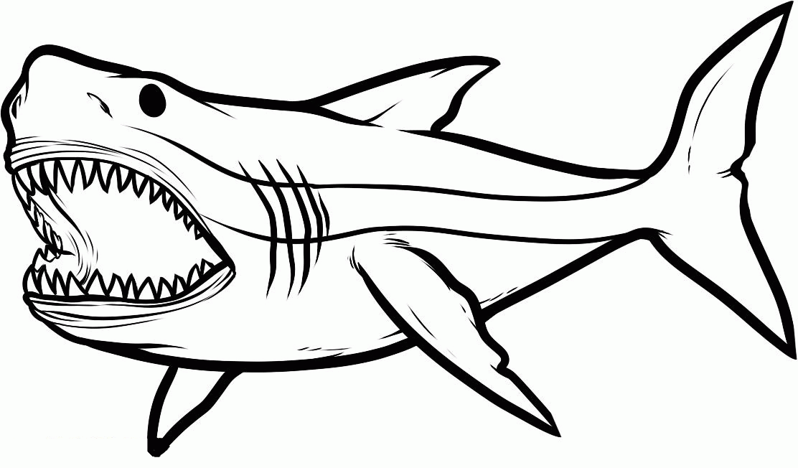



**Hiu**

**Hh**

|  |  |  |  |
| --- | --- | --- | --- |
| **h** | **h** | **h** | **h** |
| h | h | h | h |
| h | h | h | h |
| h | h | h | h |
| h | h | h | h |
| h | h | h | h |
| h | h | h | h |
| h | h | h | h |