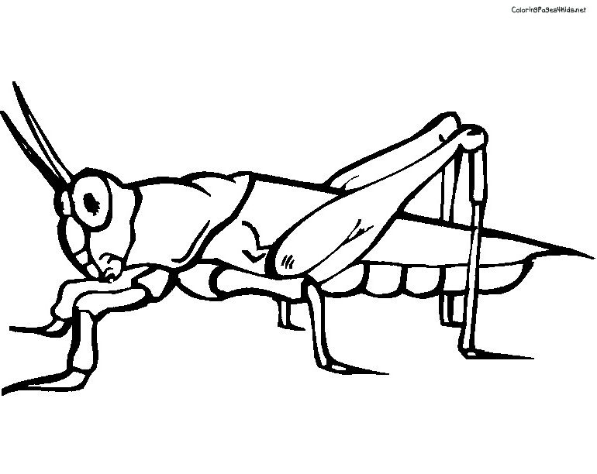

**Jangkrik**

**Jj**

|  |  |  |  |
| --- | --- | --- | --- |
| **J** | **J** | **J** | **J** |
| **J** | **J** | **J** | **J** |
| **J** | **J** | **J** | **J** |
| **J** | **J** | **J** | **J** |
| **J** | **J** | **J** | **J** |
| **J** | **J** | **J** | **J** |
| **J** | **J** | **J** | **J** |
| **J** | **J** | **J** | **J** |

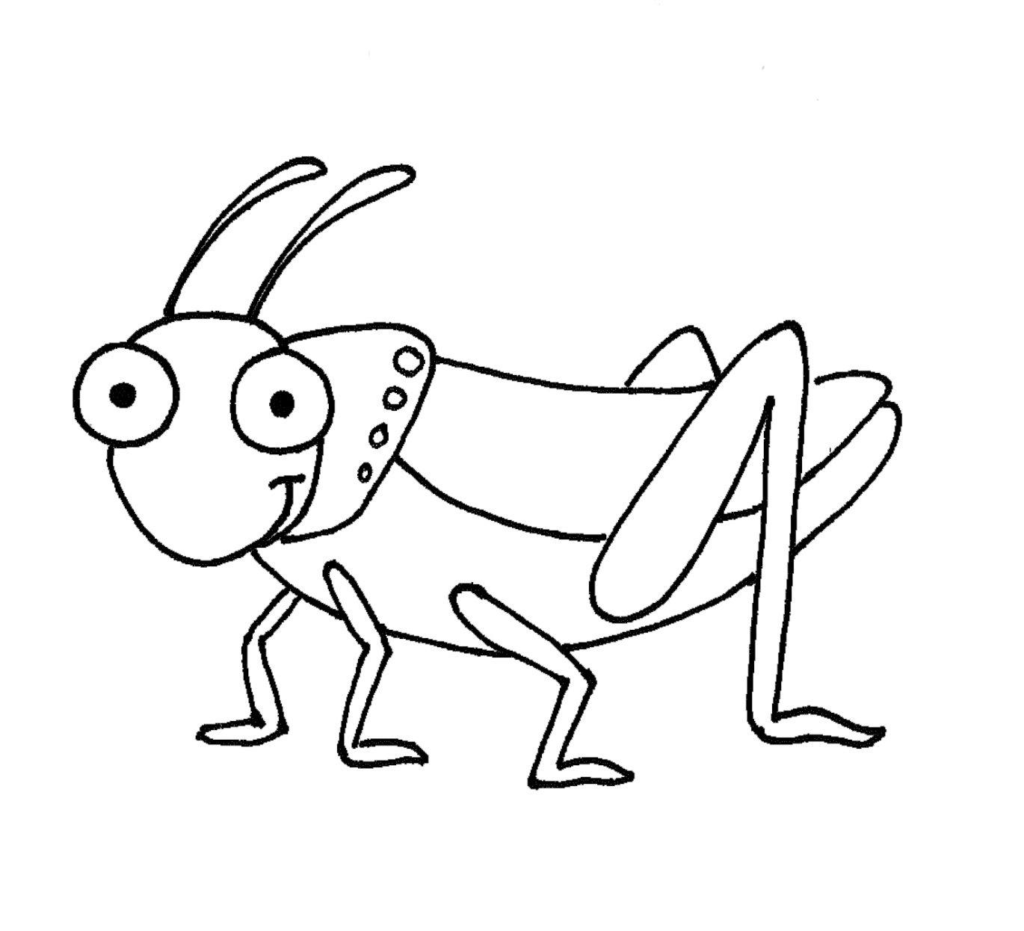

**Jangkrik**

**Jj**

|  |  |  |  |
| --- | --- | --- | --- |
| **j** | **j** | **j** | **j** |
| j | j | j | j |
| j | j | j | j |
| j | j | j | j |
| j | j | j | j |
| j | j | j | j |
| j | j | j | j |
| j | j | j | j |