**Kelelawar**

**Kk**

|  |  |  |  |
| --- | --- | --- | --- |
| **K** | **K** | **K** | **K** |
| **K** | **K** | **K** | **K** |
| **K** | **K** | **K** | **K** |
| **K** | **K** | **K** | **K** |
| **K** | **K** | **K** | **K** |
| **K** | **K** | **K** | **K** |
| **K** | **K** | **K** | **K** |
| **K** | **K** | **K** | **K** |

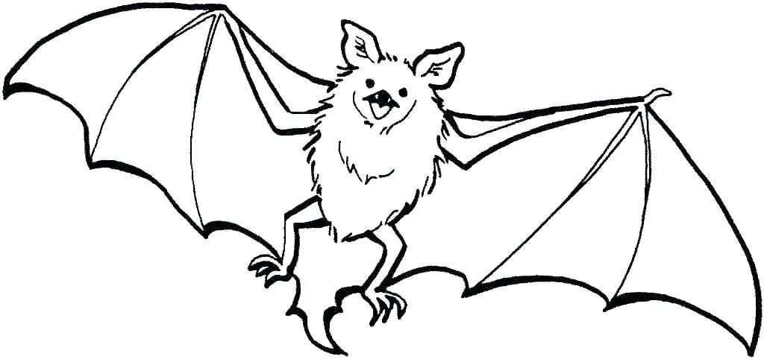

**Kelelawar**

**Kk**

|  |  |  |  |
| --- | --- | --- | --- |
| **k** | **k** | **k** | **k** |
| k | k | k | k |
| k | k | k | k |
| k | k | k | k |
| k | k | k | k |
| k | k | k | k |
| k | k | k | k |
| k | k | k | k |

