**Quoll**

**Qq**

|  |  |  |  |
| --- | --- | --- | --- |
| **Q** | **Q** | **Q** | **Q** |
| **Q** | **Q** | **Q** | **Q** |
| **Q** | **Q** | **Q** | **Q** |
| **Q** | **Q** | **Q** | **Q** |
| **Q** | **Q** | **Q** | **Q** |
| **Q** | **Q** | **Q** | **Q** |
| **Q** | **Q** | **Q** | **Q** |
| **Q** | **Q** | **Q** | **Q** |

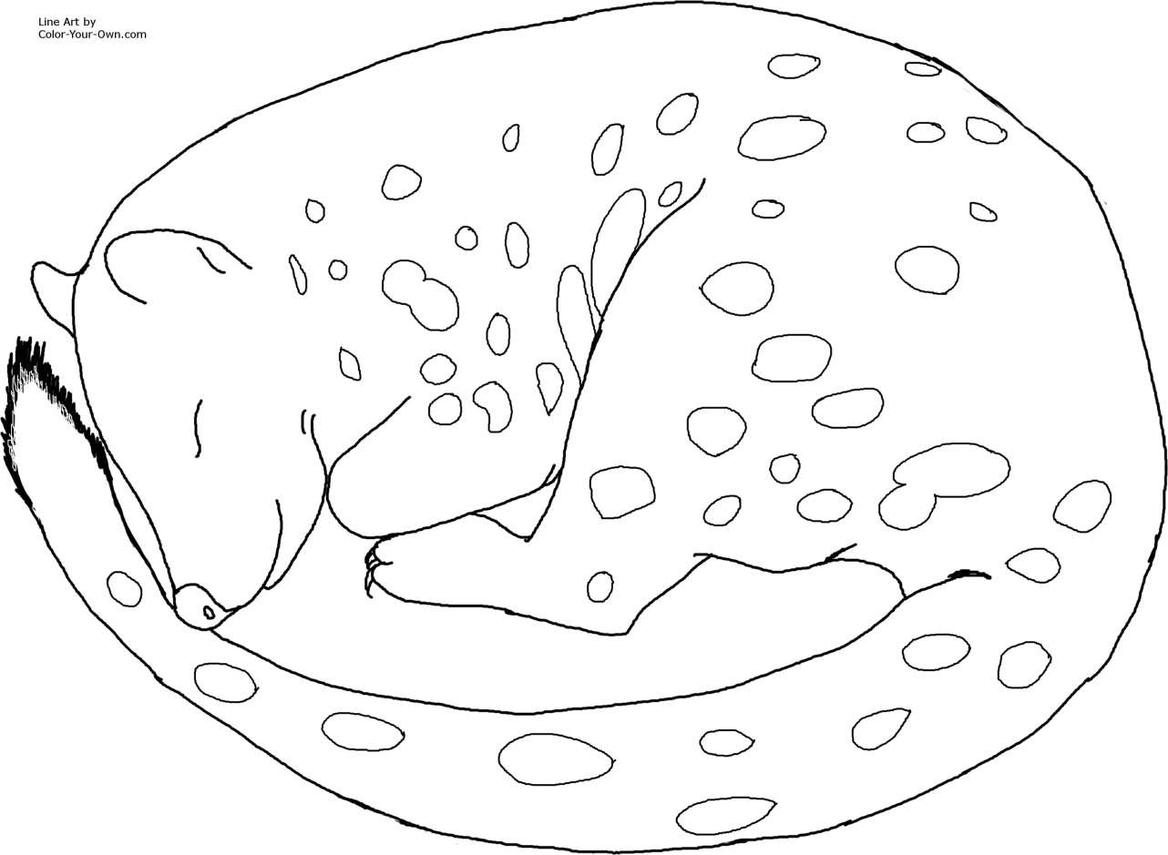

**Quoll**

**Qq**

|  |  |  |  |
| --- | --- | --- | --- |
| **q** | **q** | **q** | **q** |
| q | q | q | q |
| q | q | q | q |
| q | q | q | q |
| q | q | q | q |
| q | q | q | q |
| q | q | q | q |
| q | q | q | q |

