**Semut**

**Ss**

|  |  |  |  |
| --- | --- | --- | --- |
| **S** | **S** | **S** | **S** |
| **S** | **S** | **S** | **S** |
| **S** | **S** | **S** | **S** |
| **S** | **S** | **S** | **S** |
| **S** | **S** | **S** | **S** |
| **S** | **S** | **S** | **S** |
| **S** | **S** | **S** | **S** |
| **S** | **S** | **S** | **S** |

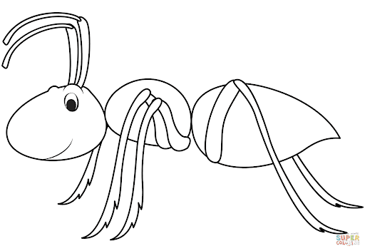

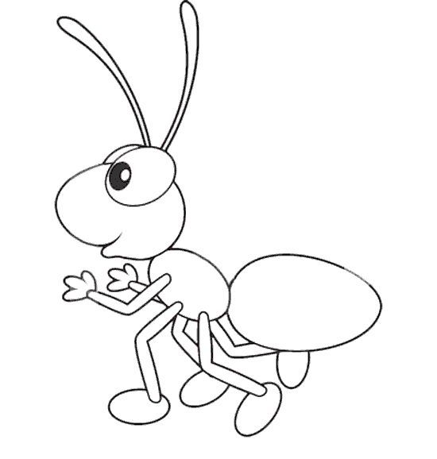

**Semut**

**Ss**

|  |  |  |  |
| --- | --- | --- | --- |
| **s** | **s** | **s** | **s** |
| s | s | s | s |
| s | s | s | s |
| s | s | s | s |
| s | s | s | s |
| s | s | s | s |
| s | s | s | s |
| s | s | s | s |