**Tawon**

**Tt**

|  |  |  |  |
| --- | --- | --- | --- |
| **T** | **T** | **T** | **T** |
| **T** | **T** | **T** | **T** |
| **T** | **T** | **T** | **T** |
| **T** | **T** | **T** | **T** |
| **T** | **T** | **T** | **T** |
| **T** | **T** | **T** | **T** |
| **T** | **T** | **T** | **T** |
| **T** | **T** | **T** | **T** |

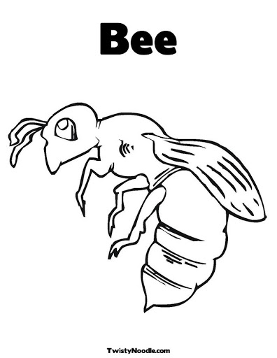

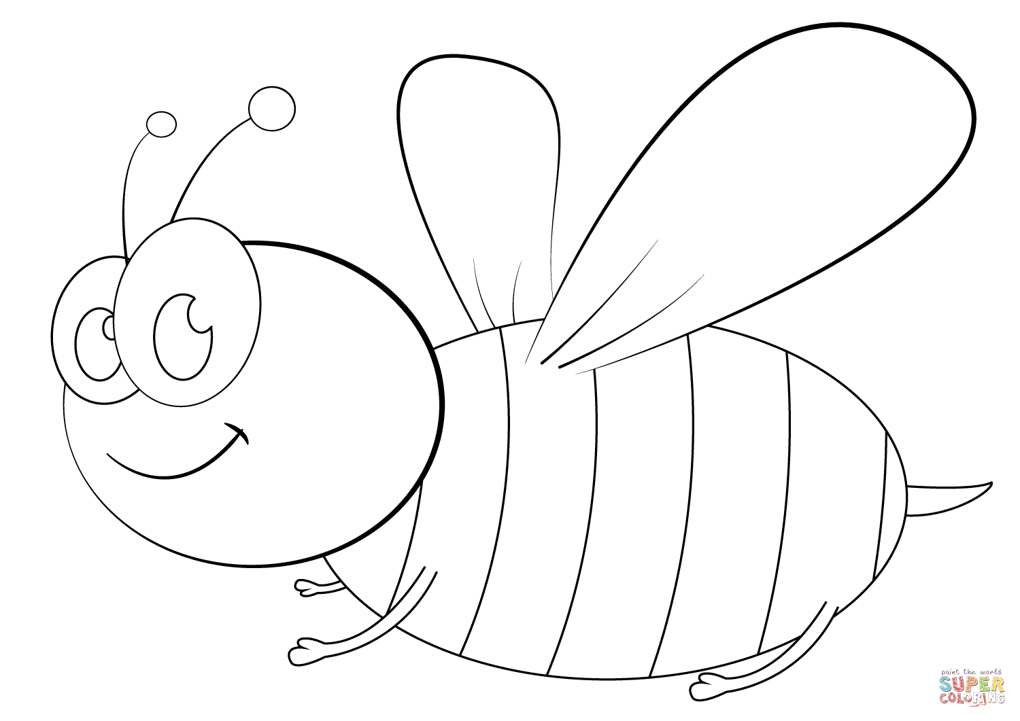

**Tawon**

**Tt**

|  |  |  |  |
| --- | --- | --- | --- |
| **t** | **t** | **t** | **t** |
| t | t | t | t |
| t | t | t | t |
| t | t | t | t |
| t | t | t | t |
| t | t | t | t |
| t | t | t | t |
| t | t | t | t |