**Walet**

**Ww**

|  |  |  |  |
| --- | --- | --- | --- |
| **W** | **W** | **W** | **W** |
| **W** | **W** | **W** | **W** |
| **W** | **W** | **W** | **W** |
| **W** | **W** | **W** | **W** |
| **W** | **W** | **W** | **W** |
| **W** | **W** | **W** | **W** |
| **W** | **W** | **W** | **W** |
| **W** | **W** | **W** | **W** |

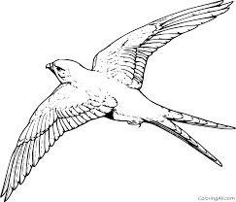

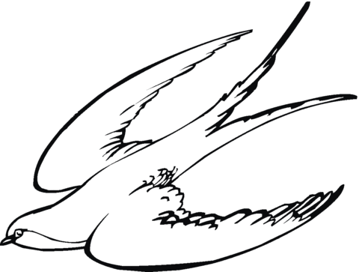

**Walet**

**Ww**

|  |  |  |  |
| --- | --- | --- | --- |
| **w** | **w** | **w** | **w** |
| w | w | w | w |
| w | w | w | w |
| w | w | w | w |
| w | w | w | w |
| w | w | w | w |
| w | w | w | w |
| w | w | w | w |