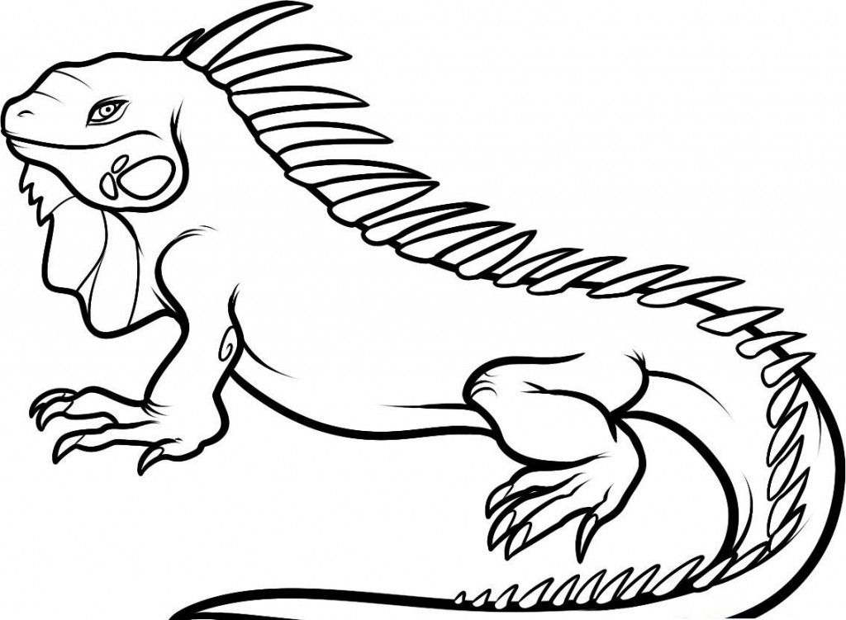

**Iguana**

**Ii**

|  |  |  |  |
| --- | --- | --- | --- |
| **I** | **I** | **I** | **I** |
| **I** | **I** | **I** | **I** |
| **I** | **I** | **I** | **I** |
| **I** | **I** | **I** | **I** |
| **I** | **I** | **I** | **I** |
| **I** | **I** | **I** | **I** |
| **I** | **I** | **I** | **I** |
| **I** | **I** | **I** | **I** |

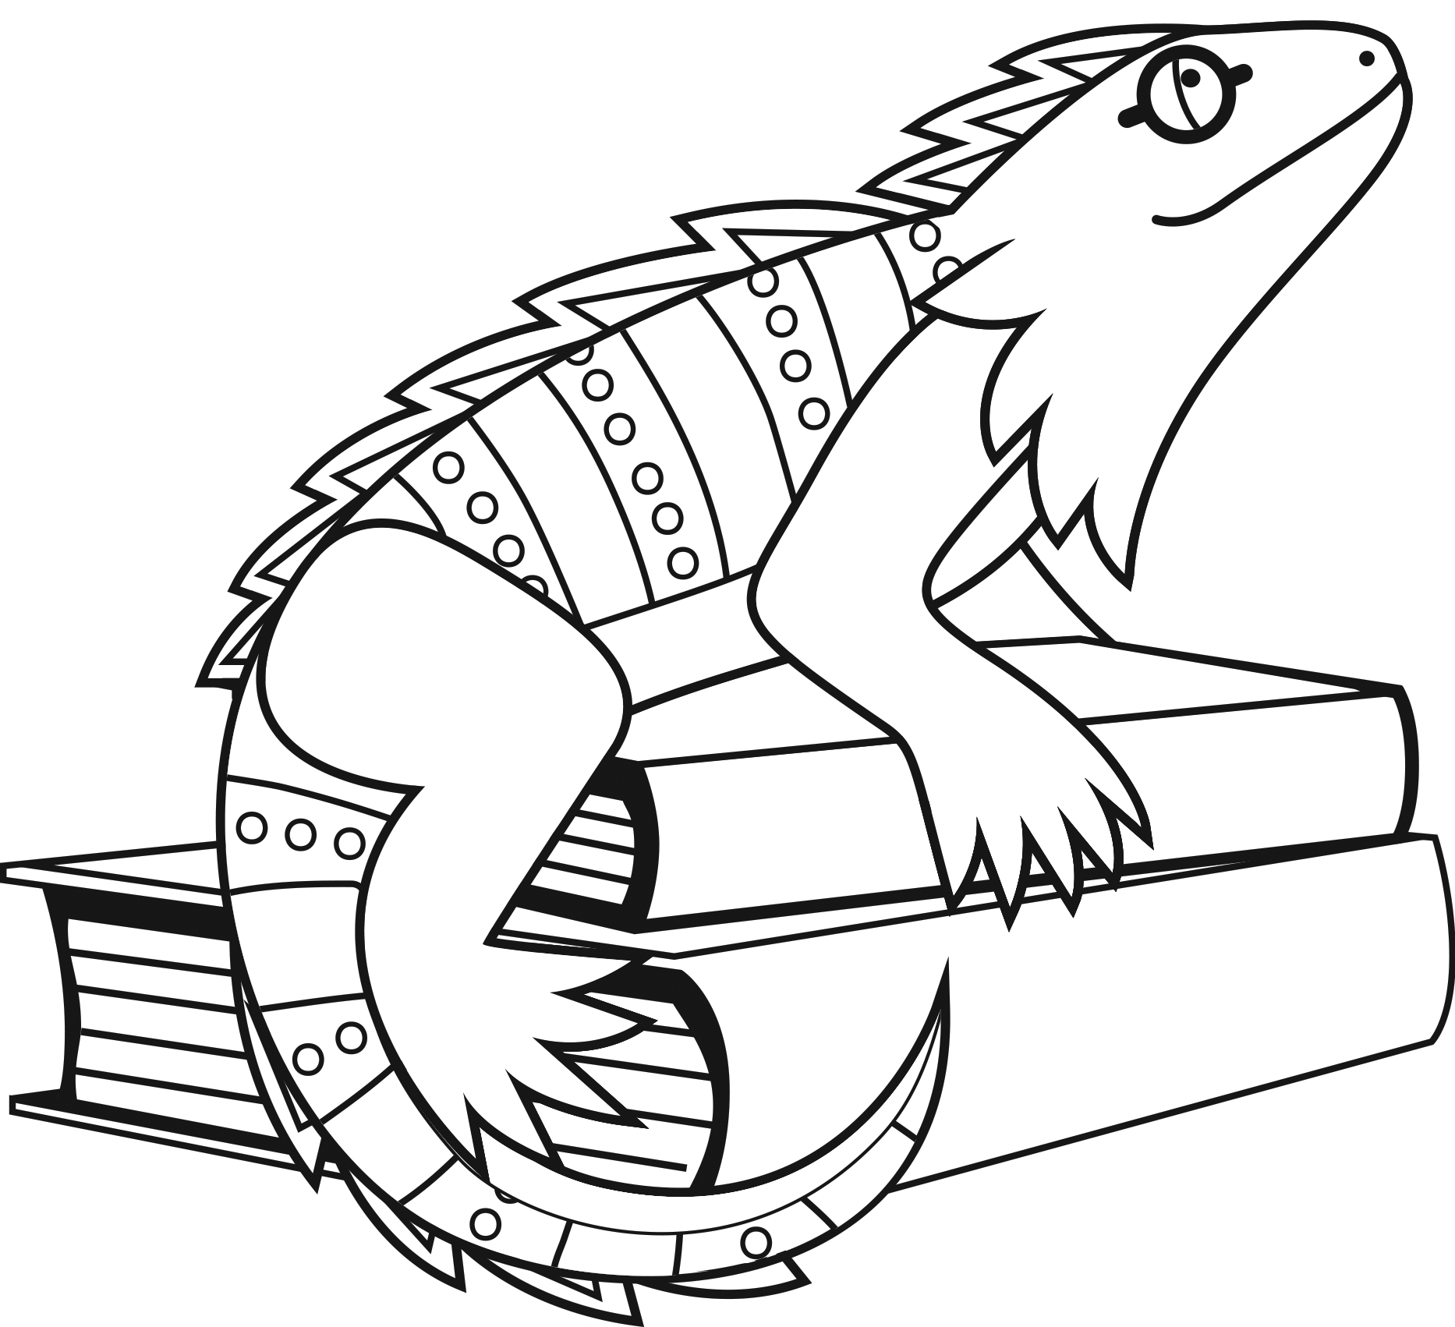

**Iguana**

**Ii**

|  |  |  |  |
| --- | --- | --- | --- |
| **i** | **i** | **i** | **i** |
| i | i | i | i |
| i | i | i | i |
| i | i | i | i |
| i | i | i | i |
| i | i | i | i |
| i | i | i | i |
| i | i | i | i |