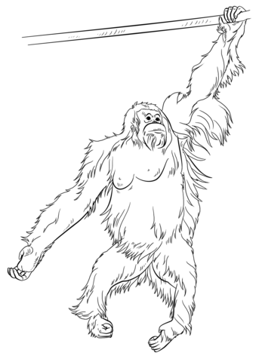

**Oo**

|  |  |  |  |
| --- | --- | --- | --- |
| **O** | **O** | **O** | **O** |
| **O** | **O** | **O** | **O** |
| **O** | **O** | **O** | **O** |
| **O** | **O** | **O** | **O** |
| **O** | **O** | **O** | **O** |
| **O** | **O** | **O** | **O** |
| **O** | **O** | **O** | **O** |
| **O** | **O** | **O** | **O** |

**Orang Utan**

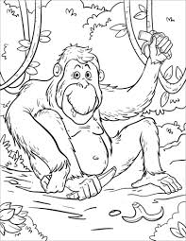

|  |  |  |  |
| --- | --- | --- | --- |
| **o** | **o** | **o** | **o** |
| **o** | **o** | **o** | **o** |
| **o** | **o** | **o** | **o** |
| **o** | **o** | **o** | **o** |
| **o** | **o** | **o** | **o** |
| **o** | **o** | **o** | **o** |
| **o** | **o** | **o** | **o** |
| **o** | **o** | **o** | **o** |

**Oo**

**Orang Utan**