**Walet**

|  |  |  |  |
| --- | --- | --- | --- |
| **W** | **W** | **W** | **W** |
| **W** | **W** | **W** | **W** |
| **W** | **W** | **W** | **W** |
| **W** | **W** | **W** | **W** |
| **W** | **W** | **W** | **W** |
| **W** | **W** | **W** | **W** |
| **W** | **W** | **W** | **W** |
| **W** | **W** | **W** | **W** |

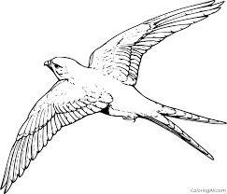

**Ww**

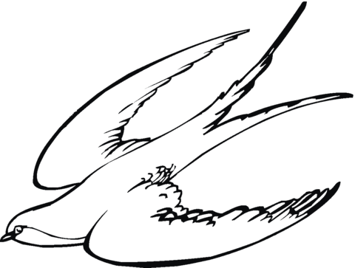

**Ww**

|  |  |  |  |
| --- | --- | --- | --- |
| **w** | **w** | **w** | **w** |
| **w** | **w** | **w** | **w** |
| **w** | **w** | **w** | **w** |
| **w** | **w** | **w** | **w** |
| **w** | **w** | **w** | **w** |
| **w** | **w** | **w** | **w** |
| **w** | **w** | **w** | **w** |
| **w** | **w** | **w** | **w** |

**Walet**