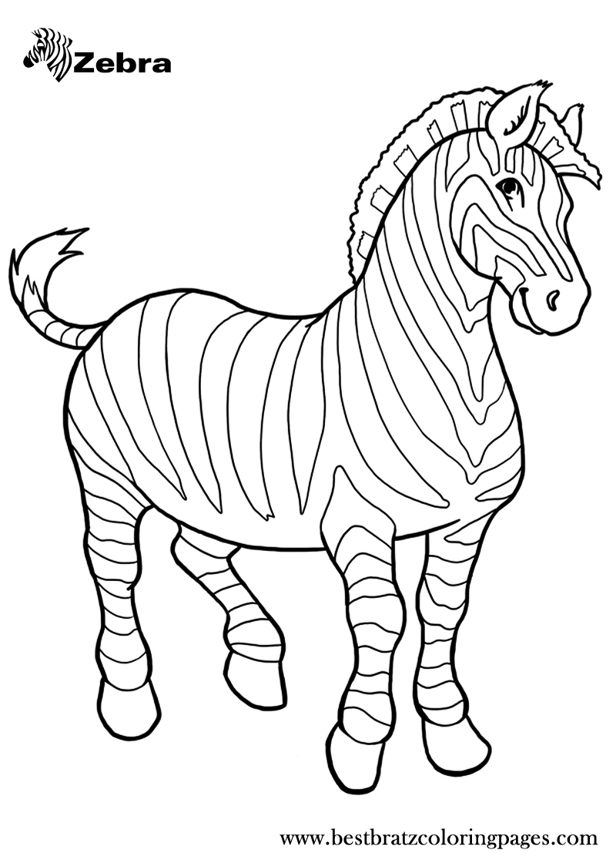

**Zebra**

**Zz**

|  |  |  |  |
| --- | --- | --- | --- |
| **Z** | **Z** | **Z** | **Z** |
| **Z** | **Z** | **Z** | **Z** |
| **Z** | **Z** | **Z** | **Z** |
| **Z** | **Z** | **Z** | **Z** |
| **Z** | **Z** | **Z** | **Z** |
| **Z** | **Z** | **Z** | **Z** |
| **Z** | **Z** | **Z** | **Z** |
| **Z** | **Z** | **Z** | **Z** |

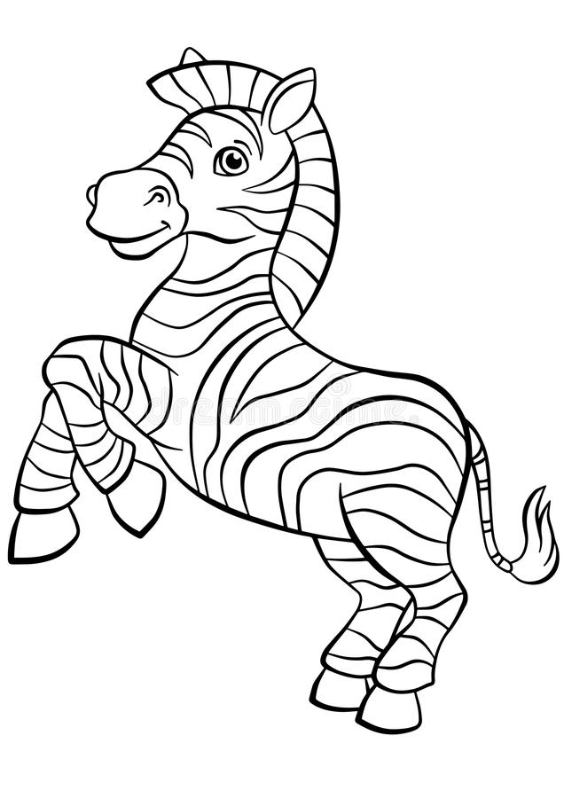

**Zebra**

**Zz**

|  |  |  |  |
| --- | --- | --- | --- |
| **z** | **z** | **z** | **z** |
| **z** | **z** | **z** | **z** |
| **z** | **z** | **z** | **z** |
| **z** | **z** | **z** | **z** |
| **z** | **z** | **z** | **z** |
| **z** | **z** | **z** | **z** |
| **z** | **z** | **z** | **z** |
| **z** | **z** | **z** | **z** |