**Capung**

**Cc**

|  |  |  |  |
| --- | --- | --- | --- |
| **C** | **C** | **C** | **C** |
| **C** | **C** | **C** | **C** |
| **C** | **C** | **C** | **C** |
| **C** | **C** | **C** | **C** |
| **C** | **C** | **C** | **C** |
| **C** | **C** | **C** | **C** |
| **C** | **C** | **C** | **C** |
| **C** | **C** | **C** | **C** |

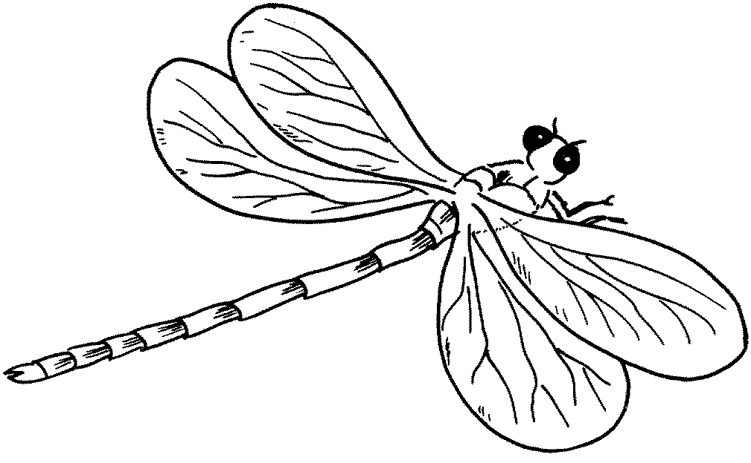

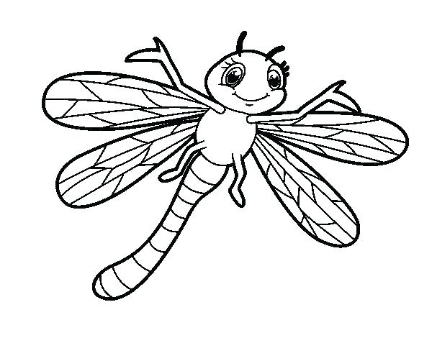

**Capung**

**Cc**

|  |  |  |  |
| --- | --- | --- | --- |
| **c** | **c** | **c** | **c** |
| c | c | c | c |
| c | c | c | c |
| c | c | c | c |
| c | c | c | c |
| c | c | c | c |
| c | c | c | c |
| c | c | c | c |