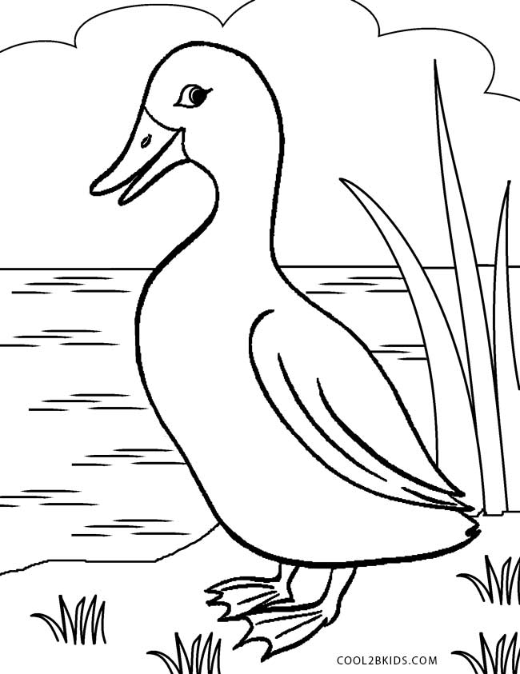

**Bb**

|  |  |  |  |
| --- | --- | --- | --- |
| **B** | **B** | **B** | **B** |
| **B** | **B** | **B** | **B** |
| **B** | **B** | **B** | **B** |
| **B** | **B** | **B** | **B** |
| **B** | **B** | **B** | **B** |
| **B** | **B** | **B** | **B** |
| **B** | **B** | **B** | **B** |
| **B** | **B** | **B** | **B** |

**Bebek**

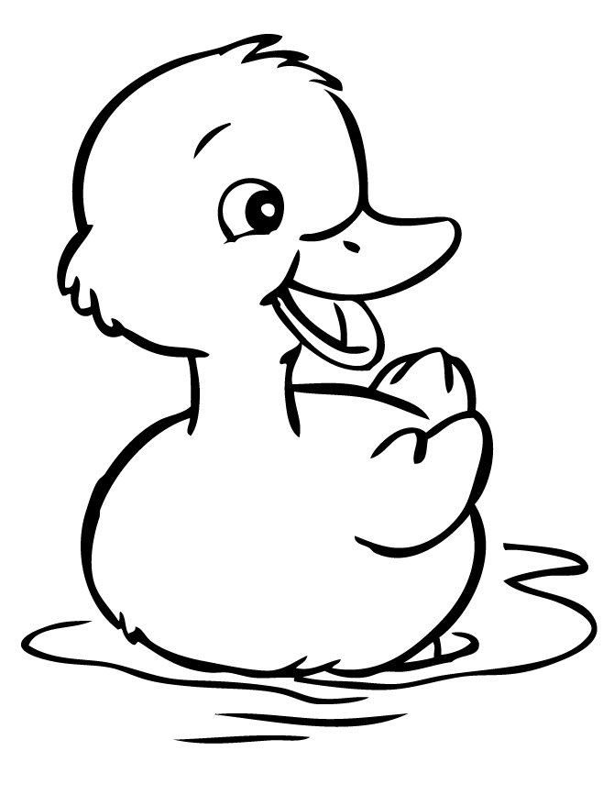

**Bb**

|  |  |  |  |
| --- | --- | --- | --- |
| **b** | **b** | **b** | **b** |
| **b** | **b** | **b** | **b** |
| **b** | **b** | **b** | **b** |
| **b** | **b** | **b** | **b** |
| **b** | **b** | **b** | **b** |
| **b** | **b** | **b** | **b** |
| **b** | **b** | **b** | **b** |
| **b** | **b** | **b** | **b** |

**Bebek**