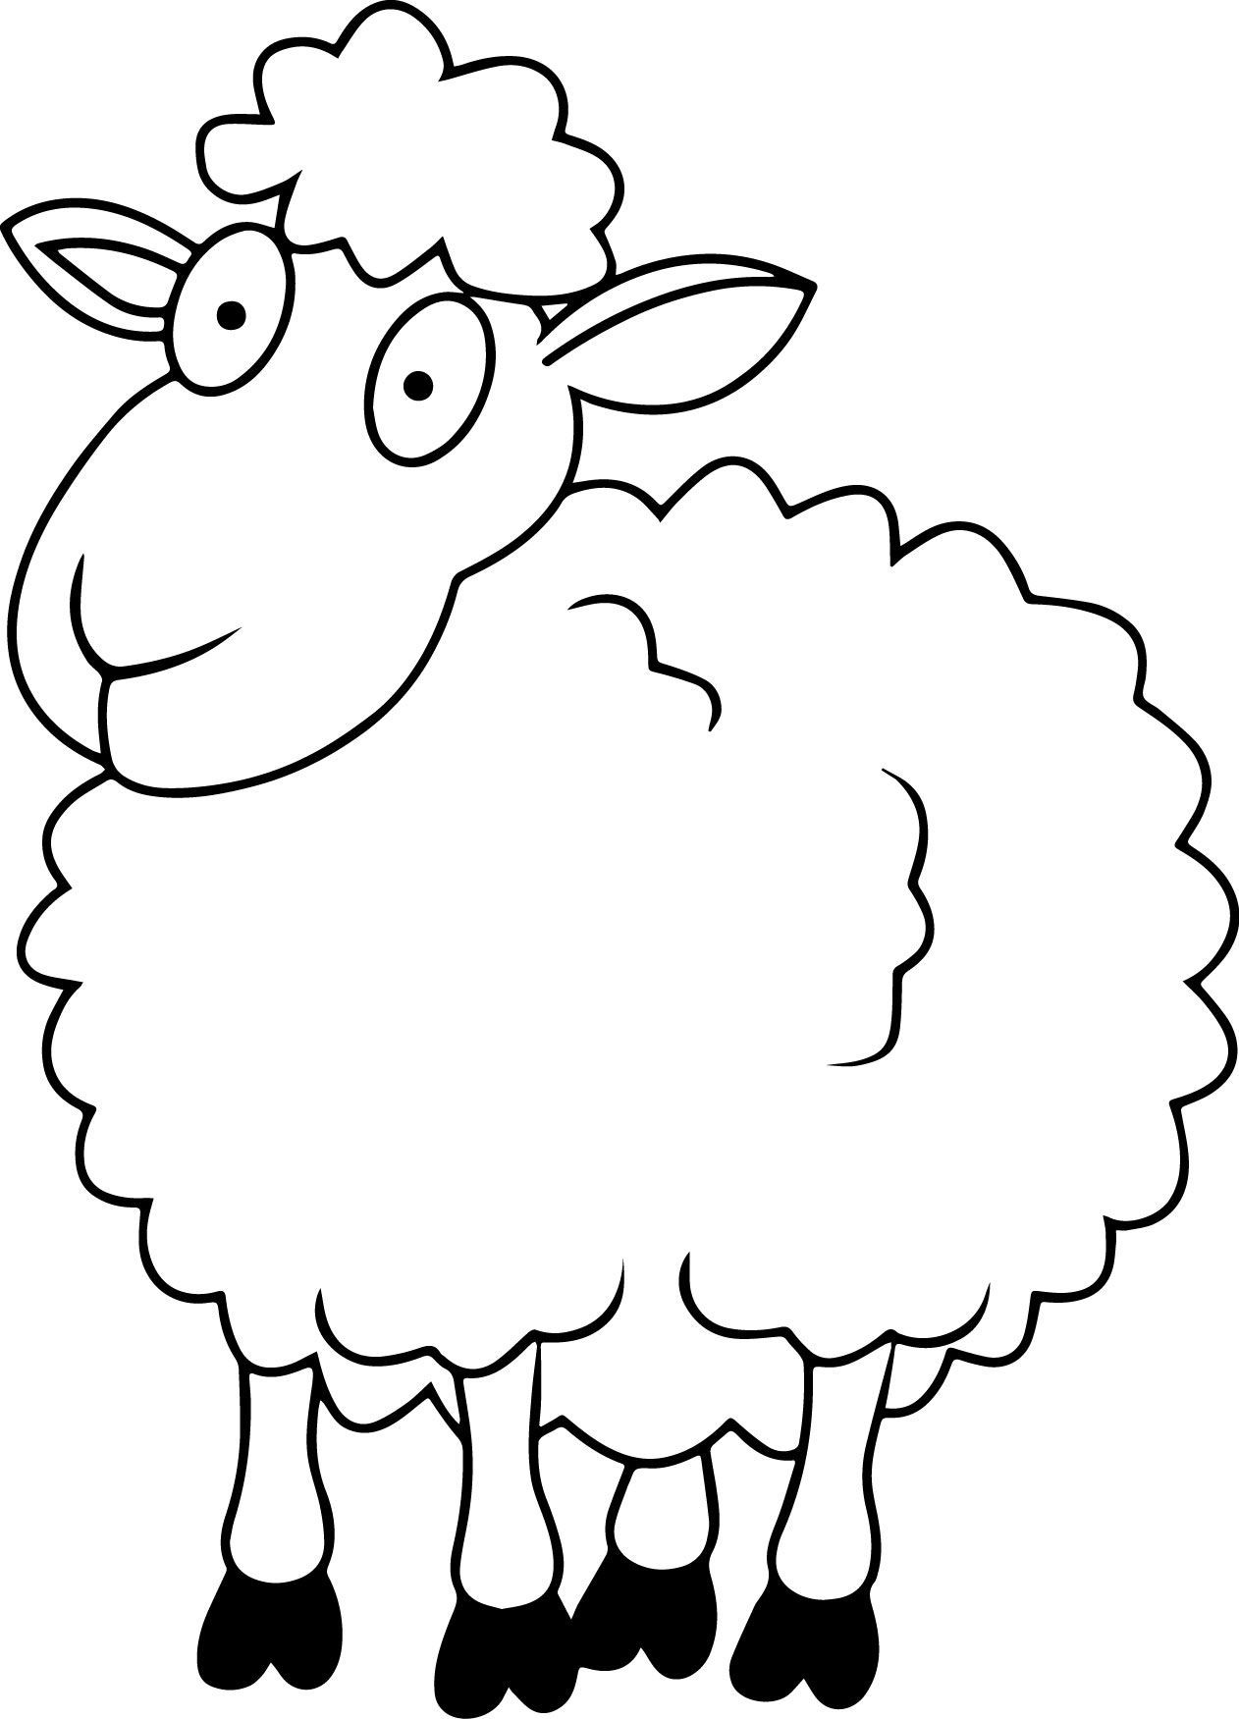

**Dd**

|  |  |  |  |
| --- | --- | --- | --- |
| **D** | **D** | **D** | **D** |
| **D** | **D** | **D** | **D** |
| **D** | **D** | **D** | **D** |
| **D** | **D** | **D** | **D** |
| **D** | **D** | **D** | **D** |
| **D** | **D** | **D** | **D** |
| **D** | **D** | **D** | **D** |
| **D** | **D** | **D** | **D** |

**Domba**

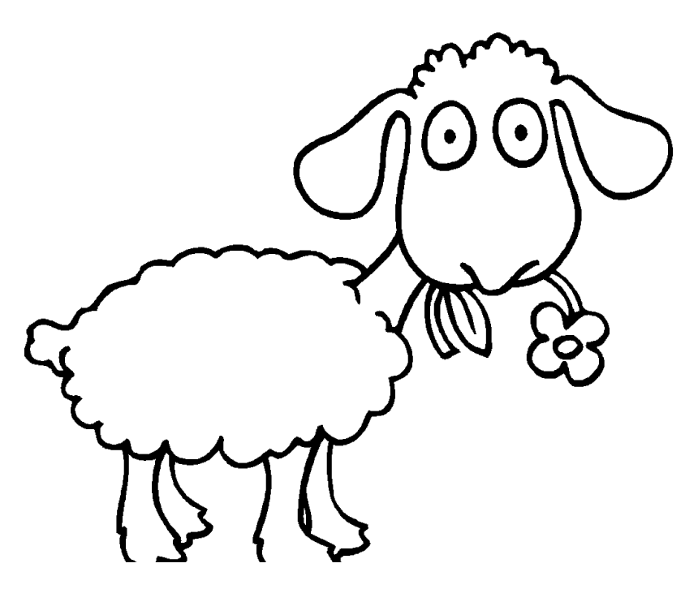

**Dd**

|  |  |  |  |
| --- | --- | --- | --- |
| **d** | **d** | **d** | **d** |
| **d** | **d** | **d** | **d** |
| **d** | **d** | **d** | **d** |
| **d** | **d** | **d** | **d** |
| **d** | **d** | **d** | **d** |
| **d** | **d** | **d** | **d** |
| **d** | **d** | **d** | **d** |
| **d** | **d** | **d** | **d** |

**Domba**